DATA SECURITY AND COMPLIANCE Research and Case Scenario in Data Security and Compliance

20/07/2026
Pawel Waszak (2417221)
Computer networks & Cyber security
Contents
Abstract 4
Task 1.1 – Introduction 4
Task 1.2 – The Threat Landscape 4
Task 1.3 – Zero Trust Architecture: Principles and Foundations 5
Task 1.4 – Technological Enablers 6
Zero Trust Network Access (ZTNA) 6
Secure Access Service Edge (SASE) 6
Identity Governance and Administration (IGA) 6
Task 1.5 – Implementation Challenges 7
Task 1.6 – Case Studies and Empirical Evidence 7
SolarWinds (2020) 8
MOVEit Transfer / Cl0p (2023) 8
Task 1.7 – Discussion 8
Task 1.8 – Conclusion 8
Task 2.1 – Executive Summary 10
Task 2.2 – Work-Stream 1: Organisational Design and Resourcing 10
Task 2.3 – Work-Stream 2: Policy Framework Development 11
Acceptable Use Policy for AI and Cloud Services 12
Hybrid Work and Remote Access Security Policy 12
Third-Party and Cloud Vendor Risk Management Policy 12
Task 2.4 – Work-Stream 3: Regulatory Compliance Strategy 12
Task 2.5 – Work-Stream 4: Technical Standards and Architecture 13
Task 2.6 – Work-Stream 5: Strategic Risk Assessment 14
Task 2.7 – Work-Stream 6: Incident Response and Business Continuity 15
Phase 1 – Preparation 15
Phase 2 – Detection and Analysis 15
Phase 3 – Containment 16
Phase 4 – Eradication 16
Phase 5 – Recovery 16
Phase 6 – Communication and Reporting 16
Task 2.8 – Work-Stream 7: Governance and Strategic Roadmap 16
Task 2.9 – Conclusion 17
References 18

TASK 1 – RESEARCH PAPER
Securing the Modern Enterprise: Implementing a Zero Trust Architecture

Abstract
Traditional perimeter based security has not kept up with the way modern enterprises actually work. Cloud adoption, remote workforces and a steady stream of supply-chain attacks have hollowed out the assumption that anyone or anything inside the network can be trusted by default. This paper reviews the Zero Trust Architecture (ZTA) model, drawing mainly on NIST Special Publication 800-207 [1] and the Cybersecurity and Infrastructure Security Agency Zero Trust Maturity Model [4]. It examines the core principles, the technologies that make Zero Trust deployable (Zero Trust Network Access, Secure Access Service Edge, and Identity Governance and Administration), and the operational challenges organisations report during adoption. Real-world case studies, including the 2020 SolarWinds compromise and the 2023 MOVEit Transfer attacks, are used to argue that perimeter trust models are no longer sufficient against modern threat actors [10], [13]. The paper concludes that Zero Trust is not a single product but a strategic programme. The findings of this research directly inform the CISO proposal in Task 2, where Zero Trust is selected as the guiding model for Aegis FinTech Innovations Ltd.
Keywords Zero Trust Architecture, ZTNA, SASE, NIST SP 800-207, identity governance, ransomware, DORA, GDPR, cloud security, micro-segmentation.

Task 1.1 – Introduction
For most of the last twenty years, enterprise security relied on a simple idea: build a strong perimeter, and treat anything inside it as trusted. The model worked reasonably well when staff sat in offices, applications ran on company-owned servers, and the firewall was the main control point. That world is gone. According to IBM’s most recent X-Force Threat Intelligence Index, identity based attacks now account for a third of all incidents observed in 2024, with valid credentials abused in nearly 30% of cases [7]. Cloud adoption has shifted critical data outside the corporate network, and the pandemic accelerated remote working in a way that has not reversed [11].
Against this background, the United States National Institute of Standards and Technology (NIST) published Special Publication 800-207 in 2020, formalising what had until then been a loose collection of practitioner ideas under the heading “Zero Trust Architecture” (ZTA) [1]. The Cybersecurity and Infrastructure Security Agency (CISA) followed in 2023 with a maturity model giving organisations a way to measure their progress [4]. Both documents now sit at the heart of how the US federal government, and increasingly UK and EU regulators, expect modern organisations to design their security.
The aim of this paper is to evaluate Zero Trust as a strategy for organisations operating in hybrid cloud environments. The motivating question is whether the model can plausibly replace perimeter security as the default for a modern enterprise. Five things are covered: the changing threat landscape (Section 1.2); the principles of Zero Trust as set out in NIST SP 800-207 (Section 1.3); the technologies that enable it in practice (Section 1.4); the challenges organisations face when adopting it (Section 1.5); and case-study evidence of attacks that perimeter models failed to stop (Section 1.6). Section 1.7 brings these together. The paper closes by setting out why Zero Trust is the appropriate model for the case organisation in Task 2.

Task 1.2 – The Threat Landscape
Three trends in particular make a perimeter only model untenable. The first is the prevalence of credential abuse. Verizon’s 2024 Data Breach Investigations Report puts the human element in roughly 68% of breaches, most of which involve stolen or phished credentials [11]. The second is supply chain compromise: attackers no longer need to break in directly when they can compromise a trusted vendor and ride that trust into the target. The SolarWinds Orion incident is the most cited example, but more recent supply chain campaigns against MOVEit Transfer (Cl0p, 2023) and 3CX (Lazarus Group, 2023) show that the pattern continues [10], [13]. The third trend is ransomware. The 2024 Sophos State of Ransomware report records that 59% of organisations surveyed were hit by ransomware in the previous year, with a mean recovery cost of US$2.73 million when ransom payments are excluded [13].
None of these trends is well addressed by a network perimeter. Stolen credentials let attackers walk straight through it. Supply chain compromise turns trusted insiders into hostile insiders. Ransomware operators who land in one system rely on lateral movement to encrypt the rest of the estate, which is precisely what micro segmentation, a core Zero Trust control, is designed to stop [3].

Task 1.3 – Zero Trust Architecture: Principles and Foundations
The clearest definition of Zero Trust comes from NIST SP 800-207, which states that ZTA is a set of concepts and design principles based on the assumption that “no implicit trust is granted to assets or user accounts based solely on their physical or network location” [1]. The same publication identifies seven tenets that any Zero Trust deployment should follow, which can be summarised as: every resource is treated as a distinct unit; every access request is authenticated and authorised on a per-session basis; access policies are dynamic and based on signals such as device posture, user behaviour and threat intelligence; the network is treated as hostile; and all flows are logged for monitoring.
The architectural pattern that follows is built around two planes. A control plane (the policy decision point and policy administrator) decides whether a request should be granted; a data plane (the policy enforcement point) carries out that decision and provides the connection. Rose et al. emphasise that the separation is logical rather than physical and that the same component can play both roles in a small deployment [1], [3]. The key change from older models is that a successful authentication does not give long running access. Every request is re-evaluated against current signals. Table I summarises how this differs from the perimeter model it replaces.

Dimension | Traditional Perimeter Model | Zero Trust Architecture
Trust assumption | Implicit trust for anything inside the network boundary | No implicit trust; every request verified regardless of origin [1]
Access granularity | Network-level: VPN grants broad internal access | Application-level: per-session, per-resource decisions [5]
Primary control point | Firewall at the network edge | Identity provider and policy decision point [12]
Lateral movement | Largely unrestricted once inside | Constrained by micro-segmentation and per-request policy [3]
Remote work | VPN extends the perimeter to the endpoint | ZTNA brokers application access; no network extension [5]
Monitoring focus | North-south traffic at the boundary | All flows, including east-west, continuously logged [1], [4]
Breach blast radius | Potentially the whole estate (cf. SolarWinds [10]) | Limited to the resources the compromised identity can reach
Table 1. Traditional perimeter security compared with Zero Trust Architecture across seven dimensions. Compiled from NIST SP 800-207 [1], CISA ZTMM [4] and Gartner ZTNA guidance [5].

CISA’s Zero Trust Maturity Model adds a useful operational layer to the NIST work. It defines five pillars (Identity, Devices, Networks, Applications and Workloads, and Data) and four maturity levels (Traditional, Initial, Advanced and Optimal) [4]. Organisations rarely arrive at Optimal in one project; the model is intended as a phased programme. The same point is made by Stafford in a 2020 NIST commentary: Zero Trust is best understood as a strategy, not a product [3].

Task 1.4 – Technological Enablers
Three technology families have come to dominate Zero Trust deployments in practice. Each addresses a different pillar of the CISA model. Table II maps the five pillars to the enabling technologies discussed in this section.

Zero Trust Network Access (ZTNA)
ZTNA replaces the traditional VPN. Instead of granting a remote user access to the corporate network as a whole, it brokers an application by application tunnel that is only established after the user, the device and the context have been verified [5]. Gartner’s 2024 Market Guide forecasts that by 2026 around 60% of enterprises will phase out their remote access VPNs in favour of ZTNA [5]. The reduction in attack surface is the main argument: a compromised endpoint can no longer broadcast its access to the whole internal network.

Secure Access Service Edge (SASE)
SASE, a term coined by Gartner in 2019 and now widely adopted by vendors, integrates network security functions (secure web gateway, cloud access security broker, firewall as a service, ZTNA) into a single cloud delivered service [9]. From a Zero Trust perspective, SASE matters because it pushes the policy enforcement point as close to the user as possible, regardless of where the user is or what they are accessing. Convergence has been the dominant theme in the security vendor market over the last three years, with established firms (Zscaler, Netskope, Palo Alto Prisma, Cisco Secure Access) building integrated SASE platforms.

Identity Governance and Administration (IGA)
Identity is described in NIST SP 800-207 as the new perimeter, and Forrester make the same argument in their Zero Trust eXtended framework [12]. IGA covers the joiner-mover-leaver lifecycle, periodic access reviews, separation of duties, and privileged access management. Without strong IGA, the policy decisions made elsewhere in the architecture are built on unreliable foundations. Microsoft’s 2024 Digital Defense Report records a 146% year on year increase in identity based attacks, much of which exploited stale or over-privileged accounts [16].
Taken together, these three families turn the high-level NIST tenets into something organisations can buy and deploy. None of them is a silver bullet on its own; the value comes from running them as an integrated programme.

CISA ZTMM Pillar | Objective at Advanced Maturity | Primary Enabling Technologies | Key Sources
Identity | Phishing-resistant MFA; continuous risk-based validation | IdP, IGA, privileged access management | [1], [12], [16]
Devices | Device posture verified at every access request | EDR, mobile device management, posture agents | [4], [5]
Networks | Micro-segmentation; encrypted east-west traffic | ZTNA, SASE, software-defined perimeter | [5], [9]
Applications & Workloads | Continuous authorisation; secure development pipeline | CWPP, DevSecOps tooling, API gateways | [2], [4]
Data | Data categorised, encrypted, and access-logged everywhere | DLP, encryption, rights management, CSPM | [4], [9]
Table 2. The five CISA Zero Trust Maturity Model pillars mapped to enabling technologies. The Advanced maturity column reflects CISA ZTMM v2.0 stage definitions [4].

Task 1.5 – Implementation Challenges
Adoption surveys consistently find a gap between strategic intent and operational reality. Gartner reports that 63% of organisations have adopted a Zero Trust strategy in some form, but only 32% have moved beyond identity focused pilots [5]. Four challenges come up repeatedly in the literature.
First is legacy estate. Most organisations still operate applications that were designed for a trusted network and cannot easily be retrofitted with continuous authentication. Buck et al. identify this as the single largest barrier in their 2021 systematic review [2]. Refactoring or replacing these systems is expensive and slow.
Second is cultural resistance. Zero Trust changes how staff access work, and the additional authentication steps (even when made invisible) create friction. Without clear executive sponsorship, programmes tend to stall after the first identity wins [8]. Eidle et al. report that user pushback was cited by 41% of CISOs in their study as the main reason for slower than planned rollouts [6].
Third is policy complexity. Once micro segmentation is in place, the number of access policies that have to be maintained increases by an order of magnitude. Stafford and Buck both note that organisations frequently underestimate the operational cost of keeping these policies current as the business changes [2], [3].
Fourth is integration cost. ZTNA, SASE, CSPM and SIEM all need to share telemetry to make Zero Trust work, and most large organisations end up running components from several vendors. The integration work, often through SOAR platforms, is non trivial and frequently bespoke [9].
None of these challenges is a reason to avoid Zero Trust. They are, however, reasons to plan the programme carefully and to set realistic expectations with the executive.

Task 1.6 – Case Studies and Empirical Evidence
Two recent incidents illustrate why perimeter trust no longer works.

SolarWinds (2020)
Russian state aligned attackers compromised the build pipeline of SolarWinds Orion, a widely deployed network management product, and inserted a backdoor that was distributed through legitimate software updates to roughly 18,000 customers [10]. Because Orion ran inside the corporate perimeter and was inherently trusted, the malicious update was free to communicate outward and laterally inside victim networks. CISA’s after action analysis concluded that organisations practising Zero Trust principles, particularly continuous monitoring of east-west traffic and behavioural baselining of trusted applications, were significantly better placed to detect the compromise [10].

MOVEit Transfer / Cl0p (2023)
The Cl0p ransomware group exploited a zero-day SQL injection vulnerability in Progress Software’s MOVEit Transfer product to steal data from more than 2,700 organisations [13]. As with SolarWinds, the initial vector was a trusted third-party application. The lesson for Zero Trust is that least privilege at the data layer matters as much as least privilege at the network layer: even compromised applications should be unable to exfiltrate data at scale without triggering data loss prevention or anomalous-egress controls.
In both cases, the controls Zero Trust prescribes (micro segmentation, continuous monitoring, strict egress policy and per application authentication) would have limited the blast radius even where they would not have prevented the initial compromise. This is the more realistic claim for Zero Trust: it does not stop every attack, but it makes attacks much harder to scale.

Task 1.7 – Discussion
Three things stand out from the literature reviewed. First, Zero Trust is now mainstream. NIST, CISA, the UK National Cyber Security Centre and the EU Agency for Cybersecurity all publish guidance built around it [1], [4], [15]. It is no longer a vendor talking point; it is the assumed baseline for new architectures.
Second, the technology stack has matured. Five years ago, deploying Zero Trust meant stitching together products that were never designed to work together. The SASE convergence has changed this, and 2024 Gartner data shows the integration burden has fallen materially [5], [9]. For an organisation starting from scratch, this matters: there is no longer a strong technical reason to design around the old perimeter model.
Third, and most important, the regulatory environment is moving in the same direction. The EU Digital Operational Resilience Act, which becomes enforceable in January 2025, requires financial entities to implement “sound and comprehensive ICT risk management frameworks” that are explicitly aligned with international standards [14]. The General Data Protection Regulation’s Article 32 already mandates “state of the art” security measures [17]. For a financial services firm in the EU, Zero Trust is rapidly becoming the practical interpretation of those obligations.
That said, the model has limits. Buck et al. are right to flag that Zero Trust does not by itself address insider threat, social engineering or supply chain risk at the design level [2]. It changes the blast radius once an attack starts but does not necessarily prevent it.

Task 1.8 – Conclusion
This paper has argued that Zero Trust Architecture is the appropriate model for modern enterprises operating in hybrid cloud environments. The threat landscape, the regulatory environment and the maturity of the technology stack all point the same way. Implementation is not trivial: legacy systems, cultural resistance and operational complexity all create real obstacles. The case studies reviewed nonetheless suggest that Zero Trust controls measurably reduce the impact of the kinds of attacks that perimeter security cannot prevent.
Task 2 of this submission applies these findings. The case organisation, Aegis FinTech Innovations Ltd, is a cloud native financial services startup preparing for EU expansion. Zero Trust is selected as the strategic model because the organisation is small enough to adopt it from the outset without legacy refactoring, the regulatory environment (GDPR and DORA) demands it, and the threat profile (ransomware, supply-chain attacks against fintech, AI data poisoning) is precisely the kind that Zero Trust is designed to limit. The remainder of the report sets out the proposal.

TASK 2 – CISO PROPOSAL
Information Security Unit Establishment and Implementation Plan
Aegis FinTech Innovations Ltd – Board Proposal
Prepared by: Pawel Waszak, Chief Information Security Officer
Aegis FinTech Innovations Ltd, London
For the attention of: The Executive Board
Date: 20 July 2026
Classification: CONFIDENTIAL – Board Members Only

Task 2.1 – Executive Summary
This proposal sets out the design of Aegis FinTech’s new Information Security Unit, the policy framework it will operate under, the compliance roadmap for European Union expansion, and the technical architecture it will implement. The whole proposal is built on the conclusion reached in Task 1: that Zero Trust Architecture, as defined by NIST Special Publication 800-207 [1] and operationalised through the CISA Zero Trust Maturity Model [4], is the right strategic model for a cloud-native fintech preparing for the EU market.
The proposal recommends a twelve-person Information Security Unit organised under the CISO, with five functional leads (Cloud Security Architecture, DevSecOps Engineering, Data Protection, GRC & Compliance, and SOC & Incident Response). The total Year 1 budget request is approximately £1.85 million, including headcount, tooling and external assurance. A twelve month roadmap is proposed (Section 2.8 and Figure 3) with prioritised initiatives in four quarterly waves: Foundations, Zero Trust, Resilience and Assurance. The compliance roadmap covers both the General Data Protection Regulation [17] and the EU Digital Operational Resilience Act [14], with critical DORA milestones aligned to the EU launch date.
Three risks dominate the strategic picture: cloud misconfiguration, ransomware against the financial sector, and supply-chain compromise of SaaS vendors. These are quantified in the risk register at Section 2.6 and mitigated through specific controls drawn from the Task 1 research.

Task 2.2 – Work-Stream 1: Organisational Design and Resourcing
The proposed Information Security Unit is organised around the five CISA Zero Trust pillars (Identity, Devices, Networks, Applications and Workloads, and Data) rather than around traditional functional silos [4]. Figure 1 shows the structure. The CISO reports to the CEO and chairs the Cyber Security Steering Committee (see Section 2.8).

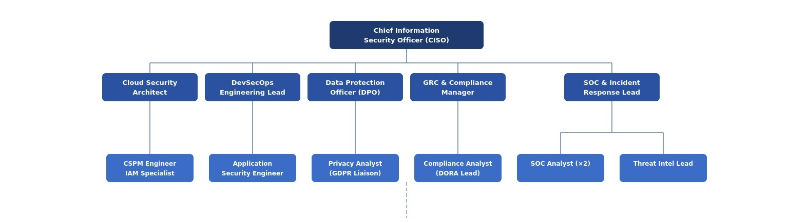
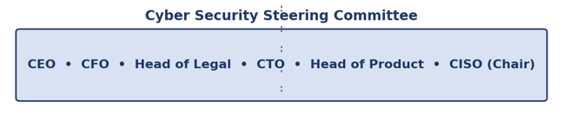
Figure 1. Proposed Information Security Unit organisational chart. Five functional leads report to the CISO; the Cyber Security Steering Committee provides cross-functional governance.
The five leads and their justifications are as follows. The Cloud Security Architect owns AWS estate hardening and Cloud Security Posture Management; this is a direct response to the Task 1 finding that cloud misconfiguration remains the single most cited root cause of fintech breaches [9]. The DevSecOps Engineering Lead owns secure software development lifecycle integration, which the Task 1 research showed is essential for closing the developer to production attack path [2]. The Data Protection Officer is mandated by Article 37 of the GDPR for organisations processing personal data on the scale Aegis FinTech intends [17]; the role is independent of the CISO line management for the parts of its remit that GDPR requires.
The GRC and Compliance Manager owns the DORA, GDPR and ISO 27001 programme, working directly with Legal. The SOC and Incident Response Lead owns continuous monitoring and the ransomware playbook (Section 2.7). Below this tier, eight specialist roles complete the unit, including two SOC analysts (24/7 coverage requires a minimum rota), a Threat Intelligence Lead, a Privacy Analyst working under the DPO, and a Compliance Analyst leading DORA implementation.
Total Year 1 headcount: twelve. Estimated payroll cost: approximately £1.45 million including employer’s national insurance and pensions. Tooling and external assurance budget: £400,000, of which the largest single line item is the SIEM/SOAR platform.

Task 2.3 – Work-Stream 2: Policy Framework Development
Three policies are recommended for immediate executive approval. Each is summarised below. The drafting standard follows NIST SP 800-53 Rev. 5 [18] and ISO 27001:2022 Annex A [3].

Acceptable Use Policy for AI and Cloud Services
This policy defines acceptable use of artificial intelligence tools (including third party large language models), software as a service platforms and cloud infrastructure by Aegis FinTech employees and contractors. As Task 1 identified, AI governance is now a recognised compliance gap [16], and Aegis FinTech’s own product depends on AI models that handle financial data. Key clauses prohibit submission of customer personal data or non public financial information to public AI services, require all AI use cases to be logged in the AI Use Case Register, and mandate review of model outputs before any use in customer facing decisions. The policy aligns with the EU AI Act risk classification published in 2024 [15].

Hybrid Work and Remote Access Security Policy
This policy implements the Zero Trust remote access controls justified by Task 1. All remote access must be brokered through the approved ZTNA gateway; the legacy VPN will be decommissioned within six months. Device posture (encryption, patch state, EDR running) must be verified at each connection [5]. The policy also covers acceptable use of personal devices for work, in line with NCSC bring your own device guidance [15].

Third-Party and Cloud Vendor Risk Management Policy
This policy operationalises the Task 1 finding that supply chain compromise is one of the most damaging attack vectors against fintech [10], [13]. All SaaS vendors handling Aegis FinTech data must complete a security assessment before contract; vendors processing personal data must additionally sign a GDPR Article 28 data processing agreement [17]. High risk vendors (those with access to production systems or PII) must demonstrate ISO 27001:2022 certification or equivalent and re attest annually.

Task 2.4 – Work-Stream 3: Regulatory Compliance Strategy
Two regulations dominate Aegis FinTech’s compliance position: GDPR (effective since 2018, covering personal data) and DORA (effective from 17 January 2025, covering ICT operational resilience in EU financial services). The compliance roadmap below combines both.
Quarter | Regulation | Milestone | Evidence / Reference
Q1 | GDPR | Appoint Data Protection Officer; publish Records of Processing Activities | Articles 30, 37 [17]
Q1 | DORA | Document ICT risk management framework and Board-approved governance | DORA Articles 5–6 [14]
Q2 | GDPR | Data Protection Impact Assessment for AI analytics platform completed | Article 35 [17]
Q2 | DORA | ICT incident classification and reporting procedures operational | DORA Articles 17–18 [14]
Q3 | DORA | Critical third-party register published; vendor contracts amended | DORA Articles 28–30 [14]
Q4 | DORA | First Threat-Led Penetration Test (TLPT) commissioned; resilience testing programme established | DORA Articles 24–26 [14]
Q4 | Both | External assurance: ISO 27001:2022 stage-1 audit booked | ISO 27001:2022 [3]
Table 1. Compliance roadmap aligning GDPR and DORA milestones over the first twelve months. DORA enforcement began on 17 January 2025; all DORA items target completion ahead of the EU service launch.
Particular attention has been given to DORA’s Articles 28–30 on critical third party providers, because the platform depends on AWS and on third party AI inference services. Both will be classified as critical ICT third party providers under the regulation. The Q3 milestone captures the contractual and operational work that classification triggers [14].

Task 2.5 – Work-Stream 4: Technical Standards and Architecture
The core security framework for Aegis FinTech will be the NIST Cybersecurity Framework version 2.0, published in February 2024 [19], with the underlying control set drawn from NIST SP 800-53 Rev. 5 [18]. NIST CSF 2.0 has been chosen over ISO 27001:2022 [3] as the primary framework for three reasons. First, it is the framework the Task 1 research aligned to. Second, its new Govern function maps directly onto DORA’s governance requirements, which simplifies dual reporting [14]. Third, it is the framework most commonly required by US based fintech investors, which matters for the Series B raise. ISO 27001:2022 will still be pursued as a certification track because European customers expect it.
The proposed Year 1 target state architecture is shown in Figure 2. It implements the two-plane model from NIST SP 800-207 [1]: a control plane that makes per-request access decisions, and a data plane that carries them out. Identity is the foundation; without it, the rest of the architecture has nothing to decide on.
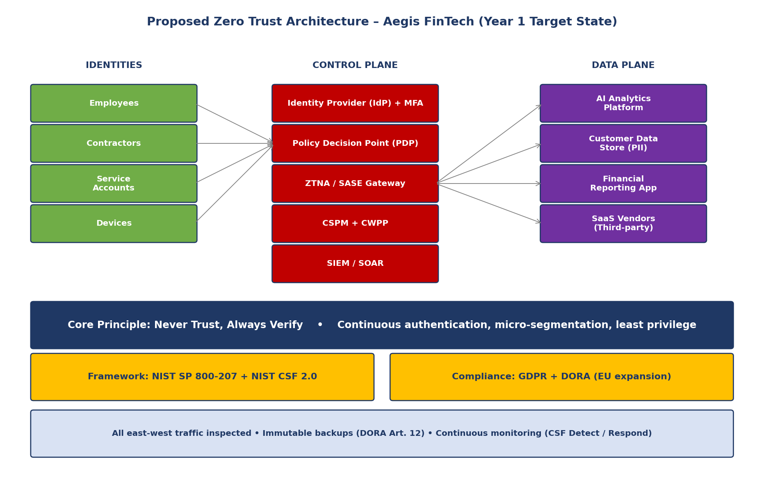
Figure 2. Proposed Zero Trust target architecture for Aegis FinTech. The control plane (centre) makes per request decisions for every interaction between identities (left) and resources (right). All east-west traffic is inspected, immutable backups satisfy DORA Article 12, and continuous monitoring feeds the NIST CSF Detect and Respond functions [4], [14], [19].
Five components form the core of the architecture. The Identity Provider with multi factor authentication is the entry point for every access decision. The Policy Decision Point evaluates each request against current signals (user, device posture, location, threat intelligence). The ZTNA/SASE gateway enforces those decisions at the network edge. The Cloud Security Posture Management and Cloud Workload Protection Platform components continuously assess the AWS estate and the workloads running on it, addressing the misconfiguration risk identified in the Task 1 research [9]. The Security Information and Event Management platform, with attached Security Orchestration, Automation and Response, ingests telemetry from all of the above and is the primary tool for the SOC.
The architecture deliberately includes no traditional VPN. The Task 1 research showed that legacy remote access is one of the most exploited entry points in fintech breaches [11]. The existing VPN will be decommissioned by the end of Q2.

Task 2.6 – Work-Stream 5: Strategic Risk Assessment
Table 2 below lists the top three strategic risks identified during the assessment phase, each linked back to the Task 1 evidence base. Impact ratings follow a five point scale (1 = negligible, 5 = catastrophic). Likelihood ratings use the same scale. Inherent score = impact x likelihood; residual score is after the proposed controls.
Risk | Description | Inherent (I×L) | Residual (I×L) | Mitigation
R1: Cloud misconfiguration | Misconfigured AWS resources expose customer data; identified by Task 1 as a leading fintech breach cause [9] | 5 × 4 = 20 | 5 × 2 = 10 | CSPM deployed Q1; infrastructure-as-code review gates; quarterly cloud security review
R2: Ransomware via supply-chain | Compromise of a SaaS vendor (cf. MOVEit 2023 [13]) leads to data theft and ransomware deployment | 5 × 4 = 20 | 5 × 2 = 10 | Vendor risk policy (§2.3); immutable backups (§2.7); micro-segmentation; ransomware playbook
R3: AI data poisoning | Adversarial inputs corrupt training data for the analytics model, degrading outputs at scale [16] | 4 × 3 = 12 | 4 × 1 = 4 | AI Use Case Register; input validation pipelines; model output monitoring; staged rollout
Table 2. Top three strategic risks with inherent and residual scoring. All three connect directly to findings in the Task 1 research; the mitigations are drawn from the ZTA controls reviewed there.
Risk R1 alone justifies the Cloud Security Architect appointment proposed in Section 2.2. R2 is the principal driver behind the SIEM/SOAR investment in the technical budget. R3 sits behind the AI governance policy in Section 2.3 and the related compliance milestones.

Task 2.7 – Work-Stream 6: Incident Response and Business Continuity
This section sets out the Ransomware Response Playbook, designed against the typical tactics, techniques and procedures observed in financial sector ransomware campaigns and analysed in Task 1 [10], [13]. The playbook follows the NIST SP 800-61 Rev. 2 lifecycle: Preparation, Detection and Analysis, Containment, Eradication, Recovery, and Post Incident Activity [20]. Six phases are outlined below.

Phase 1 – Preparation
Immutable backups are taken hourly for critical data and daily for the full estate, written to a separate AWS account with object lock and MFA delete enabled. This directly addresses DORA Article 12 on backup and restoration policies [14]. Tabletop exercises run quarterly with the Steering Committee.

Phase 2 – Detection and Analysis
The SIEM is tuned to detect the early stage TTPs identified in Task 1: anomalous credential use, lateral SMB activity, mass file rename operations, and outbound traffic to known Cl0p or LockBit infrastructure [13]. Detection triggers an automated SOAR playbook that opens a P1 incident.

Phase 3 – Containment
Containment uses the Zero Trust architecture: affected identities are revoked at the IdP, affected workloads are isolated through ZTNA policy, and affected accounts are quarantined. Because micro segmentation is in place, lateral movement is constrained at the time of containment rather than several hours later.

Phase 4 – Eradication
Eradication includes credential rotation, system rebuild from known-good images, and patching of the exploited vulnerability. The DevSecOps team owns the rebuild pipeline.

Phase 5 – Recovery
Recovery from immutable backups follows the documented restoration runbook. The recovery time objective is 4 hours for tier-1 systems, 24 hours for tier-2.

Phase 6 – Communication and Reporting
Within the first hour, the CISO notifies the CEO and the Steering Committee. Within four hours, an initial DORA Article 19 major incident notification is prepared. Within 72 hours, a GDPR Article 33 notification to the Information Commissioner’s Office is filed if personal data is involved [17]. Customer communications follow a pre-approved template held by Legal.

Task 2.8 – Work-Stream 7: Governance and Strategic Roadmap
Strategic security decisions are owned by the Cyber Security Steering Committee, which meets monthly. Standing membership is: Chief Executive Officer, Chief Financial Officer, Chief Technology Officer, Head of Legal, Head of Product, and the Chief Information Security Officer (Chair). The Data Protection Officer attends in an advisory capacity for GDPR matters. Decisions outside the Committee’s remit (for example, decisions to accept a residual risk above the Board’s risk appetite) are escalated to the full Board.
The twelve month strategic roadmap is presented in Figure 3. The sequencing follows directly from the Task 1 research: identity-first (because identity is the new perimeter [12]), then Zero Trust network controls, then resilience controls, then external assurance.
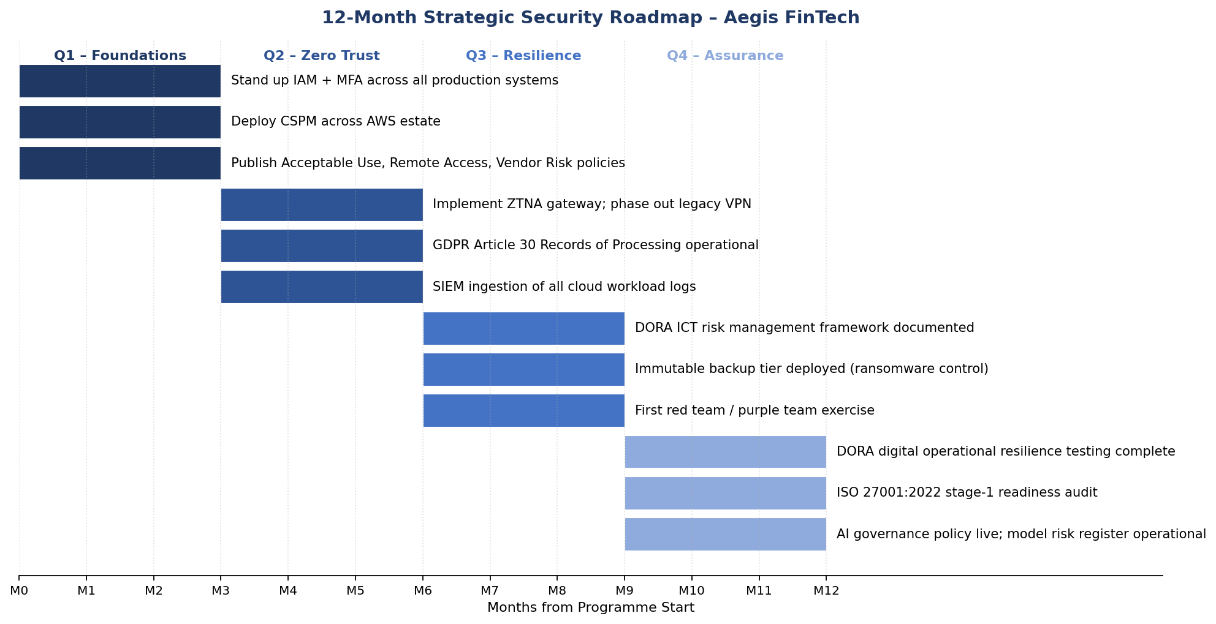
Figure 3. Twelve month strategic security roadmap. The four quarterly waves (Foundations, Zero Trust, Resilience, Assurance) prioritise the highest impact controls first, aligning with the residual risk reductions in Table 2.
Key performance indicators that will be reported to the Steering Committee from Month 1 include: percentage of production systems with MFA enabled (target 100% by end of Q1); mean time to detect (target under 30 minutes by end of Q2); mean time to contain (target under 60 minutes by end of Q3); percentage of critical SaaS vendors with completed risk assessment (target 100% by end of Q3); and DORA readiness score against the regulator’s self-assessment template (target green by end of Q4).

Task 2.9 – Conclusion
The proposal set out in this document is intentionally narrow in scope. The Information Security Unit is sized for the company that Aegis FinTech is today and for the company it intends to be at the end of the Series B round. The strategic model (Zero Trust), the framework (NIST CSF 2.0), the technical architecture (ZTNA/SASE/CSPM/SIEM), the regulatory programme (GDPR plus DORA) and the risk treatment plan are all internally consistent and rooted in the Task 1 evidence base.
The total Year 1 investment of approximately £1.85 million should be set against the average cost of a financial sector data breach, which IBM estimates at US$6.08 million for 2024 [7], and against the regulatory penalty exposure under GDPR (up to 4% of annual global turnover) and DORA (administrative penalties up to 1% of average daily turnover for serious infringements) [14], [17]. The Board is asked to approve the proposal at its next quarterly meeting so that the Q1 initiatives can begin on the planned date.

References
[1] S. Rose, O. Borchert, S. Mitchell, and S. Connelly, “Zero Trust Architecture,” NIST Special Publication 800-207, National Institute of Standards and Technology, Aug. 2020. [Online]. Available: https://doi.org/10.6028/NIST.SP.800-207
[2] C. Buck, C. Olenberger, A. Schweizer, F. Völter, and T. Eymann, “Never trust, always verify: A multivocal literature review on current knowledge and research gaps of zero-trust,” Computers & Security, vol. 110, 2021. doi: 10.1016/j.cose.2021.102436
[3] International Organization for Standardization, “Information security, cybersecurity and privacy protection – Information security management systems – Requirements,” ISO/IEC 27001:2022, Oct. 2022.
[4] Cybersecurity and Infrastructure Security Agency, “Zero Trust Maturity Model,” Version 2.0, CISA, Apr. 2023. [Online]. Available: https://www.cisa.gov/zero-trust-maturity-model
[5] Gartner, “Market Guide for Zero Trust Network Access,” Gartner Research, Feb. 2024.
[6] D. Eidle, S. Y. Ni, C. DeCusatis, and A. Sager, “Autonomic security for zero trust networks,” in 2017 IEEE 8th Annual Ubiquitous Computing, Electronics and Mobile Communication Conference (UEMCON), 2017, pp. 288–293. doi: 10.1109/UEMCON.2017.8249053
[7] IBM Security, “X-Force Threat Intelligence Index 2024,” IBM Corporation, Feb. 2024. [Online]. Available: https://www.ibm.com/reports/threat-intelligence
[8] Forrester Research, “The Zero Trust eXtended Ecosystem,” Forrester, 2022.
[9] Gartner, “The Future of Network Security Is in the Cloud,” Gartner Research, ID G00441737, Aug. 2019; updated 2024.
[10] Cybersecurity and Infrastructure Security Agency, “Advanced Persistent Threat Compromise of Government Agencies, Critical Infrastructure, and Private Sector Organizations,” Alert AA20-352A, Dec. 2020.
[11] Verizon, “2024 Data Breach Investigations Report,” Verizon Business, May 2024. [Online]. Available: https://www.verizon.com/business/resources/reports/dbir/
[12] J. Kindervag, “Build Security Into Your Network’s DNA: The Zero Trust Network Architecture,” Forrester Research, Nov. 2010.
[13] Sophos, “The State of Ransomware 2024,” Sophos Group plc, Apr. 2024. [Online]. Available: https://www.sophos.com/en-us/whitepaper/state-of-ransomware
[14] European Parliament and Council, “Regulation (EU) 2022/2554 on digital operational resilience for the financial sector (DORA),” Official Journal of the European Union, L 333, Dec. 2022. [Online]. Available: https://eur-lex.europa.eu/eli/reg/2022/2554
[15] European Union Agency for Cybersecurity (ENISA), “Threat Landscape 2024,” ENISA, Oct. 2024.
[16] Microsoft, “Microsoft Digital Defense Report 2024,” Microsoft Corporation, Oct. 2024. [Online]. Available: https://www.microsoft.com/en-us/security/security-insider
[17] European Parliament and Council, “Regulation (EU) 2016/679 on the protection of natural persons with regard to the processing of personal data (GDPR),” Official Journal of the European Union, L 119, Apr. 2016.
[18] J. T. Force, “Security and Privacy Controls for Information Systems and Organizations,” NIST Special Publication 800-53 Rev. 5, National Institute of Standards and Technology, Sep. 2020.
[19] National Institute of Standards and Technology, “The NIST Cybersecurity Framework (CSF) 2.0,” NIST Cybersecurity White Paper, Feb. 2024. [Online]. Available: https://doi.org/10.6028/NIST.CSWP.29
[20] P. Cichonski, T. Millar, T. Grance, and K. Scarfone, “Computer Security Incident Handling Guide,” NIST Special Publication 800-61 Rev. 2, National Institute of Standards and Technology, Aug. 2012.

