Introduction

By considering and referring to the theories and models associated with early years’ practice, this poster will scrutinise and establish the importance of disparate notions of health, well-being, and lifestyle within the stages of development that occur during the early years. In addition, the poster will establish the importance of the role and responsibilities of practitioners when supporting parents and children with positive health, well-being and lifestyle guidance in order to benefit their holistic development whilst ensuring the nurturing behaviours of parents. The interconnections associated with the notions of health, well-being, and lifestyles and the effects of positive and supportive relationships will moreover be explored throughout. Pirchio, Tritrini, Passiatore, and Taeschner (2013) insist that positive lifestyle and behaviour can be reformed as a result of positive relationships with professionals. Musgrave (2017) maintains this by stating that healthy and nurturing relationships with others is crucial for the well-being of children.

The Importance of Health, Wellbeing, and Lifestyle
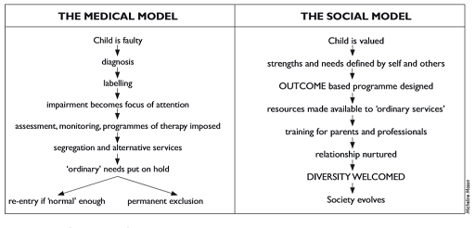
(Source: The Open University, no date).

Vaquero-Abellan, Marquez, and Martinez (2022) insist that there is a direct interrelatedness between health, well-being, and lifestyle, as all consequently have an effect upon the other. As a result of children having a poor lifestyle and suffering from poverty where food and nutritional needs are neglected, this may affect their health in view of the fact that they have low energy and suffer from weakness and extreme weight loss. Consequently, the child’s well-being is affected, as malnutrition affects cognitive functioning and academic performance (Kirolos, et al., 2022). Health is a complex notion to define, as Khran, et al. (2021) insist that concepts of health are based on results of experiences framing perceptions and behaviours. Additionally, Khran, et al. maintain that health can be influenced by a variety of interconnected characteristics. The premise of human development attributes are constructed and evolved during the early years, according to Marmot, et al. (2012). Marmot, et al (2012) continue by maintaining that circumstances that occur during early childhood hold lifelong consequences on a myriad of aspects of health, wellbeing, and lifestyle, for instance, obesity as a result of poor nutrition and diet and poor mental health as a result of abuse and neglect by parents or caregivers.
An idealistic model of health presented by the World Health Organization sustains that health is a state of utter physical, mental, and social well-being, as well as the complete absence of disease and injury (WHO, 2024). The WHO (2024) continues by maintaining that the possession of the most positive obtainable quality of health is a rudimentary right of all human beings. Additionally, the healthy development of children is of principal importance along with the cruciality of access to positive environments for development. Mason and Reiser’s diagram ‘The Medical Model and The Social Model’ defines the medical model of health and the social construct of health insists on the contrast in which the medical field and society perceive health, with the medical model maintaining a negative definition of health as the absence of physical illness and mental distress.

Health
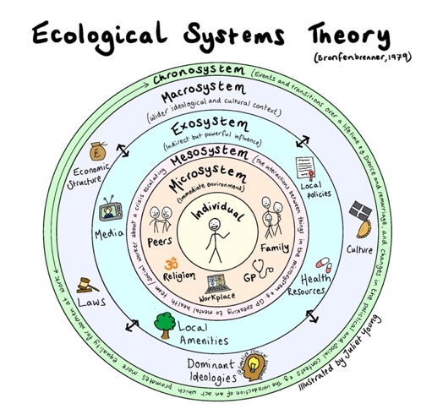

This conveys that people are defined by their disabilities and impairments, which become the focus of attention (Biesta and van Braak, 2023). In contrast, the social model of health perceives a positive definition on the perspective of health as the achievement and preservation of physical capacity and mental stability (Goering, 2015).
Braveman and Gottlieb (2016) argue that the environment in which the child is raised, the community the child is a part of, and the relationships the child possesses are all major key social determinants of health. This is supported by the Dahlgren and Whitehead Model of health, which is sometimes known as ‘The Rainbow Model’, is a model used worldwide by child healthcare and educational professionals (Rice and Sara, 2019). Dahlgren and Whitehead (2021) maintain that the model conveys the principal determinants of health as behavioural, sociocultural, economic, and biological, which can then be separated into the foundational categories of health, lifestyle, environment, and genetics. Dahlgren and Whitehead continue by emphasising that a support system is crucial when a core notion is affected or weakened. This relates to Bronfenbrenner’s Ecological Systems Theory, which can be used as an effective method to explore the interconnecting essence of health and its contributing factors (Dyar, Haglund, and Sarkadi, 2022). According to Erikkson, Ghazinour, and Hammarström (2018), the series of interrelated systems is portrayed in Bronfenbrenner’s model predominantly through the utilisation of the chronosystem. The chronosystem emphasises the factors that influence health that may change over the course of the child’s life, whilst also highlighting the improvements in health outcomes as the chronosystem also involves the impact of historical developments, for instance, immunisation and safeguarding precautions.

Wellbeing

In addition to the notion that complexity arises when defining health, well-being can also be considered a multifaceted concept, which according to Diener, Oishi, and Tay (2018) is highly subjective concerning influential contributing factors that arise from disparate factors in the individuals’ childhood. Roberts (2017) maintains that during the course of the research study which focused on researching children’s well-being within an educational setting, Roberts established that by listening to children’s views and ideas and implementing them into class work and activities, the confidence of the individual would develop and as a result, the child would take initiative and instigate play and communication with peers, and progress onto developing compassionate and healthy relationships with practitioners. Subsequently, Roberts insisted that consequently listening to the voice of the child, increased the understanding of the practitioners with regard to their individual needs, strengths, and areas of improvement. Therefore, as supported by Zaman, et al. (2021) by maintaining a healthy relationship with children and nurturing a healthy well-being the lifestyle of the individual will also be improved as caring relationships and crucial communication abilities have developed, which can configure the childhood of children.
Statham and Chase (2010) imply that the very concept of well-being is multi-dimensional as it circumscribes physical, mental, and social well-being with a focal point of a child’s present and future life. Based on the exploratory study by Thoililez (2011), the children who participated defined the fundamental derivation of happiness within compassionate and nurturing relationships. During the study, by observing and interacting with the participants Thoilliez established that children possess a healthy well-being when engaging in play, receiving appropriate emotional support, and when the body and mind are confluent. Therefore, as supported by Ben-Arieh, et al. (2014), children experience happiness with and from others. This supports that children seek eudaimonic happiness; where an individual pursues happiness by finding significance and purpose, with an attempt to strive for long-lasting and meaningful contentment (Gentzler, et al., 2021). The ABC Model of Well-Being possess many similarities to Maslow’s Hierarchy of Needs (Jajoo and Deshmukh, 2024), with both models illustrating the foundations and aspects of well-being.

(Source: Young, 2021)
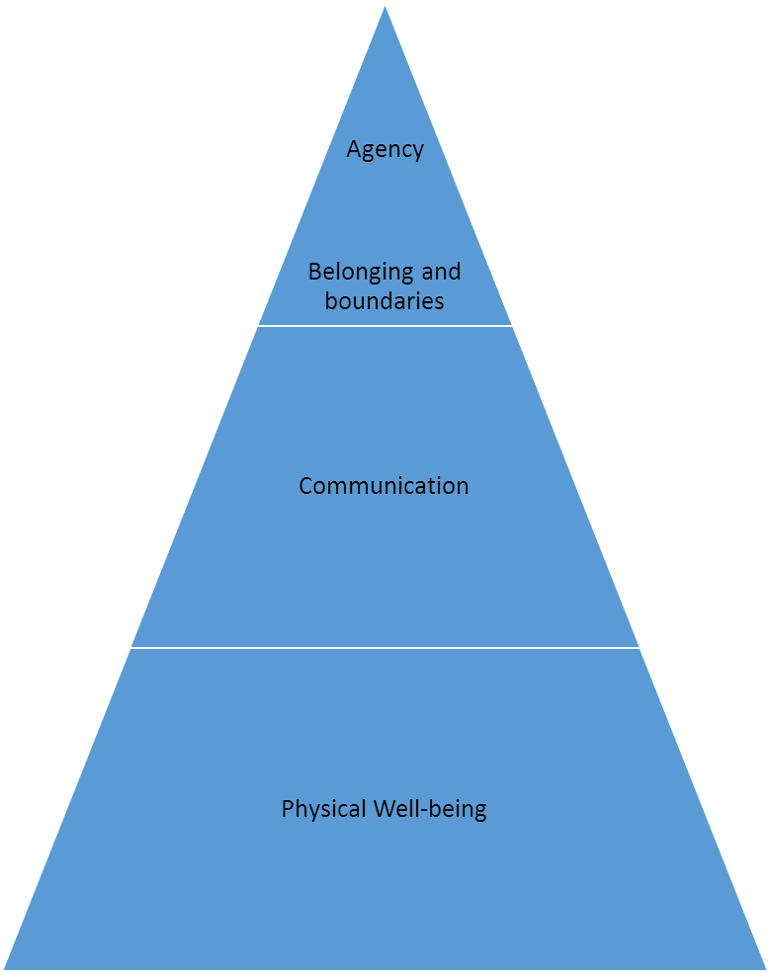
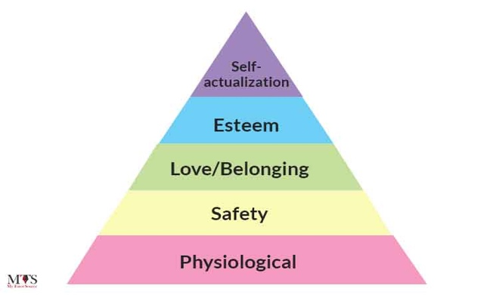

According to Lee, et al. (2020) it is a rudimentary right and essential aspect of a child’s well-being and holistic development to engage and initiate play which correlates with Article 31 of the UNCRC (UNICEF, no date and Murray, 2011). It is concurred by the Welsh Assembly Government (2002) and the Welsh Government (2015) that facets that acquire knowledge from imaginative play are entirely advantageous to children, as a result of play contributing to the development of human beings, Moreover, by producing and maintaining a natural environment within an educational setting for children to interact with promotes a healthy well-being and provides knowledge of the community in which the child is raised, as supported by theorists Piaget (Bormanaki and Khoshhal, 2021 and Montessori (Ozgen, 2023). Promoting play ensures the development of applicable and vital skills for instance, verbal and non-verbal communication skills enabling children to problem solve independently, develop gross, fine-motor, and dexterity skills, and a multitude of social and communication abilities, such as sharing along with emotional and empathetic development which supports healthy well-being development (Sutton-Smith, 1997). Kumar, et al. (2022) support the myriads of behavioural and emotional advantages that occur from play, for instance, a decrease in distress and impatience, furthermore notable progress in happiness and contentment. These experiences are adhering to the criteria of Maslow’s Hierarchy of Needs, where in order for children to attain self-actualisation, practitioners must ensure that the foundational and psychological needs of the individuals are being met (TES, 2019). Moreover, as a result of physical well-being being the foundation of the ABC Model of Well-Being (Roberts, 2010), Nijhof, et al. (2018) sustains that play constructs the foundation of well-being which as a result progresses the development of communicational abilities of the child, where healthy and compassionate relationships can be formed. Similarly to Maslow’s Hierarchy of Needs, in order for children to attain agency, physical well-being and communication abilities must be developed and nurtured (Leach, Howe, and DeHart, 2019).

(Source: Roberts, 2010).
Lifestyle

Estyn (2019) promote a healthy lifestyle by insisting that healthy living contributes abundantly towards beneficial well-being. Estyn continues by discussing the aspects of a healthy lifestyle which include healthy eating, sufficient physical exercise, good mental and emotional well-being, responsible attitudes and behaviours towards oneself and others, the absence of substance misuse, and personal hygiene. Martin-Biggers, et al. (2018) and Van Hulst, et al. (2023) agree that substandard health and well-being behaviours contribute to a disorganised and chaotic lifestyle. For instance, within home environments where the adoption of healthy lifestyle behaviours are deprived, concepts such as unhealthy diet, inadequate exercise, deficient fresh air and outdoor activities, drug and alcohol abuse, addiction, and stress are contributors to poor lifestyle behaviours.
The ‘All Wales Weight Management Pathway’ was published by the Welsh Government (2021) in order to tackle obesity to therefore prevent children from developing long-term illnesses and conditions as a result of unhealthy eating habits. The pathway conveys that individuals who are overweight have an increased risk of developing significant health complications, which can in turn threaten a risk to an individual’s mental health, where one may develop pow self-esteem and indications of depression and anxiety, as supported by Farhud (2015).

(Source: My Tutor Source, 2022).
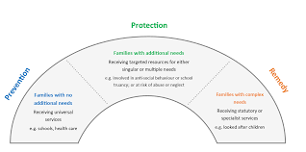
(Source: NHS Wales Executive, 2022).
The Windscreen Model, produced by Together for Children and Young People Programme in 2015 represents the strategy used in order to support children and families based on individuals’ complex needs and requirements. As the scale progresses interagency collaboration becomes profound, where effective communication and collaboration between families and agencies are crucial (NHS, 2022). The universal services comprise of healthcare, education, and social opportunities which are provided to all families. For instance, a health visitor will be provided for every family that has welcomed a newborn (Robling, et al., 2015), as well as the provision of education for all children. As the scale advances onto families with additional learning and complex needs, families will receive direct and focused support for example, social services, victim support, and the involvement of the local authority (Garbarino, 2017 and NHS, 2022). As a result of the progression of the scale, the more complex the needs of the family, moreover, the vitality of the requirement of further support and assistance from multi-agencies in order to ensure the family maintain healthy lifestyle behaviours (Barton, et al., 2021). Thomson, et al. (2018) define multi-agency as a myriad of services, agencies, and teams of professionals that collaborate for the provision of services required to support the complex needs of children. Thomson, et al. (2018) continue by stating that in order to successfully work on a multi-agency basis, professionals must have an awareness of responsibilities in addition to the roles and responsibilities of other professionals.

According to Bouton (2014) changing negative lifestyle behaviours and habits is challenging and therefore support from professionals is crucial in order to provide the necessary aid and encouragement to maintain a healthy and beneficial attitude towards well-being and lifestyle. Prochaska and Prochaska (2019) maintain that The Transtheoretical Model of Change supports this and continues by showing that a lapse during the cycle of change is expected among many individuals. There are six stages to the cycle, however, Krebs, et al. (2018) argues that the stage of pre-contemplation occurs prior to the realisation that certain lifestyle behaviours are problematic, where individuals are unmindful of the requirement and importance of changing behaviour. Contemplation begins when individuals initiate the process of considering the effects of lifestyle and behaviours on the health and well-being of the children and therefore begin to develop awareness that certain behaviours and habits may be harmful (Friman, Huck, and Olsson, 2018). Determination persists when the recognition of the need to change occurs where practical skills, confidence, and necessary support from professionals is required (Kolbert, et al., 2017). Professionals then continue with preparation for the change of lifestyle by assessing the household situation and identifying the most beneficial way to progress with support and aid. Moreover, professionals may be met with resistance from individuals who do not believe that behaviours are harmful and affecting the well-being of the child (Clark, 2014). Subsequently, action occurs, where professionals support the parents or guardian through the process of change by providing guidance and ideas once the parent is ready. Therefore, professionals have the ability to arrange objectives in order to achieve a successful change cycle that benefits the health and well-being of the child (Kwasnicka, et al., 2016). Kwaniscka, et al. (2016) continue by stating that maintenance is essential in ensuring the change towards a healthy lifestyle is effective, where parents and guardians establish long-term changes which essentially show the progress of the cycle. Prochaska and Prochaska (2019) insist that relapse is an indication of negative coping mechanisms and continues by establishing that it is essential professionals offer support and guidance and adapting methods to ensure that the family can maintain the cycle of change effectively. Moreover, it is of utmost importance that professionals recognise relapse as a normal event in the cycle of change and avoid managing the situation as a disaster. This maintains evidence by Prochaska and DiClemente (1984) that lifestyle and behaviours can be altered as a result of positive relationships with professionals.
Transtheoretical Model of Change
Conclusion
In conclusion, it is perceptible upon the evidence presented in this poster and the theories that lay the foundation that health, well-being, and lifestyle at integrated and have a significant influence upon one another. Implementing Early Years policies from the Welsh Government ensures that practitioners’ are following a holistic approach when considering child development. From the early years’ theories and models discussed, it is maintained that it is to ensure the child’s individual needs are being met whilst providing positive and beneficial guidance to promote health and well-being. Advantages in the development of young children is achieved by maintaining a healthy lifestyle, with emphasis on the importance of nurturing and compassionate relationships with adults and peers on social and emotional development. Moreover, the evidence presented conveys the cruciality of the role of the practitioner when encouraging parents to implement healthy lifestyle and behaviours with their children and the advantages on the child’s future. In closing, the notions and guidance of health, well-being, and lifestyle will continue to change, whilst also being dependant on the different stages of development, changes in society, and the various cultures present.

ddddddd
Reference List

Barton, E., et al. (2021) An evaluation of the adverse childhood experience trauma informed multi-agency early action together (ACE TIME) training: National roll out to police and parents. Wales: Public Health Wales.

Ben-Arieh, A., et al. (2014) ‘Multifaceted Concept of Child Well-Being’, Handbook of Child Well-Being, 1(1), pp. 1-27.

Biesta, G., and van Braak, M. (2023) Helping a Field See Itself. London: CRC Press.

Bormanaki, H. B., Khoshhal, Y. (2017) ‘The Role of Equilibration in Piaget’s Theory of Cognitive Development and its Implication for Receptive Skills: A Theoretical Study’, Journal of Language, Teaching and Research, 8(5), pp. 996-1005.

Bouston, M. (2014) ‘Why behaviour change is difficult to sustain’, Preventative Medicine, 68(3), pp. 29-36.

Braveman, P., and Gottlieb, L. (2016) ‘The Social Determinants of Health: It’s Time to Consider the Causes of the Causes’, Public Health Reports, 129(1), pp. 19-31.
Dahlgren, G., and Whitehead, M. (2021) ‘The Dahlgren-Whitehead model of health determinants: 30 years on and still chasing rainbows’, Public Health, 199(2), pp. 20-24.

Clark, R. (2014) Fostering Change in Institution, Environments, and People. New York: Routledge.

Diener, E., Oishi, S., and Tay, L. (2018) ‘Advances in subjective well-being research’, Nature Human Behaviour, 2(2), pp. 253-260.

Dyar, O., Haglund, B., and Sarkadi, A. (2022) ‘Rainbows over the world’s public health: determinants of health models in the past, present, and future’, Scandinavian Journal of Public Health, 50(7), pp. 1047-1058.

Erikkson, M., Ghazinour, M., and Hammarström, A. (2018) ‘Different uses of Bronfenbrenner’s ecological theory in public mental health research: what is their value for guiding public mental health policy and practice?’, Social Theory & Health, 16(2), pp. 414-433.
Estyn (2019) Healthy and happy: School impact on pupils’ health and wellbeing. Available at: https://www.estyn.gov.wales/system/files/2022-01/Healthy%2520and%2520Happy%2520report%2520En_0.pdf (Accessed: 10th June 2024).

Farhud, D. (2015) ‘Impact of Lifestyle on Health’, Iranian Journal of Public Health, 44(11), pp. 1442-1444.

Friman, M., Huck, J., and Olsson, L. (2018) ‘Transtheoretical Model of Change during Travel Behaviour Interventions: An Integrative Review’, Environmental Research and Public Health, 14(6), pp. 581-595.

Garbarino, J. (2017) Children and Families in the Social Environment. Oxon: Routledge.

Gentzler, A., et al. (2021) ‘Hedonic and eudaimonic motives to pursue well-being in three samples of youth’, Motivation and Emotion, 45(4), pp. 312-326.
Goering, S. (2015) ‘Rethinking disability: the social model of disability and chronic disease’, Current Reviews in Musculoskeletal Medicine, 8(2), pp. 134-138.

Jajoo, A., and Deshmukh, P. (2024) ‘Exploring competency: Corporate framework, learning theories, and a cognitive development model’, Multidisciplinary Reviews, 7(8), pp. 143-149.
Khran, G., et al. (2021) ‘It’s time to reconsider how we define health: Perspective from disability and chronic condition, Disability and Health Journal, 14(4), pp. 101-129.

Kirolos, A., et al. (2022) ‘Neurodevelopmental, cognitive, behavioural and mental health impairments following childhood malnutrition: a systematic review’, BMJ Global Health, 7(7)l, pp. 247-265.

Kolbert, J., et al. (2017) ‘Motivational Interviewing, the Transtheoretical Model of Change, and Academic Development’, Journal of School Counselling, 15(2), pp. 30-37.

Krebs, P. et al. (2018) ‘Stages of change and psychotherapy outcomes: A review and meta-analysis’, Journal of Clinical Psychology, 74(11), pp. 1964-1979.

Kumar, P. A., et al. (2022) ‘Play and Play Spaces for Global Health, Happiness, and Well-being’, Handbook of Health and Well-being, pp. 129-154.

Kwasnicka, D., et al. (2016) ‘Theoretical explanations for maintenance of behaviour change: A systematic view of behaviour theories’, Health Psychology Review, 10(3), pp. 277-296.

Leach, J., Howe, N. and DeHart, G. (2019) ‘“Let's make a place where giants live!”: Children's communication during play with siblings and friends from early to middle childhood’, Infant and Child Development, 28(6), pp. 246-253.

Lee, R., et al. (2020) ‘Systematic review of the impact of unstructured play interventions to improve young children's physical, social, and emotional wellbeing’, Nursing & Health Sciences, 22(2), pp. 184-196.

Marmot, M. et al. (2012) ‘WHO European review of social determinants of health and the health divide’, The Lancet, 380(9846), pp. 1011-1029.

Martin-Biggers, J., et al. (2018) ‘Relationships of family conflict, cohesion, and chaos in the home environment on maternal and child food-related behaviours’, Maternal & Child Nutrition, 14(2), pp. 125-140.

Musgrave, J. (2017) Supporting children’s mental health and well-being. London: Sage Publications.

My Tutor Source (2022) Maslow’s Hierarchy of Needs. [Image]. Available at: https://ksa.mytutorsource.com/blog/maslows-hierarchy-of-needs/ (Accessed: 6th June 2024).

Murray, J. (2018) ‘The play’s the thing’, International Journal of Early Years Education, 26(4), pp. 335-339.

NHS Wales Executive (2022) Together for Children and Young People Programme 2015. [Image]. Available at: https://executive.nhs.wales/functions/strategic-programme-for-mental-health/together-for-children-and-young-people-2/#:~:text=The%20Together%20for%20Children%20and,and%20young%20people%20in%20Wales (Accessed: 10th June 2024).

Nijhof, S., et al. (2018) ‘Healthy play, better coping: The importance of play for the development of children in health and disease’, Neuroscience & Biobehavioural Reviews, 96(1), pp. 421-429.

Ogzen, Z. (2023) ‘Nature-Based Education in the Light of Montessori Philosophy: Meaning, Principles, and Practices’, European Journal of Alternative Education Studies, 8(1), pp. 134-153.

Pirchio, S., Tritrini, C., Passiatore, Y., and Taeschner, T. (2013) ‘The Role of the Relationship between Parents and Educators for Child Behaviour and Wellbeing’, International Journal about Parents in Education, 7(2), pp. 134-142.

Prochaska, J. and DiClemente, C. (1984) The transtheoretical approach: crossing traditional boundaries of therapy. Homewood, IL: Dow Jones-Irwin.

Prochaska, J. and Prochaska, J. (2019) Transtheoretical Model. Boca Raton: CRC Press.

Rice, R. and Sara, L. (2019) ‘ Updating the determinants of health model in the Information Age’, Health Promotion International, 34(6), pp. 1241-1249.

Roberts, H. (2017) Research with Children. London: Routledge.

Roberts, R. (2010) Wellbeing From Birth. London: Sage Publications.

Robling, M., et al. (2015) ‘Effectiveness of nurse-led intensive home-visitation programme for first-time teenage mothers (Building Blocks): a pragmatic randomised controlled trial’, The Lancet, 387(10014), pp. 423-487.

Statham, J. and Chase, E (2010) Childhood Wellbeing: A brief overview. Loughborough: Childhood Wellbeing Research Centre.

Sutton-Smith, B. (1997). The Ambiguity of Play. Cambridge: Harvard University Press.

The Open University (no date) The Medical Model and The Social Model of Health. [Diagram]. Available at: https://www.open.edu/openlearncreate/mod/oucontent/view.php?id=152997&section=2.4 (Accessed: 5th June 2024).

TES (2019) Pedagogy Focus: Maslow’s Hierarchy of Needs. Available at: https://www.tes.com/news/pedagogy-maslows-hierarchy-needs (Accessed: 7th June 2024).

Thoilliez, B. (2011) ‘How to Grow up Happy: An Exploratory Study on the Meaning of Happiness from Children’s Voices’, Child Indicators Research, 4(3), pp. 323-351.

Thomson, L., et al. (2018) Forensic Psychiatry and Psychology in Europe. Edinburgh: Springer.

UNICEF (no date) A Summary of the UN Convention on the Rights of the Child. Available at: https://www.unicef.org.uk/wp-content/uploads/2019/10/UNCRC_summary-1_1.pdf (Accessed: 7th June 2024).

Van Hulst, A. et al. (2023) ‘Adolescents’ reports of chaos within the family home environment: Investigating associations with lifestyle behaviours and obesity’, PLOS ONE, 18(1), pp. 1-27.

Vaquero-Abellan, M., Marquez, F, and Martinez, P. (2022) Fertility, Pregnancy, and Wellness. United States. Elsevier.

Welsh Assembly Government (2002) Welsh Assembly Government Play Policy. Wales: Welsh Assembly Government.

Welsh Government (2021) All Wales Weight Management Pathway. Wales: Welsh Government.

World Health Oraganisation (2024) Constitution. Available at: https://www.who.int/about/accountability/governance/constitution (Accessed: 5th June 2024).

Young, J. (2021) Ecological Systems Theory. [Image]. Available at: https://twitter.com/Juliet_Young1/status/1423018236350799872 (Accessed: 16th June 2024).

Zaman, M., et al. (2021) ‘A simple behavior change communication package for school children improves lifestyle of rural Bangladeshi students’, Journal of Xiangya Medicine, 6(2), pp. 132-147.

The Effects of Poverty on Health, Well-being and Lifestyle
Today I will be discussing the effects of poverty on children’s health, well-being and lifestyle. Hagenaars (2017) defines poverty as circumstances in which foundational requirements are not sufficiently met whereas Townsend (2020) insists on the myriad of means by which poverty can be measured, therefore, maintaining the outlook presented by Brown and Long (2018) that poverty is dependent on several lifestyle, social, and economical factors and cannot be determined on an independent basis. Brady and Bostic (2015) suggest that there are distinct stages of poverty; such of which are relative poverty and absolute poverty. Brady and Bolstic (2015) continue by emphasising the contrast between both stages by maintaining that relative poverty can be defined as individuals or families maintaining a livelihood on an income less than 60% of the national median, which suggests that individuals and families within this cohort are more impoverished than the majority of society. However, individuals and families living in absolute poverty are in a deficit of foundational, material, and emotional necessities. Article 27 of the UNCRC states that all children have the right to a quality of living that is sufficient for the holistic development of the child (UNICEF, no date), which maintains that the needs and requirements of individuals who live in poverty are unfulfilled (Lu, Black, and Richter, 2016).

There are several categories in which poverty can be based, such as food poverty which includes food insecurity, food vulnerability, and hunger, meaning the inability to afford or have access to foods which produce a socially and culturally acceptable nutritious diet (O’Connor, Farag, and Baines, 2016). Jacknowitz, Morrissey, and Brannegan (2015) argue that food poverty can be triggered by many unfortunate personal and financial circumstances, which include the loss of business, delays in receiving Universal Credit, or family bereavement which Schmidt, et al. (2021) maintain can transform into a long-term experience if families are unable to access the support necessary to recover from financial loss. In regards to the circumstances of poverty being triggered Airgood-Obrycki, Hermann, and Wedeen (2023) suggest that food allowances are often what is interrupted initially in order for families to accommodate other essential living costs, such as rent and utilities. Although the relationship between diet and health is complex (Thompson, 2022), not all families who live on a low income sustain a poor diet, therefore as suggested by Ravallion and Chen (2017) particular aspects of poverty can be associated with health, nevertheless, not all aspects are universally experienced. According to Adeyeye, et al. (2023), food poverty has shown to be the catalyst for dietary illnesses and diseases such as diabetes, high blood pressure, heart disease, smoke exposure, and obesity on account of healthy and nutritious foods being more expensive than foods high in salt, sugar, and fat. Consequently, there are adverse effects on the health of children living in poverty as a result of the high cost of healthy and nutritious food which can have further effects on children’s lifestyle as Martin, et al. (2023) show that children who experience food poverty obtain difficulty concentrating, low energy, and are more likely to miss school due to illness arising from an unhealthy diet. Gordon and Cui (2016) sustain the influence of food poverty on children's lifestyles by stating that children who experience food poverty are more likely to obtain lower academic attainment, in contrast to children who do not experience food poverty. The effects of poverty on health can be discerned before birth, as (reference) suggests that children born into families living in poverty are more likely to be born at a low birthweight and therefore, less likely to survive the first year of life.

In addition to the deficit of necessities which families living in poverty experience, children may also be excluded from activities and ventures as opposed to individuals who have not experienced poverty which consequently harms children’s social and emotional well-being (reference). (reference) maintains that poverty denies children the opportunities to explore and develop interests through extra-curricular clubs and school trips which additionally has adverse effects on developing healthy and meaningful relationships with other children, creating feelings of isolation and depression, and affecting all aspects of childhood, consequently leading to a substantial risk of mental illness due to psychological distress beginning at such a vulnerable stage in development (reference). The emotional and cognitive development of children is additionally affected, in view of the fact that the lives of individuals living in poverty are out of control and sometimes chaotic (reference), consequently, individuals will develop more emotional and behavioural self-control (reference). This further conveys the perception of poverty suggested by (reference) who argues that children experiencing poverty must manage adult emotions and worries whilst still young and vulnerable.

Poverty and deprivation are key determinants in the social well-being and behavioural development of children (reference). (reference) insists that children living in deprived areas are more likely to develop ill mental health as contrasted with children living in wealthier areas, where 49% of Scottish individuals living in poverty were diagnosed with psychiatric disorders as a result of mental health distress, compared to 28% of individuals living in lesser deprived areas. (reference) continues by emphasising the interrelation between poverty and suicide, where it states that suicides are three times more likely to occur in deprived areas. The development of ill mental health arises early in childhood, as (reference) shows that the behaviour of children from deprived areas of the UK was deemed as abnormal by teachers and other multi-agency professionals, with many coherently displaying borderline emotional and behavioural difficulties at the age of four. This emphasises the comprehensive influence of poverty and inequality on the holistic development of children, where social and economical resources are in deficit.

Situational poverty can arise from unforeseen loss or sudden medical emergencies (Lister, 2021) which affects 21% of households in Wales (Welsh Government, 2023) and 22% of households in the UK (Joseph Rowntree Foundation, 2024). Children who are exposed to the effects of poverty and live in low-income households are highly likely to remain in the position of low-performing classes within an academic setting in contrast to children from higher-income households, who retain positions in top-performing academic classes (Crawford, Macmillan, and Vignoles, 2016). This shows that poverty influences lifestyle as it structures a significant element in the future academic outcomes of children (Gordon and Cui, 2016). This is supported by Save the Children (2017) who maintain the effects of poverty on children’s academic achievement by stating that a third of children living in poverty in Wales were encountering academic difficulties at ages as young as five. Evidence presented by the Welsh Government (2019) shows that the academic attainment of children who are entitled to free school meals was significantly lower than children who do not receive free school meals. Moreover, the Welsh Government (2019) continue by emphasising the decline in the academic performance of children who are entitled to free school meals at the end of the Foundation Phase, which conveyed a decrease of 20.4 percentage points. This further implies the notion by Save the Children (2017), that poverty has a strong influence on children’s academic attainment, and therefore an adverse effect on lifestyle.

The production of the School Essentials Grant by the Welsh Government (date) ensures that all children experiencing poverty have access to essentials such as uniforms, school meals, and supplies, by diminishing the financial pressures and challenges that families living in poverty face. The School Essential Grant was developed based on the requirements of children, therefore, by providing products and materials that meet the fundamental requirements of children, the stress and anxiety of parents and families that experience poverty will be reduced as a result of immediate financial barriers being overcome which ensures that families can resolve more major financial obstacles without the stress of providing school essential for the child (Welsh Government, date).

Reference List

Adeyeye, S. et al. (2023) ‘Africa and the Nexus of poverty, malnutrition and diseases’, Critical Reviews in Food Science and Nutrition, 63(5), pp. 641-656.

Brady, D. and Bolstic, A. (2015) Paradoxes of Social Policy: Welfare Transfers, Relative Poverty, and Redistribution Preferences, American Sociological Review, 80(2), pp. 268-298.

Brown, U. and Long, G. (2018) Poverty and welfare. London: Routledge.

Crawford, C., Macmillan, L. and Vignoles, A. (2016) ‘When and why do initially high-achieving poor children fall behind?’, Oxford Review of Education, 43(1), pp. 88-108.

Gordon, M. and Cui, M. (2016) ‘The Intersection of Race and Community Poverty and Its Effects on Adolescents’ Academic Achievement’, Youth & Society, pp. 947-965.

Hagenaars, A. (2017) The Definition and Measurement of Poverty. New York: Routledge.

Jacknowitz, A., Morrissey, T. and Brannegan, A. (2015) ‘Food insecurity across the first five years: Triggers of onset and exit’, Children and Youth Services Review, 53(3), pp. 24-33.

Joseph Rowntree Foundation (2024) UK Poverty 2024. Available at: https://www.jrf.org.uk/uk-poverty-2024-the-essential-guide-to-understanding-poverty-in-the-uk#:~:text=Poverty%202024%20report.-,Poverty%20has%20increased%2C%20close%20to%20pre%2Dpandemic%20levels,nearly%203%20in%2010)%20children (Accessed: 12th June 2024).

Lister, R. (2021) Poverty. Cambridge: Polity Press.

Lu, C., Black, M., and Richter, L. (2016) ‘Risk of poor development in young children in low-income and middle-income countries: an estimation and analysis at the global, regional, and country level’, Global Health, 4(12), pp. 916-922.

Martin, A. et al. (2018) ‘Physical activity, diet and other behavioural interventions for improving cognition and school achievement in children and adolescents with obesity or overweight’, Cochrane Database of Systematic Reviews, 12(1), pp. 1-149.

O’Connor, N., Farag, K. and Baines, R. (2016) ‘What is food poverty? A conceptual framework’, British Food Journal, 118(2), pp. 1-29.

Ravallion, M. and Chen, S. (2017) ‘Welfare-Consistent Global Poverty Measures’, National Bureau of Economic Research, 15(2), pp. 2-51.

Save the Children (2017) Little Pieces. Big Picture. Available at: https://www.savethechildren.org.uk/content/dam/global/reports/education-and-child-protection/stc-wales-childcare-report-2017.pdf (Accessed: 13th June 2024).

Schmidt, K., et al. (2021) ‘Society to cell: How child poverty gets “Under the Skin” to influence child development and lifelong health’, Developmental Review, 61(2), pp. 100-183.

Thompson, C. (2022) ‘Dietary health in the context of poverty and uncertainty around the social determinants of health’, Proceedings of the Nutrition Society, 81(2), pp. 134-140.

Townsend, P. (2020) Measuring Poverty. London: Routledge.

UNICEF (no date) A Summary of the UN Convention on the Rights of the Child. Available at: https://www.unicef.org.uk/wp-content/uploads/2019/10/UNCRC_summary-1_1.pdf (Accessed: 12th June 2024).

Welsh Government (2019) Achievement and entitlement to free school meals: 2019. Available at: https://gov.wales/achievement-and-entitlement-free-school-meals-2019 (Accessed: 13th June 2024).

Welsh Government (2023) Relative income poverty: April 2021 to March 2022. Available at: https://www.gov.wales/relative-income-poverty-april-2021-march-2022-html#:~:text=Survey%20(DWP).-,Main%20findings,Wales%20for%20over%2017%20years. (Accessed: 12th June 2024).

