University of Wales Trinity Saint David
Wales Institute of Science & Art


Risk Assessment Technical Report
Workshop and Practice (ACHA4011)

Shay Beer
2000890
February 2021

Contents
1 Introduction 2
2 Literature Review 3
3 Initial FMEA 4
4 Post Mitigation FMEA 7
5 Conclusion 8
6 References 9

Introduction
The purpose of this report is to analyse the importance for engineers to understand risk management, such as legislations and regulations that should be followed. Specifically, the report will focus on Failure Mode & Effect Analysis (FMEA) that relates to one stage of the assembly line process.
The intent of the report is to analyse four potential failures calculating a risk priority number (RPN) from Failure Mode & Effect Analysis (FMEA), also suggesting realistic mitigating actions, justifying each action, to lower the risk priority number for each failure. After mitigating actions have been suggested, another Failure Mode & Effect Analysis (FMEA) will be created assuming that the actions have been put into place, giving a new risk priority number to see if the actions worked.

Literature Review
When working in any form of engineering there are many different legislations and regulations that must be followed to stay safe. Especially when working in the transportation sector of engineering. It is very important that legislations and regulations are followed to make sure that employees and employers to reduce the risk of an accident of injury from happening. Also, a very important part of the transportation sector in engineering is risk management. Risk management means the method of finding potential risks before any harm or damage can be caused, the risks get investigated and then steps are put into place to reduce the chances of anything happen. The risk management process has five important steps that must take place to ensure the risk is handled correctly. The first step of the risk management process is to identify the risk, this means trying to figure out what potential risks are there that could hinder the process and stop the company for example from reaching the main objective. The second step in the risk management process is to analyse the risk, this is where the process and objectives that are taking place might change due to the risk. Once the risk gets identified it gets analysed to see the effect the risk will have on the process then the correct actions can be put into place. The third step is to evaluate/rank the risk, this is done by considering the consequences and likelihood of the risk. This part is like the FMEA when giving numbers to make the risk priority number. The fourth step of the risk management process is to treat the risk, this is the part where actions are suggested and implement to reduce or even eliminate the risk from happening. Also, the risks that were evaluated as the more serious risks should be treated and dealt with first before any others. The final step for the risk management process is monitor and review the risk, this is where the risk that got addressed get monitored to see if the actions that were put in place are working or does it need to go back through the risk management process again. Therefore, the steps before are vital to make sure that this process does not have to be done again. Some of the tools that are used to handle risk management are processes like FMEA and risk assessments get used to find the risk. Some of the legislations and regulations that are very important in risk management as these are the rules that must be followed to keep everyone safe in the factory, some of them which must be followed are personal proactive equipment, Coshh, health and safety in a workplace, they are some of the main ones that must be followed so everyone is safe plus reduce the chances of an accident from happening.

Initial FMEA
FMEA means Failure mode and effects analysis and it gets used to identify potential problems and failures that may occur in engineering such as assembly process. The FMEA gets used to reduce the risk and make it safer in the assembly process and other parts of the process. There are 6 main stages to a FMEA they are, identify a failure mode, the likelihood of detection number, severity number, likelihood of occurrence number, risk priority number and the recommend actions, to help prevent the failure from happening.
The first FMEA spreadsheet will show the risk priority number initially for the four potential failures that could happen in the assembly process, with some of the mitigating actions that could be taken to reduce that number and make it safer when doing these processes. The risk priority number is worked out by using likelihood of occurrence number multiply by the severity multiplied by the likelihood of detection number, this is what works out the risk priority number.
The first potential failure was the Brake calliper mounting bolts not torqued to correct level. The risk priority number that was given is 240. The likelihood of occurrence number was 6, this number was given because this could happen at any time if no check is done to see if they were torqued enough. The severity for this failure was 8, this number was given because if the brake calliper bolts were not torqued enough this could cause a massive failure on the vehicle when out on the road or the racetrack, as if they calliper came loose due to the bolts the vehicle is not slowing down. Finally, the likelihood of detection number that was given is 5, this number was given because the chance that this could be found or checked is low. The potential failure could be very dangerous if this vehicle were to leave the factory without them torqued.
For the first potential failure there are a couple of mitigating actions that can be recommend making sure the failure does not happen or at least reduce the chances of it happening. One mitigating action that could be taken into use is to have someone else check to see if the bolts are torqued enough, this is recommend as another set of hands and eyes to check something is always better that just one person checking to see if they are torqued to the right level. Another mitigating action that should be used to make sure the brake calliper bolts are torqued to the correct level is by using a tool called a torque wrench, the tool gets used to check torque levels, the tool is very accurate and precise which is needed when measuring something as serious as the torque on a brake calliper bolt which cannot be loose on the vehicle. Also, double check yourself to make sure they are torqued correctly.
The second potential failure that was given was the incorrect brake disc size installed. The risk priority number for this potential failure was 244. The likelihood of occurrence number was 4 as not all brake discs will fit each vehicle so not as likely as other failures. The severity for this failure was 9, as if the incorrect brake disc were fitted this would mean the brake would not work correctly on that which could cause a massive problem when the vehicle is on the road. The likelihood of detection number was 6, as there would be a problem when trying to fit other parts such as the wheel as it will not fit if the brake disc is wrong, another reason is the calliper will not fit on the disc as it should, if it were the correct brake disc that the calliper was being fitted to. This failure would be very dangerous if this were to happen on the road as the brakes would not work correctly with the wrong brake disc installed.
There are some mitigating actions that could be taken to reduce the chance of this failure of happening when doing this process. One of them mitigating actions that could be taken is to do a quality control check, this will be able to reduce the chance of the incorrect brake disc size being installed as it checks that the production process is being maintained and everything is working correctly, for example checking that all the machinery is working correctly and accurately. Quality control checks can be done through manual checking to see if the correct brake disc has been installed, one of them manual checks could just be a visual check of the disc to make sure that it is the correct size and it fits like it should. Another mitigating action that could be used to check that the correct size disc has been installed is by using measuring equipment to check the size of the brake disc, some of the equipment that could be used are a micrometer or a vernier calliper to check the size of the disc.
The third potential failure was if the brake pads installed in wrong orientation, with friction material not contacting disc surface, the risk priority number was 315. The likelihood of occurrence number was 7, this number was given as this is quite an easy thing that could be done if not always concentrating. The severity number was 9, this number is so high because if the wrong orientation happened once the car is on the road the brakes will not work as expected to as the material would be rubbing. Finally, the likelihood of detection was 5 due to it not being easy to see if the pads were on the wrong way as some brake pads are identical either side of the pad. This failure could cause a crash on the roads if the pads were the wrong way round this will cause the brakes to not work correctly and they would also make noise when braking.
There are some actions that can be taken to reduce the chances and prevent this failure from happening. One of them actions would be to a visual check to make sure the brake pad is in the correct orientation so that the friction material is not contacting the disc to cause any other damage to the brakes. A visual check can be good for this potential failure as it will be very easy to spot if it is the wrong orientation on the on the disc. Another mitigating actions that should be used is to make sure that the employees that are working on this process have the correct training to ensure that the pads are fitted correctly and the correct way round, with the correct training less chance of something going wrong.
The final potential failure that was given was brake line fitting not fully tightened. The risk priority number was 336. The likelihood of occurrence number is 6, the reason is that it cannot be guaranteed that it will be tight enough all the time, like it needs to be. This is because sometimes it can get rushed and not be checked to make sure that it is tightly fitted. The severity number was 8, as if the vehicle leaves the factory to the customer and the brake line is not at tight as it should be this could cause a serious accident as the car will not slow down as fast as it should if the brake line were fully tightened. Therefore, it is vital that these parts get check and detected before it leaves the factory. Finally, the likelihood of detection number is 7, it has this number due to it not being easy to pick up unless the brakes are tested which they should before the vehicle leaves the shop.
To reduce the risk of the potential failure, there are some mitigating actions that can be used to help prevent it. One of them mitigating actions could be used to make sure the brake line is tight is once the person who is fitting the line has finished have someone else test to see if it is tight enough or can I be tighter, this will be a benefit as they would be two people checking it instead of the one which is always a benefit. Another action that could be taken is to make sure the correct tools and training are in place for this potential fault, one tool that can be used is a brake line wrench. The brake line should not be that tight as this could also be a failure if the line is too tight.

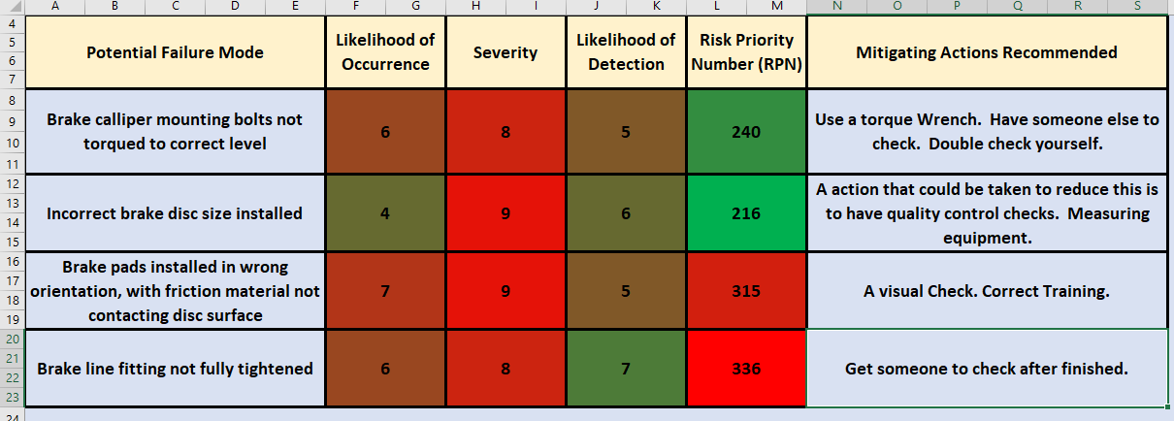
Table 1: Initial FMEA

Post Mitigation FMEA
This part of the report is the post FMEA from the actions that were proposed in the first FMEA. The new FMEA will have new rankings and if there are any potential risks remaining.
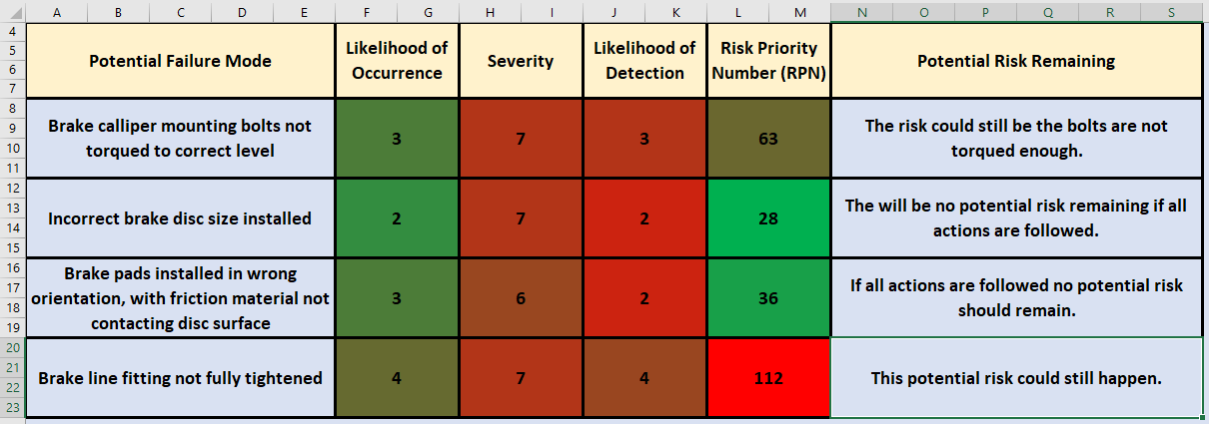
Table 2: Post Mitigation FMEA.
For the first potential failure all three of the numbers got reduce as shown in the table above. These numbers got reduce as the actions that were recommend would help reduce the potential failure from happening. For example, if the torque wrench was used every time when tighten the bolts the chances of the failure occurring are much lower and will be easier to detect if they did need to be torqued more. But if the actions are not used the risk could still be there.
The second potential failure also had the risk priority number become lower due to the actions that were suggested. The potential failure would be greatly reduced if the actions are used such as make surer to measure every brake disc, so it is the correct size, then doing a quality control check such as a visual look to make sure it is the correct size, it would be easier to detect so less chance of the risk occurring. There would be no potential risks remaining either once these checks are carried out.
The third potential failure the RPN was reduced massively due to the mitigating actions that were given. This is due to it being easier to find the failure by the actions that were recommend such as making sure everyone has the correct training, this will help as they will know exactly how the pads are meant to be fitted. Also using a visual check, the risk of something like this happening will get reduced straight away.
The final faults RPN was reduced but not as much as the others due to it being difficult to check. The mitigating actions will help reduce the number, but the potential risk is still there as it can be difficult to detect with it is at the correct tightness. The actions have not eliminated the risk from happening, but they have helped reduce the number, which is a good thing, there will be less of a chance it occurs.
The FMEA helped reduce all the potential failure’s numbers throughout the process, the severity number was still high on all the failures as if the failure were to occur on the vehicle it could still be dangerous on the road.

Conclusion
From the initial FMEA to the post FMEA it shows that the FMEA process has worked, by bringing down the risk priority number for all four of the potential failures that could have occurred, the actions that were offered were engineering based and direct to the failure. From the results showing the FMEA bringing down the risk priority number for all the potential failures, it shows that the tool is effective to help lower the risk of failures from happening in the workplace. FMEA is effective as it works out the risks then actions to reduce the risk get put into place to help lower the chance of it happening. Another reason why FMEA is a good tool is that once the initial FMEA is complete and the actions are put in place, another FMEA takes place to see if there are any other potential risks remaining. By using a FMEA it makes the products safer which means the products are more reliable to where more people will be buying the product. The FMEA is also effective as it improves the quality, reliability and safety of the process that is taking place in the workshop for example, as actions would be put in place to help with it.
Overall, the FMEA tool is a great tool to reduce potential risks in the workshop, from the results of the FMEA and actions that were put in place it works well, with the correct actions the risk can almost be eliminated or reduced to very unlikely of occurring.

References
Uwtsd Technical report guidelines, (October 2018), technical report guidelines – V2. Available at https://uowtsd.sharepoint.com/teams/Level42_GRP/Shared%20Documents/Motorsport%20Technology/Technical-Report-Guidelines-v2.pdf?CT=1607202033764&OR=ItemsView (Accessed October 2020)
Uwtsd Image, (2018). Available at https://www.ydds.ac.uk/news/press-releases/press-2018/strategic-alliance-with-jesus-college-oxford-in-the-field-of-celtic-studies.html , (Accessed October 2020)
Hse,(2014) The health and safety toolbox. Available at: https://www.hse.gov.uk/pubns/priced/hsg268.pdf (Accessed February 2021)
Researchgate, (Jan 2018) Quality-control-methods. Available at: https://www.researchgate.net/figure/Quality-control-methods-in-the-painting-process_fig3_325419126 (Accessed February 2021)
Economictime, (2021), Risk Management. Available at: https://economictimes.indiatimes.com/definition/risk-management (Accessed January 2021)
Chicago Pneumatic, (2021), 7 things you should know about torque wrenches. Available at: https://www.cp.com/en/tools/expert-corner/blog/7-things-you-should-know-about-torque-wrenches (Accessed February 2021)
FFCars, (2007), How tight? brake lines. Available at: https://www.ffcars.com/threads/how-tight-brake-lines.5424/ (Accessed February 2021)
Hse, (2021), Legislations. Available at: https://www.hse.gov.uk/legislation/statinstruments.htm (Accessed March 1st, 2021)
Imeche, (5 December 2018), Code of conduct regulations. Available at: https://www.imeche.org/docs/default-source/governance-documents/code-of-conduct-regulations-(5-12-18).pdf?sfvrsn=2 (Accessed February 2021)
Isixsigma, (2000-2021), FMEA preventing failure. Available at: https://www.isixsigma.com/tools-templates/fmea/fmea-preventing-failure-any-harm-done/ (Accessed March 2021)

