

Module Handbook

BMBM6015
Strategic Management and Sustainability

Module Co-ordinator Mike Durke

Semester 2 – 2023

Contents

Module Descriptor
Aims
Learning Outcomes
Indicative Content
Study Time
Assessment
Reading List
Assessment Specifications

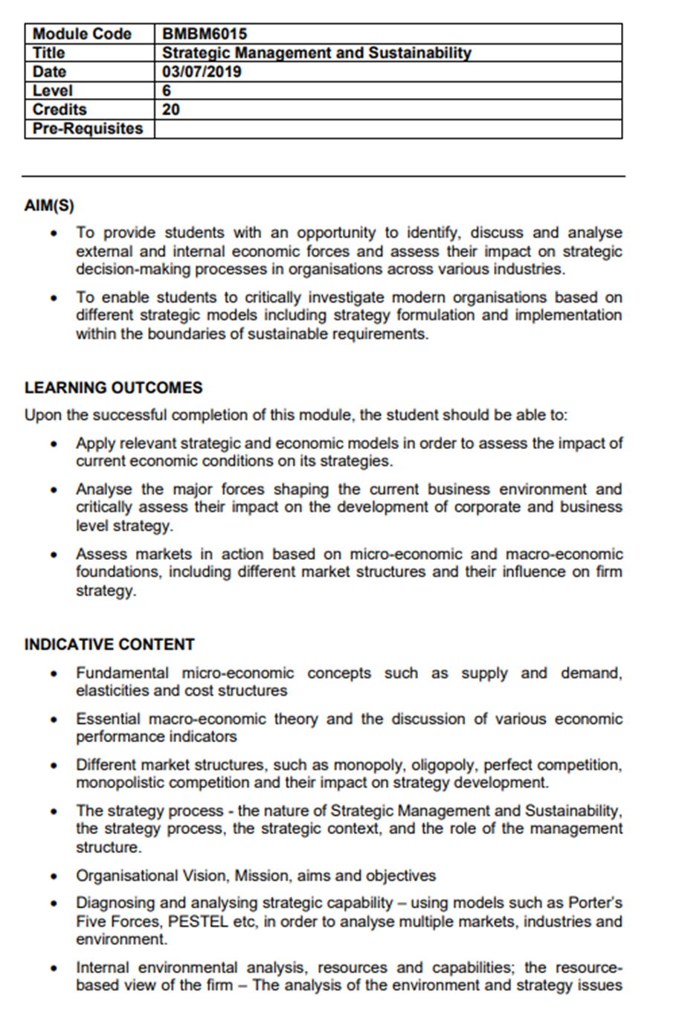

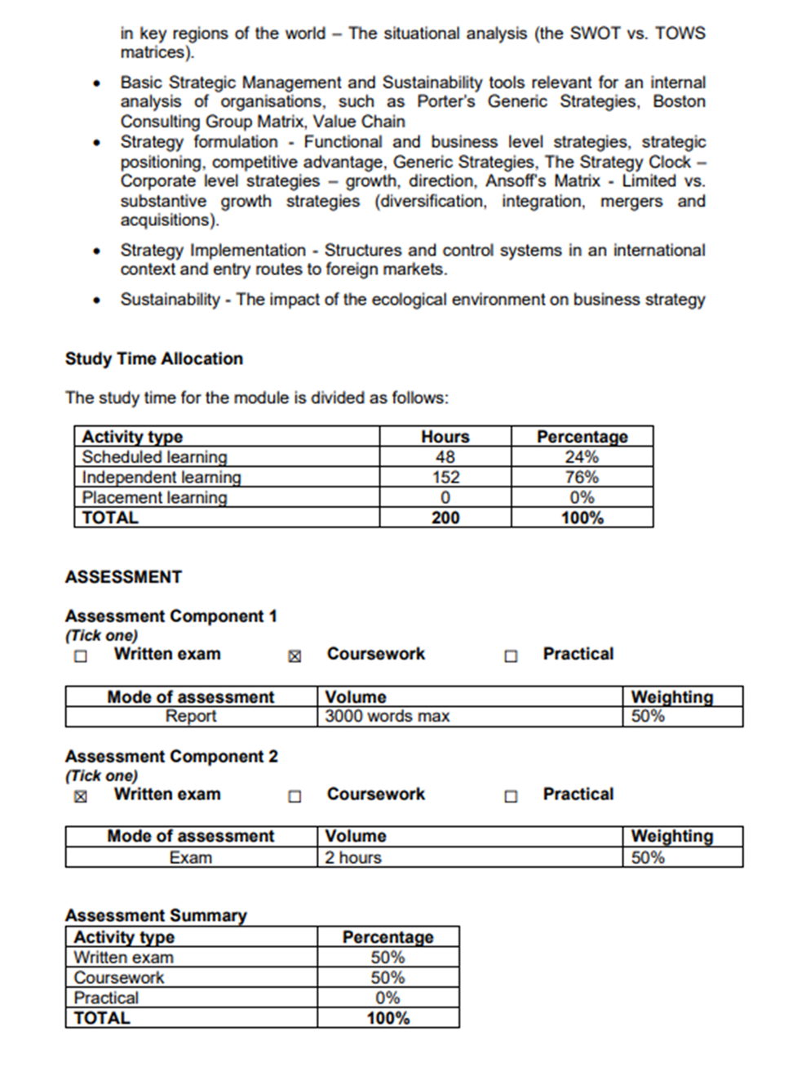
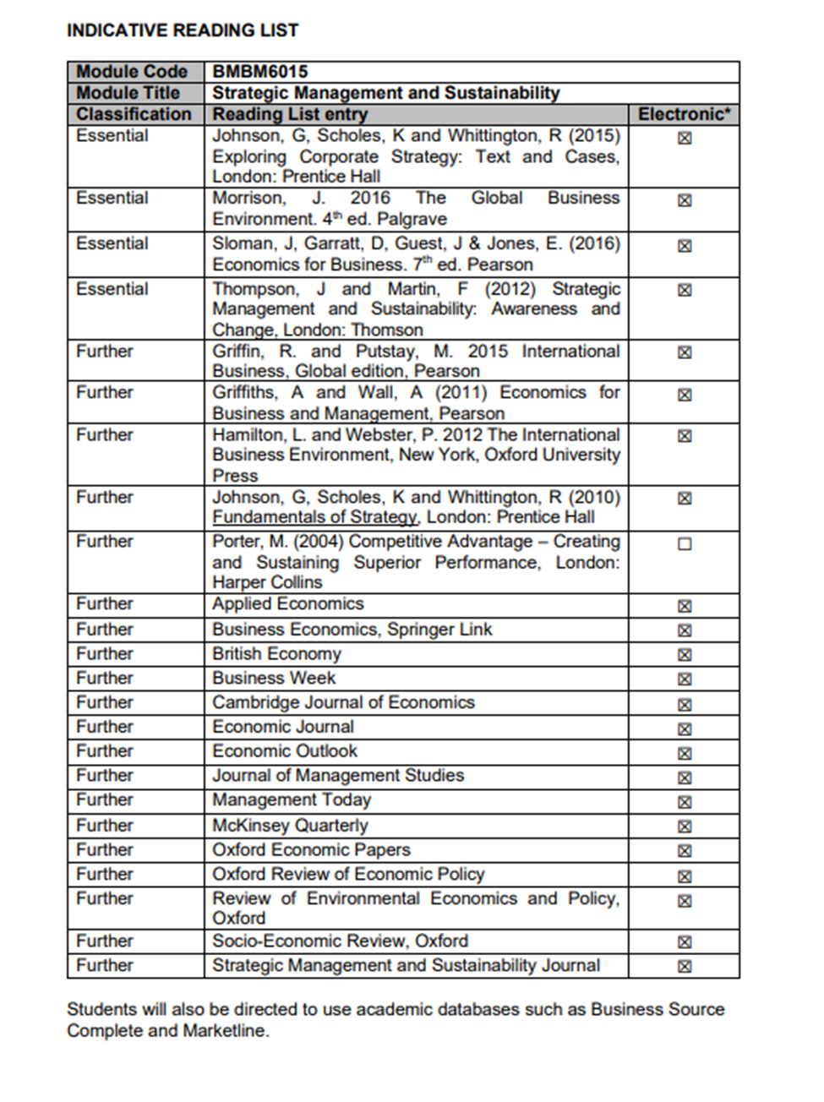
Assessment Component 1 – a 2,500-word report
- Due by Friday 15th March at 11.59pm.
- This will be placed under the assessments tile on Moodle.
Assessment Component 2 – a two-hour examination
- To be held in the examination period 4^{in} May.
- Arrangements will be explained in class.

