The Hilton 100th Anniversary

International Meetings Management for the Hotel Industry
BMIH6007, Kathryn Flynn
Student Name: Dumitru Nicolae Silviu
Student ID:2235616

I acknowledge using the Grammarly and Office Editor (embedded option) on 22.02.2025 to check my document for grammatical and syntactical mistakes.

Executive Summary
The Hilton 100th Anniversary Event is a global celebration that aims to honour Hilton's legacy of Equality, Diversity, and Inclusion (DEI) and promote conversation about future industry advancements. The Event Planning Cycle and the Event Management Body of Knowledge (EMBOK) framework are employed to strategically structure this large-scale event, which ensures its efficient execution in multiple locations.
The event is divided into three key phases:
- Pre-Event Phase → Focuses on planning, stakeholder engagement, marketing, logistics, and securing sponsorships.
- Event Phase → Features keynote speeches, panel discussions, cultural performances, and hybrid participation.
- Post-Event Phase → Measures impact, fosters long-term partnerships and sustains Hilton’s DEI initiatives beyond the event.
A well-curated attendee experience includes an itinerary of keynote addresses, interactive exhibits, panel discussions, artistic performances, education, networking, and cultural appreciation. The event's financial strategy reinforces sustainability, with sponsorships, ticket sales, and merchandise as funding sources.
The event's execution is influenced by industry trends, including AI-driven networking, sustainable practices, and hybrid event models, which guarantee that modern engagement strategies are implemented. A situational analysis (SWOT, PESTEL, and SOAR) underlines Hilton's strengths, risks, and opportunities in staging a globally inclusive and impactful event.
Hilton's centenary celebration is a commemorative milestone and a launchpad for future DEI initiatives by utilising innovative event management practices, strategic marketing, and digital interactivity, reinforcing the company's leadership in inclusive hospitality.

Table of Contents
- Executive Summary
- Introduction
- The Event Cycle and EMBOK Framework Application
  - Pre-Event Phase – Planning and Coordination
  - Event Phase – Execution and Engagement
  - Post-Event Phase – Evaluation and Legacy
- Event Concept – Attendee Experience
  - Full Itinerary
- Aim and Objectives
- Event Management – Skills and Resources
  - Operational Management
  - Planning and Strategy
  - Marketing and Outreach
  - Technology and Digital Infrastructure
- Event Budget – Financial Analysis
- Industry Trends and Impacts
- Situational and Cultural Considerations
  - SWOT Analysis
- Conclusion
- References
- Appendices
- PESTEL Analysis
- SOAR Analysis
- Cultural Sensitivity and Multiculturalism
- Experience Economy and Engagement Models

Introduction
The 100th Anniversary Event of Hilton is a celebration of the company's legacy of Equality, Diversity, and Inclusion (DEI) and a platform for discussing the future of inclusive hospitality. The event is a platform for meaningful dialogue and long-term DEI initiatives, bringing together industry leaders, activists, and the public.
The event conforms to the Event Planning Cycle and EMBOK framework to guarantee efficient execution, which includes strategic planning, stakeholder engagement, and risk management. The event is divided into three phases: Pre-Event (planning and promotion), Event (keynotes, discussions, and cultural performances), and Post-Event (impact assessment and future partnerships).
Global accessibility and engagement are guaranteed by a hybrid model integrating live streaming, virtual reality exhibits, and AI-driven networking. Sponsorships, merchandise, and ticket sales are implemented to guarantee financial sustainability, corresponding with industry developments in digital innovation and sustainability.
The event's planning, execution, and impact are detailed in this report, reinforcing Hilton's status as a pioneer in inclusive hospitality.

The Event Cycle and EMBOK Framework Application
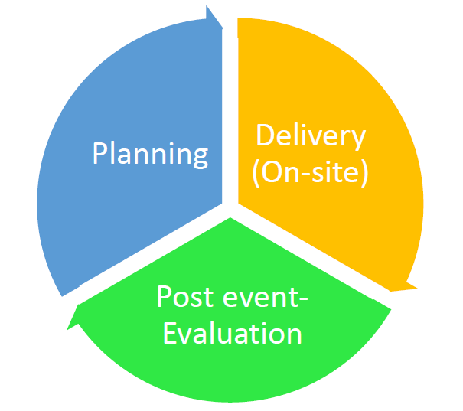
Strategic event planning necessitates a structured approach to guarantee audience engagement, long-term impact, and seamless execution. The Event Planning Cycle, following the EMBOK (Event Management Body of Knowledge) framework, offers a methodical approach to coordinating Hilton's 100th-anniversary event at various locations. The three phases—Pre-Event, Event, and Post-Event—encompass administration, design, marketing, operations, and risk management considerations, guaranteeing a well-executed and coordinated event (Van Antwerpen, 2023).

Pre-Event Phase – Planning and Coordination
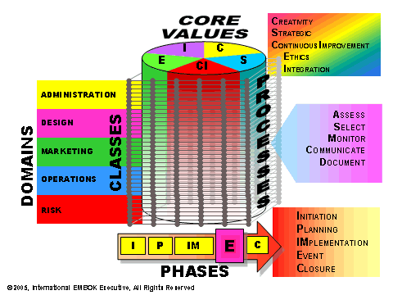
The pre-event phase establishes the groundwork for success through meticulous venue selection, stakeholder engagement, and logistical planning (Talib et al., 2024).
- Administration (EMBOK→ Administration)
Hilton must ensure that venues are coordinated across multiple capital cities, that they are accessible, and that the infrastructure is sufficient. It is imperative to prioritise financial planning, focusing on obtaining corporate sponsorships and ticket sales as revenue sources. Broad support is guaranteed through effective stakeholder engagement, which includes partnerships with NGOs and corporate sponsors (Kariuki et al., 2020).
- Marketing and Outreach (EMBOK→ Marketing)
Hilton’s global centennial celebration demands a multichannel marketing approach tailored to diverse cultural and economic landscapes. To ensure high visibility, digital campaigns will use #Hilton100Inclusion, influencer partnerships, and geo-targeted social media ads. In cities like Paris and New York, elite networking events will create media buzz, while in emerging markets like Jakarta or Nairobi, radio and localised community outreach will increase engagement. Public relations campaigns will accentuate Hilton’s DEI initiatives, promoting corporate sponsorships and NGO collaborations to align with ethical branding strategies (Namratha et al., 2019).
- Logistics and Technology (EMBOK→ Operations)
Interactive digital engagement, seamless live transmission, and accessibility for hybrid attendees are guaranteed by a robust technical setup. To mitigate disruptions, AV equipment and real-time digital platforms will undergo pre-testing (Silvers et al., 2005).

Event Phase – Execution and Engagement
The event day is designed to provide a meaningful experience, combining education, culture, and networking.
- Launch and Keynotes (EMBOK→ Design)
The event begins with a discussion of the progress and challenges of DEI, featuring Hilton's CEO and industry experts. Hilton's local inclusion history will be displayed on large screens, resulting in an engaging narrative experience (Hilton, 2024).
- Cultural Engagement (EMBOK→ Design)
The theme of diversity and inclusion will be reinforced through dance, art, and narrative performances that honour local cultures. Collaborations between activists, business leaders, and DEI professionals will be facilitated by networking sessions (Patnaik, 2024).
- Hybrid Participation (EMBOK→ Operations)
Global inclusivity will be guaranteed through interactive digital tools and live-streamed discussions, allowing remote participants to engage in real-time Q&A sessions and breakout discussions (Seid and Ali, 2024).
Post-Event Phase – Evaluation and Legacy
The post-event phase ensures that insights gained translate into long-term impact (Arnott, 2020). By integrating the Event Planning Cycle and EMBOK framework, Hilton provides a structured, impactful, and globally engaging event that aligns with its long-term DEI objectives (Van Antwerpen, 2023).
- Impact Assessment (EMBOK→ Administration)
Surveys, social media analytics, and engagement data will be implemented to gather participant feedback. Media coverage, social media trends, and partner collaborations will be used to evaluate the event's success (Hilton, 2024).
- DEI Initiatives (EMBOK→ Risk Management)
Assuring long-term partnerships with organisations that prioritise workplace diversity, the event will serve as the foundation for future collaborations. Beyond the event, Hilton's DEI leadership will be further solidified through the widespread distribution of digital content.

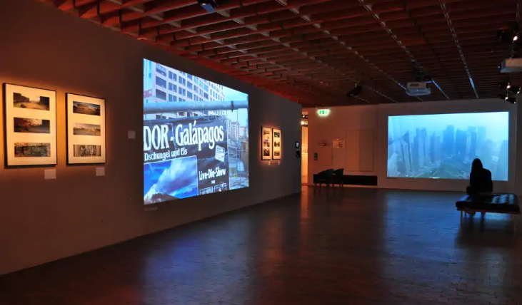
Event Concept – Attendee Experience
The Hilton 100th Anniversary event will be an immersive experience integrating education, cultural engagement, and networking. It promotes meaningful conversations and connections between industry leaders, activists, and the public while giving attendees a historical perspective on Hilton's contributions to Equality, Diversity, and Inclusion (DEI). Events of this nature have been demonstrated to improve public perception of cultural initiatives and encourage social unity, giving them an effective instrument for community impact and brand engagement (Arnott, 2020).
The event is designed to optimise engagement and guarantee that attendees have a dynamic and impactful experience. To maintain a harmonious balance between cultural appreciation, networking opportunities, and informative discussions, each phase of the day is thoroughly organised.
Full Itinerary
Morning: Inform and Inspire
- Registration and Welcome Networking →
Guests arrive, check-in, and interact with peers.
- Opening Keynote – Hilton’s 100-Year Journey in DEI →
Hilton executives and historians will discuss the company’s evolution in workplace inclusion, showcasing key milestones and challenges faced over the years (Hilton, 2024).
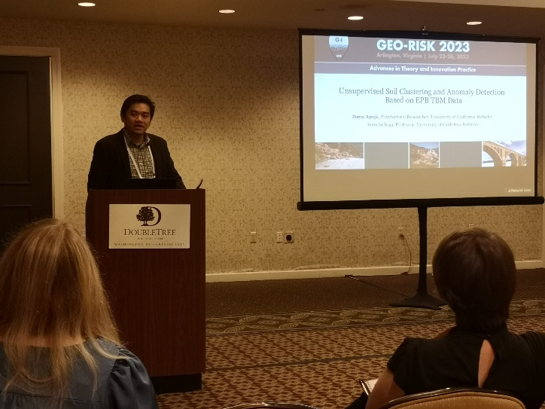
Midday → Discussion and Immersion
- Panel Discussions – Inclusive Leadership and Workplace Diversity →
Industry experts and thought leaders analyse trends and challenges in leadership equity. These discussions will highlight how organisations can integrate diversity into corporate strategies (Patnaik, 2024).
- Interactive Displays and VR Exhibits →
Guests can explore immersive exhibits showcasing Hilton’s local and global DEI efforts. Studies suggest that interactive elements enhance attendee engagement and create lasting impressions, making such exhibits a powerful storytelling tool (Silvers et al., 2005).
- Lunch and Networking with DEI Advocates →
An informal setting where guests can connect with business leaders, policymakers, and non-profit organisations, fostering meaningful dialogue on inclusion initiatives. Research highlights that networking during cultural events strengthens professional relationships and facilitates long-term collaborations (Getz and Page, 2024).
Afternoon → Cultural Celebration and Commitment
- Cultural Performances (Storytelling, Art, Music) →
Hilton will partner with cultural organisations and local performers to present performances that reflect the diverse traditions and histories of the region. Arnott (2020) has conducted research that indicates that cultural elements in events can increase affective engagement and social inclusion.
- Hilton’s Future Commitment to Inclusion – CEO Address →
The Hilton leadership team will present future strategies for DEI in the hospitality industry, demonstrating their continued commitment beyond this celebration.
Evening → Reflection and Connection
- Gala Dinner and Closing Remarks →
A formal dining experience that includes the recognition of key contributors to DEI efforts and the presence of guest speakers. Research indicates that well-executed concluding ceremonies help to reinforce event themes and leave lasting effects (Li, 2013).
- Virtual Networking for Hybrid Attendees →
Remote attendees can engage in live-streamed discussions and breakout sessions, achieving global accessibility and expanding engagement outside the physical venue (Seid and Ali, 2024).
This event is informative, emotionally engaging, and action-oriented, as it is a structured combination of education, networking, and cultural celebration.
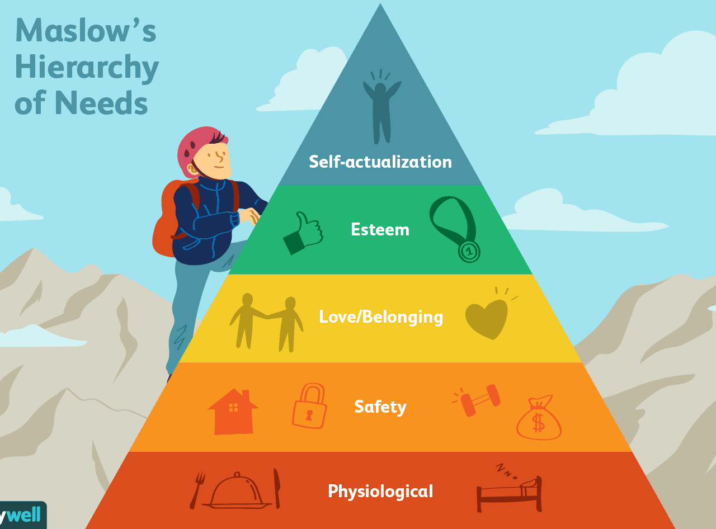
Psychological and Social Engagement → Applying Maslow’s Hierarchy (1968)
Hilton’s event design strategy aligns with Maslow’s Hierarchy of Needs (1968), creating a captivating, inclusive, and fulfilling experience for attendees.
- Physiological & Safety Needs →
High-quality catering, secure venues, and comfortable seating arrangements meet attendees' basic needs. Hybrid event accessibility further provides a safe and flexible participation option.
- Belonging & Esteem Needs →
Networking lounges, VIP roundtables, and AI-driven matchmaking tools facilitate meaningful industry connections. Recognition of DEI advocates and contributors during the closing gala fosters a sense of achievement and prestige.
- Self-Actualisation →
Tailored leadership sessions, interactive DEI panels, and cultural performances empower attendees to engage intellectually and personally, increasing their long-term industry impact (Patnaik, 2024).
Aim and Objectives

The Hilton 100th Anniversary Event was created to commemorate the company's inclusivity legacy and encourage a global dialogue on Equality, Diversity, and Inclusion (DEI). The event attempts to improve awareness, engagement, and long-term impact by incorporating educational panels, cultural engagement, and digital interactivity (Getz and Page, 2024).
Aim
- The event aims to commemorate Hilton’s leadership in DEI while providing a platform for global stakeholders to discuss advancements and challenges in creating inclusive spaces (Allen et al., 2000).
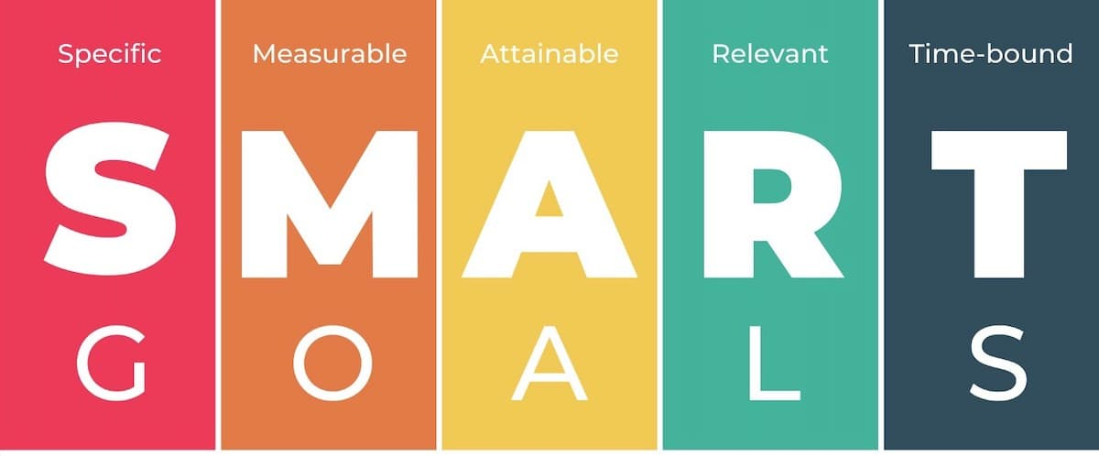
SMART Objectives
- Ensure that at least 70% of attendees interact with critical digital or physical displays by promoting Hilton's DEI initiatives through interactive content and expert-led discussions (Salama, 2021).
- Increase engagement by 25% by utilising real-time updates, influencer partnerships, and virtual networking to achieve a 25% increase in social media participation through #Hilton100Inclusion (Ramadhan and Wibowo, 2022).
- Increase engagement by 25% by utilising real-time updates, influencer partnerships, and virtual networking to achieve a 25% increase in social media participation through #Hilton100Inclusion (Ramadhan and Wibowo, 2022). Hilton guarantees that the event has a lasting impact beyond the celebration by setting precise, quantifiable objectives (Hilton, 2024).
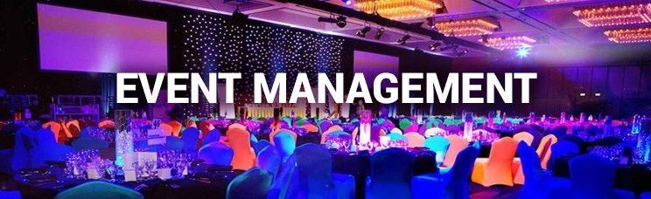
Event Management – Skills and Resources
A multidisciplinary approach is necessary to guarantee the successful execution of Hilton's 100th Anniversary Event, resulting in strategic planning, seamless operations, and impactful audience engagement. Event management frameworks, including EMBOK, prioritise the integration of administration, marketing, operations, and risk management to optimise large-scale international events (Ferdinand and Kitchin, 2016).
Operational Management
- Venue Coordination →
To guarantee that Hilton's locations are consistent with DEI principles, each area must assess its accessibility, technology requirements, and local cultural influences (Hilton, 2024).
- Logistics Planning →
Hybrid event execution, effective scheduling, AV setup, and speaker travel arrangements are essential for synchronising global event locations (Narval et al., 2019).
Planning and Strategy
- Stakeholder Engagement →
Partnerships with corporate sponsors, NGOs, and industry leaders guarantee financial sustainability and credibility. Hilton aims to forge enduring partnerships concerning post-event DEI initiatives (Fotiadis and Vassiliadis, 2020).
- Marketing Strategy - McCarthy’s 4Ps of Marketing (1960) →
Applying McCarthy’s (1960) 4Ps framework (Product, Price, Place, Promotion) ensures a structured marketing approach that aligns with Hilton’s global brand positioning (Getz and Page, 2024).
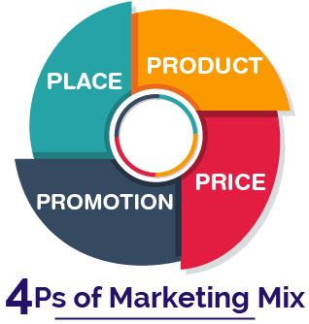
- Product → Focussing on Hilton's leadership in sustainable hospitality and DEI, the Hilton 100th Anniversary event is both a celebration and a purposeful brand experience. Its value proposition (Hilton, 2025; Altschwager et al., 2022) is strengthened by keynotes, AI-powered networking tools, and hybrid engagement platforms). Technology has helped create better event experiences by influencing audience participation and brand image (Celuch, 2021).
- Price → Ticket prices will be examined depending on the dynamics of the local market. Premium-priced VIP events in London and Tokyo comprise roundtable conversations. Discounted access will be given in developing countries to guarantee inclusivity in line with consumer-centric pricing policies (Kariuki, Kimanga, and Wanjiku, 2020). Using tiered pricing strategically in event planning has increased audience reach while preserving exclusivity (Hintermeister, 2021).
- Place → Hilton will use its worldwide hotel chain to host events throughout significant cities, considering its multi-city approach. Virtual reality (VR) experiences will also bring guests to Hilton's most famous sites, guaranteeing accessibility independent of geographical limitations (Hilton, 2024). Popular hybrid event models recently gave participants a rich and accessible experience (Latif and Zamziri, 2024).
- Promotion → Social media activity, influencer partnerships, and corporate sponsorships will drive global involvement. Localised campaigns will combine digital and traditional marketing, customising material for cultural relevance in markets including Sydney, São Paulo, Dubai, Saitiawan, Wibisono, and Purwanegara, 2022. The growing dependence on digital marketing techniques for event promotion changes audience involvement and facilitates better participation and brand recall (Namratha, Thiruchelvi, and Natasha, 2019).
Marketing and Outreach
- Targeted Campaigns →
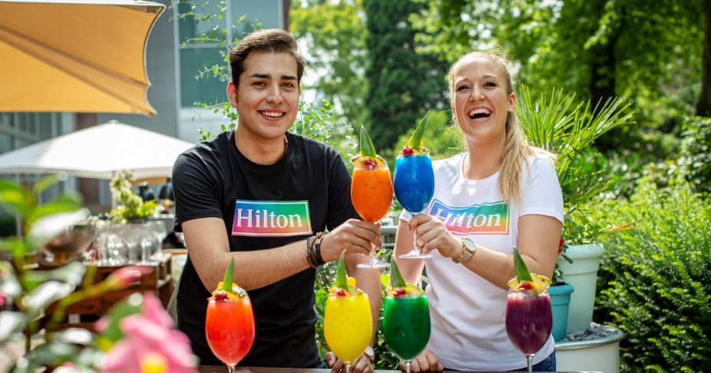
To optimise attendance and engagement, Hilton Honours members, corporate executives, and DEI professionals will receive personalised email invitations (Sha and Robertson, 2018).
- Social Media Activation →
The #Hilton100Inclusion campaign will encourage digital engagement by utilising Twitter, LinkedIn, and TikTok to provide real-time updates (Namratha et al., 2019).
Technology and Digital Infrastructure
- Hybrid Streaming →
The event will incorporate interactive Q&A sessions, post-event content sharing, and multi-platform live streaming to facilitate a global audience (Werner et al., 2022).
- AI-Driven Chatbots →
Attendees will be assisted by AI-powered virtual assistants, who will offer real-time event information, networking recommendations, and frequently asked questions (Mohiuddin, 2024).
Hilton reinforces its DEI commitments and industry leadership through a well-structured event management approach that guarantees attendees an efficient, engaging, and impactful experience (Ferdinand and Kitchin, 2016).

Event Budget – Financial Analysis
To guarantee Hilton's 100th Anniversary Event's profitability and high-quality execution, it is essential to implement effective financial planning (Salama, 2021). The budget is designed to maintain a strategic allocation of resources while also balancing cost efficiency and revenue generation (Salama, 2021).
CATEGORY | ESTIMATED COST
Ticket Sales | £120,000
Merchandise Sales | £40,000
Total Income | £400,000
AV and Live Streaming | £35,000
Catering | £40,000
Staffing | £35,000
Marketing | £35,000
Technology | £25,000
Miscellaneous | £10,000
Total Expenditure | £200,000
Net Profit | £200,000

Hilton's financial strategy is predicated on sponsorship revenue, ticket sales, and merchandise sales, which provides financial sustainability and reduces direct costs [(Hilton, 2024)]. The sponsorship strategy is consistent with corporate social responsibility initiatives, attracting partners committed to diversity and inclusion (Salama, 2021).
To guarantee an engaging hybrid experience for both in-person and virtual attendees, cost allocations prioritise critical areas, including AV and live streaming (£35,000), catering (£40,000), and technology (£25,000) (Hintermeister, 2021). Hilton's marketing investment of £35,000 will increase visibility using influencer partnerships, corporate sponsorship engagement, and social media campaigns (Getz and Page, 2024).
Hilton can reinforce its dedication to DEI and optimise profitability by implementing stringent financial controls.

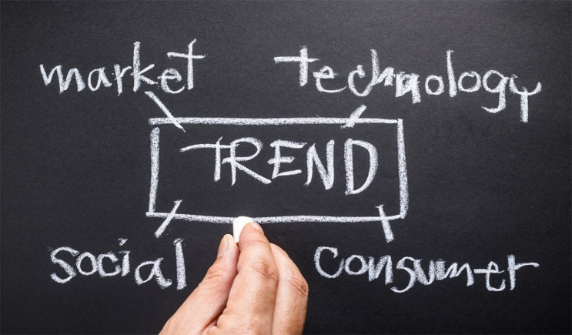
Industry Trends and Impacts
The event industry is evolving rapidly due to the increasing demand for inclusivity, sustainability concerns, and technological advancements (Bowdin et al., 2011). Hilton's event strategy is influenced by these trends, which ensure that the experiences are contemporary, engaging, and accessible on a global scale.
Key Trends in Event Management
Hybrid Event Trends →
- Events now incorporate in-person and virtual components, allowing a broader audience to participate and reducing travel emissions (Yuniati et al., 2022).
Technology Integration →
Attendee experiences are improved by AI-driven personalisation, while security and transparency are enhanced by blockchain ticketing (Hintermeister, 2021).
Sustainability Focus →
Event planning best practices are being redefined by the transition to carbon-neutral logistics, eco-friendly catering, and waste reduction (Celuch, 2021).
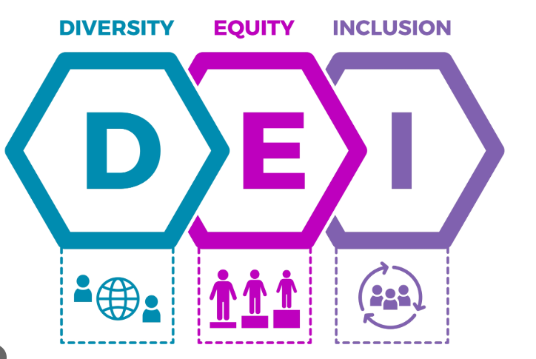
DEI Integration →
The demand for corporate events prioritising diversity, equity, and inclusion (DEI) is rising, necessitating planners to guarantee culturally sensitive content, diverse speaker representation, and accessible venues (Higgins-Desbiolles, 2023).
These trends significantly influence Hilton's 100th Anniversary Event, guaranteeing its innovative, environmentally responsible, and inclusive execution.
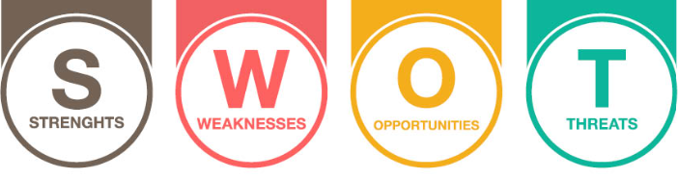

Situational and Cultural Considerations
Applying a SWOT analysis to Hilton's 100th Anniversary Event facilitates a thorough assessment of the company's internal strengths and weaknesses and external opportunities and threats (Mokhtar, 2021). Hilton's global presence necessitates a strategic and localised approach to guarantee cultural alignment and inclusivity in various regional contexts (Hilton, 2024).
SWOT Analysis for Hilton’s Event:
Strengths →
- High visibility and credibility are guaranteed by Hilton's solid brand reputation and global presence (Hilton, 2024).
- Diverse audience engagement is facilitated by multi-location execution, which reinforces DEI initiatives (Salama, 2021).
Weaknesses →
- Coordinating multiple venues, time zones, and accessibility requirements results in high logistical complexity (Mokhtar, 2021).
- According to Panteleev (2023), cultural differences necessitate tailored programming, catering, and entertainment options.
Opportunities →
- The hybrid event model expands global reach, supporting broader engagement (Hintermeister, 2021).
- New partnerships strengthen Hilton’s DEI leadership, encouraging long-term collaborations (Salama, 2021)
Threats →
- Technological failures like live-streaming issues could disrupt hybrid participation, necessitating fallback solutions (Hintermeister, 2021).
- Maintaining alignment among sponsors, presenters, and attendees is a challenge due to the diverse expectations of stakeholders (Mokhtar,2021).
This analysis guarantees a globally inclusive experience, localised adaptation, and proactive risk mitigation.

9. Conclusion
Hilton's 100th Anniversary event is a strategic commemoration of the company's future commitments and progress in the DEI field. The EMBOK Model and Event Planning Cycle offer a structured framework that guarantees effective planning, engagement, and post-event impact.
The event reinforces Hilton's dedication to inclusivity and correlates with industry trends through hybrid participation, stakeholder partnerships, and digital innovation. The event is both sustainable and impactful due to the financial strategy's guarantee of profitability.
Hilton solidifies its status as a global leader in inclusive hospitality by utilising technology, branding, and cultural engagement.

Reference List
- Allen, J., Harris, R., Jago, L.K. and Veal, A.J., (2000). Events Beyond 2000: Setting of Conference on Event Evaluation, Research and Education Sydney July 200. https://opus.lib.uts.edu.au/bitstream/10453/19788/1/Proceedings%202000%20Conference.pdf#page=16
- Altschwager, T., Conduit, J., Karpen, I., and Goodman, S., (2022). Event Engagement: Using Event Experiences to Build Brands. Australasian Marketing Journal, 32, pp. 31 - 44. https://doi.org/10.1177/14413582221127317.
- Antchak, V., Ziakas, V., & Getz, D., 2019. Event Portfolios and Stakeholder Networks. Event Portfolio Management. https://doi.org/10.23912/978-1-911396-91-8-4189.
- Arnott, I., 2020. Risk Management in Events Management., pp. 1-20. https://doi.org/10.4018/978-1-7998-3230-0.CH001.
- Bowdin, G., Allen, J. and Harris, R., (2011). Event Management. https://librarysearch.uwtsd.ac.uk/permalink/44WHELF_UWTSD/1pbrh66/alma9929233802421
- Celuch, K., (2021). Event technology for potential sustainable practices: a bibliometric review and research agenda. International Journal of Event and Festival Management, 12(3), pp. 314-330. https://www.proquest.com/scholarly-journals/event-technology-potential-sustainable-practices/docview/2565978610/se-2?accountid=130472
- Claudia, M., Dieck, P., Jung, P., and Rauschnabel, P., (2018). Determining visitor engagement through augmented reality at science festivals: An experience economy perspective. Comput. Hum. Behav., 82, pp. 44-53. https://doi.org/10.1016/j.chb.2017.12.043.
- Coetzee, W., and Pourfakhimi, S., (2020). Affective engagement as a contextual dimension for predicting intentions to revisit and recommend events – a multinational comparison. Journal of Policy Research in Tourism, Leisure and Events, 12, pp. 401 - 421. https://doi.org/10.1080/19407963.2019.1695345.
- Elbashir, B., (2024). An Investigation of Cultural Sensitivity and Teachers’ Classroom Management. International Journal of English Language Teaching. https://doi.org/10.37745/ijelt.13/vol12n12845.
- Ferdinand, N. and Kitchin, P., (2016). Events Management: An International Approach (2nd edition).
- Fotiadis, A. and Vassiliadis, (2020). Principles and Practices of Small-Scale Sport Event Management. https://doi.org/10.4018/978-1-7998-4757-1
- Getz, D. and Page, S.J., (2024). Event Studies. Theory and Management for Planned Events. Fifth Edition. https://librarysearch.uwtsd.ac.uk/permalink/44WHELF_UWTSD/11c0l68/alma99100647735602421
- Getz, D. and Page, S.J., (2024). Event Studies. Theory and Management for Planned Events. Fifth Edition. https://librarysearch.uwtsd.ac.uk/permalink/44WHELF_UWTSD/11c0l68/alma99100647735602421
- Gheibi, M., Karrabi, M., Mohammadi, A., and Dadvar, A., (2018). Controlling air pollution in a city: A perspective from SOAR‐PESTLE analysis. Integrated Environmental Assessment and Management, 14. https://doi.org/10.1002/ieam.4051.
- Goldblatt, J. (2010). Special Events: A New Generation and the Next Frontier (6th ed.). Wiley.
- Hermann, U., Lee, C., Coetzee, W. and Boshoff, L., (2020). Predicting behavioural intentions of Craft Beer Festival attendees by their event experience. International Journal of Wine Business Research. https://doi.org/10.1108/ijwbr-05-2020-0019.
- Higgins-Desbiolles, F., (2023). Response to Calver et al.'s “The (In)visibility of Equality, Diversity, and Inclusion Research in Events Management Journals”: The Vital Need to Emphasise Justice. Event Management. https://doi.org/10.3727/152599523X16907613842291
- Hilton, (2024). Event Spaces: Find Venues for Events. https://www.hilton.com/en/events/.
- Hilton, (2025). Hilton, the World’s First Global Hospitality Company, Celebrates 100 Years with a Dynamic Launch Into Its Next Century. https://stories.hilton.com/releases/hilton-the-worlds-first-global-hospitality-company-celebrates-100-years-with-a-dynamic-launch-into-its-next-century
- Hintermeister, A.M., (2021). Transitioning to Virtual and Hybrid Events: How to Create, Adapt, and Market an Engaging Online Experience. American Libraries, 52(3), pp. 52. https://www.proquest.com/trade-journals/transitioning-virtual-hybrid-events-how-create/docview/2498621653/se-2?accountid=130472
- Jamil, J., (2023). PESTLE Analysis and Sustainable Event Marketing - Evidences from Mount Kinabalu International Climbathon Destination, Borneo. Journal of Event, Travel and Tour Management. https://doi.org/10.34013/jett.v3i2.1326.
- Jung, S., FAN, A., Lehto, X. and Shin, H.W., (2024). Festivalization of business events: exploring a new strategy for designing more engaging conference experiences. International Journal of Contemporary Hospitality Management, 36(10), pp. 3427-3450. https://www.proquest.com/scholarly-journals/festivalization-business-events-exploring-new/docview/3098549637/se-2?accountid=130472
- Kamkankaew, P., (2023). Current trends in strategic management: a comparative analysis of SWOT and SOAR approaches. RMUTT Global Business Accounting and Finance Review. https://doi.org/10.60101/gbafr.2023.269044.
- Kariuki, K., Kimanga, E., and Wanjiku, J., 2020. Performance of Events Management Service Providers within the Weddings Subsector in Nairobi County, Kenya. International Journal of Innovative Research and Development. https://doi.org/10.24940/IJIRD/2020/V9/I12/DEC20033.
- Kung, W., 2023. Using the PESTEL Analysis to Determine the Effectiveness of New Digital Media Strategies. Advances in Economics, Management and Political Sciences. https://doi.org/10.54254/2754-1169/5/20220054.
- Latif, N. and Zamzuri, N., 2024. Enhancing Attendee Engagement: A Study on Designing Successful Hybrid Events in Malaysia. Information Management and Business Review. https://doi.org/10.22610/imbr.v16i3(i).3927.
- Li, Y.W., 2013. Public diplomacy strategies of the 2008 Beijing Olympics and the 2012 London Olympics: A comparative study. The International Journal of the History of Sport, 30(15), pp.1723-1734. https://doi.org/10.1080/09523367.2013.790374
- Maslow, A.H., 1954. Motivation and personality. New York: Harper and Row.
- Mohiuddin, N.O.O.R., 2024. Innovation in the tourism industry: How artificial intelligence is reshaping the management of meetings and events. https://doi.org/10.13140/RG.2.2.19952.06400
- Mokhtar, S., 2021. A framework for sustainable environmental analysis. IOP Conference Series: Earth and Environmental Science, 685. https://doi.org/10.1088/1755-1315/685/1/012005.
- Namratha, J., Thiruchelvi, A. and Natasha, J., 2019. Event management and social media marketing. International Journal of Advance Research, Ideas and Innovations in Technology, 5(2). https://www.academia.edu/download/59152847/V5I2-164120190507-35001-dmmrd8.pdf
- Narval, A., del Rosario, J. and Baraero-Era, J.S., 2019. Lessons Learned from Organizing an International Event. Asia Pacific International Events Management Journal, 1(1), pp.25-28. https://ejournal-medan.uph.edu/index.php/APIEMJ/article/download/288/150
- Niekerk, M., & Getz, D., 2019. Introduction to Stakeholder Theory. Event Stakeholders. https://doi.org/10.23912/9781911396635-4090.
- Noh, Y., Coleman, A., and Kim, D., 2024. The effects of special events on attendees’ Diversity, Equity, and Inclusion (DEI) experience: Festival pride, prior experience, and COVID-19. Journal of Convention and Event Tourism, 25, pp. 165 - 186. https://doi.org/10.1080/15470148.2024.2307006.
- Panteleiev, V., 2023. Application of SWOT analysis to justify the strategy of hotel business enterprises. Technology audit and production reserves. https://doi.org/10.15587/2706-5448.2023.274918.
- Patnaik, S., 2024. Entrepreneurship, Tourism, Local Fashion, and Curriculum Development: A South African study. Reading: Academic Conferences International Limited. https://www.proquest.com/conference-papers-proceedings/entrepreneurship-tourism-local-fashion-curriculum/docview/3074818065/se-2?accountid=130472
- Ramadhan, A.S. and Wibowo, A. (2022) ‘Strategic Marketing: The Key to Success in Maximizing Event Management’, Jurnal Publikasi Ilmu Manajemen (JUPIMAN), 1(2), pp. 1–26. https://ejurnal.politeknikpratama.ac.id/index.php/jupiman/article/download/1533/1516
- Ramely, A., Talib, M., Ahmad, R., and Yusof, N., 2023. EXAMINING PESTEL ANALYSIS OF EVENT BUSINESSES IN MALAYSIA. Journal of Event, Tourism and Hospitality Studies. https://doi.org/10.32890/jeth2023.3.4.
- Richards, G., 2020. Measuring the dimensions of event experiences: applying the Event Experience Scale to cultural events. Journal of Policy Research in Tourism, Leisure and Events, 12, pp. 422 - 436. https://doi.org/10.1080/19407963.2019.1701800.
- Salama, M., 2021. Event project management: principles, technology and innovation. https://librarysearch.uwtsd.ac.uk/permalink/44WHELF_UWTSD/11c0l68/alma99100509002002421
- Seid, A.H. and Ali, A.C., 2024. Analysis of mobilization and stakeholder participation: the case of Amhara Development Association. Ethiopian Journal of Language, Culture and Communication, 9(1), pp.40-61. https://www.ajol.info/index.php/ejlcc/article/download/280872/264794
- Setiawan, R., Wibisono, D., and Purwanegara, M., 2022. Defining Event Marketing as Engagement-Driven Marketing Communication. Gadjah Mada International Journal of Business. https://doi.org/10.22146/gamaijb.63788.
- Sha, Y. and Robertson, J., 2018. Volunteer management at international events. https://researcharchive.wintec.ac.nz/id/eprint/6454/2/AMCVol1%20no2%20excl%20conf.pdf
- Silvers, J.R., Bowdin, G.A.J., O'Toole, W.,J. and Nelson, K.B., 2005. Towards an International Event Management Body of Knowledge (EMBOK). Event Management, 9(4), pp. 185-198. https://www.proquest.com/scholarly-journals/towards-international-event-management-body/docview/2779475569/se-2?accountid=130472
- Talib, M., Zamzuri, N., and Nasir, H., 2024. A Conceptual Discussion Related to Festival Events in Malaysia. Information Management and Business Review. https://doi.org/10.22610/imbr.v16i3(i).3921.
- Van Antwerpen, S., 2023. A proposed integration of the event and project management body of knowledge. International Journal of Applied Sciences in Tourism and Events. https://doi.org/10.31940/ijaste.v7i2.108-119.
- WERNER, K., JUNEK, O. and WANG, C., 2022. Event Management Skills in the Post-covid-19 World: Insights from China, Germany, and Australia. Event Management, 26(4), pp. 867-882. https://www.proquest.com/scholarly-journals/event-management-skills-post-covid-19-world/docview/2763565398/se-2?accountid=130472
- Yanto, M., Warsah, I., Morganna, R., Muttaqin, I., and Destriani, D., 2022. Intercultural Sensitivity of Educational Management Students as the Future’s Educational Leaders in Indonesia. International Journal of Sociology of Education. https://doi.org/10.17583/rise.10483.
- Yuniati, N., Oktarini, K., and Trisnayoni, R., 2022. Shifting Trend on Management Event during the Pandemic. International Journal of Applied Sciences in Tourism and Events. https://doi.org/10.31940/ijaste.v6i1.13-23.
- Iandolo, F., La Sala, A., Turriziani, L., & Caputo, F., 2024. Stakeholder engagement in managing systemic risk management. Business Ethics, the Environment & Responsibility. https://onlinelibrary.wiley.com/doi/full/10.1111/beer.12694?saml_referrer

Appendix
Appendix A
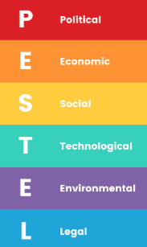
PESTEL Analysis
A PESTEL analysis assesses the political, economic, social, technological, environmental, and legal factors influencing Hilton's 100th Anniversary event. This framework facilitates proactive adaptation to market conditions (Ramely et al., 2023).
- Political →
Policies on corporate diversity and inclusion (DEI) impact sponsorship opportunities. International travel restrictions could influence attendance.
- Economic →
Fluctuations in global economies affect sponsorship funding and attendee affordability. Ticket pricing must balance profitability and accessibility (Jamil, 2023).
- Social →
There is increased demand for events promoting social justice and inclusivity. Hilton’s long-standing DEI commitment aligns with these values.
- Technological →
Advancements in AI-driven networking and blockchain ticketing increase attendee engagement and event security (Kung, 2023).
- Environmental →
Sustainability measures, such as carbon-neutral logistics and waste management, must meet modern corporate responsibility standards (Silvers et al., 2005).
- Legal →
Inclusive venue configurations are guaranteed by conforming to international accessibility regulations. Data privacy laws influence the security of event apps and the management of attendee information.
Hilton guarantees a successful, forward-thinking, and impactful anniversary celebration by coordinating its event strategy with these external factors.

Appendix B
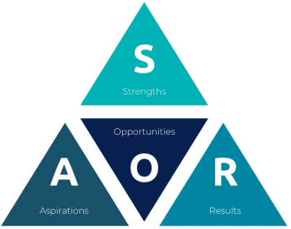
SOAR Analysis
A SOAR analysis (Strengths, Opportunities, Aspirations, Results) provides a positive, growth-oriented framework to optimise Hilton’s 100th Anniversary event (Kamkankaew, 2023).
Strengths →
- Global brand recognition and extensive venue network certify credibility and effective execution.
- DEI legacy and partnerships improve the event’s authenticity and engagement.
Opportunities →
- Hybrid model expands participation, allowing attendees from diverse regions to engage.
- Strategic sponsorships strengthen Hilton’s leadership in inclusive corporate culture.
Aspirations →
- Position Hilton as a global leader in corporate DEI initiatives beyond hospitality.
- Utilize the event as a springboard for long-term community partnerships.
Results →
- Increased social media engagement, measurable through #Hilton100Inclusion analytics.
- Expanded DEI-focused partnerships, ensuring a legacy beyond the event (Gheibi et al., 2018).
SOAR analysis ensures a strengths-driven, results-oriented approach, positioning Hilton’s event as a standard for global corporate inclusivity initiatives.

Appendix C
Cultural Sensitivity adn Multiculturalism
Cultural sensitivity plays a crucial role in event management, guaranteeing that inclusive and respectful experiences are created from various backgrounds. Events must be developed to acknowledge and incorporate cultural distinctions in accessibility, language, and dietary requirements (Getz and Page, 2024). Inclusivity and representation can be improved through partnerships with local cultural organisations and sensitivity training for event staff (Yanto et al., 2022). Additionally, research indicates that exposure to multicultural contexts promotes increased intercultural competence, which improves the overall quality of event experiences (Elbashir, 2024). Incorporating culturally diverse performances, food, and storytelling elements in global event contexts cultivates a sense of community (Getz and Page, 2024). Nevertheless, inclusive policies and stakeholder engagement are necessary to resolve obstacles such as unintentional biases and logistical complexities. Organisations can reinforce their dedication to diversity and inclusion while increasing participant engagement by incorporating cultural considerations into event planning (Getz and Page, 2024).
Appendix D
Experience Economy and Engagement Models
The experience economy is the context in which the contemporary event industry operates, with engagement models prioritising memorable and immersive interactions. Research indicates that events which stimulate emotional, cognitive, and sensory engagement increase brand loyalty and attendee satisfaction (Coetzee and Pourfakhimi, 2020). Personalised and lasting impressions are achieved through rich experiences, which include interactive installations, hybrid participation, and augmented reality (Claudia et al., 2018). Furthermore, research indicates that consumer behaviour following an event is substantially affected by online engagement, which underscores the significance of digital interactivity (Getz and Page, 2024 ). Organisations utilising technology to improve event experiences by incorporating gamification and real-time interaction increase audience engagement (Getz and Page, 2024). Moreover, implementing engagement models like co-creation, which involves attendees actively influencing the content of events, results in increased contentment (Richards, 2020). Event administrators must incorporate innovative strategies to guarantee that attendees derive value beyond mere participation as expectations for meaningful experiences continue to rise (Getz and Page, 2024).

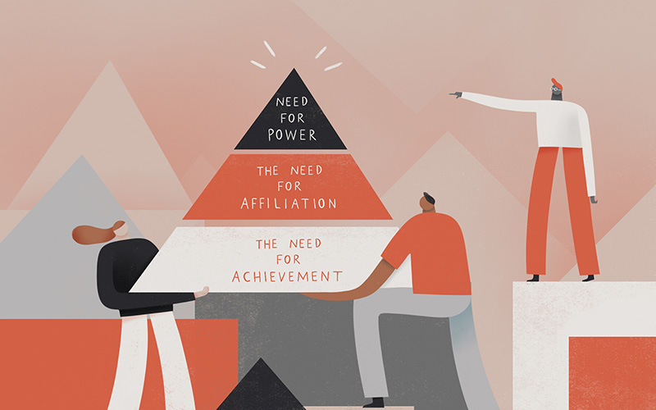
Need Theory in Event Management and Stakeholder Engagement
David McClelland's Theory of Needs (1960s) explains motivation in industrial contexts by regulating behaviour through achievement, power, and affiliation. This theory helps stakeholder engagement in Hilton's 100th Anniversary event, which aligns participants, sponsors, and organisers to ensure a successful and impactful event (Goldblatt, 2010).
- Achievement (Need for Success) →
Corporate sponsors, event partners, and other stakeholders are motivated by brand awareness and CSR incentives. Participating in Hilton's DEI-oriented event helps them improve their industry reputation and market presence, which aligns with studies on stakeholder cooperation in event portfolios (Antchak et al., 2019).
- Affiliation (Need for Belonging) →
Attendees, speakers, and panellists seek networking opportunities and meaningful engagement in industry debates. Developing AI-powered networking tools and hybrid interaction models promotes collaboration and inclusivity, a significant component of stakeholder theory in event tourism (Niekerk & Getz, 2019).
- Power (Need for Influence) →
Hilton executives and DEI advocates help to shape industry conversations and drive policy reforms. High-profile speakers and sponsors use their influence during the event to shape the future of hospitality inclusion, a key subject in stakeholder engagement research (Iandolo et al., 2024).

