Problem Solving and Decision making
in the workplace
BMSW4004_LON
Oana Pantiru (student ID:2017912)
Lecturer: Koushik Modak

Table of Contents

INTRODUCTION 3
MAIN BODY 3
One problem in the workplace including its scope 3
Impact of problem on service users, professionals and regulators 5
Analyzing decision-making process by relevant legislation 6
Range of alternative solutions to the problem 7
Decision-making technique for evaluating a range of solutions and for identify the most appropriate option 8
Appropriate monitoring and review techniques for successful implementation of the solution 10
CONCLUSION 10
REFERENCES 12

INTRODUCTION
The analytical process of for identifying the solutions that are possible of the problems is called the problem solving. This process involves decision making and it is very complex process. The choice is made according to the judgement is called decision-making. In the problem solving process the numerous decisions need to be taken. The set of steps are taken for fixing the problem. The report is about the problem solving and decision making in NHS. The term NHS can be used as the umbrella for the UK’s publically funded healthcare systems. The report provide with the overview of the challenges faced by the healthcare, one problem is discussed with the scope at the workplace and the impact of the problem on the users, regulators and professionals. The decision making of the process is analysed with the relevant organisation in the report. The implementation and the communication of the solution are discussed.

MAIN BODY

One problem in the workplace including its scope
The problem which has been created and attracted the attention concerns the mental health issue which has directly impacted NHS which has caused mental stress and mental pressure upon the employees of the organization (Talebi, 2020). This is the main problem of the organization and at the workplace where the employees are suffering from mental pressure and this has increased the scale of their problem or the issue. The employees are not able to concentrate and produce effective and significant results at the workplace and this has devalued the productivity and the organization is being affected by how the employees are performing and this has created the problem as the effectiveness and efficiency of the organization is hampered. Due to mental health and stress which is caused to the employees, there performance scale is decreasing day by day and they are unable to increase and enhance their performance while working within the organization (Maulik, 2017).
The scope of this problem or the mental issue which NHS is facing is high on the scales as the employees’ performance is being hampered and they are unable to deliver their best in an effective and efficient manner possible (MORADI and et.al., 2019). Mental health issue under which comes the mental stress is the big issue which cannot be practically solved rather this issue needs some advice and patterns through which the employees are able to put up their problems and solve them independently or take help from the other employees in organization. Mental stress is the problem which takes negative patterns in mind and is making employees professional life on degrading terms. And due to mental stress the performance in professional life is hampered and the employees are not able to concentrate at their workplace. Thus, before this problem takes major turns and creates devastating consequences which affects the employees and the organization at large scale, it should be solved significantly on the terms of effectiveness.
Regarding the issue raised above, several methods were used to analyse: SWOT analysis, PESTLE analysis and Fishbone analysis.
PESTLE Analysis examines external factors that NHS can’t directly influence.
Political – The current UK politics is that of Brexit. There has been an issue which is dealing with the staffing of professionals and this is affecting the healthcare sector and the organization NHS.
Economic – There is economic downturn and this impacted NHS at large scale and due to this, NHS has been facing the financial issues and this makes difficult to provide the care facilities to the patients (Thakur, 2021).
Social – There has been a large number of populations in UK with an aging problem and this has affected NHS having more of the health problems like diabetes and cancer.
Technological – With the help of technology there has been an improved way of providing education in the healthcare industry which results in improvement in the healthcare systems of NHS (Ghanbary and et.al., 2019).
Legal – The litigation factor for the UK is not more surprised for the country as so for the healthcare – related lawsuits which has been the phenomenon for the NHS too.
Environmental – The environmental factors also affects the healthcare NHS due to which the patients’ health is affected and this plays the major role in identifying what is the issue like.
SWOT Analysis it is used to analyse the internal factors. Using this tool we can highlight the strengths, weaknesses, opportunities and threaths in our organization – NHS, in connection with the mentioned problem.
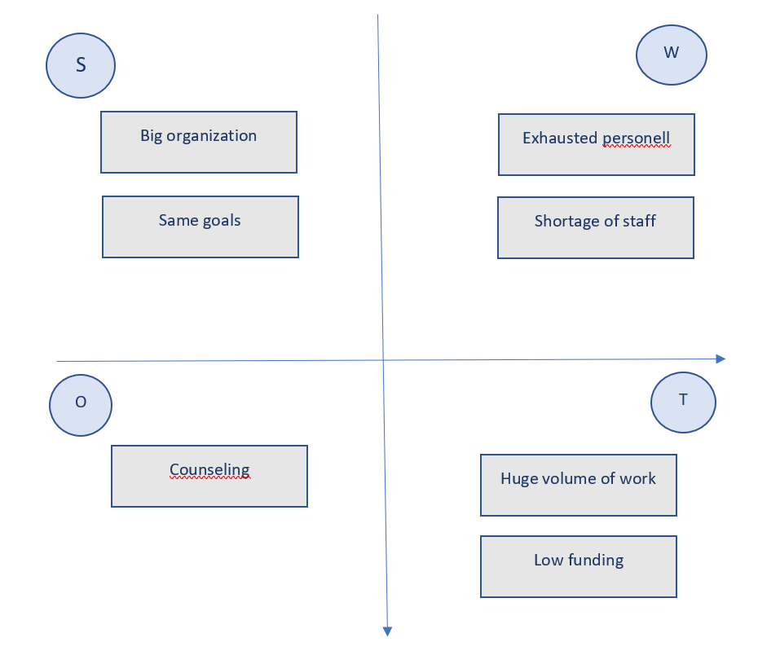
Diagram created by the student
Fishbone Analysis
For using this tool there are several steps to follow. Identifying the problem, who is involved and when it occurs. In our case the issue is the mental stress that NHS staff is facing in all NHS branches. Secondly, identify the major factors that are involved in this issue: equipment, people, time. For each and every factor identify the possible causes. After analysing every factor some conclusions can be drawn.
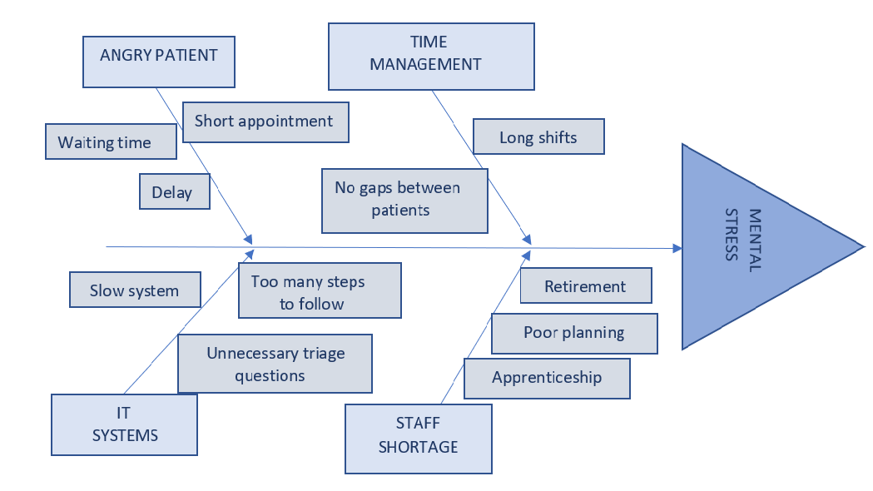
Diagram created by the student

Impact of problem on service users, professionals and regulators
Impact of mental stress in NHS organization affects the major individual groups which are described as below and how this problem is creating difficulty on service users, professionals and regulators.
Service Users – The impact of mental stress on customers is that if NHS fails to provide services to the customers then their mental peace is hampered which then affects their mental health at large. The customers are the one’s using the services of NHS but if they are not provided the services on effective and efficient terms then their mental health will be disturbed and this will be major problem for organization on large scale.
Professionals – The professionals which include the employees, managers of NHS when face the mental health issue affects their performance, and they might find it difficult to deliver their best among other organizations and serve their duties and responsibilities well. Mental stress affects the employees and managers professional lives and they are unable to perform effectively and efficiently on scales (Holman and et.al., 2018). Mental stress has caused the employees and the managers of NHS to decide and take perform on scales of being better while working in the organization and contributing their best on all scales.
Regulators – The regulators include the government bodies which are affected and are impacted by the mental health problems. There are created at the NHS organization and due to the mental stress the government is taking actions on how to improve the methods and create new practices along with formulating rules and regulations which helps the organization in positively concerning the mental health of the organization (Hiremath and et.al., 2020). Government bodies by implementing new rules will help in changing the patterns and through this the major aspect will be how the organization and the employees will help in progressing towards how the mental stress at the workplace can be reduced or can come to zero.
Legislation – The National Health Service Act 2006 (the 2006 Act) has consolidated all the previous legislations to provide the organization the facilities from the Act and provides the other organizations effective and efficient role in the healthcare industry. Health and Social Care 2012 sets out the important features of the legislation which are amended by the NHS foundation trust and this helps in allocating the governance arrangements for NHS trusts (Alderwick and et.al., 2021). NHS has been the part of the policies and legislations on large scale as the healthcare factor is being considered at priority for the UK.
Code of Conduct – The code of conduct at NHS includes integrity, honesty, impartiality, objectivity etc. Staff of NHS’s prime work is not to mislead the staff members, public, the Board, ministers etc (Lewis, 2019). Therefore, the code of conduct is framed for the analysis which is to be done for the benefit of healthcare facilities which NHS is providing to the general public and the patients at large scale.

Analyzing decision-making process by relevant legislation
Decision-making process which NHS took concerns the major aspects of how the mental health problems are solved and through this the main point which is considered is to improve the mental stress which NHS is facing. Therefore, various decisions are taken on the context of how this issue and problem can be solved so that the performance and capabilities of the employees are not affected. And for this, legislation practices are being taken into consideration which helps in improving the ways through which all the mental health problems can be solved and that the organization seeks growth and development effectively and in significant manner (Kiseleva, 2020). The legislation follows the rules and regulations which help in improving and enhancing the systems and the processes which the NHS should change so that there are no difficulties in taking actions towards improvising the work culture which NHS has created for employees. The Human Right Act take under the basic right of the people. The people are protected from the degrading treatment, given fair and equal opportunity to be treated at the healthcare under this act. The act also respects the privacy of the patient and the workers details of family, home and correspondence.
Relevant legislation that is in healthcare industry constitutes federal laws which concerns the healthcare benefits and local laws which are also considered as how NHS is taking major ways to cure the mental health and taking actions towards improving the measures of mental health so that the organization is concerned about initiating new ways and techniques on large scale. Mental health is considered as important aspect for the organization (Burki, 2018). The patient when entered the NHS organization then they are directly volunteered for being present at the healthcare, but in special cases the patient can be detained from the volunteering and can be treated without this agreement under the Mental Health Act (1983). The Equality Act help in providing the patients and the workers at the healthcare equal right for their treatment and working respectively. They are not discriminated on the basis of sex, colour, caste, disability and maternity.

Range of alternative solutions to the problem
The mental health of the employees, workers and users is highly effected by the large volume of patients in the healthcare due to the pandemic. The workers are struggling to deal with huge amount of patients on the daily basis, handling so many works and pressure is deteriorating the health as well as the effectiveness of the service they are providing. The NHS organization carry out some programs for dealing with the stress. A team can be made or hired that will be checking the mental health of the patients, professional and workers during the work. The team can understand the level of stress everyone is under. The team can analyse the particular causes of the stress, they can ask individuals for their feedback on what is making them stress the most while working and then develop strategies that will be addressing the causes as well as challenges. The strategies can include the coping techniques for people to overcome the stress.
The team can take sessions where they will be dealing with the people at the health care by practising the relaxation techniques. The team can make schedules for the worker about when they should take break from the work and relax for a bit. The team can educate the people at the health care about the trigger that might be spiking the stress and how they can reduce the effect. The patients and worker are provided with the daily exercise sessions for reducing the stress. The communication can be improved within the NHS organization as the group of people and friends can also reduce the level of stress. If any of the patient or worker is having a bad habit (smoking, alcohol and caffeine) they can reduce and certainly quit the habit for improving the stress levels.
The workers can also join the community work or volunteering for relieving the stress because when the people help other people in coping up their challenges of life they tend to consider their life problems to be small and this help in reducing the stress. The team at the organization can also help in the making the worker do the smart work rather than doing the hard work and help them concentrate on the work that is making a difference. They can also help the people at the healthcare to be positive and graceful.

It is recommended or alternative solutions are provided that -
- PESTLE analysis should be taken into concern for help in finding the key roles the NHS will play in accordance with keeping all the points into action and analyzing the various aspects of how the healthcare industry is been working with these different factors being considered (Connelly and et.al., 2018).
- Along with this, SWOT analysis should be framed for the NHS healthcare so that the strengths, weaknesses, opportunity and threats are being considered at large scale.
- PMI model should be analysed and evaluated effectively and efficiently for NHS healthcare which includes conception, planning, initiation, execution, monitoring and project close.

Decision-making technique for evaluating a range of solutions and for identify the most appropriate option
The organization can use the dimensions of help for quality assessment for the mental health solutions. The dimensions of the help in evaluating the range of solutions that are: the service needs to be suitable, the service need to be accessible to the patients and workers, the people need to accept the service, the ability of the healthcare providers to provide the services, the efficiency of the service by the professionals, the continuity of the service and safety of the patients as well as the healthcare professionals.
The solutions provided for the NHS organization are thus evaluated for the implementation. The team will be assessing the workers for their mental health, the team will be processing all the activities that are required for the maintenance of the better health at the organization. The suitability of the activities can be checked effectively by performing the activities in the organization and checking the efficiency of the activities for the health of the people. Implementing the activities for a particular time period will provide the organization with the report that will indicate the effectiveness, workers responsibilities, efficiency and duties (Guo, 2020). Practices that can be implemented in the healthcare are:
Patient education- the patient can be educated for the mental health challenges they may face and how they can reduce impact of stress. They can communicate to the providers at the organization for further queries. The health concepts need to be taught to the patients. The key topics need to be identified by the professionals and educate them to the patients.
Understanding the cultural as well as personal preferences of patient- the cultural preferences of the patient impact the care choices they make at the healthcare. These patients interact very less in the decision-making process and the providers at the health care need to understand this for providing the best care service for the mitigation of the challenges. The patient makes the choices in the care according to the life circumstances and the provider need to understand that along with the preferences. This will help in gaining the better results at the workplace.
Engaging the family as well as caregivers- it is a fact that people are less stressed when they talk with the family, friends or to whom they are comfortable sharing their views (Hill and et.al, 2017). Thus, when the family is involved with the patient for providing them the best care then the results come out to be better.

Solution implementation and communication to stakeholders
The solution for the mental health of the professionals and users can be implemented in different ways as well as the government bodies are communicated in ways. The implementation can be done by sharing the decisions to the people who are getting benefited from it. This will not only give better mental health results but also improve the efficiency of working at the healthcare.
For the education of key points of mental health to the employees, it is important to make them participate effectively in the discussion and the sessions that will be provided for the giving the information. The clinicians at the NHS organization need to explain the users with the concepts of the health that are easily understandable for the users for the effectiveness. The professional can also ask the patients to repeat the information in their own way; this will help in giving the professionals an idea about how the concepts are being understandable by the user. The patient will also get and aid for their challenges.
The mental health can be made better by understanding the culture as well as the personal preferences. The professional needs to have understanding of preferences of the client for the better care. The patients with the cultural differences make the primary decisions according to them and the secondary preferences are given to professionals in healthcare. The professional in this case can reframe the treatment idea according to believe of the user for making the treatment more effective. The professional needs to identify the motivating factor for the user to get the stress relieved rather than just assuming. It is necessary to understand the causes that are creating the stress to the users.
The implementing of the plans for the users is effective when the family is involved in the care. The plan includes the communication of the user with the family or friends for getting positive results in the mental health. The solution is to keep the patient-centered care for having best results. The workers at the organisation need to make the friendly environment for the users to talk about the mental health. The information can be communicated to the users by their respective professionals, to the professional by the head authorities and to the government by making reports.

Appropriate monitoring and review techniques for successful implementation of the solution
The monitoring and evaluation techniques help in covering all the activities that are contributing in the strengthening of the healthcare systems. The technique in the NHS organisation understands the priorities, needs and risks that are associated with the activities that are implemented. New strategies are applied on the basis of the final review of the performance as well as progress of the previous strategies. The developments in the health strategies process is evidence base and serve the initial situation analysis through the final evaluation. The situational analysis in the organisation includes the detailed analysis of the gender, political, institutional, social and cultural factors.
The result of the analysis is useful for the planner as well as the policy makers. The monitoring and evaluation component of the NHS organisation is developed that is transparent as well as systematic for the consultation with the stakeholders, civil society of organisation, different level of government and international partners. Planned assessment of the monitoring and evaluation are regularly done for ensuring the indicators are measuring the information that they need to, data generated are of the particular standards and the data analysis as well as the communication is given the information they are expected to give (Wake and Green, 2019). The technique ensures that the indicator used in the plan is fit for the process and are relevant with the needs of the users. The assessment of the analysis is required to be done in every one to two years and the report is required to be made public and discussed.

CONCLUSION
It can be concluded from the report that the healthcare is faced by many challenges in the workplace for giving out the best care to the users. The problem discussed in the report is about the mental health of the workers that is caused by the excessive stress and tension of the users at the healthcare. The degrading mental health has adverse impact on the performance of the users. The impact of the performance on the professional, regulators and professionals are given. Various recommendations which were provided like the following and framing of the PESTLE, SWOT analysis, PMI model. Furthermore, the Fishbone analysis and PESTLE analysis were explained for defining the problem and its statement.
Mental Health Act, Equality Act and Human Right Act are used for the analysis of the decision making process. Different types of solutions are provided for the problem. Decision making technique involves the education of the patient, understanding the cultural and personal preferences and engagement of the family for the care. Implementation of the plan is provided along with that the monitoring and evaluation is provided.

REFERENCES

Alderwick, H. and et.al., 2021. Will a new NHS structure in England help recovery from the pandemic? Bmj.372.
Baker, P. and et.al., 2019. The language of patient feedback: A corpus linguistic study of online health communication. Routledge.
Burki, 2018. Increase in detentions in the UK under the Mental Health Act. The Lancet Psychiatry. 5(11), p.878.
Connelly, J. and et.al., 2018. Making sense of public health medicine. CRC Press.
Guo, 2020. DECIDE: a decision-making model for more effective decision making by health care managers. The health care manager. 39(3).pp.133-141.
Hill and et.al, 2017.Navigating the challenges of digital health innovation: considerations and solutions in developing online and smartphone-application-based interventions for mental health disorders. The British Journal of Psychiatry. 211(2).pp.65-69.
Hiremath, P. and et.al.,2020. COVID 19: Impact of lock-down on mental health and tips to overcome.
Holman, D. and et.al.,2018. Stress management interventions: Improving subjective psychological well-being in the workplace. In Handbook of well-being.DEF Publishers.
Kiseleva, A., 2020. AI as a Medical Device: Is It Enough to Ensure Performance Transparency and Accountability in Healthcare?. European Pharmaceutical Law Review.(1).
Lewis, C., 2019. Realising the digital ambitions of the NHS. Practice Management.29(4).pp.20-22.
Maulik, P.K., 2017. Workplace stress: A neglected aspect of mental health wellbeing. 146(4).p.441.
MORADI, M. and et.al.,2019. Effect of Favoritism on Mental Health: Mediating Roles of Oral Negativism, Stress, and Willingness to Leave Jobs among Employees.
Talebi, N., 2020. The Effectiveness of Aerobic Exercise Interventions and Stress Coping skills Training on the Reduction of Job Stress among Employees of the Organization.
Thakur, V., 2021. Framework for PESTLE dimensions of sustainable healthcare waste management: Learnings from COVID-19 outbreak. 287.p.125562.
Wake and Green, 2019. Relationship between employee engagement scores and service quality ratings: analysis of the National Health Service staff survey across 97 acute NHS Trusts in England and concurrent Care Quality Commission outcomes (2012–2016). BMJ open. 9(7).p.e026472.

