

Student name: Amir Nahif
Student ID: 2234671

Module name: Empowering the Older Person
Module code: GMHP6027
Lecturer’s name: Dr. Laila Surani

Empowering Older Adults: Evaluating Care and Support Needs
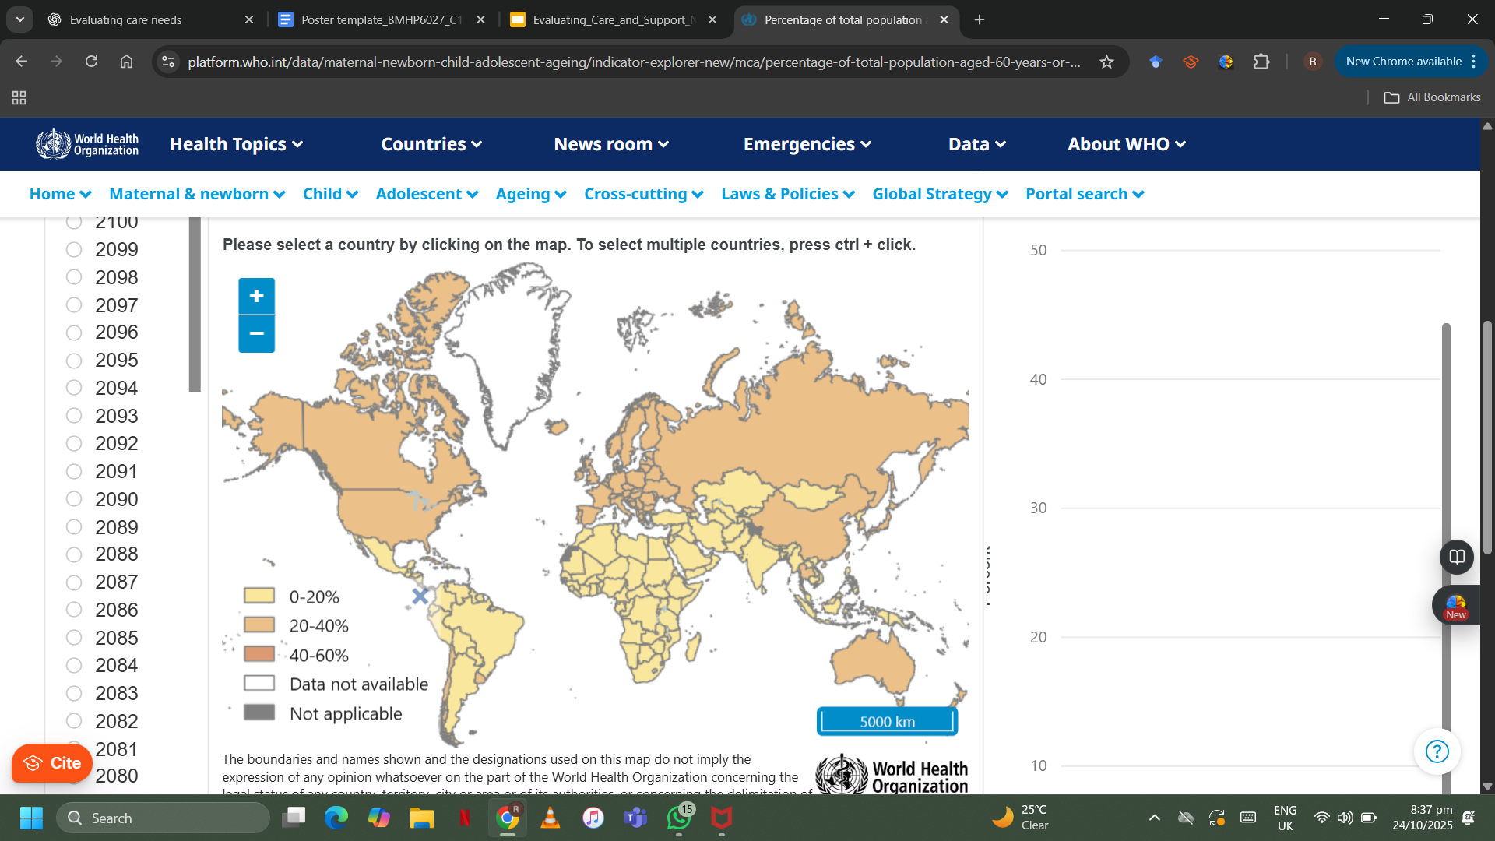  Percentage of total population aged 60 years or over (WHO, 2025) |  | Effectiveness and Benefit of Approaches and Interventions  - The UK has developed several frameworks to promote independence and empowerment among older adults.  - The Care Act (2014) highlights:  - Person-centred care  - Prevention and early intervention  - Promotion of overall well-being  - The NHS Long Term Plan (2019) focuses on:  - Community-based support  - Integrated health and social care services  - Reducing hospital dependency through localised care  - Evidence-based interventions improving independence include:  - Reablement services – short-term, intensive support helping individuals regain daily living skills and autonomy  - Assistive technologies – mobility aids, smart home systems, and digital tools enhancing safety and independence  - Theoretical frameworks supporting current practices:  - Maslow’s Hierarchy of Needs (1943):  - Older adults need basic physiological and safety needs met before achieving belonging, esteem, and self-actualisation.  - Person-Centred Theory (Rogers, 1951):  - Emphasises empathy, respect, and collaboration.  - Encourages involving older adults in decisions about their care.  - These frameworks underpin UK policies and interventions that promote dignity, inclusion, empowerment, and well-being in older adulthood. |  | 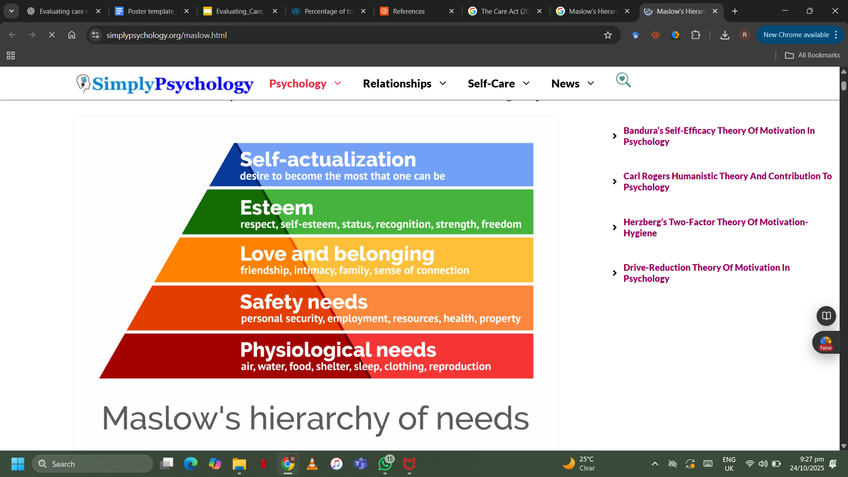  Maslow’s Hierarchy of Needs (1943)
Introduction  - Older adults are one of the fastest-growing populations worldwide.  - WHO (2023): by 2050, one in six people will be over age 65.  - Maintaining independence, autonomy, and functional ability is key to well-being.  - Care and support needs involve both physical and psychosocial aspects:  - Access to health services  - Social inclusion  - Empowerment through person-centred care  - Ageing brings biological, psychological, and social changes.  - Due to better healthcare and life expectancy, the global 60+ population is rapidly increasing.  - In the UK, over 18% of the population is aged 65 or older (ONS, 2023).  - Key challenges include:  - Chronic illnesses and mobility issues  - Loneliness and social isolation  - Limited access to support services  - Effective care should promote holistic well-being, balancing independence with necessary assistance.  - Empowerment means supporting older adults to:  - Make informed choices  - Participate in decisions  - Stay active and engaged in their communities  - The WHO Healthy Ageing model promotes intrinsic capacity and age-friendly environments that ensure autonomy, dignity, and participation. |  |  |  | Challenges in Maintaining Independence and Functional Ability  - Older adults face multiple, overlapping challenges that affect their independence and autonomy.  - Physical challenges include:  - Reduced mobility and balance  - Sensory impairments (hearing or vision loss)  - Chronic illnesses limiting daily activities  - Cognitive changes, such as dementia, further reduce independence and increase need for structured support.  - Social factors play a major role in older adults’ well-being:  - Loneliness and social isolation are widespread, especially among those living alone or in care institutions.  - Age UK (2022): Around 1.4 million older adults in the UK report feeling lonely often.  - Economic insecurity, lack of transportation, and digital exclusion worsen dependency and reduce quality of life.  - Ageism and negative societal attitudes can:  - Undermine self-worth and confidence  - Exclude older adults from decision-making  - Reduce opportunities for participation and inclusion  - These issues highlight the importance of empowerment-based care that:  - Respects individual dignity and autonomy  - Encourages active participation in personal and community life  Recommendations and Conclusion  - Expand community-based care: Connect older adults with local activities and health services.  - Improve digital literacy: Teach basic tech skills to reduce isolation.  - Challenge ageism: Promote awareness and positive attitudes toward ageing.  - Include mental health support: Address depression and anxiety alongside physical care.  - Support carers: Offer training and respite for sustainable caregiving.  Conclusion:  Empowerment means valuing older adults’ autonomy, dignity, and choice.  Through person-centred, holistic care, aging can be seen not as decline, but as a stage of growth, connection, and continued purpose.

References
Age UK (2022). All the Lonely People: Loneliness in Later Life. Accessed 24th Oct, 2025
Barnes, D., Boland, B., Linhart, K., & Wilson, K. (2017). Personalisation and social care assessment – the Care Act 2014. BJPsych Bulletin, 41(3), 176–180. https://doi.org/10.1192/pb.bp.116.053660. Accessed 24th Oct, 2025
Glendinning, C. (2003). Breaking down barriers: integrating health and care services for older people in England. Health Policy, 65(2), 139–151. https://doi.org/10.1016/s0168-8510(02)00205-1. Accessed 24th Oct, 2025
Lee, E. (2021). Care Act 2014 Principles. https://cpdonline.co.uk/knowledge-base/care/care-act-2014-principles/. Accessed 24th Oct, 2025
Maslow, A. (1943). A Theory of Human Motivation. Psychological Review. Accessed 24th Oct, 2025
NHS (2019). The NHS Long Term Plan. Accessed 24th Oct, 2025
Office for National Statistics (2023). UK Population Estimates for Older People. Accessed 24th Oct, 2025
Overview of integrated care systems and relevant guidance - National Care Forum. (2022). National Care Forum. https://www.nationalcareforum.org.uk/integrated-care-systems/ics-explained/overview-of-integrated-care-systems-and-relevant-guidance/. Accessed 24th Oct, 2025
Rogers, C. (1951). Client-Centered Therapy. Houghton Mifflin. Accessed 24th Oct, 2025
Selman, L. E., Daveson, B. A., Smith, M., Johnston, B., Ryan, K., Morrison, R. S., Pannell, C., McQuillan, R., De Wolf-Linder, S., Pantilat, S. Z., Klass, L., Meier, D., Normand, C., & Higginson, I. J. (2016). How empowering is hospital care for older people with advanced disease? Barriers and facilitators from a cross-national ethnography in England, Ireland and the USA. Age And Ageing. https://doi.org/10.1093/ageing/afw193. Accessed 24th Oct, 2025
Walker, A. (2005). Older people and health services: the challenge of empowerment (pp. 169–189). https://doi.org/10.4324/9780203980866-13. Accessed 24th Oct, 2025
WHO. (2025). https://platform.who.int/data/maternal-newborn-child-adolescent-ageing/indicator-explorer-new/mca/percentage-of-total-population-aged-60-years-or-over. Accessed 24th Oct, 2025
World Health Organization (2023). Decade of Healthy Ageing: 2021–2030. Accessed 24th Oct, 2025

