  References.
  Ashburner, J., Ziviani, J., & Rodger, S. (2008). Sensory processing and classroom emotional, behavioral, and educational outcomes in children with autism spectrum disorder. American Journal of Occupational Therapy, 62(5), 564-573.
  Ashburner, J., Ziviani, J., & Rodger, S. (2010). Surviving in the mainstream: Capacity of children with autism spectrum disorders to perform academically and regulate their emotions and behavior at school. Research in Autism Spectrum Disorders, 4(1), 18-27.
  Humphrey, N., & Lewis, S. (2008). Make me normal' The views and experiences of pupils on the autistic spectrum in mainstream secondary schools. Autism, 12(1), 23-46.
  Kanakri, S. M., Shepley, M., Varni, J. W., & Tassinary, L. G. (2017). Noise and autism spectrum disorder in children: An exploratory survey. Research in developmental disabilities, 63, 85-94.
  Williams, E. I., Gleeson, K., & Jones, B. E. (2019). How pupils on the autism spectrum make sense of themselves in the context of their experiences in a mainstream school setting: A qualitative metasynthesis. Autism, 23(1), 8-28.
  Jones, E. K., Hanley, M., & Riby, D. M. (2020). Distraction, distress and diversity: Exploring the impact of sensory processing differences on learning and school life for pupils with autism spectrum disorders. Research in Autism Spectrum Disorders, 72, 101515.
  Kanakri, S. M., Shepley, M., Tassinary, L. G., Varni, J. W., & Fawaz, H. M. (2017). An observational study of classroom acoustical design and repetitive behaviors in children with autism. Environment and Behavior, 49(8), 847-873.
  Need to reference the NHS website!! Autism.
  CHILDREN WITH AUTISM
  The Impact Autism has on School Life and Well-being.
  

What is Autism?   Autism is a spectrum where symptoms can vary considerably and everyone with Autism is completely different.  Children with Autism may have difficulty in social interactions with others which include back-and-forth conversations, have no shared interests and have difficulty in understanding other people’s emotions.  Some children with Autism are verbal and are able to speak and hold a conversation and some are non-verbal. Also, eye contact with others can be difficult along with difficulties in understanding gestures and facial expressions. They also may show lack of facial expression.  Children may have difficulty in developing and maintaining relationships were by the child has trouble playing imaginatively with other children and also have absence of interest in peers. (DSM-5, 2013). |  |  | Understanding Autism
   | Autism is a LIFELONG, DEVELOPMENTAL disability that can affect the way in which a person can communicate with others. (NHS, 2020).
    
   | Children may find bright lights and loud noises OVERWHELMING, STESSFUL and UNCOMFORTABLE. Social events may cause distress and restlessness. (NHS, 2020).
    
   | Autistic children, like everyone else have things they are very GOOD at as well as things they STRUGGLE with. (NHS, 2020).
    
 |  |  | 5
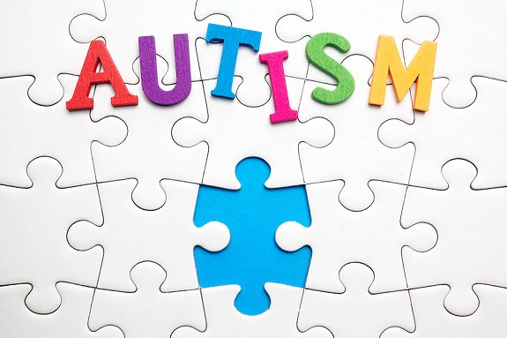
63% of children with Autism are not in the school that their parents believe would support them. (Reid, et al. 2011)
There are approximately 700,000 people on the Autistic spectrum in the UK. (National Autistic Society, 2011).
ASD begins in childhood and persists into adolescence and adulthood. (WHO, 2020).
Individuals with ASD often have other conditions in correlation with Autism, such as depression, epilepsy, anxiety and ADHD. (WHO, 2020).
In a child’s first 5 years of his/her life, conditions are apparent. (WHO, 2020).
World Autism Day, 2nd of April. (United Nations).
One in 160 children has Autism (ASD). (WHO, 2020).
School – The impact that Autism has on school life.    - Children with ASD have difficulty in processing verbal instructions and may become distressed in a loud and noisy environment, such as a classroom, and therefore may underachieve academically. (Ashburner, et al, 2008).  - The ability to maintain their attention to a specific task is a struggle and also have difficulty in their ability to regulate their behaviors and emotions in mainstream school setting. (Ashburner, et al, 2010).  - When asked about their diagnosis of ASD some children have responded with very negative comments about themselves and they show desire to fit in in the school environment. (Humphrey & Lewis, 2008).  - Some children identify themselves as ‘different’ and more research is needed to increase their level of self-esteem and well-being. (Williams et al, 2017).  This is the Quote style. It’s great for calling out a few very important points. |  |  | Hitting, ear covering, repetitive speech, loud vocalizations, blinking and complaining of increased noise levels are some of the behaviors a child with ASD may portray when distressed in a school environment.
   | Children with ASD are 20 times more likely to be excluded from their school than those who do not require special additional needs. They are also very vulnerable to being bullied in school. (Humphrey, 2008).
    
   | Classrooms can be very noisy environments for ASD children and can make them very distressed and therefore to help the level, children are recommended to wear ear defenders in times of need. (Kanakri, et al, 2017).
    
  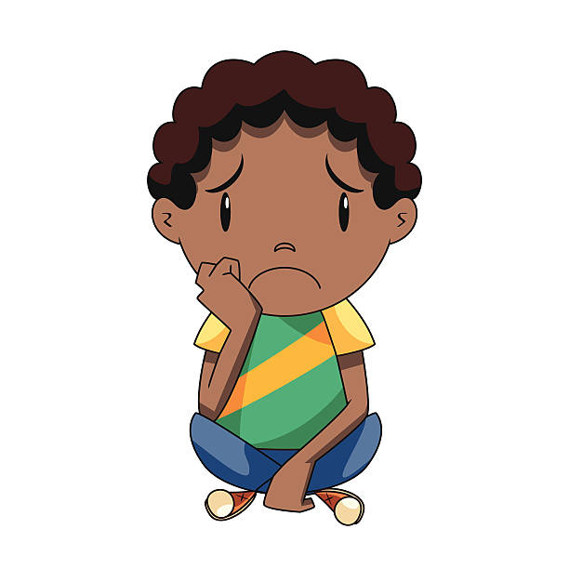
  Add your text here.
4 |  |  | 1

Home Life – How do children cope
Please scan the QR Codes below to watch and
listen to the videos that are linked for your leisure
and to support the information within this booklet.

Autism Sensory Sensitivity Video.

What is Autism?

with home life whilst living with
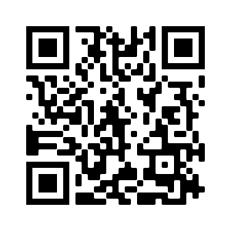
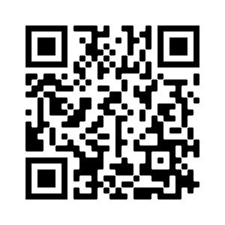
Autism.
ASD children are very sensory and find different textures of foods repulsive which can lead to refusing to eat at mealtimes (Schaff et al, 2011).
Routine is often recognised as an important and imperative part of a childs day to day living and following routine in a home setting is commonly prefered (Schaff et al, 2011).
Children require a variety of sensory objects, toys and activities to promote therapy and encourage calmness in their home environment (National Autistic Society, 2015)
Morning routines at home can be the most challenging part for many children with ASD due to sensory overload which can cause lateness to school (Schaff et al, 2011).
3
2

