
Skills for the Workplace
Module Assignment Submission
Student Name: | Amy Jones
Student Number: | 1918312
Module No: | BMSK4003
Module Title: | Digital Skills and Research Methods

Statement of Confirmation of Authenticity
By the act of making this submission, the student declares that this is the work of the student named above. The work has not, in whole or in part, been knowingly presented elsewhere for assessment, or where assessment has been built on a previous assessment, this has been identified. Where materials have been used from other sources it has been properly acknowledged. If this statement is untrue, the student acknowledges that an assessment offence has been committed.
Attention is drawn to the plagiarism and unfair practice policies of both the University and of ILM.
Permission for ILM to use this script
ILM uses learners’ submissions – on an anonymous basis – for assessment standardisation. By submitting, both the centre and the learner agree that ILM may use this script on condition that identifying information is removed. However, if you are unwilling to allow ILM use this script, please refuse by ticking the box: □

Table of Contents
What has been the impact of 21st Century Technologies on the modern workplace? 3
Research the use of modern technologies and social media in the workplace generally 3
Explore the use of modern technologies and social media in own workplace 6
LinkedIn Profile 9
9
Research LinkedIn and other social media platforms to enhance networking and career prospects 10
Appendix 1 15
Appendix 2 16

What has been the impact of 21st Century Technologies on the modern workplace?

Research the use of modern technologies and social media in the workplace generally

Each job and its many components involve learning and understanding in order to complete its responsibilities on a daily basis. In the past five years, there has been an influx in technology both in the workplace and in everyday activities. E-mail, the Internet, fax and other forms of technology have simplified office tasks and made it possible to accomplish more work more quickly. In spite of their seeming “necessity,” however, it is possible for most people to accomplish their workplace tasks without certain technological innovations.
Technology has changed the way we do things in the workplace because companies need to achieve better efficiency to deliver more products to the consumers. While technology helps to lower production costs which increase potential profits, technology has changed the way we do things in our personal lives as well because many jobs have been made more efficient through the implementation of technology and lots of tasks have been made to be less personal through the elimination of human involvement. Although these new technological advances offer a wide array of services and opportunities, they seem integrated by a single factor: increased efficiency and productivity. Companies have been quick to implement many of these technologies and publicize significant improvements in business performance. However, as the physical place of work loses significance and workers are encouraged to telecommute from their setting of choice; these physically isolated workers will without doubt experience a loss of face-to-face interpersonal skills and a weakening of associations in the office.
Howcroft and Taylor (2014) states that these innovations are creating a lot of interest in how work is perceived and is described as the ‘smart’ side however, these said innovations can also provide a large level of electronic monitoring and surveillance of employees both inside and outside of the workplace particularly when linked up with Human Resources which are designed to develop trust and committed relationship so therefore, can have a negative impact on work and employees which is the ‘dark’ side of technology.
Modern breakthroughs in technological advances have prepared the concept of the virtual office possible at home, on the road, and nearly everywhere in the planet. For a minimal budget, a home office can be equipped with the essentials: phone, fax machine, and personal computer with video conferencing capability.
With advances in technology, even student study habits have dramatically changed. It is affected the way classes are taught, students learn theories and the way information is presented.
Technology is changing the way kids learn in schools and at home. Students are now able to bring their work with them wherever they go because of laptop computers and handheld tablets, like the iPad. Having these electronic tools seems essential to all of us, including kids, nowadays and we wonder how we ever survived without them.
Not too long ago, students were lucky to have one computer in their classrooms and the teacher wrote the lessons on a chalkboard. Now it is much more common to see each student with their own laptop or iPad and the teachers writing on smart whiteboards that connect to these computers. With the way the world is becoming dependent on the use of technology in day-to-day life, it is good for the younger generation to learn a basic understanding of these tools, even though the software systems will most likely change by the time they enter the work force.
Students are also able to do more complex tasks earlier on because of the capabilities of technology. However, this does present the problem of becoming dependent on these devices to solve these challenges, especially those above their learning level.
Another growing topic, and cause for concern is the increasing use of social media in the workplace. The landscape for communication has changed, and the line between personal and professional communications has been blurred. While many employers were initially concerned that employees would use company time and equipment for socialising with friends, they are quickly learning that many social networks can also be used directly for work purposes.
In today's competitive workplace, emerging professionals should spend as much time using online tools for professional knowledge and development, as they do developing their social life and personal interests. Supervisors are learning that social media tools like Facebook, Twitter, Skype, blogs, wikis, text messaging or discussion groups can be used to engage other employees in discussions, and cultivate conversations between teams across geographic, and other boundaries. Speaking to business partners ashore and abound has never been easier and can be accomplished today with the click of a button.
Social media can also be a profitable sales and marketing tool. Through social media, business professionals now have the ability to advertise, promote, and publicise their products and services without ever having to leave their homes. There is no other low-cost promotional method out there that will easily give you large numbers of visitors, some of whom may come back to your website again and again. In fact, the benefits in most cases exceed the cost. It would take you thousands of pounds to buy several links; social media has the ability to give you that for free.
In retail customers/consumers are at the heart of the business, sales Managers and salespeople are in a never-ending quest to gain new customers, as well as retain their best ones. Organisational changes, technology adoptions and meetings by the dozen are all enacted around these very tasks. We live in a dynamic society that is rapidly changing each day.
The sales process is strikingly similar now to the process used before electronic media, or even reading and writing. Sellers move a product by meeting a need the buyer has. This need can be urgent, or at times whimsical. The seller must find the buyer’s motivation in order to make a sale. Whether the process the salesperson uses is strictly regimented and organised, or improvised in nature, there are still universal steps that everyone follows. A potential target market is identified. Once that market is identified, prospective clients are vetted for potential fit. Once the targets are set, information is exchanged between buyer and seller and after a series of interactions the buyer makes their decision. In many circumstances the buyer has made their mind up before their interaction with the salesperson. In some cases, the salesperson can exert a great deal of influence in helping the buyer make up their mind.
I believe modern technologies and social media play a big part in companies driven by sales. They are useful tools that can help find prospective customers and shorten the sales cycle. It can also help strengthen the relationships between buyer and seller and even organisations with each other. “With the proliferation of social media, it would seem that technology has the potential to dramatically influence a business or even an industry as technology did in the internet age” (A Review of Social Media and Implications for the Sales Process, Andzulis, J., Panagopoulos, N. G., & Rapp, A., Journal Of Personal Selling & Sales Management, 2012, p. 306).
As discussed earlier two of the most important activities for salespeople are finding new customers and retaining the ones they already have. With the arrival of social media and sites like Facebook, LinkedIn, and Twitter, salespeople can identify decision makers or technical users in target organisations more quickly than in the past. Those same salespeople can also learn in minutes what may have taken months regarding those buyer’s social interests, buying preferences, and opinions on competitor’s products. All of this information can be helpful in the relationship building process. “Social media can be used early in the sales process by researching the profile of the ideal target prospect” (Shih 2009).
Equipped with this information the seller can now begin to use social media to further entice those targeted customers to seek out more information regarding their offer. “To accelerate information exchange, salespeople can conduct a live question and answer session on their Facebook page with their customers and prospects. Some of the micro-blogging and social networking services are very useful to get the word out about new developments/posts for quick interaction with customers” (Agnihorti, Kothandaraman, Kashyap and Singh 2012).
This information exchange can strengthen the relationship between buyer and seller as well as build credibility for the salesperson. “Using social media to generate industry or customer specific content and making it accessible to buyers will send a signal to the buyer that a particular salesperson really cares about the buyer’s bottom line goals” (Agnihorti,Kothandaraman,Kashyap and Singh 2012).

Explore the use of modern technologies and social media in own workplace

In my own workplace I do not know where we would be without the use of social networks. Our main source of contact is through Whatsapp groups where we are all able to communicate in one place, we are able to all communicate business plans day to day, sales, tips, etc. It is therefore vital that we all have use of a smartphone in order to have Whatsapp. Another big part of our day to day business is the use of the iPad, this is where we store all of our customer information. Most things in the workplace have moved from paper to digital, this is because of the advancements in modern technology, it makes things easier for businesses.
In work on our make-up counter the company has now even started to change the way customers can see and try on the make-up, they have introduced QR codes for each different product. All the customer would need to do with their smart phone is hover their camera over the QR code which would then automatically bring up an Urban Decay application where you can see with your phone camera what the product would look like on you. You would even be able to try various colours in that particular product. Technology is becoming more and more advanced, completely changing how we shop and do day to day activities.
As well as the changes in technology, in the workplace there as also been changes with data protection policies, GDPR. In my workplace we are not allowed to post any photos of customers with make-up on we have done, during events if photos are taken and anyone is in the background then they have to sign a form. We are also not able to post about promotions going on in store, we cannot keep an appointment book storing names and numbers, and we cannot ring customers about sales and promotions on in store. We used to be able to do all these things, I believe it is important that people’s privacies are protected.
Considering the current pandemic as well we are very lucky to have such advanced technologies at hand, so we are able to work safely from home, using zoom, facetime, and using our sharing platforms such as email, whatsapp and messenger.
Social media is very important for business’s in our day and age because most of their customers spend their free time on social media. Social media is growing in terms of its reach and impact, and this statistic is here to show just that. 54% of social browsers use social media to research products (GlobalWebIndex, 2018).
The company I work for relays sorely on word of mouth and social media for advertisement of their brand. Urban Decay being a worldwide seller, social media plays a massive part in attracting and attaining their customers.
Instagram for instance, in 2014 Urban Decay had 4.1 million Instagram followers and now they have 11.2 million Instagram followers, a 37% increase. The company uses Instagram to reach their customers, they reveal new launches and post about existing products, along with tags where users can with one click purchase that product.

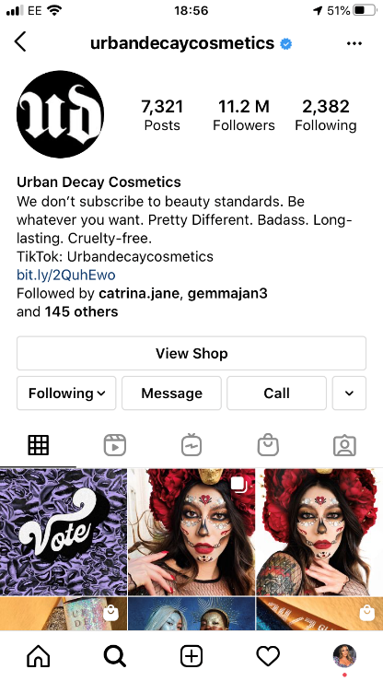
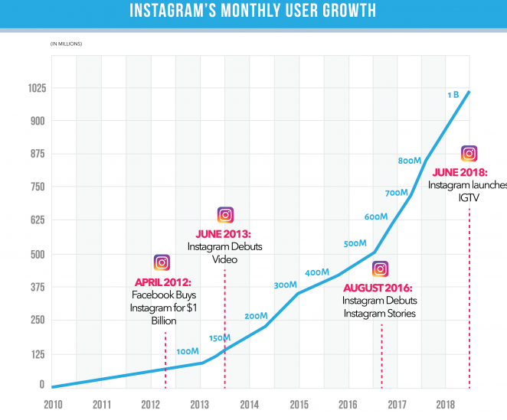

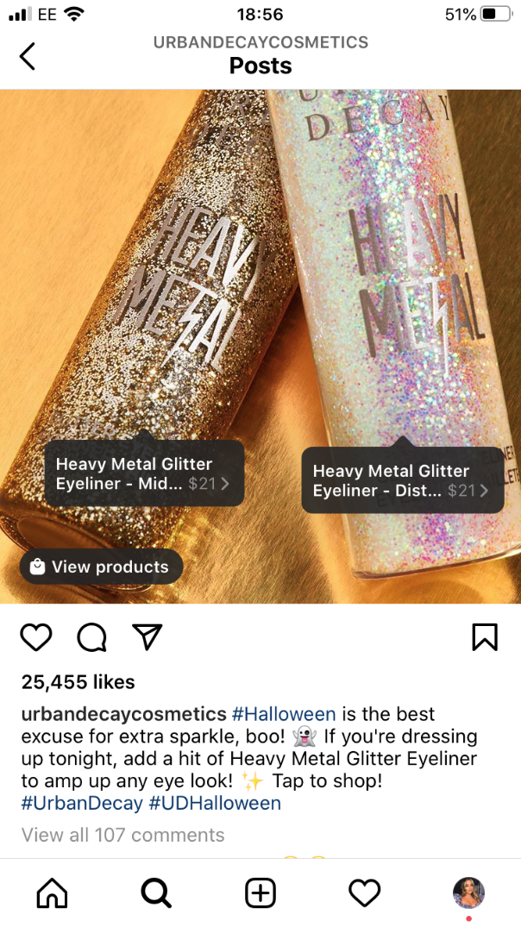


Without social media many brands would not be where they are today, many businesses are heavily reliant on social media and technology. In the above photo you can see with just a photo posted to Instagram you are able to click and be redirected to buy the product, which the customer would see on their feed by following the account, or even without following it can be found by the ‘#’s or it could just pop up on their discovery page because its similar to liked content.

LinkedIn Profile
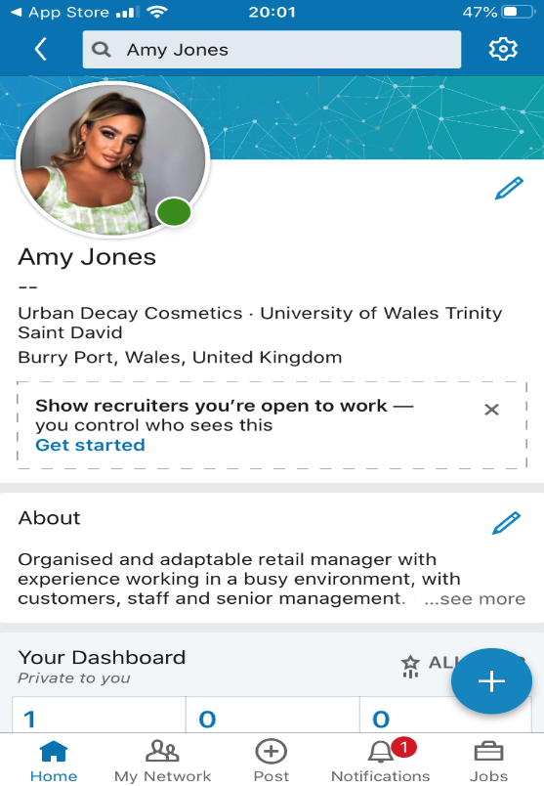

I have not been an active user of LinkedIn and many of my peers have never signed up for LinkedIn either, I believe activity on this platform has decreased with young people. Since
reactivating an account and looking into it I see how it is a necessary tool when it comes to looking for jobs. You are able to develop your profile to be desirable to businesses and companies in your desirable field, you can also find connections yourself rather than waiting for them to come to you. I am going to build on my LinkedIn profile as I think it is a great social networking profile.

Research LinkedIn and other social media platforms to enhance networking and career prospects

The exponential rise of social networking sites has impacted the lives of professionals one way or another. This is the most interesting thing about social networking that within a short span of time, it has become a necessity for every professional to stay connected to others while developing a sense of career enhancement and employability. Although, professionals are provided with several advantages with the rise of social networking but the potential negatives present significant challenges for individuals.
The term social networking can be used to describe ways through which an individual tends to interact with others. In today’s technological era, the term social networking has commonly been associated with online networking. Keeping this fact into consideration, only online social networking has been evaluated regardless of the impact of offline social networking and its impact on individual’s professional life. With exponential growth of social networking, it has been observed that several organisations have been presented with an opportunity to enhance the job satisfaction level of its employees. For instance, Google provided its employees with an opportunity to work from home, rather than waking up early in the morning and coming to the office. This significantly impacted the overall professional life of an individual.
By digging a bit deeper it was assessed that professionals tend to invest their time in online social networking primarily to improve them, while maintaining their professional identity in today’s competitive landscape. To maintain their professional identity, professional tends to prefer networks that can help them in career enhancement followed by updates on brand and current affairs. (Garibian, 2012)
Social networking has become a leading factor in young people finding employment, in most workplaces you cannot just hand in a CV anymore, everything is online. All jobs are advertised online on various platforms. Linked In is one of the main platforms for employers and those looking for a job.
- Helps you find and apply for jobs
Companies and business organisations big and small set up their LinkedIn pages in order to search for prospective employees for their business. Therefore, LinkedIn is the best place for people to apply for jobs. Instead of sending a resume to the companies, on LinkedIn you can just click a button and all of your information from your profile will be automatically sent to the page of the company.
- Allows companies to reach out to you themselves
Even if you have not applied for a job, employers will reach out to you if your profile matches the criteria the company is looking for. In order for this to happen it is important to make sure your LinkedIn profile is in good standing.
- Allows you to build a network with people all around the world
By making a good online profile and establishing yourself on the site it is possible to attract people from across the ocean and end up connecting with someone new that could have wider possibilities for employment.
- Gives a chance to showcase your qualifications and achievements
LinkedIn is a perfect platform to list down all your educational qualifications, internships undertaken, work experience (if any), activities participated in, projects undertaken, etc. which would create a good impression to the visitors of your profile. It is when the visitors go through your profile that they decide to contact you or send you an invitation to connect.
LinkedIn also allows you to stay up to date with the latest and updates in your industry as it provides you with news and blogs from the businesses and people you follow.
LinkedIn, though a social network, is built for a different purpose as compared to other social media platforms like Facebook, Instagram, Snapchat, etc. It is important to conduct yourself professionally on the platform. Keep in mind that your LinkedIn profile is like a digital/online resume. List down all your major achievements, internship and work experiences, projects undertaken, etc. Keep it short, crisp, and concise. Anyone who views your profile must find it easy to understand.
Connect with the right people. One should not go about inviting anyone and everyone on the platform to connect. Send an invitation and accept the invitation of only those who think might help you in your career and profession. Connect with groups and people who have similar career and professional interests as you. LinkedIn enables you to publish and share posts, writing/blogging about things that interest you could interest employers. Making sure it is related to your field of interest and also your connections.
LinkedIn, in spite of offering benefits also has its own cons. It is important to connect carefully and identify which accounts are authentic and which are not.
Instagram is becoming one of the best social media platforms to use when it comes to networking and promoting a business. I have many friends that are business owners, and their clientele has only increased from having a business page on Instagram and regularly posting content. Facebook as well is a very good app to use to promote business on a business page. Most people are on Facebook or Instagram or both, I have researched statistics which I will list below:
- Instagram is the second-most downloaded free app in the Apple app store
- 1 billion people use Instagram every month
- Instagram is the most popular traditional social network among U.S. teens
- The gender mix on Instagram is pretty even: 52% female and 48% male
- Instagram users will spend an average of 28 minutes per day on the platform in 2020
- 200 million Instagram users visit at least one business profile daily
- 62% of people say they have become more interested in a brand or product after seeing it in Stories
- 130 million Instagram users tap on shopping posts every month
- Instagram’s potential advertising reach is 849.3 million users

Conclusion
In conclusion 21st century technology and the Internet has changed the way we live possibly more than any other single invention since electricity. From the way we work, how we get our information or even interact, has changed. Our fundamental way of living has forever been altered. As a customer, before you even think about going into the shop for the new product you want, you would have already researched it or looked it up online. In every workplace it is almost a necessity you own a smartphone, or I can guarantee you would miss out on a lot of information. This day in age companies rely on technologies to stay relevant and to keep up to date with the consumer market.
I have been endorsed for various categories on my Linked Account where I have entered my college course which will hopefully open more doors for me and improve my opportunity to enhance and further my career opportunities. I am going to keep up to date with my business pages on Facebook and Instagram.

References

Howcroft, D., & Taylor, P. (2014). Plus, ca change, plus la meme chose? – Researching and theorising ‘new’ new technologies. New Technology, Work and Employment, 29, 1–8.10.1111/ntwe.2014.29.issue-1 [Accessed 22 Jan. 2020].
Marshall, G. W., Moncrief, W. C., Rudd, J. M., & Lee, N. (2012). Revolution in Sales: The Impact of Social Media and Related Technology on the Selling Environment. Journal of Personal Selling & Sales Management, 32(2), 349-363.
Rodriguez, M., Peterson, R. M., & Krishnan, V. (2012). Social Media 's Influence on Business-To-Business Sales Performance. Journal of Personal Selling & Sales Management, 32(2), 365-378.
Agnihotri, R., Kothandaraman, P., Kashyap, R., & Singh, R. (2012). Bringing "Social" into Sales: The Impact of Salespeople 's Social Media Use on Service Behaviours and Value Creation. Journal of Personal Selling & Sales Management, 32(2), 333-348.
Andzulis, J., Panagopoulos, N. G., & Rapp, A. (2012). A Review of Social Media and Implications for the Sales Process. Journal of Personal Selling & Sales Management, 32(2), 305-316.
Shih, Clara (2009) The Facebook Era: Tapping Online Social Networks to Build Better Products, R each New Audiences, and Sell More Stuff, Boston: Prentice Hall
Bullas, J. (2013). 12 awesome social media facts and statistics for 2013. Available from http://www.jeffbullas.com/2013/09/20/12-awesome-social-media-facts-and-statistics-for-2013/
Garibian, L
Moye, J. (2013). Hire Power: how social media is changing the way people search for job. Available from http://www.coca-colacompany.com/stories/hire-power-how-social-media-is-changing-the-way-people-search-for-jobs
https://blog.hootsuite.com/instagram-statistics/

Appendix 1

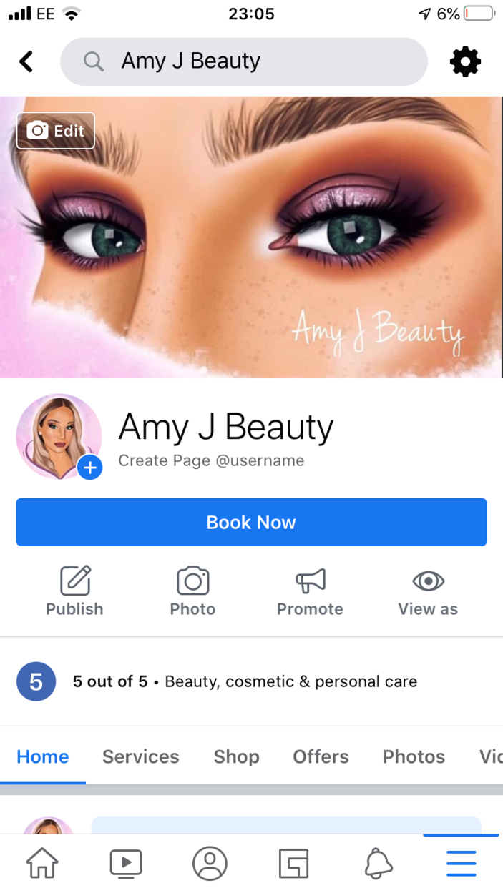

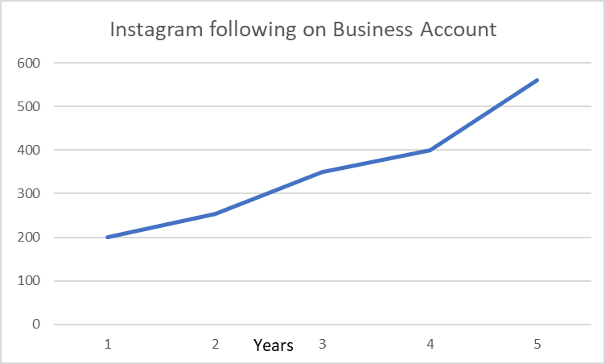
Appendix 2

