INTERCULTURAL COMPETENCE REPORT

Student Name
Catalina Gabriela Dumitru
Student ID number
2209716
MODULE
FOREIGN LANGUAGE & CULTURAL AWARENESS BMIH5003
Lecturer
LISA-MARIE BASSLER
Wordcount : 1096 words

Executive summary

- Introduction
- Content Culture, definitions, data to compare
Cultural intelligence and sensitivity
Globe project
Case study
- Conclusion
- Recommendations
- References

Chosen country is Colombia, “García Márquez deemed Colombians capable of both the noblest and the most abject acts imaginable, in a world where it seemed anyone might do anything, from the beautiful to the horrendous” (Miller, 2020, p. 3).

1 Introduction
Colombia stand for football, salsa, corrida not just for violence, narcotics and poverty. Very soon Diversity Hotel & Spa in Medelin will be open, with similar offer and activities as the hotel from London, but also very different. Why? Because it is located in another world, in many aspects different than London, England. Different people, different habitudes, different values, in one word, different culture. To be successful, should study the differences and similarities to understand how to proceed in detail. The aim of this report is a comparison of English and Colombian cultures, researches based on globeproject.com, also Hofstede and some personal findings, pointing several recommendations for most important aspects relieved in this case study
2 Culture, theory
To build a comparison have to point some key cultural aspects as follows:
- Language: In England, English is the primary language, and business operations are conducted in English. In Colombia, Spanish is the official language. While many Colombians in business may speak English, it's essential to have a good understanding of Spanish, especially for local interactions.
- Communication Styles: English culture tends to be more reserved and indirect in communication. Politeness, formalities and queuing are important. Colombian culture is generally more direct and expressive. People are often warm, friendly, and enjoy small talk. Personal relationships are highly valued.
- Punctuality: In England, punctuality is highly valued, and being on time is crucial for meetings and appointments. In Colombia, while punctuality is important for business meetings, it's more flexible, and people may not be as strict about time. Even at work.
- Hierarchy and Formality: English businesses tend to be more hierarchically structured, in England is a strong emphasis on professionalism and formality in business interactions. Colombian businesses may also have hierarchies, but there's a greater emphasis on personal relationships and informality in many interactions.
- Work-Life Balance: English workers typically value a good work-life balance, and it's common for employees to have set working hours and vacation time. In Colombia, work-life balance is also important, but working hours can be more flexible.
- Decision-Making: English business culture tends to be more bureaucratic, with decisions made through a structured process. In Colombia, decisions may be more influenced by personal relationships and connections.
- Dining and Socializing: In England, business meals are often more formal, with a focus on business discussions during the meal. In Colombia, business meals are social events where personal relationships are cultivated, and business discussions may not be the primary focus.
- Dress Code: In England, business clothing is typically formal, with uniforms, established suits and ties for employees. In Colombia, the dress code can be more relaxed, but it's essential to dress neatly and appropriately.
Highlighting and considering these cultural differences is vital for building fair and right relationships with colleagues, clients, and partners in Colombia. Consider providing cross-cultural training for your team and being open to adapting your business practices to align with the local culture, which can contribute to the success of your new subsidiary in Colombia.
Comparing English and Colombian cultures is an important step when is to open a new subsidiary in Colombia, as understanding the cultural differences can help you establish a successful and harmonious business operation. Started from Hofstede study, the comparison is not something new, see next image, directions to focus are the classical dimensions (Hofstede,2010)
Comparison Colombia - England
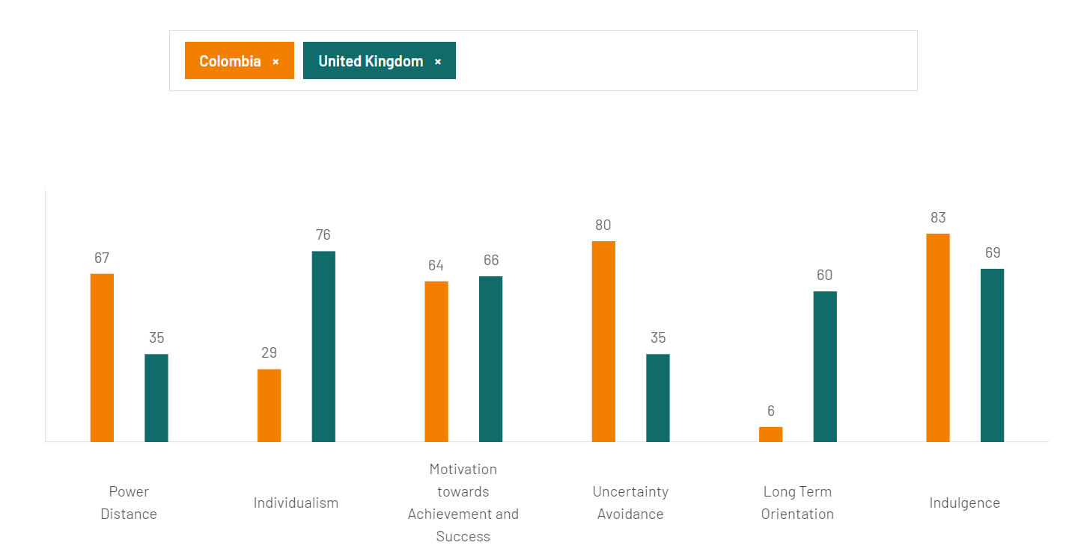
Https://www.hofstede-insights.com/country-comparison-tool?countries=colombia%2Cunited+kingdom
Geert Hofstede's cultural dimensions provide a base for comparing cultures based on data.
- Power Distance: England generally has a lower power distance score, this shows a preference for flatter organizational structures and equality in society, excepting royal class. Colombia having a higher score for power distance, could concise they have a better acceptance of superiors, of hierarchical structures, and also an unequal power distribution.
- Individualism vs. Collectivism: English culture leans toward individualism, valuing personal autonomy, and individual achievements. Colombian culture is more collectivist, this indicates a family orientation and the fact the relationships are more active in groups and society.
- Masculinity vs. Femininity: England typically exhibits a moderate masculinity score, emphasizing success, competition, and achievement in the workplace. Colombian culture tends to be more moderate in masculinity, balancing traditional masculine values with an emphasis on relationships.
- Uncertainty Avoidance: England’s score on uncertainty avoidance is lower, could say present a better tolerance for ambiguity and a more flexible attitude towards change. Colombia has a higher score, showing an acceptance for rules, and a more cautious approach to change.
- Long-Term Orientation: England tends to score lower on long-term orientation, emphasizing short-term goals, and a focus on the present. Colombia has a moderate long-term orientation score, indicating a balance between traditional values and adaptability to new.
- Indulgence vs. Restraint: England leans more toward indulgence, valuing personal freedom and the pursuit of happiness and enjoyment. Colombian culture tends to score lower on indulgence, emphasizing self-control and restraint in various aspects of life.
The basic cultural dimensions are general principles, should admit these are not universal valuable, individuals from a culture could be different. Additionally, the scores for a culture can change over time due to evolving societal norms and values. When considering opening a subsidiary in Colombia, understanding these cultural dimensions can help you navigate cultural differences and tailor your business strategies and operations to be more effective and culturally sensitive, “to be successful at working with culture, teachers and learners need to go beyond a superficial celebration of difference [..] in order to develop the skills and mindset needed to interact and communicate with people with different cultural backgrounds” (Fandiño, 2014, p. 90).
More data were collected from https://globeproject.com, data from 2004, where studies diversify fundamental 6 dimensions in 9 directions, more actual. Data from study as shown in next images are for England and Colombia exactly as figured on site (globeproject.com, last accessed nov ‘23)
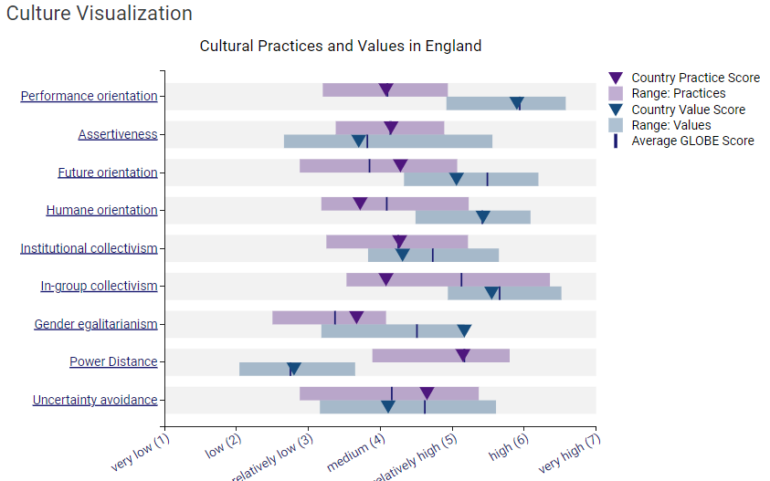
https:// /countries/GBR?menu=country#country
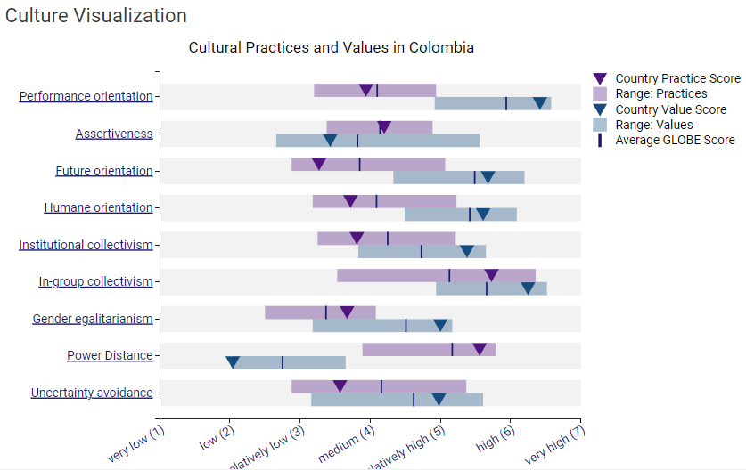
https://globeproject.com/results/countries/COL?menu=country#country

Another aspect is leadership directions, data presented from https://globeproject.com, study from 2004, as could be seen in next pictures, data for England and Colombia from site (globeproject.com, last accessed nov 2023)
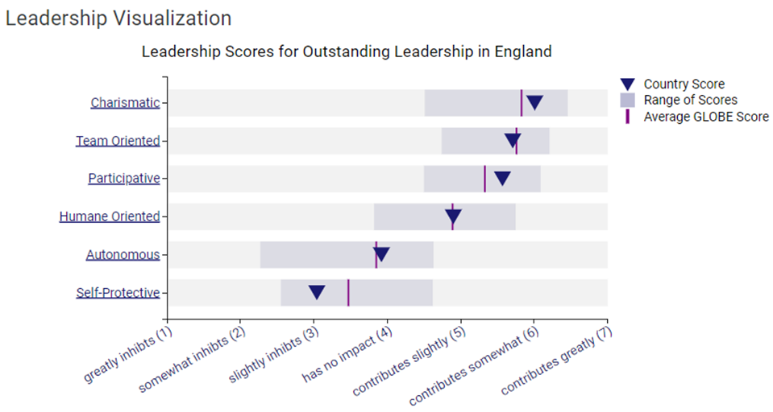
https://globeproject.com/results/countries/GBR?menu=country#country
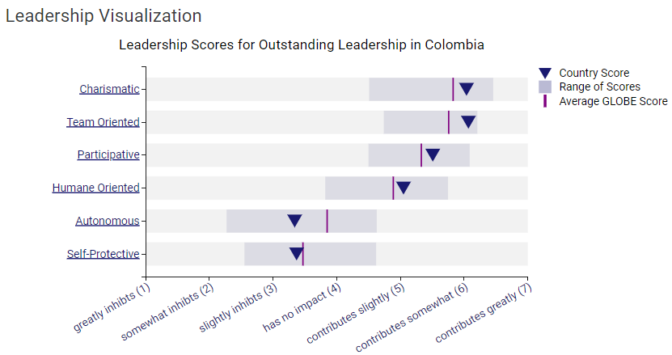
https://globeproject.com/results/countries/COL?menu=country#country
Comparing all the data, as shown in next chart, mostly the scores are similar for both countries, the differences was already highlighted in Hofstede dimensions.
Comparison chart England vs. Colombia on 9 dimensions ( globeproject, 2004):
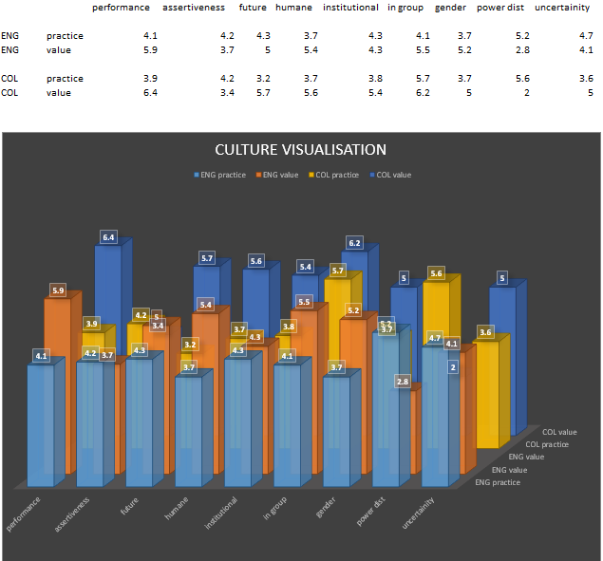

Here are some additional cultural insights into the differences between England and Colombia:
- Social Etiquette: In England, social interactions are often more reserved and formal. Politeness, queuing, and maintaining personal space are common social norms. In Colombia, social interactions tend to be warmer and more informal. People are generally more expressive, and personal space is smaller. Handshakes, hugs, and cheek-kissing are common greetings among friends and acquaintances.
- Food and Dining: In England, traditional English cuisine includes dishes like fish and chips, roast dinners, and afternoon tea. Punctuality and table manners are important during meals. In Colombia, food is a significant part of the culture, with staples like arepas, empanadas, and rice and beans. Colombian cuisine often involves sharing meals with family and friends, and food is a symbol of hospitality.
- Work Ethic: English workers typically value punctuality and professionalism. Work is often seen as a means to achieve a work-life balance. Colombian workers value hard work and dedication but may have a more flexible approach to work hours. Building personal relationships with colleagues and superiors is often emphasized.
- Religion: In England, the dominant religion is Christianity, with Anglicanism and other Christian denominations being prevalent. However, there is significant religious diversity. In Colombia, Roman Catholicism is the most widely practiced religion, and religious celebrations and traditions play a significant role in daily life.
- Festivals and Celebrations: In England, celebrated holidays include Christmas, Easter, and the Queen's birthday. There are also various local festivals and events. In Colombia, major celebrations include Carnival, Holy Week, and Independence Day. Festivals often feature music, dancing, and colourful parades.
- Sports and Hobbies: In England, sports like football (soccer), rugby, and cricket are popular. Hobbies might include gardening and watching television. In Colombia, football is the most popular sport, and people often enjoy dancing, especially salsa and cumbia. Outdoor activities such as hiking and cycling are also common.
- Social Hierarchies: In England, social hierarchies are often based on factors like education, occupation, and social class. In Colombia, social hierarchies can be influenced by factors like family background and personal connections.
- Family Values: In England, family values often emphasize individual independence, and young adults may leave home to live on their own. In Colombia, family is of paramount importance, and multiple generations often live together or in close proximity. Family support is crucial, both emotionally and financially.
These cultural insights should help to understand the nuances and differences between English and Colombian cultures, which can be valuable when establishing and operating a subsidiary in Colombia. Adaptation to local customs and values, along with open communication, can greatly contribute to the success of your business venture in a new cultural environment.
Conclusion
The study is not made to show differences between countries. This highlights the points that could create incidents and could affect the performance of business in new hotel. Informing whole team, the manager, the other detached employees from London, delegated to work in new hotel in Medelin, also supporting their preparation for the Colombian market, this could help ensure a successful establishment of your new subsidiary in Colombia and build positive relationships with local stakeholders. “Cultural values and traditions affect the attitudes and behaviours of rulers in many different ways. The values that the ruler, who was raised in a certain culture, adopts in essence, affect his attitudes and behaviours” ( Christiansen, 2020, p. 34).

Recommendations
Before the arrival in Colombia to train employees from the new subsidiary, it's crucial to prepare them with key information and recommendations. Here are some important things to know:
- Cultural Sensitivity and Adaptation: Encourage delegated employees to be culturally sensitive and open-minded. Advise them to embrace and adapt to the local culture, including communication styles, social customs, and business etiquette.
- Language: Recommend to all expatriates from England to learn some basic Spanish or hires a local interpreter/translator to assist with communication. While many Colombians may speak English, local language proficiency can be very helpful.
- Building Relationships: Emphasize the importance of building strong personal relationships with colleagues, partners, and clients. In Colombia, personal connections often play a significant role in business success.
- Punctuality: While punctuality is important, should admit schedules can be more flexible in Colombia. Should be prepared for potential delays and adjust their expectations accordingly.
- Hierarchy and Respect: Colombian business culture may have a more hierarchical structure. Employees show respect to superiors and build relationships with key decision-makers.
- Local Regulations and Laws: Be well-versed in Colombian business regulations, employment laws, tax requirements. Engage with local legal and financial experts to ensure compliance.
- Security and Safety: Be careful on safety concerns and precautions. While many areas in Colombia are safe, there are areas with high crime rates. Be aware of local safety advises.
- Networking and Local Business Organizations: Have to engage with local business organizations, chambers of commerce, and industry associations. These can be valuable for networking and staying informed about the local business landscape.
- Cross-Cultural Training: Offer or recommend cross-cultural training for all expatriate staff. This training can provide practical insights into working in a foreign culture and help them navigate cultural differences effectively.
- Understanding the Market: Ensure your manager has a deep understanding of the Colombian market, including local competitors, consumer behaviour, and market trends.
- Business Plan and Strategy: Should develop a robust business plan and strategy specific to local market; should contain market entry, target demographics, and marketing strategies.
- Local Partnerships: Consider establishing local partnerships and contacts in the new market.
- Flexibility: Advise everyone to be adaptable and patient. Challenges may arise, and it's essential to be flexible in addressing unexpected issues.
- Cultural Awareness Training for the Team: Anyone from the team traveling to Colombia, ensure that they receive cultural awareness training for a smoother transition into the new work environment.

References

Abramson, N.R. and Moran, R. (2018) Managing Cultural Differences: Global Leadership for the 21st Century. 10th Ed. Abingdon: Routledge.
Christiansen, B., Branch, J.D. and Karmowska, J. (2020) Cultural Factors and Performance in 21st Century Businesses. Hershey : IGI Global.
Deresky, H. (2017) International Management: Managing Across Borders and Cultures: Text and Cases. 9th Ed. Harlow: Pearson Education Ltd.
Hampden-Turner, C. and Trompenaars, F. (2020) Riding the Waves of Culture. 4th Ed. London: John Murray Press
Hofstede, G., Hofstede, G.J. and Minkov, M. (2010) Cultures and organizations: software of the mind. 3rd Ed. New York: McGraw-Hill.
Maheshkar, C. and Sharma, V. (2018) Handbook of Research on Cross-Cultural Business Education. Hershey: IGI Global.

Miller, T. (2020). INTRODUCTION: The Persistence of Violence. In The Persistence of Violence: Colombian Popular Culture (pp. 1–43). Rutgers University Press. (Available at https://doi.org/10.2307/j.ctv123x5rg.3)
Fandiño Parra, Y.J. (2014) ‘Teaching culture in Colombia Bilingüe: From theory to practice’, Colombian applied linguistics journal, 16(1), pp. 81–92. Available at: https://doi.org/10.14483/udistrital.jour.calj.2014.1.a07.

https://globeproject.com/
https://www.hofstede-insights.com/country-comparison-tool

