
Techniques and challenges of motivating staff at workplace

Student Name | Yordanka Todorova Kancheva
Student ID | 2017633
Module code | BMSW4001_BIRM
Assignment section | Academic and Employability Skills
Lecturer’s name | Doreen Nyaa Amundam

Table of Contents

Abstract 1
Introduction 2
The different ways that staff can be motivated 3
• Pay 4
• Recognition and awards 5
• Additional holiday 7
• Good working conditions 8
Conclusion 10
List of references 11
Appendix 12

Abstract

The paper aims to explore different ways for motivating staff. This includes the choice of management and various techniques tailored to the type and size of the business, location and social conditioning. Academic sources were used for the study, taking examples from existing companies.
To achieve the main goal, the focus will be on solving the following tasks:
- To examine the relation between type of rewards and motivation to work
- To identify ways in which managers can improve their business
- To propose different methods to achieve that

Introduction

The motivation gives strength that makes people do more than is expected or required of them. It is an inspiration; it is the desire to give the best of ourselves. A well-motivated person can achieve much more than he could do without motivation. What is done with motivation gives added value that is realized at will without external influence through pressure or violence. According to Armstrong, the motive is a reason to do something.
In general, motivation makes people put more efforts and extra work. People feel motivated when they know that their behaviour or actions will help them achieve a goal, or that they will be rewarded, whether monetary or non-monetary, to satisfy them or content their desires, their needs (moral or physical). In this report, several different ways to motivate staff are presented.
First it will be explained what the pay reward is. How does it form and the influence over the employees.
In the second point we will examine the impact of recognition and awards and the strong effect they have on staff.
Thirdly, we will understand what part of motivation additional holiday is.
And finally, is the favorable working place important to attract and retain staff.

The different ways that staff can be motivated

What we know about the reward management mission is largely based upon empirical studies that investigate how:
- to achieve business goals and strategies for high performance and development of the company
- to attract and retain talented and qualified people for the company needs
- to motivate and inspire the employees with engagement
- rewarding staff to the value they realised
- to adjust remuneration to the needs of staff

According to Armstrong there are two systems of reward:
- Informal – it is used in smaller organizations.
- Formal – it includes base pay; contingent and variable pay; non-financial rewards; performance; total reward; employee benefits. All of them can be influenced by the type of the organization, their philosophy, strategies, and policies. It is also important to consider Its location, internal culture, structure and size, external economic and competitive environment.

Pay

This firs section of this paper will examine all financial payments as section of the reward system. According to Armstrong and Brown (2019) they can be split to different parts.
- Base pay – it depends mostly on the market rate, job evaluation and grade and pay structure. Base pay is the rate for the job. When the rate is fixed (it is called spot rate) and is attached to a particular job, we call it job-based pay. The salaries can be paid hourly, weekly, monthly, and most commonly on annual bases.
The organizations must be able to offer competitive salaries to attract and retain high-quality staff. They need to analyse market rate as pay levels in similar jobs.
- Variable pay – it depends on the performance of the people if they reach the target. Can be paid individually or in team in the form of bonuses, shares, or profit sharing.
- Employee benefits – these are insurance cover, pensions, sick pay, use of a company car
- Non-financial rewards – can be much more important for the motivation of employees and their detention as part of the team. This can be recognition, achievement, autonomy, opportunity for development, as well as training, good working conditions.
- Allowances - they are paid extra to the basic salary in special circumstances. When employees work overtime, in rotated shifts, bed conditions of work (more or less than the standard), by or call-out, location
- Performance - is determined depending on the performance and contribution of the employee in the company.
All financial payments are known as “Total remuneration” and the “Total reword” consist of all financial and non-financial rewards.
Talented, skilled, capable, and committed people are wanted by every organization and the way to attract such people is to be concerned about their financial well-being.

Recognition and awards

There is a large volume of published studies describing the role of non-monetary rewards.
It doesn't always take money to show your appreciation for the work and time of your employees. According to Cohen (Nursing Management 2006), there are much more rewarding ways to express your concern to staff as a team or individually. These are a recognition or non-financial rewards. For this purpose, it is very important to know our staff. How everyone would feel more significant and valued. According to the same source cited above:
- awards must be given in a timely manner. If this does not happen, it leaves a feeling of underestimation and insignificance for the work done.
- to keep in mind the personality of everyone. If we know his nature, we will know what specifically an impact on him would have to continue to work effectively and be committed in the same or even better way to the company. Just the fact that you have taken the time to understand the needs of each individual shows concern.
- some employees like to see their names posted on the board of achievement while others just like to hear them in the meetings.
- when the manager gives an awards or recognition, he or she must be sure that the award is deserved and the person to whom it is addressed is better than the others in the specific job.
- It is more effective to use award and recognition with the individual to reach him through his heart. Respect and appreciation, these are the things employees crave.
There are several examples to demonstrate commitment and interest into employee problems, interest even in their family members. For instance, leaving a thank-you card at their workplace and do not forget to point out what gratitude is for. They can also be served with something tasty to eat. Different types of courses and trainings that will increase their qualification are also a good way to show we value them. Providing a gym, electric bicycles that can be used from the workplace to the main station and a voucher for the canteen - more and more examples to make staff feeling satisfaction. Being able to recognize current mental condition of employee is crucial for better managing his work in day-to-day tasks.
In their article (Exploring Novel Approaches to Staff Rewards and Recognition, 2017) Phillips, Bogdanich, Carter, Holler, Smith, Ticehurst, and Wascher describe some interesting recognition tools. It says that the most effective way to motivate staff and it will be with long- term effects on them are recognition and achievements. It is necessary to differentiate according to certain criteria the employees whose efforts and their attitude to work are at a much higher level, such employees are more dedicated, more responsible and demonstrate more skills and knowledge than required of them. There are various tools for recognizing this type of employee: an opinion shared by a friend, nomination from customer, tracking through various electronic programs, collaboration, and different innovations. Еach person has their strengths and it is good to evaluate them individually according to merit and contribution. Тhis thing should be more than the basic expectations for work. The development of a recognition program is an important part of the manager's strategy for attracting and retaining quality staff at all levels. As these programs may be different for different organizations. The ability to determine what exactly exceeds expected work commitments can sometimes be a big challenge for the leaders.

Additional holiday

The role and importance of additional leave and additional days off is one of the main research topics in management circles as an approach to increase motivation to work, for greater productivity and satisfaction among working people.
Time is one of the most valuable things in people's lives. Time costs money.
In addition to rewards, employees must receive incentives. This helps them stay motivated to perform better at work. With incentives such as additional holiday or shorter working hours on Friday, employees will remain motivated to achieve goals and increase results.
Maureen Lippe, president of Lippe Taylor cited in “Staff motivation presents a holiday challenge”, finds that the best present she can give to her staff is time for vocation. She and many other companies I have heard of stop work between Christmas and New Year holidays. Lippe says: "Philosophically, I think time off is important to keep people motivated, energized, and still loving the agency."
According to the same magazine Michael Kempner, president, and CEO of the MWW Group thinks that there is a kind of seasonal problem with staff enthusiasm. This is most common in December and August. Kempner says: "As long as you are conscious of them," "you will put in those programs, incentives, and motivations that are necessary during those times."
However, all this requires an in-depth analysis of the ways in which this can happen because the customers expectations for high service continue during these periods.

Another way to inspire staff and motivate them for higher productivity are paid trips. Some companies believe that organizing this type of paid travel can have a varied effect on the work and mood of its employees. On the one hand, a better connection and acquaintance is created between the members of the different departments. On the other hand, this can improve the mood of workers, refresh them, because they are rested and thus increase their contribution and productivity many times over.

Good working conditions

It is generally accepted that good working conditions motivate employees and help to achieve better results. Higher productivity, creativity and financial stability are observed in organizations with a good working environment. It follows that the work environment affects employee productivity and engagement both positively and negatively. This includes inadequate workplace, insufficient equipment, lack of ventilation, insufficient lighting, excessive noise, and insufficient safety measures. People who work in such an environment are prone to health problems and this affects their productivity, commitment, and intention to stay in the organization.
The workplace is often a source of physical and psychological stressful situations that cause emotional disturbances and reduce efficiency.
Material factors such as work equipment and work in a highly polluted environment are not the only ones that can cause health problems related to work. Of particular importance are intangible factors such as working hours, pace of work, schedule, training, awareness, teamwork, loyalty, trust, cooperation, etc. Some authors believe that the lack of positive attitudes, honesty and ethical principles in the work team can also be a reason for demotivation.
High workload, poor relationships with colleagues and line managers are among the most common prerequisites for poor general and mental health. It is believed that problems related to physical working conditions such as heating, lighting, furnishing, space, noise and equipment can lead to stress among employees (McConnell, 2003).
The most common adverse effects are associated with increased absences, high turnover, low self-esteem among employees, lack of job satisfaction and low productivity.
Working conditions are a factor in reducing life expectancy, directly as a cause of fatal accidents or diseases or indirectly as a prerequisite for general deterioration of health.
According to some researchers, the improvement of working conditions should be tailored to the needs of employees.
People's motivation and mood are interrelated. This is because mood affects energy, ability to concentrate and a sense of well-being.
If you are looking for ideas to motivate employees, then it is imperative to invest in a work environment in which people want to spend their time. That's why so many offices are starting to look like homes and why the kitchen is becoming the centre of office life.
Creating a homely atmosphere will motivate your employees, reduce distractions and your team members will look forward to work every day.

Conclusion

Motivation is what makes people do or behave in definite ways, or to achieve different goals. If we inspect people, we can ask ourselves what motivates them and, if we know the answer, we can motivate them to do something we want them to do. But in doing so, we must know that motivated people want to do the best they can for themselves, not for us.
Different people are motivated in different ways: by money, desire for achievement, recognition, responsibility, or advancement. You should not assume that what motivates you will motivate others.
This is part of leadership that aims to engage people in action and ensure that they continue to take these actions to achieve the task.
The organization provides the context in which high levels of motivation can be achieved through reward systems and opportunities for growth and development. But as a manager, you still have a key role to play in developing your own motivational skills to ensure that people give their best. The people often have choices about how to do their job and how much care, innovation, and productive behaviour they show. And it is precisely the efforts that you encourage them to make that are the difference between people who just do work and people who do great work.

List of references

- Armstrong, & Brown, D. (2019). Armstrong’s handbook of reward management practice improving performance through reward (6th ed.). Kogan Page.
- Armstrong. (2016). Armstrong’s handbook of management and leadership for HR : developing effective people skills for better leadership and management (Fourth edition.). Kogan Page.
- Armstrong. (2013). How to manage people (2nd ed.). Kogan Page Limited.
- Armstrong, M. (1992). Human Resource Management Strategy and Action. London, 153.
- Bush, M. 2007, Staff motivation presents a holiday challenge, U.S. ed. edn, Haymarket Business Publications Ltd, New York.
- Cohen. (2006). Compliment your staff with nonmonetary rewards. Nursing Management, 37(12), 10–14. https://doi.org/10.1097/00006247-200612000-00004
- Marianne Calnan. (2016). How can holidays form part of a staff motivation strategy? Employee Benefits.
- McConnell, C. (2003). The Effective Health Care Supervisor. London: Jones and Bartlett Publishers, 106.
- Murray, K. (2021) Eight ways bad managers kill conversations – and motivation. Available at: https://www.managers.org.uk/knowledge-and-insights/article/eight-ways-bad-managers-kill-conversations-and-motivation/#author
- Phillips, Bogdanich, I., Carter, K., Holler, J., Smith, T., Ticehurst, E. H., & Wascher, M. (2017). Commentary: Exploring Novel Approaches to Staff Rewards and Recognition. Hospital Pharmacy (Philadelphia), 52(11), 729–731. https://doi.org/10.1177/0018578717736242
- Thiedke, C.C. 2004, "What Motivates Staff?", Family practice management, vol. 11, no. 10, pp. 54-5.

Appendix

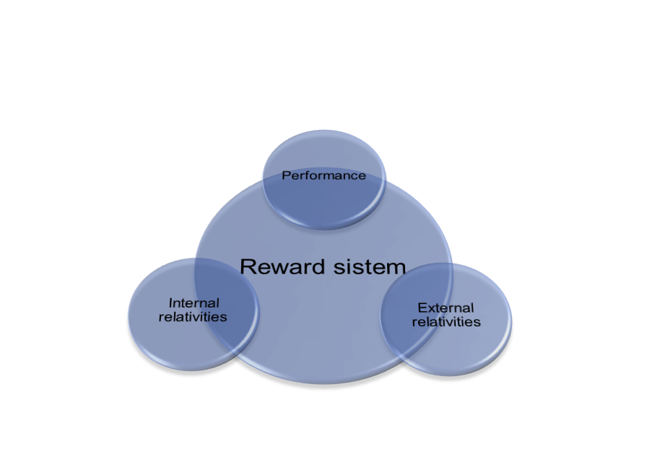

SOURCE Brown, D (2018) Fairness, Flexibility and Affordability: What are the lessons from pay and reward approaches and trends in the UK? Institute for Employment Studies, February, http://www.em ployment-studies.co.uk/resource/fairness-flexibility-and-affordability

