
CLoud engineering Priciples and pratices
ACCA7027

Name : Om Lalitbhai Gorasiya
Student No : 2435260
Lecturer : Renuga Jayakumar
Internal Verifier : Nathan Morgan

Abstract
This report is the critical analysis of the key principles and new development practices of cloud-engineering on which the modern digital infrastructure is based. The discussion is based on the history of resource abstraction between the classical Virtualisation to the light weight resource abstraction of Containerisation, and a realistic implementation of Docker is discussed in detail to experience the concept of immutability, persistence and distribution. The paper then focuses on the significance of traffic management and resource assignment and as an example should be the Amazon Web Services (AWS) system, that is, the Application Load Balancer (ALB) and EC2 Auto Scaling which involve the use of load balancing, scaling, and application gateways in an elastic load-balanced infrastructure. Furthermore, the key driving factors of cloud computing development are also discussed in the report, and, finally, it will also critically compare Serverless Functions (AWS Lambda) and Containerisation. The comparison of these deployment models is facilitated by numerical data and architectural models that prove to be vigorous in stating the comparison based on their operational overhead and cost structure and performance features. The findings confirm that the two complementary technologies chosen in the best way allow providing the most effective performance, cost-effectiveness, and resiliency in the contemporary cloud-native development of the application.
Table of Contents
I. Introduction 4
II. Foundational Principles of Cloud Engineering 5
2.1 The Principles of Virtualisation 5
Critical Evaluation of Shared Hardware and Resource Isolation 5
2.2 The Principles and Benefits of Containerisation 6
Comparison with Virtualisation (VMs vs. Containers) 6
Critical Analysis of Docker as the Leading Containerisation Technology 7
2.3 Practical Demonstration: Docker Implementation Analysis 7
Detailed Breakdown of the Docker Build Process 8
Analysis of the Container Runtime Environment 9
Critical Discussion of Docker Networking and Volume Management 10
Evaluation of Image Distribution (Pushing to Docker Hub) 10
III. Cloud Application Deployment and Management 11
3.1 Load Balancing and Scaling: Complementary Concepts 11
Critical Analysis of Synergy 12
3.2 Application Gateways and Advanced Traffic Management 13
Definition and Distinction from Traditional Load Balancers (AWS Perspective) 13
Critical Evaluation in Modern Microservices Architectures 14
3.3 Case Study: Application of Load Balancing, Scaling, and Gateways 14
IV. History of the Cloud Deployment: Serverless Functions 16
4.1 Researching the Major Motivating Forces 16
Economic Driving Forces: 17
Technical Driving Forces: 17
4.2 Serverless Functions: Principles and Practice 18
Detailed Discussion of Major Serverless Offerings 18
Critical Analysis of Benefits and Limitations 19
Numerical Data: AWS Lambda Cost and Performance 20
4.3 Comparison and Contrast: Serverless vs. Containerisation 21
V. Conclusion 22
5.1 Docker Web Server Setup: Images, Containers and Dockerhub Video 23
VI. References 24

I. Introduction
A contemporary digital world is necessarily conditioned by the principles of clouds computing that developed as a result of the technology boom into the foundation of global trade, communication, and innovations [1]. This metamorphosis which is characterized by real time service rendering of the computing services that comprise of servers, storage, databases, networking service provision, software service provision, analytics and intelligence in the Inter-net, need a deep understanding of the underlying engineering principles that shall deliver efficiency, scaling and resiliency [2]. Cloud engineering then consists of the art of creating, developing and operating applications in a cloud-based infrastructure that extends past hosting and a pretence at adopting an architectural design pattern that capitalizes upon the benefits of distributed systems to the maximum level.
This report has been envisioned with the purpose of the examination of the fundamental ideas of cloud engineering and with references to the alteration of the deployment model within the context of the traditional means of virtualisation to the latest containerisation and serverless implementation functions. The analysis will be based on three pillars of technology that are the abstraction of the resources (Virtualisation and Containerisation), traffic management (Load Balancing, Scaling and Application gateways) and evolution of architectures (Serverless Functions). Furthermore, the theoretical concepts will be documented to the practice through a concrete study of an illustration-driven course with the assistance of the Docker containerisation that will be introduced in the intended technical manual [3]. This theoretical and practical approach has to exist in order to demonstrate that one is well-versed on how such principles can be strong and workable, real world cloud solutions.
The boundaries of this report are the major specifications of the assignment brief. Part II: The change in practice between Virtualisation and Containerisation will be critically discussed, applying the successful Docker implementation because it highlights the advantages of the latter as efficient and portable. Part III will discuss a complementary concept of Load Balancing, Scaling, and Application Gateways to show how they can be used together to provide a highly available service to a customer. Lastly, Section IV will explore the motivation factors behind the growth of the cloud computing sector, and finally make a critical comparison of the concepts of Serverless Functions and Containerisation as the recent deployment frameworks. The report will be written in the third academic style and will discuss the points with a critical and well-referenced approach.

II. Foundational Principles of Cloud Engineering
The history of cloud computing is directly connected with the process of resource abstraction and virtualisation started the concept of containerisation that is lightweight and efficient. These technologies have been the foundation on which contemporary cloud infrastructure is developed on which dynamically allocates and manages resources that characterize model cloud.

2.1 The Principles of Virtualisation
Virtualisation is the art of development of a software-based, or virtual, replica of something, like applications, servers, storage, and networks [4]. It is simply a thin layer of abstraction between the physical hardware and the operating system (OS) and application that enables the running of several virtual machines (VMs) on the same physical server simultaneously.
The main process that is facilitated by this is known as the hypervisor, which is a software, a firmware or a hardware that develops and executes VMs. The Type 1 type of hypervisor simply operates on hardware and is available on bare-metal hypervisor (e.g., VMware ESXi, Microsoft Hyper-V), whereas the Type 2 type operates in a standard operating system (e.g., Oracle VirtualBox, VMware Workstation). The most important concept that can be demonstrated through the term of virtualisation is the virtualisation of shared hardware, in which the hypervisor controls the physical resources (CPU, memory, storage, network interface cards) and does allocations in a safe and efficient manner to each VM.

Critical Evaluation of Shared Hardware and Resource Isolation
The use of virtualisation has dramatic advantages, mainly in the usage of resources, and isolation. It ensures that there is an extreme reduction in the utilization of physical servers by consolidation of numerous workloads into a smaller number of physical servers and this enhances efficiency of hardware, thereby cutting down on the costs of operation [6]. More importantly, every VM is independently operated and has its own dedicated OS kernel which offers very good isolation of resources and security boundaries. An attack or failure in one VM typically does not impact other machines that are running in the same physical host.
But the nature of agile, cloud-native development units give rise to natively disadvantaged traditional virtualisation. The fact that every VM has to come with a full, separate operating system is highly overhead, which in turn makes the VM booting time slower, the storage consumption greater, and an additional cost of a so-called hypervisor tax, in which a fraction of the physical resources goes to the hypervisor and the guest operating system, not the application itself [7]. Although this was fundamental, the bulk weight of the VMs led to a smotherer version of resource abstraction containerisation.

2.2 The Principles and Benefits of Containerisation
Containerisation is the second step of evolution as compared to resource abstraction and introduces a more lightweight and portable form of virtualisation as compared to the traditional one. An application and all of its dependencies are bundled into a container and executed as an isolated process upon the kernel of the host operating system [8].

Comparison with Virtualisation (VMs vs. Containers)
The main difference here is in the fact that the operating system kernel is shared. VMs virtualise the whole machine, hardware and the OS, whilst containers do the same, but of the operating system itself. The mentioned difference has several benefits that are crucial:
Table 1: Comparison of Virtual Machine and Container Architecture
Feature | Virtual Machine (VM) | Container (e.g., Docker)
Abstraction Layer | Hardware | Operating System Kernel
OS Requirement | Each VM has its own Guest OS | Shares the Host OS Kernel
Size | Gigabytes (GBs) | Megabytes (MBs)
Typical Boot Time | Minutes (e.g., 2-5 min) | Seconds (e.g., < 1 sec)
Boot Time | Minutes | Seconds (Near-instantaneous)
Isolation | Strong (Hardware-level) | Moderate (Kernel-level)
Overhead | High (OS + Hypervisor) | Low (Process isolation)
Portability | Requires compatible hypervisor | Highly portable (OS-agnostic)

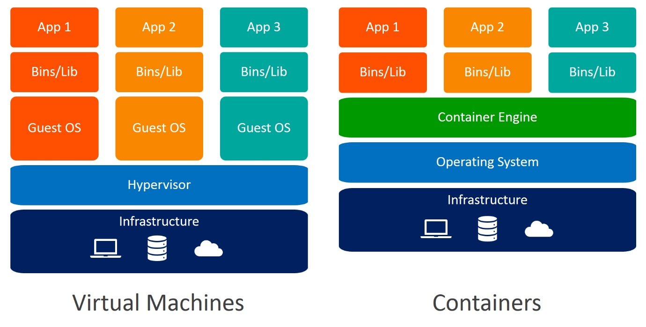
Figure 1: Comparison of Virtual Machine and Container Architecture
This shared architecture as a kernel is the root cause of the critical advantages of containerisation: portability, efficiency, speed, and resource utilisation. Containers are less consultative in that they boot up more quickly, they use a great deal less memory and disk space, and also an application will execute identically on either infrastructure, which can withstand the development challenge bane of all time: “it works on my machine” [9].

Critical Analysis of Docker as the Leading Containerisation Technology
Docker has become the standard of containerisation and has made the technology popular and offered a complete ecosystem in which to build, ship, and operate containers [10]. The success of Docker is explained by the fact that it has user friendly tooling and by launching the Dockerfile, a basic text file, containing the instructions on building a Docker image. Such declarative definition of application environments is the primary application of the concept of Infrastructure as Code (IaC) and repeatable and automated deployments. Image layers which are read only and which are cached are also used; this increases the efficiency because image can be easily updated and the general size of the image is also minimized [11].

2.3 Practical Demonstration: Docker Implementation Analysis
It is best expressed through the practical example to understand the theoretical benefits of containerisation. As a good example, the given technical guide, which describes how one can create and deploy a simple web application with the use of Docker, can be considered a good case study [3]. The given demonstration shows the main ideas on the picture of image building, container runtime, volume management, networking, and image distribution.
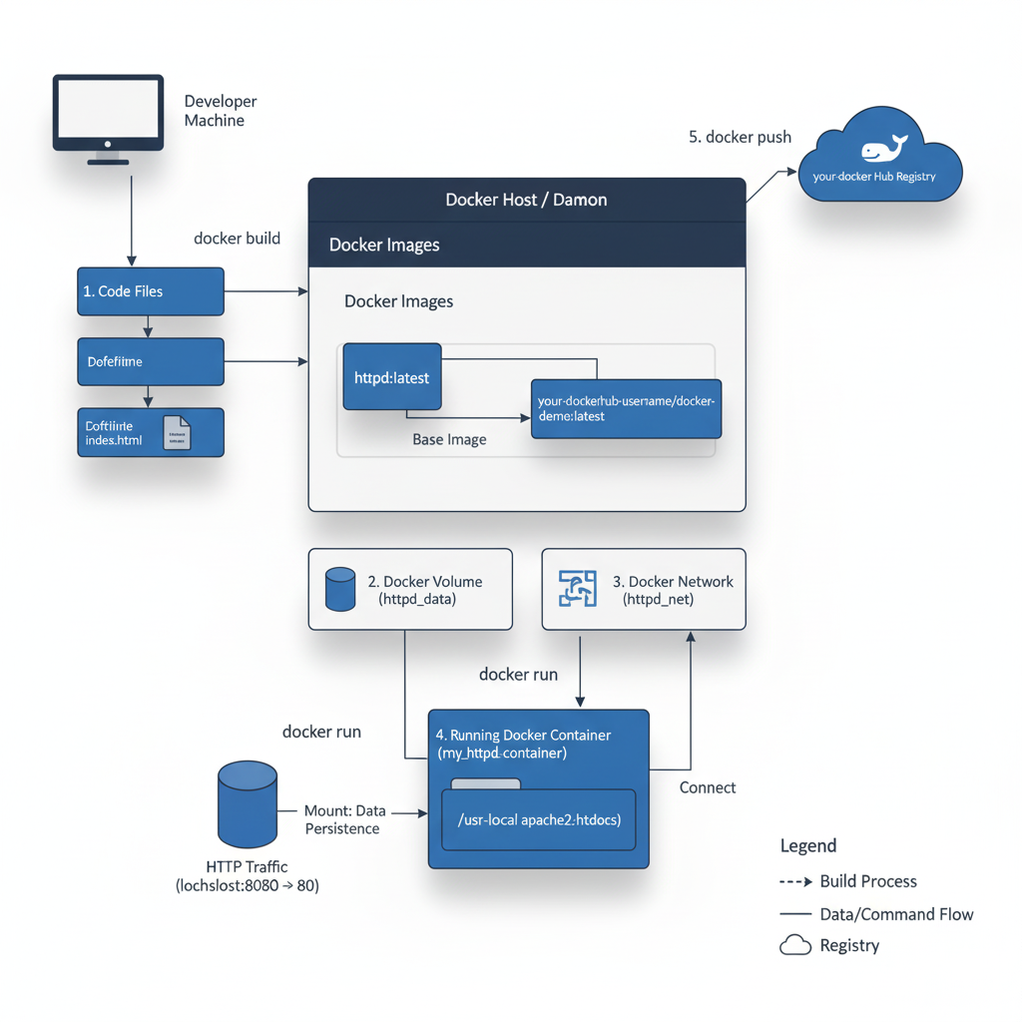
Figure 2: Visualizing your Docker deployment Steps

Detailed Breakdown of the Docker Build Process
The first thing to do is to create a file index.html and a Docker file. Dockerfile The template to the container image:

FROM httpd:latest
COPY index.html /usr/local/apache2/htdocs/

See FROM httpd:latest command The FROM httpd:latest command takes advantage of the concept of image farming with a base operating system and the Apache HTTP Server (httpd) being inherited by a reputable source. This helps save on time through the reuse of shared parts. COPY instruction will subsequently add the application specific data (index.html) to the specific web root directory in the container. These commands are executed in following command: docker build -t your-dockerhub-username/docker-demo ., and new image with these commands is an immutable image. This operation represents the fundamental containerisation idea of immutability wherein the application environment is determined at the time of build and it remains the same throughout all deployment phases [12].

Analysis of the Container Runtime Environment
One of the most important examples of the way Docker handles the hour of operation is the command to run the container:
docker run -d --name my_httpd_container \
-p 8080:80 \
--mount source=httpd_data,target=/usr/local/apache2/htdocs \
--network httpd_net \
your-dockerhub-username/docker-demo

The -d flag executes the container in detached mode which does not occupy the host terminal, which is customary to the background services. The -p 8080:80 flag illustrates port mapping which is an important concept of networking as the host machines port 8080 is port mapped to an internal 80 of the container in which the service is then accessed by the outside world. This underscores the isolations of the network of the container which has to be configured to allow them to access the outside world.

Critical Discussion of Docker Networking and Volume Management
Those two key ideas to production-ready applications are clearly covered by the demonstration: Container Volume and Container Networking.
- Container Volume (--mount source=httpd_data,target=/usr/local/apache2/htdocs) : When a volume named (httpddata) is created and bound to the web root directory it is created as a direct implementation of the principle of data persistence. Intents that are automatically written in a container are consequently volatile and consumed once the container is stopped or destroyed. Volumes do not bind the data to the lifecycle of the container, but keep it stored separately, so that configuration files, logs, or user-provided content can be stored separately, which is required in stateful applications [13].
- Container Networking (--network httpd_net): Container Networking This is the creation of a user-defined bridge gate (httpdnet) that can make containers communicate and exchange their names but not an IP address. It is basic to microservices architectures where several containers must be found (e.g., a web server, anything database, and an API service) and have to interrelate reliably and safely. It is more isolated and a service discovering network than the default bridge network [14].

Evaluation of Image Distribution (Pushing to Docker Hub)
The last operations of logging in, tagging, and pushing the image to Docker Hub (docker push your-dockerhub-username/docker-demo:latest) depict the this idea of distributing an image and its consequences to Continuous Integration/Continuous Deployment (CI/CD). The artifact of an immutable image can be stored in Docker Hub, which is an oriented central repository, and later accessed by any host machine or cloud service (e.g., AWS ECS, Azure AKS) anywhere in the world. This provides a guarantee that the same application environment that was developed and tested across the local environment is deployed to production, which is a promise of portability and consistency of containerisation [15].

III. Cloud Application Deployment and Management
After an application is containerised, the other issue in cloud engineering is the ability of the application to be able to respond to variable user demand in a dependable and economical manner. It is realized by means of traffic management and resource allocation approach, which is mainly induced by load balancing, scaling, and application gateways.

3.1 Load Balancing and Scaling: Complementary Concepts
With a distributed system, an instance of one application can not normally sustain the workload of a large set of users and is not able to provide 100 percent up-time. Load Balancing and Scaling are two complementary terms meant to do away with these limitations.
Load Balancing refers to a process activity of triggering the incoming network traffic to a pool of backend servers commonly known as a server farm or pool [16]. It is required by the reason that a single server should not act as the bottleneck so that the performance will be reduced or there will be a system crash.
- Types of Load Balancing:
  - Layer 4 (Transport Layer): Provides distribution of traffic depending on network-level details, e.g. IP addresses and ports. It is quick and bare and does not have an application context.
  - Application Layer (Layer 7): traffic is assigned to a layer, but the distribution depends on the characteristics of an application (headers, cookies, and URL paths, etc.). This can enable most intelligent routing choices including routing API traffic to a group of servers and routing static data to another set of servers [17].
- Algorithms: Round Robin (allocating requests in sequence) and Least Connections (allocating new requests to the server with the fewest running connections) are common algorithms based on performance to one or the other of a variety of traffic patterns.

Scaling describes how a system can work with an increasing number of works that is assigned. This in cloud engineering is mainly accomplished in two ways:
- Vertical Scaling (Scaling Up): Adding more capacity to a single resource meaning, adding more CPU or RAM to an already existing server. This is limited physically and financially.
- Horizontal Scaling (Scaling Down): It has to do with executing additional units of resource, e.g., deploying additional application servers or containers. This is what is desirable in a cloud based system because it has a virtually limitless potential and it is economical [18].

Critical Analysis of Synergy
Scaling and load balancing are not two separate solutions that can occur independently; rather they are inseparable. Horizontal scaling works only when there is a load balancer that will redistribute the loads on the new instances. On the other hand, a load balancer can only sustain performance given that the system is able to scale horizontally to accommodate peak system demands. They work together to ensure:
- High Availability: When one server goes offline, the load balancer will by default reroute its traffic to the other healthy servers, this is referred to as health checking.
- Performance: Traffic is distributed evenly and will not strain a single instance exhausting resources.
- Elasticity: The system will have the ability to scale out when it is in the peak capacity and scale in when the demand is low to optimise the use of costs and resources [19].
The integration of these ideas is provided by cloud providers with their advanced services. To analyze these ideas, to be applied in this analysis the strategy of Amazon Web Services (AWS) will be utilized, namely, Elastic Load Balancing (ELB) service and EC2 Auto Scaling. ELB service consists of both the Application Load Balancer (ALB) and the Network Load Balancer (NLB) to cover Layer 7 and Layer 4 traffic respectively, which are powerful managed solutions that hide the burden of manual configuration [19].
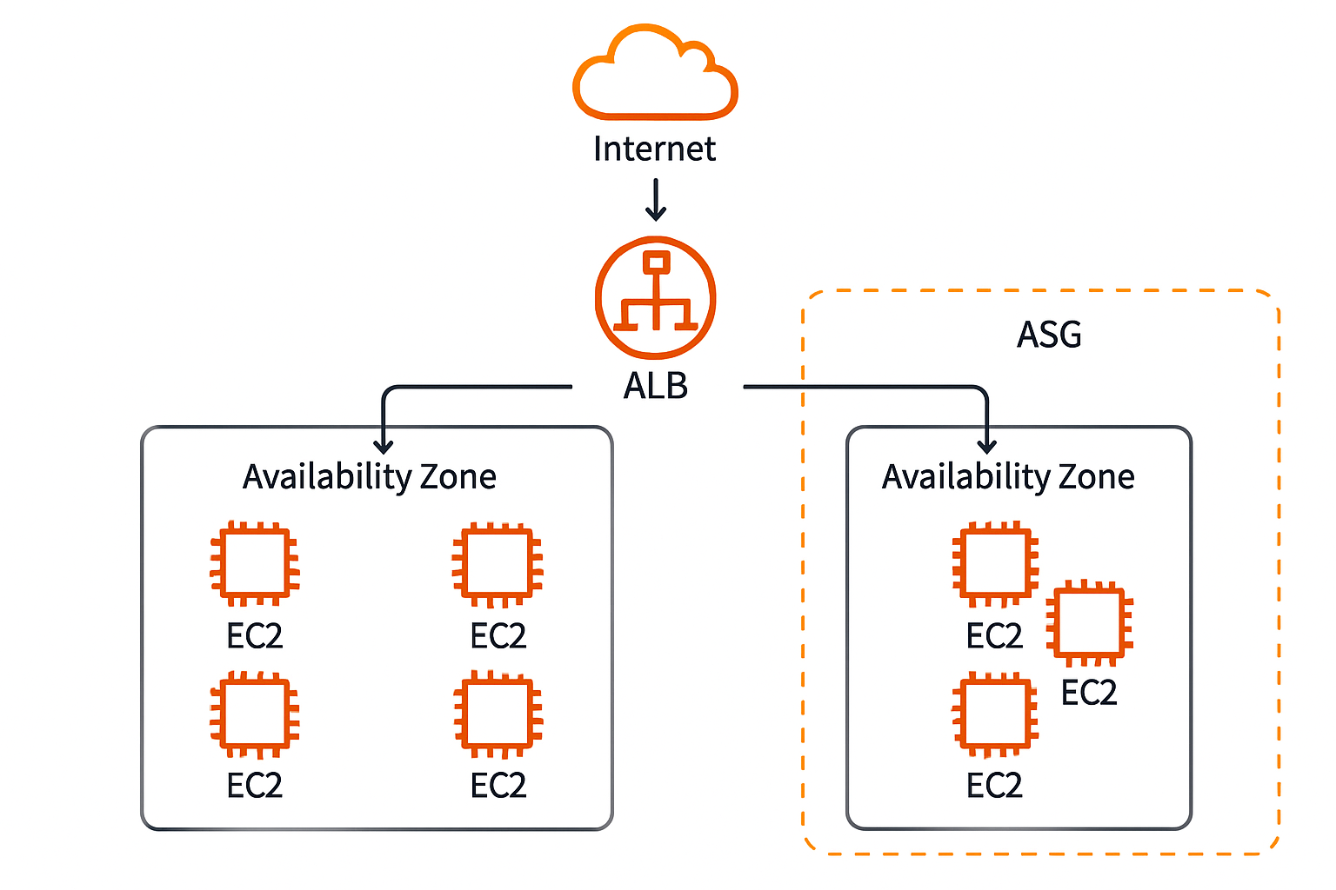
Figure 3: AWS Application Load Balancer and Auto Scaling Group Architecture

3.2 Application Gateways and Advanced Traffic Management
Although a classic load balancer is very responsive in traffic distribution, the AWS Application Load Balancer (ALB) provides a more sophisticated layer 7 functionality that may even appear as a reverse proxy and a complex traffic controller.

Definition and Distinction from Traditional Load Balancers (AWS Perspective)
Elastic load balancing (ELB) service, which belongs to the AWS ALB, functions on the application layer (Level 7) and is limited to HTTP/HTTPS traffic exclusively. It is quite different as compared to the Network Load Balancer (NLB) which is essentially a Layer 4 service and can only see the information of the IP and port, but not the content of the request. The ALB is designed to perform millions of invoques per second, and has a high level of performance consistency [20]. An example of ALB is capable of supporting more than 100,000 requests in one second (RPS) with a consistent latency of less than 10ms, which is adequate to support high throughput microservices [21].

Key Functions:
- SSL/TLS Termination: The gateway is able to decrypt traffic on the incoming HTTPS and verify the request, and again encrypt it before directing it to the servers at the back end. This removes computational intensive encryption/decryption process off the application servers [20].
- Web Application Firewall (WAF): It seems that most application gateways add WAF functionality to prevent vulnerable software in the backend applications to regular web vulnerabilities as SQL injection and cross-site scripting (XSS), and it is an essential aspect of protection.
- Path-Based Routing: The gateway is capable of directing the request to the various pools of the backends differentiated by the URL path. As an illustration, a request in the form of /api/ may be made to a cluster of APIs of a microservice, whereas a request in the form of /images/ will be made to a block of a static content server.
- Content Based Routing: This framework also provides the option of routing on other request properties such as host headers and thus enabling more than a single domain to run on the gateway (Multi-tenancy) [21].

Critical Evaluation in Modern Microservices Architectures
Application Gateways now are essential in the current microservices design. They perform the roles of API Gateway, which is accessible to all client requests. This centralisation helps with a simplified communication over the client side, and only the client has to be aware of the address of the gateway, and the backend micro services are free to develop without the need of affecting how the client interface looks. Besides, WAF and SSL termination functionality consolidate the security policy implementation, which greatly lessens the security overhead on individual microservices [22].

3.3 Case Study: Application of Load Balancing, Scaling, and Gateways
An example of how these three technologies can be synergised to each other would be to take a scenario of a high-traffic, multi-tier e-commerce platform running on a cloud infrastructure. This is done to make sure that the platform is fast and up when the shopping season occurs.
Application Architecture:
- Frontend: Abstraction Cooperative cluster of Docker containers that's a Node.js web application.
- Backend: This is a microservice Docker container cluster (Python Python based API).
- Database: One of the managed cloud database services (e.g. AWS RDS).
Integration of Technologies:
- Application Gateway (Entry Point): This is where all traffic entering the system is received by an Application Gateway (e.g. Azure Application Gateway).
  - Function: It carries out terminations of the SSL and WAF protection.
  - Routing: It makes use of path-based routing to steer traffic:
    - Any request to a https://store.com/ (frontend) is sent to the Frontend Container Cluster.
    - Events of HA to https://store.com/api/* (API calls) are landed in the Backend API Container Cluster.
- The AWS Application Load Balancer (ALB) is used as a load balancer hub and it also distributes traffic uniformly among the healthy instances within each cluster (Frontend and Backend). It is within the ongoing monitoring of health of all its containers by health checks to ensure that only operational targets are sent traffic. Scaling (Elasticity): both the Frontend and Backend Container Clusters have the AWS EC2 Auto Scaling Groups (ASGs). The size that the Amazon EC2 instances in the cluster are expanded is done by the use of ASGs in order to ensure that the applications are made available and so that the scaling offers the flexibility.
  - Policy: The scaling policy is going to be modified to kick off on a scaling-out (addition of new instances/containers) when the average CPU utilisation exceeds 70 percent in five minutes. The cost effectiveness is one of the major contributions of being able to scale dynamically. Researchers ascertained that using dynamic scaling policy based ASGs, organisations have managed to achieve an average of 30 per cent to 50 per cent. cheaper cost than the cost that they would incur in attempting to over-provision to peak capacity [22].
  - Benefit: A system will automatically add containers to the cluster during spiking. Application Gateway automatically recognizes the newly emerged cases and begins to send the traffic to them, which is why the platforms would not experience any performance loss but rather the degradation of service would not take place. When the traffic has the effect of reduction, the system will automatically scale-in (dismiss the containers), cost optimisation.
The three technologies are meshed up to constitute a single system as it would appear in this case study. Application Gateway is a smart, safe entry routing, the Load Balancer provides a full distribution, and the Scaling mechanism provides the necessary elasticity to allocate the resources based on the needs at any given moment. This is what constitutes the norm in the direction of delivering the cloud-based service that is highly resilient and cost-effective to the customer [23].

IV. History of the Cloud Deployment: Serverless Functions
It is the efficiency and cost minimisation competition, which was fought in the previous decades, which has propelled the cloud industry to much higher levels of abstraction which have resulted in serverless computing. This is a more radical sense of interpretation of infrastructure by the developers.

4.1 Researching the Major Motivating Forces
Cloud computing is not creatively caused not only by the financial but also by the technical dynamics, which contribute to the preference of abstraction and automation.
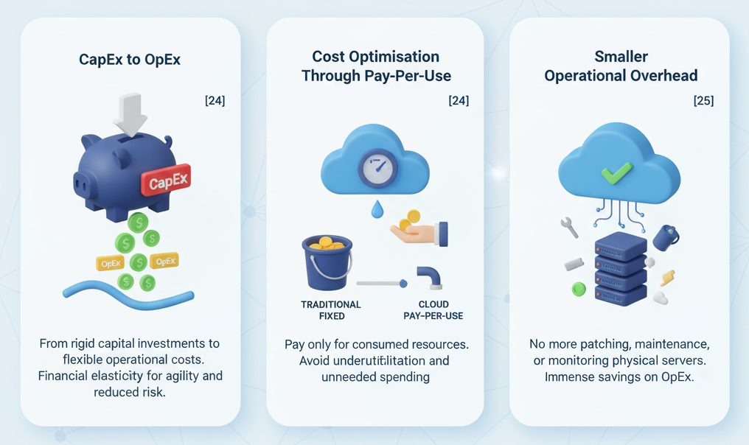
Figure 4: Cloud benefits

Economic Driving Forces:
- CapEx to OpEx: Cloud computing converts capital investment (CapEx) into colossal and rigid investments (capital expenditure on hardware equipment) to operational expenditure (OpEX) [24]. Financial elasticity is what the start -ups and businesses that seek to become less risky and have a higher agility would find highly appealing.
- Cost Optimisation through Pay-Per-Use: Pay using utility model is a heavy incentive that involves paying with the use of resource that does not match the amount that he can take as opposed to the amount that he needs to take. This particularly applies in situations where the workload that will be inseparable to the intermittent use of the sporadic patterns will lead to extreme underutilisation and unneeded spending against the traditional fixed infrastructure.
- Smaller Operational Overhead: Organisations no longer need to invest resources in patching, maintaining and monitoring of physical servers, operating systems and middlewares since by moving to the cloud, organisations can afford immense benefits on operations cost in terms of operation expenditure (OpEx) [25].

Technical Driving Forces:
- Increased Agility and Flexibility: Cloud services can be provisioned in very short periods of time and the development teams can deploy and iterate on an application and much more quickly. This agility is important to keep them ahead of the pack in the churning markets.
- Global Reach and Low Latency: Cloud providers provide enormous international network of data centres where the applications can be installed much nearer to the end-users, thus decreasing latency and enhancing user experience.
- The Rise of Microservices: The microservices architectural model that takes big applications in smaller, uniquely deployable services fits with the cloud architecture perfectly due to its distributed and on-demand characteristics. This trend would require dynamic deployment models such as containerisation and serverless.
The forces have influenced the development of Infrastructure as a Service (IaaS) to Platform as a Service (PaaS) and, most recently, to Function as a Service (FaaS), the fundamental element of serverless computing. FaaS is the highest level of abstraction, in which the developer only cares about the application code, and the cloud provider has the responsibility of taking care of all the other issues [26].

4.2 Serverless Functions: Principles and Practice
Although it is not actual servers that are eliminated (as the name suggests), it does imply that the server administration is completely out of reach to the developer. The most widespread implementation of this paradigm is named Serverless Functions (FaaS).

Definition and Core Characteristics:

A serverless function, also known as a small, single-purpose, 0.5 kilobase, and run to event piece of code is implemented by responding to an event. It has such essential features as:
- Event-Driven: Functions receive an external event which may be an HTTP request, an uploading of a file to some storage or change in the database or a message delivered to a queue.
- Auto-Scaling: The system auto-scals the count of firm instances of functions between zero and thousands, depending upon the quantity of arriving events, as manually configured.
- No Server Management: The administrator passes no responsibility on to the developer to provide, patch or maintain the underlying operating system and runtime environment.
- Statelessness: Functions are normally developed stateless such that data or state is not retained between invocations. All necessary state should be stored in some external service, either in a database or an object storage [27].

Detailed Discussion of Major Serverless Offerings
In order to conduct this critical analysis, AWS Lambda, the industry-leading Function as a Service (FaaS), and industry pioneer will be considered. AWS Lambda is multilingual and is extensively integrated into the enormous AWS ecosystem, which makes it a highly effective utility in the construction of event-driven architectures.
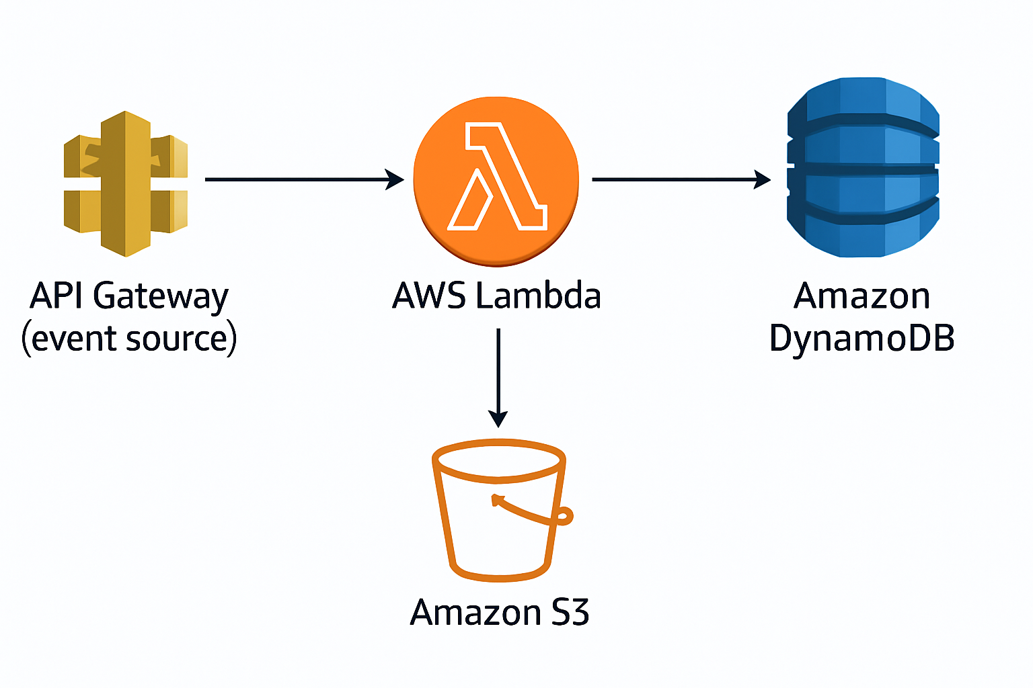
Figure 5: AWS Lambda Serverless Architecture

Critical Analysis of Benefits and Limitations
Serverless functions have the following tempting benefits:
- Lowered Total Cost of Ownership (TCO): If the pay-per-execution model is used, the cost of serving intermittent workloads will be lower than the cost of serving continuously running servers.
- Quick Time-to-Market: Developers are free to concentrate only on business logic and time to market is shortened.
- Endless Scalability: The platform does scaling automatically and gives it virtually unlimited capacity when there is a sudden surge in demand.
Notwithstanding, the serverless model includes the following drawbacks:
- Vendor Lock-in: Serverless applications coupled with the strong interdependence with cloud provider resources and proprietary runtime environments may complicate the business of shifting to another cloud service providers.
- Cold Starts: Due to the non-recent call of a function the platform will need to create a new execution environment causing a delay on the initial request (a cold start). This is possible to affect latency sensitive applications [28].
- Execution Limits: Functions usually have limits on their execution time, on their memory, and disk space, and they do not fit on long running or computationally intensive tasks. As an example, AWS Lambda has a maximum memory half globally at this point, being at 10,240 MB and 15 minutes of max execution time [28].
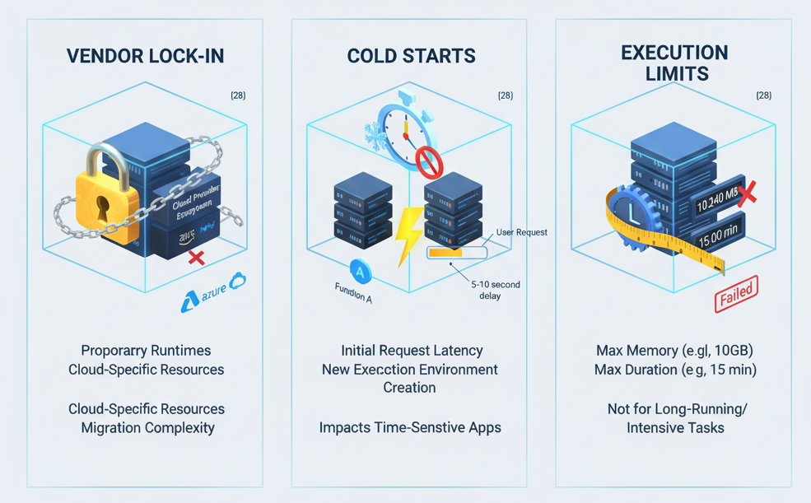
Figure 6: Challenges of Serverless Computing

Numerical Data: AWS Lambda Cost and Performance
A significant difference factor is the pay-per-use model of AWS Lambda. It is determined by the number of requests and the execution time with the round off to the nearest milliseconds.
Metric | 128 MB Memory Allocation | 512 MB Memory Allocation
Cost per Million Requests | $0.20 | $0.20
Cost per GB-Second | $0.0000166667 | $0.0000166667
Effective Cost per Hour (Continuous Run) | ~$0.00756 | ~$0.02988
Source: AWS Lambda Pricing (2025) [29]
This price model does a good job of demonstrating the economic value of FaaS in case of intermittent workloads because the effective price per hour is much lower than an EC2 instance, which is actively operational. But the important performance factor to consider critically is the cold start latency which is experienced when a function is called after an inactive period. Although AWS has added such features as Lambda SnapStart to address it, cold start times may still be several seconds or a few hundred milliseconds, an aspect that should be reconsidered with the highest severity with latency-sensitive applications [30].
Debugging and monitoring: The flow of functions which are distributed and ephemeral may also be difficult to debug and monitor, and it may demand specific tools and strategies of logging.

4.3 Comparison and Contrast: Serverless vs. Containerisation
The debate on Serverless Functions (FaaS) versus Containerisation (e.g., Docker/Kubernetes) is a pivotal architectural decision in cloud engineering. They both are modern deployment models that are abstracted over infrastructure, but they support different operational requirements and the characteristics of applications.

A Critical Comparison of the Two Deployment Models
Criteria | Containerisation (Docker/Kubernetes) | Serverless Functions (FaaS)
Operational Overhead | Moderate (Requires managing the container orchestration platform, e.g., Kubernetes cluster) | Minimal (Cloud provider manages all infrastructure and scaling)
Cost Model | Pay for provisioned resources (VMs/Nodes) running 24/7, plus container registry costs. | Pay-per-execution (Function duration and memory consumption). Free when idle.
Performance | Consistent (Containers are always running, no cold start) | Variable (Potential for cold starts, but fast execution once warm)
State Management | Can be stateful (e.g., running a database container) or stateless. | Must be stateless (State stored externally).
Runtime Flexibility | High (Can run any OS, language, or binary that fits in the container) | Limited (Must use supported runtimes and adhere to platform constraints)
Use Case Suitability | Long-running services, complex applications, legacy systems, custom runtimes. | Event-driven processing, APIs, data transformation, scheduled tasks.

Synthesis: Coexistence and Complementarity
The critical analysis shows that FaaS and Containerisation are not complementary tools, they are part of a toolkit of a cloud engineer.
- When to use FaaS (AWS Lambda): AWS Lambda is better considered when the job is a one-off event (such as image resizing after an upload, cronored reports, basic API endpoints), and the app is generally idle (therefore consumes little to no load). The economies of scale to zero scaling are tremendous as the operation is incomparable. The cost-optimisation is an incentive with an economic model where the cost of the function is free of charge when not being activated.
- When to pick Containerisation (e.g., AWS ECS/EKS): Containerisation, typically operated via AWS Elastic Container Service (ECS) or Elastic Kubernetes Service (EKS) is used with processes whose lifespan is long, multi-faceted applications are involved, or with systems that have custom dependencies that demand a particular operating environment or anticipated low-latency response. Containers are more suited to control and consistency of running a full-stack application, a full-fledged database, or a complex machine learning model. The ability to execute stateful services and guaranteed low latency (no cold start) is a major benefit in such situations compared to FaaS.
With a recent cloud ecosystem, both are commonly used by a single application. An example of this would be a fundamental e-commerce app, with its central web service implemented through a Kubernetes cluster (Containerisation), and asynchronous functionality delegated to AWS Lambda (FaaS), so as to scale order-confirmation orders (e.g. dispatching email notifications). This hybrid strategy is based on the merits of both models in order to produce maximum performance, cost, and operational efficiency [29].

V. Conclusion
The report has analytically examined the core ideas and activities of cloud engineering, the history of deployment model and analysis of the basic workings that are key in dealing out the distributed applications. This discussion confirms that the contemporary cloud architecture is anchored on abstraction layers and the hardware virtualisation by VMs followed by OS by containers then functions serverless computing.
Real life demonstration through Docker implementation was a good demonstration of the efficiency of containerisation in matters concerning the fulfilling the pledge of being portable and efficient. The formation of an unremovable picture, the functioning of permanent information via aggregates in addition to creating inter-service connections via interpersonal authoritative networks is not an easy step as a technological process; the principles simply alter psychologically to build trustful, broad, and consistent application requirements.
Moreover, the study of the Load Balancing, Scaling, and Application Gateways (LO) showed the relevance of its investment as an aspect of validation of the non-functional requirements of high availability and elasticity. Application Gateway in particular was mentioned as one of the primary components required in the microservices architectures since it would help in the centralisation of the protective measures and the elaborate routing of traffic.
Finally, the draw and comparison between Serverless Functions and Containerisation was done in detail upon the study of the forces that promote cloud expansion. Unlike the containers that provide a more substantial amount of control and predictability to the long-running and intricate workloads, the serverless functions offer unparalleled simplicity of use and cost-effectiveness to the occasion-based, ad hoc functions. Neither of the two can be seen as the future of cloud engineering but a synthesis because an engineer will adopt the most appropriate deployment model to apply on each element of a distributed system in a strategic manner.
In conclusion, the modern-day computing can be characterized by the notions of cloud engineering, namely in the form of abstraction, automation, elasticity, and resilience. It is the awareness of these concepts, beginning with the most simplistic concept of virtualisation, and proceeding to the tactical deployment of serverless functions that the computing professionals require a touch when focusing on the creation of the next breakthrough in both the viable and the large-scale digital services.

5.1 Docker Web Server Setup: Images, Containers and Dockerhub Video
https://youtu.be/86T-EkqOUac

VI. References
[1] M. Armbrust et al., “A View of Cloud Computing,” Communications of the ACM, vol. 53, no. 4, pp. 50–58, Apr. 2010, doi: https://doi.org/10.1145/1721654.1721672.
[2] P. Mell and T. Grance, “The NIST Definition of Cloud Computing Recommendations of the National Institute of Standards and Technology,” National Institute of Standards and Technology, Sep. 2011. Available: https://nvlpubs.nist.gov/nistpubs/Legacy/SP/nistspecialpublication800-145.pdf
[3] “Manuals,” Docker Documentation, Dec. 29, 2023. https://docs.docker.com/manuals/
[4] P. Barham et al., “Xen and the art of virtualization,” Proceedings of the nineteenth ACM symposium on Operating systems principles - SOSP ’03, 2003, doi: https://doi.org/10.1145/945445.945462.
[5] Avi Kivity Qumranet, Yaniv Kamay Qumranet, Dor Laor Qumranet, and A. Liguori, “KVM: The Linux virtual machine monitor,” ResearchGate, vol. 15, 2007, Available: https://www.researchgate.net/publication/228661937_KVM_The_Linux_virtual_machine_monitor
[6] R. Buyya, R. Ranjan, and R. N. Calheiros, “Modeling and Simulation of Scalable Cloud Computing Environments and the CloudSim Toolkit: Challenges and Opportunities,” arXiv.org, 2025. https://arxiv.org/abs/0907.4878
[7] J. Lindemann, “Towards Abuse Detection and Prevention in IaaS Cloud Computing,” 2015 10th International Conference on Availability, Reliability and Security, pp. 211–217, Aug. 2015, doi: https://doi.org/10.1109/ares.2015.72.
[8] S. Kang, M. Kwon, S. Lee, H. Choi, and M. Jung, “Bridging Natural Resilience and Cost-Effectiveness in SSDs for Containerized ML Applications,” pp. 19–24, Oct. 2025, doi: https://doi.org/10.1145/3766882.3767172.
[9] J. Singh et al., “Integrating Messaging Middleware and Information Flow Control,” vol. 4734, pp. 54–59, Mar. 2015, doi: https://doi.org/10.1109/ic2e.2015.13.
[10] Docker, “What is Docker?,” Docker Documentation, 2024. https://docs.docker.com/get-started/docker-overview/
[11] “Category: Blog,” CNCF, 2022. https://www.cncf.io/blog/
[12] “bliki: ImmutableServer,” martinfowler.com, 2013. https://martinfowler.com/bliki/ImmutableServer.html
[13] “Storage,” Docker Documentation, 2024. https://docs.docker.com/engine/storage/
[14] “Networking overview,” Docker Documentation, 2024. https://docs.docker.com/engine/network/
[15] S. Atawneh, “THE ANALYSIS OF CURRENT STATE OF AGILE SOFTWARE DEVELOPMENT,” Journal of Theoretical and Applied Information Technology, vol. 97, p. 22, 2019, Available: https://www.jatit.org/volumes/Vol97No22/4Vol97No22.pdf
[16] S. Afzal and G. Kavitha, “Load balancing in cloud computing – A hierarchical taxonomical classification,” Journal of Cloud Computing, vol. 8, no. 1, Dec. 2019, doi: https://doi.org/10.1186/s13677-019-0146-7.
[17] GeeksforGeeks, “Layer 4 Load Balancing vs. Layer 7 Load Balancing,” GeeksforGeeks, Feb. 13, 2024. https://www.geeksforgeeks.org/system-design/layer-4-load-balancing-vs-layer-7-load-balancing/
[18] J. Dean and S. Ghemawat, “MapReduce: simplified data processing on large clusters,” Communications of the ACM, vol. 51, no. 1, pp. 107–113, Jan. 2008, doi: https://doi.org/10.1145/1327452.1327492.
[19] “Elastic Load Balancing Documentation,” AWS, 2022. https://docs.aws.amazon.com/elasticloadbalancing/
[20] “What is Azure Application Gateway,” docs.microsoft.com, 2025. https://docs.microsoft.com/en-us/azure/application-gateway/overview
[21] “Application, Network, and Gateway Load Balancing - Difference Between Load Balancing Types - AWS,” AWS, 2025. https://aws.amazon.com/compare/the-difference-between-the-difference-between-application-network-and-gateway-load-balancing/
[22] S. Newman, Building microservices : designing fine-grained systems. Sebastopol, CA: O’Reilly Media, 2021.
[23] S. S P, “OCI High Availability, Disaster Recovery, and Reliability: A Complete Comparison,” Oracle, May 13, 2025. https://blogs.oracle.com/ateam/post/oci-high-availability-disaster-recovery-and-reliability-a-complete-comparison
[24] “What is cloud computing?,” Oracle, 2020. https://www.oracle.com/in/cloud/what-is-cloud-computing/
[25] IDC, “IDC: The premier global market intelligence firm.,” IDC: The premier global market intelligence company, 2024. https://www.idc.com
[26] H. B. Hassan, S. A. Barakat, and Q. I. Sarhan, “Survey on serverless computing,” Journal of Cloud Computing, vol. 10, no. 1, Jul. 2021, doi: https://doi.org/10.1186/s13677-021-00253-7.
[27] V. Lannurien, Laurent d’Orazio, Olivier Barais, and Jalil Boukhobza, “Serverless Cloud Computing: State of the Art and Challenges,” Lecture notes on data engineering and communications technologies, pp. 275–316, Jan. 2023, doi: https://doi.org/10.1007/978-3-031-26633-1_11.
[28] J. Wen, Z. Chen, X. Jin, and X. Liu, “Rise of the Planet of Serverless Computing: A Systematic Review,” arXiv (Cornell University), Jun. 2022, doi: https://doi.org/10.48550/arxiv.2206.12275.
[29] E. Jonas et al., “Cloud Programming Simplified: A Berkeley View on Serverless Computing,” arXiv:1902.03383 [cs], Feb. 2019, Available: https://arxiv.org/abs/1902.03383

