

LOCATION: Swansea | LLEOLIAD: abertawe
LEVEL 6 | LEFEL 6
EXAMINATION PERIOD | CYFNOD ARHOLIADAU
January 2019 | Ionawr 2019

MODULE CODE: ACCA6001
Network & Data Centre Management
TIME: 2 HOURS

answer THREE quESTIONs out of FoUR

Equipment or materials required – None
Adnoddau neu ddefnyddiau sydd eu hangen - Dim

ANSWER THREE QUESTIONS

Q1.

- With aid of a diagram explain Internet Server Farm.
(17 marks)
- Explain a Storage-area network (SAN).
(8 marks)
Solutions:

Q 3 | Question | Marks
a  b | - Internet server farms face the Internet. This implies that users accessing the server farms primarily are located somewhere on the Internet and use the Internet to reach the server farm.  - Internet server farms are then available to the Internet community at large and support business-to-consumer services. Typically, internal users also have access to the Internet server farms.  - The server farm services and their users rely on the use of web interfaces and web browsers, which makes them pervasive on Internet environments.  - Security and scalability are a major concern in this type of server farm. On one hand, most users accessing the server farm are located on the Internet, thereby introducing higher security risks; on the other hand, the number of likely users is very high, which could easily cause scalability problems.  - The Data Centre that supports this type of server farm is often referred to as an Internet Data Centre (IDC). IDCs are built both by enterprises to support their own e-business infrastructure and by service providers selling hosting services, thus allowing enterprises to collocate the e-business infrastructure in the provider’s network.  The storage-area network (SAN) as a network whose primary purpose is the transfer of data between computer systems and storage elements and among storage elements.  A SAN consists of a communication infrastructure, which provides physical connections and a management layer. This layer organizes the  connections, storage elements, and computer systems so that data transfer is secure and robust.  The term SAN is usually (but not necessarily) identified with block I/O services rather than file-access services. A SAN is a specialized, high-speed network that attaches servers and storage devices.  A SAN allows an any-to-any connection across the network by using interconnect elements such as switches and directors. | 2  2  2  3  3  5  2  2  2  2

Q2.

  - With aid of a diagram briefly explain storage layer and transport layer of the data centre architecture.
(12 marks)
b. Explain the functionality of clustering.
(6 marks)
- Draw the topology diagram of extranet server farm.
(7 marks)
Solutions:

Q 2 | Question | Marks
a  b  c | The storage layer consists of the storage infrastructure such as Fibre Channel switches and routers that support small computer system interface (SCSI) over IP (iSCSI) or Fibre Channel over IP (FCIP). Storage network devices provide the connectivity to servers, storage devices such as disk subsystems, and tape subsystems.  The Data Center transport layer includes the transport technologies required for the  following purposes:  • Communication between distributed Data Centers for rerouting client-to-server traffic  • Communication between distributed server farms located in distributed Data Centers  for the purposes of remote mirroring, replication, or clustering  Transport technologies must support a wide range of requirements for bandwidth and latency depending on the traffic profiles, which imply a number of media types ranging from Ethernet to Fibre Channel.  Clustering consists of using multiple-server computers to provide a single  application that is virtually running on a single server. The application runs effectively on multiple servers, but the end user thinks he is accessing a single server.  Clustering provides both load distribution and high availability. Clustering can be used to scale a server farm. Instead of adding processors to a single computer, you can use a farm of computers of the same power; the end result is a virtual server of higher processing power than a single device. | 4  4  4  6  7

Q3.

- Referring to IPV6, provide information to conduct an in-house training on this emerging protocol. You may give as much information as possible about IPv6 and include some of the weaknesses of IPv4. You may use appropriate diagrams if necessary.
- marks)

Solutions:
Answer should include most of these key points, appropriate diagrams may be used.
- IPv6 allows simplified mechanisms for address and prefix renumbering.
- An IPv6 interface can have multiple addresses.
- IPv6 link-local addresses are used as the next hop when IGPs are exchanging routing updates.
- DHCP is not required because an IPv6 device can automatically assign itself a unique IPv6 link-local address.
- The ability to scale networks for future demands requires a limitless supply of IP addresses and improved mobility.
- IPv6 combines expanded addressing with a more efficient and feature-rich header to meet these demands.
- While it has many similarities to IPv4, IPv6 satisfies the increasingly complex requirements of hierarchical addressing that IPv4 does not support.
- Larger address space
- IPv6 addresses are 128 bits, compared to IPv4’s 32 bits.
- There are enough IPv6 addresses to allocate more than the entire IPv4 Internet address space to everyone on the planet.
- Elimination of public-to-private NAT
- End-to-end communication traceability is possible.
- Elimination of broadcast addresses
- IPv6 now includes unicast, multicast, and anycast addresses.
- Support for mobility and security
- Helps ensure compliance with mobile IP and IPsec standards.
- Simplified header for improved router efficiency
- Extension Headers
- MTU Discovery
- Address Allocation Process
- IPv6 address specifics and subnet prefix
- Interface Identifiers
- Link local address
- Unicast, multicast,
IPv4:
- Internet routing table expansion
  - The Internet routing tables continue to grow which means Internet core routers require more processing power, memory, and overhead.
- Lack of true end-to-end model
  - IPv4 networks typically use NAT as the solution to address depletion.
  - However, NAT hides the true source address of traffic, which can cause other issues.
- IPv4 is in no danger of disappearing overnight.
- It will coexist with IPv6 and then gradually be replaced.
- IPv6 provides many transition options including:
- Dual stack:
- Both IPv4 and IPv6 are configured and run simultaneously on the interface.
- IPv6-to-IPv4 (6to4) tunneling and IPv4-compatible tunneling.
- NAT protocol translation (NAT-PT) between IPv6 and IPv4.

- Discuss Stateless Autoconfiguration for IPv6 as it relates to router solicitation (RS), router advertisement (RA), neighbor solicitation (NS) and Duplicate Address Detection (DAD).
(8 marks)
Solutions:

- Stateless autoconfiguration uses the information in RA messages to configure hosts automatically.
- RAs are sent periodically, but a node can send out RS messages when it boots so that it doesn’t have to wait for the next RA.
- All routers on the network reply to the RS immediately, with an RA sent to the all-nodes multicast address.
  - The prefix included in the RA is used as the /64 prefix for the host address.
  - The interface ID used is the EUI-64 format interface ID.
- DAD is used during the autoconfiguration process to ensure that no other device is using the autoconfiguration address.
- During the DAD phase, A Host sends an NS to query if another node on the link has the same IPv6 address.
  - If a node responds to the request, it means that the IPv6 address is already in use, and the Host needs to be manually configured.

Q4.

Figure 1 below is a poorly designed network from the late 90s that was implemented by a medium size business. The network professionals who are responsible for managing the network are planning to redesign and rebuild it. You are required to:
- Make a list of all the problems you can identify.
(6 Marks)
Solutions: (6 marks for any 6 listed problems)
Answers may include –
- No Redundancy
- No Server Information
- No User Information
- No Subnet / Notation
- Sub-netting inconsistent
- UTP not Fibre incoming
- No Firewall for incoming
- Over use of Lease Lines
- Older style of HUBS being used
- Many Brands of Equipment being used

- State the job function/responsibility for:
  - Network Manager
Solutions: (2 marks for four listed)
Answers may include:
- Oversees every aspect of network
- Manages Staff
- Verifies the connectivity
- Ensures efficiency
- Assigns roles
- Maintaining Network
- Implements Policies and Procedures
- Contingency Planning
- Recovery Planning
- Training of Staff
- Recruitment of Staff
- Procurement of New Technologies
- Ensuring that Network growth matches the companies
- Work with the Network Administrators and Planners

  - Network Administrator
Solutions: (2 marks for any 4 listed)
Answers may include:
- To ensure the smooth running of the network
- User Management
- Removal of old devices
- Updating Firmware on devices
- Reporting to Management
- Implementation of Recovery and Contingency plans
- Monitoring of Network Performance
- Monitoring of Network Intrusion
- Implementing Security Policies and Procedures
- Assist the network manager
- Actively ensures the network is up

(4 Marks)
- Rebuild/design the current network infrastructure
  - All problems and weaknesses identified should be explained and state the measures taken to correct them.
  - The improvement of network infrastructure should incorporate VOIP and a PBX server as part of a server farm.
  - State all assumptions made.
(15 Marks)
Solutions and Diagram:
Sample answers but not limited to these and design may vary –
- Inclusion of VLANs across the network
- Voice VLAN implementation for VOIP Network
- Introduction of Sub-netting across the floors
- Fibre to be used on incoming lease line
- Implementation of Firewall at entry point
- Standardisation of the equipment use
- Implement Redundancy across the network
- Cisco Proprietary SNMP ver3

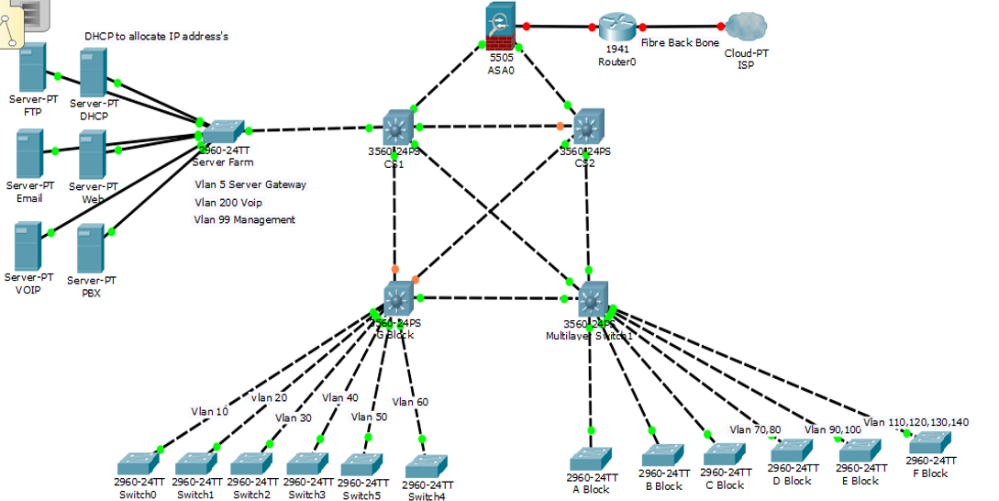

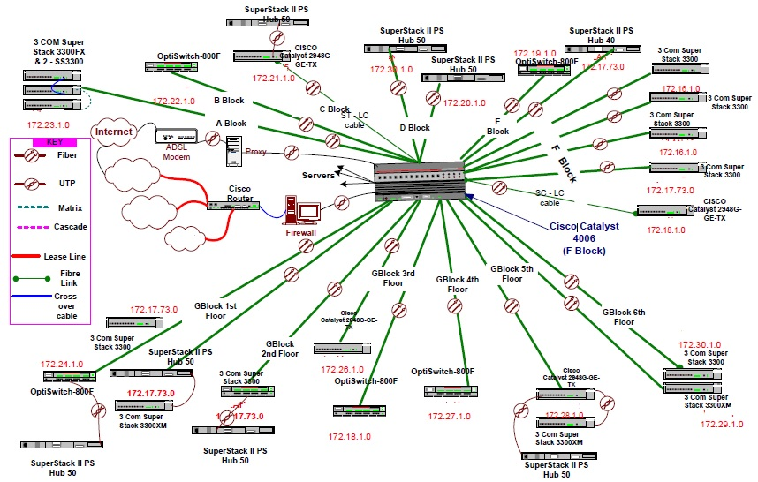
Figure 1: Poorly design network

Diwedd/End

