

Staying Independent in Later Life: Care and Support Needs of Older People in the UK
Component 1: Individual Poster Presentation
Student name: Cristina Apostol
Student ID: 2335890

Module name: Empowering the Older Person
Module code: BMHP6027
Lecturer’s name: Dr Laila Surani / Dr Ping Wu

Staying Independent in Later Life

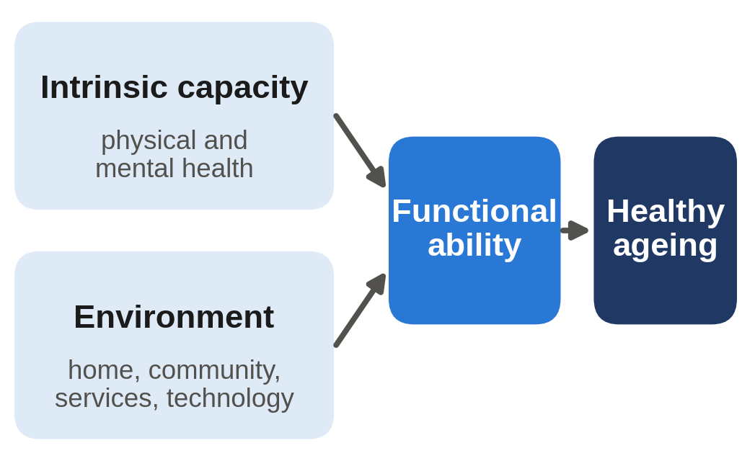  Figure 1: Healthy ageing model (adapted from WHO, 2015)  Introduction  The UK population is ageing. In 2021, 11.1 million people in England and Wales were aged 65 or over (18.6%), up from 9.2 million in 2011 (ONS, 2023). Many live for years with long-term conditions. This poster evaluates their needs, UK services and policy, barriers to independence and ways to empower them.  Two Theories  - Activity theory: people age well by staying active and involved (Havighurst, 1961). This supports reablement and community groups, but it can ignore people who are too ill or prefer a quieter life.  - Disengagement theory: pulling back from society is natural (Cumming and Henry, 1961). However, it can be used to excuse isolation, so the Care Act’s focus on wellbeing fits activity theory better.    Figure 3: Active ageing (Gareth1953 All Right Now, 2011) |  | Care, Empowerment and Support Needs  The WHO (2015) links healthy ageing to functional ability: being able to do what you value. It depends on both health and environment (Figure 1). Key needs are:  - Functional ability: help to wash, dress and move safely. About 1 in 3 people over 65 fall each year (NICE, 2025).  - Independence, freedom and choice: control over care and daily life.  - Social connection: 940,000 older people are often lonely (Age UK, 2024c).  However, older people are not one group, and ageism can limit the care and choices they are offered (WHO, 2021).  UK Approaches and Policy  Policy: The Care Act 2014 makes wellbeing and prevention a legal duty and gives people with eligible needs personal budgets for more choice. The 10 Year Health Plan (DHSC, 2025) aims to move care into communities and online.  What works: Reablement (short-term support at home) led to better outcomes at discharge, but results varied between people and services (Beresford et al., 2019). The Wigan Deal, a strengths-based model, is seen as best practice; healthy life expectancy there rose (Naylor and Wellings, 2019).  Technology: Telecare (alarms and sensors) is widely used, but large UK trials found it did not significantly reduce hospital use or delay care home moves (Steventon et al., 2013; Howard et al., 2021). Technology should support, not replace, human care. |  | 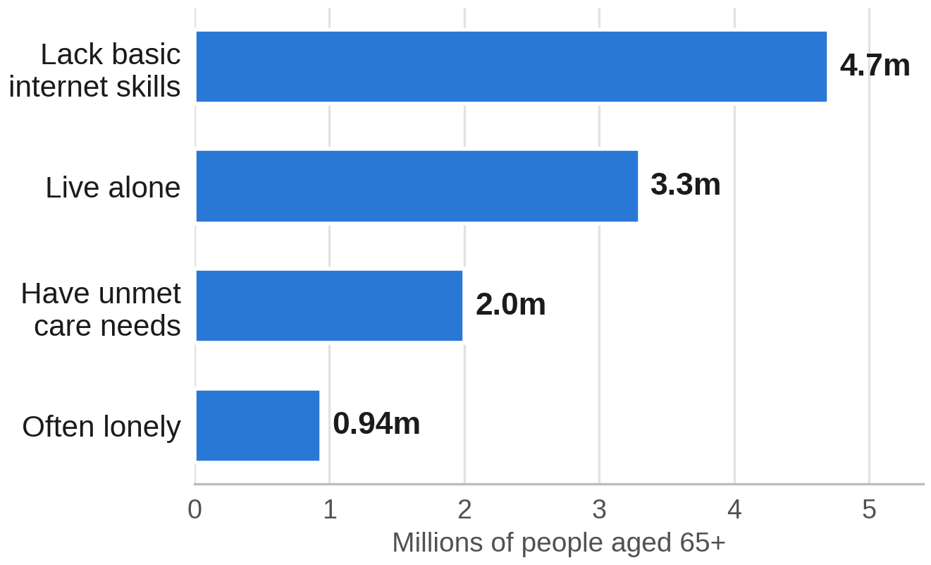  Figure 2: Older people facing barriers (ONS, 2023; Age UK, 2024a, 2024b, 2024c)  Challenges to Independence  - Unmet need: about 2 million older people in England have unmet care needs (Age UK, 2024a).  - Staff shortages: 111,000 care jobs are empty and turnover is 23.1% (Skills for Care, 2025).  - Cost: the cap on care costs was cancelled (HM Treasury, 2024), so many still face high bills.  - Digital exclusion: 4.7 million over-65s lack basic internet skills (Age UK, 2024b).  Recommendations and Conclusion  - Invest in prevention and reablement.  - Better pay and training to keep care staff.  - Free digital skills support, always with an offline option.  - Co-produce services with older people, as in Wigan.  Barriers: money and staff. Solutions: shared NHS and council budgets through Integrated Care Systems (Health and Care Act 2022) and long-term reform via the Casey Commission (2025).  Conclusion: UK policy supports independence, but unmet need, staff shortages and digital exclusion limit real choice. Services that work with older people, not just for them, can empower them.

References
Age UK (2024a) The state of health and care of older people in England 2024. London: Age UK. Available at: https://www.ageuk.org.uk/siteassets/documents/reports-and-publications/reports-and-briefings/health--wellbeing/state-of-health-and-care/state_of_health_and_social_care_24.pdf (Accessed: 30 September 2026).
Age UK (2024b) More than 1 in 3 over 65s (4.7 million) lack the basic skills to use the internet successfully. Available at: https://www.ageuk.org.uk/latest-press/articles/2024/more-than-1-in-3-over-65s-4.7-million-lack-the-basic-skills-to-use-the-internet-successfully/ (Accessed: 30 September 2026).
Age UK (2024c) Age UK’s new report shows ‘you are not alone in feeling lonely’. Available at: https://www.ageuk.org.uk/latest-press/articles/age-uks-new-report-shows-you-are-not-alone-in-feeling-lonely/ (Accessed: 30 September 2026).
Beresford, B. et al. (2019) ‘Reablement services for people at risk of needing social care: the MoRe mixed-methods evaluation’, Health Services and Delivery Research, 7(16). Available at: https://doi.org/10.3310/hsdr07160 (Accessed: 30 September 2026).
Care Act 2014, c. 23. Available at: https://www.legislation.gov.uk/ukpga/2014/23/contents (Accessed: 30 September 2026).
Casey Commission (2025) Independent Commission on Adult Social Care: terms of reference. Available at: https://caseycommission.co.uk/about/terms-of-reference/ (Accessed: 30 September 2026).
Cumming, E. and Henry, W.E. (1961) Growing old: the process of disengagement. New York: Basic Books.
Department of Health and Social Care (DHSC) (2025) Fit for the future: 10 Year Health Plan for England. London: DHSC. Available at: https://www.gov.uk/government/publications/10-year-health-plan-for-england-fit-for-the-future (Accessed: 30 September 2026).
Gareth1953 All Right Now (2011) Godalming - Oct 2011 - The Magnificent Seven [Photograph]. Available at: https://www.flickr.com/photos/40837632@N05/6258849294 (Accessed: 12 October 2026). Licensed under CC BY 2.0.
Havighurst, R.J. (1961) ‘Successful aging’, The Gerontologist, 1(1), pp. 8–13. Available at: https://doi.org/10.1093/geront/1.1.8 (Accessed: 30 September 2026).
Health and Care Act 2022, c. 31. Available at: https://www.legislation.gov.uk/ukpga/2022/31/contents (Accessed: 30 September 2026).
HM Treasury (2024) Fixing the foundations: public spending audit 2024–25 (CP 1133). London: HM Treasury. Available at: https://www.gov.uk/government/publications/fixing-the-foundations-public-spending-audit-2024-25 (Accessed: 30 September 2026).
Howard, R. et al. (2021) ‘The effectiveness and cost-effectiveness of assistive technology and telecare for independent living in dementia: a randomised controlled trial’, Age and Ageing, 50(3), pp. 882–890. Available at: https://academic.oup.com/ageing/article/50/3/882/6109729 (Accessed: 30 September 2026).
National Institute for Health and Care Excellence (NICE) (2025) Falls: assessment and prevention in older people and in people 50 and over at higher risk (NICE guideline NG249). Available at: https://www.nice.org.uk/guidance/ng249 (Accessed: 30 September 2026).
Naylor, C. and Wellings, D. (2019) A citizen-led approach to health and care: lessons from the Wigan Deal. London: The King’s Fund. Available at: https://www.kingsfund.org.uk/insight-and-analysis/reports/wigan-deal (Accessed: 30 September 2026).
Office for National Statistics (ONS) (2023) Profile of the older population living in England and Wales in 2021 and changes since 2011. Available at: https://www.ons.gov.uk/peoplepopulationandcommunity/birthsdeathsandmarriages/ageing/articles/profileoftheolderpopulationlivinginenglandandwalesin2021andchangessince2011/2023-04-03 (Accessed: 30 September 2026).
Skills for Care (2025) The state of the adult social care sector and workforce in England 2025. Leeds: Skills for Care. Available at: https://www.skillsforcare.org.uk/Adult-Social-Care-Workforce-Data/workforceintelligence/resources/Reports/National/The-state-of-the-adult-social-care-sector-and-workforce-in-England-2025.pdf (Accessed: 30 September 2026).
Steventon, A. et al. (2013) ‘Effect of telecare on use of health and social care services: findings from the Whole Systems Demonstrator cluster randomised trial’, Age and Ageing, 42(4), pp. 501–508. Available at: https://doi.org/10.1093/ageing/aft008 (Accessed: 30 September 2026).
World Health Organization (WHO) (2015) World report on ageing and health. Geneva: WHO. Available at: https://www.who.int/publications/i/item/9789241565042 (Accessed: 30 September 2026).
World Health Organization (WHO) (2021) Global report on ageism. Geneva: WHO. Available at: https://www.who.int/publications/i/item/9789240016866 (Accessed: 30 September 2026).

