Qualification: CIPD Diploma in Applied Human Resources

Module Name: Understanding the Link between Individual and Organisational Performance

On the Job Training

Word Count: Activity 1: 528
Activity 3: 298

Student Name: Maria Mellen Jimenez
Student Number: 2005457
CIPD Membership Number: 57501591

By signing below, I confirm that the work/evidence presented is my own, unaided work. I understand the regulations pertaining to candidate malpractice and the action that may be taken as a result.

Signed: 
Date: 13/09/21

INTRODUCTION

I am working as Deputy Store Manager as maternity cover, for a multinational clothes retailer. Up to that time, I worked for the same company as a Section Manager since 2009, where I have been actively involved in performance management. Unfortunately, for this assignment, I am not allowed to disclose any information regarding the organisation I work for.

- ORGANISATION’S APPROACH TO PERFORMANCE MANAGEMENT

As Taylor (2016) establishes, the formal performance management systems follow a common pattern which consists in a recorded meeting between the manager and the employee, which is kept on file and where goals are set to be worked on previous to the next review.

The approach of our company has changed during the last decade. Twice a year we would hold a scheduled meeting with our employees, called Face to Face instead of appraisal. As we can see below, the meeting required preparation from both parties, employee and manager. The forms were handed to the employees with sufficient time to prepare, in order for them to reflect on their performance in the last six months.

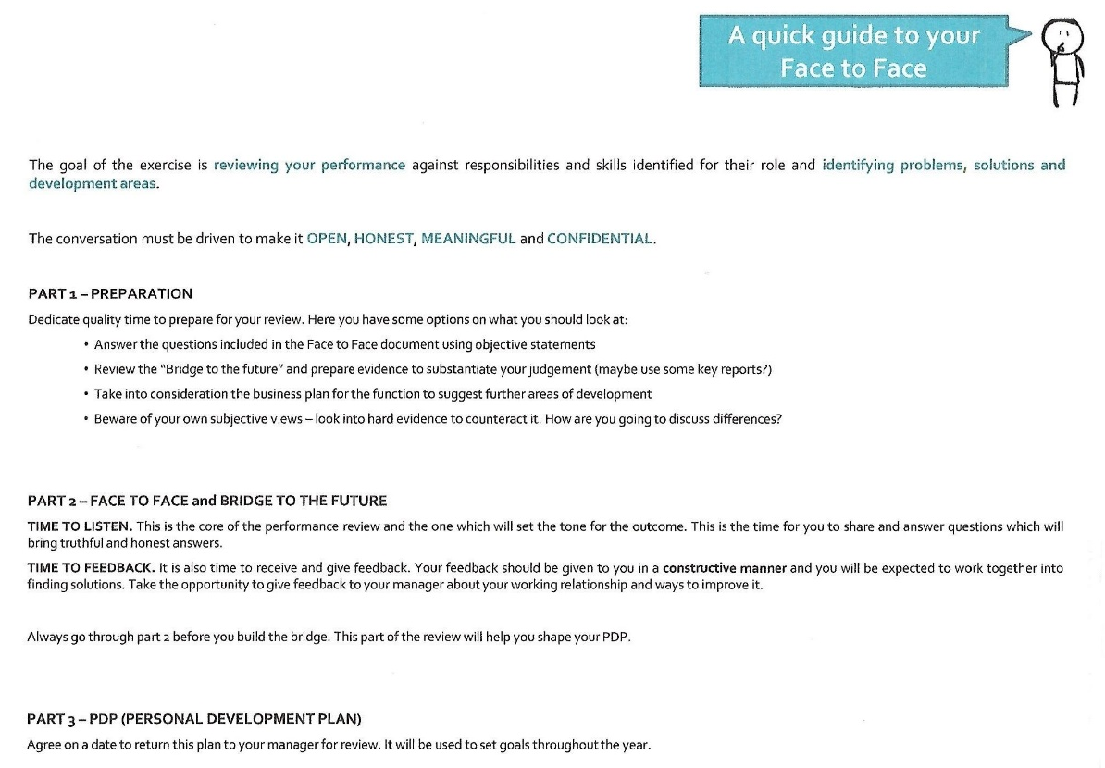
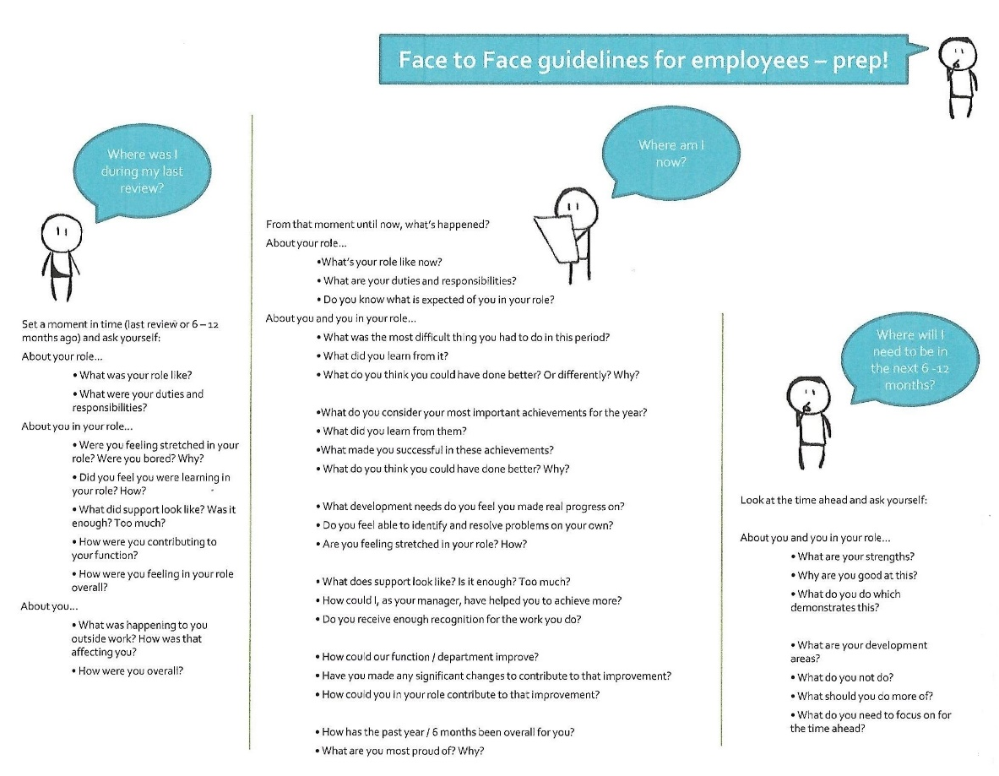

This way managers would make the process a two-way communication system, as Armstrong (2017) states in his definition of performance appraisal. The manager would be taking notes to be able to summarise them by filling the two forms below, which would be emailed to the training department after.
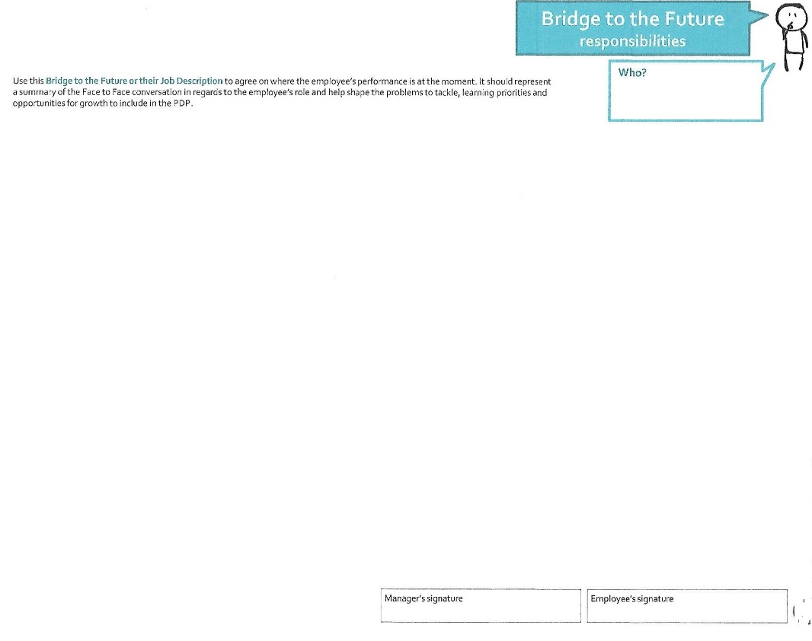

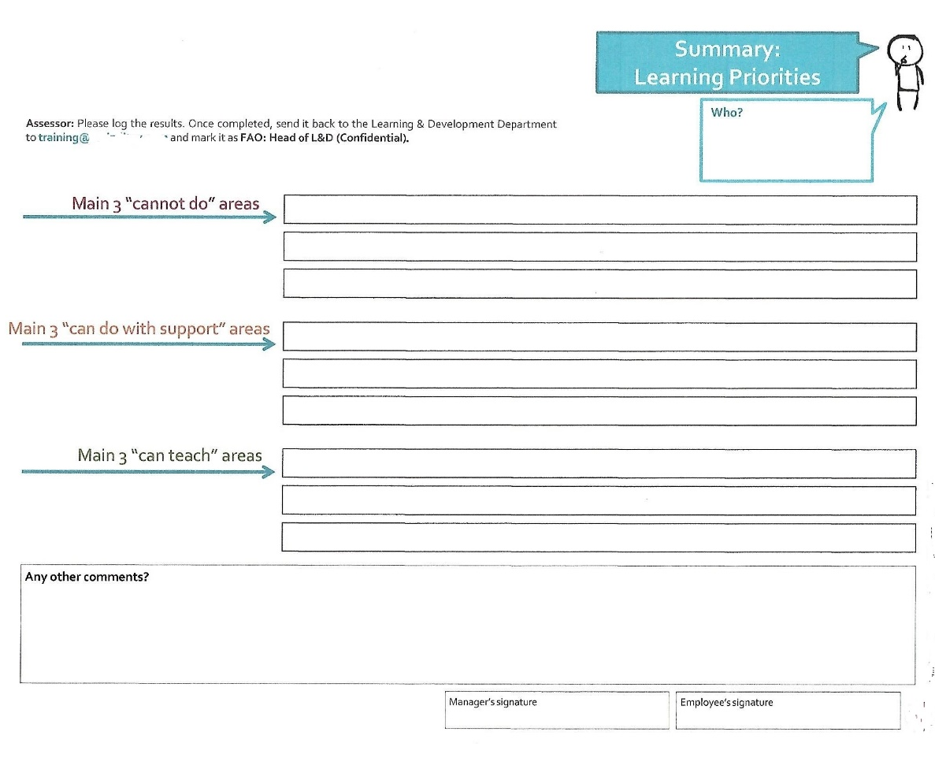
Once again, forms are handed to the employee to decide their personal development plan (PDP), which will be followed on by another meeting to discuss and agree which goals will be set to achieve the desired performance.
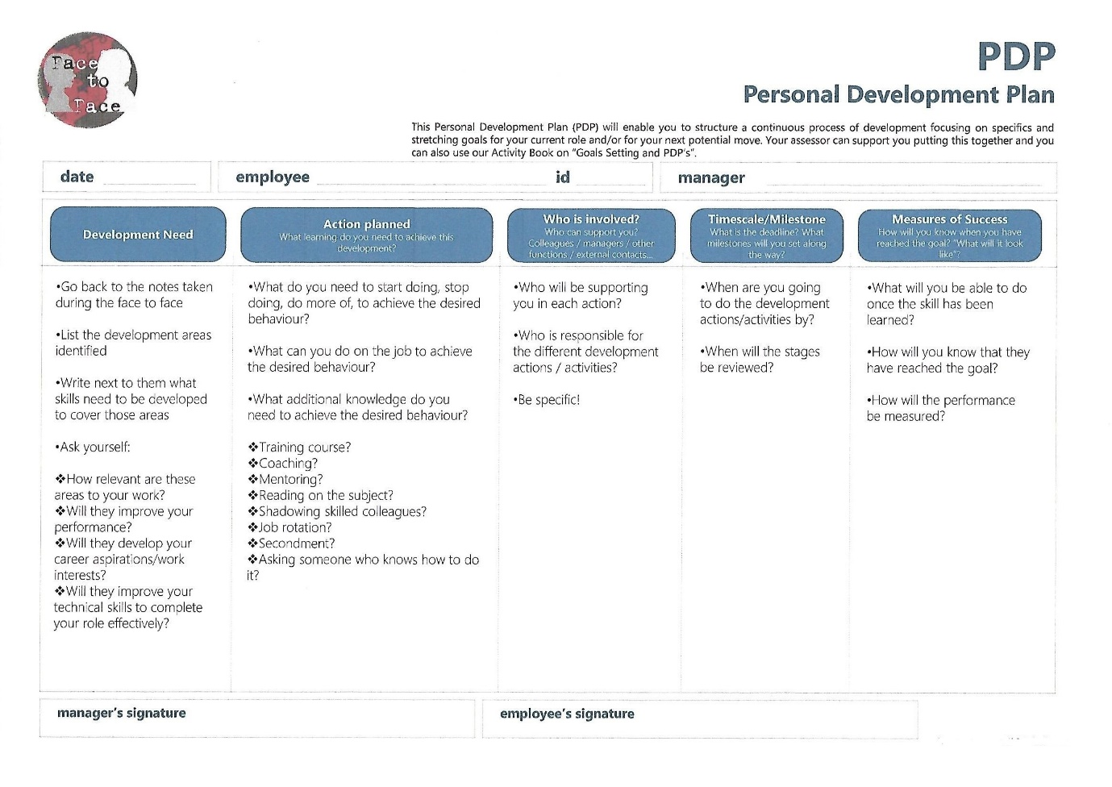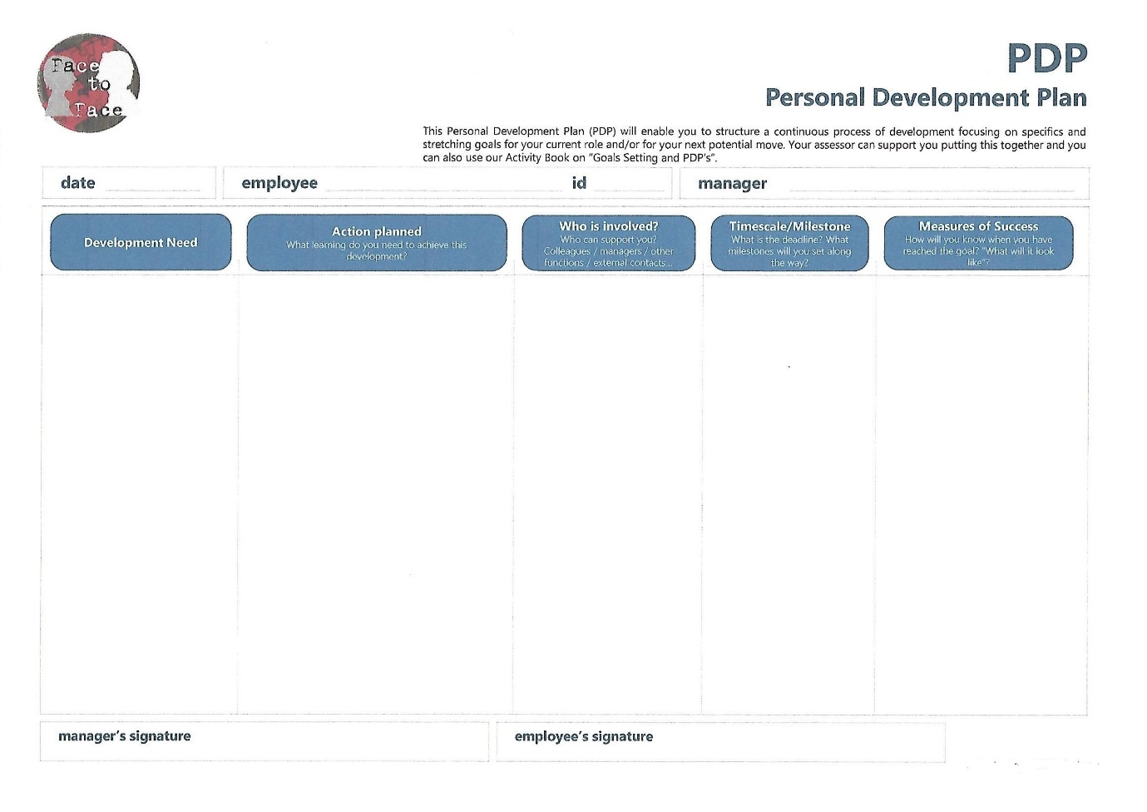

Gathering feedback from managers within the organisation, it was perceived that this process was a mere ‘tick-the-box’ exercise, where most PDPs were forgotten in the personal files and only brought back out just before the following review, unless the employee was interested in career development as a manager. This agrees with Armstrong (2017) statement about how appraisals were ineffective for improving performance.

The HR team developed a new approach for managing performance through one-to-one conversations. Bi-annual performance reviews do not take place anymore: however, at least every three months both manager and employee will meet to discuss the performance and keep setting goals, in the case of an employee who is performing well. For new starters, a meeting should take place in their first day, as part of their induction, and there should be at least three more meetings before the end of their probation period, which is usually three months. Underperforming staff will be having more regular meeting, usually every two or four weeks.

An example of the documentation provided to the management team, follows below:
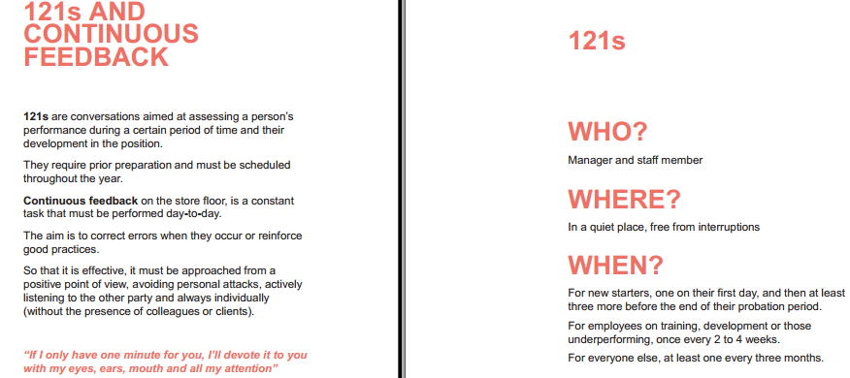
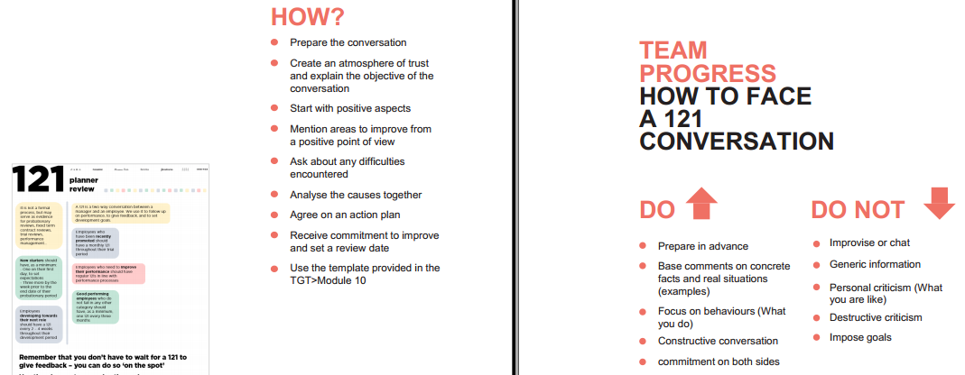
In terms of changes regarding the Covid-19 pandemic, I can confirm that, whereas other meetings such as fixed term contract reviews or investigations were voice recorded due to restrictions, performance reviews are still happening face to face. However, due to the pandemic and that the majority of the staff was furloughed for months as the business was not open, there has been a decrease on these reviews.

In conclusion, my organisation agrees with the CIPD (2020) statement which expresses that performance reviews should be more regular.
- MY DEVELOPMENT NEEDS AGAINST THE CIPD PROFESSION MAP

After having an understanding of what performance management is and, looking at the People practice standards on the CIPD Profession Map, it can be settled that I am actively involved in the performance management activities within my store, with an experience of 12 years not only following up the training for new employees, but also the career development of a few of them who became managers after coaching and mentoring them.

As I have explained before, the organisation’s approach in terms of performance reviews has evolved in the last ten years. I was fully trained on how to carry out a bi-annual review when I first became a manager, and after HR put in place the new system of more regular one-to-one reviews, I implemented them within my team.

Bi-annual reviews have negative aspects in a fast-paced environment like retail, mainly time. As a busy retailer, we cannot be away from the shopfloor for long periods of time, since to perform this type of review we would need at least one hour away, without adding the time invested in preparation. Also, I used to make notes of the employee’s negative performance to be able to bring it up during the review, taking a lot of time only to put it together. I perceived the process as something I had to do and send to the HR team in the office, but rarely as a way of improving the individual’s performance.

Whereas with regular one-to-one’s, the conversations do not last more than 20 minutes and are based on recent performance. As they are regular meetings focused on four goals, the assessment and preparation takes less time, plus it is a way for us managers to practice and refresh our training.

REFERENCE LIST

- Armstrong, M. (2017) Armstrong's Handbook of Performance Management: An Evidence-Based Guide to Delivering High Performance. London: Kogan Page. Accessed on 12/08/21.

- CIPD (2020) Performance management: An introduction. Available at: https://www.cipd.co.uk/knowledge/fundamentals/people/performance/factsheet. Accessed on 02/09/21.

- Taylor, S. (2016) ‘Improving Organisational Performance’ in Taylor, S. and Woodhams, C. Human Resource Management: People and Organisation. 2nd
Edition pp 197-218. London: CIPD. Accessed on 18/08/21.

