
Analysis of Financial Statements of Marriott International


Name: Md Shahidul Islam
ID:2026286
Module Name : Financial Management
Module ID : BMIH5001
Module Tutor: Christopher Wilkin

Table of Contents
Executive Summary 3
Introduction 4
Financial Analysis Trends 5
Profitability 5
Liquidity 15
Gearing 18
Knowledge from Ratio Analysis 20
Benefits and Limitations of Ratio Analysis 21
Conclusion 22
Bibliography 23

Executive Summary
If one wants to check the profitability, efficacy, and liquidity of a company, the ratio analysis method is a handy tool. It uses the company’s income report and balance sheet to prepare a financial statement containing a few financial ratios such as profitability and liquidity ratios. This report will be about these financial ratios based on the financial statements of Marriott International Inc. We’ll be focusing on the years 2020 and 2021. The company is running its business in 139 countries and has 8,000 branches. In 2020, the Marriott hotel has seen a significant decrease in its sales and lost a lot of liquidity. However, in 2021, the statistics are in favor, as it is making a profit. It is partly due to better asset management and sales. However, it is not a perfect tool since it doesn’t consider the social and cultural aspects.

Introduction

Ratio analysis is one of the most important tools to measure a company’s ability to profit from its business and how efficient it is. It also tells us the condition of the company’s liquidity. The purpose of this report is to analyze the financial statements of Marriott International Inc. for the years 2020 and 2021. The company currently has over 8,000 branches throughout the 139 countries in which it does business. This report will look at three financial ratios: Profitability, Liquidity, and Gearing to understand the condition of its business and provide insights. The analysis will be followed by commenting on the ratio analysis method and its limitations of it.

Financial Analysis Trends
The financial trend of Marriot International Inc. from its financial statements for 2021 and 2020 is shown and compared down below.
The financial statements of Marriott International Inc. show a clear upward trend from 2020 to 2021. Below, we’re going to be taking a look at the ratio analysis report.

Profitability
We’re going to be putting the profitability ratio data from the given link of the financial statements.
Net Profit Margin
Net profit margin is one of the major financial ratios. It shows how much a company is profitable. (Berk & Demarzo, 2020)
Year | 2021 | 2020
Formula= TTM Revenue/TTM Net Income | $1.10B /$13.86B | $-0.27B /$0.08B
Ratio | 7.93 | -2.58
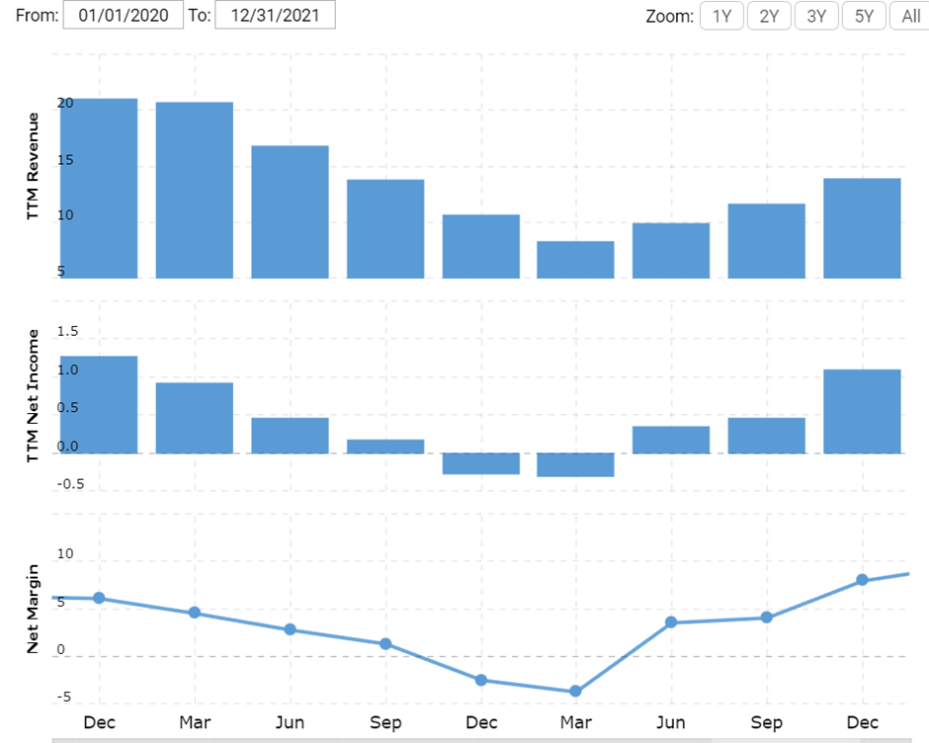
Figure 01: Net Margin

The graph report shows clearly that the company had taken a dip in profitability in 2020 which reached its bottom in March of 2021. After the market resumed its normalcy, the Marriott started getting back its business profitability it had back in 2019.
Gross Margin
Gross margin is the amount of money a company has after taking out the direct cost of production and purchase. It shows how well a company can generate revenue. (Al-Watter et Al., 2018).
Year | 2021 | 2020
Formula= TTM Gross Profit /TTM Revenue | $2.80B /$13.86B | $1.46B /$10.57B
Ratio | 20.21 | 13.80
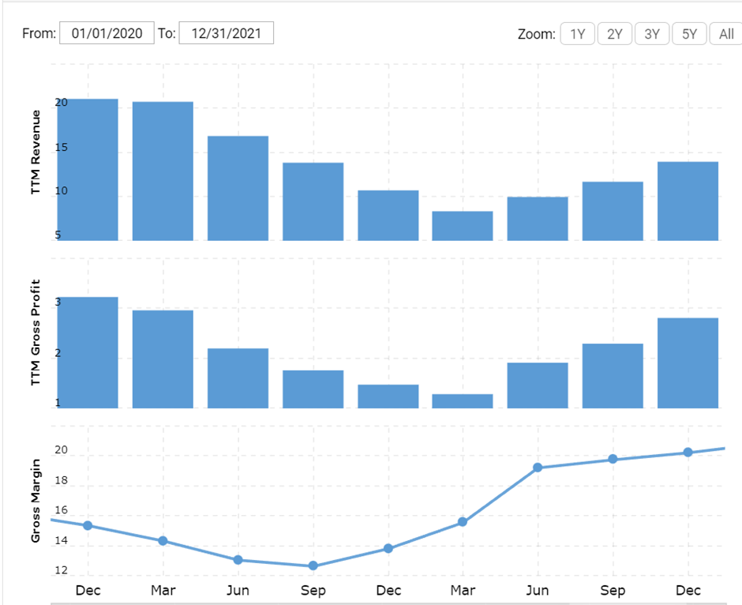
Figure 02: Gross Margin
In figure 2, you can see that the company had a significant deep in gross margin ratio which meant the company is making less sales. In 2021, it started to make sales better and surpassed its profit and revenue in had at the end of 2019.
EBIT Margin
EBIT margin can be defined as profit the business is making from its core operations. It is calculated before the interest and taxes. It gives us a true understanding of a company’s core products and services. These components will need to get replaced or fixed eventually and that is important information for the shareholders and future investors. (Brigham & Ehrhardt, 2020)
Year | 2021 | 2020
Formula= EBIT/Total Revenue | $1.75B/$13.86B | $0.08B /$10.57B
Ratio | .13 | 0.08
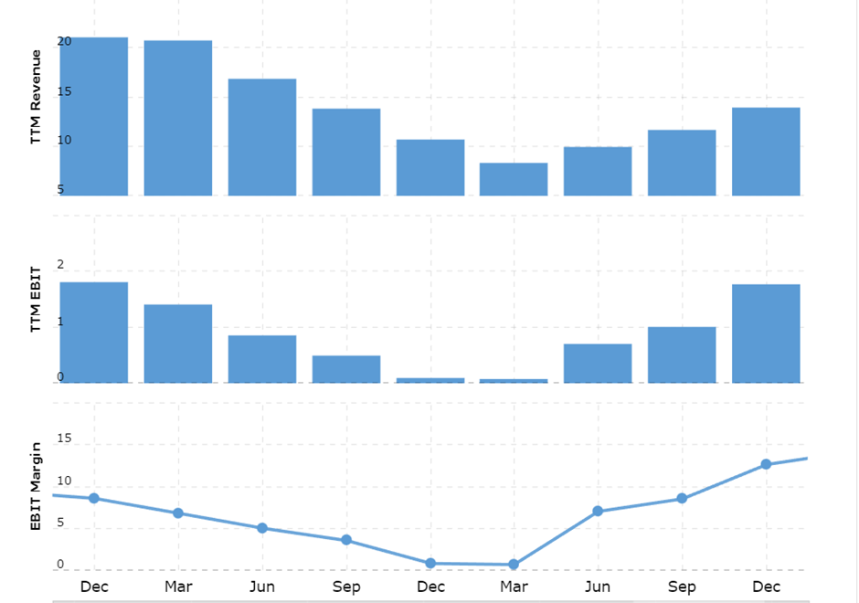
Figure 03: EBIT Margin
The graph clearly shows that the company was making much less profit in 2020 compared to its previous and next years. From April of 2021, the company saw its growth coming back and even improved upon 2019’s year-end report.
Return on Equity
Return on equity is a measure of the business’s ability to make a profit in relation to the shareholders’ equity profile. (Titman et al, 2018)

Year | 2021 | 2020
Formula= TTM Net Income /Shareholder's Equity | $1.10B /$1.41B | $-0.27B /$0.43B
Ratio | 77.72 | -62.093
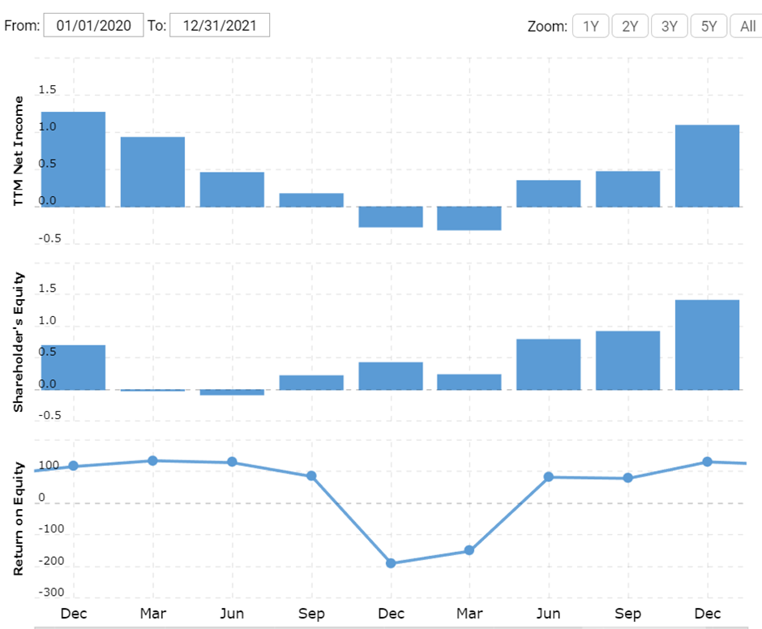
Figure 04: ROE Margin
Over the last 2 years, the company has seen a phase of low profit against the equity. It had a negative margin from the end of 2020 to the beginning of 2021. After March 2021, the company saw a boost in profit.

Return on Investment
The return on investment is a profitability measurement of a company in relation to the investment amount (Brigham and Houston, 2012).
ROI is one of the major financial ratios that decides the company’s investment profile. Return on invest is going to measure the company’s profitability against the investment money.
Year | 2021 | 2020
Formula= TTM Net Income/LT Investments & Debt | $0.08B /$9.63B | $1.75B /$10.57B
Ratio | 10.23 | -2.77
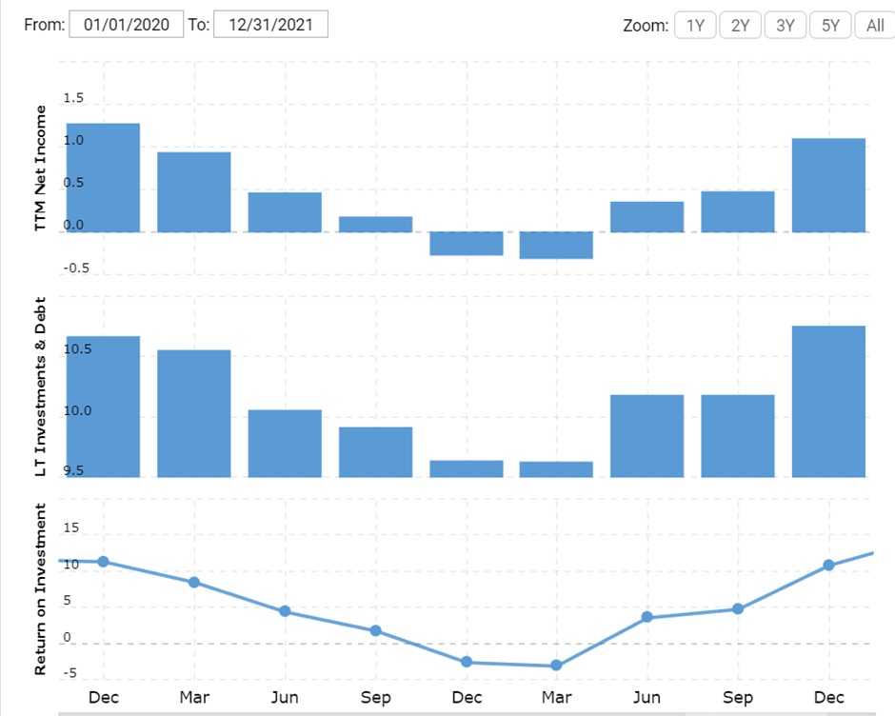
Figure 05: ROI

In figure 5, the graph tells us that the company’s ROI was on a downward curve from its average ratio until March 2021. After that it saw an upward curve which ended with a ratio of 10.23. The company is on a trajectory to make more profit in 2022 after subtracting the operating costs.
Operating Margin
Operating margin can be defined as the company’s actual profitability rate after removing all the taxes and non-operating costs. It presents a clear view of the company’s condition to the investors. (Vaidya, 2019)
Year | 2021 | 2020
Formula= EBIT/Total Revenue | $1.75B/$13.86B | $0.08B /$10.57B
Ratio | 12.62 | .79
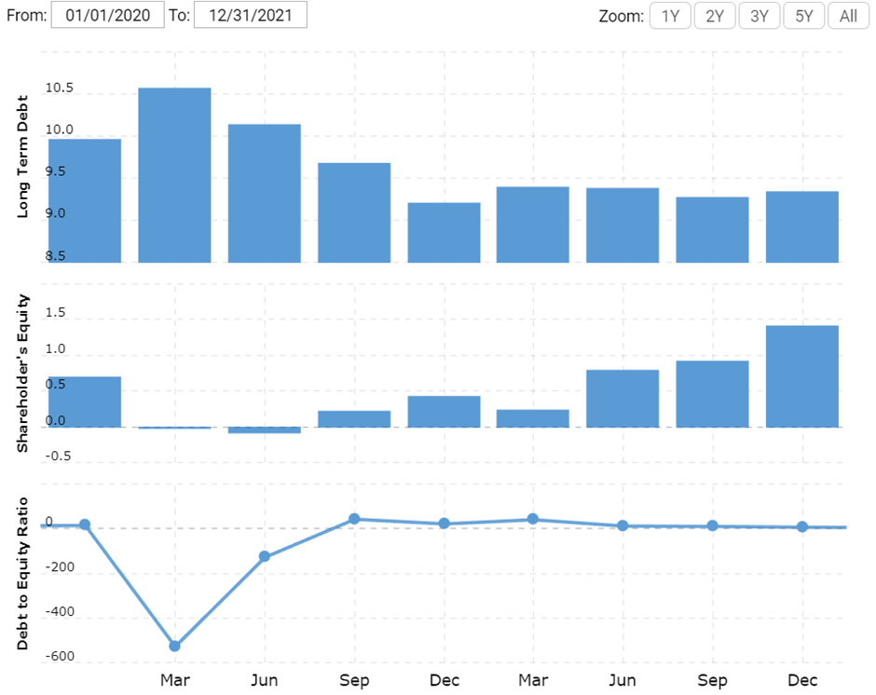
Figure 06: Operating Margin
Figure 6 shows that the Marriot Hotel has only saw a small period of downward curve in March 2020 which resulted in a 0.79 ratio. In 2021, the company ended with a 12.62 operating margin which translates to increasing profit for the investors.
Return On Assets
Return on assets, in short, ROA tells how how profitable a company is. This financial ratio shows if the company is making enough profits in relation to the total asset. (Beers, 2019)

Year | 2021 | 2020
Formula= TTM Net Income/Total Assets | $1.10B/$25.55B | $-0.27B/$24.70B
Ratio | 4.3 | -1.1
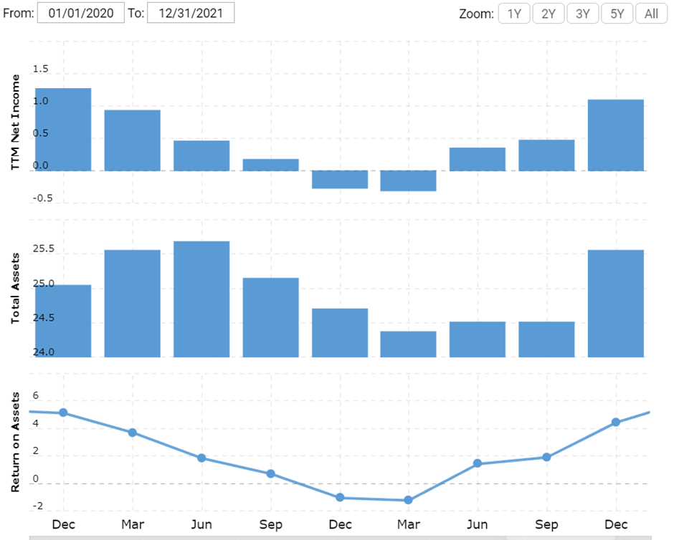
Figure 07: Return on Assets
If you look at the table and the graph above, you can see the Marriott started the year 2020 on a high note, but with the COVID policy in place, it started losing income. However, at the end of 2021, the hotel managed to return to where it was in 2019.Both income and asset has increased which is a sign of high profitability.

Liquidity
Liquidity ratio is another determinant of a company’s financial condition. It lets us know how the company is doing regarding its debts and asset management. (Berk & Demarzo, 2020)
Current Ratio
Current ratio is one of the vital liquidity ratios that determines a company’s ability to pay its short-term debts. Short-term debts refer to commitments that will mature inside the next 12 months. This is how it looks for Marriott International in 2020 and 2021.
Year | 2021 | 2020
Formula= Current Assets/Current Liabilities | $3.63B/$6.41B | $2.83B/$5.75B
Ratio | .57 | .49
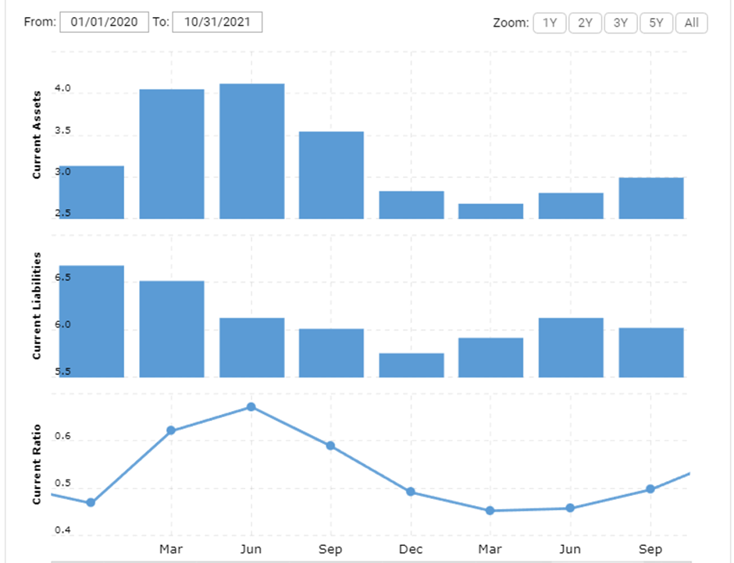
Figure 08: Current Ratio
We can see from the graph (figure 08) that the year 2020 was a bad year with a lower current ratio. In 2021, the company is now more capable of paying its short-term obligations. However, the current ratio isn’t satisfactory enough.
Receivable Turnover
Receivable turnover ratio is an accounting measure. It can be used to determine the company’s ability to collect debts and extend credit (Suraya, 2018). This is how how it looks for Marriott International.
Year | 2021 | 2020
Formula= net Sales/Average Account receivables | (data not available) | (data not available)
Ratio | 6.99 | 5.98
Figure 09: Receivables Turnover ratio

Gearing
Debt to Equity Ratio
The debt to equity ratio tells us whether or not the company is capable of paying off its long-term obligations.(Brigham et al, 2012)
Year | 2021 | 2020
Formula=Long term Debt/ Shareholder’s Equity | $24.14B/$1.41B | $24.27B/$0.43B
Ratio | 17.07 | 56.44
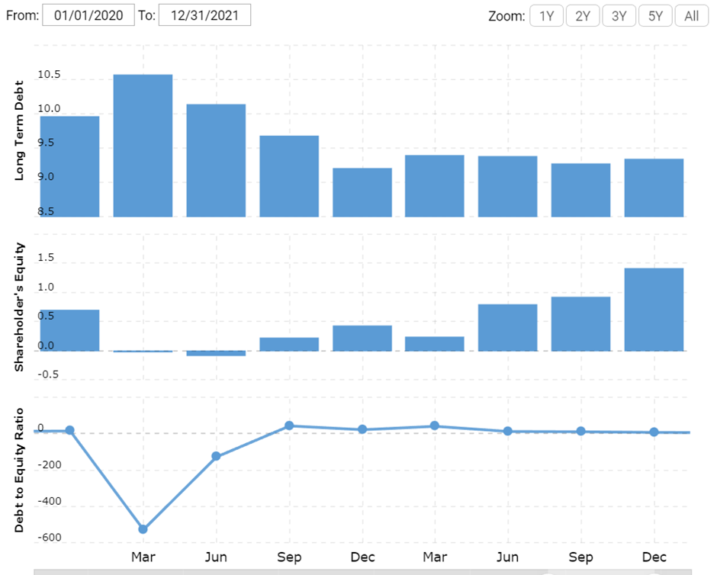
Figure 10: Debt/Equity Ratio
The company’s debt to equity ratio was the highest during the dip period in March of 2020. After the June of 2020, it saw improvement in this area and it ended the year 2021 on a high note with a 17.07 ratio.

Knowledge from Ratio Analysis
From the above ratio analysis reports of Marriott International Inc, it is evident that the company saw a downward motion in all of its financial reports. It was due to the policies during the pandemic that halted its business progress quite a lot. In 2020, the company struggled to make a profit and went into a high debt-to-equity ratio. It had to keep its operations up while not making enough sales. However, since the start of 2021, the company is back in form with a good number of sales and more ROI, ROA, and ROE. (Kim, 2018)

It is also true that the ratio analysis doesn’t show the whole scenario of everything that caused the downturn in performance. It is an essential tool, but it is not a perfect tool. If the analysts of any company keep these fluctuations in mind, it will help them make better decisions. The minute changes in the company’s financial reports are detected in the ratio analysis which is important in making necessary changes

Benefits and Limitations of Ratio Analysis
The ratio analysis method is no doubt an essential part of evaluating a company’s value and potential. It is especially significant to detect financial trends in large corporations such as Marriott International Inc. With a sound ratio analysis, it can become very easy to start making changes or improvements to the business policies. It tells the potential investors about the efficiency, profitability, and liquidity of the company. With the liquidity analysis, we can measure the company’s management condition. How it manages its assets and decreases its debt are important queries from current and potential shareholders.
With that said, ratio analysis has its flaws and is limited in terms of observational power. It depends on the one that’s using it. So, it is good to use the method while keeping reservations about it. (Valaskova et Al., 2018). Large industries and markets are a place of competition. A successful company rests its success on everyone related or unrelated to it. The economic, social, environmental, and cultural aspects can easily influence the company’s decisions. Ratio analysis is an easy and concise way of knowing the company’s current condition and it can also help us get some projected scores as well. However, simple data and results based on those data aren’t enough. If you want to understand a company’s business trends, it is important that you understand the reason behind the business policies. It is influenced by the state, the economy, and the social condition. Understanding the social and economical implications and circumstances can help us understand and use the ratio analysis method. The analysts are obligated to look for non-financial reasons and implications of the company’s business trends. Knowing the company’s prospects, it is unwise to apply the analysis at an inappropriate time. Following the ratio analysis blindly will certainly push the company into error and result in less profit. One other important factor is the bookkeeping style. Since many different corporations and entities use different bookkeeping styles, it is vital to know about the. It is helpful if the analysts use different approaches to understand the financial statements. Only then, it will be possible for the ratio analysis to come to an accurate ending.

Conclusion
Marriott International Inc. has seen some ups and downs in its financial report in the years 2020 and 2021. The good news is that the hotel managed to change its downward curve to an upward curve in all of its financial trends. The ratio analysis shows us that it has better profitability, liquidity, and gearing ratios compared to 2020. It has better ROI, ROA, and ROE which tells us that the investors and shareholders are making profits. It has also increased current and receivable turnover ratios which means the company is in a good position to handle its short-term debts. On the other hand, it has a good debt-to-equity ratio that is better for paying its long-term debts. All of these have been possible due to making more sales after the lifting of covid restrictions and better asset management. With high profitability and good efficiency, the company has a good investment profile to attract more investors. It shows us that even with its limitations, ratio analysis can do so much to gauge the competency of a company and its management.

Bibliography
- Marriott. (2019). About Marriott International | Corporate Information. Retrieved from Marriott.com
- Titman, S., Martin, T., Keown, A. J., & Martin, J. D. (2018). Financial management : principles and applications. Melbourne, Vic: Pearson Australia.
- Berk, J., & Demarzo, P. (2020). Corporate finance (5th ed.). Harlow: Pearson Education Limited.
- Vaidya, D. (2019, August 12). Return on Capital Employed (ROCE) | Top Examples | Formula. Retrieved from Wallstreetmojo.com website: https://www.wallstreetmojo.com/return-on-capital-employed-roce/
- Vaidya, D. (2019). Dheeraj Vaidya. [online] Learn Investment Banking: Financial Modeling Training Courses Online. Available at: https://www.wallstreetmojo.com/ratio-analysis/.
- Brigham, E. F., & Houston, J. F. (2012). Fundamentals of financial management: study guide. Mason, Ohio: South-Western Cengage Learning.
- Al-Wattar, Y.M.A., Almagtome, A.H. and Al-Shafeay, K.M. (2019). The role of integrating hotel sustainability reporting practices into an Accounting Information System to enhance Hotel Financial Performance: Evidence from Iraq. African Journal of Hospitality, Tourism and Leisure, 8(5), 1-16.
- Suraya, A. (2018) “The influence of accounts receivable turnover and inventory turnover on profitability at PT Sumber Alfaria trijaya tbk,” PINISI Discretion Review, 2(1), p. 77.
- Robinson, T.R. (2020). International financial statement analysis. John Wiley & Sons.
- Valaskova, K., Kliestik, T. and Kovacova, M. (2018). Management of financial risks in Slovak enterprises using regression analysis. Oeconomia Copernicana, 9(1), 105-121.
- Brigham, E. F., & Ehrhardt, M. C. (2020). Financial Management: Theory & Practice. Boston, MA: Cengage.
- Kim, S.Y. (2018). Predicting hospitality financial distress with ensemble models: the case of US hotels, restaurants, and amusement and recreation. Service Business, 12(3), 483-503.
- Beers, B. (2019). How Is Asset Turnover Calculated? Retrieved from Investopedia website:
https://www.investopedia.com/ask/answers/032415/how-asset-turnover-calculated.asp

