Student name : Vincent David Li Ah Choon, Ramen Tesigen, Martini Kerensa Langitan
Student ID number : David-1715709, Ramen-1715716, Kerensa-1715878
Module : BMPF4010
Module name : Work-based project
Word counts : 6928
Submission date : 8 November, 2019

University of Wales, Trinity St David
PROJECT REPORT
LUX* JUMPS OUT AND BARKS,
“How to create a stray-dog friendly environment
within hospitality?”
Contents

Section 1 Project Report 2
1.1. Introduction 2
1.2. Literature Review 2
1.3. Methodology 5
1.4. Research Findings 7
1.4.1. Quantitative survey report 7
1.4.2. Qualitative survey report 16
1.5. Conclusion and Recommendation 23
References 25

Section 2 - Appendices 27
Appendix 1 – Survey Questionnaire 27
Appendix 2 – Copy of Ministry of Tourism letter 30
Appendix 3 – Consent Form 34
Appendix 4 – Table A 35
Appendix 5 – Table B 36
Appendix 6 – Table C 37
Appendix 7 – Table D 38

Section 3 – Ethics Form 39

Section 1 Project Report

1.1. Introduction

Various sights of stray dogs had been noticed more and more by LUX* Grand Gaube hotel guests and team members, that sometimes resulted in a less comfortable stay and work environment. The aim of this project was to look for a sustainable way in tackling stray dog issue with care and a possibility to have a temporary shelter within LUX* Grand Gaube hotel premises.

The researchers were also keen to pilot this project, not only as a stray-dog friendly hotel but also to make a positive impact on this matter throughout the community in Northern Mauritius and the country in general.

Several survey methods were carried out to obtain opinions from guests (tourists), team members (residents), community, authorities, and animal-welfare organisations. The questions on focus group and interviews were designed to gather some insights as to what had been done so far, the challenges, and the impacts.

The outcome was unpredictable and put the researchers in contemplation to find the most appropriate recommendations.

1.2. Literature Review

Webster (2013), conducted an extensive survey on 1200 U.S. and Canadian tourists to find out their opinion on stray cats and dogs encountered during their vacation, and the impact on their future travel decisions. 41% indicated that this experience upset them and influenced their decision to go back to the same destination. 7% of the respondents took this concern so seriously that they refused to travel to destinations with stray cats and dogs. In addition to those numbers, a third of the respondents would share their experiences with their travel agents, with family and friends, and on social media. This information was considered very relevant to the travel industry, including hotels and resorts, tour operators and airlines, and eventually would affect the destination’s income negatively. According to Davis (2010), a loss of USD 15 million each year affected Puerto Rico, with its more than 150,000 strays on the beaches and streets, as tourists considered this factor before booking their stay.

Uncontrollable strays gave not only an uncomfortable image of the country but could also cause health and safety issues to human and (farm) animals, such as infectious diseases, fecal contamination, road accidents, and other incidents such as fighting and uncontrolled breeding.

In Cameroon, Africa, rabies seemed to be ignored until it became a major public health problem. Efforts to combat rabies-caused human deaths were often shut out due to lack of community awareness (Raymond, Jan 2015).
A press release by The Ministry of Environment in 2015 stated that stray dogs might attack humans, vehicles, other animals, and they could be source of excessive noise. The hospitality sector therefore could suffer significantly and Mauritius might be viewed as a country with excessive stray dogs on public and tourists areas.

There had been measures taken to reduce strays globally and some to the extreme, such as 400 stray dogs were poisoned in Somalia out of concern that they could spread rabies diseases and kill livestock. This act was condemned and investigated by the regional animal rights activists since there was no proof of the dogs having the diseases (Deutsche Presse Agentur publication Hamburg, 2016).
In the Canadian Travel Press 2010, Davis referred to the initiative taken by the non-profit organization CANDi (Canadian Non-profit organization of Cats and Dogs International) to fight and find a solution to avoid cruelty towards stray dogs and cats as had been experienced in Athens before the Olympic Games, when the government took drastic measures including electrocution, poison, and shooting.

According to Webster (2013), the solution was not mass killings. It would not address the cause of the problem and considered inhumane, furthermore the surviving strays would get more resources and might multiply faster. It would also attract negative global publicity for the country adopting these measures.
The Humane Society of the United States (HSUS) restated from Arluke & Luke (1997) the link of animal cruelty acts to a variety of other crimes such as property crimes, violence against persons and minor offenses.

Webster (2013) also indicated that the most-cited concerns from the survey participants were the emotional impact on seeing strays suffering, which was far beyond all other reasons provided. This also meant that cruelty should not be an ‘approved’ solution (or even an option).
The only permanent and cost-effective solution would be sterilisation, though some countries thought that they could not conduct this within their communities. Having a proper education program about animal welfare in the tourist destination communities, including humane treatment of animals would not only give better security to travelers but might also address hidden causes of potential violence amongst community members and guide the issue to a positive change to both animals and people.
Webster also referred to governmental support and partnerships with NGO’s, travel agencies, airlines, and hotels that could induce a sustainable change to positive views, which in return would attract more visitors, and eventually improve the country’s economy.

Davis (2010) mentioned the initiatives organised by Air Transat, who decided to support a stray adoption project and develop a significant solution on the Caribbean countries and Mexico. More than 60% of the Canadians have a pet, which could be positively influenced by travel associations and destinations who participated in the caring of stray dogs and cats. Air Transat facilitated free transportation to the strays’ new homes in Canada, as well as to the volunteers and vets in order to facilitate the engagement.

In 2015, Mauritius received approximately 200 reviews on Trip Advisor with regards to stray dogs on the island. An investigation by Daily Mail in June 2015 on a link of video of a gruesome culling, shared by a reviewer from the UK, forced the government to stop this barbaric practice. Some Mauritian citizens started to understand the impact and proposed various means such as creating more shelters and sterilisation programs on the island. In the Daily Mail, Mrs. Peerkhan-Ghoora, co-founder of My Animal Rescue Society, stated “People must stop fearing approaching the authorities; they have to be strong enough to be able to approach the relevant people and voice out for the voiceless”. (Staton, 2015)

Based on Mauritian Government News (2018), Mr. Mahen Seeruttun, Minister of Agro-Industry and Food Security, signed a Memorandum of Understanding with the Humane Society International to tackle the problem of stray and roaming dogs throughout the island and emphasized that the Mauritius Society for Animal Welfare was committed in promoting friendliness, preventing or suppressing animal cruelty.

According to Humane Society International Africa (2018), thousands of dogs and puppies had already been spayed and neutered in Mauritius, a favourite destination for tourists and celebrities. There were approximately 250,000 dogs in Mauritius, of which many were owned but still free to roam the roads and beaches.

Katz (2006, p. xviii-xix) stressed that dogs were the most loved and abused creatures. People spent lavishly for pure-and designer breeds while other animal lovers were trying to rescue and find home for unwanted dogs.

Dogs are simple animals, think and feel in a primitive way. They do not talk and to deny they are animals is a fundamental misunderstanding. We blame them, yet they are blameless. The responsibility is ours, not theirs. For all the fuss about animal rights, they have none.

Personal /Professional Learning
My first review on literature was the article of the economic impact on stray cats and dogs at tourist destinations on tourism industry, written by Webster in May 2013. It was initially difficult to find some literature related to the project, however many references were found available on the online library of the university.
I was inspired by Webster’s article, on how she encountered a sad situation of stray dogs during her vacation in Mexico in 2006. At that particular time, she started working for solutions to help strays at the tourist destination. The report on her article helped me in writing a review about stray dogs and how a guest experience could impact negatively. Many review points were shared and discussed among the researchers to build the project report.
Another interesting article was found written by Davis in 2010, who stated that the founder president of the Canadian non-profit organisation – Cats and Dogs International (CANDI), Darci Galati, had reported the strays negative impact on economy in Mexico and the Caribbean. The countries lost revenues in their tourism sector, including Puerto Rico that lost millions of dollars because of the uncontrolled stray population.
The articles above made me understand the gravity of a similar situation happening in LUX* Grand Gaube, and on the island of Mauritius in general, despite the fact that in 2018 a government press article stated that thousands of stray dogs in Mauritius had been sterilised with the collaboration of Humane Society International (HSI).
I felt concerned with the situation and thought that this should be voiced out as well as solutions sought by teaming up with different government / non-governmental organizations.
Personal contribution
I made research and do the write up personally of the above three articles and shared among the group.

1.3. Methodology

Four types of methods were used in this research to collect data and information:

- Survey:
This survey was done on internal and external participants i.e. designated hotel team members and in-house guests. Team members included security, front office, housekeeping, food and beverage, and engineering departments. The questionnaire was given out once participants had confirmed their consent and agreed to take part in the study. Google forms were used and available at the reception areas for guests and at the cafeteria area for the team members to fill out during breaks. Participation was voluntary, no personal details were recorded, and feedback was subjective to each participant. Participants were advised that they could withdraw at any time without giving any reason.

Surveys done through Google Form separated for guests and team members:

https://docs.google.com/forms/d/e/1FAIpQLSfGV3hSfXDPCCIkmTYvqm4zaGF9YIlFgS3-cLex3sP7Cit-vA/viewform?usp=sf_link

The available period of this survey was about one month for guests and two weeks for team members.

The purpose of the survey was made clear. The questionnaire was designed to be relatively concise, 10 questions with multiple-choice type of answers and some open-ended questions for further feedback. This would take approximately 10 to 15 minutes to complete. Alternatively, participants were given the choice to complete it at their leisure. A minimum of 50% of responses was anticipated otherwise a new research would be done.
Participants were also given an opportunity to give their opinions in written.
The objective of the survey was to obtain participant’s opinions on stray dog appearances within the hotel areas and possible solutions.

On the survey, participants were asked if they encountered stray dogs around their (guest) room or working areas and if this would somehow affect them physically and/ or emotionally. Further explanation could be given as an option. The researchers were also interested in the participants’ opinions on the cause of their existence, the impact on the hotel, and the island in general. The participants’ subjective responses on possible resorts engagement to improve the situation was inquired, and whether or not an area should be designated for the stray dogs found at the resort.

The researchers chose this method due to the big number of participants, and to obtain subjective feedback, and for maintaining anonymity. All information was treated confidentially and used for academic purposes only.

The data collected was put into Excel sheet framework for analysis and comparison, converted into percentage, and discussed in the findings.

- Focus group:
This method was done to obtain professional views and more detailed information with regards to stray dogs in general and the impact to tourism in particular. Participants were vets, animal care related organisations, and other hotels representatives.
Participants were invited by phone or e-mail with the purpose and meeting agenda. This was sent two weeks before and a follow up confirmation was done up to three days before the event. The event took place at the hotel conference room or other meeting areas.
The researchers chose this method to save time in collecting related advices and sources, and to obtain qualitative and objective feedback through a group discussion with people who were knowledgeable in this particular field, had similar thoughts towards animal care and the impact on hospitality. A brief presentation on the actual situation and specific questions were prepared for this meeting. Minutes of the meeting were taken. The event was anticipated to last around 2 hours.

- One to one interview:
This method was chosen to gain information from specific individuals who were high influencers and decision makers on the national level.
The initial invitees included representatives of Ministry of Agro Industry and Food Security (animal welfare), Ministry of Tourism Mauritius, and airlines representatives (public relations or senior management).
Invitees were contacted by phone two weeks before the proposed event and the purpose of the interview was explained. An official request was sent by e-mail for an appointment. The request was however only responded to by the Ministry of Tourism Mauritius through e-mails.

The researchers decided to interview the Chief Security from a sister property, LUX* Belle Mare, who had been handling stray dogs around the property and in contact with various animal welfare organisations. A brief presentation on the actual situation and specific questions were prepared for the interview, use of recording was explained and voluntary, written notes were taken. The recording was kept in company’s mobile with password and for internal or academic use only, this data would be deleted after concluding the project.

- Observation:
This method was to acquire knowledge on how to handle stray dogs and proper sheltering. Sources were existing dog shelters and kennels in Mauritius.
The researchers contacted the associations by phone or e-mail at the latest one week before the visit. The purpose of the visit was explained. One source, located at a reasonable distance from the hotel, was identified.

The researchers requested an advanced permission to take notes, use camera or video. A consent form was prepared and signed. Images and video recordings were kept in company’s mobile with password and for internal or academic use only. This data would be deleted after concluding the project.

1.4. Research Findings

1.4.1. Quantitative survey report

200 questionnaires were given, as per Appendix 1 – Survey Questionnaire, 100 to guests and 100 to the team members.
30(%) of guests had responded and 72(%) of team members participated on this survey, with responses totaling 102.

Analysis on stray dogs’ visibility, concern on their presence,
and feeling when encountering stray dogs

More than 65% of guest-participants had somehow encountered stray dogs in the hotel area, while all team members had seen their existence and most of them on a daily basis.

While most guests liked the dogs and did not mind the presence of stray dogs, most of the team member-participants felt concerned by their presence. 44 additional feedback points were received ranging from their concern of affecting guest stay and hotel image (32%), followed by hygiene and possible spreading of disease (27%). 23% of team members however were concerned for dog welfare, while 17% were afraid of being attacked (Appendix 4 – Table A).

The following table shows that guests did not mind the dog presence, however most of them were sad or frustrated when they came across stray dogs. Team members expressed feelings of sadness, frustration, and fear. Individual opinions were given in Appendix 5 – Table B.

This information indicated that a certain level of comfort was being disturbed due to the stray dogs existence in the hotel compound, including team members work environment.

Analysis on possible actions and causes of stray dogs

Majority of actions that would be taken were related to dog welfare such as being hungry, lost, and no shelter, which indicated a high level of concern.

Both guests and team members had equally responded on the causes responsible for stray dogs’ existence. The first and second cause respectively being not enough control by the government as well as ignorance and lack of knowledge. From multiple feedback, all participants somehow agreed and/ or were aware of all causes and their complexity. The matter did not only involve an individual lack of knowledge but seemed deeply rooted in the culture becoming a national issue.

Majority of the participants thought that action should be taken by the hotel or hospitality industry with some subjective ideas given by the survey participants on why and how the hotel could take part on the issue of stray dogs, Appendix 6 – Table C. From 32 individual opinions, 22% referred to contact a specific company, 22% thought of a temporary shelter including the use of hotel food waste, 10% asked to remove the dogs, while others, 46%, showed different individual opinions.

The above information confirmed the researchers’ hypothesis of a high concern and need of having various solutions in tackling this complex matter. This would only work successfully if actions were taken from all levels of community and society.

Analysis on improvement program requirements on national level

When given the choice of improvement on solutions, all of guest-participants thought education should be given to the pet owners, and none of them agreed on eliminating stray dogs. The second and third solutions were related to law and education of animal welfare, while other initiatives could also be looked at, such as dog-sterilisation and adoption-programs, and giving a temporary shelter. Similar to guests, the team-member participants had various and mixed opinions on this matter. Few of them however thought of an extreme solution by eliminating stray dogs.

The high numbers on various solutions offered above also gave an indication that there was no single ideal solution. Various programs were required to improve the situation, but eliminating stray dogs could (almost) not be part of the solution.

Analysis on LUX* Grand Gaube participation

Majority of total participants strongly agreed that the hotel should partake in the improvement programs, which was also supported by their additional feedback indicated on Appendix 7 – Table D. 88%, 28 out of 32 personal feedback agreed on the hotel participation.
60% of the total participants who agreed on having a temporary shelter at the resort.

It was evident that there was a high need of taking immediate action on improving the welfare situation of stray dogs, however having a shelter at the resort needed to be thought through as its impact on reducing stray dogs around the hotel might not be as anticipated. Obtaining professional advice from different dog-care related experts was therefore essential.

1.4.2. Qualitative survey report

1.4.2.1. Focus Group

The researchers decided to invite different stakeholders from Non-Governmental Organisations, NGO’s, concerning stray dogs in Mauritius in order to get optimum professional views and expert advice on the project. A research on social media platforms was done in order to identify their activities on the island. The meeting took place at the hotel LUX* Grand Gaube.
Eight NGO’s were contacted two weeks prior to the meeting by phone and the purpose of the focus group meeting was explained. Some organisations requested a more official invitation, by e-mail and an inclusion of the list of participants.
After a follow up, the meeting was finally attended by four different representatives: the director of Human Society International (HSI), a veterinarian from Prevention Animal Welfare Society (PAWS), the director of All Life Matters Animal Sanctuary (ALMAS), and one rescuer of 4 Paws on Wheel (4PoW).

Representatives of District Council of Grand Gaube (DC) and the Security department were also attending the meeting. DC was invited as part of the strategy in reaching one of the project aims, which was to spread animal care awareness within the community. The researchers hoped to voice out this concern to the public in a more effective way.
The purpose of inviting the hotel security representative was to give access to various information provided by the experts, in order to find better and effective ways on how to handle stray dogs on the hotel premises, other than chasing the dogs away that might create a negative image for the property.

The meeting was conducted in English and commenced with a brief presentation of the project.

During the meeting, the researchers were informed that some organisations had differences in how to handle animal welfare/ stray dogs, some were conflictive and not on good term with each other. None of the organisations however thought that the government had given enough attention to this matter.

Most participants agreed on a shelter within the hotel, however there were different opinions. Two NGO representatives, HSI and ALMAS, suggested to have a shelter with an open-park style. The reason was that stray dogs were not meant to be confined in a gated park as they used to be free and would not survive the closed environment. Two separate areas were suggested, one being an open park and one being confined environment for stray puppies, as they would adjust to being kept in a closed area. The other reason was because of the risk of fights as a confined environment filled with different stray dogs might make them fight and cause noise disturbance.
It was also explained that the term stray for dogs in Mauritius was actually incorrect, since most of the dogs were usually owned but they were either abandoned or let free.
The sterilisation program was suggested as a must-do action, regardless of any welfare project for stray dogs. PAWS confirmed the cost of sterilization per dog was MUR 700. Several attempts were made by the participants to involve different hotels in getting their support on the program but the result was minimum. HSI had been already working with two resorts, a sister hotel, LUX* Belle Mare, and Trou aux Biches Golf & Resort. PAWS had also helped LUX* Belle Mare with the stray dog adoption to foreign countries and Trou aux Biches helped advertise to their guests about the collaboration with HSI.
The director of HSI also mentioned that for a sterilisation program to become successful, there should be a clear strategy, such as:
- Media involvement to spread the news i.e. local radio, television, and social media
- Creating an incentive system, valuing people who participated in the program, and having sponsors that could contribute financially
- LUX* Grand Gaube might need to invite the authorities, NGOs, resorts on the northern part of the island, and residents in vicinity to work hand in hand in order to create a synergy and the same vision or direction
- An organized workshop for team members concerning animal welfare focused on stray dogs in the area to help the situation

The DC agreed and gave a very positive response and would like to start with collaborating the Village Council of Grand Gaube with NGOs and LUX* Grand Gaube to materialise this project. It could start by spreading flyers to promote the sterilisation program day amongst residents of the village.
According to PAWS, education about dog sterilisation was very important and mentioned about the compulsory requirement not to feed the dog on the procedure day, the importance of marking or microchipping, which was very common in modern countries to indicate sterilised dogs or the “V” mark that would be done on one ear of the dogs. This mark would make it easy to recognise even from a distance and the action would prevent from double procedures, wasting of resources and time.
As from 2018, HSI had launched a pilot project of free sterilization program on the east side of the country and set a target of 10,000 dogs per year. It was also mentioned about the initial challenges in convincing the government that catching and killing stray dogs was not the right solution neither sustainable. HSI had 3 vets working for the organisation and they could sterilise up to 40 dogs per day. It was also declared that Mauritius was included amongst the few countries that had been chosen by Lion’s Share Fund to launch this program and HSI received their financial support. HSI would then need to prove the impact to the government that it was the right means to reduce stray dogs. In the case of positive impact, the same program would be extended to the whole island.
Since the shelter project was meant as a temporary solution, the researchers were also keen to know about any potential care continuation including dog adoption programs.
According to the representative of ALMAS, their organisation received a lot of phone calls, requiring stray dog rescues. This happened mostly from a hotel or someone in the vicinity. Most of the times the dogs were either injured or in a very bad condition. Once they arrived at the dog sanctuary, the vet would took care, give them an appropriate treatment, and if necessary sterilise the dog. The dog would be practically ready for adoption, however it was unusual to have someone coming to the association to adopt dogs. ALMAS therefore often organised adoption program days in a shopping mall where it was easier to attract people and the adoption process could be simplified.
It was also noticed that people from Germany were keen in adopting handicapped dogs. ALMAS had been also working in close relation with airlines Concord and Lufthansa to facilitate dog transportation from Mauritius to foreign countries. This association took all administrative responsibilities with the airlines as well as the government.
4 PoW representative contributed in implementing house checks whenever they received a request for a dog adoption in Mauritius to ensure enough space and a kennel for the dog, and avoid mistreating. A spot check was recently done to an adoptive dog and it was noticed that the dog was in a very bad condition and therefore the dog was taken back to the shelter.
All participants were pleased to know about the interest of The Lux Collective for taking the lead in the stray dogs issue in the country. The director of HIS was proud to be able to initiate the program with LUX*Belle Mare in the east of the country. The director of ALMAS mentioned that taking care of animals could also contribute the hotel marketing as many guests were pet lovers. If the program of stray dog welfare was implemented efficiently and carefully, this might boost the sales in a sustainable way.
The meeting lasted around 2 hours with 9 participants, including 3 researchers.

1.4.2.2. One to one interview

The initial plan was to meet with a representative of the Ministry of Tourism and/or Agro Industry. Several attempts were made through phone calls and e-mails with no response. The researchers decided to forgo this interview option and looked for another option.

At a later stage, the Ministry of Tourism nevertheless sent the researchers a letter related to actions taken on stray dogs in Mauritius that is detailed on Appendix 2 – Copy of Ministry of Tourism letter. It was clearly understood that the matter was complex and sensitive. There were different opinions coming from tourists who were animal lovers and the ones who did not wish to see any stray animals during their holidays. The Ministry seemed to be challenged in reconciliation the needs of these different groups of complainants. The researchers received two letters, sent within four hours, with a highlighted difference as follows: first letter including euthanasia and the second one, being revised, excluding the procedure. These contradictive letters had shown the researchers that the Ministry had used the same draft of previous operation, that euthanasia was indeed used, but it had been discontinued currently. This was also in line with the HSI intervention and used sterilisation program as opposed to catching and killing stray dogs.

The researchers then decided to contact the Chief Security at LUX* Belle Mare, who was already involved in a similar project about stray dogs on the east region. An invitation was sent and accepted. The interview took place at the sister hotel LUX* Belle Mare at the Security Office.

The Chief explained the reason why he was interested in the stray dogs matter. It was not for a social cause but he thought that the issue could affect the business negatively. He noticed the existence of stray dogs, in front of his resort and more on the public beach, especially after week-ends when people threw away food after parties. Furthermore, he also noticed the invasion of stray dogs as he drove from his place, 40 km away in the southern part of the island. One day he counted the number of stray dogs and came across around 250 stray dogs within the first 20 km.

Security department had received many calls from several team members on the beach asking for support in controlling aggressive stray dogs that disturbed them during their work. The team members informed that the dogs got agitated towards them but not toward guests. Through several observations, the Chief came to realise that one of the reasons was simply because tourists fed the dogs while team members always chased them away.

The Chief further explained that he firstly contacted Mauritius Society for Animal Welfare (MSAW) to report about the stray dog issue, but the authority never intervened.

The first experience to come in contact with a NGO was when a stray dog gave birth to 6 puppies in front of one of the hotel villa’s. This event became a resort attraction and the villa guest wanted to adopt these dogs. The Chief then contacted PAWS and the director came in person to see the female dog with her puppies. The partnership had since continued and he was proud to be able to support the guests in adopting more than 12 stray dogs. Guests came from European countries such as England, Netherland, Germany, and Switzerland. The Chief also humbly mentioned that his role was only being a bridge between guests and the NGO. All administration was dealt directly between them. The cost of sending a dog to Europe was around MUR 50,000 and around EUR 200 if a person accompanied the dog.

The Chief also explained that he received full support from the Management since most guests were concerned on this matter and highlighted the special relationship that he developed with the first family who adopted the dog with her puppies. This family sponsored an 8-day sterilisation campaign in Belle Mare region and actively participated with the village residents. This campaign was made available in partnership with PAWS. The Village Council was contacted to inquire for a suitable location and members of the Council were favorable to offer their contribution in deciding an area to launch the sterilization campaign.

Similar to the focus group, the Chief also mentioned the importance to involve team members who live in the hotel vicinity to encourage their families and friends in bringing their dogs for sterilisation. The Chief also visited Primary Schools in the area to explain on how stray dogs could bring negative impact on the country’s economy and that sterilisation was the best solution to reduce number of stray dogs.

Another international, Switzerland based, organisation was mentioned, known as Susy Utzinger Animal Protection Trust, which had sent thousands of brochures titled as “Love animals at holiday resorts and how to avoid the guilty conscience after your holiday”. These brochures were placed in the resort shops and distributed at schools.

The Chief also spoke about the partnership with HSI in achieving its objective of sterilisation of 3000 dogs per year on the east coast. Moreover, the hotel team members also participated actively in the adoption program. This had resulted to a media exposure on the local newspaper, a positive ‘free’ advertising on the Trip Advisor, and various social media platforms. The Chief frequently received mails, messages, and pictures from the adoptive guests and was delightfully surprised to see the physical, healthy, transformation of the dogs.
It was also noticeable that since the HSI project implementation, the stray dog issues had considerably decreased around Belle Mare, on the east coast of Mauritius.

The interview lasted 2 hours.

1.4.2.3. Observation

Observation was held at All Life Matters Animals Sanctuary (ALMAS), Pamplemousses, Mauritius.

The purpose of this method was to acquire knowledge on how to handle stray dogs and provide a proper sheltering. This observation was inquired and explained by the researchers during the focus group. A follow-up email was sent the day before to reconfirm the visit. The researchers noticed the big ground catered for different animals. The dog shelter had its own veterinary clinic and was manned by a team of 8, consisted of a vet from India and a Mauritian assistant, 2 helpers for grooming and animal care, 2 cleaners, and 2 Swiss ladies who managed the shelter.

The researchers started the visit by presenting the manager a consent form, Appendix 3 – Consent Form, that was agreed and signed.

During the observation time, it was informed that all workers were volunteers and funded through donations from foreigners including dog adoptions, which allowed the NGO to fund the shelter.
All volunteers were very commited in helping (injured) stray dogs and mentioned that the island was in need of shelters and volunteers in different locations.

In contradicion to the previous recommendation during focus group, not to confine stray dogs, the researchers were asked to ensure that the gate was shut at all times to avoid escape. Once inside the shelter it was observed, to an unexpected surprise, that all dogs were calm, in peace with other dogs, and did not bark at any visitor. All dogs seemed social and friendly (loose and wiggly body language, relaxed ears, low wagging tail). It was later explained that all the dogs were (badly) injured when captured. They received care, felt safe there, and therefore were calm.

There were around 65 stray dogs in total, including few good breed dogs. Some of traumatic rescued dogs had many difficulties in adapting to a new living environment. They had fear, excessive barking, hyperactivity, and sometimes aggression amongst themselves. The most common behaviours that hinder interactions between dogs and humans were fear and aggression. Interestingly, adult dogs living in shelters were also able to develop a connection rapidly with humans who took care and interacted with them.
It was also noticed that the manager had named each dog and each dog would respond reciprocally when they were called.

The researchers further observed the following:

- Feeding time
Feeding schedule was very important for development and growth, and varied between adult dogs and puppies. The recommendation was twice a day for adult dogs and thrice a day for puppies.

Adult
- Morning time at 07.15 - Breakfast
- Evening time at 06.15 - Dinner

Puppies
- Morning time at 07.15 - Breakfast
- Afternoon time at 02.15 - Snack
- Evening time at 06.15 - Dinner

Dog food was normally donated and preferred rather than money in order to minimise transportation and time to shop.

Water
- Morning time at 07.15 - washing and cleaning the bowl
- Afternoon time at 02.15 - cleaning and refilling
- Evening time at 06.15 - cleaning and refilling
- Bedtime - cleaning and refilling ¼ bowl
Water was very essential. It was advised to provide fresh bowl of water in the morning and all day till evening.

- Proper dimensions of kennels, raw materials used, and health care
- The kennels were designed according to the dogs range of age (puppies and adult dogs)
- The dimension of the kennels was approximately 6×6×7 feet with sealed and impermeable surface and sealed concrete flooring, for effective cleaning and disinfection
- The kennels were not in a position that dogs would be exposed to an excessive amount of sun but had enough natural light
- Kennels must have separation areas between food, defecation and urination.
- Water stations available in all areas
- Soft bedding was required for animals who were rescued with injury or muscle weakness.
- Flooring should be slightly sloped to enable water and waste to easily run into drains.
- A proper ventilation needed for fresh air which was essential for maintaining a good health, reducing infectious diseases and bad odour
- It should not have any sharp edges or gaps that could cause an injury

- General observations during discussions and walkthrough
- During the observation, the researches observed a treatment room, a small food storage and a laundry where cleaning and disinfection products were kept.
- Solution and disinfectant for proper cleaning was very important to maintain clean surfaces, free from dirt and debris.
- There was one isolation kennel for dogs with contagious diseases.
- Pest control to avoid rodents and insects

The organisation suggested that human interaction was necessary in the shelter, including playing and dog walking. This would create a big impact on their emotional and social health.

Upon finishing the visit, the researchers were shown ‘before and after’ pictures of adopted dogs, many were injured rescued dogs. They were transformed to beautiful and joyful dogs in their new home.

The observation was very fruitful and the researchers could gather lots of related information. The visit took around 1 hour.

Personal /Professional Learning
Together as a group, we had analysed and taken the decision to use four methods: survey questionnaires via google forms, which was the easier way to compile data, focus group discussion between professionals, observation, and one to one interview.
The challenge came mostly from team members due to busy operation and not enough time. On the contrary, the guest participants were willing and very glad to participate in the project by answering the survey questions. Guests even congratulated the researchers for the initiative. Target of participants was successfully achieved.
It was my first experience as a researcher to sit around the table with professionals. It was a challenge for me to understand due to different nationalities and different English and French accents, but we managed to communicate and it turned to a real success. All points were then shared with my two colleagues. The write-ups of different methods were assigned equally amongst the researchers.
During the observation, I particularly learnt that taking care of dogs when they were injured was not an easy job. The most important part was about the size and dimensions of the kennels, what raw materials to be used to build the kennels, and essential amenities for the welfare of stray dogs. I learnt about the feeding times, which were very specific for both adult dogs and puppies.
Personal contribution

My individual contribution in this part was done together with another researcher in engaging guests and team members to participate in the survey questionnaire, after explaining the purpose of the project.
As for the observation part, I was also in charge of taking notes and doing the write up. I noted all the important points related to building a dog shelter at the resort and helped with filming and taking pictures in order to have a better overview. This could be also helpful and used as a guidance for team members training once we launch the project.
During the focus group with the NGO’s, my responsibility was to take notes on the discussion.

1.5. Conclusion and Recommendation

The outcome of this project was far beyond building a simple shelter within the hotel or ensuring zero stray dogs in the guest area. It was eye opening to the researchers, as there were so many aspects involved and needed to be considered before drafting any plan. Experiences and feedback from different stakeholders were equally important and yet there was no single ideal solution.
Experts only agreed with each other on certain areas and not on others. Culture played certainly a very important role and it would take time to re-educate and understand the purpose of treating animals well. The initiative however could be always taken by anyone, from any level, at any moment.
The researchers therefore recommend to start with a workshop concerning stray dog impacts, sterilisation program, and animal welfare for the hotel team members. Many of them live in the vicinity and could help spread this information to their families and friends in the neighbourhood so this could be put in practice immediately.

Simultaneously, the hotel is suggested to identify a maximum of 6 guardian stray dogs that are currently present at the resort area, followed by sterilisation and tagging them with the hotel logo. A feeding, shelter-like area, properly designed and opened for guests to visit. The hotel food waste can be repurposed to feed the dogs. An option of a confined, proper sized, area may be added for stray puppies since they could be kept until they adjust to the closed environment. This can be considered as a temporary shelter for stray puppies found in the vicinity and for possible dog adoption.

Transparency about the project should be clear to everyone in the hotel, guests and team members, giving them the encouragement to participate. Events and campaigns should be organised in collaboration with the sustainability and marketing departments.

Good relations with NGO’s and government should be maintained at all times for direct support and communication so the positive impact can reach out further in the country.

Personal /Professional Learning
The key learning for me was working as a team in completing the project, which was more efficient.
I acquired a general knowledge of dog behaviors, proper alimentation and dog sheltering, and gained some awareness on how rabies could result in human death.
My professional learning outcome was that I improved my English writing and speaking. I could also align my last individual project on food waste reduction with the current project of creating a stray dog friendly environment as I proposed the use of the food waste from the hotel as dog feed.
I would be confident if I had to build this project in the near future since I acquired points of considerations, the steps, and aspects to draft the plan.

References
- Beharry, R., 2018. Mauritius Times. [Online]
Available at: http://www.mauritiustimes.com/mt/are-stray-dogs-a-problem/
[Accessed 29 May 2019].
- Webster, D., 2013. The economic impact on stray cats and dogs at tourist destinations on tourism industry. [Online]
Available at:
http://turismo-responsable.com/userfiles/The%20Economic%20Impact%20of%20Stray%20Cats%20and%20Dogs%20at%20Tourist%20Destinations%20on%20the%20Tourism%20Industry%20May%202013-2(1).pdf
[Accessed 28 May 2019].
- Siettou, C., 2015. The UK public's perceptions on the issue of the dog overpopulation problem and people's willingness to pay (WTP) for a humane stray dog management. [Online]
Available at:
https://search-proquest-com.ezproxy.uwtsd.ac.uk/docview/1697445690?accountid=130472&rfr_id=info%3Axri%2Fsid%3Aprimo
[Accessed 28 May 2019].
- Kuriloff, 2016. Wall Street Journal. [Online]
Available at:
https://search-proquest-com.ezproxy.uwtsd.ac.uk/docview/1769797430/715DB3DDE4054BC8PQ/1?accountid=130472
[Accessed 28 May 2019].
- Davis, 2010. Air Transat's bark takes bite out of stray animal problem. Canadian Travel Press, 42(43), p. 6.
- Raymond, Jan 2015 . Do open garbage dumps play a role in canine rabies transmission in Biyem-Assi health district in Cameroon?. Infection Ecology & Epidemiology, Volume 5, p. 1.
- The Ministry of Environment, S. D. D. a. B. M., 2015. Communiqué on Stray Dogs. [Online]
Available at: http://environment.govmu.org/English/DOCUMENTS/COMMUNIQU%C3%89%20ABOUT%20STRAY%20DOGS%2027.01.15.PDF
[Accessed 28 May 2019].
- Mauritius, R. o., 2018. MoU signed to reduce street dog population in a humane and sustainable way. [Online]
Available at:
http://www.govmu.org/English/News/Pages/MoU-signed-to-reduce-street-dog-population-in-a-humane-and-sustainable-way.aspx
[Accessed 28 May 2019].
- Staton, J. (2015, June 18). Daily Mail. Retrieved May 29, 2019, from Mail Online: https://www.dailymail.co.uk/news/article-3128120/Shocking-hidden-camera-footage-reveals-stray-dogs-rounded-tortured-killed-enjoy-unspoiled-holiday-Mauritius-puppies-not-spared.html
- International, H. S., 2018. Thousands of beach & street dogs in Mauritius visit paradise island’s first ever spay/neuter clinic as luxury hotel to the stars helps charity campaign. [Online]
Available at: https://www.hsi.org/news-media/mauritius-dogs-spayed-neutered-103118
[Accessed 28 May 2019].
- (English), .. D. I., 2016. Somali town poisons 400 stray dogs over disease fears. [Online]
Available at: https://search-proquest-com.ezproxy.uwtsd.ac.uk/docview/1781035380/AC09621408E14CE5PQ/2?accountid=130472
Accessed 29 May 2019].
- Katz, J., 2006. Katz on dogs - A commonsense guide to training and living with dogs. New York: Random House Publishing Group.
- Pizam, A. and Mansfeld Y., 2006. Tourism, security and safety: from theory to practice. Burlington, Massachusetts: Butterworth-Heinemann.

Section 2 - Appendices

Appendix 1 – Survey Questionnaire
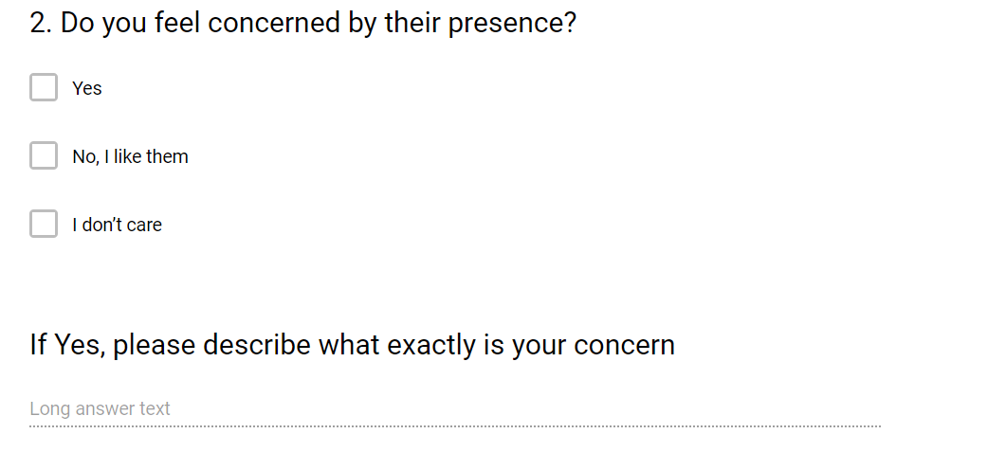
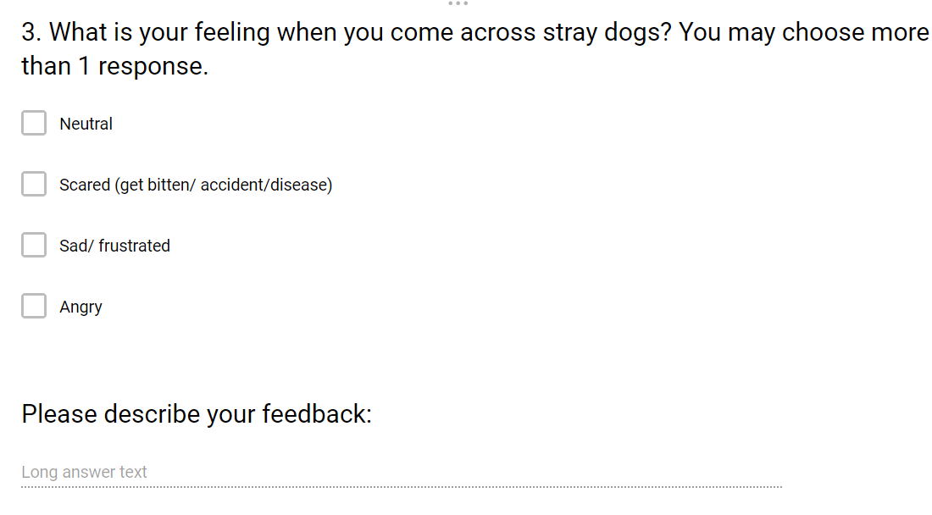
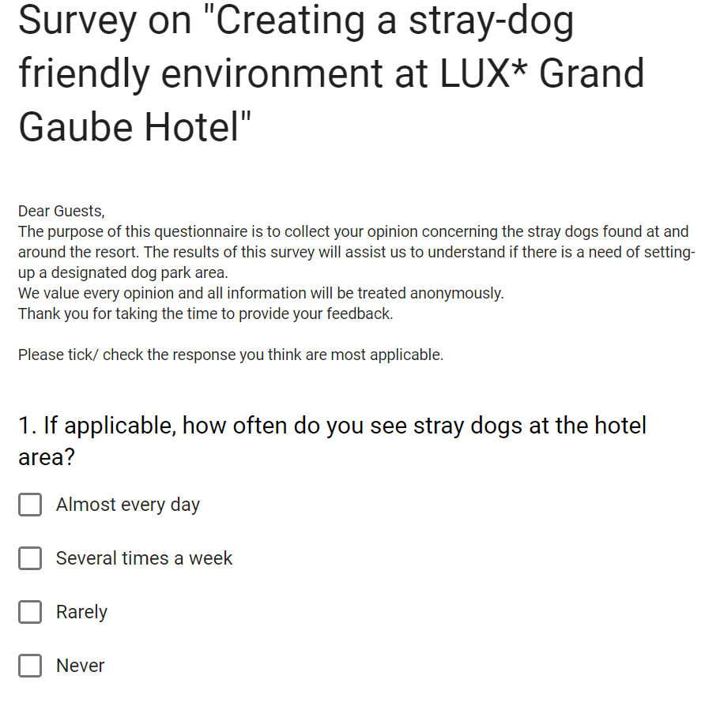

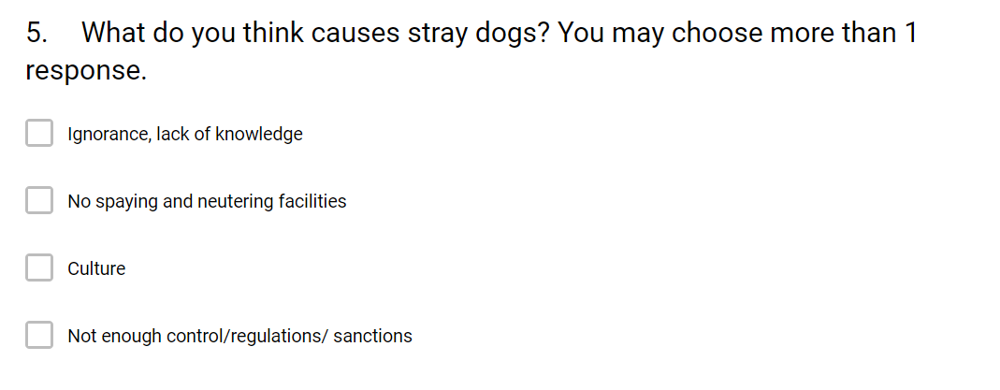
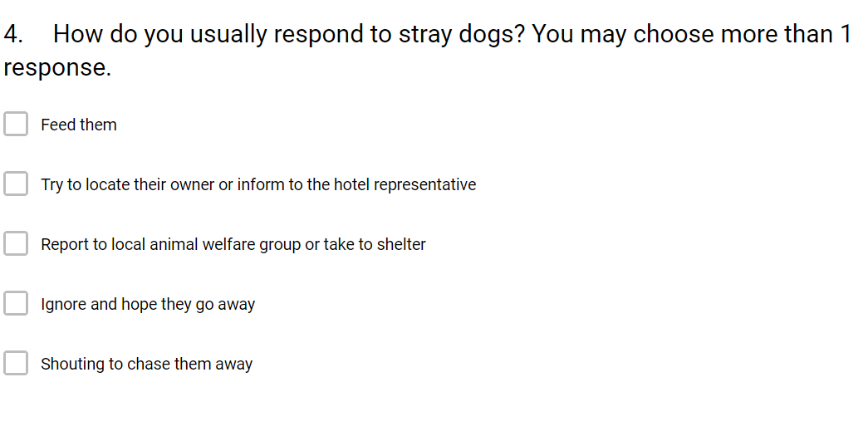
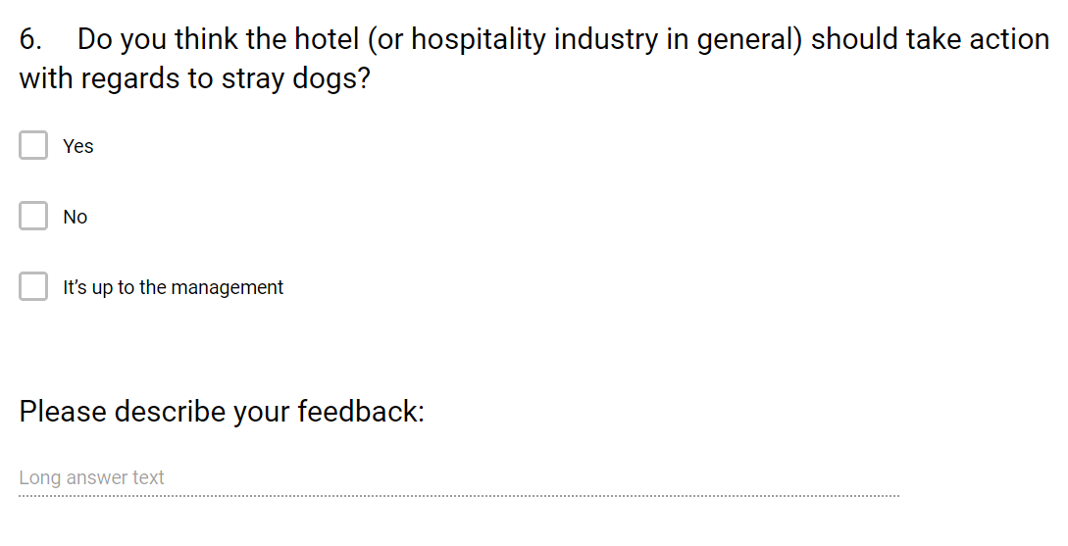
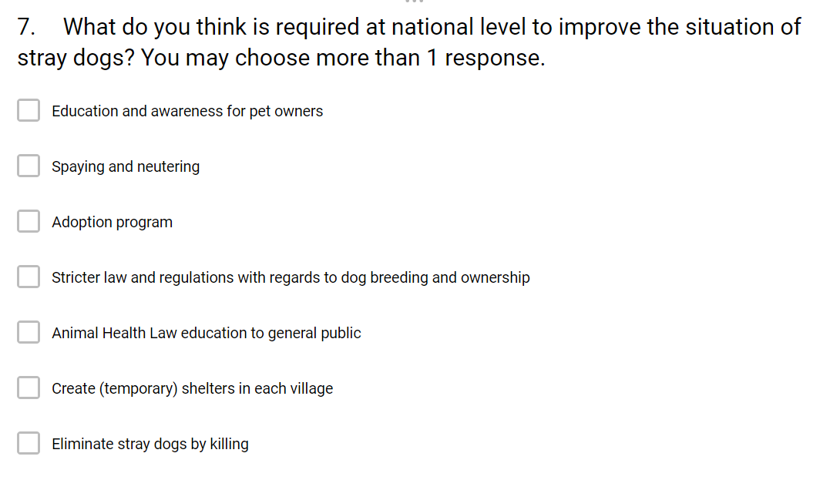
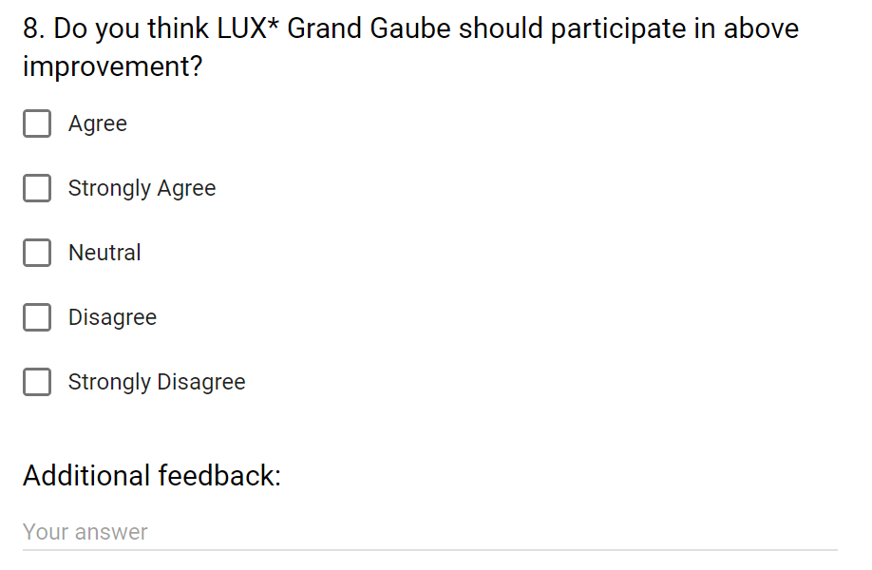
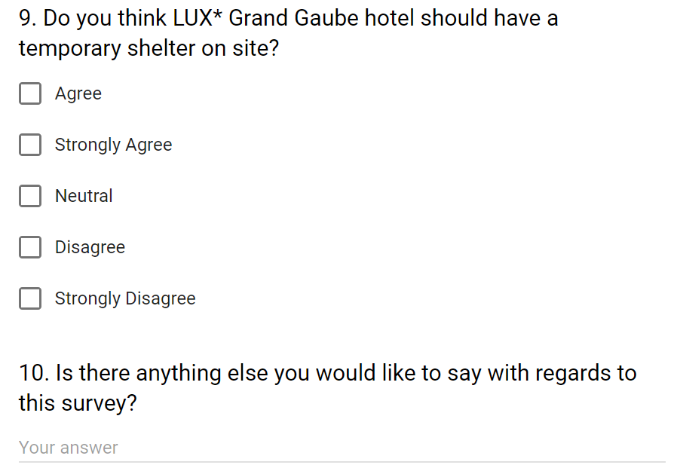

Appendix 2 – Copy of Ministry of Tourism letter

First letter received: 28 August, 2019 at 09:58
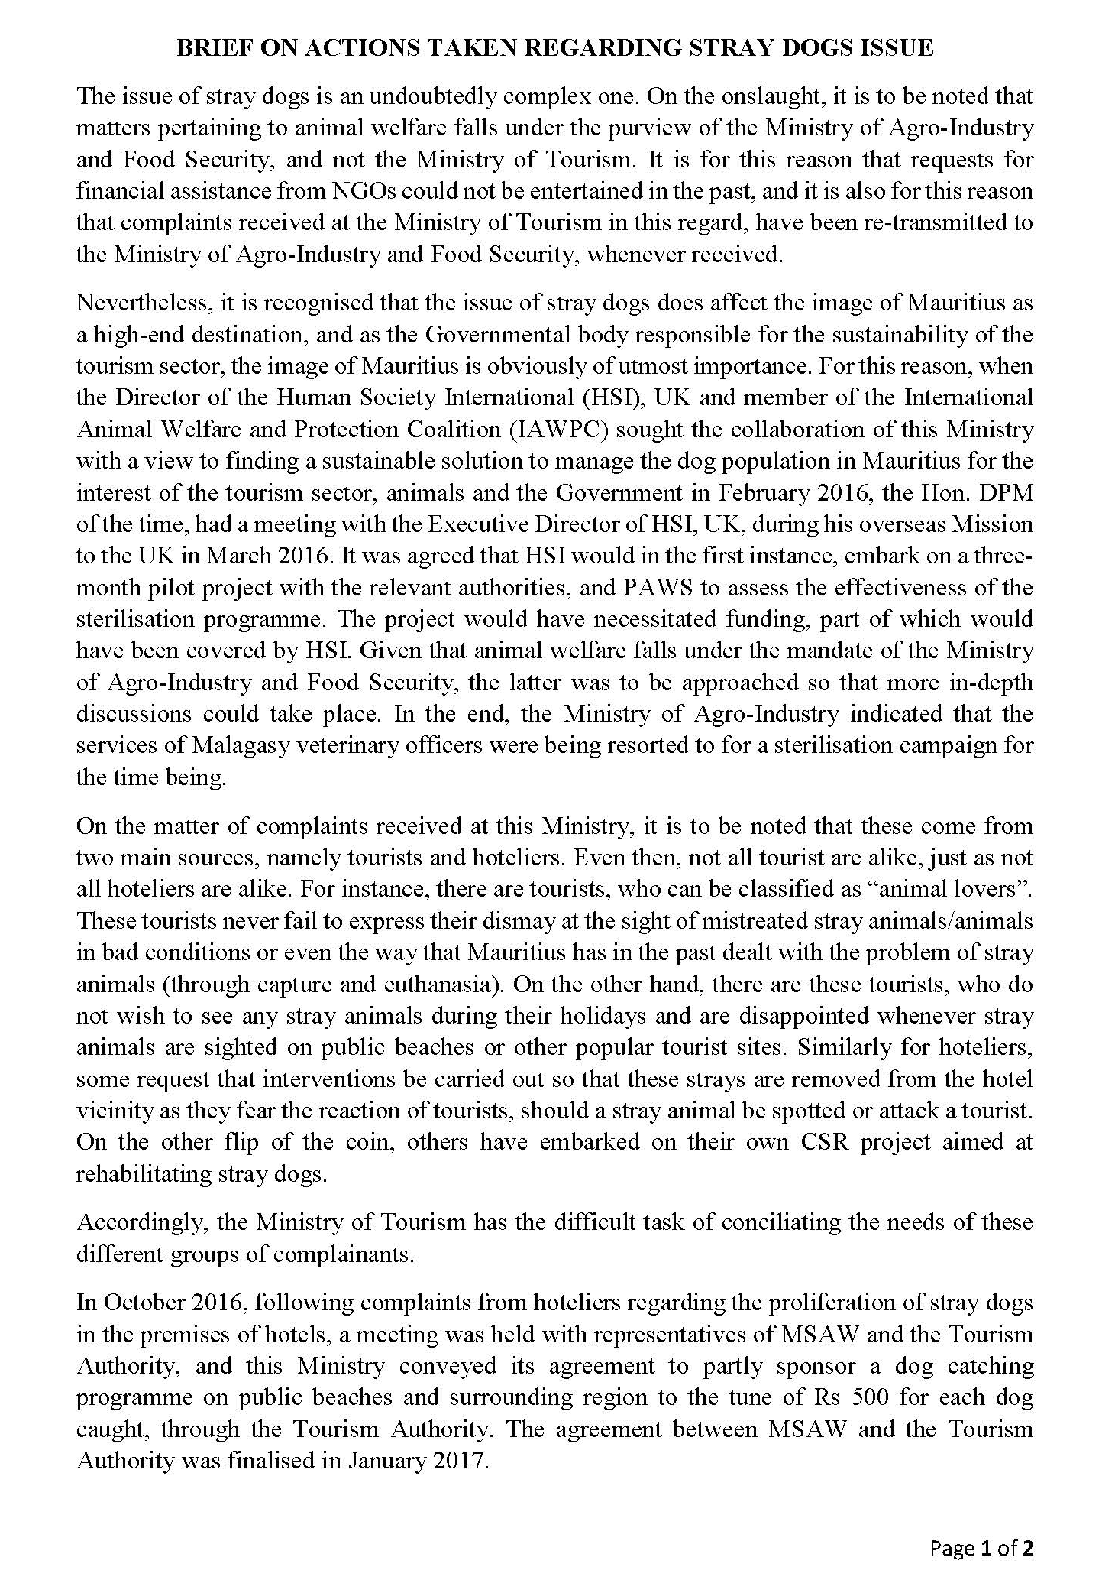
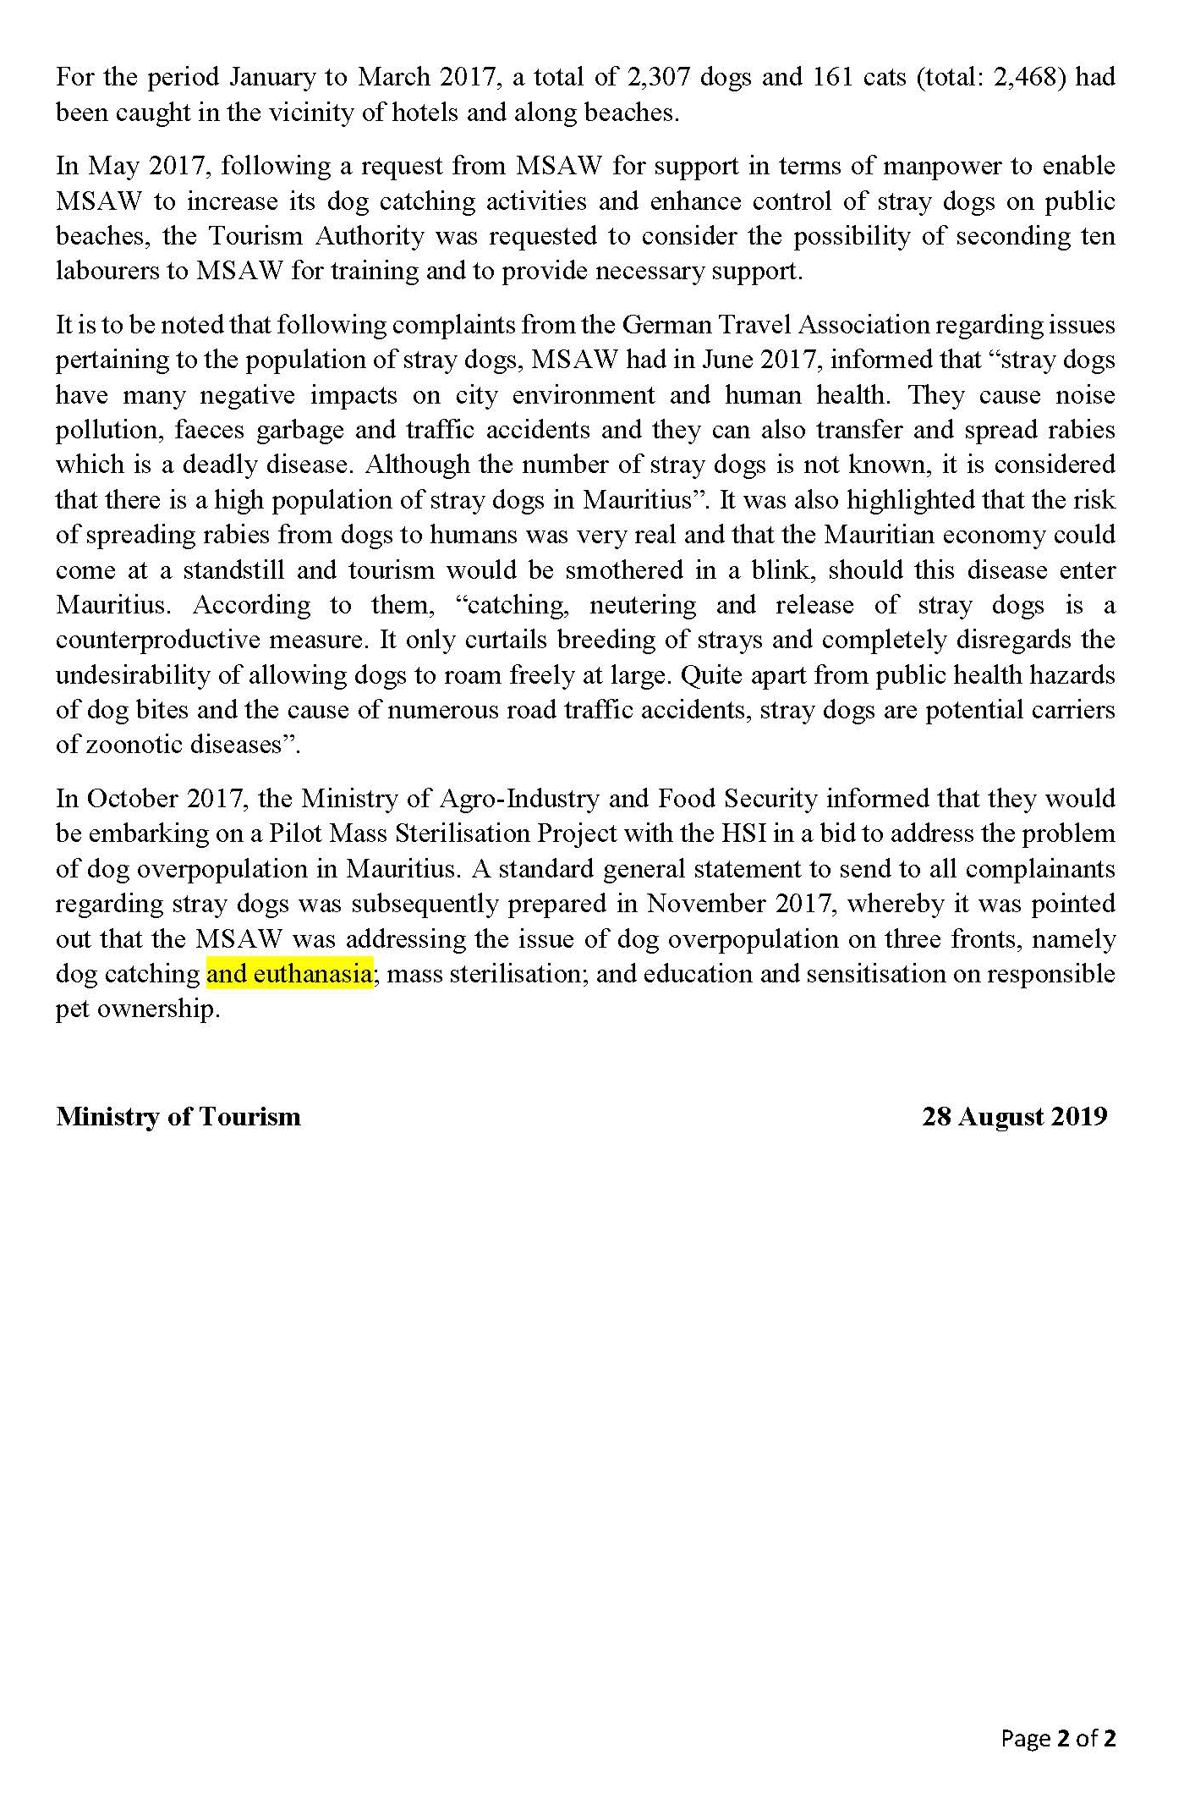
Second letter received: 28 August, 2019 at 13:34
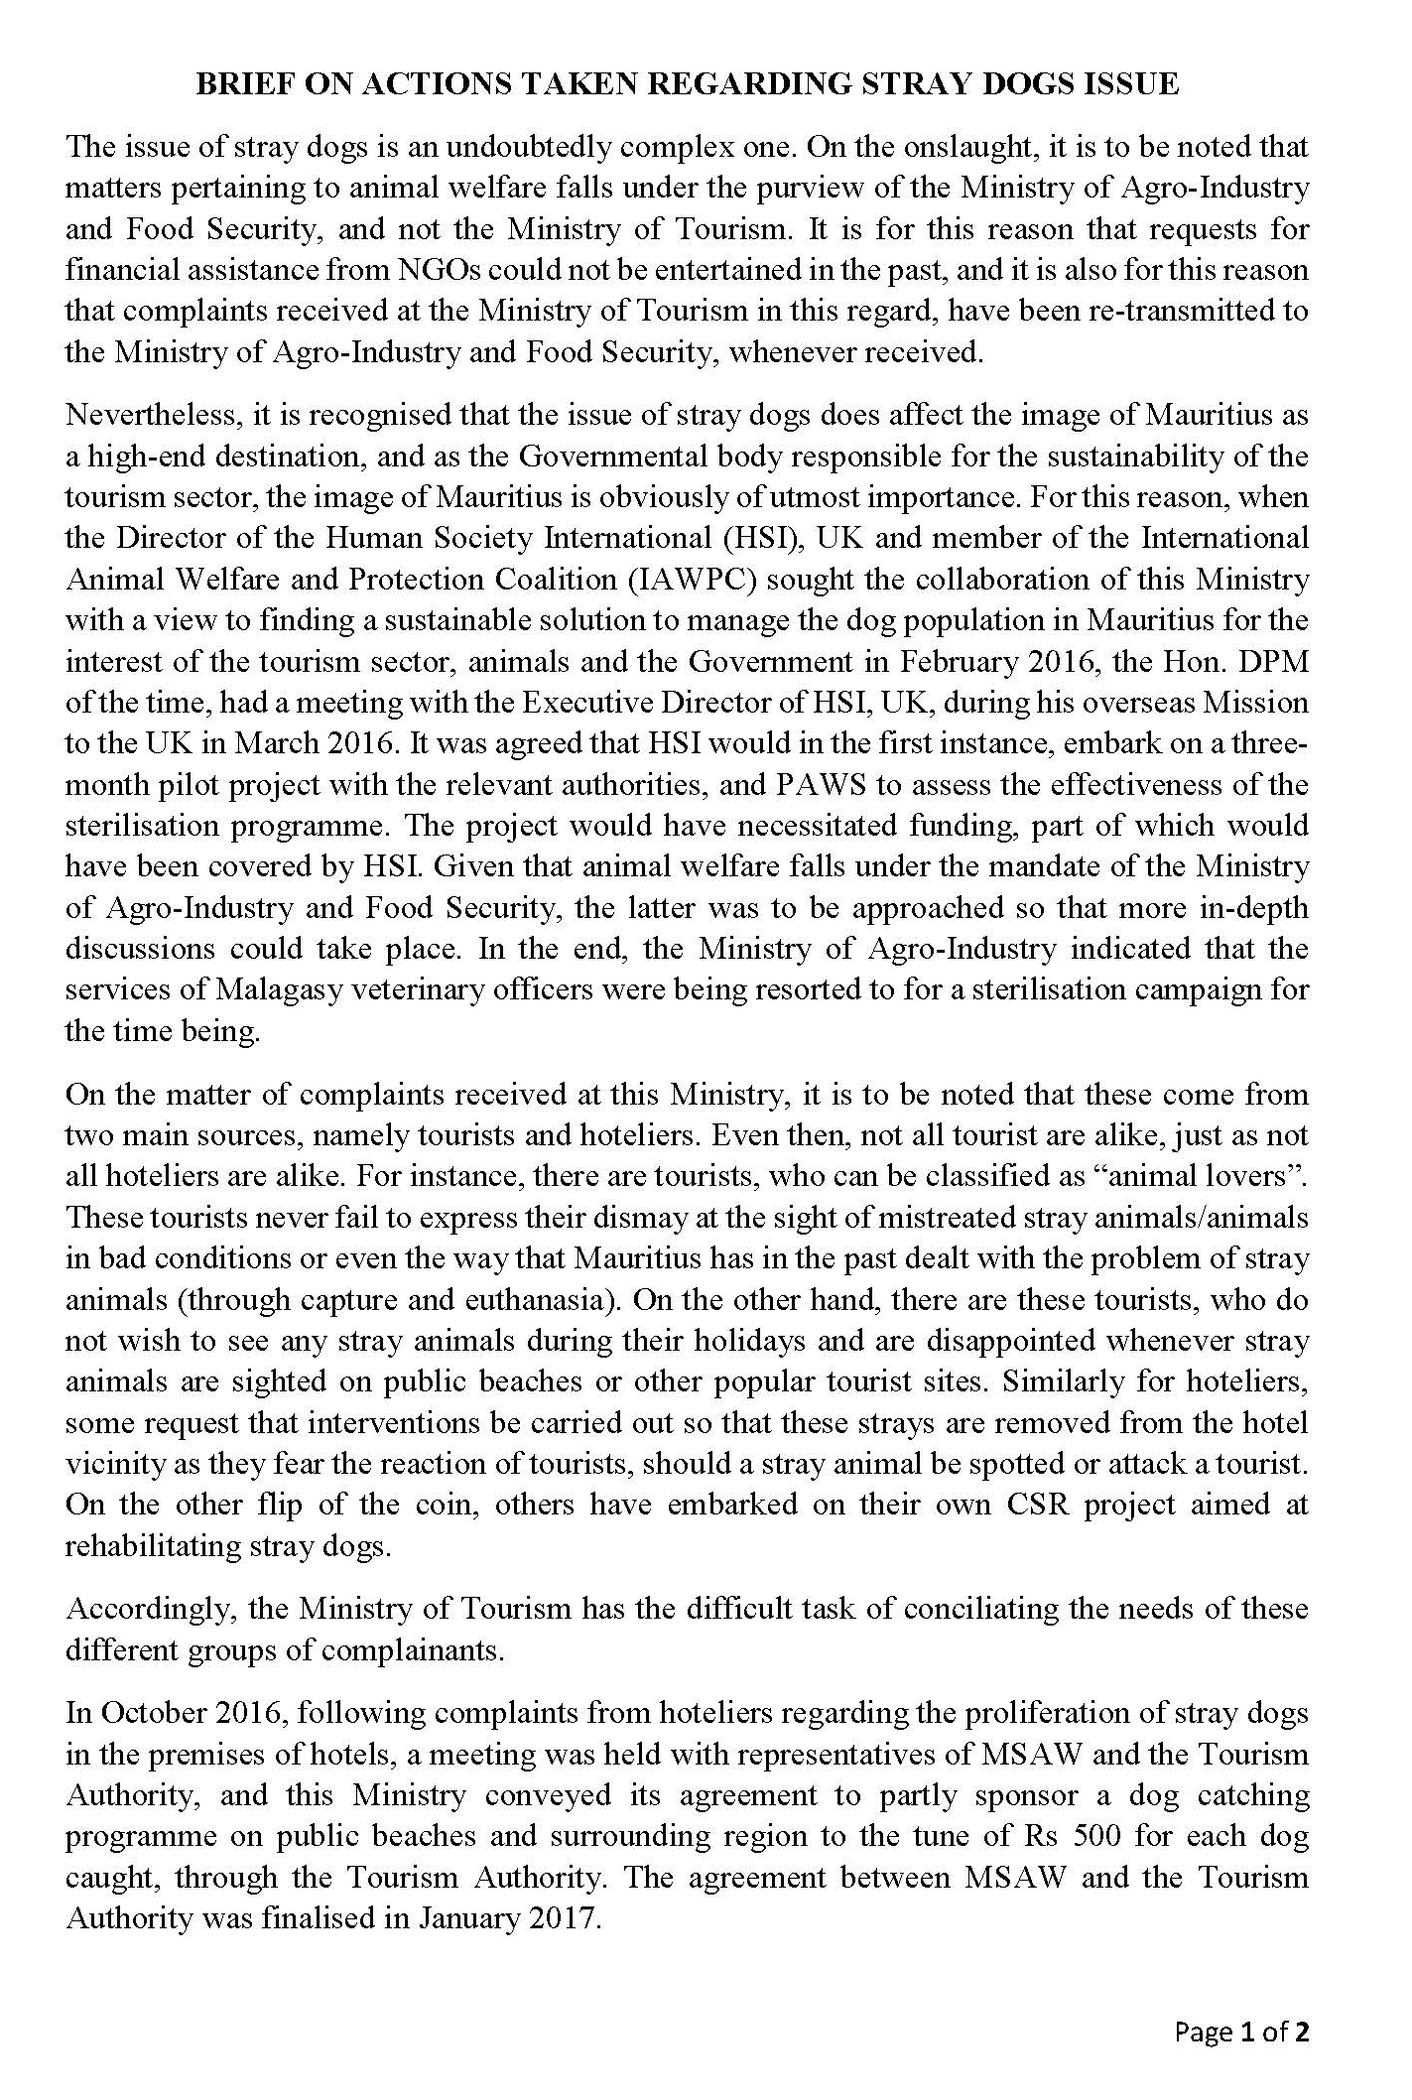
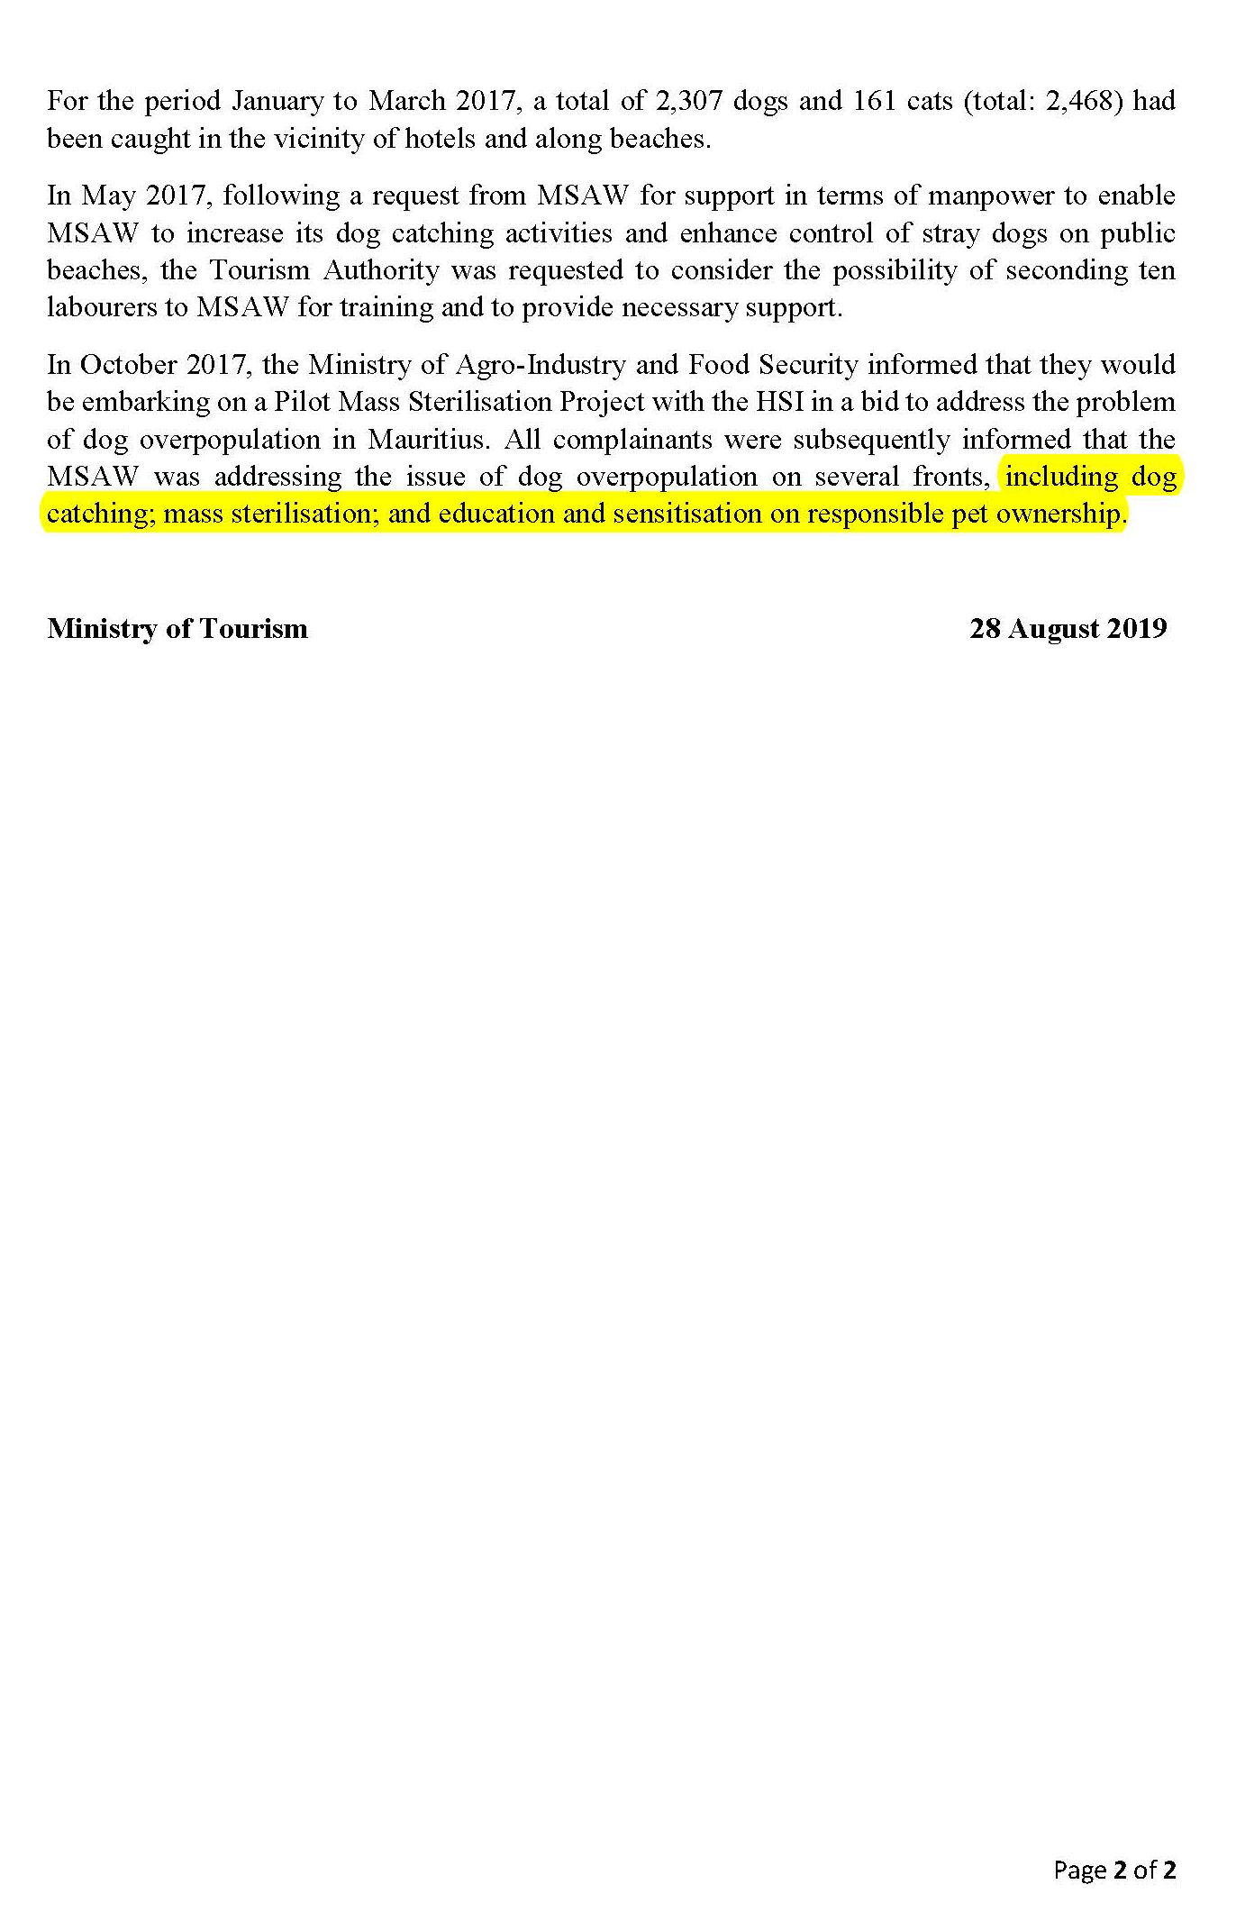

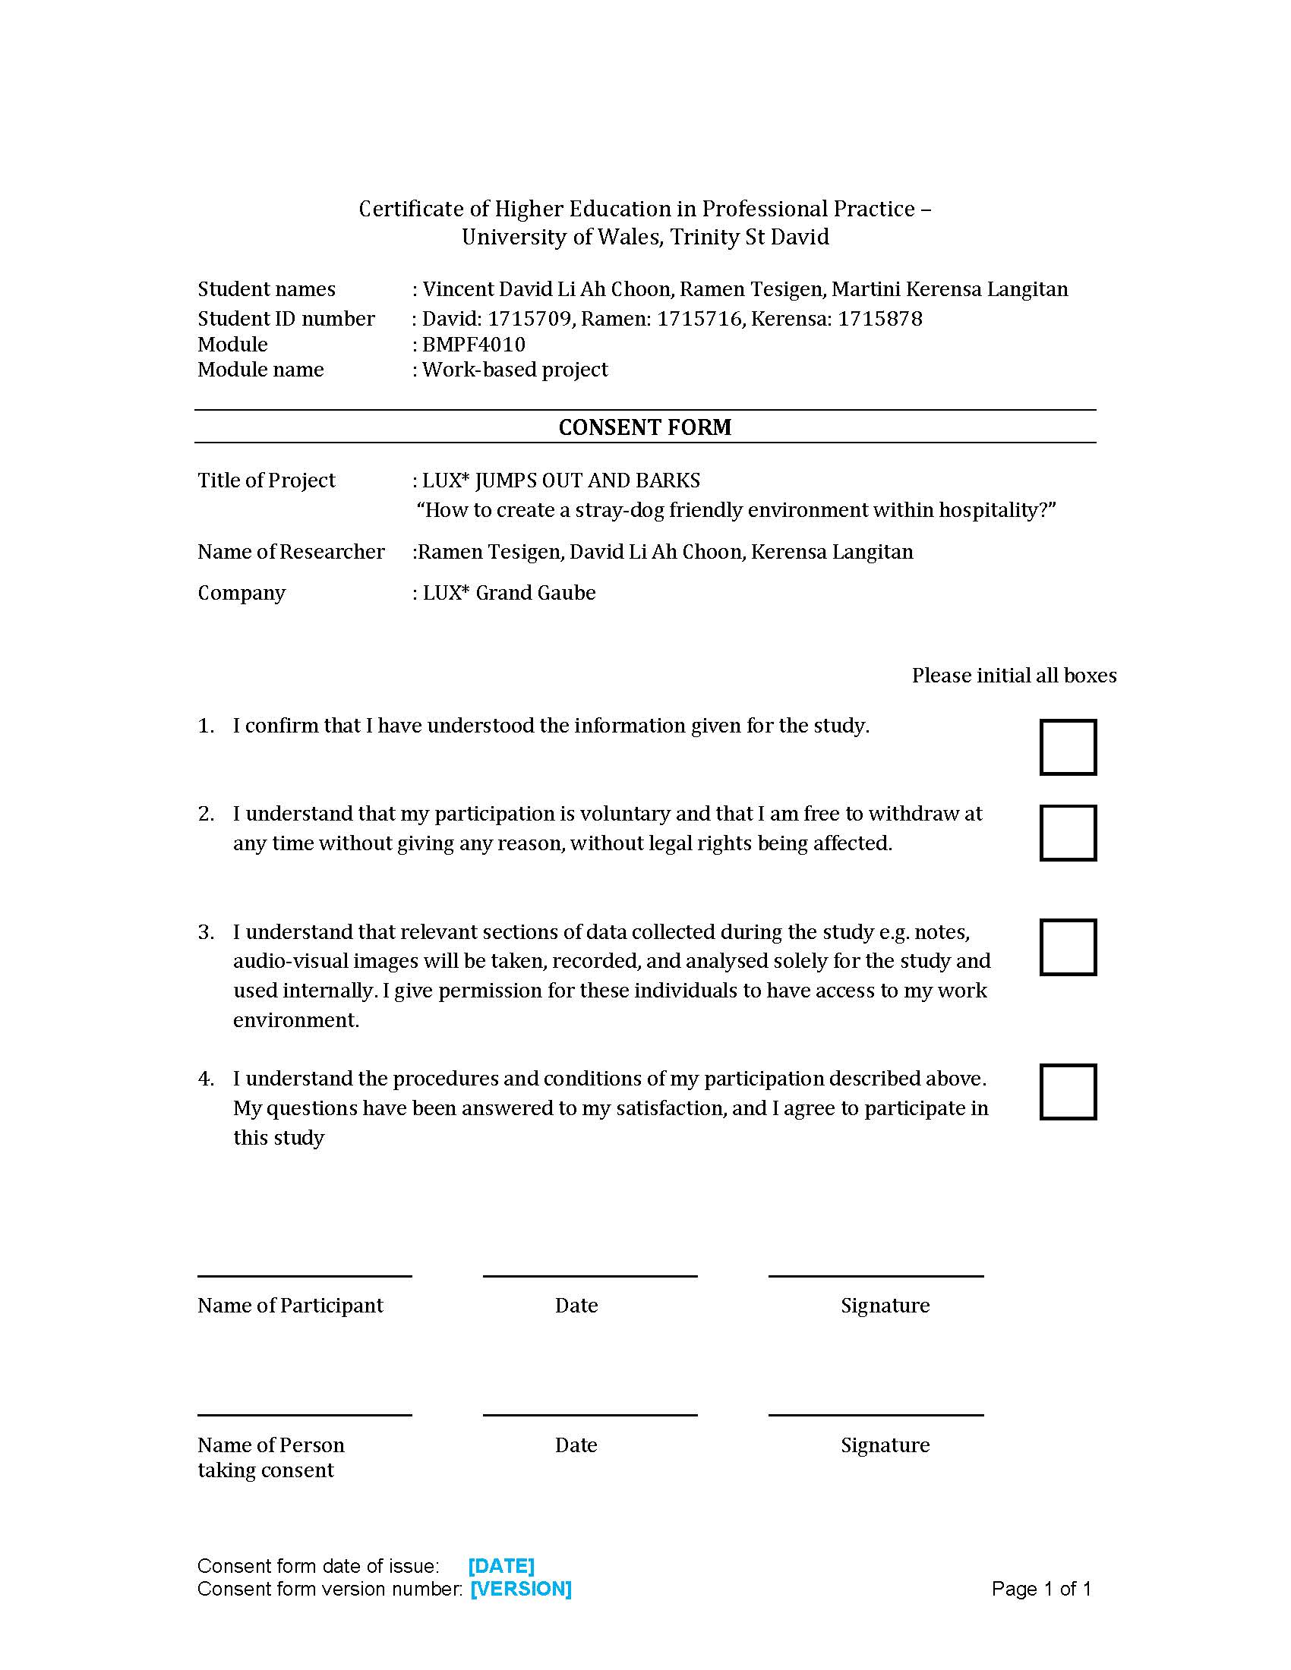
Appendix 3 – Consent Form

Appendix 4 – Table A

Team members’ feedback on dog presence in the hotel:

- Owners of dog should take care of their dogs
- They don’t have food. That y d r at the resort.
- They bark and annoyed the guest
- biting, disease
- bad image for the hotel, possible harm for kids, guests or team members, and dog poo
- ils semblent abandonnés certains clients peuvent être effrayés par leur presence
- Stray dogs does not look good roaming around the hotel. It creates bad image of the hotel..
- they look hungry not hygiene
- in a hotel its not comfortable while dog handing around as they mind be dangerous
- I fear they can attack somebody anytime
- I think they don't have a place to stay and need food also.
- They may bring a bad reputation for the hotels
- Stray dogs doesn't not get food to eat. Don't have shelter during cyclone, rain, bad weather and at the same time they might bite guest at the hotel.
- They should be treated well by security officers of the hotel. Sometimes they hurt the stray dogs.
- it can bites guest
- I ask the security
- Am concerned of the cleanliness of the resort and danger for the guest if the dog is ill....(disease)
- They feel like lost and they get scared when they see people, they should be captured and sent to a dog shelter where they can be adopted.
- it's about the security of guest and our team members. this also may bring disease to us and guest
- They come from grand gaube village and some time they have injury and others problems
- They need to be loved and protected
- sometimes it's interact with my duties and unfortunately security are more busy with handling dogs issues than performing their respective duties which is time consuming.
- Danger for guest and disturbing guest while barking
- They are noisy and disturb clients; they mess up around.
- LUX* Grand Gaube is a five star and finding dog running in guest room is not what I call a good and health environment.
- They walk in middle of the road and very often causes accidents
- Not every person likes to see stray animals roaming around. Especially not in a 5* resort and some will use this argument to get freebies on their stay extras and accommodation.
- In some cases one or two dogs were aggressive specially towards kids and also for hygienic reasons we don't know where they have been and they just sleep on guests sunbeds
- Street dogs roaming around a 5 star resort and that's too inside the restaurants doesn't give the company a good impression
- Not to neglect them.as they have a life as human being. They need attentions. Dog is most faith animal is the world.
- It can be a danger for a guest as if can get bitten.
- It's scary and unhygienic
- Guess safety
- disease and biting
- Sanitary. It's does not look good for a five star hotel as it's not allow.
- Stray dogs maybe they are looking for shelter & food as they don't have a mate or someone to adopt them.
- spread disease
- Each should have a family that care for them and feed them
- disease
- diseases spread
- spread of disease
- it can be dangerous for the guests and especially for the children.
- They might be harmful to our customers and disturb them from enjoying their stay.

Appendix 5 – Table B
Guests’ feedback when they encounter stray dogs:

- Poor dogs
- We feel sorry for them
- I think they are hungry, the reasons they are roaming around

Team members feedback when they encounter stray dogs:

- Dogs are like children and owner should take care of them and not let them roam without supervision
- Afraid of being bitten and dogs should not be in a five stars hotel
- Because I like dogs and am an animal lover
- because they are wild dog
- I am scared of dogs and sad that we cannot find a permanent situation for this issue
- Dog form part in human life and environment
- I just make them afraid and they go away
- Used to seeing them
- They have no place to stay and no foods to eat, they had a heart
- I am a pet lover and would like them to have a better treatment
- The dogs don't look aggressive and they run away as soon as they see team members.
- its may bring to the company a great loss as if a guest got bitten he may sue the company
- You might bitten by them
- They should not be abandon they have full right to be treated correctly
- They are abandoned to the nature, which make me feel outraged.
- All stray dogs should be sterilized and should be taken up by an association.
- They can have disease and be aggressive
- Since my childhood, I’m scared of dog and never walk on the road because of that. In a resort you must feel secure but you’re not
- They need a home to stay and someone who take care...
- Just had an accident because of dogs
- Sad to see the physical state of the animal and that it might be infested with fleas and other sort of bugs /pest
- I’m afraid they get aggressive
- I tried to chase some dogs from the restaurant but instead they were barking at me
- it s not good to see these animals. If it was possible all people adopt one of them and take good care of them as there own family member.
- In the past I can bitten by a dogs.
- I don’t like dog's
- Stray dogs are normally aggressive when they see stranger.
- It is sad to see these poor dogs walking around, searching for food.
- I don't get anything by their presence. I like dogs so it is something natural for me but I think that the tourist might not like it.
- Some stray dogs are very aggressive. Feel sad as these stray dogs are not feed properly.
- If they had some kind of disease it may affect the internal and external guest.

Appendix 6 – Table C
Guests’ feedback on the idea of involving hospitality sector to take actions:

Help them find a home and in the meantime care for them

Team members’ feedback on the idea of involving hospitality sector to take actions:
- Can create awareness program to educate people in their surroundings
- Everyday we throw food. Y dont we provide them the food instead of throwing away
- Should create like an intern task force to handle the matter
- The management will see if they want to do something for the stray dogs like try to feed them or give them a better place
- Stray dogs in the hotel may be a concern for guests as these animals have an unpredictable temperament. On the streets during night shift the dogs can be pretty dangerous.
- Animal welfare societies like PAWS should assist in this type of issue
- Getting in touch with non governmental animal association
- Should find a way to get rid of them
- They must find a shelter and feed them until they get owners .Secondly, the hotel should contact animal welfare group to relocate the dogs.
- We have to find a way how we can feed them, for example the foods which are being thrown away .
- they should block all the way
- No they are just animals in their natural habitat
- They should contact PAWS so that they can come and capture them
- we need to remove them from the resort
- Can call authorities concern
- They should cater for
- It may become very difficult in a certain period to cater the problem with the increasing numbers of dogs.
- Stray dog disturb guest who are here to relax
- They have to be aware and take action
- For the security is the guest and for the environment
- If they think it is affecting the business they should
- Each hotel group has its own approach towards this issue, however it is a hotel where you are requested to respect all types of hygiene protocols and stray animal is considered as a pest.
- My main concern is hygiene
- Every citizen should assume their responsibility and if in case they fail action should be taken by authorities
- It should be one specific company.
- To avoid negative impact on tourist industry.
- Of course as its could cause harm to guest
- Hotels can invest into more non governmental NGOs for them since the ones that are operational, they are already overpopulated, no space enough
- The management has to make decision about it as everything lies in their hand.
- They contact a shelter to take them and find someone to adopt them
- As a brand it is more easy to impact on national level.

Appendix 7 – Table D

Guests’ additional feedback:
- I like dogs
- Give the dog a name and make hm a celebrity!
- very good initiative.
- It is not nice to see animals neglected. There needs to be a lot of education given to dog owners

Team members’ additional feedback:
- God bless you all for thinking such ideas like this. Providing a shelter.
- Dogs in a hotel can be dangerous for guest. If one guest get bitten this could lead to some big problem
- the whole community should care
- Dogs are animal best friend so we must also do something for them so that they have a better place for them live
- it will be very good if we could fight animal stray.
- that the owner should be more careful and take their responsibilities
- Dogs make people happy so treat them well
- Dog like human more than themselves and is the best friend a human can have
- To give them foods', don't make them afraid to take care of them
- This survey is a possibility for us to give the stray dogs a better life as they are the best friend of human .
- Since Lux participate a lot in environmental protection cause, it will be great

- Helping stray dogs would definitely give them a second chance in life
- I am strongly agree to control and stop more dogs on the street.it should have permit to dogs for each owner.
- Shoots them
- Change human behaviour towards stray dogs ,together we can do better prevention for improvements.
- Should take all into consideration in order to stop these stray dog
- There are so many dogs and less people to handle them. We must have a program of awareness regarding pets habitat
- Positive thinking...
- The animal is not in fault in this issue, it is more a question of education and care. A shelter nearby and offsite would encourage the animal to move towards the shelter where it would be taken care of and fed properly. Doing this LUX* would employ more people and have a better image nationwide, and may be worldwide.

- it's important as Standard of living is improving at all level. it shall benefit for the country and health..
- I would advise for a shelter outside the hotel as they can cause noise pollution among themselves.
- this is a good idea of the shelter at the hotel, this can help stray dogs future
- I think lux should strongly contribute to the project as its is a method to differentiate from others hotel as its prove that we care for animal life
- hope you find a solution for stray dogs
- Animal are living creature they need food shelters and care like people
- amazing idea for the dog shelters at hotel
- LUX should work with Government and NGOs for long run solutions.

Section 3 – Ethics Form
APPLICATION FOR ETHICAL APPROVAL

In order for research to result in benefit and minimise risk of harm, it must be conducted ethically. A researcher may not be covered by the University’s insurance if ethical approval has not been obtained prior to commencement.

The University follows the OECD Frascati manual definition of research activity: “creative work undertaken on a systematic basis in order to increase the stock of knowledge, including knowledge of man, culture and society, and the use of this stock of knowledge to devise new applications”. As such this covers activities undertaken by members of staff, postgraduate research students, and both taught postgraduate and undergraduate students working on dissertations/projects.

The individual undertaking the research activity is known as the “principal researcher”.

Ethical approval is not required for routine audits, performance reviews, quality assurance studies, testing within normal educational requirements, and literary or artistic criticism.

Please read the notes for guidance before completing ALL sections of the form.

This form must be completed and approved prior to undertaking any research activity. Please see Checklist for details of process for different categories of application.

SECTION A: About Group Researchers

Full Names | E-mail address | Contact Tel. Number | Student Number
Vincent David Li Ah Choon | david.liahchoon@luxgrandgaube.com | +230 59193282 | 1715709
Ramen Tesigen | tesigen@hotmail.com | +230 57696691 | 1715716
M.Kerensa Langitan | kerensa.langitan@theluxcollective.com | +230 5258 0457 | 1715878

Tick all boxes which apply:
Member of staff: | ☐ | Student: | ☒ | Honorary research fellow: | ☐

Faculty/School/Centre: | WIWBL
Campus: | Carmarthen
Student Number: | See above | Undergraduate | ☒
Programme of Study: | Certificate of Higher Education in Professional Practice | Taught Postgraduate | ☐
Director of Studies/Supervisor: | Tessa Oosthuizen | Research | ☐

SECTION B: Approval for Research Activity

Has the research activity received approval in principle?  (please check the Guidance Notes as to the appropriate approval process for different levels of research by different categories of individual) |  | YES | ☒ | NO | ☐
 |  |  |  | Date
If Yes, please indicate source of approval (and date where known): | Research Degrees Committee |  | ☐
 | Faculty Research Committee |  | ☐
 | Other (write in)  WIWBL Ethics Board Representative |  | ☒
Approval in principle must be obtained from the relevant source prior to seeking ethical approval.

SECTION C: External Ethical Guidance Materials

Please list the core ethical guidance documents that have been referred to during the completion of this form (including any discipline-specific codes of research ethics, and also any specific ethical guidance relating to the proposed methodology). Please tick to confirm that your research proposal adheres to these codes and guidelines.
The Lux Collective Code of Conducts | ☒
Data Protection Act 2017 | ☒
 | ☐

SECTION D: External Collaborative Research Activity

Does the research activity involve collaborators outside of the University? |  | YES | ☐ | NO | ☒
If Yes, please provide the name of the external organisation and name and contact details for the main contact person:
Institution
Contact person name
Contact person e-mail address

Where research activity is carried out in collaboration with an external organisation
Does this organisation have its own ethics approval system? | YES | ☐ | NO | ☐
If Yes, please attach a copy of any final approval (or interim approval) from the organisation

SECTION E: Details of Research Activity

Indicative title: |  | LUX* JUMPS OUT AND BARKS  “How to create a stray-dog friendly environment within hospitality?”
Proposed start date: |  | June 2019 | Proposed end date: | October 2019
Purpose of research activity (including aims and objectives)
Outline the purpose, aims and objectives of the research activity, including key research questions. Show briefly how existing research has informed the proposed activity and explain what the research activity will add and how it addresses an area of importance. (Maximum 300 words)
Background
The group consists of three members from different hotel departments: Front Office (V. David Li Ah Choon), Kitchen (Ramen Tesigen), and Spa & Wellness (M. Kerensa Langitan).
Based on the LUX* Grand Gaube hotel incident reports that are collected from the reopening in December 2017 to current, the hotel has been challenged with regards to stray dogs coming to various areas in the hotel on almost daily basis. This has resulted in a less comfortable experience for some guests, brought down the luxury hotel image and reputation, and created a negative impact on social media due to online posting by guests.
The existence of overpopulated stray dogs has also become a common problem on national level. According to the statistic of Ministry of Agriculture there were approximately 80,000 stray dogs in 2016 and according to Protection of Animal Welfare Society, PAWS, Mauritius the number has increased at least by 250% in 2018 (200,000 – 300,000 stray dogs).
The objective is to build a dog park within the hotel grounds, using the food waste for feeding, while promoting stray-dog care awareness within the community in general and the hotel in particular.

Aims
The aims of the research will therefore be:
- To find out the most suitable stray-dog care program on location, using friendly and creative means
- To give a significant positive impact for tourists and community as part of the hotel marketing campaign
- To promote animal care awareness within hospitality

Previous Research:
- Webster, D., 2013. The economic impact on stray cats and dogs at tourist destinations on tourism industry. [Online]
Available at:
http://turismo-responsable.com/userfiles/The%20Economic%20Impact%20of%20Stray%20Cats%20and%20Dogs%20at%20Tourist%20Destinations%20on%20the%20Tourism%20Industry%20May%202013-2(1).pdf
[Accessed 28 May 2019].
- Siettou, C., 2015. The UK public's perceptions on the issue of the dog overpopulation problem and people's willingness to pay (WTP) for a humane stray dog management. [Online]
Available at:
https://search-proquest-com.ezproxy.uwtsd.ac.uk/docview/1697445690?accountid=130472&rfr_id=info%3Axri%2Fsid%3Aprimo
[Accessed 28 May 2019].

Reference Material:
- Kuriloff, 2016. Wall Street Journal. [Online]
Available at:
https://search-proquest-com.ezproxy.uwtsd.ac.uk/docview/1769797430/715DB3DDE4054BC8PQ/1?accountid=130472
[Accessed 28 May 2019]
- Davis, 2010. Air Transat's bark takes bite out of stray animal problem. Canadian Travel Press, 42(43), p. 6.
- Pizam & Mansfeld, 2006. Series: Management of hospitality and tourism enterprises series. In: Tourism, security and safety : from theory to practice. s.l.:Butterworth-Heinemann

Group’s Learning Outcomes:
- Optimise effective team-working in completing the research project
- Acquire general knowledge of safety and security impacts on tourism
- Develop abilities to deal with different organizational types such as non-profit and commercial
- Acquire a general knowledge of dog behaviour, domestic and stray dogs, appropriate dog alimentation and sheltering, and the health impact such as possible diseases and spaying
- How to draft a strategy to monitor and control stray dogs within the hotel compound

Proposed methods
Provide a brief summary of all the methods that may be used in the research activity, making it clear what specific techniques may be used. If methods other than those listed in this section are deemed appropriate later, additional ethical approval for those methods will be needed. (Maximum 600 words)
Methods used are both quantitative and qualitative.

- Survey:
The objective of the survey is to obtain participant’s opinions on stray dog appearances within the hotel areas and possible solutions.

This survey is done on internal and external participants i.e. designated hotel team members and in-house guests. Team members include security, front office, housekeeping, food and beverage, and engineering departments. Participation is voluntary and no personal details are recorded.

The purpose of the research will be explained. The questionnaire will be relatively short, with approximately 10 questions and taking approximately 15 minutes to complete. It is anticipated that a minimum of 30% out of responses are expected.
The questionnaire includes a space should participants like to give further feedback or comments.

Analysis:
The survey is to compare point of views between guests and team members, to find out whether there is a concern in establishing a dog park, and possible new ideas to prevent dogs coming to hotel areas.

- Focus group:
The purpose of this method is to obtain professional views and more detailed information with regards to stray dogs in general and the impact to tourism in particular. Participants will be vets, animal care related organisations, and other hotels representatives.

Analysis:
Different advice and sources may be used on how to promote awareness of animal care, such as dog adoption opportunities, spaying program, and possible collaboration amongst hotels in Mauritius.

- One to one interviews:
The purpose of this method is the same as focus group and also to acquire information whether or not a strategy already put in place. Participants will be representatives of Ministry of Agro Industry and Food Security (animal welfare), Ministry of Tourism Mauritius, and airlines representatives (public relation or senior management).

Analysis:
To find out opportunities and/or facilities on a higher or national level based on the feedback.

- Observations:
The purpose of this method is to acquire knowledge on how to handle stray dogs and proper sheltering. Sources will be existing dog shelters and kennels in Mauritius. Video filming of the dog care and handling may be done, which will be used as a guidance for team members training.

Analysis:
To acquire various ways of animal care in order to find out the most appropriate one to be implemented in the hotel.

Before final recommendations are made, there will be an indicative cost made.

Location of research activity
Identify all locations where research activity will take place.
Questionnaires and focus group will be at the hotel. One to one interviews and observations will be on different locations and/ or public places in Mauritius.
Research activity outside of the UK
If research activity will take place overseas, you are responsible for ensuring that local ethical considerations are complied with and that the relevant permissions are sought. Specify any local guidelines (e.g. from local professional associations/learned societies/universities) that exist and whether these involve any ethical stipulations beyond those usual in the UK (provide details of any licenses or permissions required). Also specify whether there are any specific ethical issues raised by the local context in which the research activity is taking place, for example, particular cultural sensitivities or vulnerabilities of participants.
Mauritius

SECTION F: Scope of Research Activity

Will the research activity include: | YES | NO
Use of a questionnaire or similar research instrument? | ☒ | ☐
Use of interviews? | ☒ | ☐
Use of diaries? | ☐ | ☒
Participant observation with their knowledge? | ☒ | ☐
Participant observation without their knowledge? | ☐ | ☒
Use of video or audio recording? with permission of the person in charge of the organisations, the video will be used for internal use only | ☒ | ☐
Access to personal or confidential information without the participants’ specific consent? | ☐ | ☒
Administration of any questions, test stimuli, presentation that may be experienced as physically, mentally or emotionally harmful / offensive? | ☐ | ☒
Performance of any acts which may cause embarrassment or affect self-esteem? | ☐ | ☒
Investigation of participants involved in illegal activities? | ☐ | ☒
Use of procedures that involve deception? | ☐ | ☒
Administration of any substance, agent or placebo? | ☐ | ☒
Working with live vertebrate animals? | ☐ | ☒
Other primary data collection methods, please explain in this box | ☐ | ☒

If NO to every question, then the research activity is (ethically) low risk and may be exempt from some of the following sections (please refer to Guidance Notes).

If YES to any question, then no research activity should be undertaken until full ethical approval has been obtained.
SECTION G: Intended Participants

Who are the intended participants: | YES | NO
Students or staff at the University? | ☐ | ☒
Adults (over the age of 18 and competent to give consent)? | ☒ | ☐
Vulnerable adults? | ☐ | ☒
Children under 18? | ☐ | ☒
Prisoners? | ☐ | ☒
Young offenders? | ☐ | ☒
Those who could be considered to have a particularly dependent relationship with the investigator or a gatekeeper? | ☐ | ☒
People engaged in illegal activities? | ☐ | ☒
Others (please identify): | ☐ | ☒

Participant numbers and source
Provide an estimate of the expected number of participants. How will you identify participants and how will they be recruited?
Survey:
Participants will comprise of any adult in the hotel and team members in chosen departments. The maximum number is 200, but number of expected respondents is expected to be around 30%.
Focus group:
Maximum 15 - consisting of vets, animal care related organisations, and other hotels representatives
One-to-one interviews:
Maximum 5 - consisting of representatives of Ministry of Agro Industry and Food Security (animal welfare), Ministry of Tourism Mauritius, and airlines representatives (public relation or senior management).
Observations:
Dog kennels and shelters

Information for participants: | YES | NO | N/A
Will you describe the main research procedures to participants in advance, so that they are informed about what to expect? | ☒ | ☐ | ☐
Will you tell participants that their participation is voluntary? | ☒ | ☐ | ☐
Will you obtain written consent for participation? | ☒ | ☐ | ☐
Will you explain to participants that refusal to participate in the research will not affect their treatment or education (if relevant)? | ☒ | ☐ | ☐
If the research is observational, will you ask participants for their consent to being observed? | ☒ | ☐ | ☐
Will you tell participants that they may withdraw from the research at any time and for any reason? | ☐ | ☐ | ☐
With questionnaires, will you give participants the option of omitting questions they do not want to answer? | ☒ | ☐ | ☐
Will you tell participants that their data will be treated with full confidentiality and that, if published, it will not be identifiable as theirs? | ☒ | ☐ | ☐
Will you debrief participants at the end of their participation, in a way appropriate to the type of research undertaken? | ☒ | ☐ | ☐
If NO to any of above questions, please give an explanation
Participation on the survey questionnaire is anonymous. Written consent will be obtained from the participants of observations.

Information for participants: | YES | NO | N/A
Will participants be paid? | ☐ | ☒ | ☐
Is specialist electrical or other equipment to be used with participants? | ☐ | ☒ | ☐
Are there any financial or other interests to the investigator or University arising from this study? | ☐ | ☒ | ☐
Will the research activity involve deliberately misleading participants in any way, or the partial or full concealment of the specific study aims? | ☐ | ☒ | ☐
If YES to any question, please provide full details

SECTION H: Anticipated Risks

Outline any anticipated risks that may adversely affect any of the participants, the researchers and/or the University, and the steps that will be taken to address them.

If you have completed a full risk assessment (for example as required by a laboratory, or external research collaborator) you may append that to this form.
Full risk assessment completed and appended?

Yes ☐
No ☒

Risks to participants
For example: emotional distress, financial disclosure, physical harm, transfer of personal data, sensitive organisational information
No risks are anticipated

If research activity may include sensitive, embarrassing or upsetting topics (e.g. sexual activity, drug use) or issues likely to disclose information requiring further action (e.g. criminal activity), give details of the procedures to deal with these issues, including any support/advice (e.g. helpline numbers) to be offered to participants. Note that where applicable, consent procedures should make it clear that if something potentially or actually illegal is discovered in the course of a project, it may need to be disclosed to the proper authorities
No such issues are anticipated

Risks to investigator
For example: personal safety, physical harm, emotional distress, risk of accusation of harm/impropriety, conflict of interest
No risks are anticipated

University/institutional risks
For example: adverse publicity, financial loss, data protection
No risks are anticipated
Adverse outcomes
List measures put in place to limit any adverse effects or outcomes of research activity where appropriate. Include any emergency protocols.
Low response rate of survey: if response rate is below 30%, the survey procedure will be repeated with other volunteers

Disclosure and Barring Service
If the research activity involves children or vulnerable adults, a Disclosure and Barring Service (DBS) certificate must be obtained before any contact with such participants. | YES | NO | N/A
Has a DBS certificate been obtained? | ☐ | ☐ | ☒

SECTION I: Feedback, Consent and Confidentiality

Feedback
What feedback will be provided to participants, how will this be done and when?
No feedback will be provided unless requested. Quantitative, anonymous result can be shared once the survey is completed.
Informed consent
Describe the arrangements to inform potential participants, before providing consent, of what is involved in participating. Describe the arrangements for participants to provide full consent before data collection begins. If gaining consent in this way is inappropriate, explain how consent will be obtained and recorded.
Participants are aware of the researcher’s identity, purpose of the activities, and method including a possibility of data gathering. Participation is voluntary and participants remain free to withdraw at any time without giving any reason.

Participants will be informed of the objective of the questionnaire and their subjective answers are inquired. This will be carried out through a questionnaire with multiple choice feedback system. Participants are also explained that their feedback is anonymous.

Other methods will be carried out in group, in person, through interviews, and observations. Written consent will be obtained from each participant before the observations.
Feedback will be in writing. Audio visual will be recorded or taken by company’s mobile after participants’ approval. All feedback and other material will be only used internally.

Confidentiality / Anonymity
Set out how anonymity of participants and confidentiality will be ensured in any outputs. If anonymity is not being offered, explain why this is the case.
Not applicable on the survey – names will not be used.
Survey and other methods’ feedback will be kept safely and secured in a locker at the front office.
Audio visual material will be kept in a company’s mobile secured with a password.

SECTION J: Data Protection and Storage

In completing this section refer to the University’s Research Data Management Policy and the extensive resources on the University’s Research Data Management web pages (http://uwtsd.ac.uk/library/research-data-management/).
 | YES | NO
Does the research activity involve personal data (as defined by the Data Protection Act)?  “personal data” means data which relate to a living individual who can be identified—  (a) from those data, or  (b) from those data and other information which is in the possession of, or is likely to come into the possession of, the data controller, and includes any expression of opinion about the individual and any indication of the intentions of the data controller or any other person in respect of the individual. | ☐ | ☒
If YES, provide a description of the data and explain why this data needs to be collected:
Does it involve sensitive personal data (as defined by the Data Protection Act)?  “Sensitive personal data” means personal data consisting of information as to –  (a) the racial or ethnic origin of the data subject,  (b) his political opinions,  (c ) his religious beliefs or other beliefs of a similar nature,  (d) whether he is a member of a trade union (within the meaning of the Trade Union and Labour Relations (Consolidation) Act 1992),  (e) his physical or mental health or condition,  (f) his sexual life,  (g) the commission or alleged commission by him of any offence, or  (h) any proceedings for any offence committed or alleged to have been committed by him, the disposal of such proceedings or the sentence of any court in such proceedings. | ☐ | ☒
If YES, provide a description of the data and explain why this data needs to be collected:

Will the research activity involve storing personal data on one of the following: | YES | NO
Manual files (i.e. in paper form)? | ☒ | ☐
University computers? | ☐ | ☒
Private company computers? | ☒ | ☐
Home or other personal computers? | ☐ | ☒
Laptop computers/ CDs/ Portable disk-drives/ memory sticks? | ☒ | ☐
“Cloud” storage or websites? | ☐ | ☒
Other – specify: | ☐ | ☒
For all stored data, explain the measures in place to ensure data confidentiality, including details of password protection, encryption and anonymisation:
Files will be only stored in a company’s/ researcher’s laptop or computer, which are password-protected, to collect responses and stored according to company guidelines.
Will the research activity involve any of the following activities: | YES | NO
Electronic transfer of data in any form? | ☒ | ☐
Sharing of data with others at the University? | ☐ | ☒
Sharing of data with other organisations? | ☐ | ☒
Export of data outside the European Union or importing of data from outside the UK? | ☐ | ☒
Use of personal addresses, postcodes, faxes, emails or telephone numbers? | ☐ | ☒
Publication of data that might allow identification of individuals? | ☐ | ☒
Use of data management system? | ☐ | ☒
Data archiving? | ☐ | ☒
If YES to any question, please provide full details, explaining how this will be conducted in accordance with the Data Protection Act (and/or any international equivalent):
Company’s computer will make use of this information, which will remain confidential with protected password.

List all who will have access to the data generated by the research activity:
The researchers only

List who will have control of, and act as custodian(s) for, data generated by the research activity:
The researchers only

Give details of data storage arrangements, including where data will be stored, how long for, and in what form. Will data be archived – if so how and if not why not.
Data generated by this research will be stored on company’s / researchers laptops and mobiles, which are password-protected. Data will be used for the outlined research purposes only. All data will be archived once the assignment is complete.

SECTION K: Declaration

The information which I have provided is correct and complete to the best of my knowledge. I have attempted to identify any risks and issues related to the research activity and acknowledge my obligations and the rights of the participants.

In submitting this application I hereby confirm that I undertake to ensure that the above named research activity will meet the University’s Research Ethics and Integrity Code of Practice
Signature of applicant: | David Li Ah Choon, Ramen Tesigen, M. Kerensa Langitan | Date: | 31st May 2019

For students:
Director of Studies/Supervisor: | Tessa Oosthuizen
Signature:
Date:

For staff:
Head of School/Assistant Dean: | pp A.fillery-travis
Signature: | 
Date: | 7/7/19

Checklist: Please complete the checklist below to ensure that you have completed the form according to the guidelines and attached any required documentation:
☒ | I have read the guidance notes supplied before completing the form.
☒ | I have completed ALL RELEVANT sections of the form in full.
☒ | I confirm that the research activity has received approval in principle
☐ | I have attached a copy of final/interim approval from external organisation (where appropriate)
☒ | I have attached a full risk assessment (and have NOT completed Section H of this form) (where appropriate)
☒ | I understand that it is my responsibility to ensure that the above named research activity will meet the University’s Research Ethics and Integrity Code of Practice.
☒ | I understand that before commencing data collection all documents aimed at respondents (including information sheets, consent forms, questionnaires, interview schedules etc.) must be confirmed by the DoS/Supervisor, module tutor or Head of School.

RESEARCH STUDENTS AND STAFF ONLY
All communications relating to this application during its processing must be in writing and emailed to pgresearch@uwtsd.ac.uk , with the title ‘Ethical Approval’ followed by your name.
You will be informed of the outcome of your claim by email; therefore it is important that you check your University and personal email accounts regularly.

STUDENTS ON UNDERGRADUATE OR TAUGHT MASTERS PROGRAMMES should submit this form (and receive the outcome) via systems explained to you by the supervisor/module leader.

This form is available electronically from the Academic Office web pages: http://www.uwtsd.ac.uk/academic-office/

Application Process

All staff research projects and all research students must submit the Ethical Approval Form to the University Ethics Committee via the Academic Office (pgresearch@uwtsd.ac.uk). Staff research directly in relation to personal study for taught undergraduate or Masters programmes should be submitted via the Faculty procedures explained below.

Taught masters and taught undergraduate research Ethical Approval Forms are considered within Faculties. Faculties will provide details of the specific processes for this. Where the Ethical issues within any single ethical application are of particular concern the Faculty will refer these to the University Ethics Committee. Any student activity that involves the collection of primary data needs to undergo Ethical approval, this includes assignment work as well as dissertations.

Notes for guidance in completion of this form

Section A: About You
Please complete all relevant sections

Section B: Approval for research activity
Research proposals must be approved in principle before applying for Ethical Approval. The proposal approval only becomes final when the ethical approval is received.

The process for proposal approval varies according the individual and programme of study:
- Research students, by application on form PG1 to the Research Degrees Committee
- Taught students by review of research proposal within Faculties (Faculties provide specific details of these processes)
- Staff, by agreement by the Head of School/Assistant Dean

Section C: External Ethical Guidance materials
Many discipline areas are required to operate with the discipline specific codes of research ethics (for example health, psychology, education etc.), any such codes must be listed and you must tick to confirm that you have consulted with these.

Section D: External Collaborative Research Activity
Provide details of the external collaborative partners, where appropriate you might want to submit a copy of the external collaboration agreement with the Ethical Approval Form. If the partner requires the research to be subject to its own internal Ethical approval process then please provide details of that process and a copy of any final (or interim) approvals received from the organisation.

Section E: Details of Research Activity
Remember that the individuals reviewing this Ethical Approval Form may not have seen your research proposal, and also may not be experts in the specific area of your research. The information provided should therefore be jargon free and clearly stated.
Indicative Title: please use the same title as used on the research proposal.
Purpose: the Ethical approval process will want to ensure that the methods you propose are adequate and appropriate to address the research aims and objectives. Excessive additional data collection can be seen as unethical.
Proposed Methods: the Ethical approval process seeks to ensure that you understand the methods that are intended, and that the implementation of those methods will be appropriate and without unnecessary impact on respondents. Please be specific.
Location: this needs to mention geographical location and also local situation (for example, within Local Authority Offices in Cardiff, using a private room but close to other individuals). If you are collecting data within an organisational setting then you need to explain the permissions that you have obtained to do this.
Research Activity outside of the UK: please complete this section in detail, and note any guidance you have received. Also describe your own familiarity (or not) with the location that you will be utilising.

Section F: Scope of Research Activity
Please tick ALL of the research activities that might be undertaken. If any additional types of activity are intended then please add an extra box and describe these.
If you have answered no to all questions in F then sections G and J do not need to be completed. Section H should be considered, and may be completed. Signatures are still required in section K.

Section G: Intended Participants
Please tick all categories that might apply.
Numbers & Source: if you are using a series of different methods or research activities please list numbers for each stage/phase. Be clear about how you will find respondents. Will you use intermediaries, and if so how? How will you ensure compliance with your sampling strategy?
Information for participants: all participants should be appropriately informed about the research, what is expected of them and what will happen to the information that they provide. The Ethical review process does not ask to see this documentation, but requires this to be reviewed and approved by the Director of Studies in the case of research students, the supervisor/module tutor in relation to students on taught programmes and the Head of School/Assistant Dean in relation to staff research.

Section H: Anticipate Risks
All research carries some level of risk. The answers you provide to questions in this section will be reviewed to ensure that you have an appropriate understanding of the type of risks involved and how you can mitigate against these risks. If you have completed a full risk assessment, as required for example for laboratory work, field work, clinical tests, diving operations, or by a collaborative partner, you may append that to this form. In that case, please tick the box indicating this has been provided. You will not then be required to complete Section H.
Risk to participants Think very carefully about how your actions/questions/discussions might affect the people you are involving as participants. You might identify the risk as small but it would still be a risk. Many types of question have the potential to make respondents less content with their life / job; you need to recognise and try to ameliorate any such effects
If these are business owners, time with you may reduce profit.
In some locations physical risk is very real to both participants and yourself, please consider this.
Risk to you, the researcher Think about where you will meet people, if there are any dangers involved in the location. If you are meeting people as individuals think about using a public place. In general do not visit people in their own homes or remote locations. If you are talking to individuals about certain issues think about how their responses might affect you emotionally. What about the risk of collecting insufficient data?
Risk to the University When undertaking your research, you are acting as a member of the University (student or staff). Professionalism is important, so it is important to be well organised and well prepared. Punctuality, clarity etc. are all part of this. What will you do to ensure this? You must ensure you do not harm the good name of the University in any way and do nothing to undermine the reputation of the research it conducts and sponsors. Upholding high standards of conduct and integrity are vital in this regard. You must also conduct the research in such a way to minimise the potential for claims of negligence made against the University, its researchers and any collaborating individual or organisation. In this respect you should always comply with ethical, legal and professional frameworks, obligations and standards as required by statutory and regulatory authorities, as well as the university’s Research Integrity and Ethics Code of Practice. Research misconduct in this respect can take many forms, including:
- fabrication: making up results or other outputs (eg, artefacts) and presenting them as if they were real
- falsification: manipulating research processes or changing or omitting data without good cause
- plagiarism: using other people’s material without giving proper credit
- failure to meet ethical, legal and professional obligations: for example failure to declare competing interests; misrepresentation of involvement or authorship; misrepresentation of interests; breach of confidentiality; lack of informed consent; misuse of personal data; and abuse of research subjects or material
- improper dealing with allegations of misconduct: failing to address possible infringements such as attempts to cover up misconduct and reprisals against whistle-blowers

Adverse Outcomes. Think carefully about the possibilities, and cover here

Section I: Feedback, Consent and Confidentiality
Feedback to participants: outline your approach. Will interview transcripts be shared with respondents to check accuracy? Will summaries of questionnaire analysis be made available to respondents in some way? Will an overview report be provided? How and when?
Informed consent: Draft letter / e-mail / or heading (or footer) section of questionnaire must be approved by DoS/supervisor (if research student), supervisor/module tutor if taught student, or Head of School / Assistant Dean if a member of staff.
Confidentiality/Anonymity. Explain clearly how you will ensure confidentiality and anonymity.

Section J: Data Protection and Storage
Before completing this section it is necessary to read the University’s Research Data Management information. The questions that follow are designed to ensure compliance with the Data Protection Act as well as established research protocols.

Many research activities will involve electronic transfer of data and use of data management systems in the summarisation and analysis of data. You will need to explain these in relation to compliance with the Data Protection Act.
Think carefully about who will have access to your data, this will include supervisors and examiners. Also that a thesis will be made available via the University library and the British Library system. If you are seeking an access bar for a period of time after completion then mention it here. If you will provide a copy of your findings, or intend to give a presentation, to a facilitating/ supporting/accessing organisation then explain that in this section. But also think about the general principle of data sharing, as explained in the Research Data Management information.
In terms of storage of data please ensure security, and also mitigate against loss of data.

Section K: Declaration
Ensure the appropriate countersignatures have been provided
Look carefully at the checklist and ensure that you comply with and tick all that are relevant to your research.

