Name: Lara Adigun
Student Number: 1920483
Module Title: Digital Skills and Research Methods
(BMSW4003)
Assignment Title: The Impact of Virtual Learning Environment
on the Learning Experience of Students at
UWTSD London Campus

Lecturer: Dr. Modak

TABLE OF CONTENTS

Contents………………………………………………………………………. 2

1 Introduction............................................................................................. 3

2 Rationale………...……………………………………..……………… 3

3 Research Objectives…...………………………………………………. 4

4 Literature Review…………..……………………………..……………4

5 Research Methodology……………………………….…………………5

7 Results, Analysis and Discussion……………………………….…..…..5

7 Conclusion and Recommendations……………………………….…….16

9 Reference List……………………………………………………….….17

10. Appendices……………………………………………………………..18

1.0 INTRODUCTION
In today’s world, technology as a resource is crucial to enabling an interactive environment. The use of web-based information systems and virtual resources has been conventional in our educational outputs across board. According to Greenwood (2010), teachers, students, education administrators and school managers face the growing challenges of having access to data from diverse sources. He further submits that it is now a norm, to find varieties of web-based systems in regular schools, colleges or academies that students and teachers are required to use as part of their daily routine (Greenwood, 2010). As at 2008, British schools were instructed to embrace the usage of virtual learning environment platform in teaching and delivering of lessons to students. A VLE possesses so many benefits and tools that would facilitate the progression of students in their various courses (Becta, 2007).

With the knowledge that highly digital technologies are being integrated in our system, consequently producing a more literate society, teachers are creating strategies to inculcate them into classroom sessions (Henderson, 2011). Traditional teaching methods, which require teachers to stand for long hours in front of a board do not go well with students of this generation and certainly will not be a good strategy for tomorrow. By using ICT (Information and Communication Technologies) the teacher’s role is metamorphosed from the traditional profession to an intermediate supporter towards the facilitation of the students to garner knowledge and skills (Kalogiannakis, 2010).

2.0 RATIONALE
The rationale of the research work is clearly to discover the extent of impact made by virtual learning environment (Moodle) on students learning experience in UWTSD London Campus.

3.0 RESEARCH OBJECTIVES
- To review virtual learning environment in relative to the Moodle platform.
- To ascertain the level of impact that Moodle platform have on independent learning and student experience.

4.0 LITERATURE REVIEW

Across Britain Universities, students learn via participation in online courses with the advent of internet and web-based educational technologies (Butterfield, 2002). This learning methodology which came as a result of technology is known as virtual learning. As the desire for a better, more flexible but manageable learning environment continues, virtual learning remains key to the development of our education system. A virtual learning environment (VLE) in in the field of educational technology is a web-based platform for the digital aspects of courses of study, usually within educational institutions. This platform present resources, interactions and activities within the course structure and provide for the different stages of evaluation and assessment. VLEs usually report on participation of students in activities and have some level of integration with other institutional systems for smooth-running.

In the words of Moodle creator, he called Moodle an Open Source Course Management System (CMS), also known as a Learning Management System (LMS) or a Virtual Learning Environment (VLE) (Moodle, 2020). Moodle has become known far and wide among educators around the world as a tool for running virtual learning for their students and teachers. Many institutions use this platform to conduct full online courses, while some institutions use it to support face-to-face courses. Moodle is a very delectable platform for virtual learning (Hölbl & Welzer, 2010). According to Brooks-Young (2008), Moodle allows educators to effectively control the features associated to course content and delivery using that single integrated system. Based on research, Moodle is already widespread in all segments of education, from primary schools to universities.

5. 0 RESEARCH METHODOLOGY
The questionnaire comprises of both closed questions and open questions to enable openminded responses. The questionnaire was submitted for ethical and content approval by the course lecturer. Approval was issued for administration and respondents were fully communicated to on the purposes of the research. The data is analysed using descriptive statistics in research.

6.0 RESULTS, ANALYSIS AND DISCUSSION
- RESULTS AND ANALYSIS
The responses from the respondents has been collated and will be presented as results in a tabulated and chart form. 10 responses where gotten from 10 questions outlined in the questionnaire. After the presentation of results, analysis of data and discussion will follow.

Q1: Have you heard about virtually learning (VL) before now?
 |  | Frequency | Percent | Valid Percent
Valid | Yes | 4 | 40 | 40
Valid | No | 6 | 60 | 60
Valid | Total | 10 | 100 | 100

Table 1 Analysis:
Out of 10 respondents, 6 which represents 60% have not heard about virtual learning before their enrollment into the programme while 40% have some knowledge of it or have interacted with it.

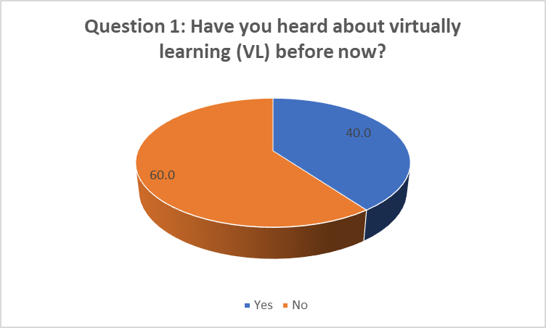
Fig. 1: Students Who Heard OF Virtual Learning Before The Programme
Q2: Have you been exposed to other forms of learning instruction outside VL (Moodle)?
 |  | Frequency | Percent | Valid Percent
Valid | Yes | 3 | 30 | 30
Valid | No | 7 | 70 | 70
Valid | Total | 10 | 100 | 100

Table 2 Analysis:
The table shows that 70% of the students have not been exposed to any other virtual learning platform outside Moodle as this is the platform for instruction in UWTSD, London campus while 30% affirmed that they have had interactions with other platforms.
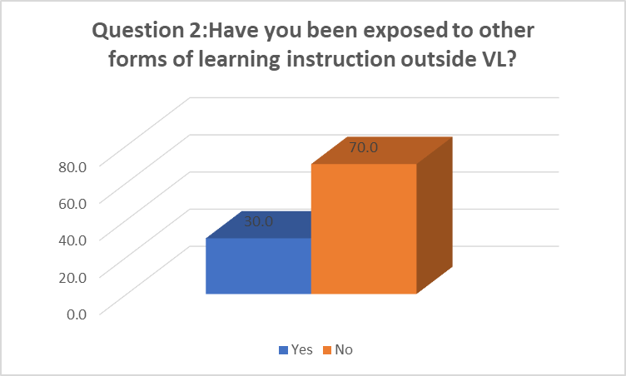

Fig. 2: Students Exposure To Other Platforms Outside Moodle In Virtual Learning

Q3: Briefly itemise other types of learning instruction you are familiar with apart from VL.
 |  | Frequency | Percent | Valid Percent
Valid | Nil | 3 | 30 | 30
Valid | Skype, Zoom | 7 | 70 | 70
Valid | Total | 10 | 100 | 100

Table 3 Analysis:
Out of the total number of respondents, 70% are familiar with some other learning instruction platforms like zoom, skype and so on while 30% only have their experience with the Moodle platform.
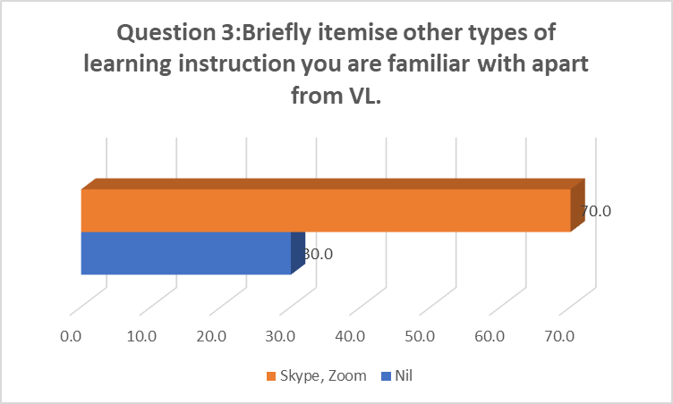
Fig 3: Familiarity With Other Learning Platforms Aside from Moodle in Virtual Learning

Q4: Do you consider these other forms of instructional learning more preferable and suitable to VL and why? Kindly write you response below.
 |  | Frequency | Percent | Valid Percent
Valid | Indifferent | 6 | 60 | 60
Valid | Sometimes | 4 | 40 | 40
Valid | Total | 10 | 100 | 100

Table 4 Analysis:
The table above shows that 60% of the respondents are inddiferent about the consideration of other vurtial learning platfroms being more preferable than Moodle while 40% are of the oppinion that sometimes they find other platfroms prefereable.
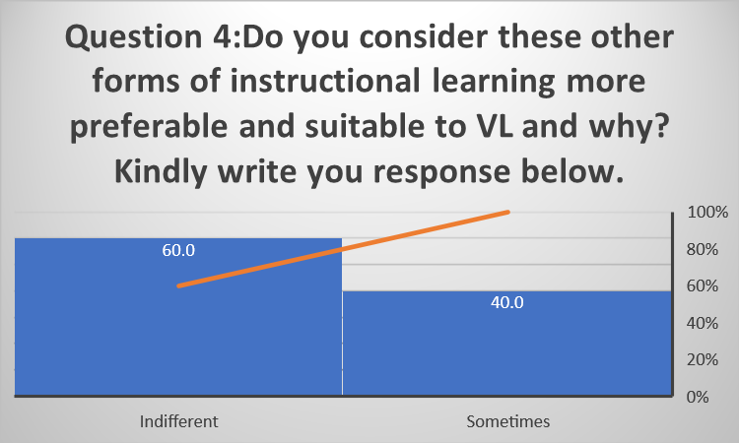

Fig. 4: Considering Other Platforms As Preferable And Suitable For Instructions To Moodle In Virtual Learning

Q5: How will you describe VL as a mode of instruction?
 |  | Frequency | Percent | Valid Percent
Valid | Fair | 2 | 20 | 20
Valid | Good | 3 | 30 | 30
Valid | Excellent | 5 | 50 | 50
Valid | Total | 10 | 100 | 100

Table 5 Analysis:
The table clearly indicates that majority of the respondents (students) see virtual learning as an excellent mode of instruction with 50% while 30% consider it a good mode of instruction. In the same vein, 20% consider it to be fair in their opinion.
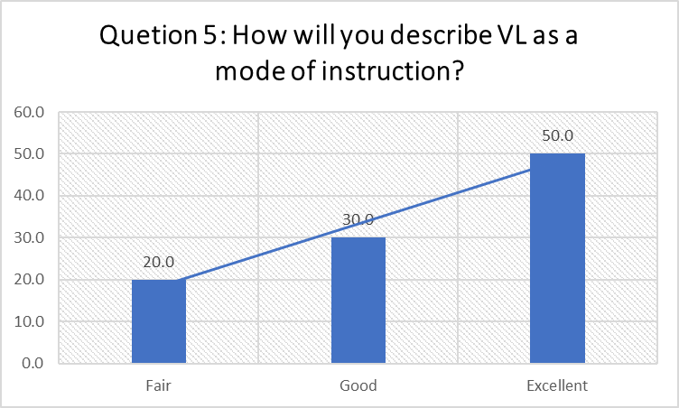
Fig. 5: Q5: Description Of Virtual Learning As A Mode Of Instruction

Q6: How many hours do you spend daily in reading and working on materials online?
 |  | Frequency | Percent | Valid Percent
Valid | 1-2hrs | 6 | 60 | 60
Valid | 3-4hrs | 3 | 30 | 30
Valid | 5-6hrs | 1 | 10 | 10
Valid | Total | 10 | 100 | 100

Table 6 Analysis:
In the table above, it is clear that 60% of the total respondents spend between 1-2 hours in reading and working on materials online. Total of 40% spend 3 hours above online to work on materials.
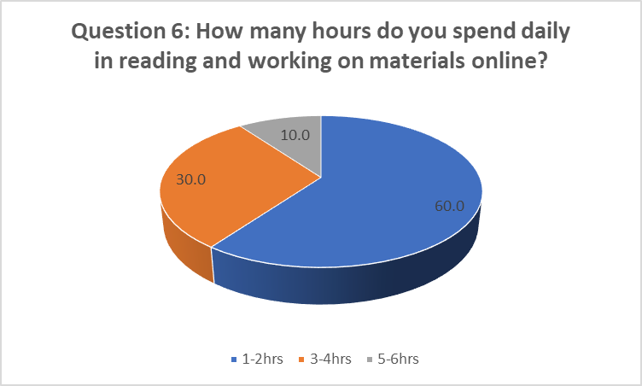
Fig. 4: Hours Spent Daily Reading And Working On Materials Online

Q7: VL through the use of Moodle has positively impacted my effectiveness as a student.
 |  | Frequency | Percent | Valid Percent
Valid | Disagree | 1 | 10 | 10
Valid | Undecided | 2 | 20 | 20
Valid | Agree | 1 | 10 | 10
Valid | Strongly Agree | 6 | 60 | 60
Valid | Total | 10 | 100 | 100

Table 7 Analysis:
The table above clearly shows that 70% of the respondents agree that virtual learning through the use of Moodle has positive impact on their experience and effectiveness while as 20% remain undecided we have 10% who disagree with it.
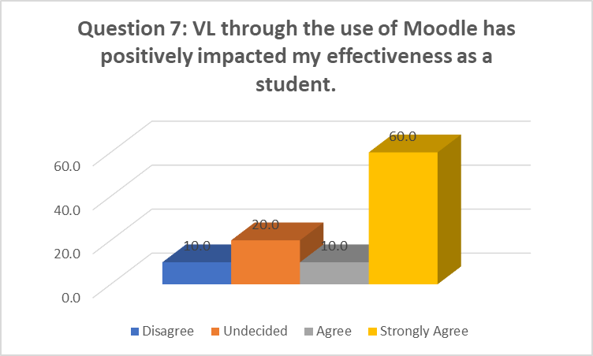
Fig. 7: Effect Of Virtual Learning Through The Use Of Moodle On Students Effectiveness
Q8: The quality and pace of my learning has significantly improved through the use of VL.
 |  | Frequency | Percent | Valid Percent
Valid | Undecided | 2 | 20 | 20
Valid | Agree | 1 | 10 | 10
Valid | Strongly Agree | 7 | 70 | 70
Valid | Total | 10 | 100 | 100

Table 8 Analysis:
The table clearly shows students improvement since interaction with virtual learning as 80% agreed while 20% disagreed that the quality and pace of learning has significantly improved through the use of virtual learning.
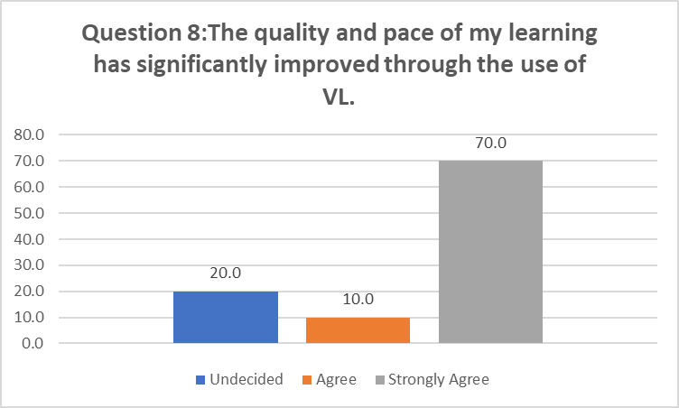
Fig. 8: Significant Improvement Of Quality And Pace Of Learning Through The Use Of Virtual Learning.

Q9: How often are you compelled by your lecturers to work through the Moodle?
 |  | Frequency | Percent | Valid Percent
Valid | Not at all | 1 | 10 | 10
Valid | Occasionally | 2 | 20 | 20
Valid | Frequently | 7 | 70 | 70
Valid | Total | 10 | 100 | 100

Table 9 Analysis:
In the table displayed above, 70% of the responded concluded that they are frequently compelled by their lecturer on the use of the Moodle. 20% affirm that they are occasionally compelled while 10% submitted that they are not compelled at all.
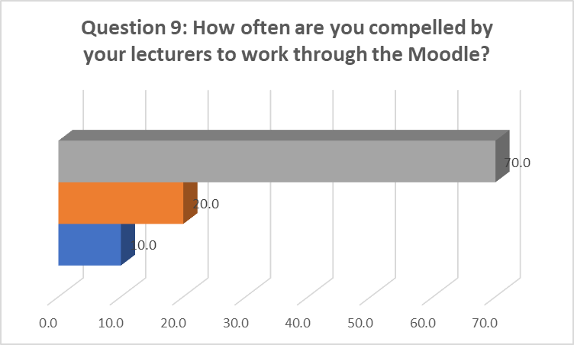
Fig.9: How Lecturers Often Compel Students To Work Through Moodle

Q10: How often do you access Moodle outside the classroom to support your learning without being compelled by your lecturer?
 |  | Frequency | Percent | Valid Percent
Valid | Not at all | 1 | 10 | 10
Valid | Occasionally | 6 | 60 | 60
Valid | Frequently | 3 | 30 | 30
Valid | Total | 10 | 100 | 100

Table 10 Analysis:
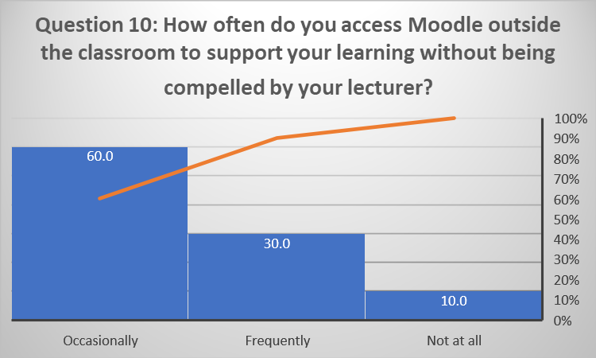
The table above shows that 90% of the total respondents occasionally and frequently access Moodle outside the classroom activities to support learning without being compelled by the lecturer while 10% do not use the Moodle except when compelled by the lecturer.

Fig. 10: Moodle Access Outside The Classroom To Support Learning Without Being Compelled By Your Lecturer

- DISCUSSION
Based on the results and analyses above, the findings made it known that a good percentage of our students in UWTSD had no knowledge of our Moodle (VLE) before they started the programme and 70% have not been exposed to any other platform aside Moodle. The students have experienced the platform and see Moodle as an excellent platform for learning which boost their effectiveness in their programme. The platform, was highly instrumental during the covid19 pandemic. 90% of the students equally access the Module platform of the London campus without being compelled.

7.0 CONCLUSION AND RECOMMENDATIONS
This paper, concluded that VLE is an effective tool for learning and supportive tool to traditional classroom method as disclosed by satisfied students. The platform gives room for independent learning at your own convenient time and also provides opportunity to interact with colleagues more. The results provided by this study will enable our institution to understand the view of students and experiences after interacting with the platform. Findings in this research offers empirical justifications that will be of greater assistance course creators in developing strategies and activities for quality VLE in London campus.

REFERENCES
Becta, 2007. Personalising Learning: The Opportunities Offered by Technology.. s.l.:s.n.
Brooks-Young, S., 2008. Got Moodle?. T.H.E.Journal, 35(4), pp. 28-28,30,.
Butterfield, S., 2002. Highways and pathways — exploring New Zealand's e-learning opportunities. New Zealand e-Learning Advisory Group.
Chen, Y., Zhang, Q., Zeng, T. & Li, X., 2011. Assisting undergraduate nursing students to learn evidence-based practice through self-directed learning and workshop strategies during clinical practicum. Nurse Education Today.
Fraley, R. C., Waller, N. G. & Grennan, K. A., 2000. An item-response theory analysis of self-report measures of adult attachment. Journal of Personality and Social Psychology, Volume 78, pp. 350 - 365.
Greenwood, J., 2010. Using a VLE for Teaching and Learning; ICT@C, Teaching and Learning with technology.. s.l.:s.n.
Henderson, R., 2011. Classroom pedagogies, digital literacies and the home-school digital divide. International Journal of Pedagogies and Learning, 6(2), pp. 152-161.
Hölbl, M. & Welzer, T., 2010. Students' Feedback and Communication Habits using Moodle. Electronics & Electrical Engineering, July, Volume 102, pp. 63 - 66.
Kalogiannakis, M., 2010. Training with ICT for ICT from the trainer’s perspectivepp. A Greek case study. Education and Information Technologies, 15(1), pp. 3-17.
Leedy, P. D. & Ormrod, J. E., 2005. Practical Research: Planning and Design. 8th ed. New Jersey: Pearson Prentice Hall.
Moodle, 2020. Moodle. [Online] Available at: http://moodle.org/about/
[Accessed 02 January 2021].
Moodle, 2021. Moodle Statistics. [Online] Available at: https://www.stats.moodle.org/
[Accessed 02 01 2021].

APPENDICES
APPENDIX 1 (QUESTIONNAIRE)


