Use Cases and BPMN’s
For Lego Mindstorms

Ethan Needham
Computational Thinking

Table of Contents
Use Case 1 – 3 Rectangles 2
Use Case 2 – 3 Right Angled Triangles 3
Use Case 3 – 3 Circles Inside Squares 4
Use Case 4 – 3 Sets of Triangles Opposite Each Other 6
BPMN 1 - 3 Rectangles 7
BPMN 2 - 3 Right Angled Triangles 8
BPMN 3 - 3 Circles Each in Squares 8
BPMN 4 - 3 Sets of 2 Triangles Opposite Each Other 9
Coding For Rectangles 9
Coding For Triangles 10
Coding For Circles within a Square 11
Coding For Triangles opposite each other 11

Use Case 1 – 3 Rectangles

Actor | Lego Mindstorms Robot
Task Description | The Lego Mindstorms Robot will draw 3 rectangles one after another, with each being 10cm bigger than the other.
Preconditions | Code needs to be created in order to allow the robot to perform the use case.  The code that needs to be executed needs to be saved onto the power brick of the robot. This is done by plugging the robot into a computer and then running the code. When unplugged, the robot should remember this code in its files on board the power brick.
Main Course | The robot should draw a rectangle with approximate measurements of 10cm x 20cm and return to origin.  The robot should then start to draw the second rectangle with the measurements being 10cm bigger than the previous. It should then return to origin.  The robot should then start to draw the final rectangle with the measurements being 10cm bigger than the previous. It should then return to origin.
Postconditions | 3 rectangles have been drawn with each being 10cm than the previous.
Alternative Course | If an obstruction of red color appears along the plotted course the robot should immediately stop. It will then raise an alarm, move the object and continue along its course.  If an obstruction not of red color appears along the plotted course the robot should immediately stop. It will then raise an alarm and stop drawing.
Any Exceptions

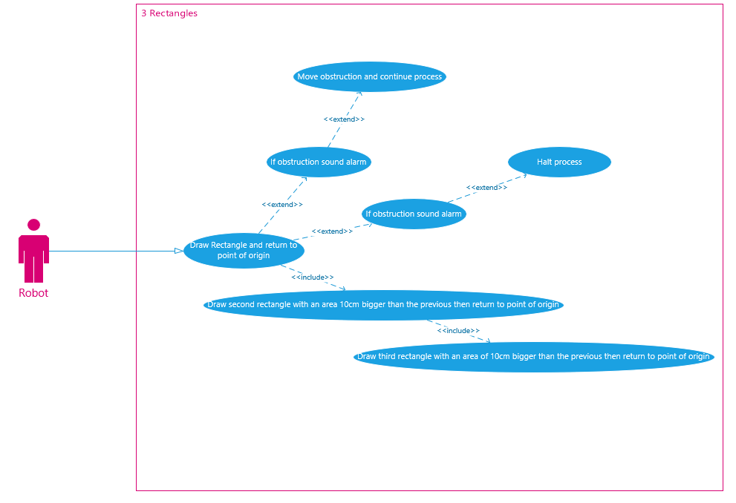

Use Case 2 – 3 Right Angled Triangles

Actor | Lego Mindstorms Robot
Task Description | The Lego Mindstorms Robot will draw 3 triangles one after another, with each being 10cm bigger than the other.
Preconditions | Code needs to be created in order to allow the robot to perform the use case.  The code that needs to be executed needs to be saved onto the power brick of the robot. This is done by plugging the robot into a computer and then running the code. When unplugged, the robot should remember this code in its files on board the power brick.
Main Course | The robot should draw a triangle with approximate measurements of 10cm x 15cm and return to origin.  The robot should then start to draw the second triangle with the measurements being 10cm bigger than the previous. It should then return to origin.  The robot should then start to draw the final triangle with the measurements being 10cm bigger than the previous. It should then return to origin.
Postconditions | 3 triangles have been drawn with each being 10cm than the previous.
Alternative Course | If an obstruction of red color appears along the plotted course the robot should immediately stop. It will then raise an alarm, move the object and continue along its course.  If an obstruction not of red color appears along the plotted course the robot should immediately stop. It will then raise an alarm and stop drawing.
Any Exceptions

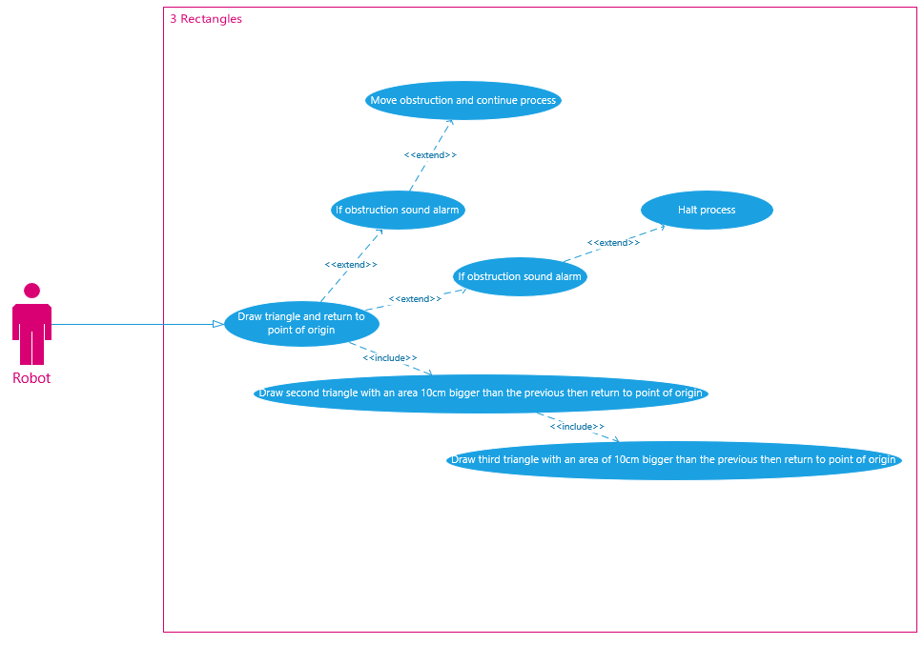

Use Case 3 – 3 Circles Inside Squares

Actor | Lego Mindstorms Robot
Task Description | The Lego Mindstorms Robot will draw 3 circles inside squares one after another, with each being 10cm bigger than the other.
Preconditions | Code needs to be created in order to allow the robot to perform the use case.  The code that needs to be executed needs to be saved onto the power brick of the robot. This is done by plugging the robot into a computer and then running the code. When unplugged, the robot should remember this code in its files on board the power brick.
Main Course | The robot should draw a circle within a square. The approximate measurements of the square is 10cm x 10cm and the circle has a radius of 5cm. It should then return to origin.  The robot should then start to draw the second circle inside another square with both of the measurements being 10cm bigger than the previous. It should then return to origin.  The robot should then start to draw the final circle inside a square with the measurements being 10cm bigger than the previous. It should then return to origin.
Postconditions | 3 circles inside squares have been drawn with each being 10cm than the previous.
Alternative Course | If an obstruction of red color appears along the plotted course the robot should immediately stop. It will then raise an alarm, move the object and continue along its course.  If an obstruction not of red color appears along the plotted course the robot should immediately stop. It will then raise an alarm and stop drawing.
Any Exceptions

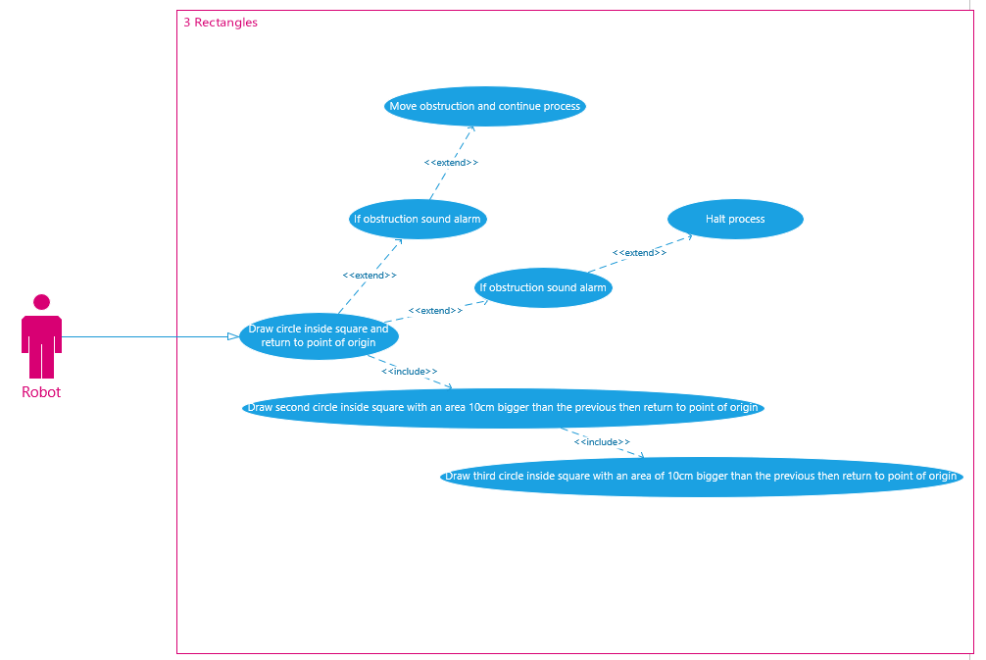

Use Case 4 – 3 Sets of Triangles Opposite Each Other

Actor | Lego Mindstorms Robot
Task Description | The Lego Mindstorms Robot will draw 3 sets of two triangles opposite each other one after another, with each being 10cm bigger than the other.
Preconditions | Code needs to be created in order to allow the robot to perform the use case.  The code that needs to be executed needs to be saved onto the power brick of the robot. This is done by plugging the robot into a computer and then running the code. When unplugged, the robot should remember this code in its files on board the power brick.
Main Course | The robot should draw two triangles both opposite each other. The triangles will be equilateral with approximate measurements of 10cm on each side and return to origin.  The robot should then start to draw the second two triangles with the measurements being 10cm bigger than the previous. It should then return to origin.  The robot should then start to draw the final two triangles with the measurements being 10cm bigger than the previous. It should then return to origin.
Postconditions | 3 sets of 2 triangles opposite each other have been drawn with each being 10cm than the previous.
Alternative Course | If an obstruction of red color appears along the plotted course the robot should immediately stop. It will then raise an alarm, move the object and continue along its course.  If an obstruction not of red color appears along the plotted course the robot should immediately stop. It will then raise an alarm and stop drawing.
Any Exceptions

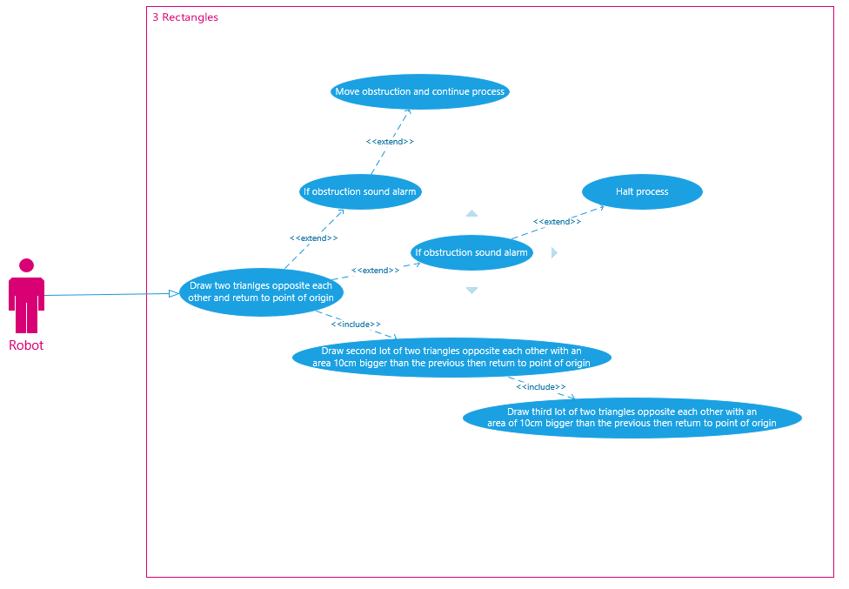

BPMN 1 - 3 Rectangles
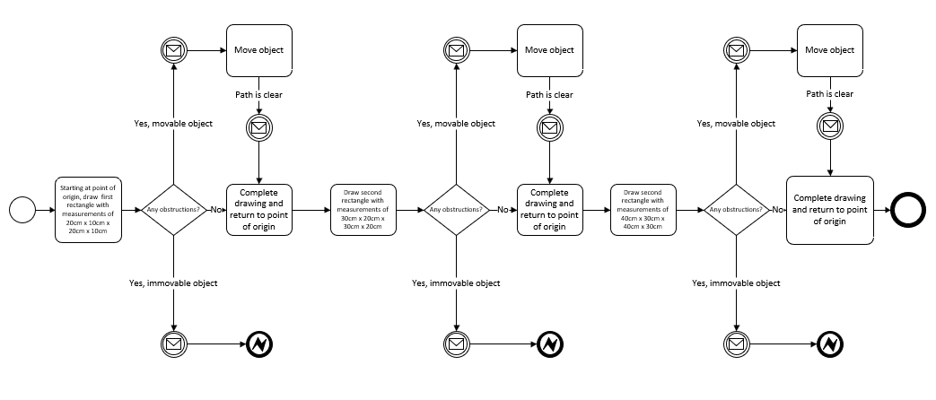

BPMN 2 - 3 Right Angled Triangles
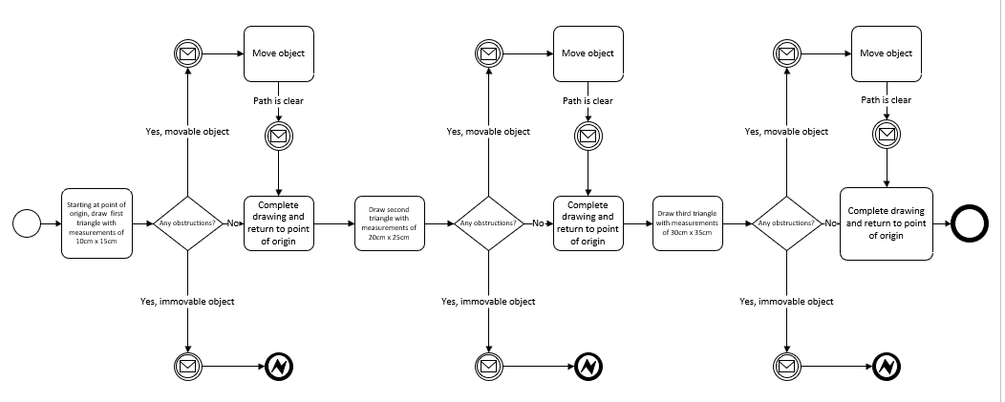

BPMN 3 - 3 Circles Each in Squares
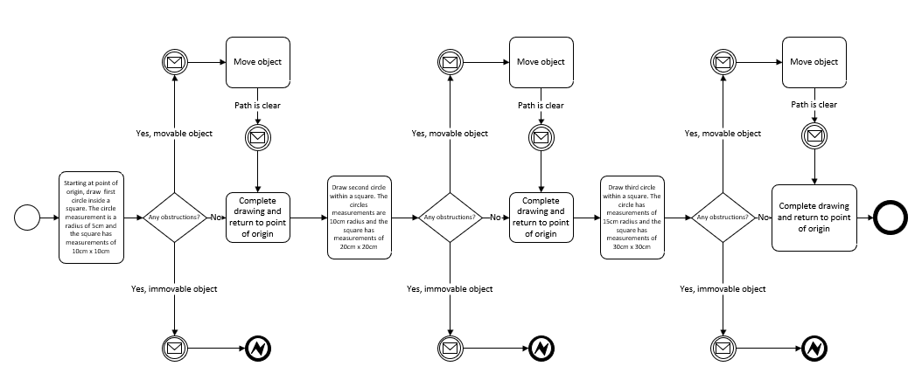

BPMN 4 - 3 Sets of 2 Triangles Opposite Each Other
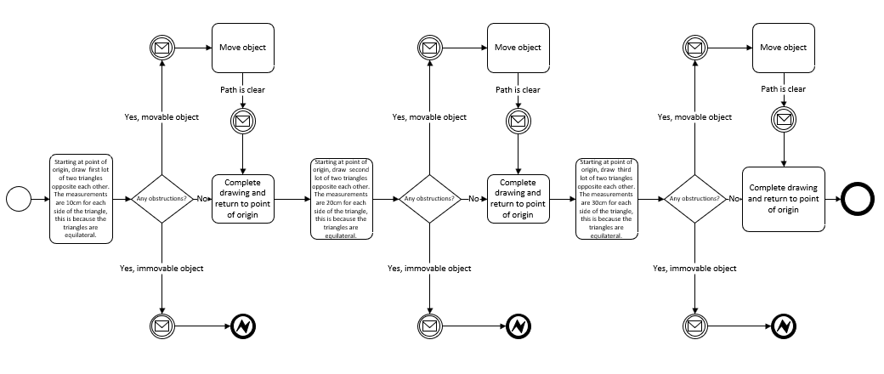

Code and attempt For Rectangles
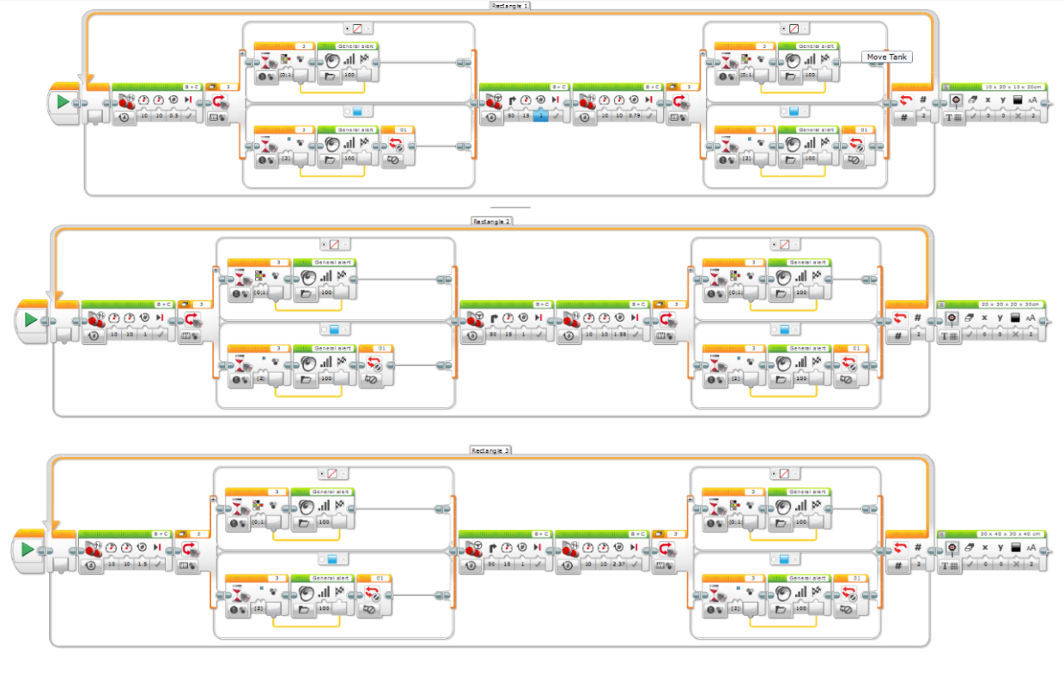
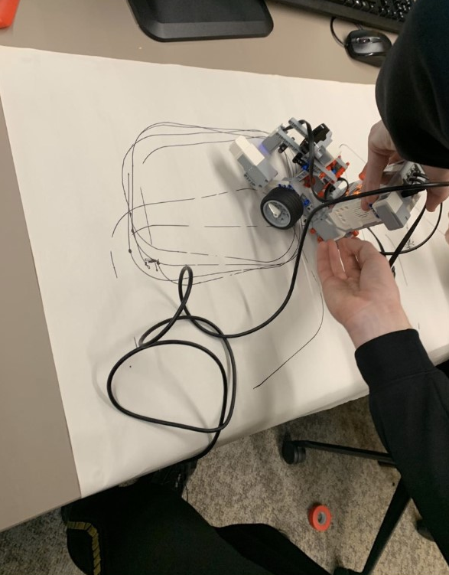
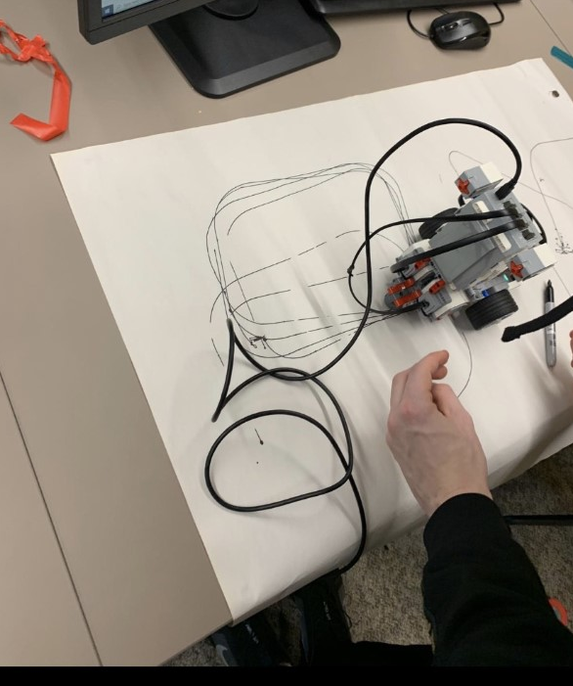
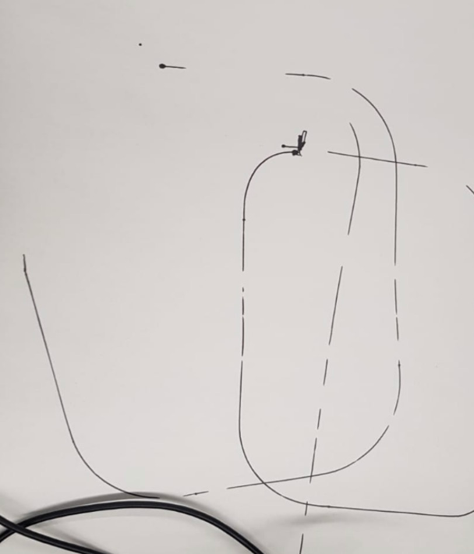
In the previous three images you can see my groups attempt at drawing 3 rectangles on the paper with our robot. Although this test wasn’t successful, we still managed to create one complete rectangle. Our robot struggled with the cornering aspect of the rectangle, this may be down to the fact that the power brick was attached to the back. Therefore, making it uneven and not allowing for a precise corner to be drawn.

Code and attempt For Triangles
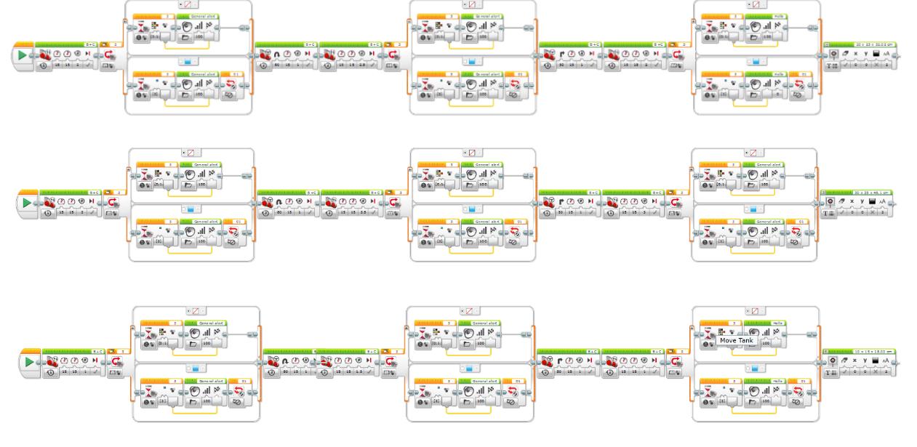
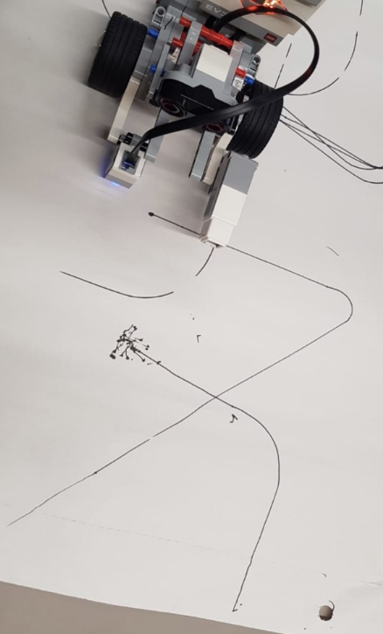
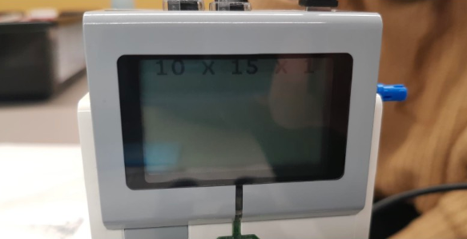
Here you can see the attempt for the right-angled triangle. Again, this test wasn’t successful. We were able to make it create 2/3 of the triangle, but we were unable to get the robot to fully return to the point of origin. Again, our robot struggled with the cornering aspec, this may be down to the fact that the power brick was attached to the back. Therefore, making it uneven and not allowing for a precise corner to be drawn.

Code For Circles within a Square
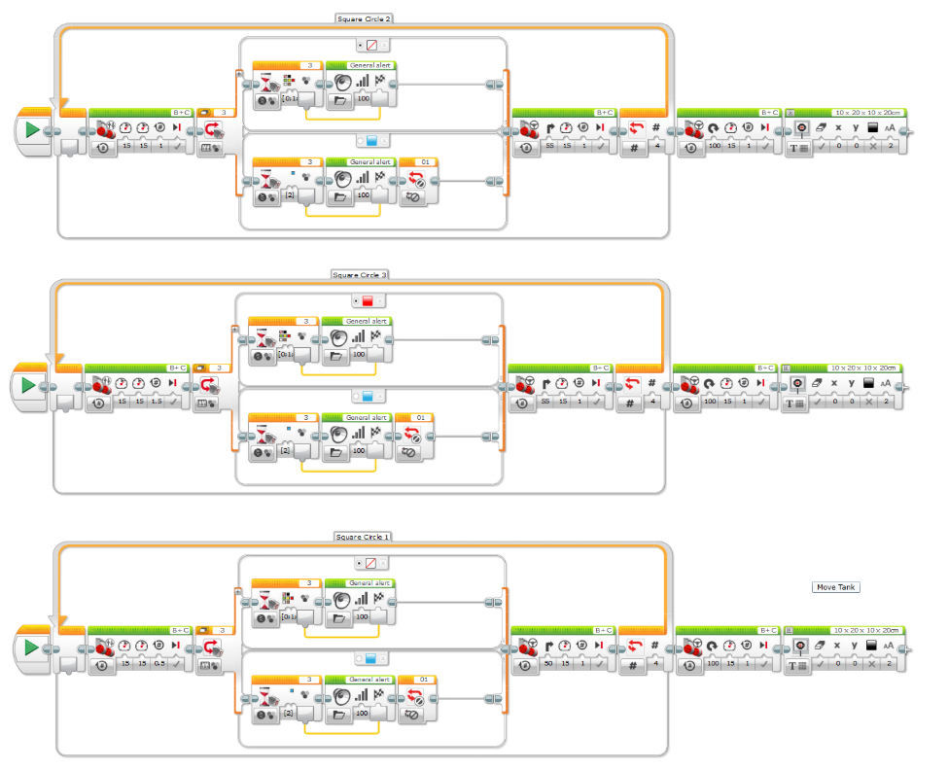
Unfortunately, we were unable to make a presentable attempt for the circle within the square. This may be because due to our robot being very back heavy, it made it very uneven and unable to perform a steady corner.

Code and attempt For Triangles opposite each other
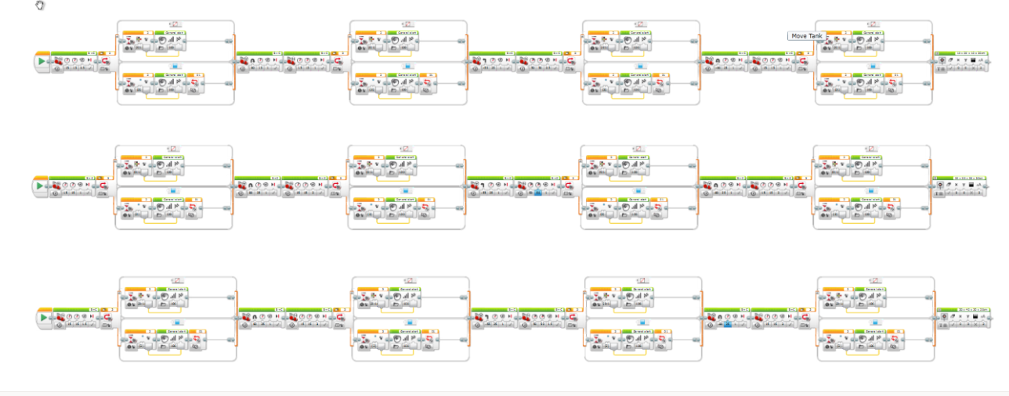
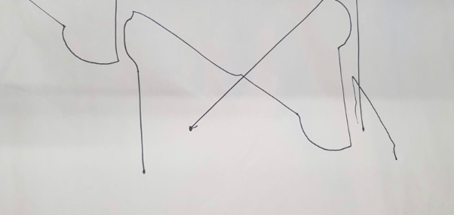
Here we have the two triangles diagram. This was our most successful attempt. Although not completed we were able to get the robot to complete the first triangle.

Future Improvements
If we were able to do this again we would completely change the structure of our robot. The reasoning for this was because it was uneven in terms of weight distribution. We would put the brick in the middle of the robot instead of the back. Our team also struggled with time, this is because we spent too long creating the code and not enough time designing and building our robot. If we were able to do this another time. We would thus spend more time creating a better and more steady design for our robot.

