ACDB 4011: Flame Test Laboratory Report

Simon Shepherdson
Student Number: 2309878

Date: June 2024

Contents
Keywords 3
1 Introduction 3
2 Results 5
3 Discussion 6
3.1 Interpretation 6
3.2 Relevance to OME 7
3.3 Advantages and Drawbacks 7
4 Conclusions 8
5 Annex A 9
5.1 Associated CoSHH hazards for the materials to be tested in the current study. 9
5.2 List of equipment utilised in current study. 10
5.3 Experimental Procedure. 10
6 Annex B 10
6.1 References 10

Figure 1 – Cycle of electron from ground to excited state and return to ground. 3
Figure 2 - Diagram of the visible spectrum of light 4
Figure 3 - Metal Ions and observed flame colour 5
Figure 4 - Observed flame colour for metal solutions 6

Table 1 - Experimental data 5

Keywords
Laboratory testing, Flame Photometry, Visible light, Photon.

Introduction

This report sets out the experimental procedure and resulting observations of unknown solutions of metal salts subjected to a naked flame. The experiment aims to identify metal ions by the visible light spectrum produced when subjected to a high temperature flame; this will be supplemented with observations and interpretation from known scientific methods.
Atoms exist in two states, known as ground state and excited state. In the former, the electrons occupy the lowest energy level. When specific energy is applied, these electrons become excited and are promoted to a higher energy level. Electrons that are excited are further from the nucleus and have a higher potential energy. As this energy is released, the electron will return to its original state and in doing so the equivalent lost energy is released in the form of photons with a wavelength specific to the material.
This journey is represented in Figure 1 below;
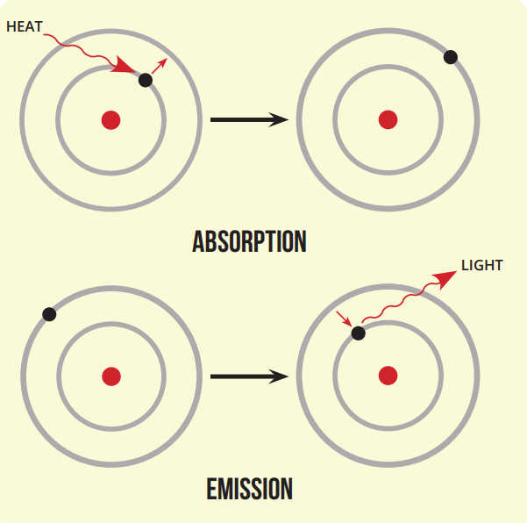

Figure 1 – Cycle of electron from ground to excited state and return to ground.
Materials emit photons that are unique to those materials; these photons correspond to specific wavelengths in the visible spectrum of light. The emissions can therefore be utilised to identify the element under investigation.
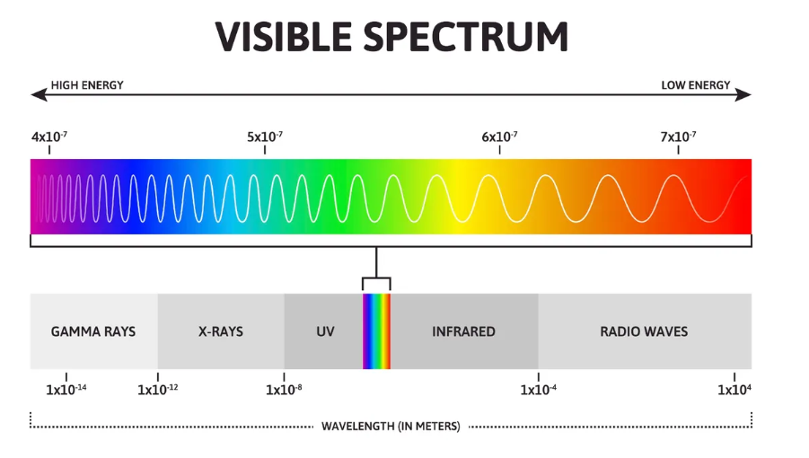

Figure 2 - Diagram of the visible spectrum of light
As seen in Figure 2 above, the energy level of the colour emitted is related to its frequency.
$$∆E=hf$$
Equation 1 - Energy differential
Where; ΔE – energy differential between levels
h – Planck constant (6.63 x10⁻³⁴ J.Hz⁻¹)
f – Frequency of light (Hz)

Frequency and wavelength are inversely proportional to the speed of light, shown in Equation 2;
$$c=fλ$$
Equation 2- Relationship between speed of light, frequency and wavelength
Where; c – speed of light (3.0x10⁸ ms⁻¹)
λ – wavelength (m)
f – Frequency of light (Hz)
Any resultant observation of light is dependent on the material under investigation.
Figure 3 - Metal Ions and observed flame colour
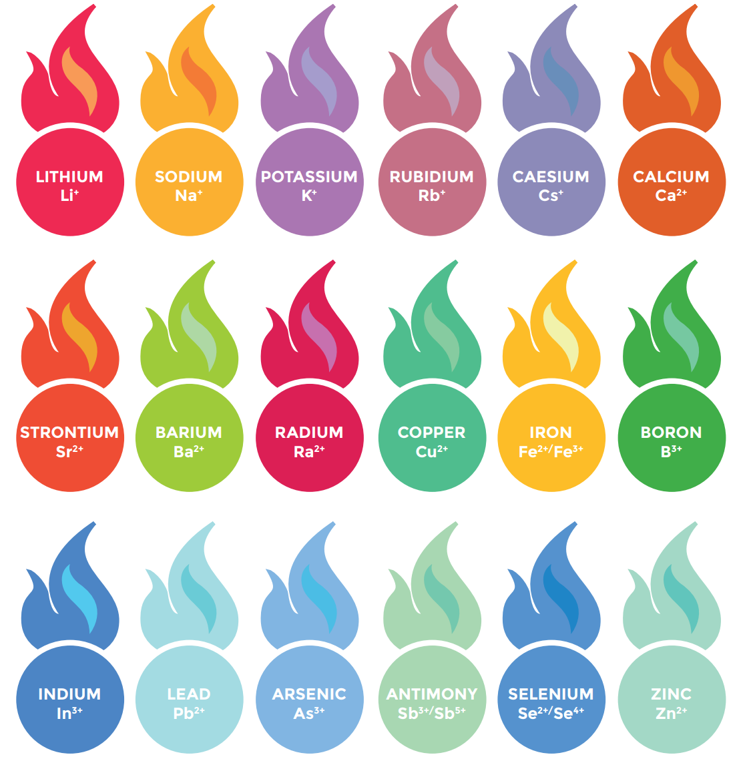

Results

Following the experimental setup as described in Annex A (Section 5.3) in combination with the visible spectrum (Figure 2) a compilation of the unknown solutions and their responses can be tabulated as follows:
Unknown metal salt solution | Colour of observed flame | Identity of metal ion | Wavelength (nM)
Deionised water | Orange | N/A | N/A
1M HCl | Green / Blue | N/A | N/A
Solution A | Orange | Sodium | 600
Solution B | Lavender | Potassium | 450
Solution C | Red / Orange | Calcium | 650
Solution D | Red | Strontium | 700
Solution E | Blue / Green | Copper Chloride | 500
Solution F | Red / Pink | Lithium Chloride | 650
Solution G | Yellow / green | Barium | 550
Solution H | Yellow / Orange | Sodium Chloride + Potassium | 600
Table 1 - Experimental data
The wavelengths designated in Table 1 are approximate based on the observation and discussion from the report Author and experimental team (A. Clarke & S. Deane) as they were made.
The eight materials tested display colours that cover almost the entirety of the visible spectrum of light, with five being above 600nM in wavelength. The observations were then compared to the visible light spectrum in Figure 4. The observations of the group also closely match the reference colours in Figure 3.

Figure 4 - Observed flame colour for metal solutions
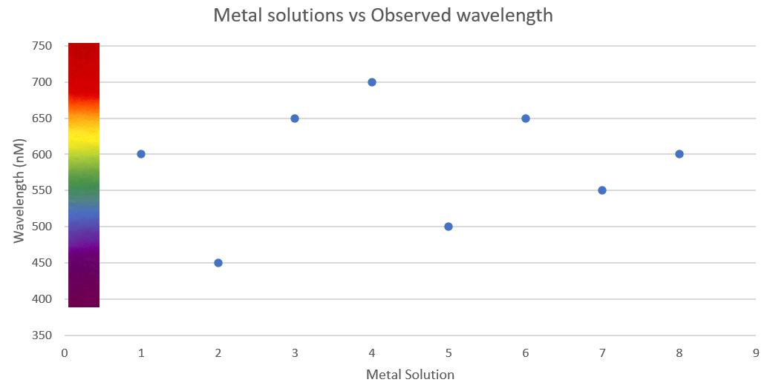

Discussion

Interpretation

With the speed of light being a fixed constant (3.0 x10⁸ ms⁻¹) the relationship between frequency and wavelength in Equation 1 are inversely proportional. That is to say, the shorter the wavelength, the higher the frequency must be to maintain the constant speed. In addition to this, the higher the frequency, the higher the energy associated with it, which increases proportionally.
Two of the materials from Table 1 have been selected for further analysis; solutions B and D. These have been identified as Potassium and Strontium solutions respectively, with these metals appearing at opposite ends of the visible spectrum. Using Equation 1 to estimate the change in energy associated with observed flame colour gives for Potassium;
$$2.98x{10}^{-40}J=(6.63*{10}^{-34})*(450*{10}^{-9})$$
Equation 3 - Energy Differential for Potassium
Also for Strontium;
$$4.64x{10}^{-40}J=(6.63*{10}^{-34})*(700*{10}^{-9})$$
Equation 4 - Energy Differential for Strontium
Further to this, rearranging Equation 2 to solve for frequency gives;
$$f=\frac{λ}{c}$$
Equation 5 - Solving for frequency.
Substituting in known and observed values into Equation 3 for the two solutions selected above gives;
$$1.50*{10}^{15}Hz= \frac{450 {*10}^{-9} }{3.0* {10}^{8} }$$
Equation 6 - Substituted values for Potassium
Potassium is seen to have an approximate frequency of 1.5x10¹⁵ Hz.
$$2.33*{10}^{15}Hz= \frac{700 {*10}^{-9} }{3.0* {10}^{8} }$$
Equation 7 - Substituted values for Strontium
Strontium is seen to have an approximate frequency of 2.3x10¹⁵ Hz
From these it can be interpreted that a subtle change in the observed wavelength will affect the frequency and therefore the amount of energy released as photons are emitted. This correlates broadly with the expectations at the outset.

Relevance to OME
The most recognised application of this test method can commonly be found around typical holiday periods either in public or private functions, and beloved by children. That is of course fireworks. However, there are other uses of photon emission used in the OME sphere; these can range from signal flares to countermeasures for a variety of vehicle or situation. A non-exhaustive list is summarised below;
- Signal flare,
- Illumination flare,
- Pyrotechnics for film & television industry,
- Decoy countermeasures
Signal and illumination flares come in many colours, these are typically red, green and yellow. However, others visible colours are available, for example blue or white. The latter being used predominantly for night signal operations. For red flare compositions, strontium is typically used. Green flare compositions require a chlorine or copper component, such as strontium chloride and for yellow compositions require a mixture of sodium and barium to offset the visible spectra from orange to yellow. Decoy countermeasures are designed in the near ultraviolet spectrum to mimic heat signatures to mislead heat seeking ordnance. Representative colour spectra can be seen in Figure 3.

Advantages and Drawbacks
There is plenty that can be said about the flame test undertaken in this study, for there are a multitude of advantages and disadvantages to the technique. For brevity these can be briefly summarised as follows
Advantages –
- Quick and easy to perform, including outside of a controlled laboratory setting.
- Cheap – Requires minimal equipment and small volumes of material.

Disadvantages –
- Subjective – error can be introduced from the operator from observed colour interpretation e.g., colour blindness.
- Contamination – small amounts of contamination or impurities can alter the observed flame colour.

Conclusions

A quick and easy testing methodology was utilised to successfully identify unknown dissolved metal ions by subjecting them to a high temperature flame. Observations from these trials were backed up with calculation which correlate broadly to the hypothesis outset at the beginning. It can be seen that although drastically different visible colours are observed the frequency of the electromagnetic wave are still in the same order of magnitude.
Whilst the data here is considered valid, further studies would be recommended using more specialist methods for the determination of flame photometry, such as using an automated photoelectric flame photometer or an Inductively coupled plasma atomic emission spectroscopy (ICP-AES) apparatus. However, it is appreciated the additional time, effort and cost associated with these methods is significantly more than that presented in the current study. They would however better define the wavelengths of light generated much more accurately.

Annex A

Associated CoSHH hazards for the materials to be tested in the current study.
Chemical | Symbology | Hazards
Hydrochloric Acid Solution (1M HCl) | 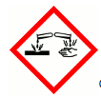  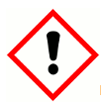 | Causes severe skin burns and eye damage.  Harmful if swallowed.
Barium Chloride (BaCl₂) | 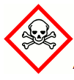 | Acute toxicity (oral, dermal, inhalation), Cat. 3.  Irritant.
Calcium Chloride (CaCl₂) |  | Causes serious eye irritation.
Lithium Chloride (LiCl) |  | Causes serious eye irritation.  Harmful if swallowed.  Causes skin irritation.
Strontium Chloride (SrCl₂) |  | Serious eye damage.
Strontium Nitrate (Sr(NO₃)₂) | 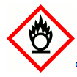 | May intensify fire; oxidiser.  Harmful if swallowed. Causes eye irritation. Can cause respiratory irritation.
Potassium Chloride (KCl) |  | Causes serious eye irritation.
Potassium Nitrate (KNO₃) |  | May intensify fire; oxidiser.
Sodium Chloride (NaCl) |  | Not classified as a hazardous material.
Copper Chloride (CuCl₂) | 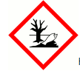 | Harmful if swallowed or in contact with skin.  Causes skin irritation and serious eye damage.  Very toxic to aquatic life with long-lasting effects.

List of equipment utilised in current study.
- Bunsen burner
- Heat-resistant baseplate
- Matches
- Metal rod
- 1M solutions of unknown metal salts labelled A through H
- Beaker of 1M Hydrochloric Acid (HCl)
- Beaker of deionised water (DI water)
- Blue cobalt glass.

Experimental Procedure.
1 Initially, a Bunsen burner is placed on a heat resistant baseplate and set-up on a laboratory bench. The burner is lit with matches with the vent set on the burner to leave an orange flame for safety purposes. At the point of experimental use, the vent is moved to allow the non-luminous double coned blue flame.
2 In order to clean the test wire, it is repeatedly dipped in the HCl solution and then heated in the non-luminous flame. This is repeated as necessary until no colour is offered from the wire when heated; any indication of colour is an indication of impurities being present.
3 Once no colour is obtained in the above cleaning step, the wire is dipped in deionised water and re-heated to remove remaining residue of HCl. These two steps are repeated between each experimental run.
4 Prior to each experimental run the wire is first allowed to cool before being dipped into the unknown salt solution. It is then heated in the flame and observations are recorded in the results table, Table 1. The cobalt glass is used for each experiment to identify the mixture of sodium and potassium.
5 Steps 2 through 4 are repeated for the remaining unknown samples.
6 Initial observations are made for the deionised water and the 1M HCl and recorded in Table 1

Annex B

References
- Health & Safety Executive Website, Hazard Pictograms, Hazard symbols and hazard pictograms - Chemical classification (hse.gov.uk), Accessed 12/06/2024.
- LiveScience.com What is visible light? | Live Science ; Accessed 20/06/2024
- Metal Flame test infographic, www.compoundchem.com A.Brunning February , 2014. Accessed 12/06/2024
- Aircraft Infrared principles, signatures, threats and countermeasures. J.R.White, September 2012, Naval Air Warfare Center Weapons Division
- Spectrally adapted red flare tracers with superior spectral performance, K. Elkoba, Defence Technology 13 (2017) p406 to 412
- Elimination of perchlorate oxidizers from pyrotechnic flare compositions, Dr R. Shortridge et al, March 2007
- Genesis of infrared decoy flares, 1st Edition, B. Douda, Naval service warfare center, 26 January 2009

