PROJECT INITIATION DOCUMENT (PID)

Investigating a Business Issue from a HR Perspective

Students Name: Sonia Green

INSTRUCTIONS:
Give as much justification as possible for every question asked. This means, you must not limit yourself to just stating WHAT you believe is an appropriate response, but WHY.
ALWAYS provide an outline of the financial and cost imperatives associated with your report tasks. Imagine you must be able to SELL your project idea.
Put effort into the PID and your will benefit from this when it comes to undertaking the research. Use your skills as a “Thinking Performer” and take the “Business Partner” approach.

PID submission date detailed on the IBI Activity Schedule

- Name | Sonia Green
- Organisation name: | South Wales Police
- Type of business:  Nature of business and customer profile: | Public Sector. Protecting the communities of South Wales
- Number employed by organisation: | 5,667
- Number employed within human resources (HR) department (if applicable): | 81
- List the main HR functions that are undertaken by your organisation: | Operational – to look after the attendance and performance of Police Officers and Staff. Making sure that resources are at a suitable level and to look after the those that serve the community.  Talent, reward and recruitment – to recruit the numbers required Officers and staff alike. To develop and enhance the development of those within the force.
- Your job title: | Human Resources Advisor
- How long have you been in this job? | 5 years
- Outline main purpose of your job: | Operational – looking after the Police Officers and Police Staff through attendance and performance, guiding them through processes and to help with understanding of the policies and procedures that are in place as well as developing and creating them.
- List the HR responsibilities within your job: | Sickness absence, advice and guidance  Guidance through performance difficulties  Advising on resourcing levels and best practice  Creating, amending and reviewing policies  Project work  Supporting the HR Business Partner for Operational Support Services (Justice Services, Specialist Operations such as Dog Unit, Custody and the Public Service Centre)
- Who is the person mainly supporting your report (Sponsor)? State their job title and their relationship to you: | Name: Lesley Davies  Job title: HR Business Partner  Relationship to you: OSS Business Partner

- Aim of report:
In no more than twenty words, state the overall aim of the report. Here you need to compile a sentence that communicates clearly what you intend the report idea to achieve.

Aim: Critically analyse the rise in sickness absence within OSS post covid

TOP TIP: KEEP IT SPECIFIC. IMAGINE YOU ARE A SELF-EMPLOYED CONSULTANT DETERMINING THE PARAMETERS OF YOUR report FOR WHICH YOU WILL GET PAID. A CLEARLY STATED AIM HELPS TO ACHIEVE PARAMETERS AND SERVES TO ESTABLISH THE BASIC DESIRED OUTCOME OF THE report. ONLY WHEN WE DELIVER ON THE AIM, SHOULD WE EXPECT TO GET PAID BY OUR PAYMASTER.
- Objectives of report:
List four objectives that are each directly related to the report aim. Here you must ensure the objectives are SMART (specific, measurable, achievable, realistic, time bound). Essentially, objectives are steps you need to take to achieve the report aim. Each objective must begin with a verb that states clearly how the objective is to be undertaken.
Objectives:
1 Analysing the data and any trends it may reveal for pre, during and post covid

2 The correlation between the rise in absence for staff and officers

3 Analysing the gaps in learning to find best practice in managing sickness absence

4 To make recommendations on proactive approaches to assist in managing sickness absence from the learnings taken from the findings.

TOP TIP: KEEP OBJECTIVES SIMPLE AND ADHERE TO SMART PRINCIPLES. THE OBJECTIVES ARE THE STEPS YOU WILL TAKE TO DELIVER ON THE AIM OF YOUR report. AGAIN, THESE ARE MEASURABLE PARAMETERS AND SERVE TO DEMONSTRATE A LOGICAL AND EASILY UNDERSTANDABLE APPROACH TO SUCCESSFULLY COMPLETING THE report. OBJECTIVES ARE ALWAYS AGREED AND “SIGNED OFF” BY YOUR PAYMASTER SO THAT BOTH PARTIES KNOW WHAT IS BEING CARRIED OUT AND IN THE END, PAID FOR.

- Give an outline of the sorts of tasks and questions you want to undertake and ask that will allow you to deliver on your objectives and ultimately achieve your aim.
Questions relevant to objective one: Analysing the data and any trends it may reveal for pre, during and post covid
What is the difference in absence between staff and officers?
Is there similarities in the trends that they present?
Why is there a rise in absence post covid? What did the business do differently during covid?

Tasks relevant to objective one:

Gather the absence records for the last year and a half to two years
Statistical analysis of that data
A comparison of the data to show any correlation in departments

Questions relevant to objective two: The correlation between the rise in absence for staff and officers

What is being done differently between staff and officers?
What are the reasons in the absences and the differences that there are?
What more can be done to prevent individuals from going sick?
What could have been done?
Is there any similarity in the absence categories?

Tasks relevant to objective two:

What trends can be found in the data collected within objective one
To get first hand understanding from those involved in order to understand what is being done differently and to hear their opinions on what is happening

Questions relevant to objective three: Analysing the gaps in learning to find best practice in managing sickness absence

What more do line managers require in order to keep staff in work?
Is the staff absence guidance enough to help line managers in preventing and returning staff to work?
Is there enough information in what is available to line managers and those who are suffering?

Tasks relevant to objective three:

Go through the current guidance, toolkits and information available to see if there is anything further that could be done

TOP TIP! THE MORE TIME YOU TAKE EARLY ON IN YOUR REPORT TO WORK OUT WHAT YOU ARE GOING TO ASK AND WHAT YOU HAVE TO DO, THE MORE TIME YOU WILL SAVE LATER ON.

- What is the business case for considering undertaking the report? Here you need to justify how achieving the report aim will advantage and benefit the business and its stakeholders. For example, savings, gaining intelligence of competitors, promoting innovation, and return on investment.

The reasoning behind conducting this report is to find the reasoning and learning behind why the changes in absence. Back in 2019 South Wales Police was XX amount of staff on sick with XX amount of days lost potentially costing the force hundreds of thousands of pounds of public money, which could have been used for resourcing events, protests and responding to calls in an adequate and efficient time.

However, come along the pandemic and the absence rates went down dramatically, why was this? Was this just because of the “call” that officers felt, responding to the need of the public or was it because there was other initiatives such as working from home?

The difference we find now is that there is an increase in absence, on the top level it seems to be mental health related. The questions come with why? What is the force doing that has incurred this increase?

The focus will be within Operation Support Services (OSS) within this arena of operational work, it will allow for the investigation of the difference in staff and officers, learning gaps and outcomes and what Human Resources can do further to initiate a steady and preventative nature.

The below provides an idea of the current absence categories affecting SWP as of this date 02.07.2021.

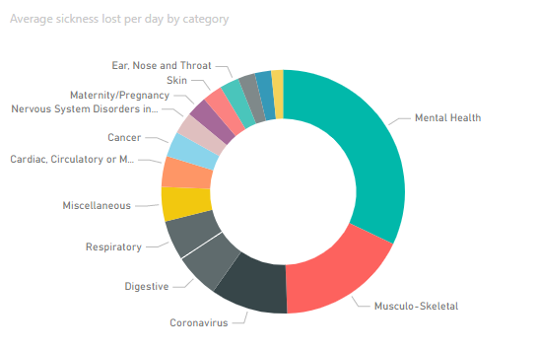

The below figures also highlight the changes in the pattern of sickness absence that this report is looking to address.

The “total daily sickness by date” reveals the downward trend that occurred when the critical incident for the pandemic was announced. It shows officers returning but than a steep incline at the time of the covid recovery.
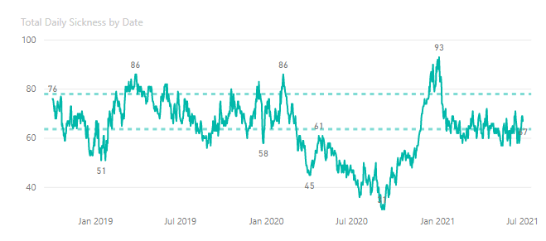

The below again shows the relevant rises but split between staff and officer. It shows the significant rise that was had on staff absences.

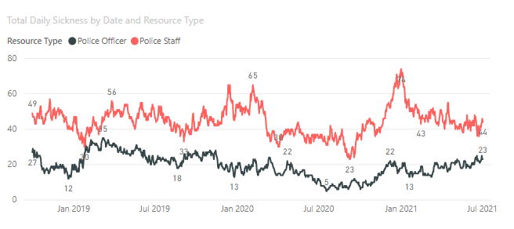

Please note the above are for OSS areas only.
The full force is represented in the two graphs below which have also identified the same trends
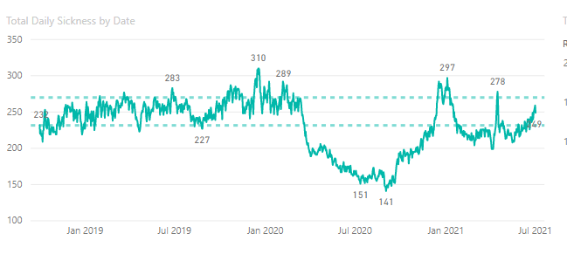

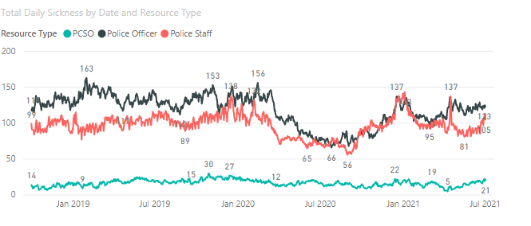

TOP TIP: NO BUSINESS CASE? BIN REPORT, START AGAIN - BETTER NOW THAN LATER!
- Identify the risks associated with the report and how these could be overcome.

As with any investigation there are several risks.
Firstly the data, although this will tell a story, will it tell the whole story? There is a potential for the categories to have been put on wrong, which may allow for a persuasion and alteration in the data results. This will be managed by checking and using data that has been verified, any anomalies will be highlighted throughout the process.

There may be difficulties in accessing the data for the last two years due to system changes. This however should be managed by requesting the data from not only the sickness team but also the other HR Advisors that have looked after this operational area previously.

The stigma that surrounds sickness will impact on any questionnaires or focus groups that may take place. It will require careful planning and work in order to increase the rapport to allow for honest and open conversations.

During the last two years there has been a merge of areas, 4 Basic Commands Unit which sets out the geographical area of the force has been amended to reflect 3 command areas. This was developed and in place after the financial year had started in 2019, although this will be taken into account it could allow for a skewing of the data.

When completing the primary research, there are potential issues that may surround the collecting of this. Although it will be anonymous and sent to a different HR inbox for redaction, individuals may not be fully aware of the context that this will be used, the why causing concerns to be around attempting to put the right answer rather than the correct one. This will be attempted to be overcome by a full explanation of why the survey/questionnaire is being conducted and the emphasis that it will be anonymous and will have no impact on what has been done but for the wellbeing of the staff and officers going forward and what more SWP can do for them.

TOP TIP: THERE ARE RISKS TO ALL RESEARCH PROJECTS HOWEVER, GOOD THEY MAY SEEM! THE SKILL IS TO IDENTIFY AND MANAGE THE RISK(s).
- List the resources you will need to make your report a success. State why such resources are needed. These may include, people, time, cash, technology, data. Identify any constraints that you may encounter and explain how you would overcome these.

Data from the absence records from the last two years – This is needed to show the absence categories, the levels of absence, how many days lost, the cost to the organisation and ultimately pinpoint any changes to the trends that take place. Data is only reliable if it is firstly recorded properly, secondly interpreted correctly and thirdly and most importantly have the correct access to it. As this is part of the role of the HR Advisor access is already in place but permissions have also been granted by line managers to use this data. The sponsor for this form is not only a HR Business Partner but also knows and understands the best formats to interpret the data without compromising the results that are shown.

People are the second resources that will need to be used. They are the key to the data, as this data is about them and what SWP can do for them going forward. It is also the way to receive the primary data, through the people that manage the absences, it will be able to show their personal experiences as line managers and potentially as those that have been absent but also gather what they believe will and/or has improved sickness absence.

Time, the collection of data, research and primary gathering will all cost time and money.

Technology, there may be recommendations from the conclusions of this report that rely on the focus of how technology may impact on sickness. There is the possibility that it will cost the force to implement and embrace new and upcoming technology or further technology that is already in place. All of which will cost the force additional monies.

TOP TIP: THE ASTUTE MANAGER IS FULLY AWARE OF THE REQUIRED RESOURCES AND THEREFORE, BUILDS POSITIVE RELATIONSHIPS WITH PEOPLE WHO CAN HELP HIM/HER IN OBTAINING SUCH RESOURCES. IT IS ESSENTIAL TO IDENTIFY ALL RESOURCES AT THE BEGINNING OF A PROJECT SO THAT YOU CAN INCLUDE THEM IN YOUR COSTS.
- State what method you intend to use to collect your primary data. For example, questionnaire, interviews, telephone surveys, focus groups etc. Outline why a particular research method was chosen over alternatives.

Questionnaires to go forward to line managers and HR Advisors and potentially HRBP’s.

TOP TIP: CHOOSE AN APPROPRIATE METHOD AND THEN, USING THIS METHOD, ENSURE YOU WILL ACTUALLY BE ABLE TO COLLECT THE DATA YOU REQUIRE. AGAIN, KEEP IT SIMPLE AND TAKE ADVICE FROM RESEARCH METHODOLOGY TEXT BOOKS AVAILABLE IN THE LIBRARY.
- State HOW you plan to collect primary data and justify the appropriateness of your chosen research method. Consider whether or not you will be given or denied access to personnel and why.

Survey

TOP TIP: BE SURE THAT THE METHODOLOGY YOU USE TO COLLECT YOUR DATA IS APPROPRIATE AND AFFORDABLE IN TERMS OF YOUR TIME. KEEP IT SIMPLE! DO NOT MAKE YOUR LIFE DIFFICULT.
- State from WHOM you plan to collect primary data and detail any challenges you anticipate. Outline how you plan to approach people to take part in your research and why you have chosen such individuals. State why individuals may agree to take part in your report or indeed, refuse.

Those that already work within OSS these will be line managers, Inspectors, Sergeants but this will also be done in a staged manner that will dictate the workings for each survey.

TOP TIP: BE SURE THAT THE PERSONS YOU WANT TO PARTICIPATE IN YOUR REPORT ARE THE APPROPRIATE PERSONS.

- State from where you plan to collect secondary data. This means providing an early list of alphabetised websites and a bibliography that details (using Harvard method) the books, journals, research and magazines that you intend to use.

Website addresses:
Approximately 10

Books (on topic area and associated subjects):
Approximately 10

Books (on research methodology):
Approximately 3

Peer reviewed research papers:
Approximately 10

TOP TIP: REFERENCES TO APPROPRIATE LITERATURE AND OTHER RESOURCES GIVE CREDIBILITY TO ANY PIECE OF WORK – BEWARE OF CUTTING AND PASTING INTERNET MATERIAL AND CLAIMING IT AS YOUR OWN – THIS IS PLAGIARISM IN THE REAL WORLD TOO!

- Design a time plan for the lifetime of the report. Begin by breaking down all tasks that need to be undertaken and assess the duration of time you need to devote to each task. Be sure to show tasks in a logical sequence. Be further sure that you plan well enough to enable you submit your report on the deadline date. Include any meetings that you plan to have with your report supervisor at UWTSD. Be realistic and make your report manageable, account for holidays and other “off-days”.
Task | Date to be completed

TOP TIP: IMAGINE YOU ARE SELF-EMPLOYED AND WANT TO DEMONSTRATE TO YOUR PAYMASTER EXACTLY WHAT YOU HAVE TO DO TO SUCCESSFULLY COMPLETE YOUR report. MOREOVER, DATES PROVIDE A TIMELINE TO WHICH WE HOLD OURSELVES (AND OTHERS) ACCOUNTABLE.

- Make a list of questions here that you wish to ask your supervisor about your report. Such questions could be about: meeting dates and venues; any forthcoming events that you may have interfere with you completing your report; relevant books, journals, websites, research papers; research methodology; etc etc etc.

Apart from the CIPD how will I be able to introduce different sources?
There may be a focus on one particular sickness absence area as this project continues, is this ok?

