Business Plan for

‘Beyond the campfire’ – an aftercamp travel agency

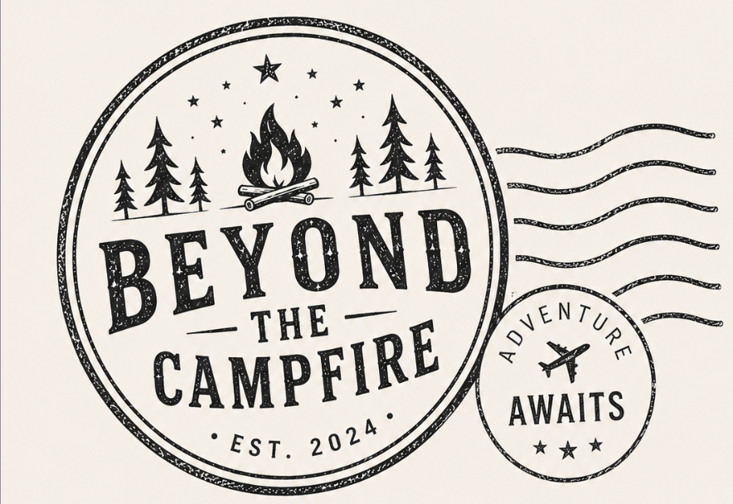

Produced By:

Charlotte Palmer

Dated: 07/06/2026

Student Number: 2404336
Module Name: Enterprise Project
Module Code: BMTP5020

CONTENTS

 |  |  | PAGE
1. | Executive Summary |  | ………………….
2. | The Business Idea |  | ………………….
3. | The Team |  | ………………….
4. | Market Research |  | ………………….
5. | Marketing Plan |  | ………………….
6. | Key Resources |  | ………………….
7. | Finances & Start-Up Support |  | ………………….
APPENDICES:
Appendix A |  |  | SWOT Analysis
Appendix B |  |  | PEST Analysis
Appendix C |  |  | Copy of Pitch Supporting Material

1. EXECUTIVE SUMMARY

Beyond the campfire is a travel company that allows summercamp staff to continue their travels after camp and to do it without the hassel of booking it themselves. This brand will be an online company and will work off zoom calls. The opportunities that can rise from this include expanding the hourney section of the brand and including more pre bookable trips that require less work when organising. This brand stands out as there is currently no brand that comes close to this one, no brand offers the parent portal or offers the option to choose their own path that they wish to take around America. A short-term goal for this company would be to gain 10 customers in the first year of opening

2. THE BUSINESS IDEA

2.1 The Product/Service
Beyond the camfire is an after camp trael agency which allows individuals who participate within camp America to travel freely, stress free and safly while also insuring that they get the most out of their travels. This brand will be operated online matainig that connection with the customers through zoom calls and emails, both while they are home and embarking on their American adventcher.
Expirencing camp is a truly remarkable experience however, most indiviudlas tend to leave their after camp travles till they are in America and after they finish camp. This leads to them potentally missing out on locations, experiences and … This platform will insure that each indivdiaul is able to get the most out of there travels by providing accomidation flights and activity/ excursion recommendations in the form of an intinary. There is another side to this company, the parents. This brand will generate a perent portal type page where partisipances can send whoever they like the perent portal login to be able to access all travel details, flight number, emergency numbers and help numbers when is needed.

The benefit of this product allows individuals who may feel too busy, stressed or unsure where to start with booking after camp travels. A hub to go to and explan exactly what they want and want to get out of it and have it done for them. The benefits of this are having the hard part done for them and simply sitting back and enjoying the trip.

2.2 SWOT Analysis Summary

Beyond the Camp Fire has many strenths and opportunities, allowing this company to have the ability to successed. However, for this company to sustain long term it must take the weaknesses and threts and work on how they will reduce them.
A strentgth of this company is the knowledge of the routes, visa application, and the process of both a first time and second time councillor through camp America. Some opportunities would be potentally working along side major companies like camp America, americamp, camp leaders to maximise my target market and ensure the company is getting promoted. It also could partner with other companies like tour opperators and excursions allowing prices to be reduced over all reducing the price for the customer. But looking at the weaknesses, it is obvious that this company is only for the summar period. And after summer the company will really struggle for business due to a lack of demand. To over come this the company can do more advertising through the winter months and early bird sales to encourage more indiviuals to sign up. Some threats of this company may be the economics of America increasing at an increasing rate making the prices becoming higher making it less attractive. To try to over come this challenge would be by trying to create parners to ensure the prices can be reduced, this can be done as the company will bring in more businesse to these companies and in retrune makes the cost lower. This also over comes the threat of DIY councilors as they would get the cost lower by booking through this company, and maximise sales ddue to the price of the product being cheaper thwen what they would be able to book on thiwe own.

3. THE TEAM

3.1 Key Personnel

Name and Company Position: Myself – Charlotte Palmer – Owner
Skills and Experience: 3rd year councillor and have done my own travel plan that will be offered on this site. Also have experience as a content creator through Camp Canada

Role and Responsibilities: Create custome made and per bookable trips, set up zoom calls and manage the company

Name and Company Position: Rebecca L Palmer Graffic design – graffic and web designer
Skills and Experience: 6 Years in graffic design, specialise in layout, typeography and web design.

Role and Responsibilities: generate website and branding for leaflets, posters and promotional gain.

3.2 Skills Gaps & Key Partners

3.2.1 Additional Staff Requirements (Roles and Responsibilities):
- Generic soft skills eg. Hardworking, good communication
- Digital Marketing
- Transferable skills

3.2.2 Training and Development:

- Travel agents training – by TheKnowledgeAcademy Cardiff - £1495 – 1 Day cource (TheKnowledgeAcademy, 2026)
- Travel and Tourism degree – Univerity of Wales Trinity Saint Davids - £27000 – 3-year course (University of Wales trinity saint david, 2024)

3.2.3 Outsourced Support / Key Partners:
- Rebecca L Palmer Designes (Palmer, 2026)
4. MARKET RESEARCH

4.1 Market Information, Trends and External Factors

4.2 Customer Profiles

- Students:
- Usually have their summers free and looking for a change and able to afford it with student finance
- Its trending now to go in the second year of university
- Returning camp councillors
- Already done it and more comfortable going for longer and further away
- Will be paid more due to them returning to the same camp
- Gap year students
- looking for cheap places to go and would be a great option for them to travel and earn on a budget
- allows them to meet new people and continue to travel after

4.3 Competitor Profiles

- Camp America
The after-camp travels they provide are set ones with no felxability, they will leave on a set date and return on a set date. This leaves little room for fleability, the travels they provide are also only going to set states not multiple which is an offer beyond the Camp Fired offers. There are also limited spaces and they are set prices wich often seems high and expencive which tend to range from $2000 to $3500. The average camp councillor will earn $1000 to $3400.

- DIY Councillors
The Prices alwase range depending when it is booked, the positives of this is that they could catch the price when its o a drop making it cheaper but they will not get any of the support/ help lines that Beyond the Camp Fire offers.

- Treck America

Treck America is a company that works on travels around America, not necacerily for after camp but for travels around America in general, this is a positive as it allows flexability to go whenever, however, this can be a negative as there is less understanding that indivdiviudlas have just worked for the past 3 months and prices tend to. Be high and donnt take it into concideration.

5. MARKETING PLAN

5.1 Price
Journey:
The journey package will be a veriety of different packages ranging from different prices dependet on the location, duration and how many are planning on attending. This can range anywhere from £1500 -£3500. (This data has been generated from a trip around the US that has been done and achived which cost £2100)

Mappers:
This product will be completely dependant on the individual and what they would like to achive which will be a cost that will be deturmend by them. However, for my time and zoom calls with them will be priced at £20 per zoom call per hour and half. This is on top of the end price of hotel, flights, activities. There will also be a fixed price of £300 per trip generated by me for the time ive put into organising the trip.
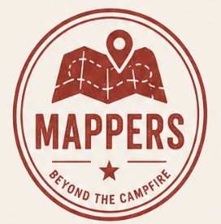
Document support:
This will be again per zoomcall booked, which will be at a fixed rate of £10 per zoom call.
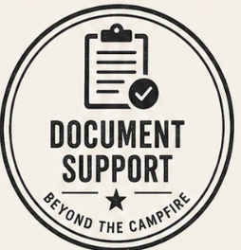
Parent Portal:
This portal cost £20 per login however, this will then get taken off the over all cost for the child participating. This acts as a gift card. This will allow parents to get the information they are wanting while the camper is getting money off their over all cost of the trip

5.2 Product

The price for this service will depend on the package they purchase. Journey packages will be a set package that will be pre planned with set desternations and a set duration. Mappers will be decided by them and will work around where they want to go and how long for, this will be discussed by multiple zoomcalls over a set timeline. The last two services will be document support and a parent portal where individuals can get help on visa documents, DS190 forms etc. The parent portal will also give parents help lines, support lines, and the full intinary of their childs travels. The logos below will be buttons on the website that they will be able to press, and it take them directsaly to the page.
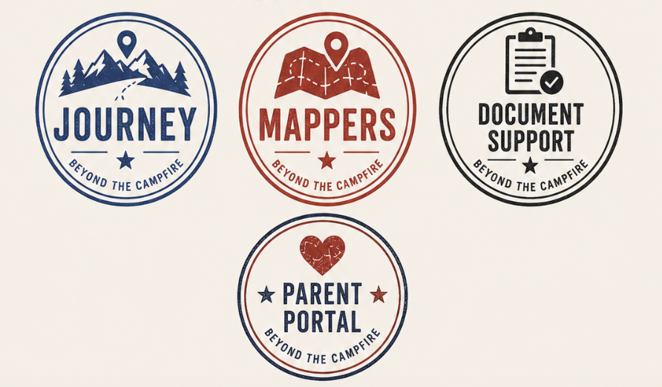

5.3 Placement
This product will be offered online and will be sold online and through zoom meetings, allowing it to be sold directly to the customer. The product will be all produced, sold and generated online making it so there is no physical object needing to be sent to the individual.

5.4 Promotion

Promotion is vita for any new business, it bridges the gap between what the business offers and potential customers, it generates business awaewness, sales and helps to generate market research (Staff, 2023). When you look at promoting and creating awareness its important to make it stand out in order to generate a need to participate. This will de done by using Photos and videos to generate content that sparks the idea that this is a possibility, using social media to my advantage. Advertisment must be bold, and hits the right audience failing to do so could result in a waste of money (aimeenov, 2025). It is vital that for this brand there is a relationship built with both the company, the customers and the customers family. This can only be done by making a connection through the types of advertisement and marketing promotions the brand uses. This is achived by consistancy, and the type of language it uses. In order for the brand to excel the brand must hit advertising to both the customer which will be by the use of social media, leaflets, posters, Univerity talks, School talks etc. But it must also hit advertisement for the partents, for example softer branding that welcomes the parten and assures them that their child will be safe in the care of the brand. This type of marketing will be hard to generate, especially as this will be the first year of opening and there is only the owner’s story.
Brand loyalty is an important part of any new company, it opens new potential business with new customers. This can be done by ensuring that the customer feels comfortable and supported all through their trales not just before they embark on their trip, but also when they land back in the UK. By having a check in when they arrive back home and asking for feedback will allow the brand to pubish real experiences intising more indiviudals to us the brand in future. As a thank you for usingthe brand, Beyond the Camp Fire (BCF) will offer all returning customers a discount of 25% off.

6. KEY RESOURCES

6.1 Premises
As a new business to ensure that the costs are low, this business will take place online ensuring it can be worked on in any location. By saving on this will allow the brand to spend money in other departments.

6.2 Equipment
- Macbook/Phone – Already sourced
- Printer – Already sourced
- Accounting tool eg. QuickBooks $11 per month (QuickBooks, n.d.)
- ABTA & ATOL protection certificates

7. FINANCES AND START-UP SUPPORT

EXPENDITURE | Year 1  £
Company Registration
Rent/Rates | 0
Staff Wages | 49,569
Travel/Accomodation | 0
Telephone (mobile) | 480
Broadband | 240
Utilities | 1000
Marketing and materials | 12000
Insurance | 600
Capital Expenditure/Equipment | 2000
Training & Development | 28495
Accounting/Legal | 6000
Outside Services | 3000
Stock/Materials Purchases | 0
Bank Charges | 0
Office Consumables | 0
Loans Repayments | 27000
Total Expenditure | £ 129,784
INCOME | Year 1  £
Sales A | 30,000
Sales B | 40,000
Sales C | 0
Capital Introduced
Funding | 10,000
Loans/Borrowing | 70,000
Total Income | £ 150000

YEAR ONE PROFIT/LOSS | £
Total Income | 150,000
Total Expenditure | 129,784
Profit/Loss | £20,216

7.1 Financial Summary

EXPENDITURE | Year 1  £
Company Registration
Rent/Rates | 0
APPENDICES

Strength:  - As I have already done my own travels after camp it gives me the expert knowledge for destinations and routes  - Have knowledge of visa process etc  - Reduce the stress of planning after camp travels | Weakness:  - Individuals may feel that they can book on their own and won’t need to use my service  - The business is only seasonal  - Relies heavily on third party organisations and partners eg. Airlines and excursions
Opportunity:  - Working abrord at summer camps are becoming more popular and trendier, creating a wider market for the company.  - Partner with companies, excursions, camps, and companies  - Creating different packages that don’t involve flying (road trips)  - Offering visa help workshops and other specific document help | Threat:  - New companies  - Treck America  - Camp America  - DIY campers who want to organise their own travles  - Cancellations  - Negative reviews due to third party let downs  - Cost of living  - The rise of economics = prices rising making it less attractive
Appendix A – SWOT Analysis

Appendix B – PEST Analysis

P political  - War and political arguments | E economic  - Cost of living affecting the spending  - Rise in costs in America like tariff
S social  - Lifestyle trends  - Social trends | T technological  - Social media  - Booking platforms

Appendix C – Copy of Pitch Supporting Material

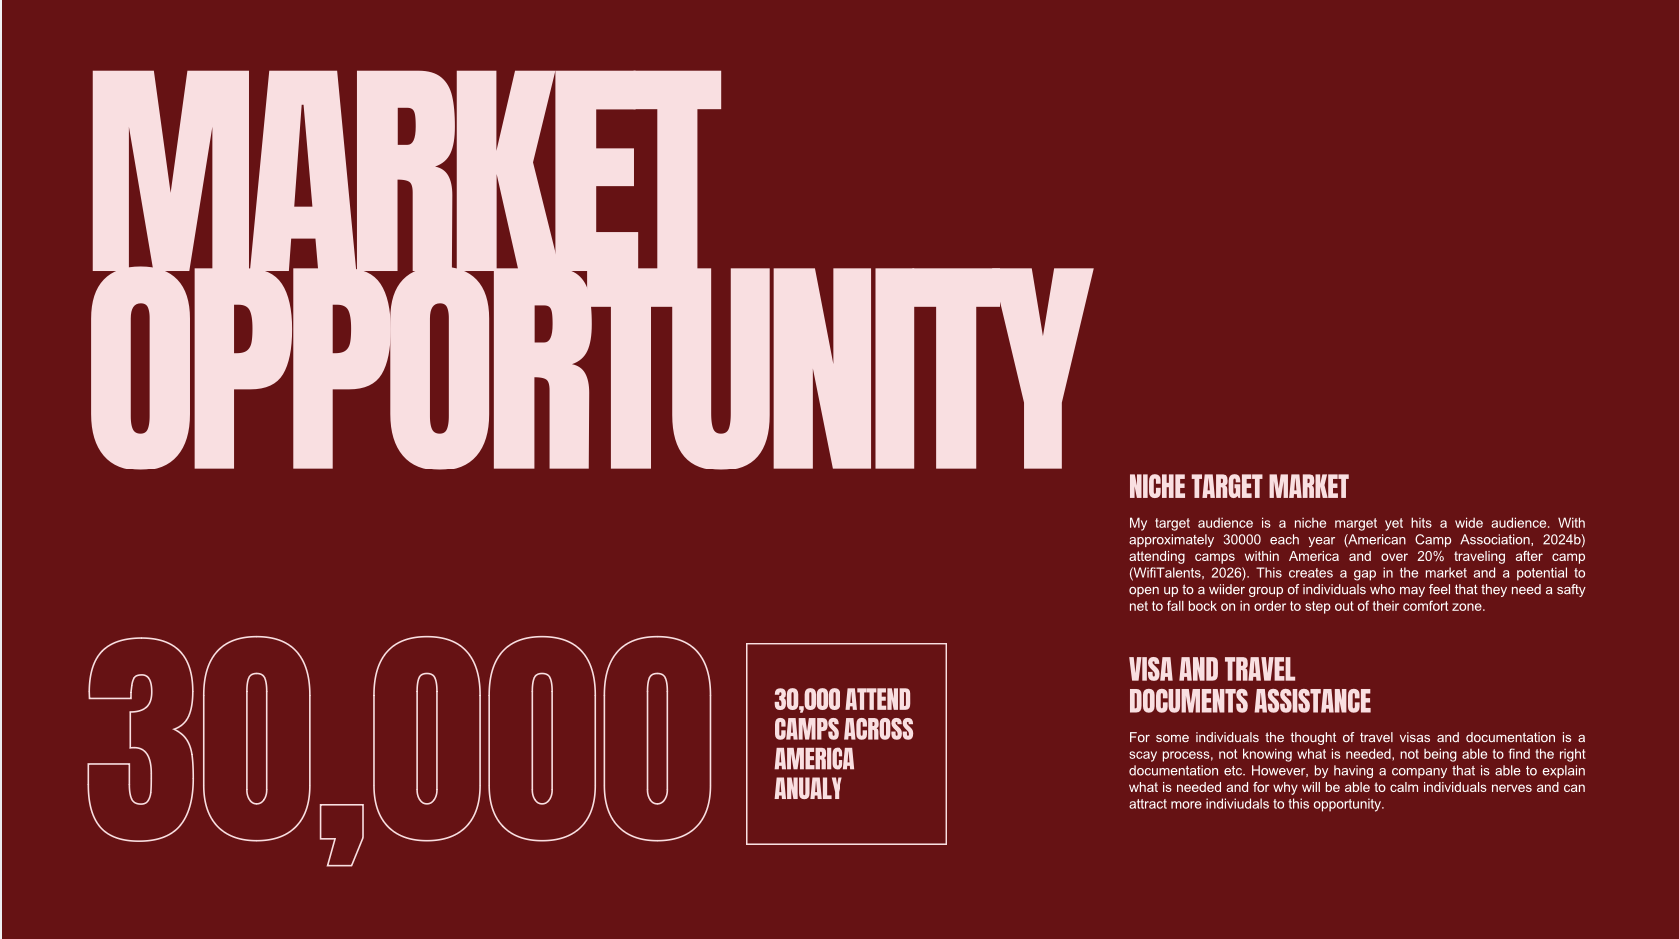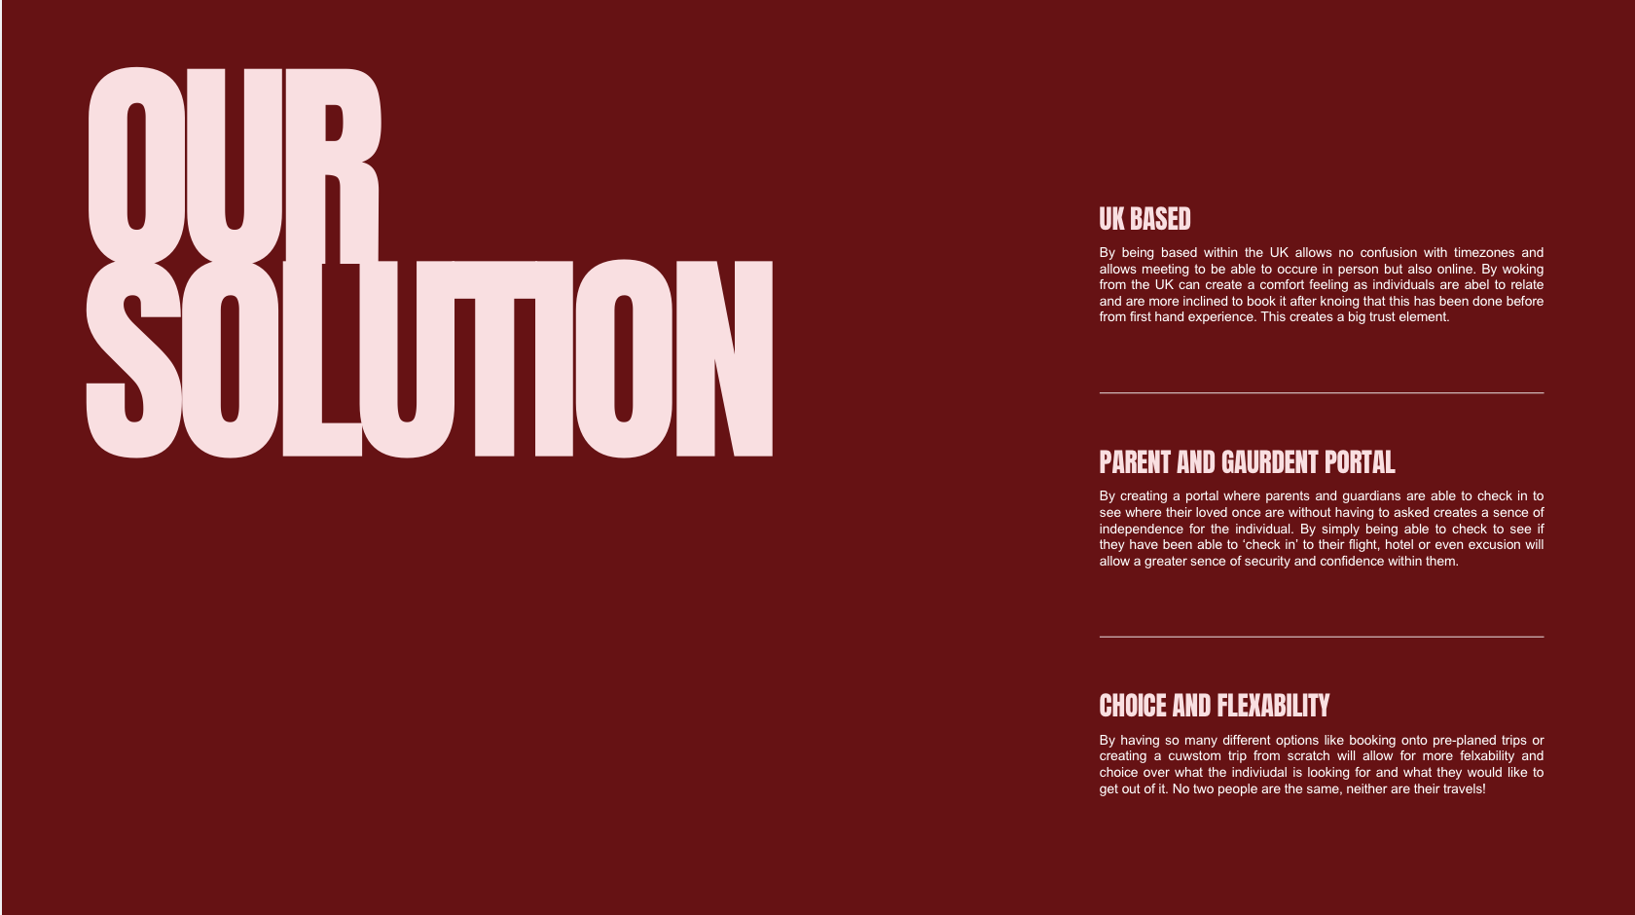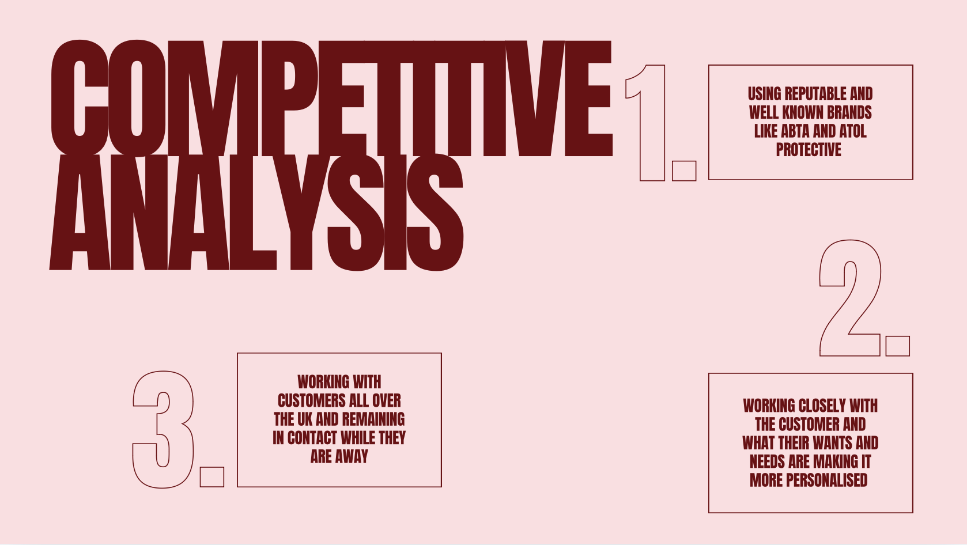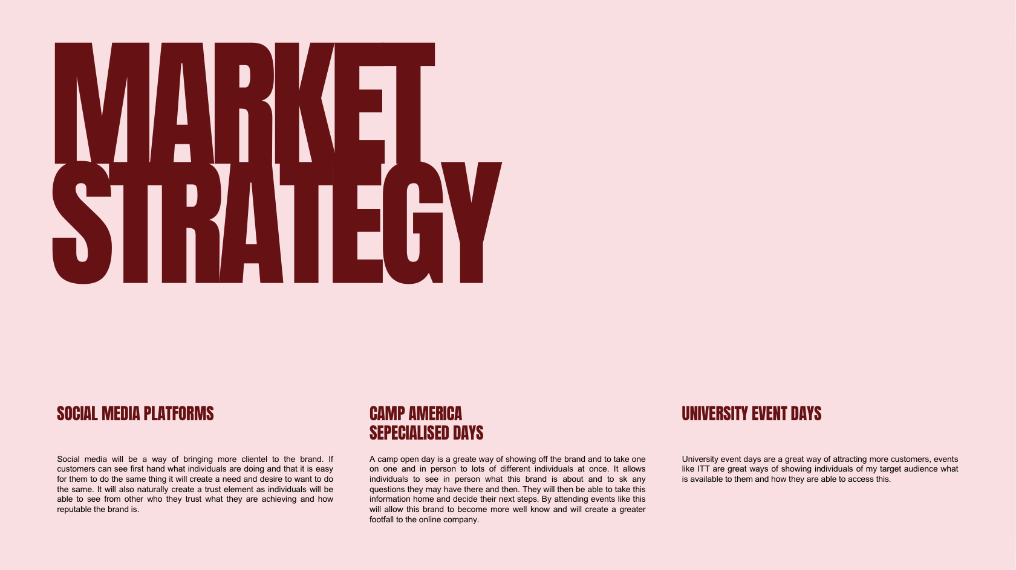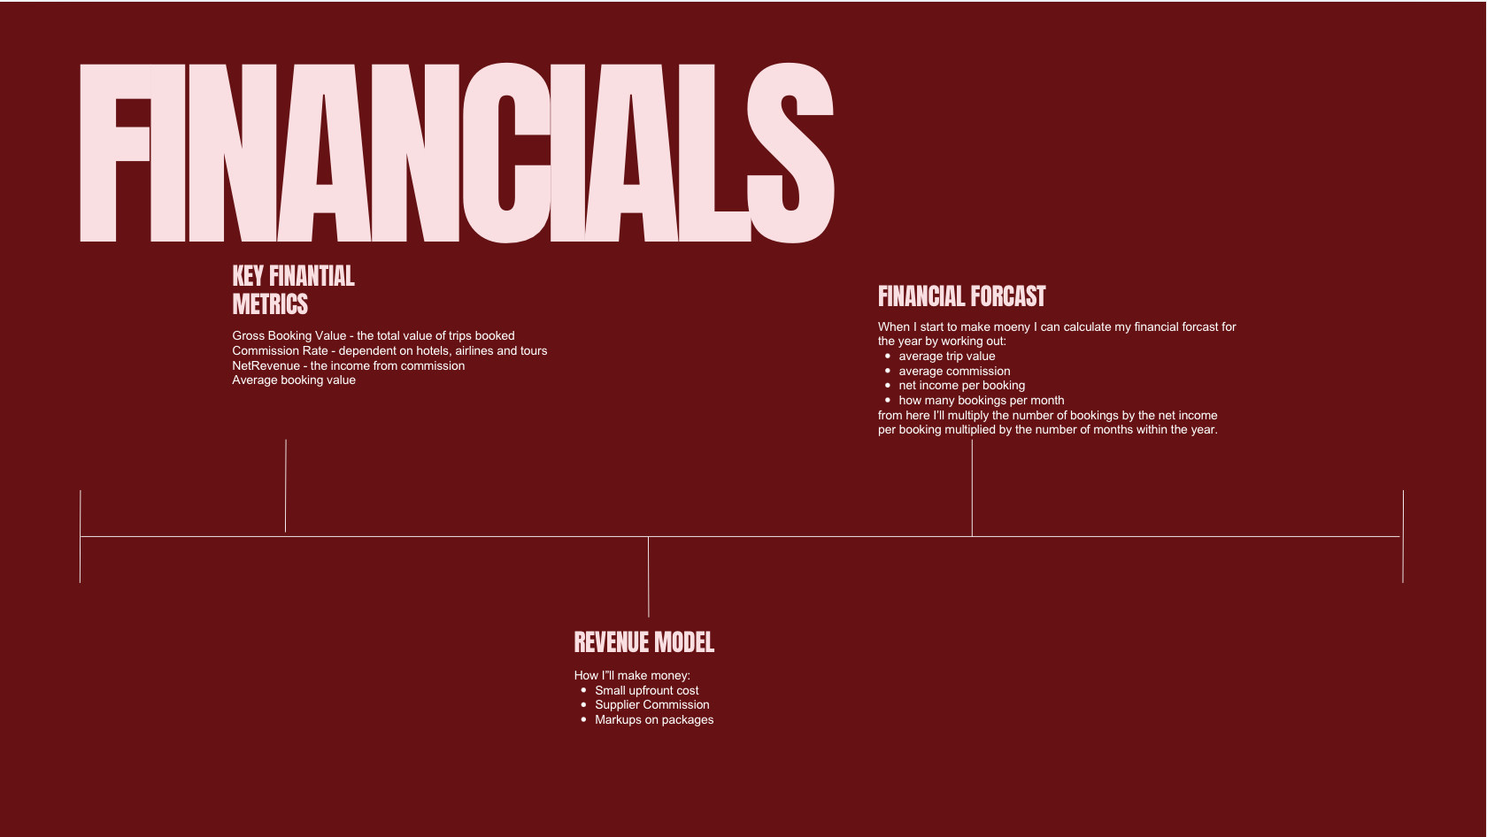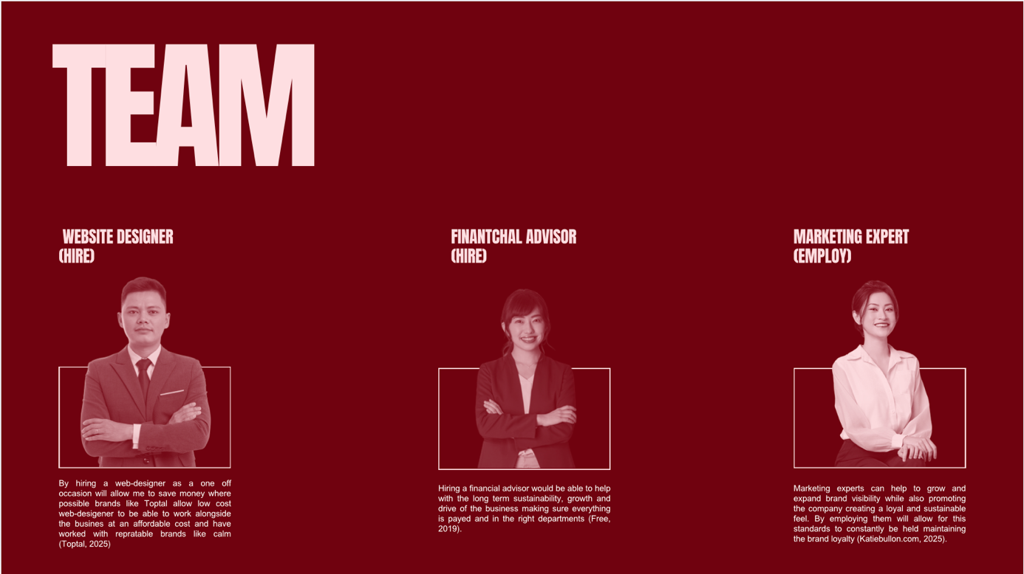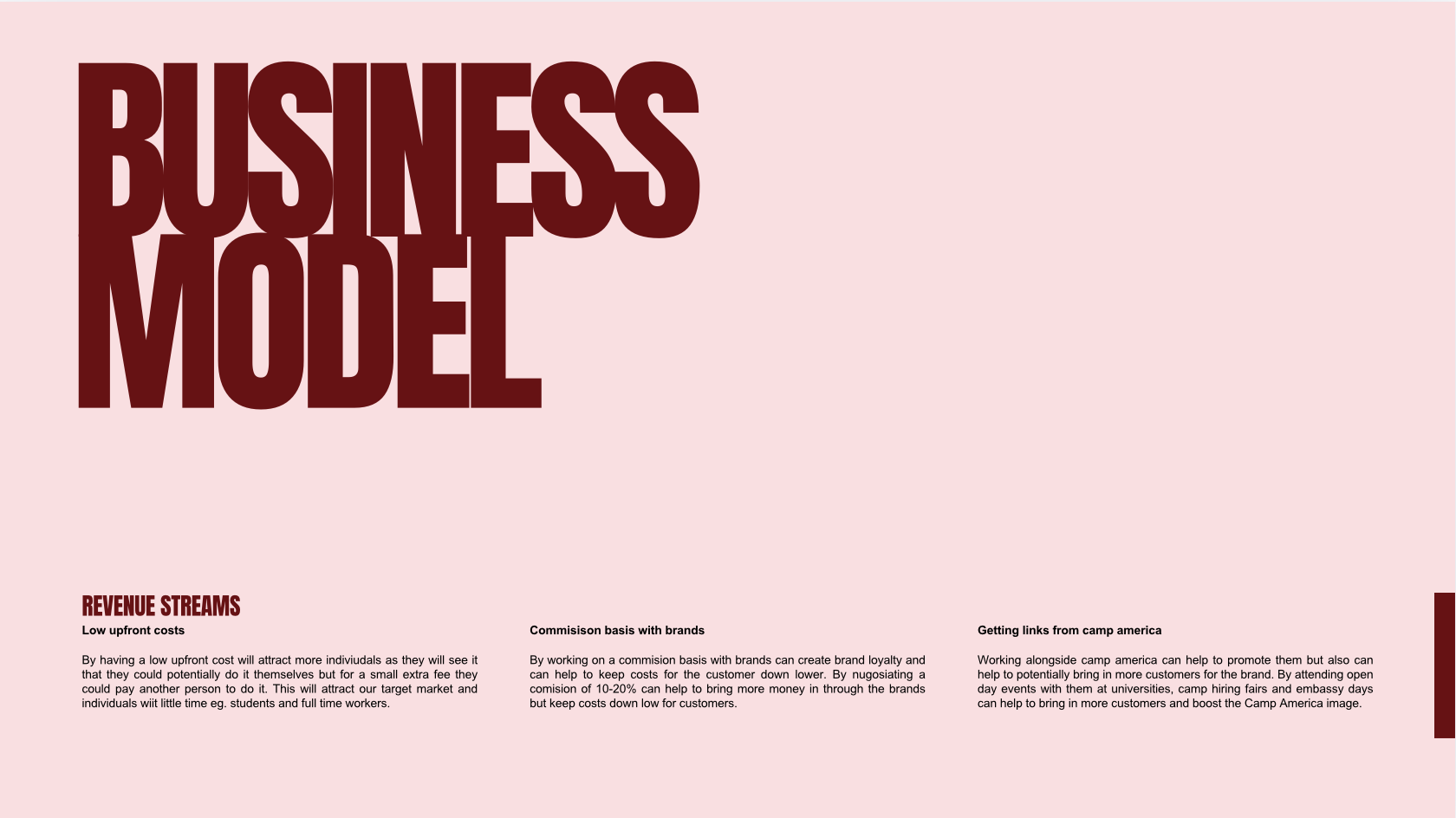
REFERENCE LIST:

aimeenov (2025). The cost of Incorrect audience targeting. [online] Flow. Available at: https://flowplatform.com/blog/the-cost-of-incorrect-audience-targeting/ [Accessed 19 July 2026].
Camp America. (2026). Camp America The Turing Scheme 2026–27. [online] Available at: https://www.campamerica.co.uk/about-us/university-partnerships-student-funding/the-turing-scheme [Accessed 7 June 2026].
Palmer, R. (2026). Rebecca palmer (@rebecca.l.palmer) • instagram photos and videos. [online] Instagram.com. Available at: https://www.instagram.com/rebecca.l.palmer/ [Accessed 19 July 2026].
QuickBooks (n.d.). Plans & pricing | compare features | QuickBooks Canada. [online] Quickbooks.intuit.com. Available at: https://quickbooks.intuit.com/ca/pricing/ [Accessed 19 July 2026].
Staff (2023). Marketing: What Is It and Why Do Companies Need It? [online] Coursera. Available at: https://www.coursera.org/articles/marketing-is [Accessed 12 July 2026].
TheKnowledgeAcademy (2026). Travel agent training course in Cardiff. [online] Theknowledgeacademy.com. Available at: https://www.theknowledgeacademy.com/courses/virtual-online-job-roles-training/travel-agent-masterclass/cardiff/ [Accessed 19 July 2026].
University of Wales trinity saint david. (2024). International travel and tourism management (full-time). [online] Available at: https://www.uwtsd.ac.uk/programme-courses/undergraduate/hospitality-leisure-and-tourism/international-travel-and-tourism [Accessed 19 July 2026].

