

Programme name: Master of Business Administration
Module name: Marketing Management
Module Code: LCMB7024
Title of submission: Assessment component 1: Marketing Environment Analysis
Lecturer’s name: Taonga Kaonga Sobere-Snithers
Student’s name and ID: Visana Shanti Malde and 2613994
Final word count: 2528

Submission date: 22nd October 2026

Table of Contents
Task 1: Marketing Environment Analysis 3
1.1 Environmental factor 3
1.2 Political factor 4
1.3 Economic factor 5
Task 2: Strategic Growth and Competitive Positioning 8
2.1 Ansoff matrix and its evaluation 8
2.2 Recommended strategy 9
2.3 Achieving competitive advantages 9
Task 3: Managerial and professional reflection 11
Reference list 13

Task 1: Marketing Environment Analysis
The marketing environment is the external situation and landscape that broadly impacts the strategic measures and various other areas of businesses. Using PESTLE analysis, the marketing environment could be analysed specifically for Tata Steel. Three factors found to be more specific for Tata Steel are as follows:
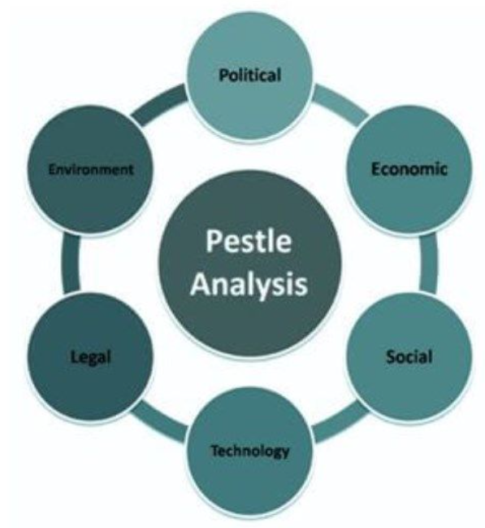
Image 1: PESTLE framework
(Source: Eierle et al. 2022)

1.1 Environmental factor
Environmental factors are highly influential for a mining organisation since their operations have a direct negative impact on natural conservation (Padhiary and Kumar, 2024). Global mining industry is responsible for 7-9% of global greenhouse gas emissions, with 70% of its production specifically based on the coal-intensive 'Blast Furnace and Basic Oxygen Furnace (BF-BOF)’ route (Tata Steel, 2025).
Tata Steel operates in an industry in which reduced emission is not directly impacting sustainability but it is a fundamental need for maintaining long-term legitimacy and competitiveness (Belavadi and Kulkarni, 2026).
The environmental pressure is imposing a direct impact on the structural change with Tata Steel in the UK for the transition towards Port Talbot for scrap-based 'Electric Arc Furnace (EAF)' production (Tata Steel UK, 2026). This project has an investment of more than £1.25 billion, with an EAF capacity of 3.2 Million Tonnes Per Annum (MTPA).
The project is secured by £500 million government funding that helps Tata Steel to expect transition from reduced emission by 50 million tonnes of CO₂ in next ten years (Kleinman, 2026). It can also be seen similarly in the Indian context, which is the home market for Tata Steel. For example, in March 2026, Tata Steel commissioned a 0.75 MTPA scrap-based EAF with a value of ₹3200 crore (Tata Steel India, 2026).
The primary objective of this project is to reduce the level of emissions by 0.3 tCO₂e per tonne of crude steel. However, Falcone (2023) argued that challenges including scrap availability, the energy system, local policy conditions in India and technological maturity had a direct impact on this project, considering the different geographical situation.
Even with such influence of the environment identified for mining-based companies, the environmental transition can create major cost-technology issues, as argued by (Renu, 2022). Hydrogen-based direct reduced iron and EAF plants can currently cost around 50-140% of conventional BF-BOF plants based on regional conditions (OECD, 2025).
Zhang et al. (2025) also found that low-carbon steelmaking needs investment that can increase energy and material investment. For instance, technological transformation cannot translate into better economic performance. It imposes a direct tension for Tata Steel, showing the opportunity of developing lower-carbon products and a greener production method in the global landscape.

1.2 Political factor
Juhász and Lane (2024) stated that political factors can increasingly impact the imposition of environmental pressure in industrial policy, carbon regulation, public funding and trade protection. In the context of the Indian Government's national steel policy, a target of 300 million tonnes of crude steel capacity with 255 million tonnes of crude steel production is set by 2030-2031 (Indian Ministry of Steel, 2017).
According to Mahapatra et al. (2024), the Indian government has a strong interest in motivating Tata Steel's operations in the domestic market landscape to reduce its negative influence on differentiated products. The "Green Steel Taxonomy" in December 2024 also focused on green steel according to emission measures more intensively.
According to this policy, steel below 2.2 tCO2e per tonne is qualified for the green rating system, with 1.6 tCO2e per tonne being identified as a five-star category (Indian Ministry of Steel, 2025). This rating system imposed major pressure on brands like Tata Steel to follow specific measures on investing towards a sustainable value system.
The opportunities in such a political landscape for Indian operations in Tata Steel provides strong capabilities that ensures handling barriers while operating in the manufacturing, sales and operations for vehicle sales.
For Tata Steel's operations in the UK region, it can be effective, as the government is imposing a direct impact on decarbonising steel production and protecting domestic steelmaking from international competition. For example, the '2026 Steel Strategy' by the UK government aims to increase the share of UK steel demand supplied from domestic production to 40-50%.
It was 30% in 2024, which resulted in only 2.5 billion to support, rebuild and modernise the UK steel industry (Department for Business & Trade UK, 2024). The strategy also links industrial resilience with the transition towards green production. Also, the case example of Port Talbot mentioned in the environment section shows the government taking stake in the economic investment for Tata Steel that also increased their decision-making authority in the project (Tata Steel UK, 2026).
The trade policy also changed in the UK from 2026, with the government introducing new steel trade measures to reduce the tariff-free import quota volume to 51%. Steel imports above this are expected to face a surcharge tariff of 50% (Department for Business & Trade UK, 2024). The government identified global overcapacity as a major reason for imposing such measures.
For Tata Steel, such changes in the competitive environment require it to focus more on the actual trade economics by lowering carbon production to form market protection as an environmental response.

1.3 Economic factor
The economic conditions for Tata Steel show the ability to evaluate decarbonisation investment based on sustainable competitive advantages. The global steel market is characterised by weak demand compared to the installed capacity.
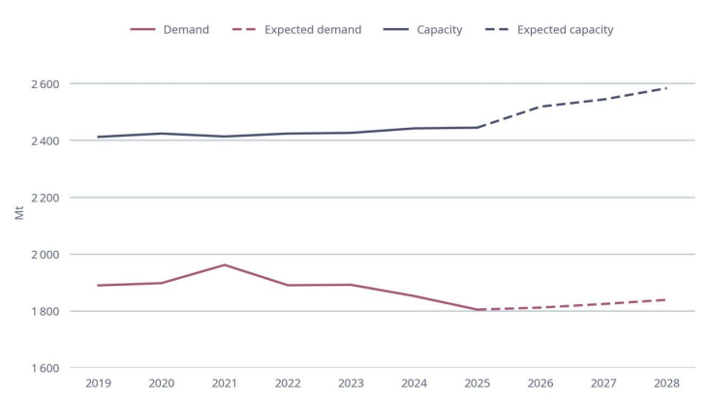
Figure 1: Global excess steel capacity
(Source: OECD, 2026)
The OECD report shows that global excess steelmaking capacity reached 640 million tonnes in 2025 and could further increase to 745 million tonnes by 2028 (OECD, 2026). Global demand is projected to grow by 0.9% per year through 2030, with steelmaking capacity increasing by 138.8 million tonnes between 2026-28. It is widely important for Tata Steel as the low carbon production needs high capital expenditure in the hydrogen based routes for more operating cost.
In an oversupplied market, Tata Steel cannot assume the increased additional cost can be transferred to customers through high steel prices. OECD (2025) explained low carbon primary steel can change based on hydrogen sourcing and electricity cost that can produce €90-per-tonne premium with external hydrogen purchases.
Economic conditions can have a direct impact on Tata Steel in India and the UK. India offers stronger growth potential but the UK steel industry faces greater competitive and operational pressures. According to the World Steel Association (2026), Indian steel demand is expected to grow by 7.9% in 2026 and 8.0% in 2027. It is strongly driven by infrastructure, construction and manufacturing that have a positive impact on buying impact on the choice for Tata Steel.
By comparison, the UK Steel Strategy projects demand to increase from 9.1 million tonnes in 2025 to 14 million tonnes by 2050, representing average annual growth of 1.7% (Department for Business & Trade UK, 2024). Tata Steel financial performance also provided evidence of such interpretation for its operations. In FY2025–26, its Indian operations managed to achieve ₹34,272 crore in EBITDA.
It is achieving a 24% EBITDA margin but the UK operations faced EBITDA loss of £217 million (Tata Steel, 2026). It is based on intensifying price competition across the market. Even with Tata Steel needing to capitalise on India's demand growth, improving UK cost efficiency can help in supporting commercially sustainable, lower-carbon production.

Task 2: Strategic Growth and Competitive Positioning

2.1 Ansoff matrix and its evaluation
Ansoff matrix provides a framework for the identification of growth opportunities based on using a combination of existing and new products and markets. For Tata Steel, selecting a growth strategy needs to be based on balancing decarbonisation objectives with a complete focus on competitive positioning and measures of profitability.
The four strategic options for the company can be based on Ansoff, which focuses on the following factors:
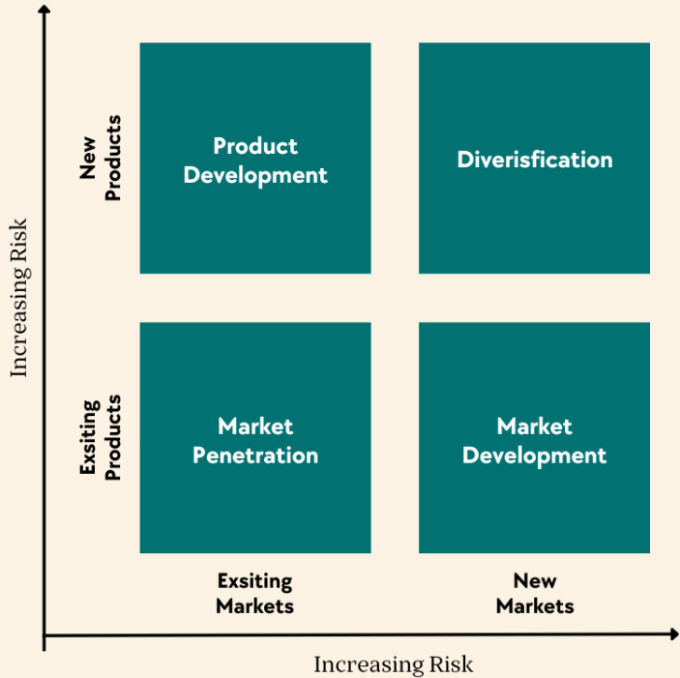
Image 2: Ansoff matrix
(Source: Ferreira and de Sá, 2024)
Product development: Product development is based on the launch of new products in existing markets, through which suitable clarity in the competitive landscape can be seen. The risk level is moderate since Tata Steel already have some considerable advantages in its comprehensive operations in the market.
Market penetration: Market penetration is focused on the selling of existing products in the existing market by ensuring relevant strategies and tactics. It can be beneficial for increasing market share and increasing the quantity of purchases for existing customers.
Balci and Kumral (2022) stated that the mining products industry is majorly dominated by large firms, which reduces the scope of market penetration strategy, as it can only provide a negligible increase in market share.
Market development: Kreiterling (2023) explained the expansion of existing products in a new market could offer strong benefits through which effective benefits can be seen. Market development can expand sales through new geographical and industrial contexts, even with an additional focus on distribution, market access and customer-development investment.
Diversification: It is based on launching new products in new markets. Considering the specific risk and the existing challenges, such issues could impose a negative and major impact on the context of Tata Steel.

2.2 Recommended strategy
The choice of product development strategies could be considered in Tata Steel for delivering a strong impact on the business operations. Tata Steel needs to focus on prioritising its development and commercialisation strategy for independently verified low-carbon steel grades to enhance its offering to customers.
This can be done practically for construction, automotive, engineering and infrastructure customers to align the company's product development capabilities. Tata Steel's (2026) annual report shows 20.48 million tonnes of enriched and value-added product sales, along with 120 new products developed, with R&D expenditure of ₹1456 crore.
These capabilities could be beneficial for providing benefits in developing differentiated steel products rather than competing on commodity prices, as identified by Algieri et al. 2022).
In the Indian circumstances, Tata Steel could use such strategies for expanding lower emission steel offerings by using such new production measures for infrastructure, construction and fulfilling the domestic demand with the rise of the construction sector. Gayathri (2026) Projected Indian Steel demand to increase by 8% by 2027.
Therefore, such expanding market scope can provide strong opportunities for Tata Steel to capture and capitalise on developing positive growth in the economic measures and landscape.
In the UK environment, Tata Steel needs to focus on using environmentally differentiated product ranges that specifically meet the imposed guidelines of the government. Planned 3.2 MTPA in Port Talbot in the UK can also be fulfilled by the company with the choice of offering innovative and low-emission product ranges (Tata Steel UK, 2026).
The investment in technology, as already considered by Tata Steel, is focused on enhancing its actual capabilities. For instance, the company could focus on changing production technology through which product-level emissions, recycled content information and transparent comparison with conventional steel are also to be considered.

2.3 Achieving competitive advantages
According to Farida and Setiawan (2022), Porter's generic strategies can be beneficial for determining the suitable measures through which a company can achieve strong capabilities. In this context, differentiation can provide competitive advantages when customers perceive a distinctive value of a product (Jerab and Mabrouk, 2023).
Tata Steel should focus on environmental differentiation as a measure through which it can achieve a strong position in the UK market for increased market share. On the other hand, the use of such strategies in the context of the Indian market can be beneficial for developing positive benefits in the landscape of demonstrating their progress.
The strategy could be relevant for the context of global steel markets with strong competitive pressure. Demand growth of 9% till 2030 in Tata Steel can be a specific condition through which product quality, traceability, emission performance and customer-specific solutions are offered based on suitable volume measures.
Customer partnerships are essential for realising the advantages for Tata Steel since the brand needs to focus on established product specifications, testing low-carbon grades and negotiating long-term partnership investments.
Tata Steel (2026) Annual Report shows that operational efficiencies are also to be considered for Tata Steel, through which the company can improve scrap utilisation, energy efficiency, renewable electricity sourcing and technologically feasible solutions.
Tata Steel need to consider strategic execution as an executable measure through which its overall operations and brand capabilities could be considered by the actual measures and considerable landscape of operations.

Task 3: Managerial and professional reflection
Reflecting on this report, I selected Tata Steel as it provides a relevant example of explaining the role of multinational organisations in balancing environmental sustainability with commercial competitiveness. While conducting research for my report, I learned that the steel industry faced substantial decarbonisation pressure.
I also found a similar issue with Tata Steel since the company is a leading brand in the mining sector around the globe. Being an Indian brand operating in the UK, I focused on the analysis as a comparative landscape between the Indian and the UK market.
To conduct PESTLE analysis, I selected political and economic factors along with the environmental factor for analysing the macro-environmental factors of Tata Steel. The environmental factor established the need for decarbonisation, with political and economic factors helping me to explain the external conditions affecting investment decisions and competitiveness in the market.
The approach reflected on the learning in my class, which explained that market strategy needs to respond to the macro environmental forces which organisations cannot directly control. However, I understand that technological, legal and social factors provide limited breadth since each of the factors has a strong impact on the context of the steel business.
Apart from that, the key strategic decision, with the recommendation of product development from the four key dimensions of the Ansoff matrix, also helped me in undertaking the choices based on the changing nature of the Indian and the UK market.
With product development to be considered in both markets, Tata Steel can use its existing production capabilities and customer relationships to develop verified lower-carbon steel products in the UK market. I also recommended differentiation supported by operational efficiency, recognising that environmental benefits alone may not justify higher prices.
The report findings show organisational capabilities to be associated with the opportunities and threats in the market. Compared to the Indian and the UK markets, I found differences in growth, financial performance and decarbonisation. However, my analysis is based on the available secondary information online.
The findings are not based on a standardised measure. It clearly evaluates the differences in reporting period, accounting measure, currency fluctuation, FDI and regional operational conditions, which can have a direct impact on Tata Steel.
Before presenting final recommendations to leadership, I could have further incorporated product-level emissions, capital expenditure forecasts, electricity, customer research, competitor pricing and scrap procurement costs. Interviews with procurement managers and industrial customers would also help establish demand for low-carbon steel and potential price premium. It could have strengthened environmental objectives with financial feasibility.
Overall, researching the industry and writing the report developed my understanding of strategic decisions needed for identifying market opportunities. These are critical for organisational capabilities, external pressure and implementation risk management. With such consideration, I found Tata Steel to be considering a suitable preferred strategy through which evidence of customer demand, achievable emission reduction and acceptable financial returns could be considered.

Reference list
- Algieri, B., Aquino, A. and Succurro, M., (2022). Trade specialisation and changing patterns of comparative advantages in manufactured goods. Italian Economic Journal, 8(3), pp.607-667.
- Balci, M. and Kumral, M., (2022). Building an innovation strategy and culture on the structural characteristics of the mining industries. Resources Policy, 78, p.102936.
- Belavadi, N. and Kulkarni, G.S., (2026). Forging a zero-carbon future: Tata Steel Ltd.’s sustainability transformation in an emerging market. Emerald Emerging Markets Case Studies, 16(1), pp.1-9.
- Department for Business & Trade UK. (2024). The UK steel strategy. Available at: https://www.gov.uk/government/publications/steel-strategy/the-uk-steel-strategy-web-version [Accessed 6 October 2026]
- Eierle, B., Hartlieb, S., Hay, D.C., Niemi, L. and Ojala, H., (2022). External factors and the pricing of audit services: A systematic review of the archival literature using a PESTLE analysis. Auditing: A Journal of Practice & Theory, 41(3), pp.95-119.
- Falcone, P.M., (2023). Sustainable energy policies in developing countries: a review of challenges and opportunities. Energies, 16(18), p.6682.
- Farida, I. and Setiawan, D., (2022). Business strategies and competitive advantage: the role of performance and innovation. Journal of open innovation: Technology, market, and complexity, 8(3), p.163.
- Ferreira, A.P.P.F.S. and de Sá, M.M.B.P., (2024). The importance of the Ansoff matrix for the study of the information services market. The Canadian Journal of Information and Library Science, 47(2), pp.78-84.
- Gayathri G. (2026) India’s steel demand to grow 8% in 2027, fastest among major markets bl-premium-article-image. Available at: https://www.thehindubusinessline.com/markets/commodities/indias-steel-demand-to-grow-8-in-2027-fastest-among-major-markets/article71575163.ece [Accessed 10 October 2026]
- Indian Ministry of Steel. (2017). National Steel Policy. Available at: https://steel.gov.in/node/84 [Accessed 6 October 2026]
- Indian Ministry of Steel. (2025). Greening the Steel Sector in India Roadmap and Action Plan. Available at: https://steel.gov.in/sites/default/files/2025-03/GSI%20Report.pdf [Accessed 6 October 2026]
- Jerab, D. and Mabrouk, T., (2023). Strategic excellence: Achieving competitive advantage through differentiation strategies. Available at SSRN 4575042.
- Juhász, R. and Lane, N., (2024). The political economy of industrial policy. Journal of Economic Perspectives, 38(4), pp.27-54. DOI: 10.1257/jep.38.4.27
- Kleinman, M. (2026). Ministers hand EY contract to scrutinise Tata Steel funding request. Sky News. Available at: https://news.sky.com/story/ministers-hand-ey-contract-to-scrutinise-tata-steel-funding-request-13593946 [Accessed 6 October 2026]
- Kreiterling, C., (2023). Digital innovation and entrepreneurship: A review of challenges in competitive markets. Journal of Innovation and Entrepreneurship, 12(1), p.49.
- Mahapatra, D., Roy, K. and Saha, B., (2024). Tata Steel’s Acquisition of Bhushan Steel: Steeling the Competition. Vikalpa, 49(2), pp.167-180.
- OECD (2025). HYDROGEN IN STEEL: ADDRESSING EMISSIONS AND DEALING WITH OVERCAPACITY. Available at: https://www.oecd.org/content/dam/oecd/en/publications/reports/2025/03/hydrogen-in-steel_f4d15f8d/7e2edc69-en.pdf [Accessed 6 October 2026]
- OECD (2026). OECD Steel Outlook 2026. Available at: https://www.oecd.org/content/dam/oecd/en/publications/reports/2026/06/oecd-steel-outlook-2026_a79fb861/99ab9b0c-en.pdf [Accessed 6 October 2026]
- Padhiary, M. and Kumar, R., (2024). Assessing the environmental impacts of agriculture, industrial operations, and mining on agro-ecosystems. In Smart internet of things for environment and healthcare (pp. 107-126). Cham: Springer Nature Switzerland.
- Renu, M.N., (2022. Futuristic scenario of climate resilient agricultural and approaches in changing climate and global warming. Agriculture & Food E-Newsletter.
- Tata Steel India. (2026) Tata Steel reports Consolidated EBITDA of Rs 34,848 crores and Profit after Tax of Rs 10,886 crores for the twelve months ended March 31, 2026. Available at: https://www.tatasteel.com/newsroom/press-releases/india/2026/tata-steel-reports-consolidated-ebitda-of-rs-34-848-crores-and-profit-after-tax-of-rs-10-886-crores-for-the-twelve-months-ended-march-31-2026/ [Accessed 6 October 2026]
- Tata Steel UK (2026) Tata Steel and the UK Government jointly agree on investment proposal. Available at: https://www.tatasteeluk.com/green-steel-future [Accessed 10 October 2026]
- Tata Steel. (2025) Climate change report 2025. Available at: https://www.tatasteel.com/investors/integrated-report-2025-26/climate-change-report.html [Accessed 6 October 2026]
- Tata Steel. (2026) Integrated Report and Annual Accounts 2025-26. Available at: http://tatasteel.com/media/25904/tatasteel-iar-2025-26.pdf [Accessed 6 October 2026]
- Worldsteel Association. (2026). World steel Short Range Outlook October 2026. Available at: http://worldsteel.org/media/press-releases/2026/worldsteel-short-range-outlook-october-2026/ [Accessed 10 October 2026]
- Zhang, J., Guo, H., Yang, G., Wang, Y. and Chen, W., (2025). Sustainable transition pathways for steel manufacturing: Low-carbon steelmaking technologies in enterprises. Sustainability, 17(12), p.5329.

