HPFY 3014
‘PEOPLE ACROSS TIME’.
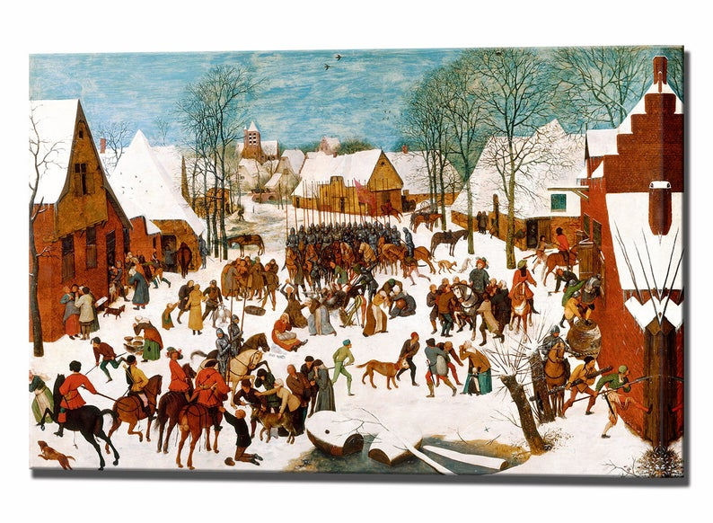
(Level 3 - 20 credits)
2021-2022 Semester Three (Lampeter)
Commencing: Wednesday 1st June 2022
Distance Learning delivery (via Teams)
Module Lead: Lester Mason
Resources contributed by: Louise Steel, Quentin Drew, Matt Cobb, Luci Attala.

AIMS:

- To introduce students to the study of peoples and cultures across different periods, from pre-history to the present

LEARNING AND TEACHING STRATEGY:

- Lectures will introduce the students to the concepts, themes and historiographical developments relating to this subject matter. Tutorials and seminars will introduce students to the areas of study summarised in the indicative content. These will be used to encourage and support discussion, and critical evaluation of themes and concepts relating to the study of people and cultures across time

LEARNING OUTCOMES:

Upon the successful completion of this module, the student should be able to:
- Demonstrate an awareness and introductory knowledge of the academic study of history, archaeology, and anthropology.
- Demonstrate an understanding and knowledge of disciplinary fields related to human cultures and societies across time.

INDICATIVE CONTENT:

The module will begin with an overview of the course aims, outcomes and content , as well as a discussion on assignments etc. This will be followed by Ages, Eras, and Epochs - a chronologically-ordered overview through time and human experience. The aim of this opening lecture is for students to attain a basic understanding of the ages and eras listed in the handbook and when they occurred, whilst remaining alert to the module’s core outcome: to attain an understanding and knowledge of human culture and society through time.
The resource input for this module will be provided by academics from a number of fields, including Anthropology, Archaeology, Ancient History, The Classics, and History. The module discusses the approaches adopted by each discipline, with one eye on the learning outcome: to demonstrate an awareness and knowledge of these distinct disciplinary fields.
Following these introductory sessions, the module teaching will take a chronologically-based examination of different periods, and how people adapted to their changing environment, beginning with pre-history and archaeological approaches to the Stone Age, Bronze Age, and Iron Age, asking how early man adapted to his ever changing environment.
.
. Focussing on the rise of Civilisation in the Middle East, the module will then examine major cultural shifts, focussing on man’s instinct to settle, based upon changing relationships with the landscape and environment, and the impact of new technologies. Central to this session will be a discussion on the origins of urbanisation in Ancient Mesopotamia (modern-day Iraq).
Following a discussion on the different perceptions of the world by people in these societies, this session will then analyse the Economy and the Environment in the Roman World, looking at how peoples in the Roman world exploited their environment to provide food, raw materials and goods.

How to capture the essence of life in the Middle Ages, a period spanning a thousand years, will then be the focus of the module. A period of technological advancements, agricultural innovation, nurturing a flourishing ‘feudal’ based economy, but one punctuated by calamitous famines, plaques, and bloody conflict.

The module will then turn its attention to that period, beginning circa 1500, that witnessed increasing globalisation around ‘mercantilist’ economies and supporting institutions. The rise of the ‘city-state’ will be examined, as centres of political, economic, and cultural activity that impacted far beyond city boundaries.

Through a discussion centred on ‘The Age of Anthropocene’ the narrative is brought right up to date, as from an anthropological viewpoint, the current global position is examined, asking how distinct areas of the planet are differently affected and how people are adapting to climate change – moving on by imagining our collective futures, while thinking about the role of novel technologies.
Throughout the module attention will also be given will to the Portfolio and the module will end by recapping on the main themes discussed throughout. This will include discussions on future degree programme choices etc.

The allocation of teaching to deliver the module is:
Activity type | Hours | Percentage
Scheduled learning | 20 | 10%
Independent learning | 180 | 90%
Placement learning | 0 | 0%
TOTAL | 200 | 100%

SCHEDULE:
Week One : (on lines resources provided by Lester Mason) – Introduction, including an overview of the course aims, outcomes and content , as well as a discussion on assignments etc. Followed by Ages, Eras, and Epochs - a chronologically-ordered ‘breeze’ through time and human experience. The aim of this opening lecture is for students to attain a basic understanding of the ages and eras listed in the handbook and when they occurred, whilst remaining alert to the module’s core outcome: to attain an understanding and knowledge of human culture and society through time.
Week Two (on lines resources provided by Lester Mason) – Disciplines and Approaches. Resource input for this module will be provided by academics from a number of fields, including Anthropology, Archaeology, Ancient History, The Classics, and History. This session will discuss the approaches adopted by each discipline, with one eye on the learning outcome: to demonstrate an awareness and knowledge of these distinct disciplinary fields.
Week Three: (on line resources provided by Quentin Drew) – The world of Pre-History and ‘Embracing the Three Ages’. A journey through pre-history from the standpoint of the Archaeologist; discussing aspects of the Stone Age, Bronze Age, and Iron Age, and examining how early man adapted to his ever changing environment.
Week Four: (on line resources provided by Louise Steel) - Ancient Civilisations: ‘How Clay made us human’. Focussing on the rise of Civilisation in the Middle East, this session will examine major cultural shifts, focussing on people’s instinct to settle, based upon changing relationships with the landscape and environment, and the impact of new technologies. Central to this session will be a discussion on the origins of urbanisation in Ancient Mesopotamia (modern-day Iraq).
Week Five: (on line resources provided by Matt Cobb). Understanding the Graeco-Roman world. Following a discussion on the different perceptions of the world by people in these societies, this session will then analyse the Economy and the Environment in the Roman World, looking at how peoples in the Roman world exploited their environment to provide food, raw materials and goods.

Reading Week

Week Six : (on line resources provided by Lester Mason). - The Medieval World. How to capture the essence of life in the Middle Ages, a period spanning a thousand years? A period of technological advancements, agricultural innovation, nurturing a flourishing ‘feudal’ based economy, but one punctuated by calamitous famines, plaques, and bloody conflict.

Week Seven : (on line resources provided by Lester Mason). The Early Modern World : That period beginning circa1500 that witnessed increasing globalisation around ‘mercantilist’ economies and supporting institutions . The rise of the ‘city-state’ will be examined, as centres of political, economic, and cultural activity that impacted far beyond city boundaries.

Week Eight: (on line resources provided by Luci Attala). Through a discussion centred on ‘The Age of Anthropocene’ the narrative is brought right up to date, as from an anthropological viewpoint, the current global position employing the notion of the Age of the Anthropocene as a reference point is examined. How distinct areas of the planet are differently affected and how people are adapting to climate changes – moving on by imagining our collective futures, while thinking about the role of novel technologies.
Weeks Nine and Ten: will be devoted to the Portfolio and recapping on the main themes discussed throughout the course. This will include discussions on future degree programme choices etc

ASSIGNMENTS :
The assignment for this module will require students to produce a Portfolio of work, consisting of three elements, (3000 words in total).

Part One: Essay plan consisting of 500 words (weighted at 20%) :

The assignment is a plan of the essay for part two. Set out your subject matter and research ideas, while identifying the sources that will be at the heart of your essay. This should take the form of a 500 word report, ideally using sub-headings to introduce various aspects of the essay – direction of the research and core arguments and counter arguments; primary sources; secondary sources; conclusions, etc. Advice on how to approach this part of the portfolio will be given early in the module. Submission of the assignment is through Turnitin, in tile 10 on the Moodle site.
THE DEADLINE FOR THE ESSAY PLAN IS: 23.59 HRS SUNDAY 3rd JULY 2022

Part Two: Essay 1500 words (weighted at 50%) : This part of the portfolio is an essay of 1500 words. You should choose one part of the module (that is one age or era) and discuss how you believe people during this period adapted to their environment. It need not address the period in total, but can take a specific example from either Pre-history, the Ancient World, the Classical World , the Medieval World, the Early Modern period. You will also need to consider the approaches of enquiry and research that experts in the field adopt when examining ‘People Across Time’ in a specific period. To help you with this, due attention will be given to this part of the portfolio early in the module, where approaches, academic norms and scholarship will be discussed. This will include advice on the essay construction. Submission of the assignment is through Turnitin in tile 10 on the Moodle site.

THE DEADLINE FOR THE ESSAY IS: 23.59 HRS SUNDAY 7th AUGUST 2022

Part Three: Gobbet or short analytical exercise, 1000 words (weighted at 30%) :

This will take the form of a short analytical narrative that examines a secondary source related to the module. This could be a book, set of essays, journal article, etc , and can be related to your essay subject, or from another period covered in the module. The aim of the analysis will be to address:

(i) the PROVENANCE, or origin, of the work:

- What type of work is it, and who is it written for - e.g. an academic journal etc; which discipline – History, or Classics, or Archaeology etc
- Who is it written by? – discuss the author
- When was it written? – if possible discuss the historiography of the work. Can you detect a possible reason for why the work was written at this time, in relation to our understanding of ‘People Across Time’.

(ii) Discuss the SUBJECT MATTER and, in particular, the strengths and weaknesses of the work. This is a more subjective exercise that will allow you formulate your own opinion of the source.

(iii) Linked to (ii) above is the need to give a step-by-step analysis of the CONTENT OF THE WORK, and the main arguments put forward by the author. In the case of a short extract, you will need to expand ‘outwards’ so to speak, and give the source context.

(iv) Discuss the worth of the book/article as an ACADEMIC AID; again a subjective exercise, which may involve a compare and contrast element involving other work.

FINISH THE ANALYSIS WITH A BIBLIOGRAPHY, EVEN IF IT JUST LISTS THE SOURCE UNDER REVIEW

THE DEADLINE FOR THE GOBBET IS: 23.59 HRS SUNDAY 7th AUGUST 2022

BIBLIOGRAPHY:
This is still being compiled and will be available in due course

Module Code | HPFY 3014
Module Title | PEOPLE ACROSS TIME
Classification | Reading List entry | Electronic*
Essential |  | ☒
Essential |  | ☒
Essential |  | ☒
Essential
Further |  | ☒
Further |  | ☐
Further |  | ☐
Further |  | ☐
Further | ). | ☒

