Eleanor Louise Morgan (1802145)
Computer Games Design (BA)
SFDM Major Project Stage 1 (M6X01898)
Research Study Proposal
Word count: 3125

Art in the digital age: The evolution of online communities

In the digital world, there has always been a tendency for groups of people to form communities based around mutual interests and hobbies. These online communities can grow into a very large number of people, purely just from the fact that it’s easy to join and be a part of, compared to a local group in your home town/country, especially if it is a very niche topic. As it’s so convenient to join, people can gather from all over the world and share their interests over any topic ranging from something as simple as their favourite tv show/movie or a hobby like skateboarding or cooking ,and as people come together from all over, it allows a broader range of viewpoints and opinions because it brings together a collection of people who have different life experiences and cultures.

The exact same goes for artist communities, there is a big presence of artists online and these groups of artists can have a huge impact especially because, with a community like this, it allows individual artists to grow and learn from the experience and knowledge that others can share to them. Whether this is from tutorial videos, dedicated websites, online spaces to critique each other's work, group chats, etc. There is a unique energy that comes from online art communities, because it’s not just about sharing the passion and joy people find within art, it's also about improving yourself and others along their artistic journey, and that special element of art communities isn't something you find often in online groups.
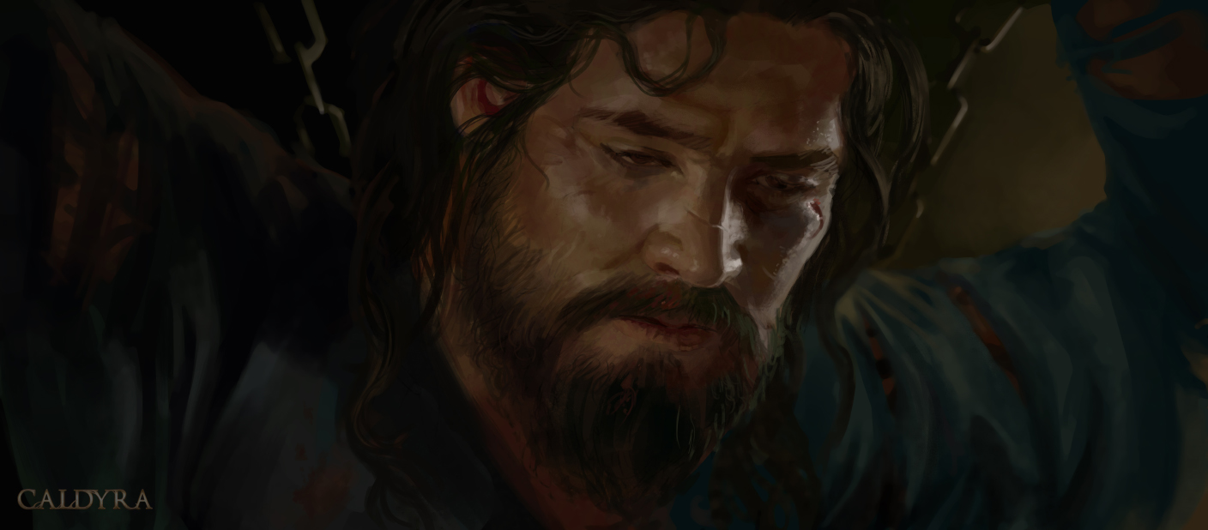
(Helmigh, 2018)

One artist, Suzanna Helmigh, an art director and illustrator, from the Netherlands, wrote in one of her blogs:

I think the good thing about those groups is that they serve for companionship. Being an artist all by yourself with no one to share/talk about/discuss your work with can feel rather lonely. And that lonely feeling is not encouraging at all. Most of us keep a lot of things taboo as well, like techniques or rates. If we were more openly with these the changes of being underpaid or missing out on a job because someone else does it for hardly any money at all will grow slimmer. People should know what they are worth and not be afraid to ask for it.

(Helmigh,2014)

In this dissertation proposal, I will be looking at the main timeline of events within the online artist community, seeing what changed about it over the years and briefly looking at the positives and negatives this had, and what some of the impact these changes made to the community.
As art as a whole has a broad range of different categories, that looking into the whole artistic community would require me to delve into too many different aspects that would be too big of a task to look at within this proposal. So instead the focus will be on artists related to the media industry, in particular, such as games, film and animation.

Within the artist community, there was a major shift in how artists engaged with each other online, this happened gradually and naturally alongside the widespread improvement of the internet, which resulted in changing the mainstream way in which people interacted virtually over the years.
This meant that instead of singular websites or forums, even though these still are used today, major platforms and social media such as Instagram, Twitter, Facebook, etc, have become the normal way in which people connect. This switch in how we engage with other people has had both negative and positive effects and it has changed the overall outlook artists had within these different communities online, as people feel like it switched from something more close-knit to something broader and less personal.

In an article talking about online art communities, Kelsey Ables encaptured this feeling of artists turning more commercialised in order to keep up with the demands of modern connectivity, they said:

There are a myriad of reasons people leave platforms—an unfriendly interface; outdated design; increased spam—but the shift away from tight-knit spaces for collective creativity marks more than just a natural fall in popularity. As the internet consolidated, it moved toward homogeneity and passivity, and the internet’s once-vibrant art communities became casualties in social media’s rapid, obliterative rise.

(Ables,2019)

During the earlier days of the internet, around the 2000’s, artists formed groups in forums and had dedicated websites for the sole purpose of sharing art with other artists, Such platforms as DeviantArt, WetCanvas and ConceptArt.Org. The intention of sites such as these was less about showing off or to impress, it was more about showing your work in a space where other individuals would appreciate it and you could see other peoples art and communicate openly back and forth. Having spaces like DeviantArt, it helped pave the way for a better alternative for artists to share their work online, ‘’DeviantArt has played a crucial role in the artistic growth of many millions of artists since its inception in 2000. What sets DeviantArt apart is the focus and purpose of the network and community as a whole.’’ (Sotira,2014).

Because of this openness, it allowed people to feedback and give tips to each other, with no malice behind it, but with the objective to help each other, and with this community feeling, there was no ill competition amongst each other and you could watch and see how artists developed and see them improve as well as yourself because of these online community spaces. ConceptArt.Org, was infamous for this feeling of learning with each other and being a witness to other artists growth, as the site was made with the purpose of being an educational workshop dedicated to industry artists, that you could join for free with different tiers that allowed you more access to assignments and tutorials.

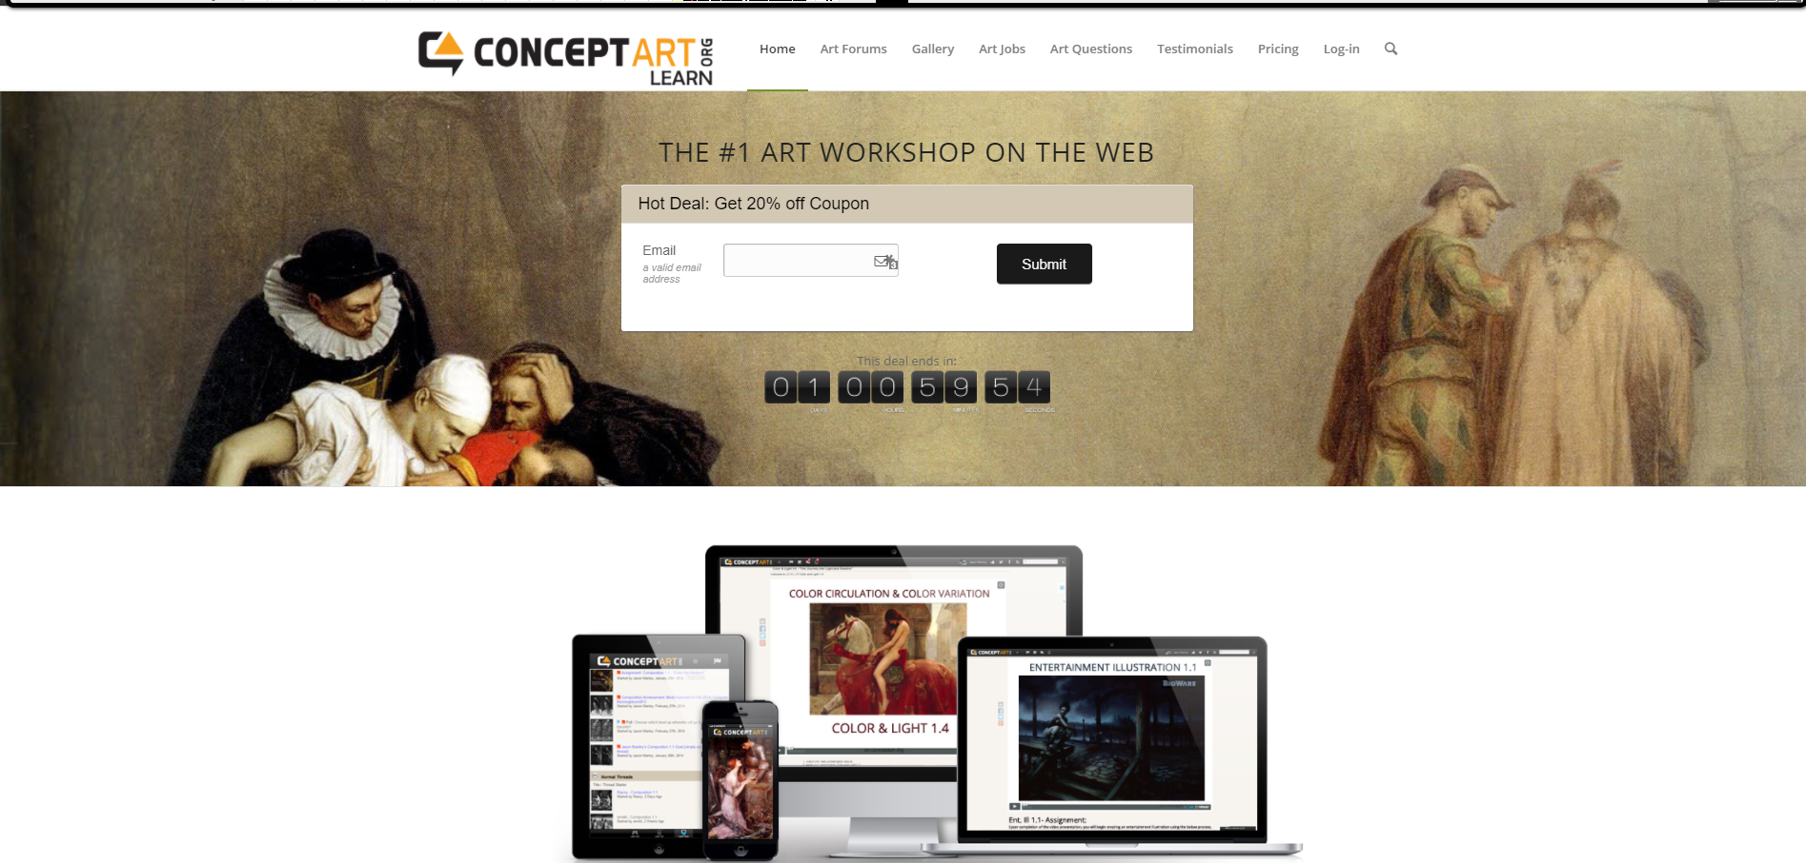
(Using the Wayback Machine, a site that allows you to view archived websites that may no longer exist, we are able to view how the site used to look back in its original days in 2014.)

In a forum, a couple of prior users of ConceptArt.Org, reminisced about the website stating:

‘’The site was unusually engaging, it fostered active participation to a level that was unheard of. It was a community, in the truest sense of the word. Today's social media are far, very far, from accomplishing anything similar.‘’

‘’I have cherished memories about that site. While I do have my critiques, I believe that the thing that made it so great was that we were all learning the fundamentals together. Even the pros were learning from each other. I had my own sketchbook, as did a lot of other people, and I joined a sketch group, as did a lot of other people. We would post our drawings and paintings daily, and we would give and receive cool critiques and tips on how to improve.’’

(OpenGameArt.Org, 2020)

Being able to have this back and forth between artists is incredibly beneficial in learning art and by having this open interaction, it helped to draw back the curtains about how artists could make a living working in the industry, and what everyone's process in creating their own art was. It showed the level that professional artists were working at and from this it could allow other artists to have a clearer goal in what they needed to accomplish in order to begin similar careers.
Along with this, it could inspire and motivate artists who would never have realised that working as an artist in media was possible, and artists could come together and share this passion with like minded individuals.

However over time this way that the majority of artist communities functioned changed slowly, it wasn't an instant development, it was a gradual one that changed how artists went about posting their art online. And this switch didn't happen just in the artist community, the entire way people engaged with each other online changed, it was just a case of the community adapting to how the rest of the online world developed.
Certain websites began to shut down, whether it was due to being unable to afford to keep up servers or a lack of users, there was now a whole new generation of people who primarily engaged via social media platforms, and so artists also switched over.
An example of how you could see this development happening is with sites like Kickstarter, a crowdfunding site, that allows people to donate money towards your project or creation. This idea of selling your work in an almost subscription type of manner and being able to start commercialising your art, this idea could have been one of the catalysts towards artists fully embracing the idea of being able to make a living online.
So sites that exist now like Patreon, were able to fully capitalize on a new need that artists had, because now instead of having to wait for commision requests, another form of income could potentially come from whether you had a name for yourself, and if you had enough support from your followers or fans, they could now pay to see extra art or more behind the scenes of your work. This way of thinking may have paved the way to what we see now, where artists feel like they need to constantly promote their work and sell themselves in order to build up this reputation.

So in modern times, now, there are a lot more varied ways in which to share art online whether that's on social media, art based platforms, or even among smaller art groups created by more popular artists. However, as mentioned due to the shift of the artist community, there tends to be a feeling of self promotion, the feeling that you need to plug your work, rather than showing your work for the sole purpose of sharing with other artists. There is now a lot of focus on trying to build up followers and this idea of gaining traction online is linked to what people believe to be success.
It is much more common especially on social media sites, for artists to struggle with this idea of linking a successful art career or valuing their artwork based on the amount of likes and comments they receive, and when this doesn't happen, it's very demotivating because you can get stuck into a self belief that your not good enough because of this.
However the reason why artists tend to not receive as much attention on sites like these is that, the very core of these platforms are not made with the content creators in mind, there is a lot more attention towards trying to keep people on these sites for as long as possible, ‘’...Facebook, Snapchat, Twitter, Instagram, Youtube, companies like this, their business model is to keep people engaged on the screen’’ ( Harris, 2020).
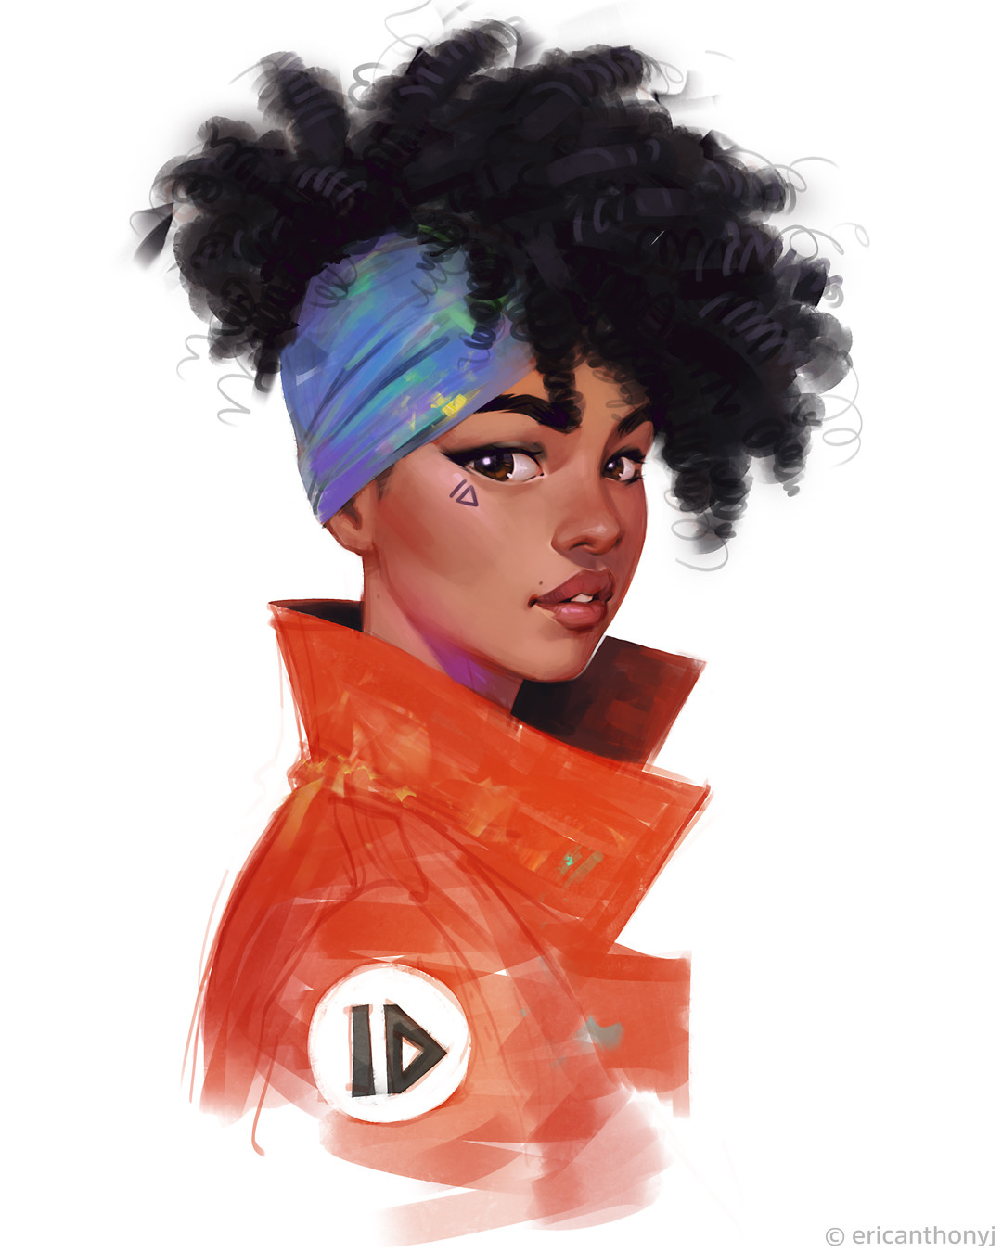

In a Youtube video, Eric-Anthony an illustrator and concept designer, talks about their experience in meeting someone with more followers than themselves:

we started talking to her and asking her about her followers and how she got so many followers and…..I mean she was being nice but she was kind of like bragging and acting like she was a celebrity compared to us and we sort of believed her because we only had 800 followers……...she had more than 20,000 and were kind of like impressed
(Johnson,2018)

(Image: Johnson, 2018)

This reflects this feeling that a lot of artists feel towards bigger artists than themselves, and a lot of artists are expressing this frustration about not feeling like they get enough followers, it has now led into other artists teaching others how to gain followers and traction. Artists now have to work alongside an algorithm that does not favour them, posting at certain times of day, making artworks that will appeal to the mainstream audience, and by creating art in this way, it takes away an element of free creative space that used to be commonplace in older art communities.

Adam Duff, founder of LucidPixel and illustrator, in his video talked about the effect that social media had on artists, he said:

….random artists online who reach out to me at a point of almost desperation, very often frustration...feeling completely down in the dumps, being completely overwhelmed by the competition... other people, even very seasoned, very professional artists will reach out to me with these same concerns because what they are witnessing feels like a lack of popularity, a lack of support from the community out there with their artwork..
(Duff,2019) - (Image: Duff,2019)
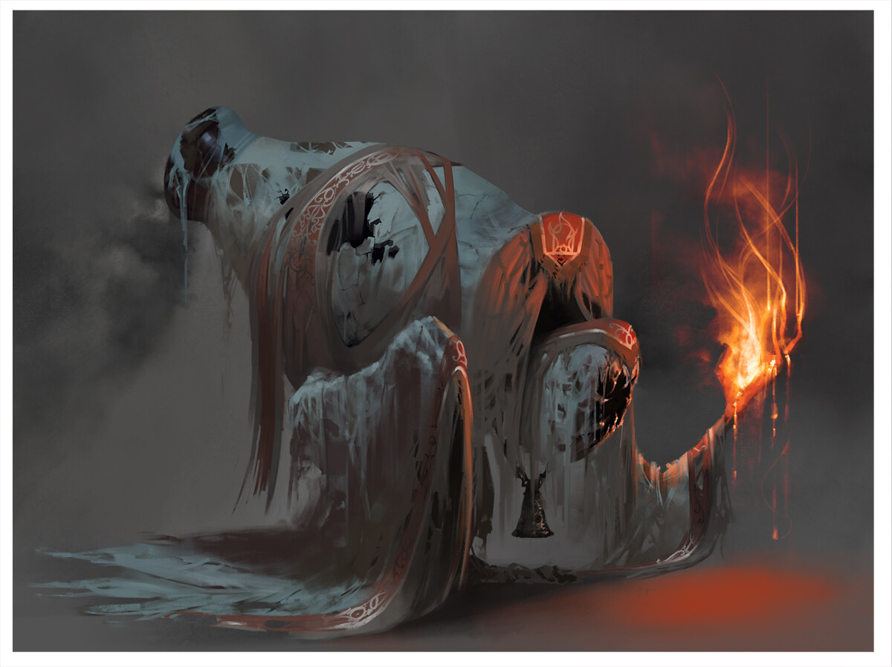
So there is clearly a widespread effect and overall concern, not just with artists starting out but also within professional artists, that the shift towards posting their content in this new way has caused a serious impact towards their creation and their motivation to work. It is as if artistic growth has been replaced by follower growth.

Now thats not to say that these more close knit communities that were more common place earlier in the 2000’s dont still exist now, there are still many ways to find groups that have that similar feeling, whether its by artists themselves who have created communities with the intent to educate younger artists and help them develop their skills or by joining group chats and being able to have quick conversations with a whole number of different artists. The difference now is that spaces like that are not commonly seen, especially for the public or people who are not already in the know how.
For example ConceptArt.Org, has now developed into LevelUp!, and still has the same principles in what the site originally was created for, an education platform for artists. They now have abandoned the website and have switched over into a Facebook group where you can post art and receive feedback from others and have also created a Youtube channel, in which their videos feature podcasts and talks with professional artists working in the field.
There are also new sites, made especially for artists, some popular ones being Artstation and Behance, however these platforms even though targeted towards artists, lack the same community feel in comparison to something like DeviantArt. The focus feels like it's more of a space where you can put all your artwork together in order to create a portfolio, it does not have as strong a community feel to it like previous based art sites and virtual spaces.
So with this development in art platforms and online groups, we must now look at what the impact of this shift means and ask whether or not communities can prosper when artists commercialise?

Overall the development of art communities has had a huge impact that clearly has both its negative and positives, as working online has become one of the vital ways in which an artist can make a living, so any time there is a major development such as this, it doesn't only change how people participate in groups online, it also impacts careers and people's well being.
One of the negatives being, that there is now this overall distant feeling between each other, as people are more likely to produce a more fake or perfect version of themselves, even just something as simple as showing how much work you can produce in a day, because if something as small as this is exaggerated, it can cause others to feel as if they are lazy or not working hard enough. And with this constant feeling of everyone performing for each other, there isn't as much of a real, human connection that you can form between each other if everyone is making an unrealistic online persona of themselves.
However a positive aspect of this evolution is that there is an incredibly massive amount of information at peoples disposal, whereas before you might have to look and buy a book and spend hours reading through fundamentals and techniques that may not even be relevant at the time anymore due to the big delay and amount of work it takes to create and publish a single book, now you can find thousands of different resources created by thousands of different artists. A single rule of art, can now be shown and demonstrated in so many different ways and where one artist's method may not work well, others may work perfectly for you.

While looking at this chronological account of events, and going over the overall changes that has taken place within the artist community over the years, it has provoked me to delve further into the effects that this has had on artists, both as a collective and on an individual level.
There are clearly benefits and disadvantages that have come around through this shift in the online communities and there are many issues that this transition into the modern online world has caused. But it has also opened up new solutions to problems that artists face, solutions that would not have even been possible before without this current evolution, so you could easily argue the case of it being both unhelpful and extremely helpful depending on what aspect you are looking at and what your viewpoint or opinion is.
This new headway in online communities leads into asking questions such as does the homogenization of art communities lead to a lack of creativity or self expression within artists? Or does the aspect of being able to fill your screen daily with an almost infinite amount of artworks produced by people across the globe counteract this?
Again you could constantly go back and forth with whether modern art communities and social media is actually supporting artists or is it a detriment to artists, due to the many positives and negatives of this topic.

However I want to look further into the business and work environment of industry artists,where their income and career is heavily influenced by their online presence, whether this is by using platforms and tools to earn money, or they were able to be hired at a job due to them having a large online follower count.
I aim to explore issues such as toxicity within the artist community and the potential it has in destroying careers and reputations, regardless if it was caused by rumours or gossip, or by real claims that have been put into the spotlight of the public eye that would only of come to the surface because of social media and online forums.
I want to look at the mental health effects that social media has on artists, where you can so easily put your self worth into whether or not your work has got as many likes as another artist or not, how it can affect moral and general well being when an artist feels as if their being ignored simply because they don't have as many followers, and the effects of having so much access of other people's work, that it is so much easier now to compare yourself to others and give up on art all together.
As well as all this I want to investigate the possibility that we still have a severe lack of diversity in workspaces, are certain groups of artists facing discrimination due to their identity, skin colour, culture/religion etc. in studios and how artists can open up conversations on this issue with a simple tweet. How does a lack of diversity affect the content that a group of artists create within a piece of media. Wouldn't the very presence of an online community, where your artwork is viewed and evaluated before anyone even knows who you are as a person or what you look like help stop this problem and allow more opportunities for work?

There are a lot of serious topics that can stem and originate from online artist communities, something that on the surface looks simple and wouldn't have deeply rooted issues such as these, but because of the vast amount of people from all across the globe, there are very obvious ripple effects both coming in and out of this community of industry artists. It has progressed further than before so that it is no longer something to just share your passion for art with others, it has now developed into a way to make a living for yourself. Even though you can use these platforms for both casual connection or use it to make an income, it doesn't stop the fact that with its development and how much impact it has within and without, it now comes with deeper and larger problems that go further than what it started out as originally.

In conclusion I have looked at a general overview into how the online artist community has developed and evolved into what we see today and some of the effects this has caused. I intend to further explore the impact that the modern internet and communities has caused in artists, diving more into how this may impact an artists wellbeing and living wages, as well as looking at topics such as issues with racism, sexism, trans/homophobia, etc, and how these issues can affect artists and how these type of topics are especially important towards industry artists, as these are the groups of people creating content for the mass media, and if these issues bleed into work and studio spaces, it will also bleed into the making of films, games and animation.
I do believe that artist communities are an important factor of being an artist in general, especially now where we live surrounded by technology and where we can spend hours in a single day on the internet. Without these communities, especially beginner artists, would find it much more difficult to learn and have this open access to information that we have today, and with this almost instant insight on how to create better works of art and how to improve yourself so that you can begin your artistic journey, these communities have paved a way forward for this ethos.

Bibliography

Helmigh.S (2014) Why it’s so important to unite as artists [blog] Available at: https://www.deviantart.com/suzanne-helmigh/journal/Why-it-s-so-important-to-unite-as-artists-447465113 (Accessed: 16th November 2020).

Helmigh.S (2018) Doomed [digital painting] Available at: https://www.deviantart.com/suzanne-helmigh/art/Doomed-773376656 (Accessed: 16th November 2020)

Ables.K (2019) The Rise and Fall of Internet Art Communities [blog] Available at: https://www.artsy.net/article/artsy-editorial-rise-fall-internet-art-communities (Accessed: 19th October 2020)

Orin.A (2014) I’m Angelo Sotira, Co-founder of DeviantArt, and This Is How I Work, LifeHacker. [blog] Available at: https://lifehacker.com/im-angelo-sotira-co-founder-of-deviantart-and-this-is-1626582164
(Accessed: 20th November 2020)

OpenGameArt.Org (2020) Does anybody remember conceptart.org? [forum] Available at: https://opengameart.org/forumtopic/does-anybody-remember-conceptartorg
(Accessed: 19th October 2020)

The Social Dilemma (2020) Directed by Jeff Orlowski, [Netflix documentary] Exposure Labs.

Johnson.E.A (2018) Instagram:Get followers as an artist [video] Available at: https://www.youtube.com/watch?v=bJw8gGYqXQE (Accessed: 20th November 2020)

Johnson.E.A (2018) Orange. [digital painting] Available at: https://www.artstation.com/artwork/lmQ3O (Accessed: 20th November 2020)

Duff.A (2019) How social media is ruining your art (Pyromancer Painting P1) [video] Available at: https://www.youtube.com/watch?v=Ss1XJ79byVU&t=99s
(Accessed: 20th November 2020)

Duff. A (2019) Pyromancer [digital painting] Available at: https://www.artstation.com/artwork/xzoBZE (Accessed: 20th November 2020)

