
Tsvetomila Metodieva
1808619

Understanding and Engaging in the Customer Experience
(BMSW5103_LON)
Dr Kenny Tang

Mc Donald’s

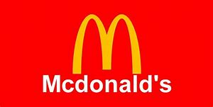

Contents

Introduction 1
Part 1 Customer Value 1
Part 2 (A) Service Quality 13
Part 2 (B) Service Gaps 18
Part 3 Conclusion 23
References 24
Appendix 27

Introduction

This study is going to analyse the customer value in the context of the McDonald and will compare the customer value of McDonald with KFC. It will analyse the dimensions and elements of the customer value in detail and with a comparison of two organizations. Apart from this, this report will include the analysis of the service quality by investigating five dimensions of the service such as reliability, assurance, tangibility, empathy, and responsiveness. In addition to this, the service gap will be assessed in this report by considering the SEQUAL model. The gap in services of McDonald and KFC will be analysed in this study.

Part 1: Customer Value

Customer value can be described as the satisfaction of consumers with goods or services. The marketing by the companies to communicate creates and delivers the values to the consumers in the market. This is the habit of the consumers to compare the perceived values of similar kinds of products while making important decisions. The perceived value can be computed and measured by dividing the perceived benefits to the consumers by the cost spent on the product or services (Yi and Gong, 2013). The value to consumers can be the factor and important element in the marketing because consumers want more benefit in return of lesser investment in the product or services. Hence, the degree of satisfaction and consumer value may affect the decision of the consumers in the future regarding the purchase of the products or services (Schmitt et al., 2011). The consumer value can be driven by the marketer by improving the function of products, by setting up a good point of difference between same kinds of products, by assuring good quality in products, by focusing the branding and marketing of the goods or services, by setting up a good price for products, and others.
According to Simchi-Levi Customer Value can be measured in five dimensions such as Conformance to requirement, product selection, Price and brand, value-added service, relationship and experience (Simchi-Levi, et al., 2003).

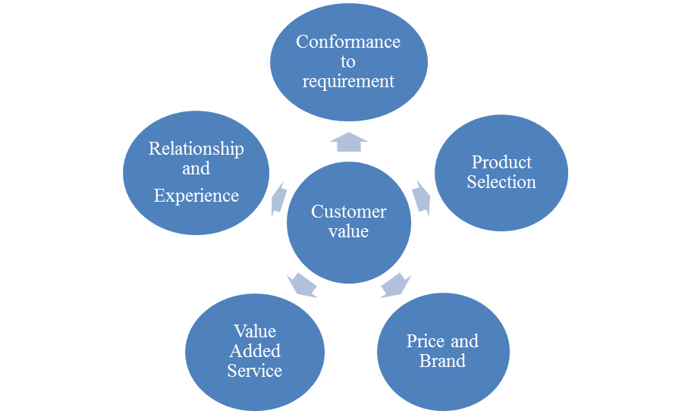

Figure 1. Five Dimension of Customer Value by Tsvetomila Metodieva
Source: Simchi-Levi 2003
1st Dimension of Customer Value is Conformance to Requirement
This is an important dimension for creating value for consumers. How good the companies are conforming to the needs and requirements of the consumers can have an effect on the perceived value and improving the satisfaction of consumers. The lack of confirmation to the consumer requirement and demand in the market may cause the cost to the company in terms of inventory cost or loss of sales. If the supply is higher than the demand, it causes inventory cost to the company and lesser supply than demand cause lesser sales of products or services of the company. The responsiveness of the supply chain can have an influence on customer value and demand (Gallarza et al., 2013).
McDonald's is quite good to conform to the requirement of the consumers in the market. The company ensures a match between the requirement of consumers in terms of taste and preference of the customers. This is leading McDonald at a higher rate in the competition against KFC, Subway, and others. McDonald identifies the requirement of the consumers in the different markets on the basis of taste and preference and to determine the design and taste in Burger, chicken, breakfast, and others. This improves the satisfaction of consumers with the products and services of McDonald's.
Both the KFC and McDonald focus on taste and preference and keep the taste and preference standardized across the market (Mondurailingam, Jeyaseelan, and Subramani, 2015). Any mismatch between the requirement of the consumers and products may lead to dissatisfaction that can lead the consumer value down. Hence, the matching concept is followed in McDonalds and KFC stores across the world which is raising the preference of these two bands in the market (Liu and Sun, 2015). The spices in the products are determined by the company and proper requirement of the consumers regarding spices, requirements such as veg burger, cheeseburger, chicken burger and other are produced by McDonalds which is offered to the consumer and delivered as per their order.
According to the 1st dimension of Customer Value –Conformance to requirements the Ranking out of 10 for McDonalds is 9/10, with 7/10 for competitor KFC.
2nd Dimension of Customer Value is Product Selection
The products of the company are very important for delivering consumer value. The product selection may have an implication on the decision of the consumers (Chen & Hu, 2010). The proliferation of the product options can generate a number of choices before the consumers where they can choose a suitable product that best matches their requirements. However, a larger variety of product options can cause it very hard for managing the suppliers of the products and predicting the demand for the products. Specialization in offering a product and specialization in particular kinds of product lines may have an implication on the consumer value (Chen, 2015).
McDonald is one of the favorite destinations for people around the world for food. KFC is also the brand that is mostly preferred by consumers and KFC is the biggest competitor of McDonald's in the market. They have a variety of products and food options. However, Hamburger is a specialized product in McDonald’s that attracts people in the store of the company. KFC comes in the mind of the people when they want and like to eat fried chicken. This is because both the companies claim for a specific kind and particular product which has become their trademarks and identification in the market (Hu, W., & Xie, 2013).
The varieties of the burger in McDonald's create good unique selling proposition (USP) in the products of the company and it creates good value for the consumers (McDonald, 2019). The variety of chicken meals determines good USP in the marketing of KFC that has a good influence on consumers creating good value to them and ensuring their satisfaction. The Aloo Tikki to be produced in McDonald's is mostly sold product of the company and this has a good influence on the decision of the buyers in the market (McDonald, 2019). The options of the product in the company are much specified and they are mostly preferred by the consumers. More options for the consumers may cause confusion and dissonance behavior that may affect the buying behavior and can have an influence on the value of the consumer because the company can lose the control and expertise in the product.
Both KFC and McDonald's are operating in the same market, but they are being known and identified for the different products that indicate they are creating good consumer value by different products. McDonald's creates value by the products by improving the product functions and meeting the needs (Research Gate, 2015). The functions and attributes of products cause functional value while the satisfaction and meeting the needs for pleasure may cause experience and convenience value. McDonald's meets the needs of consumers for a taste of burger while the KFC meets the needs of the taste of the Chicken. The taste of the foods and satisfaction of consumers with products indicates they are getting good value against the money they are paying for the foods.

Ranking the Top 50 Fast-Food
RANK | COMPANY | CATEGORY |  | 2018 US SYSTEMWIDE SALES MILLIONS | 2018 AVERAGE SALES PER UNIT THOUSANDS | 2018 FRANCHISELICENSE UNITS | 2018 COMPANY UNITS | 2018 TOTAL UNITS | TOTAL CHANGE IN UNITS FROM 2017
1 | McDonald's | Burger | 38,524.05 |  | 2,768.73 | 13,229 | 685 | 13,914 | -122
2 | Starbucks* | Snack | 19,700.00 |  | 1,349.32 | 6,332 | 8,493 | 14,825 | 895
3 | Subway* | Sandwich | 10,410.34 |  | 420.00 | 24,798 | 0 | 24,798 | -1,110
4 | Taco Bell | Global | 10,300.00 |  | 1,600.00 | 6,126 | 462 | 6,588 | 142
5 | Chick-fil-A* | Chicken | 10,000.00 |  | 4,166.67 | 2,400 | 0 | 2,400 | 175
6 | Wendy's | Burger | 9,993.70 |  | 1,636.40 | 5,825 | 353 | 6,711 | 77
7 | Burger King* | Burger | 9,950.00 |  | 1,357.00 | 7,278 | 49 | 7,327 | 101
8 | Dunkin' | Snack | 8,787.00 |  | 933.00 | 9,419 | 0 | 9,419 | 278
9 | Domino's* | Pizza | 6,600.00 |  | 1,123.00 | 5,486 | 390 | 5,876 | 258
10 | Panera Bread* | Sandwich | 5,734.63 |  | 2,739.91 | 1,131 | 963 | 2,093 | 50
11 | Pizza Hut | Pizza | 5,500.00 |  | 878.00 | 7,432 | 24 | 7,456 | -41
12 | Chipotle | Global | 4,800.00 |  | 2,000.00 | 0 | 2,491 | 2,491 | 83
13 | Sonic Drive-In | Burger | 4,447.10 |  | 1,250.00 | 3,427 | 179 | 3,606 | 13
14 | KFC | Chicken | 4,400.00 |  | 1,210.00 | 4,019 | 55 | 4,074 | -35

Source: https://www.qsrmagazine.com/content/qsr50-2019-top-50-chart
According to the 2nd dimension of Customer Value - Product Selection the Ranking out of 10 for McDonalds is 9/10, with 8/10 for competitor KFC.
3rd Dimension of Customer Value is Price and Brand
Price
The name of the brand and brand recognition in the market may have an influence on the decision of the consumers. There is a good connection between the name and recognition of the brand in the market which has an implication on the decision of buyers. Hence, consumers can pay a good price for the products which may generate higher perceived value to the consumers. If the prices are higher than the perceived value of the goods or services among the consumer may affect the satisfaction of the customer and it may affect the customer base in the market (Von Martens and Hilbert, 2011).
Price is a very important factor in consumer satisfaction, and this may improve customer value. Price can be determined by using different methods such as cost-plus pricing, premium price, skimming price, odd pricing, market-based pricing, competition-based pricing, and others (Chen, 2015). The prices of the foods to be produced and marketed by McDonald's are determined according to the market affordability, USP in the products and others. KFC uses a skimming pricing strategy in the market that aids into charge higher and premium prices for USP in the products. McDonald's determines an affordable pricing strategy which aids the company to find a good price level where the company can reap out good profit along with allowing the consumers to buy the hamburgers and other products of the company. The consumers are satisfied with McDonald's as they perceive that they are paying equal to the value and utility they are getting from the foods of McDonald's (Liu and Sun, 2015). They are ready to pay for their products which indicate consumers prefer the hamburger of McDonald's by paying a high price as well.
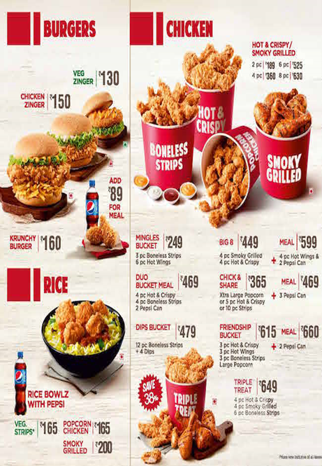
Price comparison McDonalds & KFC
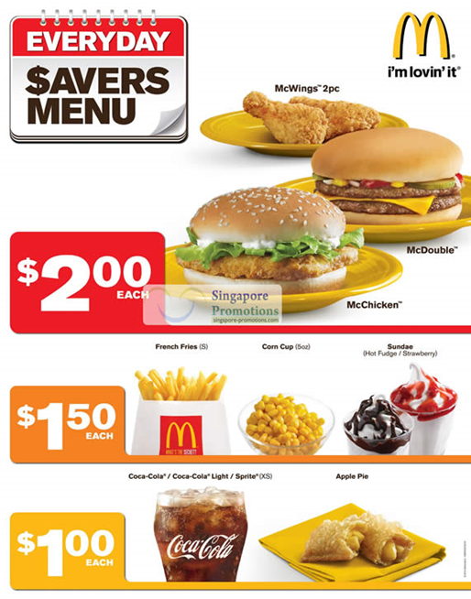
Source:https://www.google.com/search?q=price+comparing+mcdonalds+kfc&rlz=1C1GCEV_enGB879GB879&tbm=isch&source=iu&ictx=1&fir=wF32aez5TFyXkM%253A%252CMDoavd71IdDUoM%252C_&vet=1&usg=AI4_-kTDV6-Lnwo8ibefYsG4G4T6ewC8vA&sa=X&ved=2ahUKEwipot3VjbDmAhUFSBUIHfHGBUwQ9QEwDHoECAoQFw#imgdii=hIGa_uYnQV24BM:&imgrc=COrAsdY_5QX6YM:&vet=1
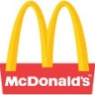  McDonald's  (prices in British Pounds) | 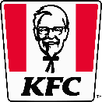  KFC (prices in British Pounds)
Sandwiches (Individual, Medium Meal Deal, Large Meal Deal)  Big Mac 2.99 / 4.49 / 4.89  French Fries 0.99 / 1.09 / 1.39  Fillet O Fish 2.89 / 4.49 / 4.89  Chicken McNuggets (6) 2.99 / 4.49 / 4.89  Cheeseburger 0.99  Double Cheeseburger 1.49  Hamburger 0.89  Coca-Cola, Sprite, Fanta 0.89/0.99 / 1.39  Milk Shake 1.59 / 1.89  Latte/Cappuccino 1.99 / 2.29  Chocolate 1.49 / 1.79  Tea 0.99 / 1.09 | Chicken Pieces 1/2/3 1.99 / 2.99 / 3.99  Fries (Reg/Large) 0.99 / 1.59  2 Piece Meal (2 pieces + drink + fries) 4.29  3 Piece Meal (2 pieces + drink + fries) 5.29  Bargain Bucket 6/10/14 Pieces (+ 4 Fries) 10.49/13.49/16.99  Cappuccino 1.69  Chocolate 1.69  Tea 0.99
Source: https://www.londontoolkit.com/briefing/prices_fast_food.html
McDonald's have very efficient operations and comparatively low costs on their goods. KFC has quick service and comparatively high rates for their goods. The skimming pricing strategy aids KFC to exploit the market opportunity by deciding the higher price for its new products and when it enters a new market. Hence, the brand name and prices are related because a good brand name in the market can charge higher prices and consumers can pay but low recognized brands can consider it very hard to take higher prices for products (Liu and Sun, 2015). Hence, McDonald's should focus on making good price decisions so that it can deliver good value to consumers.
According to the 3rd dimension of Customer Value - Price Ranking out of 10 for McDonalds is 10/10, with 7/10 for competitor KFC.
Brand
Brands are strong signs that represent not only the identity which producers and advertising agencies are seeking to imbue them with, but also the cultural environment in which they are embedded (Levi, 1959).
McDonald's is the world's leading food service provider with more than 37,000 stores in more than 120 countries. Over 90% of McDonald's restaurants in the world are owned and managed by independent local entrepreneurs. McDonald's is actually ranked the 9th best global brand in the world as one of the most successful restaurants in the world. With a brand sold in more than 120 countries that serves millions of consumers every day, McDonald's marketing impact is clear (Interband, 2019). Segmentation and innovation were essential to McDonald's branding and advertising growth. In reality, given its regional diversity, the brand is very focused, with a great deal of attention to detail to guarantee that the principles are implemented internationally. Although as a global company, McDonald's adapts its market and menu to the different countries in which it resides. They value cultural differences and each nation has its own method for designing menu items. In reality, given its regional diversity, the product is very cohesive, with a great deal of attention to detail to ensuring that the principles are implemented internationally (Gadsden, 2014).
Comparing to McDonalds, KFC brand is ranked 93rd best global brand in the world in 2019 (Interband, 2019). There is clearly visible comparing brand value growing for the period of 18 years’ time between McDonalds and Competitor KFC in the Figure2 below.
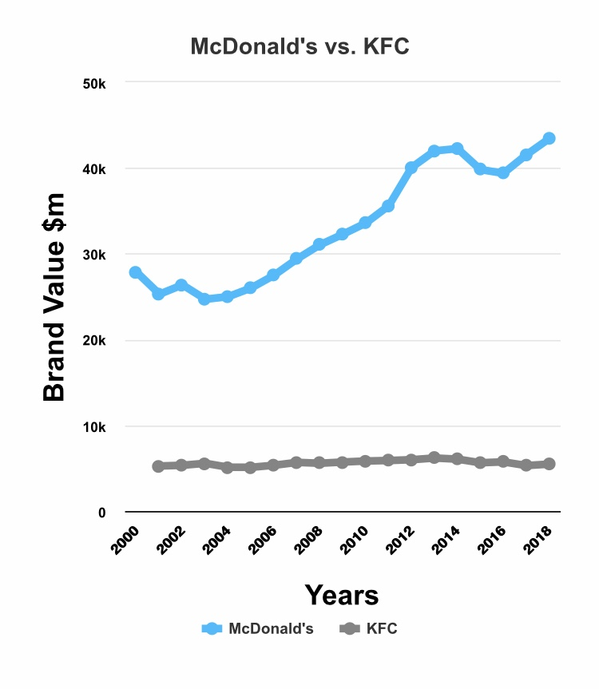
Source: www.interband.com
Figure 2. Brand Value growing for McDonalds and KFC
According to the 3rd dimension of Customer Value - Brand Ranking out of 10 for McDonalds is 10/10, with 7/10 for competitor KFC.
4th Dimension of Customer Value is Value-added Service
The services to be offered by the entities and to be associated with the products can also have a good impact on the consumer value and this may affect the consumer decision and behavior. The value to consumers may do affect the purchase behavior of the customers. Consumer seeks for the good services and this may aid the organizations to attract the consumers and influence their decision of purchase of the products. Differentiation in the products, uniqueness in the products, building a good relationship with the consumers and others may improve the customer value (Chen, 2015). The value-added services are considered in the non-core products or services which are offered by the firms along with the products so as to improve the consumer experience and delight the consumers. The guarantee, customer service, customer feedback, and others are good value-added services to the customers in the restaurants and to improve customer satisfaction. The value-added services cannot be copied, and this can be different in different companies and can be different at different points of time in the same organization (Chen, 2015). This is very critical to raise the value to consumers delighting the consumers. Ignorance of consumers and ineffective customer services in the stores may affect the satisfaction of the consumers.
McDonald provides very speedy services and the staff in the restaurant of the company respond to consumers in a warm manner with good speed (Research Gate, 2015). The location of the company may also affect the values because the location near the market may be more convenient for consumers. McDonald's offers after-sales service, information service, free calling, online booking, good music system in-store, and others cause the good value to consumers.
McDonalds provide free wireless service, so customer can get some stuff done, read their emails, or get in touch with friends. Every customer has access to the Internet on laptops or mobile devices at more than 11,500 participating restaurants with Wi-Fi, always free of charge. They also offer a free coffee if customer buys 5 coffee. McDonalds offers Arch cards, gift card perfect for any special occasion. Moreover, free information is introduced to the customer in the website and in the restaurants. McDonald's is giving away 500,000 FREE children's books-The Holiday Tales of Archie (the reindeer). To save cash on dining out at McDonald's, shoppers may use discounts with vouchers or earn stickers during their monopoly event (McDonalds, 2019).
KFC also stresses on raising the value-added services because the satisfaction level of consumers can be affected the customers (Hu & Xie, 2013). McDonald's provides good service, the staff in the stores of the company welcome the consumer in a warm manner, and the waiter in the store are too fast that delight the consumers.
As well as McDonalds, KFC offer home delivery. The fast food market is highly competitive, KFC's main competitors are fast food chains such as McDonald's and Domino's, which are well known.
According to the 4th dimension of Customer Value - Value-added service, and additional with my experience as their customer I Rank out of 10 for McDonalds is 9/10, with 7/10 for competitor KFC.
5th Dimension of Customer Value is Relationship and Experience
Many of the organizations focus on building a strong relationship with the consumer to achieve the goals for raising consumer loyalty to the brand. The relationship may make it harder for the consumer to switch the brand. It means the relationship has a direct influence on the decision by creating good value for respective buyers and consumers (Chen, 2015). Apart from the relationship, the experience may be a good factor and dimension for improving the value. What experience the consumer had with the product or services of the company may affect their decision regarding the purchase of the same product of the same brand in the future. The uniqueness in the product or services and fulfillment of the desires with the products may improve the experience of the customers (Von Martens and Hilbert, 2011). This is very necessary for the firms in the modern era to build up good relationships and links of the consumer with the brand.
The services in the stores of McDonald's are the same and consistent that is making a good relationship with the customers. The company is retaining and maintaining a good relationship by creating a good value of money for customers (Write work, 2011). KFC is focusing on making customers happy that is generating a good relationship with the targeted customer with the firm. McDonald's ensures the loyalty of customers that raises the number of consumers and improves sales. KFC as well as McDonald is providing coupons and discounts on the prices by combining different products that may lead base of delighted consumers. The bad experience of the consumers in the stores of the company may have effects on the decision of buyers. McDonald's and KFC are also focusing on raising the experience of consumers by offering good services and making consumers happy with their products (Hu and Xie, 2013). It leads to good consumer value and this influences the decision of buyers.
According to the 5th dimension of Customer Value - Relationship and Experience the Ranking out of 10 for McDonalds is 8/10, with 7/10 for competitor KFC.

Summary Table:
Five Dimension of customer value | McDonald  Ranking out of 10 | Competitor – KFC  Ranking out of 10
Conformance to requirement | 9/10 | 7/10
Product selection | 10/10 | 8/10
Price and brands | 10/10 | 7/10
Value added service | 9/10 | 7/10
Relationship and experience | 8/10 | 7/10
Total | 46 | 36

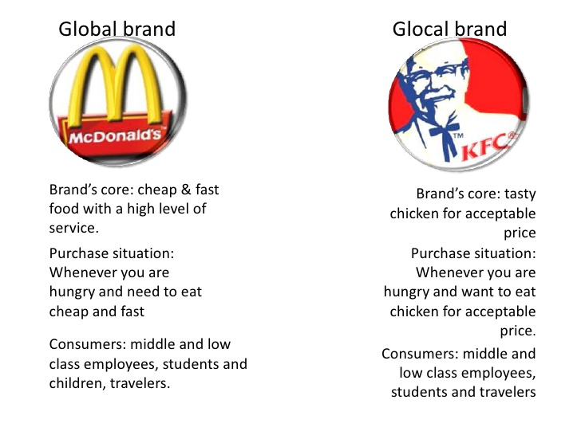

Source: https://researchpedia.info/difference-between-mcdonalds-and-kfc/
McDonald's have a wide range of sandwiches, whereas KFC has a wider range of solutions to chicken cooking. McDonald's has a share of 19 percent and KFC has a position of 9 percent on the world market. McDonald's is in the first place, but KFC ranks 14th. McDonald's also serves breakfast, which does not serve KFC (Researchpedia info, 2015). From the above analysis, it can be stated that customer value is very important for getting success and for the long-term sustainability of businesses. Hence, the customer values and dimensions of customer value in the context of McDonald are ranked higher than KFC for each dimension. For Product selection and Price and Brand, McDonalds has higher possible ranking, and in total for all customer value ranking has 46 compare to KFC with only 36 total ranking. This indicates McDonald's is more capable to generate customer value in comparison to KFC.

Part 2: (A) Service Quality

Quality is a very critical factor in the services to have an implication on the decisions. The lower quality in comparison to the expectations and money paid by the consumers may lead to cost in the company. This is because mismatch and lesser qualities may affect the supply chain and consumer satisfaction in the market (Al Khattab and Aldehayyat, 2011). Consumers in the market seek out good quality in the products or services and this can raise the satisfaction of consumers. How efficiently and how effectively the company’s services conform to the expectations and desires of consumers may determine the quality of the services. The ineffective qualities in the products or services can be a reason behind consumers switching the brands and this can cause a huge loss in the companies. This may be bad for companies. Businesses in the marketing carrying higher quality in their products or service can better meet the expectations of consumers or can exceed the expectation so the customers. The service quality can be said as the achievement of the firms that they get in customer service (Yarimoglu, 2014). The experience of the consumers from their expectations regarding services, quality in services and this may affect the decision and marketing of the firms in the market. The services are intangible in nature that causes it very hard for define the concept of quality in the services. Intangible means the things which cannot be seen and touched by hand, but tangible means the things that are touched and seen. Historically, the quality was measured in two dimensions such as technical quality and functional quality. The technical quality is objective which can be measured but the functional quality measurement is very hard.
According to Parasuraman, Zeithaml and Berry, Service Quality can be measured in five dimension such us reliability, assurance, tangibility, empathy, and responsiveness (Parasuraman, et al., 1985).
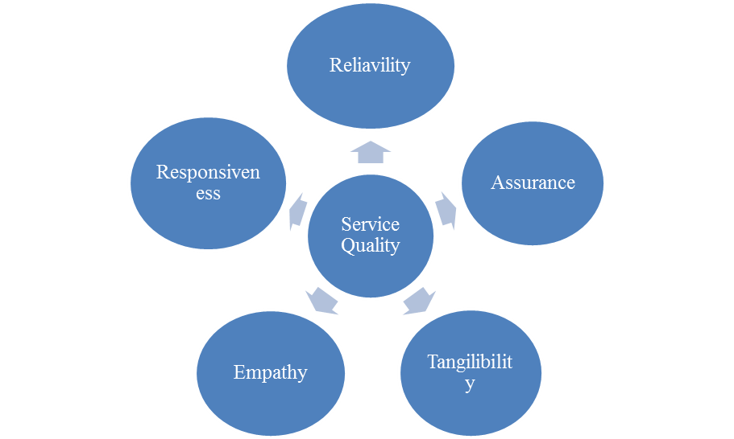
Figure 2. Five Dimension of Service Quality by Tsvetomila Metodieva
Source: Parasuraman, Zeithaml and Berry 1985

1st Dimension of Service Quality is Reliability
Reliability indicates the ability of an organization to perform the promised services accurately and dependently. If the firm does not perform and keep the promise that it has made to consumers, it may lead to unreliability and can affect the quality of service. This may lead to dissatisfaction in consumers which in turn may have an implication on the performance of the organization. This is the duty and responsibility of the firm to ensure good reliability regarding the services of the company (Yarimoglu, 2014). McDonald maintains the taste in its foods, and it performs its all the services considering them as its promise. It provides its services in the same way over time and the consistency of the services ensures the reliability in the services of the company. However, during peak hours, the services of the company are slower which causes customer complaints (Yunus and Zulkeflee, 2013). On the other hand, KFC is a competitive firm of the McDonald that carries out its promise made to customers. However, KFC is not effective in comparison to McDonald in terms of reliability. There is a high level of consistency in the taste, interior and exterior design of the store, dress code of staff and other things across a different geographic area that causes more confidence and reliability of the brand of McDonald's in comparison to KFC.
According to the 1st dimension of Service Quality – Reliability the Ranking out of 10 for McDonalds is 8/10, with 6/10 for competitor KFC.
2nd Dimension of Service Quality is Assurance
This dimension indicates the understanding of the staff, courtesy of the staff, the capability of staff to inspire and lead confidence and trust in consumers. Lack of assurance may lead gap in the service, and this may affect the quality of the services. If there is a lack of courtesy in the staff and they do not have the capability to make the customer assure about the quality, it can influence the customer base and it may lead to loss of sales in the company (Ryu and Han, 2010). The staff members in McDonald are quite effective in assuring the quality of the services. The processes of the McDonald for service delivery and transactions are too effective which gives good confidence to the customer while making a transaction with the company. The staff sometimes gets irritated when consumers ask a number of questions that affect the courtesy of the staff to the consumers. This may influence the confidence and trust of the consumers in the services. The understanding of the staff in the KFC is not effective and they are not much capable to assure the quality in services to consumers due to lack of understanding and knowledge (Hu and Xie, 2013). It has an implication on the service quality of the company.
According to the 2nd dimension of Service Quality – Assurance the Ranking out of 10 for McDonalds is 8/10, with 6/10 for competitor KFC.
3rd Dimension of Service Quality is Tangibility
This is a very important element that may have an implication on the perception and decision of the consumers. The appearance of the staff, types of equipment, and physical facilities and design may give a sense of tangibility in services. It has to be included and ensured while delivering services to give evidence of service purchases to customers. The companies in the modern era are using advanced technology, equipment and methods for performing their services (Kritikos et al., 2013). Modern equipment, the appearance of the staff in the store, physical facilities like sitting arrangements, toiletries, aisles, and other things such as price display are some physical facilities that improve the confidence of customers in McDonald's. The same design, structure, and format are used across all the stores of the McDonald throughout its market which generates good confidence in the customers (Write Work, 2013). KFC design and interior, structure, and format are different from McDonald's. The store of McDonald is more than the stores of the KFC in the market. Hence, the physical evidence and physical content in the services can have an implication on the decision of the buyers. Both KFC and McDonald's focus on ensuring a clean surface, tables, and stores to improve the experience of the customers (Hu and Xie, 2013).
According to the 3rd dimension of Service Quality – Tangibility the Ranking out of 10 for McDonalds is 6/10, with 4/10 for competitor KFC.
4th Dimension of Service Quality is Empathy
Personalization of services and caring for the customers in the store of the company can be stated as empathy. How good the firm care about customer requirement may determine the level of the empathy of the firm to the customers. There is a different philosophy of consumers regarding customer services. McDonald's is a Giant organization that focuses on creating value to consumers by understanding their needs and wants. It may aid to personalize the product or services to consumers for leading good satisfaction and attracting the consumers proving good quality in the services. McDonald cares for the taste of the consumer and gives them good taste as they expect. KFC is also a Food Chain that stresses the hospitality service to raise empathy for consumers. It focuses on ensuring good quality in products and offering sincere and friendly services (Hu and Xie, 2013). However, there is a lesser concern of the company regarding customer wants and needs that may cause it to be below McDonald for customer empathy.
According to the 4th dimension of Service Quality – Empathy the Ranking out of 10 for McDonalds is 9/10, with 8/10 for competitor KFC.
5th Dimension of Service Quality is Responsiveness
This dimension indicates how well the firm responds to queries of consumers, and to resolve their issues and complaints. The less or lack of response to the queries and complaints of the consumers may affect the mind-set of the customer and this may cause an impact on the purchase behaviour in the future (Kritikos et al., 2013). The service of McDonald is fast but during the peak season, the services become lesser speedy. On the other hand, the services of KFC are too speedy which leads to good customer satisfaction. The employees in KFC are not quite able to offer prompt services as the employees in McDonald. There is high staff turnover in the McDonald that affects the quality in customer service as a lack of understanding of staff and lack of their response to the consumers may affect the quality of services. It may have an influence on consumer satisfaction (Lu, 2010). On the other hand, employees in McDonald's are more responsive and willing to respond to the request and complaints of consumers in comparison to KFC.
According to the 5th dimension of Service Quality – Responsiveness the Ranking out of 10 for McDonalds is 7/10, with 5/10 for competitor KFC.
Summary Table
Five Dimension of service quality | McDonald  Ranking out of 10 | Competitor – KFC  Ranking out of 10
Reliability | 8/10 | 6/10
Assurance | 8/10 | 6/10
Tangibility | 10/10 | 4/10
Empathy | 9/10 | 8/10
Responsiveness | 8/10 | 5/10
Total | 43 | 29

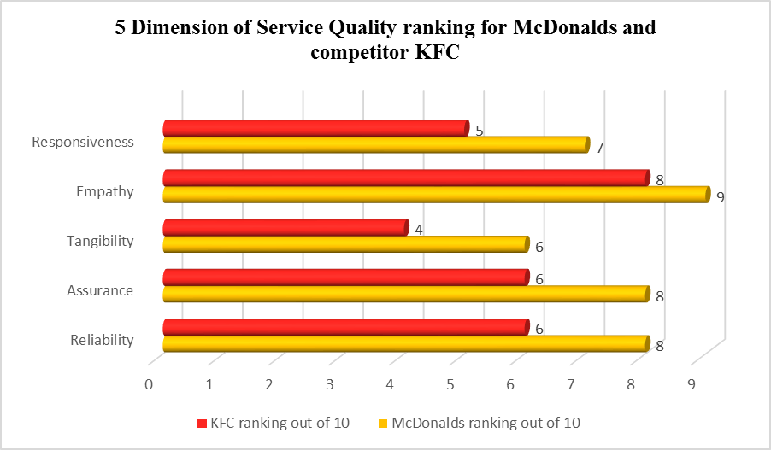
From the analysis of the service quality dimensions, it can be stated that consideration of these dimensions such as reliability, assurance, tangibles, empathy, and responsiveness is very necessary for raising the trust and confidence of customers. It is found that service quality is being ensured by both KFC and McDonald, but McDonald is ranked higher than the other in each dimension of service quality with total ranking of 43 comparing to only 29 ranking for KFC. It means McDonald's is serving good quality in its foods and services to the consumers than KFC.

Part 2 (B) Service Gap
The SERQUAL model is used for assessing the gap in the services of the company. The gap in the services to be offered by the companies may affect the satisfaction and value to the consumer that can have adverse implications on the performance (Tajzadeh-Namin & Pilevary, 2012). According to Parasuraman, Zeithaml and Berry there are 5 Gaps in service quality such as: Gap 1 not knowing what customer expect, Gap 2 wrong service quality standards, the service performance Gap 3, Gap 4 promises do not match actual delivery and Gap 5 the difference between customer perception and expectation (Parasuraman, et al., 1985). Those gaps in services will be analysed below in the context of McDonald and KFC.

GAP 1 not knowing what customer expect
This gap occurs in the company’s services when the difference between the provision of the services by the company and the expectations of the consumers. This difference is triggered by a lack of knowledge. If the management of the company does not have a detailed knowledge of what customer wants, it can cause this difference. Insufficient researchers by the company in the market, ineffective interaction between the consumers and management, lack of communication between the management and staff of the company and others can be the reason for this gap (Naik et al., 2010). McDonald's involves hard marketing research to determine the needs and desires of consumers. For instance, McDonald before entering India, it did good research in the market and find different taste and preference of customers. It designed more spicy foods for Indian consumers to meet their expectations. Hence, the management in McDonald's has good knowledge of the market to ensure meeting the needs of customers (Raju et al., 2013). There is a high knowledge gap in the services of the KFC as a lack of knowledge of the market affected the service and decision of the company. It is charging higher prices and there is a limited area for delivery of services that is reflecting this gap. McDonald and KFC are facing challenges in knowing the customer expectations because the desires and expectations of the consumers change frequently. McDonald and KFC should do more research in the market to understand the behaviour of the consumers so that they can meet the expectations of consumers and can reduce this gap.
According to the 1st Gap of Service Quality – not knowing what customer expect the Ranking out of 10 for McDonalds is 1/10, with 3/10 for competitor KFC.
GAP 2 Wrong service quality standards
This gap may occur to due to lack of adequate commitment of the organization to ensure good quality in the services. The failure of the company to match the supply of the services with the demand as per the quality mentioned may cause this gap. Poorly defined services and a lack of effective service standards may affect the policies to be framed in the company (Ravichandran et al., 2010). Lack of commitment to the management and unclear design of services in McDonald's causes this gap because the commitment and design of the services may affect the determination of standards for services and policies for service delivery. The consumers are complaining regarding the service quality during the peak hours as the company is not considering the standards and regulations during the peak hours to ensure quick delivery to the consumers. The management in McDonald thinks of quick delivery of foods and services to customers in the store and for this, the staff ignores the standards and policies in making and delivering the foods which have an implication on the quality of services (Raju et al., 2013). This is causing the mismatch between the process of translation of needs into products and policies. The policies and standards are in KFC are being considered by the firm while preparing and delivering services. It also posts the sign to make customer inform regarding the elements used in the foods and that can influence their health. McDonald is surfing inadequate commitment to the qualities in services to customers by ignoring the hygienic process in making foods. This is leading this gap in the performance of the company and this needs to be removed for improving the customer satisfaction.
According to the 2nd Gap of Service Quality – wrong service quality standards, the Ranking out of 10 for McDonalds is 4/10, with 5/10 for competitor KFC.
GAP 3 The service performance gap
This gap may occur in the services due to the difference between service quality specification and service desires of the customer and the serviced actually delivered by the firms to the consumers. This gap may present the weaknesses in the performance of the employees. The employee lacking product and service knowledge, poor resources, and lack of cohesion in the team may have an influence on the service quality and can cause a huge service gap (Yousapronpaiboon, 2014). This may occur due to poor employee management and ineffective technology fit in the process of company. Ineffective teamwork and supervisory control can also be reason for this gap. The staffs in McDonald lack the knowledge and are not fluent or fast in delivering services to the consumers. The staff in the welcome to the consumers in-store with warmness and greet with a pleasing smile. However, they get irritated when the consumers ask something to the employees. There is good consistency in the service delivery of McDonald's that has a positive influence. High pressure on staff during peak hours can affect the staff’s interaction with consumers (Mondurailingam et al., 2015). KFC is not providing self-service information to the consumer that is causing this gap in its services. The specification of the quality of the service and the actual delivery of the service are carrying difference that is affecting the quality of services by KFC (Sin et al., 2019). There is a role conflict in the teams within the stores of the McDonald that is causing influence on the performance of the company.
According to the 3rd Gap of Service Quality – service performance, the Ranking out of 10 for McDonalds is 4/10, with 5/10 for competitor KFC.

GAP 4 Promises do not match actual delivery
This is the gap that may occur due to the difference between service delivery and communication with the consumers. The communication by the company to the consumer through the advertisement media and promotion may influence the expectations of consumers. Hence, if the promises and information communicated to the consumers do not match to the services delivered to consumers, it can lead dissatisfaction to consumers (Yousapronpaiboon, 2014). McDonald cares for its promise and it ensures that the consumers are getting the quality in the goods that it has promised to them. It is found that more than 90% of the consumers say that McDonald's is able to keep its promises and assurance of match between the product quality, services and the promise that it has made. The care for customers, their desires, needs, and their expectations shows the concern of the organization and it does a thing as per the communication it has made (Raju et al., 2013). It is found that there is a gap in the communication by the KFC to the customer and the service it provides to the customers. This erodes the confidence of the consumers in its services and it influences the customer perception towards its services (Sin et al., 2019). Hence, it is having a communication gap that it should minimize to improve customer experience.
According to the 1st Gap of Service Quality – promises do not match actual delivery, the Ranking out of 10 for McDonalds is 5/10, with 8/10 for competitor KFC.
GAP 5 the difference between customer perception and expectation
This is the gap that is derived and achieved when the difference between expectations of the customer and perception of the customer occurs regarding the services being offered by the company. This gap may occur due to misinterpretation of the services by consumers. This may cause a loss of a large proportion of the customer in the company that can affect the sustainability of the company (Tajzadeh-Namin & Pilevary, 2012). The management in McDonald concerns for producing and providing healthy and tasty foods to the consumers as they expect. McDonald's posts a sign which forced by the law. This sign presents that McDonald uses a Chemical known to cause cancer and this may cause obesity. It means there is a gap in the expectations of consumers and the foods or services to be delivered by the consumers. The customer wants health and the amusing environment in the store that is being offered by the McDonald through the store design, theme, and auxiliary services. There is more customer gap in services of KFC to customers (Mondurailingam et al., 2015). The customers experienced no good welcome in the store and found a limited variety in the store of KFC along with no effective response to their requests. It states ineffective service and a higher customer gap in services of KFC. Insufficient research in the market may result into this gap in the performance of the KFC. This company needs to conduct effective marketing research for identifying the information about the consumer expectations so as to ensure good match between the perception of management and expectations of consumers.
According to the 1st Gap of Service Quality – the difference between customer perception and expectation, the Ranking out of 10 for McDonalds is 5/10, with 7/10 for competitor KFC.
Summary Table:
Five Gaps of service quality | McDonald  Ranking out of 10 | Competitor – KFC  Ranking out of 10
GAP 1 not knowing what customer expect | 1/10 | 3/10
GAP 2 Wrong service quality standards | 4/10 | 5/10
GAP 3 The service performance gap | 4/10 | 5/10
GAP 4 Promises do not match actual delivery | 5/10 | 8/10
GAP 5 The difference between customer perception and expectation | 5/10 | 7/10
Total | 19 | 29

From the analysis, it is found that the gap in the service may bring and nourish negative results for the company in terms of sales and profit. Hence, the gap in services may occur in different forms such as not knowing what customer expect, wrong service quality standards, the service performance gap, promises do not match actual delivery and the difference between customer perception and expectation. It is found that the gap in the services of KFC is higher than McDonald's. In all 5 Gaps KFC has higher rating which indicate of more issue in their service than McDonalds. McDonalds has total ranking 19 comparing to Competitor KFC, which has higher total ranking of 29 in all gaps. However, both McDonald and KFC should focus on the improvement of the services to remove the gap in services.

Part 3 Conclusion
From the analysis, it is found that this report has analysed learning outcomes. It is found that customer value is very important, and it should be improved for attaining satisfied customers and improving the loyalty of the consumers. McDonald and KFC strive to ensure good customer value through product selection, branding, and price, customer relationship, and experience, conformance to requirement and value-added service. Moreover McDonalds has a leading position and better ranking for each dimension of customer value. Furthermore, it is found that McDonald ensures good service quality and focuses on raising the quality in the services by improving the reliability, assurance, tangibility, empathy, and responsiveness to the consumers. McDonald's is ranked higher than KFC in all service quality dimensions. In the case of the service gap, it is found that KFC carries a higher gap in its services in comparison to McDonald's. After analyse customer value, service quality and gaps for McDonald and KFC it can be conclude that McDonald has leading position than KFC in all aspects, even McDonalds has been one of the biggest preferred fast food company for long period of time (See Appendix1,2).

References
Al Khattab, S. A., and Aldehayyat, J. S. (2011) Perceptions of service quality in Jordanian hotels. International Journal of Business and Management, 6(7), 226.
Chen, P. T., and Hu, H. H. (2010) How determinant attributes of service quality influence customer-perceived value: an empirical investigation of the Australian coffee outlet industry. International Journal of Contemporary Hospitality Management, 22(4), 535-551.
Chen, S. C. (2015) Customer value and customer loyalty: Is competition a missing link?. Journal of Retailing and Consumer Services, 22, 107-116.
Crosby, Philip B. (1979), Quality Is Free: The Art of Making Quality Certain, New York: New American Library.
Gallarza, M. G., Gil‐Saura, I., and Holbrook, M. B. (2011) The value of value: Further excursions on the meaning and role of customer value. Journal of consumer behaviour, 10(4), 179-191.
Gadsden, D., 2014. What is the Secret to McDonald’s Global Branding Success. [Online]
Available at: https://www.maistro.com/blogs/secret-mcdonalds-global-branding-success/
[Accessed 9 Dec 2019].
Hu, W., and Xie, Y. (2013) Comparative Study of McDonald's and Kentucky Fried Chicken (KFC) Development in China. Sanovia: Internal Business Administration. 2-53
Interband, 2019. Best Global Brands 2019. [Online] Available at: https://www.interbrand.com/best-brands/best-global-brands/2019/ranking/
[Accessed 9 12 2019].
Kritikos, K., Pernici, B., Plebani, P., Cappiello, C., Comuzzi, M., Benrernou, S., ... and Carro, M. (2013) A survey on service quality description. ACM Computing Surveys (CSUR), 46(1), 1.
Levi, S., 1959. Symbols for Sale. Cultural Paradoxes Reflected in Brand, 4(Harvard Business Review), pp. 117-24.
Liu, Y., and Sun, Q. (2015) A Comparative Study of Competitive Brand Based on Customer-Perceived Value—Evidences from IAT. Open Journal of Social Sciences, 3(07), 275.
McDonald (2019) Home. [Online] available at: https://www.mcdonalds.com/gb/en-gb.html# [Accessed: 05 Dec 2019].
McDonalds, 2019. Free Wi-Fi. [Online] Available at: https://www.mcdonalds.com/us/en-us/services/free-wi-fi.html[Accessed 10 Dec 2019].
Mondurailingam, M., Jeyaseelan, V., and Subramani, A. K. (2015) Comparative study on customer satisfaction towards KFC and McDonalds, Chennai. ZENITH International Journal of Multidisciplinary Research, 5(6), 50-62.
Naik, C. K., Gantasala, S. B., and Prabhakar, G. V. (2010) Service quality (SERVQUAL) and its effect on customer satisfaction in retailing. European journal of social sciences, 16(2), 231-243.
Parasuraman, A., Zeithaml, V. & Berry, L., 1985. A Conceptual Model of Service Quality and Its Implications for Future Research. Journal of Marketing, 49(4), pp. 41-50.
Raju, N., Singh, S., and Tariyal, M. (2015) Service Quality of McDonald's. Global Journal of Enterprise Information System, 7(3).
Ravichandran, K., Mani, B. T., Kumar, S. A., and Prabhakaran, S. (2010) Influence of service quality on customer satisfaction application of servqual model. International Journal of Business and Management, 5(4), 117
Research gate (2015) Report on: Marketing Strategies at McDonald's. [Online] available at: https://www.researchgate.net/publication/301621368_Report_on_Marketing_Strategies_at_McDonald's [Accessed: 05 Dec 2019].
Researchpedia info, 2015. Difference between McDonald’s and KFC. [Online] Available at: https://researchpedia.info/difference-between-mcdonalds-and-kfc/[Accessed 10 Dec 2019].

Ryu, K., and Han, H. (2010) Influence of the quality of food, service, and physical environment on customer satisfaction and behavioral intention in quick-casual restaurants: Moderating role of perceived price. Journal of Hospitality & Tourism Research, 34(3), 310-329.
Schmitt, P., Skiera, B., and Van den Bulte, C. (2011) Referral programs and customer value. Journal of marketing, 75(1), 46-59.
Simchi-Levi, D., Kaminsky, P. & Simchi-Levi, E., 2003. Designing and managing the supply chain: concepts,. Boston.: McGraw-Hill/Irwin.
Sin, L. K., Kee, D. M. H., Shin, S. T. K., Qing, L. T., and Ying, O. J. (2019) High Competence Faced by KFC Malaysia. International journal of Tourism and hospitality in Asia Pasific, 2(2).
Tajzadeh-Namin, A., and Pilevary, N. (2012) Measuring customer satisfaction using SERQUAL survey. Management Science Letters, 2(3), 933-938.
Von Martens, T., and Hilbert, A. (2011) Customer-value-based revenue management. Journal of Revenue and Pricing Management, 10(1), 87-98.
Write work (2011) Ray Kroc and Mc Donald’s Marketing Strategy, [Online] available at: http://www.writework.com/essay/ray-kroc-and-mcdonald-s-marketing-strategy[Accessed: 05 Dec 2019].
Yarimoglu, E. K. (2014) A review on dimensions of service quality models. Journal of Marketing Management, 2(2), 79-93.
Yi, Y., and Gong, T. (2013) Customer value co-creation behavior: Scale development and validation. Journal of Business research, 66(9), 1279-1284.
Yousapronpaiboon, K. (2014) SERVQUAL: Measuring higher education service quality in Thailand. Procedia-Social and Behavioral Sciences, 116, 1088-1095.
Yunus, N. K. Y., Zulkeflee, M., Razak, A., and Ilias, A. (2013) Expectation towards McDonald's Malaysia: A Study on Service Quality. International Journal of Independent Research and Studies, 2(3), 119-129.

Appendix

Appendix 1 Biggest Fast Food Chain in the World (1970-2019)
https://youtu.be/sTPCU9I0CKA
Appendix 2 Top 7 Biggest Fast Food Chains in the World (1970-2019)
https://youtu.be/wiqvfY3jAhg

