[1] [2]
  Electrostatic powder coating process  Investigative Report | Abstract  The electrostatic powder coating process has widely been used in industries for a long period of time and has drastically increased with capability and popularity when being used as a coating technique to a work piece in a manufacturing process. Many different fields for applications that require a coating technique to their product, chose the electrostatic powder coating process because of the advantages of being low cost in its process and the fact that any mistakes when coating a workpiece, can simply be erased and applied again. There are two types of guns that use different methods of charging particles for adhesion to a workpiece that are the corona and tribo-gun, although these methods are different when wanting to coat a workpiece by electrostatic coating method, principles of the powder still stay the same. The properties of chemical composition, charging characteristics, resistivity of electrics, shape and particle size distribution all are accounted for. This is essential for the performance of a grounded part being applied and has significant effect on appearance, film thickness, transfer efficiency, fluidity and adhesion of the accomplishment of a part being coated successfully. The electrostatic powder coating process is seen to be environmentally friendly when applying powder to a wanted coated part, but on a flip side, there are other issues that draw concerns to this process and its operations in the system that are carried out in industries for manufacturing purpose. Hazards can occur in a process such as fires, and explosions in a workplace mainly due to discharges, sensitivity of a material and the dust exposures created in a process. If potential risks are not effectively controlled, then it could lead to catastrophic danger to a human operative and damage an industry. There are also effects to a human’s health when in this environment of this job’s nature, such as long-term conditions being brought on to them such occupational asthma. if they are not fully protected with equivalent PPE for carrying out their tasks this could lead to that certain health risk. There could be other methods used in a work place that could reduce the risk of human exposure and there could be a better solution for when using nitrogen as an inert gas to discharge oxygen levels in a powder, especially with aluminous coating powders.  Paul Davies (P151993)  Manufacturing with Materials

Table of Contents

1.Introduction 1
2. Scientific Principles and Manufacturing 2
3.1 Health and Safety; Fire Dust and Explosion Hazards 6
3.2 Health and Safety; The Environment and Biological Health Effects to Humans 10
4. Conclusion 12
5. Recommendations 14
6. Works Cited……………………………………………………………………………………………………………………...15

1.Introduction

The use of electrostatic powder coating of a material in industrial manufacture for many applications such as the capability of electrostatics for coating tablets for pharmaceutical purposes and medical equipment needed in that industry. It is widely used in the automotive/ and finishing industries as paints and has vastly increased in popularity since earlier commercialisation of this technology [1] [2] [3].The first years of recognition came about in the 1960’s[1] [4] [7] [3]and has improved and evolved more effectively in coating process to this present era [5] , such as being enhanced in providing polymeric applications and many others. [6]. Many advantages can be obtained from its versatility, such as being low cost in its process, and being environmentally friendly meaning that no solvents are needed when being implemented as a dry paint. It can also deliver excellent corrosion resistance when used as an aluminium coating technique to a metal surface. This process is seen by many industries worldwide as being very aesthetically valuable to their finished product [1] [4]. Although there has been a drastic increase with the capability of electrostatic powder coating there are still possibilities for more improvements [1].

This report will look at the electrostatic powder coating process and try to understand some of the scientific and manufacturing principles. Then look at the environmental, health and safety implications that is entailed within this technology. With better understandings it is possible to determine by analysing these findings if there could be improvements made in this process. Although the process is seen to be environmentally friendly in some respects which is seen as an advantage to some industries, there are also concerns from dust hazards created in a process that can not only lead to ignition hazards but also lead to serious health effects of a person’s wellbeing. The focus of improvement is due to the control of hazards created from dust particles in a working environment, by analysing some of the findings found in this report we can then determine recommendations that could improve the process regarding health and industrial purposes.

2. Scientific Principles and Manufacturing

Electrostatic powder coating processes are widely used in many industries. Solids are most suitable for powder coating when they are most conductible and thematical stable, with the scientific principle that parts with opposite charges attract. This means that the powder coating and the part being applied will attract with each other when a opposite charge. [6] This electrostatic attraction occurs when the charged powder is being held and then cured to the applied part that requires heat added to the flow of the powder to the grounded part. Damages or blemishes occurred to the part in the coated process can simply be removed in some processes, with the aid of blowing off the particles or vacuuming the surface of the applied part, and the process started again. [7][2] There is usually no additional support needed for powder systems which deposit a powder bed layer by layer, especially for simple bulids like coatings. [8]

The powder feeder, power unit, electrostatic gun, and the power booth recovery system, are the four basic parts of the equipment in an electrostatic powder spray coating system that is used mainly in a manufacturing process. [7] [2]The powder is transferred to the powder feeder from a hopper where then compressed air is used to convey and fluidize it to the spray gun. [6] This fluid- like state powder is passed out by the high velocity air flow through the venturi and then propelled to the spray gun through the feed tubing. [7] With the grounded workpiece and the powder gun there is an electrical field created. By taking accordance to the cascade principle a low voltage of 10 V is converted in to the powder gun to a higher voltage, this would mean that powder sprayed from the gun is charged 60-100 kV in the front because of one or more electrodes . [6] [9] When the propelled cloud of diffused powder leaves the spray gun to the part, the field emitted by the charged electrodes imparted in the powder particles cause them to attract and attach themselves to the part being worked from the gun from a possibility of 10-25 feet away. This is made capable by the powder feeder because it can provide enough discharge pressure and velocity. It can be adjusted independently to suit a variation of product shape, desired coverage thickness, and dilutions in ratio. [7] [9]
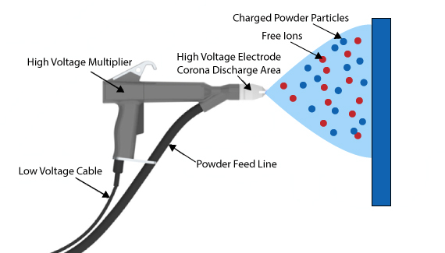
Figure 1; The functions of a corona spray gun. [10]
For application in the powder coating process a mixture of air is used that is needed for fluidization in the powdered source from the hose and in to the coating gun, from this supply a high voltage dc electrode can be provided in to the powder. The setting on the controls of the electrostatic sprayers can control density, shape, size and how much powder is used to coat a certain product. Coating film thickness is dependant of dwell time, preheat temperature and the chemistry of a powder. [10]

When both charges mutually attract with each other they create a “counter charge” because of a remained attractive force, the charge cannot discharge because of the powder being not electrically conductive. From an electrical conductor the discharge is created from free electrons of unimpeded discharge, high electrical field strength is needed and the only way to makes this achievable in the process. High voltage and a thin wire are required so there is a decreased wire thickness when the voltage is increased. [7] The powder particles and the free electrons contact and remain adhere, the free electrons seek for the shortest route which is towards the grounded part. The ionised powder particles are also attracted to grounded objects just like the free electrons. Instantly when the grounded part is in contact with the ionized particles of powder, the residual charge in the object remains adhered because the particles follow these field lines. [7]

Transfer efficiency is increased on a grounded object because of the combination of electric and aerodynamic forces that can be manipulated by the motion of charged powder particles which improve distribution in film thickness. [11]The next stage for the processed workpiece is curing. The part is automatically or manually conveyed in to the curing oven where different conditions are set for different types of material. [2] For example, organic powder is melted at 16-200 degrees in to a smooth film and then hardened, a much higher temperature is required for enamel powder because of its chemical characteristics. The condition set for organic could be due to it being used for a decorative purpose and the coating thickness is required to be 30-80microns. [7]

There are two types of guns used in electrostatic powder coating processes that can be used. [12] The corona which is shown in figure 1, which has already been discussed, and tribo- charging guns. There is often a decision that industries will have to choose out of the two options of coating processes from a spray gun that is available, a process will be mainly chosen if it is more applicable for their process of manufacture. [9]

Tribo-charging guns act differently to corona charged guns because they charge powder particles from the touching contact from the following separation of the powder particles in the gun wall. The imbalance of charge is eliminated because of the transfer of charge from one to another. Chemical and the electronic structure of these materials cause the factors of the charge direction transfer and magnitude dependence. [9]

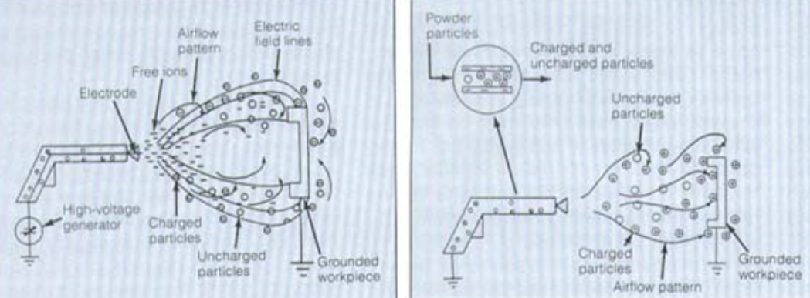
Figure 2; The difference between corona and tribo-charged. [9]

It can be noticed that there is no electro field created with tribo- charged particles but there is with corona. This is since the tribo-gun does not have a high electrode capacity which results in there being no electric field between the gun and certain work piece. To achieve a successful appliance coating of this process the air flow of the gun plays an important role for transportation of particles to a grounded part. [9]

Powder particles which are the composition of resin, fillers, pigment and more, contact the walls of the tribo- gun which is usually Polytetrafluoroethylene (PTFE) material, are used from the theoretical understandings in this studied field of this process. The accumulation of charged powder particles in polarity are opposite but are equal from the charge left in the gun walls, finishing powders will become positively charged from this contact with PTFE. A shock hazard is a risk with tribo-charging because of this potential charge build up inside the gun, so conduction is necessary in the process to take way that potential risk. [9]

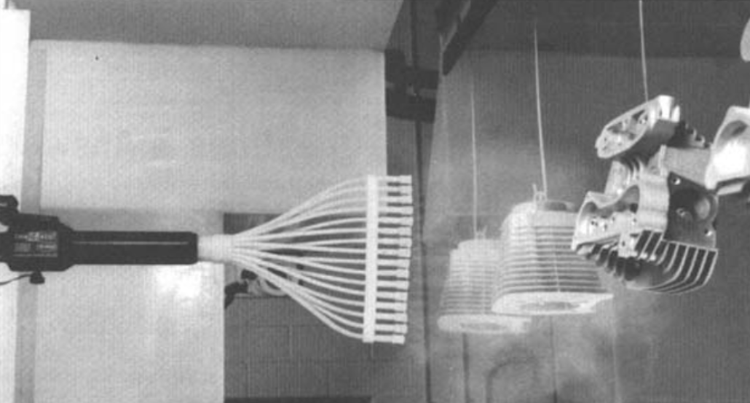
Figure 3. Advanced Tribo-gun. [9]
The image in Figure 3, shows a tribo-gun in process. The transfer to a work piece is decided by the contact of powder particles to the wall of the gun, more contact will result in a higher deliverance of powder coating on to that grounded work piece. [9]
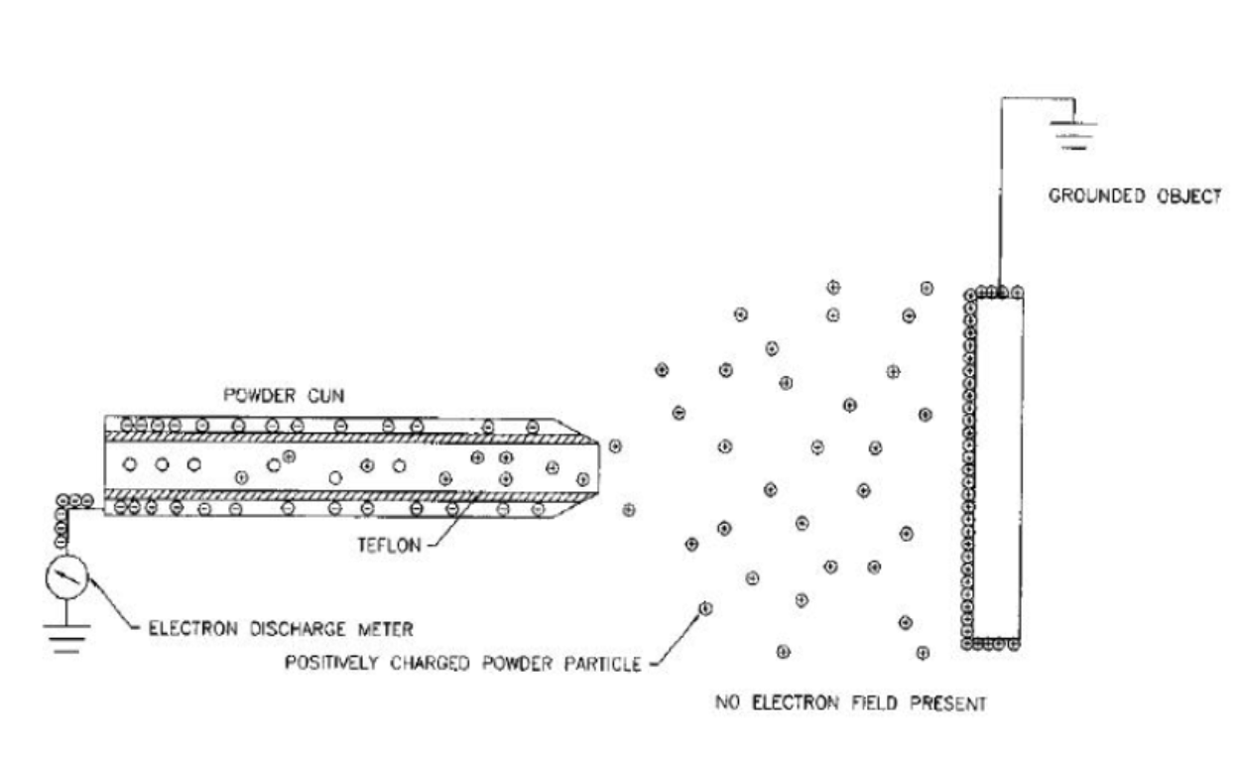
Figure 4; Better understanding of how particles are charged. [13]

The tribo-gun particles are charged by the contact of two different types of material. Teflon which is commonly used as a coating in the gun wall causes the electrons in a powder particle process to break off and contact causing the needed charge. This results in a net positive outcome because the particles leaving, have given up their electrons so that the positive charged powder particles can be transported to a part by air stream. The grounded part is the accumulated by powder particles that attach long enough for the film coating to cure and harden on the work piece. The electrons from the powder passing through the gun are removed by discharge and grounded by the Teflon material inside the gun. However, this process must happen quickly of disgracing the electrons to the ground so that tribo-electro gun process can effectively operate. [13]

There is a limitation of the use of tribo-electrostatics when being used to apply powder to a source. Teflon is typically used in a gun but for example positive charges in material such as Nylon have a strong positive charge so that would be acceptable, but PVC material has a weaker positive charge, so it means it would not be most suitable compare to Nylon. However there have been developments learned for the capability of tribo-coating powders with epoxy materials such as polyester and others that share similarities of material, appliance for an industrial purpose has shown success when used in tribo-electrostatic coating processes. [13]

Although the process of charging being corona or tribo-electrostatics of powder particles when being applied to a workpiece are different the fundamental principles still lay adjacent. Such as the properties of chemical composition, charging characteristics, resistivity of electrics, shape and particle size distribution all are accounted for. This is essential for the performance of a grounded part being applied and has significant effect on appearance, film thickness, transfer efficiency, fluidity and adhesion of the accomplishment of a part being coated successfully. [12]
An attractive adhesion force onto a metallic workpiece is formed from the operation of combined forces from a complex layer of electrostatically charged powder that combine particle/particle, chemical forces, particle/substrate Van der Waal’s adhesion force. These forces are impossible to isolate in a process. The powder is attracted to the workpiece from the derivation of the dominant force of adhesion which is the corresponding image force and the Coulombic electrostatic charge. [14]

It has been found from spray tests that different systems of spraying operations that when a specific charge (Q*) is <2~tC/g there tends to be higher adhesive characteristics, there is a reduction of the adhesion layer when the specific charge is >3.5laC/g. A combination of a bulk electrostatic attractive force, inter particle/ particle cohesion and an interracial electrochemical phenomenon at the surface, are the combination of effects that result in the total force holding a layer of electrostatically charged powder on a workpiece. [14]

3.1 Health and Safety; Fire Dust and Explosion Hazards

There have been many incidents that have caused fires and explosions when carrying out the electrostatic powder coating process of a material, and sometimes these ignition hazards get unnoticed by manufacturers because of not being fully understood. [4] [11] [15]

Experiments are carried out to determine what can cause these aluminous powders to explode. The MIE which means the maximum ignition energy must be considered and is seen as being very important to the safety standards (BSI,2001; IEC,1994). [4] [16][21]

In an experimental study it was found that there a lower risk of combustion with polymeric coating powders but a higher risk when applying aluminous coating powder due to the pigments being more sensitive [4]. An electro spark energy lower than 10mj could ignite an aluminous powder because of it being very sensitive. Micron size particle distribution in a powder D50(Mm) of when being applied to the same type of material and the consideration of the MIE, contributes to the potential hazard of combustion (fire/explosion). It has also been stated in the conclusion from the study that if the aluminous pigment concentration (mixing ratio) was greater than 6 wt.%, it could enhance the hazard of a spark energy 10mj with a certain condition. [4]. The equation to show the MIE’s dependence of the D50 when a same material can be calculated from this formula
MIE2 = MIE1 X (D2/D1) ^25. [4]

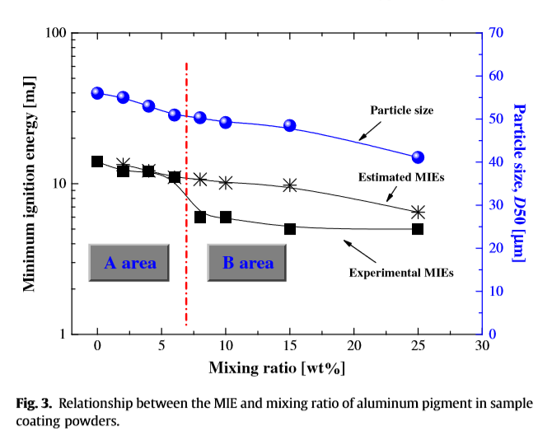

Figure 5; Graph shows the results from the experimental MIE’s Against the Estimated MIE’s. [4]

The experimental MIE’s matched the estimates of a mixing ratio of aluminous pigment lower than 6 (wt.%), because the lines of the graph show a linear trend in accuracy of ignition when at the same mixing ratio percentage. However, there were slight inaccuracies with comparison to the estimated MIE’s relationship with D50 values 50-40Mm after 6(wt.%) and up to 25(wt.%). [4]

It is understood from observation of the graph above from a personal perspective; if the D50 particle size shown in the estimated MIE’s is in a range of the D50 being 40Mm-55Mm and the mixing ratio 0-25%(wt.%), is that certain particle size of the D50 contributes to the factor of sensitivity to when the ratio is mixed with aluminous pigment thus creating spark energy at a level that creates the MIE. The larger particle size D50 of 55-55Mm and the lower mixing ratio of 0-10(wt.%) created a higher MIE, and a lower MIE when the particle size D50 was 40Mm and the mixing ratio was 25%. [4] If the D50 particle size of 40Mm was in the mixing ratio of 0-10(wt.%) there would be a lower MIE. This would mean that the D50 micron size of the aluminous powder used for manufacture would ideally have to have finer particle size distribution, but it is understood this could also be not suitable for a certain task. Coarser powder would risk ignition, if the grade was a lot finer for example the D50 being a size as low in the region of 5-10Mm, could then allow a larger mixing ratio of 0-100(wt.%) without creating electro spark MIE. [4] Though there might not be a need to have these conditions for manufacturing purposes.

In another experiment similar apparatus were used to carry out the test of the combustion of aluminous coating powders, but a different factor was studied. [16] There i extensive researches that are carried out for the detailed reports about spark ignition and MIE. The techniques that are employed usually require apparatus with two circular electrodes with flanges at the tips. The mixture is ignited because of the orientation of the flanges being parallel and a separation distance being greater than the quenching distance. [17]

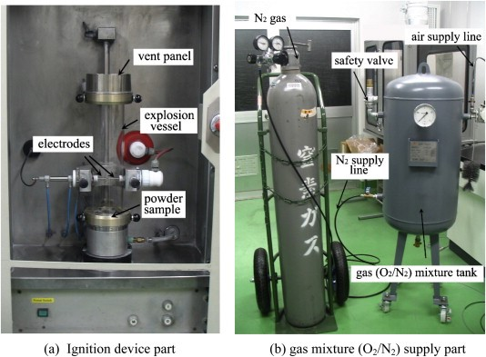

Figure 6; Apparatus used to carry out the experiment. [16]

Many manufactures already use nitrogen to discharge oxygen levels in a coating powder, but it was found that discharging could affect MIE energy and cause it to potentially reach a level of 1000mj if the concentration level of N2 was 90% and above in aluminous coatings. However, this is highly unlikely to reach this level in a manufacturing process. For polymeric there was not much effect due to the low sensitivity. [16]

This experiment also considered micron size distribution because of electrostatic dust particles (ESD), contributing to the electro spark energy of ignition from when applying the powder to a source. Information has been brought forward from this experiment and has been implemented in to the standard risk assessment of ESD when in a manufacturing process of this nature. Operatives now acknowledge another potential danger that could enhance combustion. [16] The electrostatic spark energy value of the discharge is calculated; W ¼ 0.5 C _ V2. This would mean W is the stored energy in joules(J), the total discharge capacitance in farads (F) is C, and the voltage capacitor in volts (V) is V. [16] [17]

There is an importance to better understand and control the electrostatic consequences because the associated charge generation mechanisms in manufacturing multifaceted processing systems are not fully understood. [15] Numerous processes such as sieving, pneumatic conveying, mixing and fluidization, can result in having dangerous impacts on tribo-charging of powders. The development of equipment laboratory-scaled, help allow proper measurement of tribo-electric charging of powders. [15] Although looking at the experiment in figure 5 was corona charging it could still be the factor on why the estimated MIE was out of sync with the actual MIE in experiment [4]

There is an influence of plastics on electrostatic hazards with the introduction of plastic components in to a metal system that could cause ignition from flammable vapours and dust clouds, and with plastics that are non-conductible. [18] [19] [20] This is because the material is readily electrostatically charged and can significantly retain the charge for periods of time. Anti-static additives can be incorporated to eliminate risks by making the plastics more conducting. When non-conducting plastics must be used for a process there are potential hazards such as an incentive discharge from the plastic surface, isolation of metal components from earth, and charge accumulation on a plastic surface that can lead to brush discharges propagation. [20]
Brush discharges occur when a nonconducting surface is approached by a rounded electrode. In space and time there is an extension of the discharge that only releases a fraction of the total charge on an object making it more vulnerable for ignition ability. A concept to overcome this problem is to introduce equivalent energy. The minimum ignition energy of a flammable atmosphere could ignite from the brush discharge, nonconducting materials can have multiple uses in industry such as storage vessels, gaskets, packaging, pipelines and more. [20] An indication from experiments with gases and vapours that there is a probability of ignition by discharges from flat surfaces and the gas vapour atmospheres of different MIE, and the equivalent energy of brush discharges in pipes. [20] [18]

Other discharges occur such as the corona discharges from the sharp edges on a conductor or in another incident from a conductor to a sharp point. In that gap the field is non-uniform which means it is not full ionised. However, because of this the density of energy is low so the ignition ability of the discharge would also be low. Discharges inside a dust cloud or from to an earth can create Lightning Discharges, but occurrence would be extremely unlikely with the use of industrial scaled equipment. [20]

Spark Discharges are created from the characteristics of being single channel and having high current density between two conductors that release all the stored energy from them. In industrial situations conductors are electrically analogue for the essential capacitance with resistance of leakage to earth. For a metal plant for example there would be reasonable estimates of risks obtained from ignition from the accumulation of charges on metal components on the structural systems of a processing plant. [20] [9] By using a capacitive circuit, you can determine by comparing the total energy on the conductor to the MIE of the ignitable atmosphere. Personnel could also be the source of high ignition of spark discharges such as the conductivity of footwear to floor and would mean that they would act as an electrical conductor, but there are long standings practices in a work place to control this type of hazard. [20]

The understandings of the phenomena of electrostatics play an ever emerging and important role in many industries not just for powder coating applications. There are xerography and pharmaceutical processing, which are all regarded a troublesome hazard source. Atmospheric conditions, area and frequency of contacts, surface purity, nature and work function of the contacting surface and the particulate material, particle size and shape are all factors that affect the charging properties. The handling of powder operations due to the collisions of different material type surfaces being particle to particle, particle to wall contacts, will often mostly lead to electrostatic charging of a product. Poor flowability, electrostatic discharge that can ignite flammable dust organic vapours or dust clouds, are all typical examples that can affect the behaviour of the quality of handled products from the acquired electrostatic charges. [15] This would mean extra care and awareness is needed for processing especially with aluminous coating powders because of the chemistry of the material being highly sensitive. [15] [16] [4]

The charging of the polymer particles influences the impact of behaviours of polymers on electrification, there are different charging mechanism between polymer to metal and for polymer to polymer. [19] During the contact of equipment and the particles from handling processes there is usually a charge transfer created between the particles and the wall surface from this rebounding and contacting deliverance. Electrification of particles is brought from this that can sometimes excite troublesome hazards being explosion from dust, or in some cases cause deposition or blockages to pipelines, and other hazards that can be created. Electrically charged powder is mostly effectively utilized today in modern processes of coating processes but it is still necessary to control these charged particles. [18]

3.2 Health and Safety; The Environment and Biological Health Effects to Humans

Several environmental advantages can be obtained in many applications with industries choosing electrostatic powder coating, with the major being there are no solvent emissions during the process and curing. This has seen an increase in interest over the years, when being compared to the conventional solvent or water based wet paints. [14] [3] Powder paints present larger advantages from an economic and ecological point of view over the conventional paints. In all automotive production manufacturing processes and any industrial finisher field, this process has replaced the solvent- borne paints because of the low emission from the powder paints being very finely solvent-free polymer coatings. Restrictions in European legislation set the trend for replacement because there was a concern for the volatile organic compounds (VOC) emissions [14], it is understood that conventual painting operations contribute directly to environmental emissions. [15] [11] [3]

Coating tablets which is an old pharmaceutical process that still is used today, is made possible by coating the surface of the tablet with the application of a polymeric or sugar coat. The advantage is the odour and taste masking, physical and chemical protection, the protection and control of the realise of the drug in the stomach. The disadvantages of the old technique have been overcome because coating materials can now be directly applied to a surface without the use of any solvent. This is another advantage from an economic and ecological point of view. [21]

Studies have been carried out with the effect of exposure of electrostatic field created from power lines that can have negative health risks to human or animal. It has been found that there is limited risk from exposure. However, there have been reports from the sensory of stimulation within a person through their skin and hair, there were effects to psychological responses, such as metabolic activity, blood parameters, protein synthesis, genetic information and metabolic activity. These cases were found to be caused by environments caused by electrostatic phenomena not being properly controlled such as being ozone, air ions or corona. [22] Power lines work from a higher voltage compared to corona spray gun systems so there is hardly any risk, but still if a person is subject to that environment for long periods of time on a daily bases and controls are not properly measured it could cause an effect in the long term to that operative health and wellbeing.

Exposure from working with powder coating can cause serious and life-threatening effects with person’s health if the health safety aspects in the process have not been properly addressed in certain operations. There could be causes of allergic reactions to the skin, irritations to the lungs, skin and eyes, some materials used in the coating powder process can also cause long term effects such as occupational asthma. Some curing agents can cause damage to genetic material and lead to impaired fertility or even cancer. [23] [24]

Prevention of skin contact and the avoidance of breathing in dust from airborne particles during operations in the process should always be avoided. Essential PPE should be worn by personnel such as the correct raspatory protective equipment and clothing such as gloves and overalls. [24] [23] A person should also wash their hands after working with coating powders and should also avoid eating or drinking during operations in the process. If an operative believes his health has been affected through this type of work, they should inform the company and seek medical advice. [23]

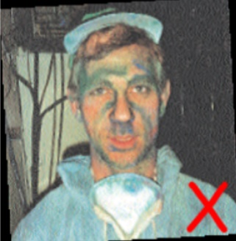
Figure 7; An operative’s face is covered with powder from activities being carried out in a coating process, this should never happen because of the potential dangers of effects to a person’s health that could occur from situations like this. [23]

In operations with the spay gun, following the standard working practices must be addressed and any damage or defects with equipment and ventilation should be reported. The unnecessarily increase of corona voltage must not be carried out because this could lead to more dust and stop the process working properly. Delivery rate of what is needed for a task should be kept and not increased because this can waste material and cause more dust, it does not add improvements to the finish of a part. [23]

For when cleaning spray booth ideally, it should be cleaned from standing outside by using equipment with long reachability. The ventilation system should be running, scrapers and vacuum cleaners should be used instead of brushing and compressed air usage should be minimum. [23]

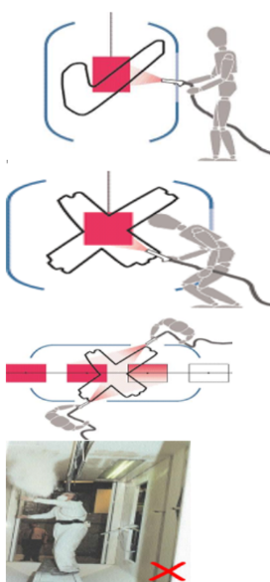
Figure 8; What is ideal for coating a grounded workpiece when spraying into a spray booth, and what is not acceptable. [23]

The images in figure 8, show the correct procedure of standing out of the both when spraying, and what should not be carried out in operations. Leaning in to the spray booth should be avoided, spraying operations should always be directed into the booth, standing between the extraction and workpiece should never occur and spraying towards work colleagues from opposite sides. When access is unavoidable such as for maintenance then suitable gloves, overalls and mask should be worn, also the ventilation and extraction system must be used. [23]

It is also noted that usually polymeric powder materials are safe to handle but a person should also take care when doing so because some do have health concerns when being exposed to over long periods of time. Powder materials should be kept in situatable conditions to prevent chemical reactions and should be kept away from direct exposure to moisture and sunlight. [8]

4. Conclusion

It is possible to understand why the electrostatic powder coating process is chosen as a manufacturing technique for finishing purposes in different industries, mainly because of the versatility of the process and what positively can be achieved when applied as a coating. Being easy to work with in systematic operations offers simplicity to the task for the appliance of coating a workpiece. Especially when there is not a need for any added support and blemishes or defects can simply be blown off and the process started again. It is seen as being a low-cost operation and although It is not entirely environmentally friendly, it can be in some respects when being used as a solvent free paint. For example, when used for coating tablets for pharmaceutical uses in the medical industry, and for paints in the finishing and automotive industries.

The two different electrostatic powder coating guns used in processes to charge powder particles are the corona charged and tribo-charged. Corona creates an electro field between the work piece and the gun that creates the attractive forces that is needed for charged particles to adhere towards a grounded part, whereas tribo- guns creates charged particles through friction of particles passing through the walls of the gun and the flow of air pushing them towards the grounded part. This is because the electrode capacity of the tribo-gun is significantly low compared to the corona gun, thus why there can not be an electric field created between the gun and workpiece. Although two processes are different many fundamental principles with the powder particles are the same such as Such as the properties of chemical composition, charging characteristics, resistivity of electrics, shape and particle size distribution. These all are important for performance of when applying coating to a grounded part, such as taking in to account of a part being coated successfully with appearance, film thickness, transfer efficiency, fluidity and adhesion.

There are some potential hazards that could occur in the electrostatic power coating process, such as ignition and fire. Many studies are carried out to prevent the minimum ignition of when coating powders to a source. The MIE is a very important considering a manufacturer need to apply to safety standards (BSI,2001 and IEC,1994) in their process. Although it is found that polymeric powders cause a lesser threat compared to aluminous powders with ignition hazards due to the electro sensitivity of the material, they still can cause a threat if not also treated with care in a certain workplace such as the hazardous discharges they can create. By observation of the findings from the experiments of ignitability Figure 5 and Figure 6, it is found that even if the spark energy was as low as 10mj and a certain sized particle size distribution of when being applied to the same material, there would be even more of a risk that could cause fire/explosion if the contents of N2 was of 90%>, and even more if there was a high exposure of ESD in the process. Although many industries use N2 because it is an inert gas and used to reduce 02 levels, it has been found that this could exhibit more of a hazard if it were a concentration level of 90%>.

From these experiments discussed it is determined that both polymeric powders did not react because of being low in sensitivity, aluminous powder being very high in sensitivity reacted in both. Extra awareness of danger must be addressed with a possibility of having added techniques and systems in the manufacturing processes of Aluminous powders. Because of the difference of react ability, there is a need to adhere with different practices with using aluminous costing powders. with polymeric coating powders in comparison there would not be a need because of the process being a lower risk.

Another personal conclusion from the findings understood in these experiments, is that a high Nitrogen content of 90% could create an electro spark energy of a MIE 1000mj but this high ignition energy is created with the inclusion of the powder particle size ESD levels. It is believed that particle size D50 would have to be of a much larger scale than usual for there to be a significant reaction for when mixed in a certain aluminous pigment ratio, coarse powder would not create much of a dust cloud compared to finer grade powder particles. This would mean that if there was a high nitrogen content used in a process and even if the aluminous coating powder used was a fine grade D50 of 5-10Mm to minimise MIE, there still could be potential for an explosion with a very high energy that could be catastrophic. This could occur in certain industries, if there was a high ESD created in their process. However, these conditions are highly unlikely to reach these levels in manufacturing processes. But there is a need for this phenomenon to be addressed, because even if the risk is very low there still is potential that needs to be understood to counteract the hazard.

There are influences of electrostatic hazards when using plastic material in a process, such as ignition from vapour and dust clouds and even with the fact that plastics are noncontactable there are still potential hazards from discharges such as spark, brush and corona. Usually a method to overcome these issues is anti-static additives that can be incorporated to eliminate risks by making the plastics more conducting. There is even discharges inside a dust cloud or from to an earth can create lightning discharges, but this is highly unlikely to occur with in industries.
Atmospheric conditions, area and frequency of contacts, surface purity, nature and work function of the contacting surface and the particulate material, particle size and shape are all factors that affect the charging properties. It is also understood that charging of the polymer particles influences the impact of behaviours of polymers on electrification, there are different charging mechanism between polymer to metal and for polymer to polymer. Handling processes can create a charge transfer from between the particles and wall surface that is delivered from rebound and contact from equipment and the particles. This could then bring on electrification of particles that could then create a troublesome hazard such as an explosion from dust. However, in modern era these processes are effectively controlled.

The creation of dust is the catalyst for most of the potential hazards that could occur in an electrostatic powder coating process and is understood that micron size distribution of the powdered material would play a factor on how much would be created in a process. Also, the cloud created by the dust particles can react with other hazardous sources that can lead to potential ignition. Not only can it create a danger in an industrial manufacturing process, it can also affect a person’s health with it being immediate such as skin allergies or long term such as occupational asthma. To prevent this from happening a person must always protect themselves from exposure with the aid of the corrective PPE being worn that is applicable to this type of manufacturing nature.
A person should be fully aware of potential dangers when carrying out tasks in this industry.
Standard working procedures must be addressed at all time when carrying out operations, such as when handling materials and applying a material to a source. There is need for controlling risks with it being keeping materials stored in suitable places and using different extraction methods to minimise dust exposures. There are substances hazardous to health in different materials used in this process which also must be controlled to eliminate risk to a person’s health.

5. Recommendations

A recommendation from the experiment discussed from “The Experimental study on ignitability of pure aluminium powders due to electrostatic discharges and Nitrogen's effect” Figure 6, is that because of the high potential risk of spark ignition due to sensitivity, it could be better for manufactures to look at an alternative solution of using a different inert gas type to try and counter act the potential MIE of when used to discharge oxygen levels in a aluminous coating powder. Although it could be a case that many already do. Argon is completely inert and does not readily react with other substances, mainly because being a noble gas means it has full outer shell electrons that are tightly held together and will share with other compounds. Because of this it is considered as a good choice when wanting to blanket the sensitivity of certain chemicals. [25] This blanketing effect on applications is better accomplished with Argon than Nitrogen because the density is 40% heavier per cubic foot and will not readily diffuse with air because it tends to sit on top of a liquid column. Though, this could be costlier to use Argon in a process instead of Nitrogen because of the abundance of the two gasses, Nitrogen makes up 79.1% of our atmosphere whereas Argon makes up only 0.9%. It is easy to see why Nitrogen is the preferred choice. [25].

Another Recommendation would be to reduce the contact of human influences when carrying out processes in an operation for electrostatic powder coatings. From the understanding of the potential health effects that could be brought on from activities being carried out by a person in a manufacturing process, it could be better to look at other alternatives where a person does not need to get close to exposures of dust and vapour created in the system. Surely currently there can be a system where a coating gun can be controlled by personnel from inside a separate enclosed booth, that would still enable them to control the movement and spray from a gun from the control panel inside the booth. [26] This would reduce exposure to dangerous dusts and vapours, which promotes a healthier work place environment for an operative.

6. Works Cited

[1] | Q. Ye, T. Steigleder, A. Scheibe and J. Dominick, “Numerical simulation of the electrostatic powder coating process with a corona spray gun,” Journal of Electrostatics, vol. 54, no. 22, pp. 189-205, 2002.
[2] | “What Is The Powder Coating Process,” Electro Powder Coating Tech, 2018. [Online]. Available: http://electrotechcoatings.com/powder-coating/. [Accessed 08 11 2018].
[3] | M. Qiao, Y. Luo, L. Zhang, Y. Ma, T. S. Stephenson and J. Zhu, “Sustained release coating of tablets with Eudragit® RS/RL using a novel electrostatic dry powder coating process,” International Journal of Pharmaceutics, vol. 399, no. 1-2, pp. 37-43, 2010.
[4] | K. Choi, N. Sakurai, K. Yanagida and H. Itou, “Ignitability of aluminous coating powders due to electrostatic spark,” Journal of Loss Prevention in the Process Industries, vol. 23, no. 1, pp. 183-185, 2010.
[5] | “What is Powder Coating,” Powder Coating Institute, 2016. [Online]. Available: powdercoating.org. [Accessed 27 October 2018].
[6] | “Powder Coating (Electrostatic),” Plastic Coating Solutions UK, 2017. [Online]. Available: https://www.plasticcoatings.co.uk/. [Accessed 27 October 2018].
[7] | “The Electrostatic Powder Coating,” ITWGEMA, 2018. [Online]. Available: http://www.sfeg.co.uk/sites/default/files/What%20is%20powder%20coating.pdf. [Accessed 08 11 2018].
[8] | I. Gibson, D. W. Rosen and B. Srucker, “Additive Manufacturing Technologies,” in Rapid Prototyping to Direct Digital Manufacturing, New York, Springer, 2010, pp. 48-53.
[9] | Knobbe, J A, “Tribo or Corona?, Here's How to Decide,” 2008. [Online]. Available: http://norsdon.com. [Accessed 21 11 2018].
[10] | “About the Powder Coating Process,” Ontorio Coatings, 2015. [Online]. Available: http://ontariocoatings.com/powder-coating-what-it-is.html. [Accessed 09 11 2018].
[11] | Q. Ye and J. Domnick, “On the simulation of space charge in electrostatic powder coating with a corona spray gun,” Powder Technology, Vols. 135-136, no. Elsevier, pp. 250-260, 2003.
[12] | M. K. Mazumder, D. L. Wankum, R. A. Sims, J. R. Mountain, H. Chen, P. Pettit and T. Chaser, “Influence of powder properties on the performance of electrostatic coating process,” Journal of Electrostatics, Vols. 40-41, pp. 369-374, 1997.
[13] | M. J. Thies, “Tribo Charging Method, How it Works,” Jinhu Color Powder Coating Co. LTD, 2018. [Online]. Available: https://www.chinapowdercoating.com/tribo-charging-method-how-it-works/. [Accessed 22 November 2018].
[14] | H. Strtzei, H. J. Schmidt, D. Auerbach, B. Makin, K. Dastoori and H. Bauch, “Adhesion Measurements for Electrostatic Powder Coatings,” Journal of Electrostatic, Vols. 40-41, pp. 253-258, 1997.
[15] | K. Biller, “Electrostatic Properties of Powder Coatings,” Focus on Powder Coatings, pp. 3-5, April 2010.
[16] | K. Choi, H. Sakasai and K. Nishimura, “Experimental study on ignitability of pure aluminum powders due to electrostatic discharges and Nitrogen's effect,” Journal of Loss Prevention in the Process Industries, vol. 35, pp. 232-235, 2015.
[17] | I. Glassman and R. A. Yetter, “Combustion,” in Fourth Edition, London , Elsevier, 2008, pp. 396-401.
[18] | A. Ema, D. Yasuda, K. Tanoue and H. Masuda, “Tribo-charge and rebound characteristics of particles impact on inclined or rotating metal target,” Powder Technology, Vols. 135-136, pp. 2-13, 2003.
[19] | M. Yoshida, A. Shimosaka, Y. Shirakawa, J. Hidaka, T. Matsuyama and H. Yamamoto, “Estimation of electrostatic charge distribution of flowing toner particles in contact with metals,” Powder Technology , Vols. 135-136, pp. 23-24, 2003.
[20] | N. Gibson, “Static electricity — an industrial hazard under control?,” Journal of Electrostatics, Vols. 40-41, pp. 21-30, 1997.
[21] | A. Basu, A. De and S. Dey, “Techniques of Tablet Coatings: Concepts and Avancements: A Comprehensive Review,” Research and Reviews: Journal of Pharmacy and Pharmaceutical Sciences, vol. 2, no. 4, pp. 1-6, 2003.
[22] | K. Shmiedehen, D. Studer, D. Dechent, T. Kraus, H. W. Baily and S. Driessen, “Biological effects of exposure to static electric fields in humans and vertebrates: a systematic review,” Environmental Health, 17 April 2017.
[23] | HSE, “Working with coating powders - employees,” Health and Safety Executive, [Online]. Available: http://www.hse.gov.uk/surfaceengineering/working-with-coating-powders-employees.htm. [Accessed 22 11 2018].
[24] | World Health Organisation, “Hazard prevention and Control in the Work Environment: Airborne Dust,” 1999. [Online]. Available: https://www.who.int/occupational_health/publications/airdust/en/. [Accessed 22 11 2018].
[25] | D. Cannaughton and J. Fiorello, “Argon or Nitrogen: Which is Best for your Application,” 2016. [Online]. Available: http://blog.parker.com/argon-or-nitrogen-which-is-best-for-your-application. [Accessed 22 11 2018].
[26] | “Compact, Easy-to-Use AutoJet Spray System Provides Basic Control of Automatic Nozzles,” Spray Systems Co., 2018. [Online]. Available: https://www.uk.spray.com/automated_systems/1550.aspx. [Accessed 23 11 2018].

