


Asset Management

HNC Process Operations Engineering Year 1

Lecturer: Kadi Berry

Student Name: Connor Hay

Student Number: 2223689

Abstract
In the first section of the following report, one of the most important processes at Pembroke Refinery is highlighted. Distillation is a process where crude oil is broken down into bottoms and tops product and exited through different trays, creating different products. Methods of distillation are explained and how they can be applied with different types of equipment. The distillation unit at Pembroke Refinery has different tray sections, towers and fractionators which are essential components of the process, all of which have been explained and how they all tie in to make the process unit an essential part of Pembroke Refinery. The daily operation of the distillation unit can impact the rest of the process units on the refinery, so it is essential that this is performed correctly. This report includes how the daily operation is performed and what variables are controlled to achieve certain outcomes.

In the second section of the following report, one aspect of waste segregation and recycling at Pembroke Refinery is included. The aspect that is reported on is the wastewater treatment plant. The wastewater treatment plant is where all water from Pembroke Refinery ends up. The purpose of the wastewater treatment plant is to ensure that the water is clean enough to be disposed of either to Milford Haven or back into the refinery’s processes. The requirements of the wastewater treatment plants are highlighted, along with the different steps that are performed to allow the wastewater treatment plant to meet this specification. In the latter of the second section of the report, it is concluded. The conclusion entails why each part of the report is important to the relative scenario and why they are both important to each stage of the refining process at Pembroke Refinery.
Table of Contents
Abstract 2
Table of Figures 4
Acronyms 5
Task 1 6
Distillation at Pembroke Refinery 6
Introduction to distillation 6
Methods of distillation 6
Distillation towers and fractionators 8
Strippers and stripper towers 9
Rectification section 10
Operation of a distillation tower 10
Methods employed to reduce energy losses within the process 11
Applying heat pumping distillation systems 11
Vapour recompression systems 11
Evaluation and conclusion on how improvements to the process for energy recovery and meeting local and global regulations and standards 12
Task 2 13
Wastewater Treatment Plant at Pembroke Refinery 13
Process Fundamentals of the Wastewater treatment plant 14
Separation process 15
Biological treatment 15
Surface water and raw influent 15
Conclusion 16
References 17

Table of Figures
Figure 1 - separation of crude oil 7
Figure 2 - batch distillation 8
Figure 3 - continuous distillation in a two still setup. 9
Figure 4 - a distillation and fractionation tower 9
Figure 5 - strippers added to a fractionator. 10
Figure 6 - rectification section of a distillation column. 11
Figure 7 - anticipated influent flow and composition of the wastewater treatment plant. 14
Figure 8 - conditions for the discharge to Milford Haven. 14

Acronyms
DAF – Dissolved Air Flotation.
BOD – Biological Oxygen Demand.
Cu – Copper.
Ni – Nickel.
Zn – Zinc.
HSE – Health and Safety Executive.

Task 1

Distillation at Pembroke Refinery

Introduction to distillation
Distillation units are used on oil refineries as the base process for refining crude oil by creating separation of multiple hydrocarbon molecules that are in crude oil and turning them into raw products. The raw products are then further refined into more marketable products. Separation of a liquids components is performed by using their boiling point temperature, which correlates to the relative density of a component. When a hydrocarbon mixture boils, the lighter components begin to vaporize. Light hydrocarbons vaporize quickly and the heavier hydrocarbons vaporize slower, creating a separation between the light end products and heavy end products. The three most common methods of distillation on oil refineries are batch distillation, continuous distillation and fractional distillation. (Green, 2019)
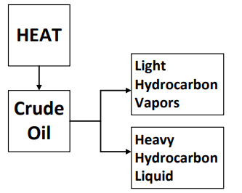
Figure 1 - separation of crude oil

Methods of distillation
Batch distillation is the oldest form of distillation for petroleum products and it gets its name because it only distils one batch at a time. A batch of hydrocarbons are fed into a still vessel where the still is heated to bring the mixture to a boil. Lighter components vaporise to the top and go through a vapor line and pass through the condenser. In the condenser, light components are cooled and condensed into a liquid and collected in a receiver as product. The remaining liquid is usually heavy portions of the feed and this is cooled and then drained. Batch distillation units are still used in many processes for chemical and pharmaceutical applications, but are not as prevalent in refineries any more as they are deemed inefficient because it takes so long. (Batch distillation process, 2020)
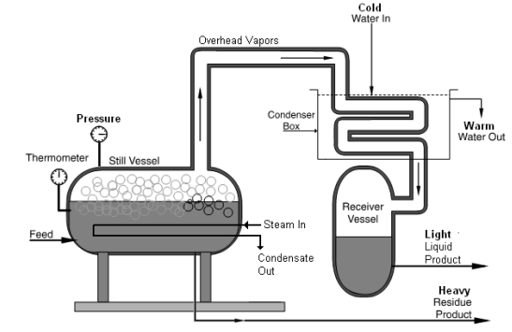
Figure 2 - batch distillation

Continuous distillation operates with a continuous feed which conserves heat and saves time. This distillation type improves product purity. In operation, continuous distillation uses a series of stills that are connected to each other. The first still is charged with a constant feed rate. As vapours rise overhead, they are collected and condensed. The bottom residue is collected from the first still and refed to the start of the process as a continuous cycle. (Difference between batch and vs continuous distillation, 2018)
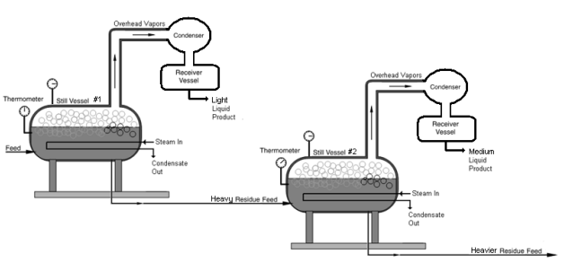
Figure 3 - continuous distillation in a two still setup.

Distillation towers and fractionators
Both distillation towers and fractionators apply the method of continuous separation of a mixture containing different boiling points. A distillation tower separates a mixture into two products where the separation results in overhead product and a bottoms product. Usually one and sometimes both products are distilled to a high purity. A fractionator separates a feed into multiple products in a single step. Products are taken from the tower as overhead vapours, liquids, from side draws and also as a liquid from the bottom of the tower. The purity of the separation is not as high from a fractionator as it is from a distillation tower. (Ibrahim, 2014)
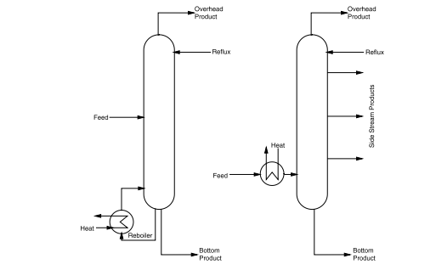
Figure 4 - a distillation and fractionation tower

Strippers and stripper towers
A stripper tower is a type of two-component distillation tower. They are used to purify the side-draw products from a fractionator by means of removing the light components from the drawn fraction. This method is performed because most side drawn fractions are contaminated with lighter hydrocarbons. The stripper has a steam distributor that is in situ beneath the bottom tray which injects steam into a mixture causing the hydrocarbons to vaporise. Steam is used to lower the partial pressure of the mixture. When the mixture has a lower partial pressure, the mixture boils at a lower temperature allowing the lighter molecules to boil out.
When strippers are added to a fractionator, each side draw product is routed to a stripper to remove the light products. The light vapours that are stripper then return to the fractionator just above the tray that they are taken from. The heavy bottoms product leaves the stripper as a purified product. (Distillation, 2019)
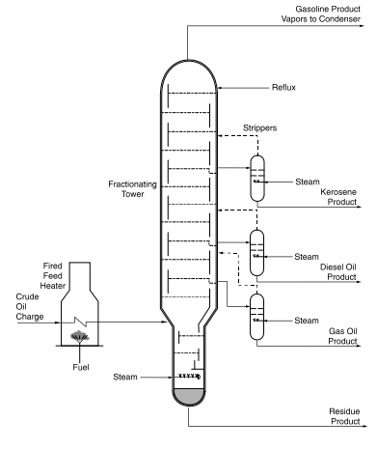
Figure 5 - strippers added to a fractionator.

Rectification section
The rectification section is the section above the feed tray. The purpose of a rectification section is to purify the overheads product. When the mixed vapours travel through feed trays to the top of the tower, heavier components condense in the upper trays. The components in the upper trays descend, returning to the feed tray again. This process purifies the vapour from the overhead product. (E & R, 2019)
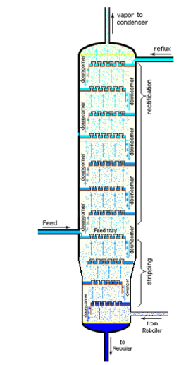
Figure 6 - rectification section of a distillation column.

Operation of a distillation tower
When a distillation tower is in operation, process variables are adjusted to ensure the product meets specification. During start-up and shutdown activities, the majority of the tower’s variables are controlled by the panel operator. Feed flow is kept at a specific feed rate which may vary depending on upstream or downstream conditions. The reflux flow is set to maintain the temperature desired at the top of the tower. The level at the bottom of the tower is controlled by adjusting the flow of product leaving the system. The overhead receiver level is maintained by adjusting the flow of overhead product leaving the system and quantity of reflux sent back to the tower. The atmospheric pressure of the tower is maintained by adjusting the flow of non-condensable gases venting from the overhead receiver. Reboiler vapour temperature is maintained by changing the flow of steam to the reboiler, which changes the quality of products. Tray temperature is the most sensitive control point of the distillation tower and has the greatest change in composition per increment of temperature change. Lastly, the product quality is controlled by regulating the reflux flow rate or temperature of the reboiler vapours. When temperature of the reboiler vapour is increased, light components leave the bottoms product. When the reflux is increased, heavy components leave the overhead product. Tests such as purity, gravity, colour, initial boiling point, flash point and end point are performed to ensure the specification of the product. (S, 2007)

Methods employed to reduce energy losses within the process

Applying heat pumping distillation systems
Heat pumps require external driving thermal energy to remove the heat from a low temperature source and transform it to a higher level. Conventional heat pumps are vapour recompression types which are electrically driven, they work on a principle where a liquid would boil at a higher temperature if the pressure is increased. Heat pump cycles may be added to a distillation column in three ways. The easiest method to adapt this method is to replace steam and cooling water with a refrigerant. The alternative two methods apply column fluids as a refrigerant. If the distillate is a good refrigerant then the vapour compression can be used and if the bottom product is a good refrigerant then the bottom flashing can be applied. (Heat Pump Distillation, 2023)

Vapour recompression systems
Vapor recompression systems require a compressor to increase the energy level of a vapour that is condensed in a reboiler-condenser by means of exchanging the heat with the bottoms. The condensate distillate passes into a reflux drum whilst the bottom product is vaporised into the column. Vapour recompression can be explained as taking the overhead vapour of the column, condensing it into a liquid and using the heat generated by the condensation to reboil the bottoms liquid from the very same column. To allow heat to flow from the cooler overhead vapours to the hotter bottom’s product liquid, the overhead vapour would need to be compressed so that it becomes condensed at a higher temperature. It could also be achieved by lowering the pressure of the reboiled liquid so it boils at a lower temperature, allowing the bottoms vapour to be compressed back to the column pressure. An advantage of vapour compression is that it has the ability to move large amounts of heat between the condenser and reboiler of the column with a small input. The temperature and pressure at any point may be set to achieve maximum separation, this effect is of high importance because changing pressure will change the volatility of the process. (Mechanical Vapour Recompression, 2022)

Evaluation and conclusion on how improvements to the process for energy recovery and meeting local and global regulations and standards

The two methods that have been explained, ‘vapour recompression systems’ and ‘applying heat pumping distillation systems’ would both improve energy recovery for this process. However, they both prove to be costly for the company. Heat pumping distillation systems would be less to initially install, but would cost more to maintain over time. These maintenance costs would be for planning job scopes, employment costs and part costs. Vapour recompression systems would be expensive to initial install as it would require new pipework, new vessels, new drawings, etc. After installation, vapour recompression systems would essentially run themselves, with minimal maintenance, other than unexpected failures.
The benefits that heat pumping distillation systems would offer for energy recovery are that the heat source would not have to be a new one as it is generated from the distillation process, it just simply transfers it to a higher source. This would be beneficial for less energy loss as the temperature and pressure generated from the initial breaking of crude would not be wasted, it would be used and applied and re-used for further separation of crude oil. The benefits of using vapour recompression systems in this application is that the overhead vapour from the column that would more than likely would be wasted, would be re-used for the bottom product, which would heat up the bottom product and making it a top product. Top products are more lucrative for the company, so creating more of these would be generating more income for the business. As well as being more efficient, it would also prevent vapour loss as it circulates back into the process, meaning less energy loss.
When it comes to meeting local and global requirements and standards, Pembroke Refinery have constraints as to how much product they can send to flare and the amount of waste that can be put through the stack. The product that goes through both flare and stack deemed to harm the environment, so the less that Pembroke Refinery send through both will help improve efficiency rating and limit the number of unnecessary fines that the company will have. The reason both methods would help to meet local and global requirements and standards is that they both prevent energy loss. Vapour recompression would help to meet all standards and requirements because it helps limit the amount of waste bottoms product, which is what typically gets sent to flare, so the more that this bottoms product is wasted will also limit the amount of unnecessary flaring. Heat pumping distillation systems could also help the amount of waste because it is not sourcing a new heat source, it is simply reusing an already present source. When this heat source is maximised, flaring and stack waste will be lowered. It is important that flaring and stack waste is minimised as it allows Pembroke Refinery to continue operation and if either method are applied to the distillation process, then it will result in the limitation of flaring and stack waste.

Task 2

Wastewater Treatment Plant at Pembroke Refinery
The main reason why waste water treatment plants are used is to allow the water to be cleaned of toxins such as oil, solid and liquids that are contaminated in water systems during the refinery’s processes. Once cleaned, the water is allowed to be disposed of or reused for process. Most refineries use around 2.5 gallons of water for every gallon of crude oil that is processed. Depending on the quality and type of crude oil, will affect how the characteristics are broken down in the plant. The operation and design of a refineries wastewater treatment plant are challenging and driven by multiple pieces of equipment.

Process Fundamentals of the Wastewater treatment plant
The design of the wastewater treatment plant is based upon the following anticipated influent flow and composition:
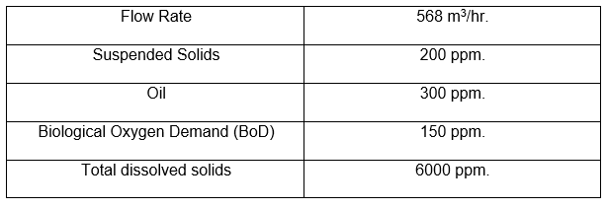
Figure 7 - anticipated influent flow and composition of the wastewater treatment plant.
With the above flows, composition and local conditions, the wastewater treatment plant will deliver effluent to the outfall into the Milford Haven, the conditions of discharging into the Milford Haven waterway, which must be strictly adhered to are as follows:

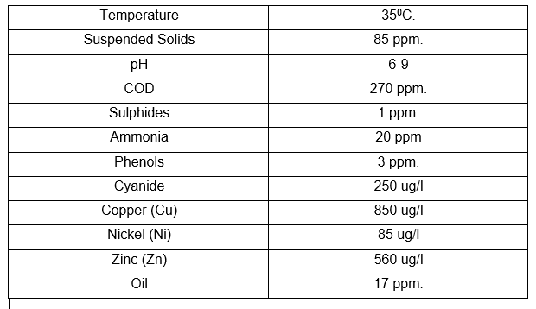
Figure 8 - conditions for the discharge to Milford Haven.
Wastewater streams in Pembroke refinery
A vast volume of water is applied to refining processes, in applications for cooling systems, desalting and fractionation. Water also comes from tank drains, equipment flushing, sanitary and surface water runoffs. Refinery wastewater treatment plants include an initial primary treatment such as water and oil separation, a clarifier to remove solids, a secondary to remove organic particles, metals and other contaminants and lastly tertiary treatment for polishing before discharge into environmental resources, in Pembroke Refinery’s case, the haven.

Separation process
Traditionally, oil and water separation are the first and most important wastewater treatment steps in the process. The removal of oils and greases from the refinery’s wastewater streams reduces overloading equipment and potential process issues. Separators are used for tank washes, ballast water, desalter waste and wastewater runoff. Further processes for additional removal of suspended solids typically follow. The three most commonly used processes for solid and liquid separation are flotation, filtration and gravity sedimentation. Prior to separation of solid and liquid, chemical pre-treatment is typically required to boost efficiency.

Biological treatment
Biological wastewater treatment is essentially used to remove organic compounds that come from petrochemical refinery processes. This process can either be aerobic or anaerobic, with the most common being aerobic. Aerobic treatment is used at Pembroke Refinery, this includes trickling filters, aerated lagoons, oxidation basins and packaged tanks. Jet aeration offers high oxygen transfer efficiency that can be applied to mixing characteristics in a wide variety of refinery wastewater streams.

Surface water and raw influent
To remove large pieces of solid matter that could potentially damage or restrict further processing operations or equipment, screening equipment is used. Examples of coarse screening devices are perforated plates, wedge wire, wire mesh or parallel bars. Rotating drum screens are a cost-effective method for stripping debris or bulky components from the surface water. Rotating drum screens are usually followed by DAF, clarifier or filters for further process treatment. (Development, 2023)

Conclusion
In conclusion, two improvements for the prevention of energy loss in the distillation process at Pembroke Refinery have been highlighted and explained how they can help limit energy loss for the refinery. Both methods have reasonable justification for meeting the criteria for local and global requirements and standards. Not only do they pose greater efficiency for the refinery, they also provide positive financial outcomes for the refinery too. Also, segregation and recycling of wastewater streams at Pembroke Refinery have been explained and how all water that goes through the plant must meet local requirements prior to going to Milford Haven. The wastewater treatment plant is a critical part of Pembroke Refinery meeting environmental requirements set by the HSE.

References
Batch distillation process. (2020, May 22). Retrieved from Chemical Engineering World: https://chemicalengineeringworld.com/batch-distillation-process/
Development, V. P. (2023, April 15). Wastewater Treatment Plant Manual. Pembroke.
Difference between batch and vs continuous distillation. (2018, April 12). Retrieved from Difference between: https://www.differencebetween.com/difference-between-batch-and-vs-continuous-distillation/
Distillation. (2019). Retrieved from Science Direct: https://www.sciencedirect.com/topics/earth-and-planetary-sciences/distillation
E, M., & R, M. (2019). Separation and Purification Technology. In M. E, & M. R, Separation and Purification Technology (pp. 49-54). Retrieved from Science Direct.
Green, J. D. (2019). Distillation. Encyclopedia of Analytical Science, 214-219.
Heat Pump Distillation. (2023, April 03). Retrieved from chem eng help: https://www.chemengghelp.com/heat-pump-distillation/
Ibrahim, H. (2014, September 8th). Desgin of Fractionation Columns. Retrieved from Intech Open: https://www.intechopen.com/chapters/45966
Mechanical Vapour Recompression. (2022, October 19). Retrieved from Howden: https://www.howden.com/en-gb/industries/industrial/mechanical-vapour-recompression-mvr
S, S. (2007). Chemical Engineering Research and Design. In S. S, Chemical Engineering Research and Design (pp. 13-23).

