Line Rosenskiold (P151225)

Digital Marketing

Increased digital marketing budget for swansea business school
As the Digital Marketing Executive for the University of Wales Trinity Saint David´s School of Business, this briefing paper aims to get an increased budget to support the digital marketing activities to the university. It will discuss the benefits of using digital marketing as a part of the school of business’s marketing strategy. In addition to this, it will look at changes in online customer behaviour and how it can be beneficial to Swansea Business School.

UWTSD Background
Swansea Business School is a separate faculty of the University of Wales Trinity Saint David. The business school offers a wide range of courses which are designed in order to make graduating students attractive when entering the permanent job market (UWTSD, 2018). Swansea Business School is currently using digital marketing platforms such as Instagram, Facebook and Twitter. According to their social media channels, they are seen to be posting between two and four pictures on Instagram every month. They are however, seen to be even more active on Twitter, and less active on Facebook.

Analysis
Traditional marketing methods such as television, printing leaflets and brochures is still seen as an effective marketing method. However, it can possibly be very time-consuming resulting in organisations using digital platforms in order to market themselves (Cave, 2016). Using digital marketing is argued to be the best way to target your ideal buyers. The business school can use social media advertising to target the audience who is seen to be most likely to have an interest in their service based on demographic information (Standberry, 2017). Digital marketing is also argued to be brand building platforms as it presents opportunities to promote and communicate its brand image (Raman, 2015).
According to Mander (2017) an average person spends two hours on social media per day. This has resulted in changes in customer behaviour as the customers now have the ability to both build and destroy brands due to the customer having the opportunity to write both good and bad reviews of a product or service (Mander, 2017)
Badenhorst (2015) also reported that the majority of customers do not compare brands with their direct competitor, but to all brands they consume.
It can be argued that the two mentioned consumer behaviour changes can have an effect on Swansea Business School as their consumers are able to post both negative and positive feedback on social media pages for possible future students to see. As customers are comparing brands with not only its competitors, this could result in a greater competition between the different universities across the UK.

Recommended actions
It can be argued that Swansea Business School will benefit hugely by combining traditional marketing methods with digital marketing. It is therefore recommended that Swansea Business School increase their marketing budget in order to support any digital marketing activities.

Table of Contents
1.0 Introduction 4
1.1 Aims and Objectives 4
2.0 Context Analysis 4
2.1 Business Context 4
2.2 Customer Context 5
3.0 SWOT Analysis 5
4.0 Digital Marketing Mix 6
4.1 Strategy and Tactics 8
5.0 Timescales and Budget 9
6.0 Performance Measures 10
7.0 Conclusion 11
8.0 Recommendations 11
9.0 Bibliography 13

1.0 Introduction
This report will focus on providing University of Wales Trinity Saint David with a communication plan in order to enhance their digital marketing strategies. Strategic recommendations on what the researcher thinks is necessary in order to improve will be developed throughout this plan with a comprehensive list of necessary measures.

1.1 Aims and Objectives
The aim of this digital marketing communication plan is to find ways University of Wales Trinity Saint David can promote themselves and be more productive on social media.
The objectives are summarised as;
- To investigate context analysis in order to find communication drivers that are more likely to influence the social media presence of UWTSD
- To analyse effective integration and how this can be achieved
- To present budget and implementation plan that will be deemed the most effective

Context Analysis
Fill (1999:199) defined contextual analysis as “the purpose of compiling a context analysis is to determine and understand the key (business) marketing and communication drivers which are likely to influence (or are already influencing) a brand (or organisation) and either help or hinder its progress towards meeting its long-term objectives”.
It can be argued that communication is one of the main marketing approaches used by universities to reach their target audience. This includes producing brochures, leaflets, having an updated website as well as using other social media platforms. Using these approaches will help the university in building a strong reputation. However, due to a fast-moving global market, it can be argued that the university could benefit from developing a more disciplined and strategic approach appropriate to the university.

Business Context
The brand of an organisation is often defined by the interactions the customers have with it, according to Greatrix (2011). Higher education and universities are slightly different from other businesses as it usually involves a one-off transaction. This means that there are few opportunities for repeat purchase of the same service. Another factor that distinguishes universities from other types of businesses is that the purchaser has little or no knowledge of the product on beforehand, which means that the customer is unable to test the product or service before purchasing it (Greatrix, 2011)

Customer Context
Customer context involves to fully understand who the organisations customers are and their motivation. It is often defined by highlighting segments of customers who are involved with your business (Vascellari, 2018). It is often It can be argued that the audiences of University of Wales Trinity Saint David are not only potential and existing students, but also 6th form tutors, career officers, employees and the local community.

3.0 SWOT Analysis
Professional Academy (2018) stated that a SWOT analysis is argued to be a helpful tool when analysing internal and external factors.
The researcher has therefore done a SWOT analysis of the UWTSD in order to gain a better understanding of their current strengths and weaknesses. Doing this analysis has also enabled the researcher in looking at their possible opportunities and threats and to investigate whether there are changes to be made to market themselves.

 | Helpful | Harmful
Internal | Strengths  -Attractive location  -High level of interaction between students and lecturers  -High level of expertise  -New facilities  -International student programme  -Diversity of programs offered | Weaknesses  -Lack of marketing communication strategy  -Lack of digital marketing
External | Opportunities  -Improve UWTSD´s brand name through more effective marketing  -increased activity on social media platforms  -Build a relationship with other universities | Threats  -Competition (Swansea University, Cardiff University, Cardiff Met, Bristol)

4.0 Digital Marketing Mix
The digital marketing mix is merely an adaption of the traditional marketing mix. Kotler and Armstrong (2014:76) defined marketing as “the set of tactical marketing tools that the firm blends to produce the response it wants in the target market”
McCarthy (1964) in Goi (2009) grouped Borden´s 12 elements into four main elements (Rafiq and Ahmed, 1995). The 4Ps can be summarised as;
- Product – A product can either be a tangible product or an intangible service.
- Price – Finding the right price representing good value for money
- Place – The product or service should be within reach of the targeted audience
- Promotion – Adverting, digital marketing, PR are all good communication tools
The marketing mix is a set of tools that an organisation can use to produce the response it wants. Tangible products traditionally use the 4P marketing mix model, the service sector tends to use a 7P approach which includes these additional factors; People, Physical Evidence, Processes. In addition, Singh (2014) stated that marketing mix is a set of controllable variables in which the company can utilise in order to influence buyers’ responses. According to the analysis of marketing mix, it is in essence about how to create, communicate and deliver value to consumers in order to create profit (Badi, 2015).
Rafiq and Ahmed (1995) created a table in order to understand what each of the P´s involve. This table can be used to interpret what UWTSD needs to focus on when using the marketing mix to enhance their digital marketing strategy.
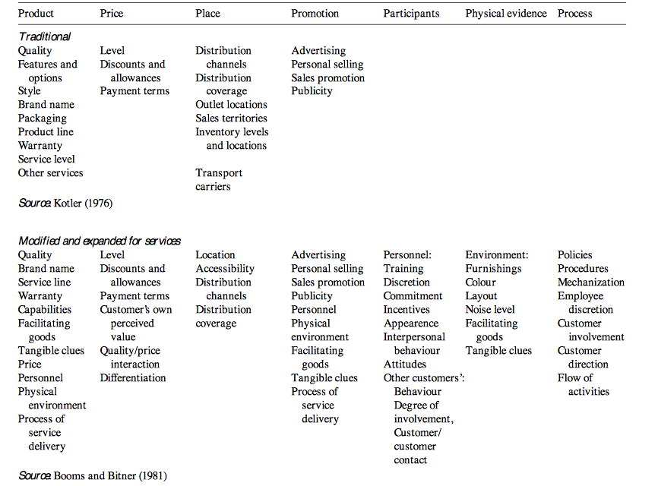
Table 1 – An Interpretation of the 7P´s and what they include (Rafiq and Ahmed, 1995)
As a result of this digital marketing plan and the above table, the researcher has modified the 7p Marketing Mix in order to relate this more distinctly to the University of Wales Trinity Saint David by using Ivy (2008);
Product: What the university is providing
Price: What the university is asking for in return for their product
Place: Where the courses are being delivered
Promotion: How the university communicate what they do and what they offer
People: Those staff who come in contact with students and stakeholders
Physical Evidence: Helping the students to see what they are buying, e.g. facilities available on campus.
Processes: The effectiveness of the systems and processes the university use.

Each of the components of the Marketing Mix is vital to the success of an organisation and no element should be determined in isolation. Manchester University (2015) reported that the product-price equation is simple: university courses are the product and the tuition fee and entry requirements is the price. People comprise all staff, students and alumni, and these have the utmost potential to communicate about UWTSD. In order to enhance this, the university can focus more on engagement, training and support (Manchester University, 2015). In higher education, place and physical evidence are interrelated and the campuses are fundamental to both. It therefore needs to symbolise and embody the UWTSD brand. Likewise, all elements of the process need to be effective and professional. That could mean anything from using social media to target and attract new international students, to being able to read about the aids the university provides on a responsive website.

4.1 Strategy and Tactics
Once the organisation has defined their audiences, it is important to decide what channels to be used in order to deliver the message. In terms of the University of Wales Trinity Saint David, it is noted that the organisation would benefit from doing the following strategy and tactics
- Keeping all social media platforms updated at all times. This should include posting pictures on platforms such as Instagram and Facebook, in addition to writing posts and articles on their own website and/or any other digital platform they might be using.
- Regularly post news and upcoming events, as well as the university´s achievements
- Host events such as open days in order raise awareness of the university and to attract new possible customers. UWTSD is also recommended to advertise their events across all social media platforms in order to reach their audiences in the most efficient way.
- Emails to external stakeholder as well as to internal staff
- Monthly staff meetings

All mentioned tactics are recommended in order to maintain a good atmosphere within the organisation. However, increasing traffic on social media can be considered as one of the most effective way in order to maximise student recruitment. The University of Cambridge is a good example of a university who has a strong focus on using social media as a way of marketing. The university is currently using Instagram and YouTube as their main digital marketing channels, displaying photographs and videos of the beautiful city. The University of Wales Trinity Saint David could be seen to benefit from applying a similar strategy in the way they market themselves as an organisation.
Using digital platforms regularly will most likely not only drive more traffic to their website and other profiles, but it is also seen as a great way for prospective students to understand the university’s standard of education and their teaching style (QS, 2018).
Using social media is often defined as a cost-efficient marketing method. UWTSD would also benefit from using the social media platform Snapchat as a way of connecting with their audience. Snapchat was originally developed to encourage a more natural flow of communication, as stated by Betters (2018). It was reported that snapchats user base consists of 100 million people. Agrawal (2016) reported that snapchat is a good method to use to reach the younger audience. It is also a way of communication with the audience on a more personal level. The university could show “behind the scenes” of the university that could possibly encourage people to get involved with the organisation.

5.0 Timescales and Budget
Timing of implementation of the businesses tactics is important. It is critical to make sure to have staff willing and able to complete the tasks that the organisation has planned.
Hill (2018) argued that by considering tactics in calendar form, it is quicker way to understand if the organisation has taken on too many tasks within a short amount of time. Further, it is important that UWTSD acknowledge that some tactics require financial support in order to accomplish them. Therefore, planning the timing of all tasks helps the organisation to see what funds that are required for each month. Therefore, highlighting key dates and keeping a schedule including the different activities and who is responsible for them would be beneficial to UWTSD. Therefore, the researcher has created a simple schedule as an example of the recommended tactics

Jan | Feb | Mar | Apr | May | Jun, Jul, Aug | Sep | Oct | Nov | Dec | Price
 | Open day |  |  |  | Open  Day |  | Open day |  |  | £6,240
Social  Media | Social  Media | Social  Media | Social  Media | Social Media | Social  Media | Social  Media | Social  Media | Social  Media | Social  Media | £500
 |  |  |  |  | Prospects  To enrolled students |  |  |  |  | £22,140
Staff Meeting | Staff  Meeting | Staff  Meeting | Staff  Meeting | Staff  Meeting | Staff  Meeting | Staff  Meeting | Staff  Meeting | Staff  Meeting | Staff  Meeting | £529
 |  |  | Promotion  (leaflets,  Brochures) | Promotion  (leaflets,  Brochures) | Promotion  (leaflets,  Brochures) | Promotion  (leaflets,  Brochures) |  |  |  | £18,761
 |  |  |  |  |  |  |  |  |  | Total: £48,170

6.0 Performance Measures
Navarro (2014) stated that a large proportion of social media platforms use analytics to measure their performance. One of the most common ones is Google Analytics where organisations can link their website to Google Analytics and then analyse their performance. The use of analytic methods may arguably help the university in measuring the overall traffic of their website and other social media platforms. In addition to this, it will assist UWTSD to see their most popular posts in terms of likes, shares and comments that has been generated.
Klipfolio (2018) defined Key Performance Indicator (KPI) as an effective method to measure how effectively the university is achieving key objectives. It is often used on multiple levels in order to evaluate overall success, as well as how the different the achievements within the different departments (Kipfolio, 2018)

7.0 Conclusion
In conclusion, the University of Wales Trinity Saint David have good opportunities to improve their marketing strategy. It can be argued that it is more beneficial to the organisation to focus more on using digital platforms in order to communicate with their target audience and to attract future students. It is however, also recommended that the organisation continues to use a traditional marketing strategy.

8.0 Recommendations
It is believed that University of Wales Trinity Saint David should focus on the following in order to enhance their digital marketing strategy;
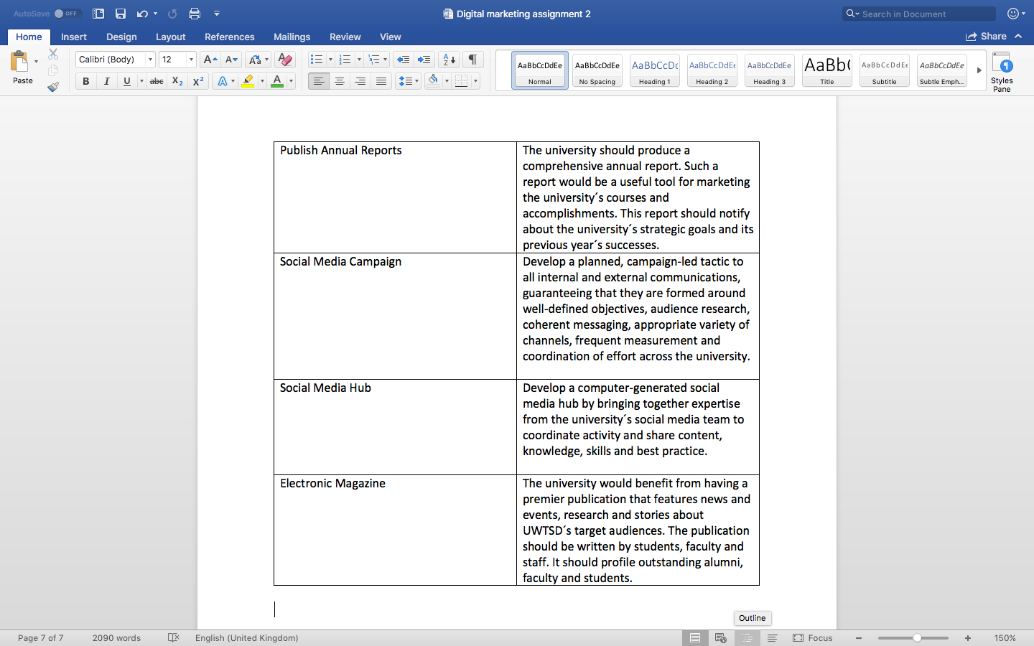
Alongside these, the researcher stated that the university must keep all social media platforms updated at all times by regularly post news and upcoming events. It is also recommended that the university continues to post its achievements with a strong focus on staff, students and alumni´s. The university needs to host more events in order to raise awareness and to attract new prospective students. These events should be advertised across all social media platforms in order to reach a large proportion of their target audience whilst being cost-effective. More focus needs to be on stakeholders. It is recommended that all stakeholders must be updated regularly with e-mails and notifications. In order to enhance the digital marketing strategy, it is also recommended to host monthly staff meetings where it is discussed the progress and performance.

9.0 Bibliography

Agrawal, A., 2016. 5 Reasons Your Business Should Be on Snapchat. [Online]
Available at: https://www.forbes.com/sites/ajagrawal/2016/04/05/5-reasons-your-business-should-be-on-snapchat/#4adee9ef3db5
[Accessed 08 05 2018].

Badenhorst, M., 2015. How Digital is Changing Customer Behaviour. [Online]
Available at: https://www.mediavisioninteractive.com/social-media/how-digital-is-changing-consumer-behaviour/

Badi, K. S. A., 2015. The Dimensions of Marketing Mix. Management and Organizational Studies, 2(1), pp. 136-142.

Betters, E., 2018. What is Snapchat, how does it work and what is it used for?. [Online]
Available at: https://www.pocket-lint.com/apps/news/snapchat/131313-what-is-snapchat-how-does-it-work-and-what-is-it-used-for
[Accessed 08 05 2018].

Booms, B. & Bitner, M., 1981. Marketing Strategies and organization structures for service firms. In: J. Donnelly & W. George, eds. Marketing Services. Chicago: American Marketing Association, pp. 47-51.

Cave, J., 2016. Digital Marketing Vs. Traditional Marketing: Which One Is Better?. [Online]
Available at: https://www.digitaldoughnut.com/articles/2016/july/digital-marketing-vs-traditional-marketing

Fill, C., 1995. Marketing Communications: Framework, Theories and Applications. 1st ed. Herfortshire: Prentice Hall.

Fill, C., 1999. Marketing Communication: Contexts, contents and strategies. 2nd ed. Essex: Prentice Hall.

Goi, C. L., 2009. A Review od Marketing Mix: 4Ps or More?. International Journal of Marketing Studies, 1(1), pp. 1-15.

Greatrix, P., 2011. University isn´t just a business - and the student isn´t always right. [Online]
Available at: https://www.theguardian.com/higher-education-network/higher-education-network-blog/2011/mar/14/students-as-consumers
[Accessed 02 05 2018].

Hill, B., 2018. What is Timing in a Tactical Plan in Marketing?. [Online]
Available at: http://smallbusiness.chron.com/timing-tactical-plan-marketing-63257.html
[Accessed 08 05 2018].

Ivy, J., 2008. A New Higher Education Marketing Mix: The 7Ps for MBA Marketing. International Journal of Educational Management, 22(4), pp. 288-299.
Kennesaw State University, 2015. University College Strategic Communication Plan 2015-2017, Georgia: Kennesaw State University.
Klipfolio, 2018. What is KPI?. [Online]
Available at: https://www.klipfolio.com/resources/articles/what-is-a-key-performance-indicator
[Accessed 09 05 2018].

Kotler, P., 1976. Marketing Management. 3rd ed. Englewood Cliffs: Prentice Hall.

Kotler, P. & Armstrong, G., 2014. Principles of Marketing: Global Edition. 15th ed. s.l.:Pearson Education Limited.

Mander, J., 2017. Daily Time Spent on Social Networks Rises to Over 2 Hours. [Online]
Available at: https://blog.globalwebindex.com/chart-of-the-day/daily-time-spent-on-social-networks/

McCarthy, E., 1964. Basic Marketing. 1st ed. Homewood: Richard D. Irwin.
Navarro, A., 2014. 9 Metrics for Measuring Marketing Performance. [Online]
Available at: https://www.outbrain.com/blog/9-metrics-for-marketing-performance-measurement/
[Accessed 09 05 2018].

Professional Academy, 2018. Marketing Theories - SWOT Analysis. [Online]
Available at: https://www.professionalacademy.com/blogs-and-advice/marketing-theories---swot-analysis
[Accessed 02 05 2018].

QS, 2018. University Social Media Marketing: Who´s Getting it Right?. [Online]
Available at: http://www.qs.com/university-social-media-marketing-whos-getting-it-right/
[Accessed 06 05 2018].

Rafiq, M. & Ahmed, P., 1995. Using the 7Ps as a generic marketing mix: an exploratory survey of UK and European marketing academics. Marketing Intelligence & Planning, 13(9), pp. 4-15.

Raman, V., 2015. 5 Key Benefits of Social Media for Higher Education Institutions. [Online]
Available at: https://www.linkedin.com/pulse/5-key-benefits-social-media-higher-education-venkatesh-raman

Singh, M., 2012. Marketing Mix of 4P´s for Competitive Advantage. IOSR Journal of Business and Management, 3(6), pp. 40-45.

Standberry, S., 2017. Top 10 Benefits of Digital Marketing & Why Digital Marketing is a Must for Every Small Business. [Online]
Available at: https://www.lyfemarketing.com/blog/benefits-digital-marketing/

The University of Manchester, 2015. Communications and Marketing Plan: Summary Document 2015-2018, Manchester: The University of Manchester.

Vascellari, A., 2018. Context Analysis - What? Why? How?. [Online]
Available at: http://www.andreavascellari.com/2014/01/context-analysis/
[Accessed 09 05 2018].

