Strategic and Agile Business Management
BMMB7072

Shell plc - Reviewing Shell plc’s Strategic
Developing an Agile Customer-Centred Energy Ecosystem for Sustainable Competitive Advantage During the Energy Transition

Lecturer: Daniela Hellyer
Student: Liviu Topala
ID 1905828 – Master Of Business Administration
Table of Contents
Executive Summary 4
1. Introduction 6
2. External Strategic Analysis (PESTLE) 8
2.1. Political Factors 8
2.2. Economic Factors 8
2.3. Social Factors 9
2.4. Technological Factors 9
2.5. Legal Factors 9
2.6. Environmental Factors 10
2.7. Strategic Synthesis 10
3. Internal Strategic Analysis 11
3.1. SWOT Analysis 11
3.2. Resource-Based View and VRIO Analysis 13
3.3 Strategic Synthesis 14
4. Critical Evaluation of Strategic Options 15
4.1. Option one: AI-Enabled Customer Personalisation 15
4.2. Option two: Developing an Integrated Customer Energy Ecosystem 16
4.3. Option three: Agile Organisational Transformation 17
4.4. Comparative Evaluation 17
4.5. Strategic Transition 18
5. Strategic Recommendation 19
5.1. Proposed Strategic Initiative 19
5.2. Implementation Priorities 20
5.3. Expected Strategic Benefits 21
5.4. Risks and Mitigation 21
5.5. Strategic Outcome 22
6. Organisational Implications 23
6.1. Leadership and Organisational Culture 23
6.2. Technology and Digital Integration 24
6.3. Human Resource Implications 24
6.4. Governance, Ethics and Corporate Responsibility 24
6.5. Organisational Impact 25
7. Conclusion 26

Executive Summary
Shell plc is one of the world’s largest integrated energy companies, operating across Oil and gas, liquefied natural gas (LNG), renewable electricity, electric vehicle charging, hydrogen and custom energy solutions. This is an increasingly volatile and complex global energy environment shaped by decarbonisation policies, technological innovation, geopolitical uncertainty and rapidly evolving customer expectations. While the organisation has made significant progress in transitioning towards integrated energy solutions, maintaining sustainable competitive advantage requires more than investment in renewable technologies. Increasingly, long-term organisational resilience depends upon delivering customer-centric services that strengthen customer loyalty, trust and long-term value creation. Consequently, this report evaluates Shell’s strategic direction through the lens of strategic and agile business management, with particular emphasis on customer care.

This report undertakes a comprehensive strategic analysis of Shell’s external and internal environment. A PESTLE analysis identifies the principal macro-environmental factors influencing the organisation, including political commitments to net-zero emissions, economic volatility, changing customer expectations, technological advances in artificial intelligence and digital platforms, increasing legal obligations relating to data governance and growing environmental pressures. Building on these findings, an integrated SWOT and VRIO analysis evaluates Shell’s ability to respond to external change. The analysis concludes that Shell possesses significant strategic strengths, including global brand recognition, substantial financial resources, extensive infrastructure and an expanding portfolio of customer-facing digital services. However, organisational complexity, legacy reputational challenges and increasing competitive pressure may constrain future competitiveness unless these capabilities are more effectively integrated around customer needs.

Three strategic options are critically evaluated: AI-enabled customer personalisation, agile organisational transformation and the development of an Integrated Customer Energy Ecosystem. Each option is assessed according to its strategic fit, ability to leverage Shell’s existing capabilities, contribution to organisational agility and potential to strengthen customer care. The evaluation concludes that the Integrated Customer Energy Ecosystem provides the strongest strategic response because it combines digital innovation, personalised customer engagement and organisational agility within a single customer-centred business model.

Accordingly, the report recommends that Shell develops an Integrated Customer Energy Ecosystem supported by artificial intelligence and agile business management. This strategy would integrate renewable electricity, electric vehicle charging, mobility services, loyalty programmes and digital customer engagement through a unified platform, enabling Shell to build continuous customer relationships rather than isolated transactions. By integrating its existing capabilities around customer needs, Shell can strengthen customer loyalty, improve operational responsiveness and maximise the value of its current strategic investments.

Successful implementation will require organisational transformation extending beyond technology to encompass leadership, organisational culture, workforce capability, digital integration, ethical governance and cross-functional collaboration. By embedding customer-centricity throughout its strategic direction, Shell will be better positioned to enhance organisational resilience, respond effectively to changing market conditions and maintain sustainable competitive advantage throughout the global energy transition.

1. Introduction
The global energy industry is undergoing one of the most significant strategic transformations in its history. Historically, competitive advantage was largely derived from access to natural resources, operational efficiency and economies of scale; however, accelerating technological innovation, increasing environmental regulation, geopolitical uncertainty and changing customer expectation are fundamentally reshaping how energy companies create value. However, accelerating technological innovation, increasing environmental regulation, geopolitical uncertainty and changing customer expectations are fundamentally reshaping how energy companies create value. Organisations can no longer compete solely through energy production; they must also develop customer-centric business models that are sufficiently agile to respond to an increasingly dynamic external environment (Johnson et al., 2020; Mintzberg, Ahlstrand and Lampel, 2009; Rumelt, 2011). Strategic success therefore depends not only on responding to environmental change but also on continuously adapting organisational capabilities to sustain long-term competitiveness (Teece, 2018).

Shell plc is one of the world’s largest integrated energy companies, operating across oil and gas production, liquefied natural gas (LNG), renewable electricity, electric vehicle (EV) charging, hydrogen, mobility services and energy solutions. Recognising the pace of the global energy transition, Shell has repositioned its corporate strategy around delivering “more value with less emissions”, reflecting its ambition to create shareholder value while supporting customers in reducing their carbon emissions (Shell plc, 2024a; Shell plc, 2024e). Alongside investments in lower-carbon energy, the organisation has expanded customer-facing digital platforms, including Shell Recharge, the Shell App and the Shell GO+ loyalty programme, demonstrating a strategic shift from transactional relationships towards continuous customer engagement (Shell plc, 2024a; Shell plc, 2024b).

This transformation reflects broader changes across the global energy sector. The International Energy Agency (2024), BloombergNEF (2024) and World Economic Forum (2025) forecast continued growth in electrification, digitalisation and customer participation, requiring energy companies to rethink both their business models and customer engagement strategies. Similarly, Lemon and Verhoef (2016), Homburg, Jozić and Kuehnl (2017) and Becker and Jaakkola (2020) argue that organisations increasingly compete through the quality of the customer experience across the entire customer journey rather than through isolated service encounters. Furthermore, Vargo and Lusch (2008) contend that value is co-created through continuous interactions between organisations and customers, reinforcing the strategic importance of customer-centricity within increasingly service-oriented business models.

Despite its strong market position, Shell faces a complex strategic challenge. The organisation must continue generating value from its traditional energy business while simultaneously accelerating investment in lower-carbon energy solutions, responding to evolving regulatory requirements and meeting increasing customer expectations for personalised, digitally enabled and environmentally responsible services. Failure to balance these competing priorities could weaken customer trust, reduce organisational adaptability and limit Shell’s ability to compete effectively within an increasingly customer-driven energy market. Conversely, successfully embedding customer-centricity within Shell’s strategic direction has the potential to strengthen customer loyalty, improve organisational resilience and support sustainable competitive advantage (Freeman, 2010; Porter and Kramer, 2011).

Accordingly, this report critically evaluates Shell’s strategic direction through the lens of strategic and agile business management, with particular emphasis on customer care. It addresses the following strategic question:
How can Shell strengthen personalised customer care through strategic and agile business management to maintain sustainable competitive advantage during the global energy transition?

To answer this question, the report first analyses the external environment using the PESTLE framework before translating these findings into an internally focused SWOT and VRIO analysis. The integrated findings are then used to critically evaluate alternative strategic options before recommending a customer-centric strategy that aligns with Shell’s long-term business objectives.

Finally, the report considers the wider organisational implications of implementing the proposed strategy, including its impact on leadership, organisational culture, innovation, technology, corporate social responsibility (CSR) and ethical governance. Throughout the report, customer care is positioned as a strategic capability that enables Shell to adapt to external change while strengthening long-term organisational resilience and sustainable competitive advantage.

2. External Strategic Analysis (PESTLE)
Understanding the external environment is fundamental to strategic management because organisations operate within macro-environmental conditions that are largely beyond their direct control (Johnson et al., 2020; Mintzberg, Ahlstrand and Lampel, 2009). For Shell, these external forces are particularly significant as the global energy transition is reshaping customer expectations, regulatory frameworks and competitive dynamics. Rather than considering each PESTLE factor in isolation, this analysis examines how macro-environmental changes influence Shell’s strategic direction and customer care, providing the foundation for the subsequent SWOT and VRIO analyses.

2.1. Political Factors
Government policies promoting decarbonisation continue to reshape the global energy industry. The UK’s commitment to achieving net-zero emissions by 2050, together with the European Green Deal and wider international climate agreements, is accelerating investment in renewable energy, hydrogen and electric vehicle (EV) infrastructure (International Energy Agency, 2024; UK Government, 2023; United Nations, 2015). In response, Shell’s Energy Transition Strategy focuses on expanding lower-carbon energy solutions while maintaining value from its existing energy portfolio (Shell plc, 2024a).

Political intervention therefore creates both pressure and opportunity. Organisations that align strategic investment with evolving public policy are better positioned to strengthen long-term competitiveness, while failure to adapt increases regulatory and reputational risks (World Economic Forum, 2025).

2.2. Economic Factors
Global economic uncertainty, inflation, volatile energy prices and geopolitical instability continue to influence organisational investment and consumer behaviour (International Energy Agency, 2024; World Bank, 2024). Customers increasingly seek energy providers capable of balancing affordability, reliability and sustainability.

For Shell, these conditions reinforce the strategic importance of customer retention rather than price competition alone. Kotler, Kartajaya and Setiawan (2021) argue that long-term value increasingly depends on building customer relationships rather than individual transactions. Similarly, PwC (2024) highlights that energy companies are increasingly competing through integrated service offerings and customer value rather than commodity pricing alone.

2.3. Social Factors
Changing consumer expectations represent one of the most significant drivers of strategic transformation. Customers increasingly expect organisations to demonstrate environmental responsibility, transparency and high-quality digital experiences alongside competitive products (Becker and Jaakkola, 2020; Lemon and Verhoef, 2016; Homburg, Jozić and Kuehnl, 2017). Customers increasingly sick energy providers capable of balancing affordability, reliability, system ability and personalise services, reflecting broader shifts in consumer expectations and purchasing behaviour (Deloitte, 2024). Consequently, customer care has evolved from an operational function into a strategic capability.

For Shell, this presents both opportunities and challenges. While investments in renewable energy and digital services support changing customer preferences, the organisation’s historical association with fossil fuels continues to influence stakeholder perceptions. Frynas (2019) argues that sustainability commitments must be supported by genuine organisational change if trust is to be maintained.

2.4. Technological Factors
Digital technologies, artificial intelligence (AI), predictive analytics and connected customer platforms are transforming competition across the energy sector. Davenport et al. (2020) suggest that AI enables organisations to personalise services and improve customer engagement, while Huang and Rust (2021) argue that technology increasingly complements human interaction rather than replacing it. Dwivedi et al. (2021) further suggest that AI adoption creates strategic value when integrated into wider organisational decision-making and customer engagement processes (see also Gartner, 2024).

Shell has already invested in customer-facing technologies including Shell Recharge, the Shell App and Shell GO+, providing a foundation for integrated digital customer experiences (Shell plc, 2024b). However, Becker and Jaakkola (2020) contend that technology creates competitive advantage only when embedded across the entire customer journey.

2.5. Legal Factors
The legal environment has become increasingly complex as energy companies face stricter environmental regulation, consumer protection requirements and data privacy obligations. In addition, regulators are placing greater emphasis on transparency, customer outcomes and fair market practices, increasing the importance of effective compliance and governance (Ofgem, 2024)

Carroll (2021) argues that responsible governance strengthens stakeholder trust, suggesting that legal compliance should be viewed as a strategic capability rather than simply a regulatory obligation. ISO (2024) similarly emphasises that effective governance and transparent ESG practices increasingly influence organisational legitimacy and stakeholder confidence. For Shell, maintaining transparency in the use of customer data will become increasingly important as AI and digital services expand.

2.6. Environmental Factors
Climate change and the transition towards lower-carbon energy continue to reshape competitive conditions across the energy industry. The International Energy Agency (2024) forecasts continued growth in renewable electricity, EV adoption and energy efficiency, while investors and customers increasingly expect organisations to demonstrate measurable sustainability performance. Similar trends are identified by IRENA (2024), BloombergNEF (2024) and EY (2024), all of which highlight accelerating investment in renewable energy, electrification and low-carbon technologies as key drivers of future competitiveness.

Shell has responded by investing in renewable energy, hydrogen, LNG and EV charging infrastructure as part of its Energy Transition Strategy (Shell plc, 2024a). Nevertheless, organisations specialising exclusively in renewable energy continue to intensify competitive pressure.

2.7. Strategic Synthesis
The PESTLE analysis demonstrates that Shell operates within an increasingly dynamic external environment in which political regulation, economic uncertainty, changing customer expectations, technological innovation, legal obligations and environmental sustainability are closely interconnected. Collectively, these factors indicate that future competitive advantage will depend less on traditional energy production and more on the organisation’s ability to deliver integrated, customer-centric and digitally enabled energy solutions.

Several recurring themes emerge from the analysis, including the growing strategic importance of customer care, digital transformation, sustainability and organisational adaptability. These external drivers provide the foundation for the following SWOT and VRIO analyses by identifying the opportunities and threats against which Shell’s internal strengths and capabilities are evaluated.

3. Internal Strategic Analysis
The PESTLE analysis identified significant external pressures affecting Shell, including decarbonisation, digitalisation, increasing customer expectations and regulatory change. The strategic question is therefore not whether these changes exist, but whether Shell possesses the internal capabilities to respond effectively. According to Barney (1991), sustainable competitive advantage depends upon resources that are valuable, rare, difficult to imitate and effectively organised. Peteraf (1993) further argues that competitive advantage depends on the organisation’s ability to protect and exploit strategic resources over time. Consequently, this section evaluates Shell’s internal strategic position through an integrated SWOT and VRIO analysis to determine whether its existing capabilities are sufficient to exploit the opportunities and mitigate the threats identified in the external analysis.

3.1. SWOT Analysis
The SWOT analysis translates the external opportunities and threats identified in the PESTLE into an assessment of Shell’s internal strengths and weaknesses. Rather than introducing new strategic issues, it evaluates how well the organisation is positioned to respond to a changing business environment.
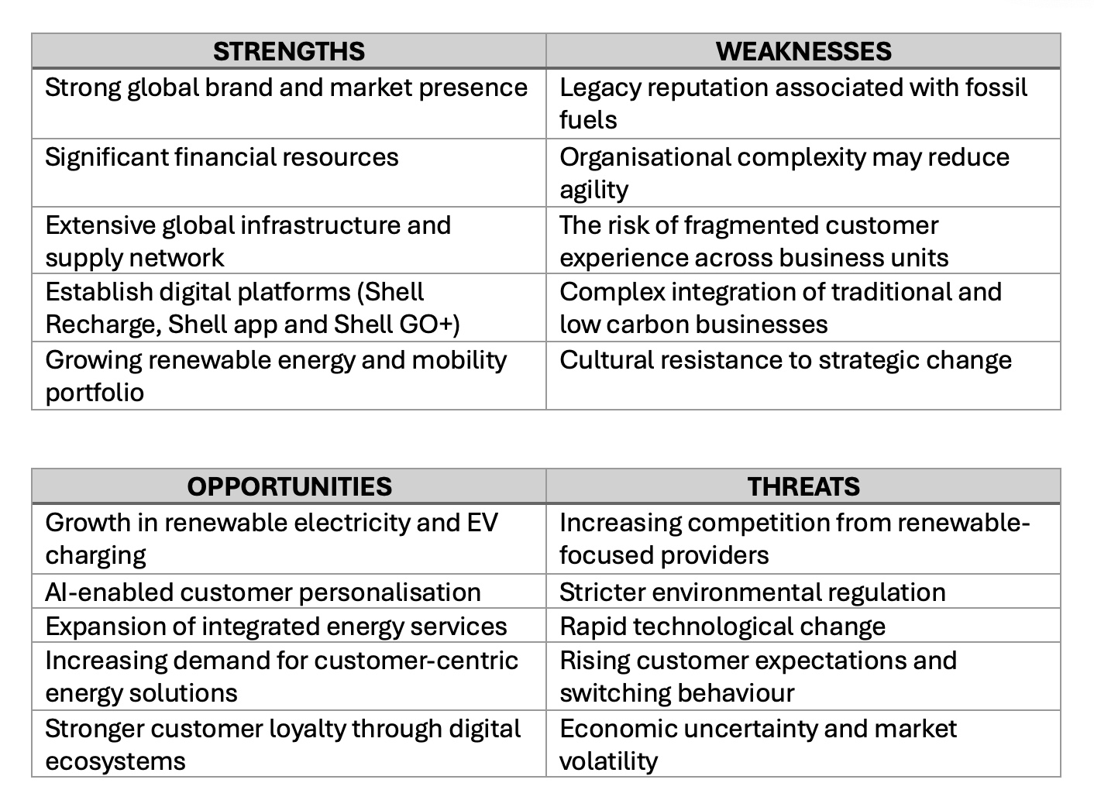
Source: Author’s own analysis derived from the PESTLE analysis and informed by Barney (1991), Frynas (2019), Becker and Jaakkola (2020), Shell plc (2024a) and Shell plc (2024b).

Critical Evaluation
The analysis indicates that Shell’s principal strengths (its financial resources, global infrastructure and established customer platforms) place the organisation in a favourable position to respond to external market change. Existing investments in Shell Recharge, Shell Energy and digital customer services demonstrate that the company has already begun repositioning itself beyond traditional fuel retailing (Shell plc, 2024a; Shell plc, 2024b).

However, these strengths are counterbalanced by internal challenges. Organisational complexity may slow decision-making, while the company’s historical reliance on fossil fuels continues to influence stakeholder perceptions (Frynas, 2019). Becker and Jaakkola (2020) argue that customer experience must be embedded across the organisation rather than delivered through isolated service improvements. Similarly, Homburg, Jozić and Kuehnl (2017) emphasise that competitive advantage increasingly depends on consistently managing customer experience across all organisational functions. Consequently, Shell’s future competitiveness will depend less on additional investment and more on integrating its existing capabilities into a consistent customer experience.

Overall, the SWOT analysis suggests that Shell possesses the resources required to exploit emerging opportunities, but success will depend upon organisational integration and customer-centric execution rather than resource availability alone.

3.2. Resource-Based View and VRIO Analysis
The Resource-Based View (RBV) argues that organisations achieve sustained competitive advantage through resources that competitors cannot easily replicate (Barney, 1991). The VRIO framework extends this perspective by assessing whether key organisational resources are Valuable, Rare, Inimitable and Organised to create competitive advantage (Barney and Hesterly, 2021). Collis and Montgomery (1995) similarly argue that competitive success depends not only on possessing strategic resources but also on deploying them more effectively than competitors.
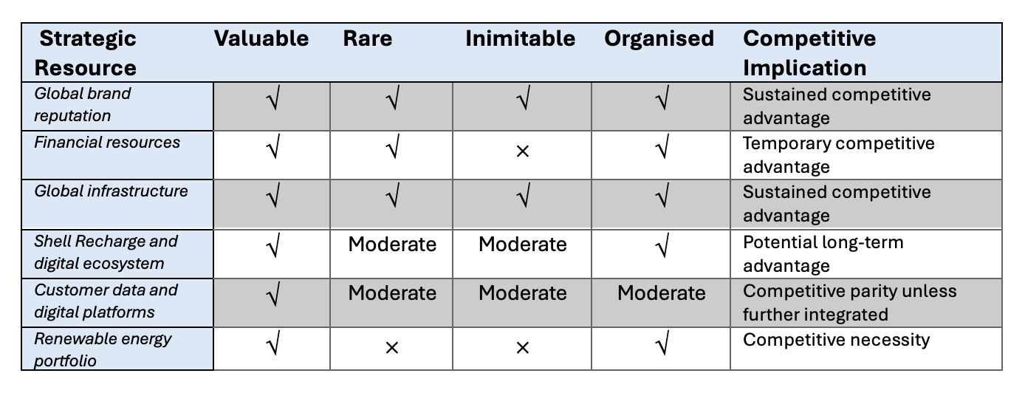
Source: Author’s own analysis based on Barney (1991), Barney and Hesterly (2021), Peteraf (1993), Collis and Montgomery (1995), Eisenhardt and Martin (2000), Shell plc (2024b) and Teece (2018).

Critical Evaluation
The VRIO analysis confirms that Shell’s enduring advantages remain its global brand, financial capacity and operational infrastructure. These assets are difficult for competitors to replicate and provide the organisation with a strong platform for long-term strategic transformation.

In contrast, customer-facing digital capabilities (including AI, customer data and integrated digital services) are valuable but not yet sufficiently rare to provide sustained competitive advantage. As competing energy providers continue investing in similar technologies, differentiation will increasingly depend upon how these capabilities are integrated to deliver superior customer experiences rather than on technology ownership alone (Lemon and Verhoef, 2016). Eisenhardt and Martin (2000) similarly argue that competitive advantage increasingly arises from the ability to reconfigure resources in response to changing market conditions rather than from static resource ownership.

For Shell, the strategic priority is therefore not acquiring additional resources but integrating its existing capabilities into a coherent customer-focused business model that continuously evolves alongside customer expectations (Teece, 2018).

3.3 Strategic Synthesis
The internal analysis demonstrates that Shell possesses the financial strength, infrastructure and digital capability required to respond to the opportunities identified in the external analysis. Nevertheless, these resources alone do not guarantee future competitiveness. The SWOT analysis highlights organisational integration and customer trust as the principal internal challenges, while the VRIO analysis indicates that future differentiation will depend upon deploying existing capabilities more effectively rather than accumulating additional assets. This finding is consistent with the Resource-Based View, which suggests that competitive advantage depends not simply on valuable resources but on how effectively they are coordinated to create customer value (Peteraf, 1993; Collis and Montgomery, 1995).

These findings provide a direct transition to the next section. Since Shell already possesses the strategic resources required to compete successfully, the remaining question is how those resources should be deployed to strengthen customer care and achieve sustainable competitive advantage. The following section therefore evaluates alternative strategic options before identifying the most appropriate strategic direction for the organisation.

4. Critical Evaluation of Strategic Options
The external and internal analyses indicate that Shell possesses the resources required to respond successfully to the changing energy market. The remaining strategic challenge is determining how these capabilities should be deployed to strengthen customer care while supporting long-term competitiveness. This section evaluates three strategic options identified from the preceding analyses. Rather than introducing new strategic issues, each option is assessed according to its strategic fit, ability to utilise Shell’s existing capabilities and potential to enhance long-term customer value.

4.1. Option one: AI-Enabled Customer Personalisation
The first option focuses on expanding the use of artificial intelligence (AI) and predictive analytics to personalise customer interactions across Shell’s existing digital services. Potential applications include tailored energy recommendations, predictive maintenance alerts, personalised loyalty rewards and proactive customer support.

This option builds on Shell’s existing digital investments and responds directly to the technological opportunities identified in the PESTLE analysis. AI has considerable potential to improve operational efficiency while supporting more responsive customer engagement (Davenport et al., 2020; Huang and Rust, 2021). Dwivedi et al. (2021) further argue that AI generates the greatest strategic value when embedded within wider organisational processes rather than implemented as an isolated technology.

However, this strategy has limitations. AI capabilities are becoming increasingly accessible across the energy sector, reducing their potential to provide sustainable competitive differentiation. Furthermore, although AI enhances customer interactions, it does not fundamentally change Shell’s overall customer value proposition. Consequently, AI should be viewed as an important strategic enabler rather than a standalone competitive strategy.

4.2. Option two: Developing an Integrated Customer Energy Ecosystem
The second option proposes integrating Shell’s customer-facing services into a single ecosystem connecting renewable electricity, EV charging, mobility services, digital engagement and loyalty programmes through a unified customer platform.

Unlike the previous option, this approach directly addresses the strategic challenge identified throughout the report. The PESTLE analysis demonstrated increasing demand for digitally enabled, lower-carbon energy solutions, while the SWOT analysis confirmed that Shell already possesses many of the capabilities required to respond effectively. Rather than creating entirely new resources, this strategy integrates existing assets, including Shell Recharge, Shell Energy, the Shell App and Shell GO+, into a coherent customer proposition (Shell plc, 2024a; Shell plc, 2024b; Shell plc, 2024f; Shell plc, 2024g).

The strategy also maximises the value of the capabilities identified through the VRIO analysis. Shell’s financial strength, infrastructure and global brand provide a strong platform for ecosystem development, while greater integration increases the strategic value of its customer data and digital platforms. Vargo and Lusch (2008) argue that organisations create competitive advantage by co-creating value through ongoing customer relationships rather than isolated transactions. Similarly, Payne, Storbacka and Frow (2008) suggest that integrated customer relationships strengthen long-term value creation by connecting multiple service interactions within a unified customer experience.

An integrated ecosystem also encourages continuous customer engagement rather than isolated transactions. Customers could manage home energy, EV charging, loyalty rewards and mobility services through a single platform, creating greater convenience while increasing switching costs. This approach supports Shell’s ambition to become an integrated energy company rather than simply a traditional fuel supplier.

Implementation would, however, require significant organisational coordination. Existing business units would need to share customer data, align customer experience standards and adopt common digital platforms. Investment in technology alone would therefore be insufficient; leadership commitment, cross-functional collaboration and effective change management would be essential to ensure a seamless customer experience (Schein and Schein, 2021).

Despite these implementation challenges, this option provides the strongest strategic fit because it simultaneously exploits external opportunities, addresses internal weaknesses and leverages Shell’s existing competitive advantages.

4.3. Option three: Agile Organisational Transformation
The third option focuses on embedding agile management practices across Shell through cross-functional teams, faster decision-making and continuous customer feedback.

This approach addresses the organisational complexity identified in the SWOT analysis and could improve Shell’s responsiveness to market change (Doz and Kosonen, 2010). Rigby, Sutherland and Takeuchi (2016) similarly argue that agile management improves organisational responsiveness by enabling faster learning, experimentation and customer-focused innovation.

Nevertheless, organisational agility should be regarded as an enabling capability rather than a strategic objective. While improved internal processes support innovation, they do not independently create additional customer value. Consequently, this option is unlikely to provide sufficient competitive differentiation unless implemented alongside broader customer-focused initiatives.

4.4. Comparative Evaluation
Each option contributes positively to Shell’s future strategic direction but differs considerably in strategic impact.

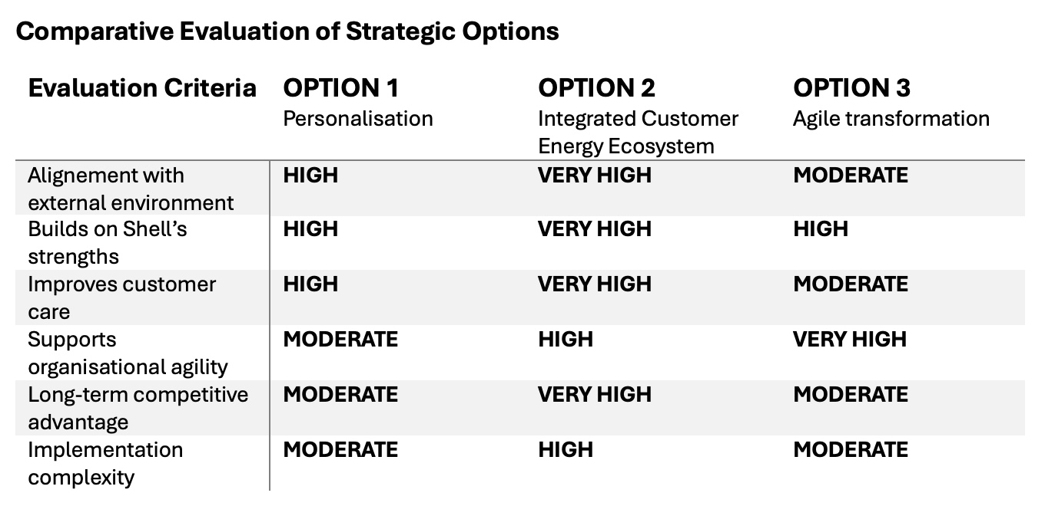

The comparison demonstrates that each option addresses a different aspect of Shell’s strategic challenge. Option One strengthens digital capability, while Option Three improves organisational responsiveness. However, neither independently addresses the broader objective of creating a differentiated customer proposition.

By contrast, Option Two combines the principal strengths of both alternatives within a single strategic direction. Artificial intelligence becomes a mechanism for delivering personalised services, while agile management supports continuous improvement and organisational responsiveness. Consequently, the Integrated Customer Energy Ecosystem provides the most comprehensive response to the external opportunities and internal capabilities identified throughout the report.

4.5. Strategic Transition
The evaluation indicates that Shell’s future competitiveness depends less on introducing isolated technological or organisational initiatives and more on integrating existing capabilities into a customer-centric business model. Accordingly, the following section recommends the development of an Integrated Customer Energy Ecosystem as the strategic direction most capable of strengthening customer care, enhancing organisational resilience and sustaining sustainable competitive advantage throughout the energy transition.

5. Strategic Recommendation
The evaluation of strategic options concluded that developing an Integrated Customer Energy Ecosystem (ICEE) offers the strongest strategic response to the challenges identified throughout this report. Unlike the alternative options, this approach combines Shell’s existing renewable energy services, digital platforms and customer relationships into a unified customer proposition that supports both business performance and long-term organisational resilience. This recommendation also aligns with the growing emphasis on integrated value creation and customer-centric business models within the energy sector (Vargo and Lusch, 2008; Payne, Storbacka and Frow, 2008).

Rather than requiring a fundamental change in corporate strategy, the recommendation builds upon Shell’s existing investments in Shell Recharge, Shell Energy, the Shell App and Shell GO+, strengthening their collective value through greater integration (Shell plc, 2024a; Shell plc, 2024f; Shell plc, 2024g; Shell plc, 2024h). This approach allows Shell to maximise the return on existing strategic investments while improving customer experience across the entire energy journey.

5.1. Proposed Strategic Initiative
It is recommended that Shell develops an Integrated Customer Energy Ecosystem that enables customers to access multiple services through a single digital platform.

The ecosystem should integrate:
- Shell Recharge and EV charging services;
- Shell Energy products;
- Shell GO+ loyalty programme;
- AI-supported customer insights;
- personalised communications and rewards.

Rather than managing separate customer relationships across different business units, Shell would provide a consistent experience that connects mobility, home energy and digital services. Customers would receive personalised recommendations based on their usage patterns while maintaining flexibility to access multiple products through one account. Payne, Storbacka and Frow (2008) argue that integrating multiple customer touchpoints enables organisations to create greater value through coordinated customer relationships, while Kumar et al. (2010) demonstrate that strengthening long-term customer engagement increases customer lifetime value.

This integrated approach supports Shell’s transition from a product-focused organisation towards a customer-focused energy provider while strengthening customer loyalty and increasing engagement across its service portfolio.

5.2. Implementation Priorities
Successful implementation depends upon organisational integration rather than technological investment alone. Four priorities are particularly important.

Firstly, Shell should establish a single customer data platform capable of connecting information across its digital services. A unified customer view would improve personalisation while allowing customers to move seamlessly between energy products and mobility services.

Secondly, cross-functional teams should be established to coordinate customer experience across business units. Bringing together specialists from digital technology, renewable energy, mobility and customer operations would reduce organisational silos and improve service consistency (Doz and Kosonen, 2010; Schein and Schein, 2021).

Thirdly, artificial intelligence should be used selectively to enhance customer interactions rather than replace them. Routine enquiries, personalised recommendations and predictive support can be automated, while more complex issues should continue to receive human assistance. This balanced approach supports efficiency without compromising customer trust (Huang and Rust, 2021). McKinsey & Company (2024) further argues that organisations achieve the greatest value from AI when it is integrated across business processes rather than implemented as a standalone technological solution.

Finally, customer care should become a strategic performance measure rather than solely an operational responsibility. Senior leadership should regularly review indicators such as customer retention, Net Promoter Score (NPS), digital engagement, complaint resolution and customer lifetime value alongside traditional financial measures (Rawson, Duncan and Jones, 2013).

Together, these actions would embed customer-centricity across the organisation while supporting continuous service improvement.

5.3. Expected Strategic Benefits
Implementing the proposed strategy is expected to generate benefits across several areas of the organisation.

From a customer perspective, integrating multiple services into one platform should simplify the customer journey, improve convenience and strengthen long-term relationships. Customers using several interconnected services are generally less likely to switch providers because of the additional value created through ecosystem integration (Lemon and Verhoef, 2016; Kumar et al., 2010).

From an organisational perspective, greater coordination between business units should improve operational efficiency while enabling faster responses to changing customer needs. A unified customer platform would also generate richer customer insights, supporting better strategic decision-making and continuous improvement.

Commercially, stronger customer retention and increased cross-selling opportunities are expected to improve customer lifetime value while reducing customer acquisition costs. At the same time, supporting customers in adopting lower-carbon energy solutions reinforces Shell’s wider sustainability objectives and strengthens its position within the evolving energy market (Porter and Kramer, 2011; Shell plc, 2024c).

5.4. Risks and Mitigation
The proposed strategy also presents several implementation risks.

The greatest challenge is organisational integration. Existing business units may operate with different systems, priorities and performance measures, making collaboration more difficult. Strong executive sponsorship and clear governance arrangements will therefore be essential.

Data privacy represents a second challenge. As greater volumes of customer information are collected and analysed, Shell must maintain robust governance, transparency and compliance with data protection legislation to preserve customer confidence (ISO, 2024; UK Government, 2023).

Finally, implementation will require substantial financial investment and organisational change. A phased rollout beginning with selected customer segments would reduce operational risk while allowing Shell to evaluate performance before wider implementation.

5.5. Strategic Outcome
The recommended Integrated Customer Energy Ecosystem directly addresses the strategic issues identified throughout this report. It responds to changing customer expectations, builds on Shell’s existing strengths and provides a practical framework for improving customer care without fundamentally altering the organisation’s long-term strategic direction.

Rather than treating customer care as a support function, the recommendation positions it as a core strategic capability that strengthens customer loyalty, improves organisational agility and supports sustainable competitive advantage throughout the energy transition. By combining digital innovation, integrated services and customer-centric value creation, the proposed strategy enables Shell to strengthen both its commercial performance and its long-term strategic resilience (Vargo and Lusch, 2008; Shell plc, 2024a).

Attention should now turn to the wider organisational implications of implementing this strategy, including its impact on leadership, organisational culture, technology, ethics and corporate governance.

6. Organisational Implications
Implementing an Integrated Customer Energy Ecosystem (ICEE) requires organisational transformation that extends well beyond technology. Delivering a consistent customer experience across Shell’s energy, mobility and digital services will require changes to leadership, organisational culture, technology, human resources and corporate governance. These organisational implications are significant because sustainable customer-centricity can only be achieved when strategic priorities are embedded throughout the organisation rather than remaining the responsibility of individual business units.

6.1. Leadership and Organisational Culture
Successfully implementing the proposed strategy requires leadership capable of driving organisational change while maintaining strategic alignment across diverse business units. Johnson et al. (2020) argue that effective strategy implementation depends upon aligning organisational structures, resources and behaviours with strategic objectives. However, organisational culture is equally important. Schein and Schein (2021) contend that sustainable change occurs only when new organisational values become embedded within everyday behaviours, decision-making and performance expectations.

For Shell, customer-centricity must therefore become a shared organisational priority rather than the responsibility of customer service functions alone. Leadership should encourage collaboration between renewable energy, mobility, digital technology and commercial teams, ensuring that customer outcomes are prioritised alongside operational and financial performance. Kotter (2012) further argues that visible leadership commitment and clear communication are essential for overcoming resistance to large-scale organisational change, making executive sponsorship a critical success factor.

6.2. Technology and Digital Integration
Technology provides the operational foundation for the proposed strategy, but competitive advantage will depend on how effectively digital capabilities are integrated across the organisation rather than on technology investment alone. Existing platforms should operate through a unified customer architecture that enables seamless movement between Shell’s products and services (Davenport et al., 2020; Shell plc, 2024b).

Huang and Rust (2021) argue that artificial intelligence should enhance customer experiences by supporting personalisation, automating routine enquiries and improving decision-making, while maintaining appropriate human oversight for more complex interactions. Dwivedi et al. (2021) similarly emphasise that AI creates long-term value only when integrated into wider organisational processes and supported by high-quality customer data.

Brynjolfsson and McAfee (2017) further argue that organisations achieve the greatest competitive advantage when digital technologies complement human capabilities rather than simply automating existing processes. Consequently, Shell’s ability to integrate customer information across business units will be essential for delivering a consistent and personalised customer experience.

6.3. Human Resource Implications
The proposed strategy will significantly influence workforce capabilities as customer interactions become increasingly digital, integrated and data-driven. Employees will require enhanced competencies in digital systems, customer relationship management and data interpretation alongside their existing technical expertise.

Cross-functional collaboration will become increasingly important because customer experience depends upon coordinated decision-making across operational, commercial and digital teams. Doz and Kosonen (2010) argue that organisational agility depends upon flexible structures and collaborative working practices, while Rigby, Sutherland and Takeuchi (2016) suggest that agile organisations encourage continuous learning, experimentation and rapid knowledge sharing. Consequently, recruitment, training, performance management and leadership development should reinforce behaviours that support collaboration, adaptability and customer-focused innovation.

6.4. Governance, Ethics and Corporate Responsibility
Expanding the use of customer data and AI-supported decision-making increases the importance of effective governance, ethical leadership and regulatory compliance. Carroll (2021) argues that responsible governance strengthens stakeholder trust through transparency, accountability and ethical decision-making. Similarly, ISO (2024) emphasises that effective governance frameworks are increasingly important for organisations managing large volumes of digital customer information.

The proposed strategy also supports Shell’s wider sustainability ambitions by helping customers adopt lower-carbon energy solutions through integrated digital services. Elkington (1997) argues that long-term organisational success depends upon balancing economic performance with environmental and social responsibilities through the Triple Bottom Line framework. Similarly, Porter and Kramer (2011) argue that organisations create sustainable competitive advantage when commercial objectives generate wider social value. By combining customer care with environmental responsibility, Shell can strengthen both customer relationships and corporate legitimacy while supporting its Energy Transition Strategy (Shell plc, 2024a).

6.5. Organisational Impact
Collectively, these organisational changes are expected to strengthen Shell’s long-term resilience by improving its ability to respond to changing customer expectations, technological developments and competitive pressures. Rather than relying solely on individual strategic assets, the proposed strategy integrates leadership, culture, technology, governance and customer relationships into a coordinated organisational capability.

Teece (2018) argues that organisations achieve sustainable competitive advantage by continually reconfiguring their resources to respond to dynamic market conditions, while Eisenhardt and Martin (2000) similarly suggest that dynamic capabilities enable organisations to adapt more effectively than competitors operating with static organisational structures.

For Shell, stronger customer relationships are likely to improve customer retention, increase cross-selling opportunities and enhance long-term organisational performance. At the same time, greater collaboration across business units should improve innovation, operational efficiency and strategic responsiveness.

Overall, successful implementation requires organisational transformation rather than technological change alone. By embedding customer-centricity throughout leadership, culture, digital capability and governance, Shell will be better positioned to deliver consistent customer value while strengthening its long-term competitive position (Shell plc, 2024b).

7. Conclusion
This report has critically evaluated Shell plc’s strategic direction within the context of the global energy transition, demonstrating that future competitiveness will increasingly depend on the organisation’s ability to integrate lower-carbon energy solutions with customer-centric innovation. The external analysis showed that political commitments to decarbonisation, accelerating technological development, changing customer expectations and increasing environmental accountability are fundamentally reshaping competition across the global energy sector (International Energy Agency, 2024; World Economic Forum, 2025; IRENA, 2024).

Consequently, energy companies must compete not only through operational performance but also through their ability to deliver integrated, personalised and digitally enabled customer experiences.

The internal analysis demonstrated that Shell possesses significant strategic strengths, including global brand recognition, financial resources, extensive infrastructure and an expanding portfolio of digital and lower-carbon energy services (Shell plc, 2024b). However, the report concluded that sustainable competitive advantage would depend less on resource ownership than on the organisation’s ability to integrate those capabilities to create superior customer value. This finding supports the Resource-Based View, which suggests that long-term advantage is achieved through the effective deployment and coordination of strategic resources rather than their possession alone (Peteraf, 1993; Collis and Montgomery, 1995).

The comparative evaluation identified the development of an Integrated Customer Energy Ecosystem as the most appropriate strategic direction for Shell. By connecting renewable energy services, electric vehicle charging, digital platforms and personalised customer engagement, the proposed strategy strengthens customer relationships while supporting Shell’s ambition to deliver “more value with less emissions” (Shell plc, 2024a). Rather than requiring a fundamental shift in corporate strategy, the recommendation builds on Shell’s existing investments and integrates them into a more coherent customer value proposition.

Successful implementation will depend upon effective organisational alignment. Leadership, organisational culture, digital integration, workforce capability and governance must operate cohesively to ensure customer-centricity becomes embedded throughout the organisation rather than remaining an operational objective. Embedding these capabilities will strengthen Shell’s responsiveness to changing customer expectations while improving organisational resilience, innovation and long-term strategic adaptability (Schein and Schein, 2021; Teece, 2018).

Ultimately, the report concludes that Shell’s long-term success will be determined not simply by the energy it produces, but by the value it creates throughout the customer journey. Organisations capable of integrating sustainability, digital innovation and customer-centricity into a coherent strategic direction will be best positioned to achieve sustainable competitive advantage in an increasingly dynamic global energy market (Porter and Kramer, 2011; Vargo and Lusch, 2008).

References
Barney, J.B. (1991) ‘Firm resources and sustained competitive advantage’, Journal of Management, 17(1), pp. 99–120.
Barney, J.B. and Hesterly, W.S. (2021) Strategic Management and Competitive Advantage: Concepts and Cases. 7th edn. Harlow: Pearson.
Becker, L. and Jaakkola, E. (2020) ‘Customer experience: Fundamental premises and implications for research’, Journal of the Academy of Marketing Science, 48(4), pp. 630–648.
BloombergNEF (2024) Energy Transition Investment Trends 2024. New York: BloombergNEF.
Brynjolfsson, E. and McAfee, A. (2017) Machine, Platform, Crowd: Harnessing Our Digital Future. New York: W.W. Norton & Company.
Carroll, A.B. (2021) ‘Corporate social responsibility: Perspectives on the CSR construct’s development and future’,Business & Society, 60(6), pp. 1258–1278.
Collis, D.J. and Montgomery, C.A. (1995) ‘Competing on resources: Strategy in the 1990s’, Harvard Business Review, 73(4), pp. 118–128.
Davenport, T.H., Guha, A., Grewal, D. and Bressgott, T. (2020) ‘How artificial intelligence will change the future of marketing’, Journal of the Academy of Marketing Science, 48(1), pp. 24–42.
Deloitte (2024) 2024 Global Consumer Trends. London: Deloitte.
Doz, Y.L. and Kosonen, M. (2010) ‘Embedding strategic agility: A leadership agenda for accelerating business model renewal’, Long Range Planning, 43(2–3), pp. 370–382.
Dwivedi, Y.K., Hughes, L., Ismagilova, E., Aarts, G., Coombs, C., Crick, T., Duan, Y., Dwivedi, R., Edwards, J., Eirug, A., Galanos, V., Ilavarasan, P.V., Janssen, M., Jones, P., Kar, A.K., Kizgin, H., Kronemann, B., Lal, B., Lucini, B., Medaglia, R., Le Meunier-FitzHugh, K., Le Meunier-FitzHugh, L.C., Misra, S., Mogaji, E., Sharma, S.K., Singh, J.B., Raghavan, V., Raman, R., Rana, N.P., Samothrakis, S., Spencer, J., Tamilmani, K., Tubadji, A., Walton, P., Williams, M.D. and Wright, R. (2021) ‘Artificial intelligence (AI): Multidisciplinary perspectives on emerging challenges, opportunities, and agenda for research, practice and policy’, International Journal of Information Management, 57, 101994.
Eisenhardt, K.M. and Martin, J.A. (2000) ‘Dynamic capabilities: What are they?’, Strategic Management Journal, 21(10–11), pp. 1105–1121.
Elkington, J. (1997) Cannibals with Forks: The Triple Bottom Line of 21st Century Business. Oxford: Capstone.
EY (2024) Global Energy Transition Report 2024. London: EY.
Freeman, R.E. (2010) Strategic Management: A Stakeholder Approach. Cambridge: Cambridge University Press.
Frynas, J.G. (2019) Corporate Social Responsibility and Global Governance. Cambridge: Cambridge University Press.
Gartner (2024) Top Strategic Technology Trends for 2024. Stamford, CT: Gartner.
Grant, R.M. (2021) Contemporary Strategy Analysis. 11th edn. Hoboken, NJ: Wiley.
Homburg, C., Jozić, D. and Kuehnl, C. (2017) ‘Customer experience management: Toward implementing an evolving marketing concept’, Journal of the Academy of Marketing Science, 45(3), pp. 377–401.
Huang, M.-H. and Rust, R.T. (2021) ‘A strategic framework for artificial intelligence in marketing’, Journal of the Academy of Marketing Science, 49(1), pp. 30–50.
International Energy Agency (2024) World Energy Outlook 2024. Paris: International Energy Agency.
International Renewable Energy Agency (2024) World Energy Transitions Outlook 2024. Abu Dhabi: IRENA.
ISO (2024) ISO ESG Guidance. Geneva: International Organization for Standardization.
Johnson, G., Scholes, K., Whittington, R. and Angwin, D. (2020) Exploring Strategy. 12th edn. Harlow: Pearson.
Kotler, P., Kartajaya, H. and Setiawan, I. (2021) Marketing 5.0: Technology for Humanity. Hoboken, NJ: Wiley.
Kotter, J.P. (2012) Leading Change. Boston, MA: Harvard Business Review Press.
Kumar, V., Aksoy, L., Donkers, B., Venkatesan, R., Wiesel, T. and Tillmanns, S. (2010) ‘Undervalued or overvalued customers: Capturing total customer engagement value’, Journal of Service Research, 13(3), pp. 297–310.
Lemon, K.N. and Verhoef, P.C. (2016) ‘Understanding customer experience throughout the customer journey’, Journal of Marketing, 80(6), pp. 69–96.
McKinsey & Company (2024) The State of AI in Early 2024: Gen AI Adoption Spikes and Starts to Generate Value. New York: McKinsey & Company.
Mintzberg, H., Ahlstrand, B. and Lampel, J. (2009) Strategy Safari. 2nd edn. Harlow: Pearson.
Ofgem (2024) State of the Energy Market 2024. London: Office of Gas and Electricity Markets.
Payne, A., Storbacka, K. and Frow, P. (2008) ‘Managing the co-creation of value’, Journal of the Academy of Marketing Science, 36(1), pp. 83–96.
Peteraf, M.A. (1993) ‘The cornerstones of competitive advantage: A resource-based view’, Strategic Management Journal, 14(3), pp. 179–191.
Porter, M.E. and Kramer, M.R. (2011) ‘Creating shared value’, Harvard Business Review, 89(1–2), pp. 62–77.
PwC (2024) Global Energy Survey 2024. London: PwC.
Rawson, A., Duncan, E. and Jones, C. (2013) ‘The truth about customer experience’, Harvard Business Review, 91(9), pp. 90–98.
Rigby, D.K., Sutherland, J. and Takeuchi, H. (2016) ‘Embracing Agile’, Harvard Business Review, 94(5), pp. 40–50.
Rumelt, R.P. (2011) Good Strategy Bad Strategy. London: Profile Books.
Schein, E.H. and Schein, P.A. (2021) Organizational Culture and Leadership. 6th edn. Hoboken, NJ: Wiley.
Shell plc (2024a) Energy Transition Strategy 2024. London: Shell plc.
Shell plc (2024b) Annual Report and Accounts 2024. London: Shell plc.
Shell plc (2024c) Sustainability Report 2024. London: Shell plc.
Shell plc (2024e) Our Strategy. London: Shell plc.
Shell plc (2024f) Shell Recharge. London: Shell plc.
Shell plc (2024g) Shell Energy. London: Shell plc.
Shell plc (2024h) Shell GO+ Rewards. London: Shell plc.
Teece, D.J. (2018) ‘Business models and dynamic capabilities’, Long Range Planning, 51(1), pp. 40–49.
Teece, D.J., Pisano, G. and Shuen, A. (1997) ‘Dynamic capabilities and strategic management’, Strategic Management Journal, 18(7), pp. 509–533.
UK Government (2023) Powering Up Britain: The Net Zero Growth Plan. London: HM Government.
United Nations (2015) Transforming Our World: The 2030 Agenda for Sustainable Development. New York: United Nations.
Vargo, S.L. and Lusch, R.F. (2008) ‘Service-dominant logic: Continuing the evolution’, Journal of the Academy of Marketing Science, 36(1), pp. 1–10.
World Bank (2024) World Development Report 2024. Washington, DC: World Bank.
World Economic Forum (2025) The Future of Growth Report 2025. Geneva: World Economic Forum.

