 |   Electronics II  Critical Evaluation of Braun’s Multiplier and Wallace Tree Multiplier Using VHDL.  Williams, Brett 2215656  B.Eng. (Hons) in Electrical and Electronic Engineering

Contents
Table of Figures 2
Introduction 3
Background research 3
Types of Multipliers 4
Braun’s Multiplier 4
Wallace Tree multiplier 5
Task 1 10
Design an 8 bit Braun multiplier 10
Methodology for Braun VHDL verification(inc Wallace) 12
Braun VHDL verification 13
Task 2 14
Design an 8X8 Wallace multiplier 14
Wallace Tree VHDL verification 16
Task 3 17
Multiplier performance and comparisons 17
Summary of the actual and simulated time delays 19
Critical paths 19
Multipliers critical path summary 22
Multiplier comparisons 23
Timing summary 24
Speed and Power Comparisons 26
Power and Speed summary 27
System Operational Flow Chart 27
Conclusion 28
Recommendations 29
Bibliography 30
Appendices 31
Braun multiplier 8X8 VHDL program 31
Wallace tree Multiplier 8X8 VHDL program 39
Online Hex calculator 44

Table of Figures
Figure 1 - Illustrative photograph 3
Figure 2 - 2X2 Braun multiplier 4
Figure 3 - Wallace tree table 5
Figure 4 - Wallace tree function structure 6
Figure 5 - Multiplier comparison table 6
Figure 6- Half Adder I/O connections 7
Figure 7 - HA Truth Table 7
Figure 8 - HA K-maps 7
Figure 9 – HA logic cct 8
Figure 10 - Full Adder I/O connections 8
Figure 11 - FA Truth Table 8
Figure 12- FA K-Maps 9
Figure 13 - FA Logic cct 9
Figure 14 – Braun DOT diagram 10
Figure 15 - 8X8 Braun Logic Structure 11
Figure 16 - Hex test values 12
Figure 17 - Clock and force screenshots 12
Figure 18 - calculated verification values 13
Figure 19 – Braun VHDL verification evidence 13
Figure 20 – Wallace tree dot diagram 14
Figure 21 - Wallace tree 8X8 structure 15
Figure 22 - Wallace tree VHDL verification 16
Figure 23 - multiplier speed comparison table 18
Figure 24- Delay time comparison table 19
Figure 25 - Braun Critical Path 20
Figure 26 - Wallace Tree Critical path 21
Figure 27 - Braun critical path schematic 22
Figure 28 - Wallace VHDL critical path schematic 22
Figure 29- Pin allocation 22
Figure 30 - Multiplier comparison screen shot table 23
Figure 31 – Braun Timing summary 24
Figure 32 – Wallace tree Timing summary 24
Figure 33 - Braun RTL design logic 25
Figure 34 - Wallace RTL design logic 25
Figure 35 - Speed comparison table 26
Figure 36 - Power comparisons 26
Figure 37 - Power comparison table 27
Figure 38 - System flow chart 27
Figure 39 - Power consumption error 28
Figure 40 – Vivado error messages 28
Figure 41- Online calculator screen shot 45

Introduction
Digital multipliers are a common place in combinational circuits, they are used to quickly compute multiple digital calculations required in today’s fast paced society where demand for faster and more detailed applications are continuously required.
The arithmetic operation is performed using multiplication, the multiplication can be defined by a multiplier, these help determine the systems performance. The multiplication is one of the most important considerations of VHDL ‘’VHSIC Hardware Description Language’’ which stands for ‘’Very High-Speed integrated Circuit.
As an example, the average family car has over 100 microcontrollers carrying out multiple functions from minute fuel/air mixture balancing to complex voice activated infotainment and fault analysis.
These combinational circuits are continuously monitoring the inputs and outputs of each system to ensure the vehicle is safe, reliable, and practical, providing the driver with active human machine interface touchscreens and use encoders to navigate and interact with the graphical resultants.

Figure 1 - Illustrative photograph
Due to the large amount of related operations required, the size, power and consumption and silicon area greatly depends on the multiplications word length, efficiency is a key factor to maximising the operating performance and the multiplier can help focus performance.

Background research
Multipliers
Binary multipliers are common place in digital electronics. A binary multiplier is a digital circuit used in digital electronics to multiply two binary numbers, the resultant is provided as an output.
VHDL was an initiative by the U.S Department of Defence, developed in the late 1980’s, it’s primary focus was to be used to develop advanced and high speed integrated circuits for military applications. VHDL was developed as a hardware description language to facilitate the design and development of complex, high- speed and reliable integrated circuits. VHDL has since developed into various everyday applications like telecommunications and consumer electronics. It’s strength lies in the ability to model both behaviour and structure enabling simulation, verification and synthesis of digital circuits. [1]

Types of Multipliers

There are various types of multipliers used throughout industry, these include Sequential Multiplier, Shift and Add Multiplier, Booth’s Multiplier, Braun’s multiplier, and Wallace Tree Multiplier. For the purpose of this assignment we will be focusing on the Braun and Wallace Tree Multipliers, investigating how they perform and comparing the results using a simulation software Vivado program provided by the university.
The multiplier comparisons will be based upon Braun and Wallace Tree 8X8 multipliers focusing on the signal delay time and power consumptions to evaluate and summarise their performance.
The use of multipliers can hugely effect the size of a system due to it requiring less transistors which take up valuable space on a integrated circuit. By reducing the transistor count also significantly reduces the power required to drive the IC and helps improve speed, this is why the design phase is extremely important when there are many multipliers required within a single system. [2]

Braun’s Multiplier
The Braun’s Multiplier was first developed in 1963 by Braun Edward Louis, it’s a type of parallel array multiplier, also known as a carry array multiplier. It is designed using unsigned numbers and is commonly found within digital signal processors and image processors.
Consisting of an array of logic gates and adders it does not require any logic registers. Increased power demand can be a slight flaw as the number of bits increases, The number of adders and AND gates also increases. These multipliers can be large in size and this can be their main disadvantage [3]
This expansion takes up more physical space and can be slower during demanding circumstances. [2]
A basic 2x2 Braun multiplier can be seen here is figure 2
It consists of just 4 inputs and 4 outputs but is very limited on its ability.
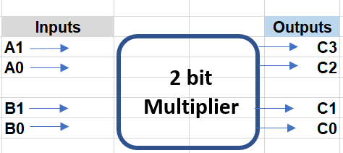
Figure 2 - 2X2 Braun multiplier
The Braun’s multiplier is also known as non-additive multiplier as it does not add an additional operand to the result of multiplication, It is only suitable for applications using up to 16-bits.[3]

Wallace Tree multiplier
The Wallace Tree Multiplier was first developed by Chris Wallace in 1964.
It is used to multiply two binary integers. It’s design is based on the concept of carry save adder. By generating and summing the partial product in parallel it improves in speed and power due to using a critical path through the multiplier.
There are three effective operations:
- Formation of partial products
- Grouping of the formed partial products
- Addition using adders [4]
Wallace tree is the fastest multiplier that uses a count of the number of logic 1’s in the input stage
Inputs |  |  | No of | Outputs
A | B | C | 1’s | Cout | Sum
0 | 0 | 0 | 0 | 0 | 0
0 | 0 | 1 | 1 | 0 | 1
0 | 1 | 0 | 1 | 0 | 1
0 | 1 | 1 | 2 | 1 | 0
1 | 0 | 0 | 1 | 0 | 1
1 | 0 | 1 | 2 | 1 | 0
1 | 1 | 0 | 2 | 1 | 0
1 | 1 | 1 | 3 | 1 | 1
Figure 3 - Wallace tree table
From the table in figure 3 we can see that when the inputs are all 0, the outputs are also 0
Sum is also 0 if the no of 1s is 0 or an even number eg 2
If the no of 1‘s is 3 then the Sum and the carry are both 1

Therefore the output logic can be used as a compressor. A half adder has 2 inputs and 2 outputs, while a full adder has 3 inputs and just 2 outputs, this achieves compression of the calculation. [4]

Compression 3:2 4:3 7:3 8:4

The multiplying signals continue through the structure using the full and half adders until there are only 2 bits left in each position and an output is developed.
A 4x4 has a total of 16 bits.

Wallace tree multiplier functionality

Stage 1 A3 A2 A1 A0
X
B3 B2 B1 B0

A3B0 A2B0 A1B0 A0B0
A3B1 A2B1 A1B1 A0B1
A3B2 A2B2 A1B2 A0B2
A3B3 A2B3 A1B3 A0B3

Figure 4 - Wallace tree function structure
The 1st stage multiplies the least significant bit or LSB of the multipliers partial products B0 with each of the input bits in turn. A0B0,A1BO,A2B0,A3B0 then A0B1,A1B1,A2B1,A3B1 and so on. After the second row it will also include the sum and carry.
The multiplier reduces the number of partial products to two by utilising half and full adders.
The Wallace tree can suffer from critical path delays through the carry and sum circuitry during certain input patterns.

Multiplier Conclusion
If we compare both the Braun and Wallace tree multipliers, the Braun is more simplistic while the Wallace Tree is more efficient and due to its efficiency it has a faster performance. Overall this would demand less power. The final choice of which multiplier to use would come down to the actual application required.

The Braun multiplier is susceptible to glitching problems due to the ripple within the carry aspect of the circuit. [6]

The Wallace tree multiplier may be a slight overkill on smaller multiplication systems, where simpler multiplier construction could be of benefit. Whereas the Braun can take up too much IC space for some compact systems.

Summary table of multiplier comparison
Multiplier | Accuracy | Speed | Area | Efficiency
Braun | Med | Low | High | Low
Wallace Tree | Med | High | Low | High
Figure 5 - Multiplier comparison table

Adders

Half Adder

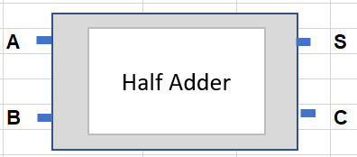
A half adder is a combinational logic circuit, it can be designed by connecting one AND gate and one EX-OR gate. It consists of two inputs ( A+B) both of these add two input digits (one bit numbers) and generate the output in the form of a carry and a sum, these being the output terminals.
Figure 6- Half Adder I/O connections

The output obtained from the AND gate is called the carry, this cannot be forwarded in one addition into another, there is no logic gate to process it, this is why its called the half adder. [4]

The half adder has two inputs A and B and two outputs Sum (S) and Carry (C).
Half adder truth table

Half adder truth table
A | B | Sum (S) | Carry ©
0 | 0 | 0 | 0
0 | 1 | 1 | 0
1 | 0 | 1 | 0
1 | 1 | 0 | 1
Figure 7 - HA Truth Table

Half adder K-map and expressions
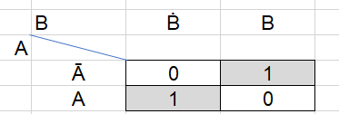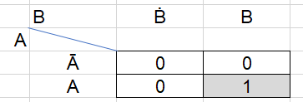
S= A B C = A.B
Figure 8 - HA K-maps

Half adder logic diagram
Half adder logic diagram using an XOr gate with an AND gate
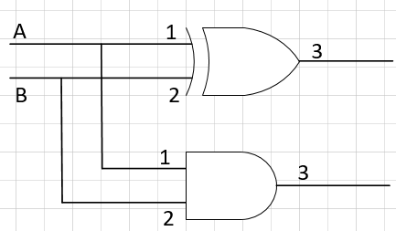
Figure 9 – HA logic cct
expression
S = ĀB. AḂ = A B
C = A.B

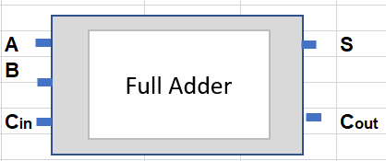
Full Adder
A full adder is a combinational circuit that performs the arithmetic sum of three input bits and produces two outputs, these are the sum and the carry (Cout) [4]

Figure 10 - Full Adder I/O connections

The Full adder has three inputs A, B and Cin and two outputs Sum (S) and Carry (C) or Cout.

Full adder truth table
Full adder truth table
A | B | Cin | Cout | Sum
0 | 0 | 0 | 0 | 0
0 | 0 | 1 | 0 | 1
0 | 1 | 0 | 0 | 1
0 | 1 | 1 | 1 | 0
1 | 0 | 0 | 0 | 1
1 | 0 | 1 | 1 | 0
1 | 1 | 0 | 1 | 0
1 | 1 | 1 | 1 | 1
Figure 11 - FA Truth Table
Full adder K-map – Sum and Carry
Sum
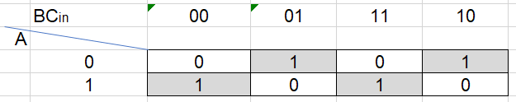

Expression
Sum = AḂĊ + ĀḂC + ABC + ĀBĊ

Full adder K-map
Carry
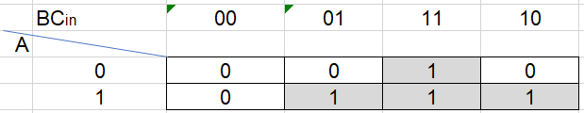
Expression
Cout = AC + BC + AB

Figure 12- FA K-Maps

Full adder Logic diagram
Full adder logic diagram using an XOr, AND and a OR gates.

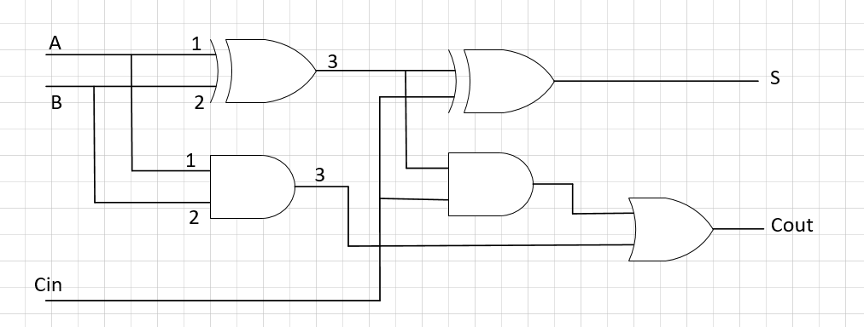
Figure 13 - FA Logic cct

Task 1

Design an 8 bit Braun multiplier

In order to develop the 8 bit multiplier, first stage in development was to understand the structure required. This was illustrated by developing a dot diagram based on the 4bit example shared in lecture 5. [6]

Dot diagram of the Braun 8X8 multiplier
The Wallace tree dot diagram below in figure 14 clearly shows the stages of the program starting with the partial products which are made up of two 8 bit numbers, utilising only two components, the half and full adder until an output is clearly determined.

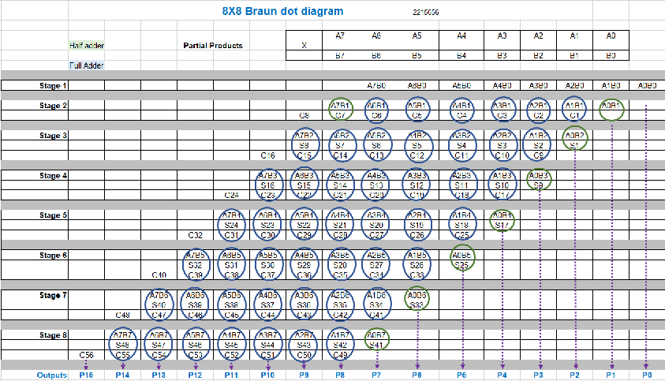
Figure 14 – Braun DOT diagram
Braun Dot diagram
The dot diagram in figure 14 shows the 8X8 Braun multiplier is created using 8 x half and 48 x full adders. The Sum and the Carry were added to complete the structure until after 8 stages of computed signals evolved into 16 outputs P0-P15

8X8 Braun multiplier Logic Structure
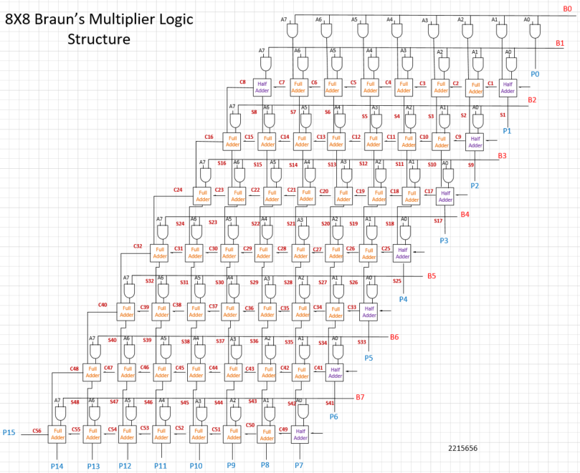
Figure 15 - 8X8 Braun Logic Structure

Braun’s multiplier logic structure summary
Half Adders are coloured purple while the full adders are depicted in Orange.
There are a total of 8 Half Adders and 48 full adders that make up the 8X8 Braun multiplier structure with 64 AND gates linking them with their individual Sum and Carry output signals.
The outputs are coloured blue and identified as P0-P15

Confirming the program
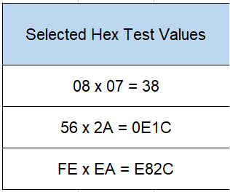
After completing the full Braun Multiplier 8X8 code, the program was verified and checked against an online calculator. As can be seen below in figure 16 separate values were chosen to correctly asses that the multiplier was working correctly.

Figure 16 - Hex test values

Methodology for Braun VHDL verification(inc Wallace)

The first value was given as Hex calculator multiplier in the Vivado software
A, 08 x B, 07

The clock was set to force a leading edge of 1 and a trailing edge of 0 before the force values were inputted in each occasion.
The Force clock 1 + 0, force constant A-08, force constant B-07
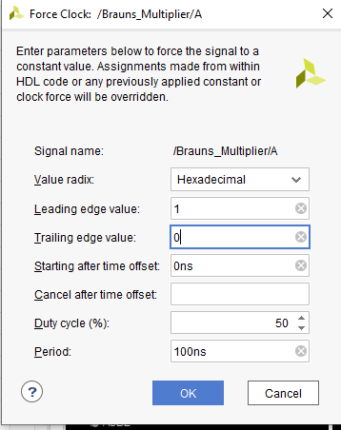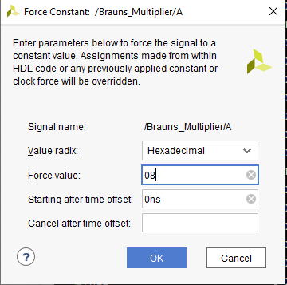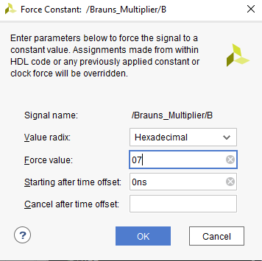
Figure 17 - Clock and force screenshots

Figure 17 shows the screen shots from the actual VHDL program that was utilised to clarify the calculations within the Vivado software
The hex calculations were first simulated using the Braun multiplier VHDL and verified using an online calculator, they were also converted to decimal values to aid the checking process.
Hex Value | Decimal Value
08 x 07=38 | 8 x 7= 56
56 x 2A =E1C | 86 x 42 = 3612
FE x EA = E82C | 254 x 234 =59436
Figure 18 - calculated verification values

Braun VHDL verification
Here the partial screen shots prove the Braun Multiplier was functioning correctly. The outputs directly match the online calculator as expected.
08 x 07 = 38
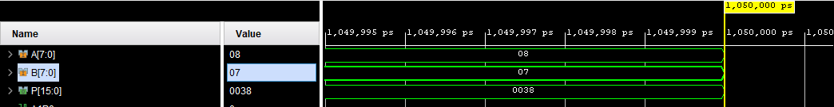
56 x 2A = 0E1C
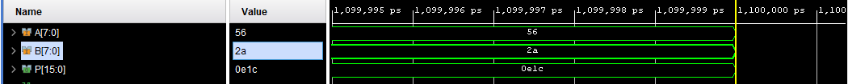
FE x EA = E82C
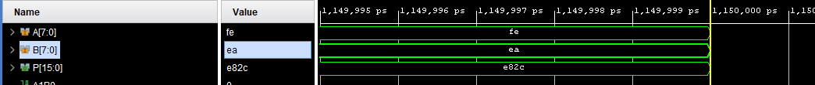
Figure 19 – Braun VHDL verification evidence

The same methodology was also completed for the Wallace tree multiplier in task 2.

Braun multiplier program code
The code for this structure was then written following the examples in the lecture notes from lecture 6+7. [6]
The full code can be found in the appendices.
Sample of Braun multiplier 8X8 code
Brauns Multiplier 8X8
Library IEEE
use IEEE.STD_LOGIC_1164.ALL;
use IEEE.STD_LOGIC_ARITH.ALL;
use IEEE.STD_LOGIC_UNSIGNED.ALL;
entity brauns_multiplier is
Port ( A : in STD_LOGIC_VECTOR (7 downto 0) ;
B : in STD_LOGIC_VECTOR (7 downto 0) ;
P : out STD_LOGIC_VECTOR (15 downto 0)) ;
end brauns_multiplier;

Task 2

Design an 8X8 Wallace multiplier
First a table view was constructed in excel incorporating half and full adders
Half adders are depicted in Green whilst Full Adders are in Blue.
Dot diagram of the Wallace Tree 8X8 multiplier
The Wallace tree dot diagram below in figure 20 clearly shows the stages of the program starting with the partial products which are made up of two 8 bit numbers, utilising only two components, the half and full adder until an output is clearly determined.
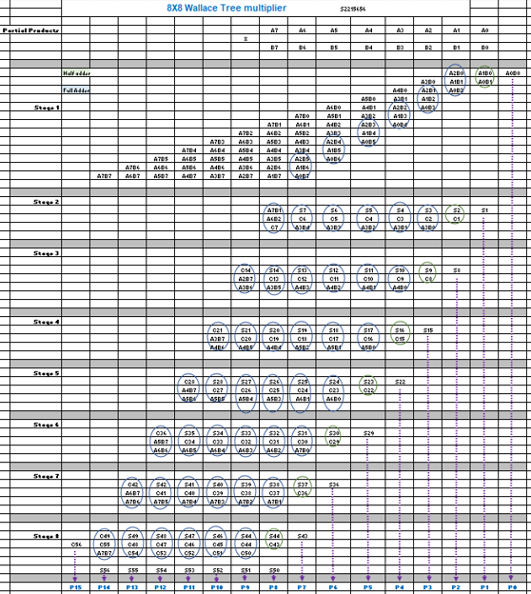
Figure 20 – Wallace tree dot diagram
The Structure for the 8X8 Wallace Tree multiplier was constructed using the drawing software package Visio.
The structure in figure 21 shows the 8X8 Wallace Tree multiplier created using half and full adders. The structure consists of 8x half adders and 48 Full adders. The Sum and the Carry were added to the completed structure. The structure followed the example given in the lecture 5 presentation for the Wallace Tree multiplier 4X4 example. [6]

Wallace Tree Multiplier Logic Structure

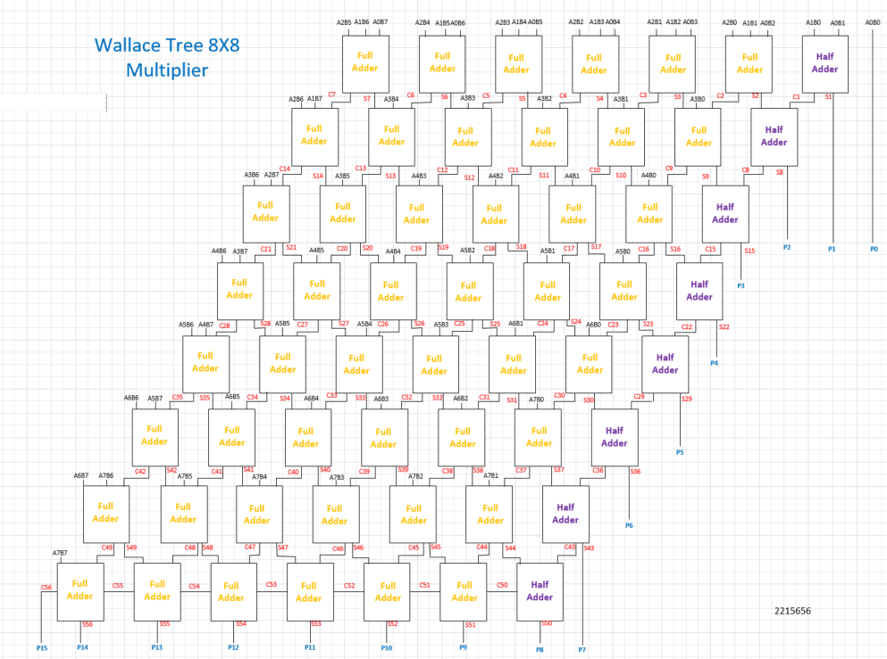
Figure 21 - Wallace tree 8X8 structure

Wallace Tree VHDL verification
The hexadecimal calculations were simulated using the Wallace Tree multiplier as verified using an online calculator as evidenced in the Braun multiplier section of this assignment.

Below are the partial screen shots prove the Braun Multiplier was functioning correctly. The outputs directly match the online calculator as expected.

08 x 07
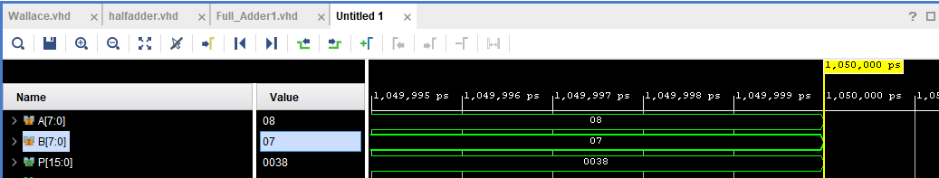
56 x 2A
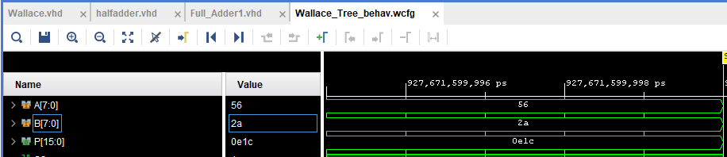
FE x EA
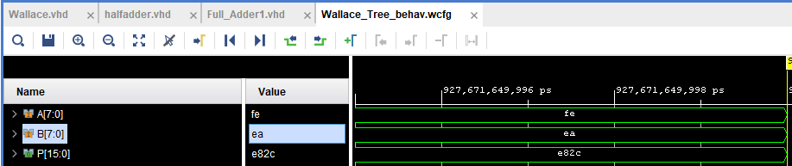
Figure 22 - Wallace tree VHDL verification

The code for this structure was then written following the examples in the lecture notes from lecture 6+7. [1] [5]
The full code can be found in the appendices:-

Sample of Wallace Tree multiplier 8X8 code
Wallace VHDL program
Library IEEE
use IEEE.STD_LOGIC_1164.ALL;
entity wallace is
Port ( A : in STD_LOGIC_VECTOR (7 downto 0) ;
B : in STD_LOGIC_VECTOR (7 downto 0) ;
P : out STD_LOGIC_VECTOR (15 downto 0)) ;
end wallace;
architecture Behavioural of wallace is
component Fulladder is
Port ( A : in STD_LOGIC;
B : in STD_LOGIC;
Cin : in STD_LOGIC;
Sum : out STD_LOGIC);
Cout : out STD_LOGIC;
end component ;
component Halfadder is
Port ( A : in STD_LOGIC;
B : in STD_LOGIC;
Sum : out STD_LOGIC);
Cout : out STD_LOGIC;
end component ;

Task 3

Multiplier performance and comparisons

Evaluation of the results, of both multipliers was then completed to compare the speed and power consumption as determined by using the VHDL software.
We start the critical analysis by comparing the longest delays from both multipliers.

In figure 23 is a full comparison of the overall delay of both multipliers. Their results from running the Vivado multiplier programs include calculations of the suggested delay expected and a comparison of the time delay difference between the actual time delay and the calculated time delay.

For clarity, a sample of 5 signal delays were used to calculate speed differences from both multipliers.

Multiplier speed delay comparison
Braun 8X8 multiplier | Wallace tree 8X8 multiplier
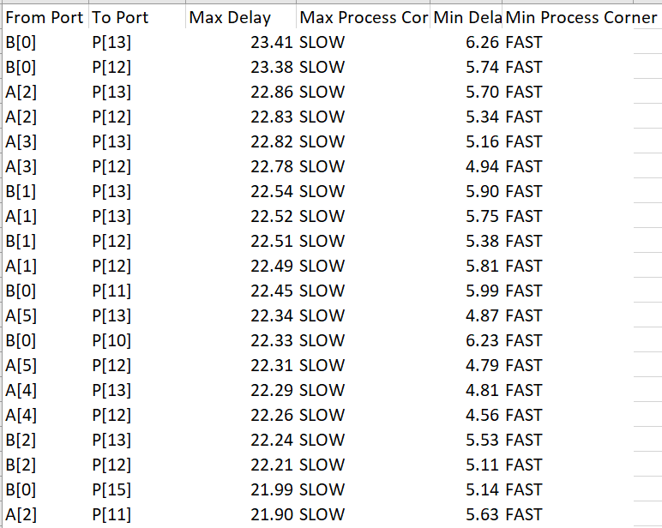 | 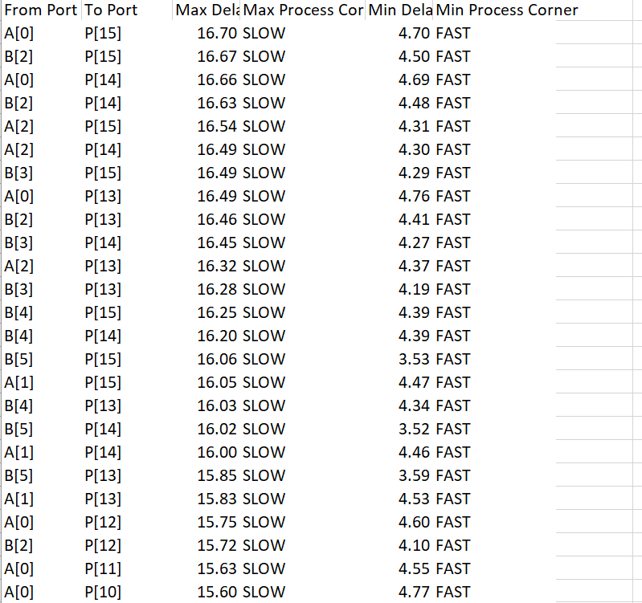
B0-P13 Max Delay time 23.41ns | A0-P15 Max Delay time 16.70 ns
A sample of 5 various time delays were compared and placed in the table below to help evidence the summary of time delays.

Time Delay |  | Braun | Wallace
From Port | To Port | delay ns | delay ns
A0 | P15 | 18.64 | 16.70
B2 | P15 | 20.82 | 16.67
A0 | P14 | 20.95 | 16.66
B2 | P14 | 20.33 | 16.63
A2 | P15 | 21.45 | 16.54
Total |  | 102.19 | 83.20

Figure 23 - multiplier speed comparison table

Multiplier calculated delay comparison
Braun | Wallace Tree
To calculate the longest delay we used the following:-  AND gate delay is t_{g = 1ns}  ½ or Full adder delay is t_{ad = 2ns}  The critical path on the Braun Multiplier is from port B0-P13  The critical signal path encompasses 8 AND gates, 7 halfadders and 6 Full adders  AND gate delay is t_{g = 8ns}  ½ or Full adder delay is t_{ad = 26ns}  t_{ad = 34ns}  Total delay time for the critical path is 34ns | To calculate the longest delay we used the following:-  AND gate delay is t_{g = 1ns}  ½ or Full adder delay is t_{ad = 2ns}  The critical path on the Wallace tree Multiplier is from port A0-P15  The critical signal path encompasses 8 halfadders and 6 Full adders  t_{g = 0ns}  t_{ad = 28ns}  Total delay time for the critical path is 28ns
- Comparison between actual and calculated time delays between the multipliers are:
Actual 23.41ns  Calculated 34.00ns  Difference 10.59ns | Actual 16.70 ns  Calculated 28.00ns  Difference 11.30ns
Figure 24- Delay time comparison table

Summary of the actual and simulated time delays
The manual calculations on signal time delay for both multipliers was misleading and does not reflect the actual real world system. In the case of the Wallace the calculated value was almost 67% higher than the actual value and the Braun was 45% higher. This could add up to a significant misinterpretation when used solely at the design stage.

Critical paths
Braun’s multiplier critical path
The critical path for the Braun’s multiplier incorporates the signal passing from ports B0 through the logic structure to P13, the signal delay is made up of 8 AND gates, 7 half adders and 6 Full adders as can be seen in the highlighted logic structure in figure 24
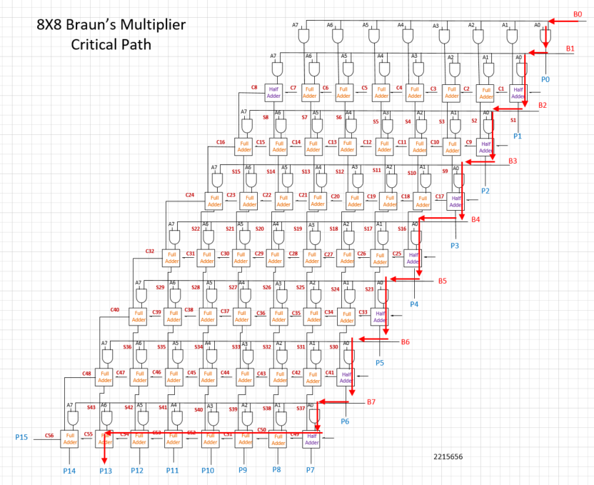
Figure 25 - Braun Critical Path

Wallace Tree multiplier critical path

The critical path for the Wallace tree multiplier incorporates the signal passing from ports A0 through the logic structure to P15, the signal delay is made up of 8 half adders and 6 Full adders as can be seen in the highlighted logic structure in figure 25

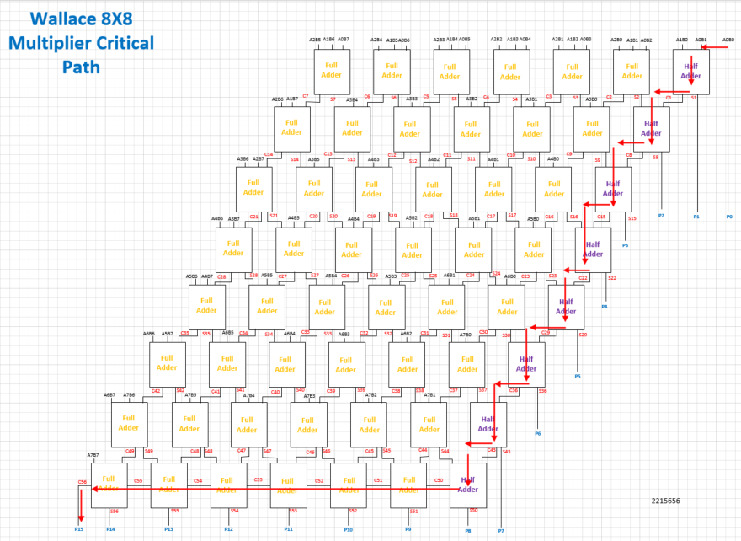
Figure 26 - Wallace Tree Critical path

Braun VHDL critical path schematic
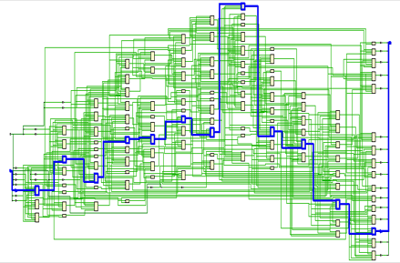
Figure 27 - Braun critical path schematic
Wallace Tree VHDL critical path schematic
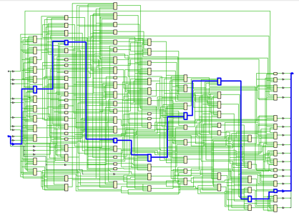
Figure 28 - Wallace VHDL critical path schematic

Multipliers critical path summary
From figures 26 +27 , both multipliers fail to take a more direct route through the logic to ascertain the function, this could be because the pin option (figure 28) chosen was not studied and selected for best overall performance.
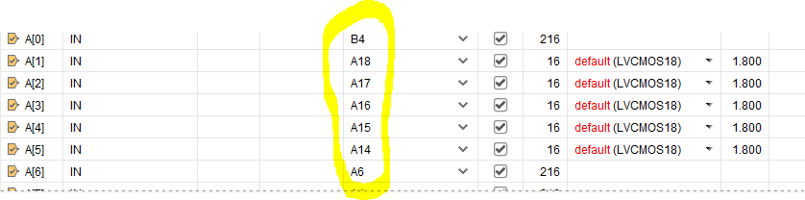
Figure 29- Pin allocation

Multiplier comparisons
From the VHDL software screen shots in figure 28 we can quickly compare both multipliers schematics, reports, timing summary, power summary, design and IC view.

Braun |  | Wallace Tree
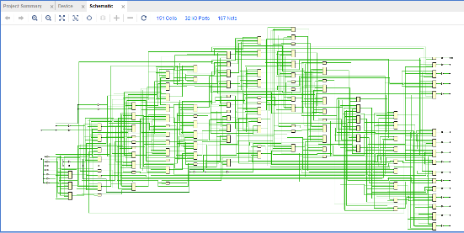 | Synthesized design Schematic | 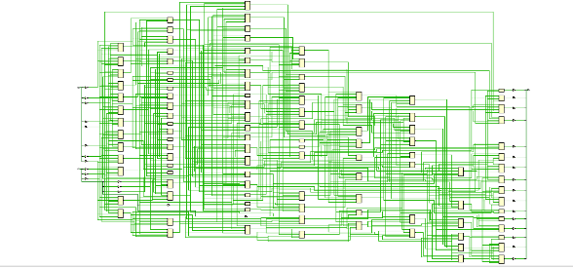
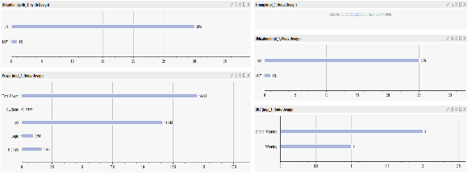 | Report Summary
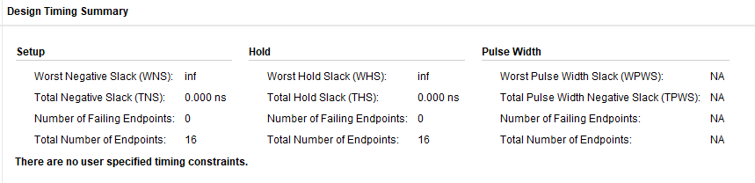 | Design Timing Summary, showing WNS of 0 | 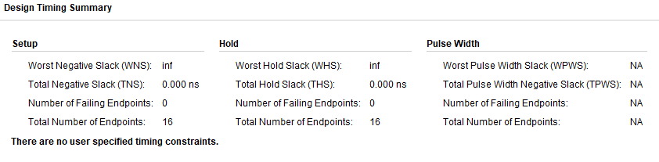
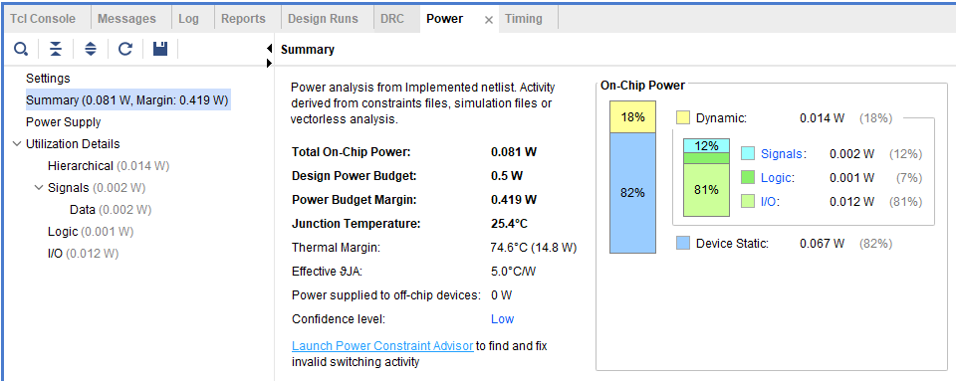 | Power Summary | 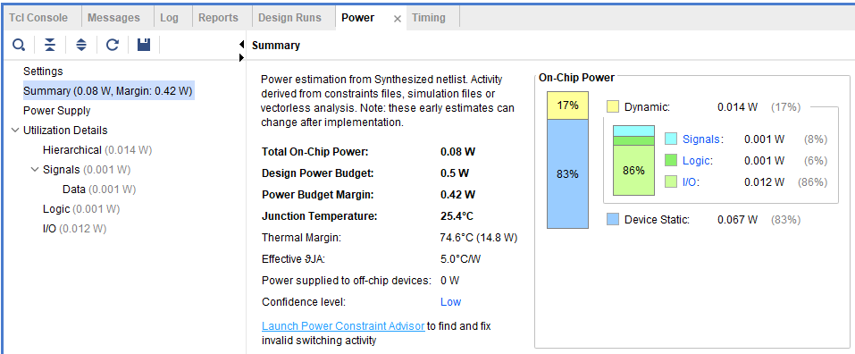
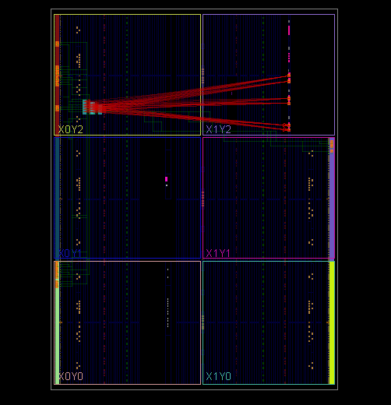 | Synthesise design | 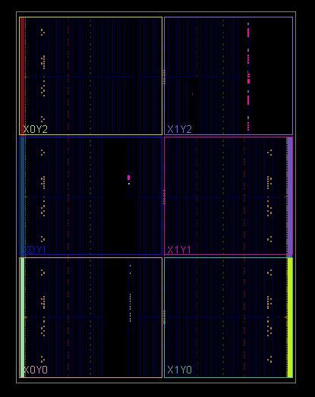
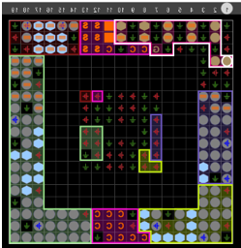 | IC view | 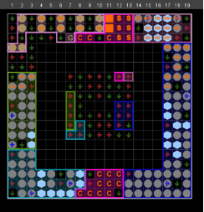
Figure 30 - Multiplier comparison screen shot table

Timing summary
To check the delay of the signal an external clock was used and the timing summary was recorded for both multipliers.

Braun design timing summary
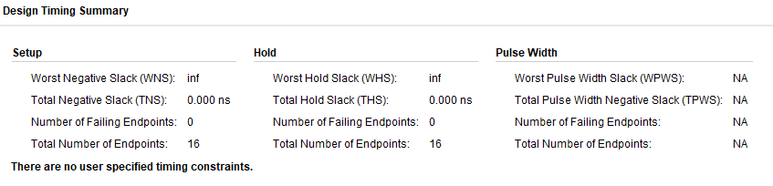
Figure 31 – Braun Timing summary
Implementation-
- Worst negative slack (WNS) :- There is no signal missing the timing
- Total negative slack (TNS) :-There is no slack in the timing
- Number of falling Endpoints :- There are no 0 endpoints that are not meeting the specified timing constraints, therefore no violations present.
- Total number of end points 16 :- This is a true representation of the endpoints in the design that are subjected to the timing analysis.

Wallace design timing summary

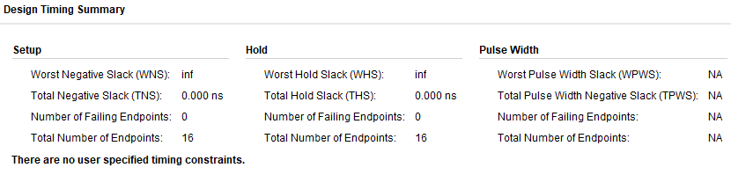
Figure 32 – Wallace tree Timing summary
Implementation-
- Worst negative slack (WNS) :- There is no signal missing the timing
- Total negative slack (TNS) :-There is no slack in the timing
- Number of falling Endpoints :- There are no 0 endpoints that are not meeting the specified timing constraints, therefore no violations present.
- Total number of end points 16 :- This is a true representation of the endpoints in the design that are subjected to the timing analysis.

Braun RTL design
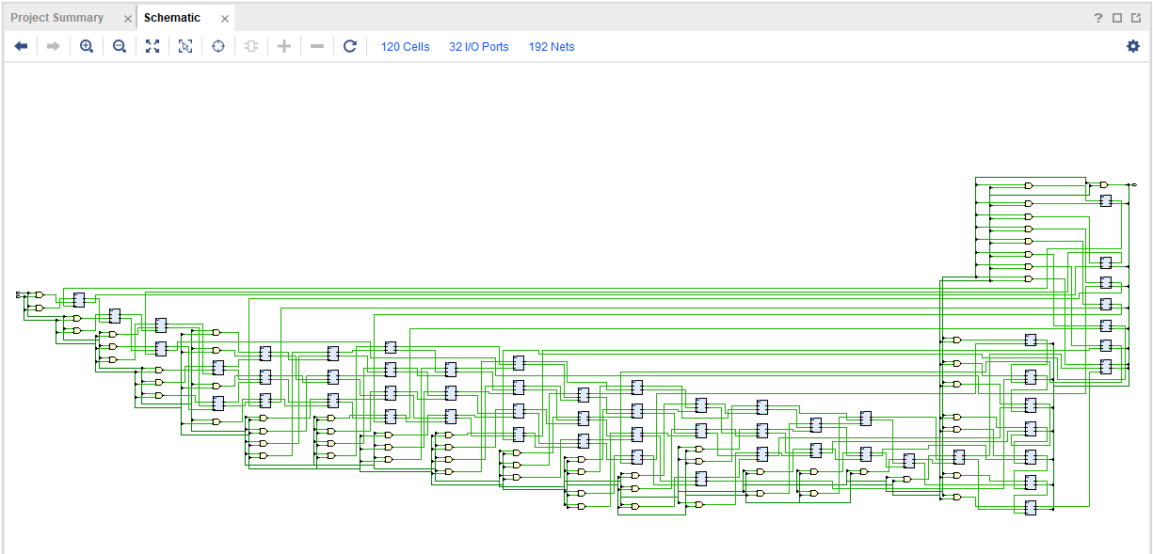
Figure 33 - Braun RTL design logic

Wallace RTL Design
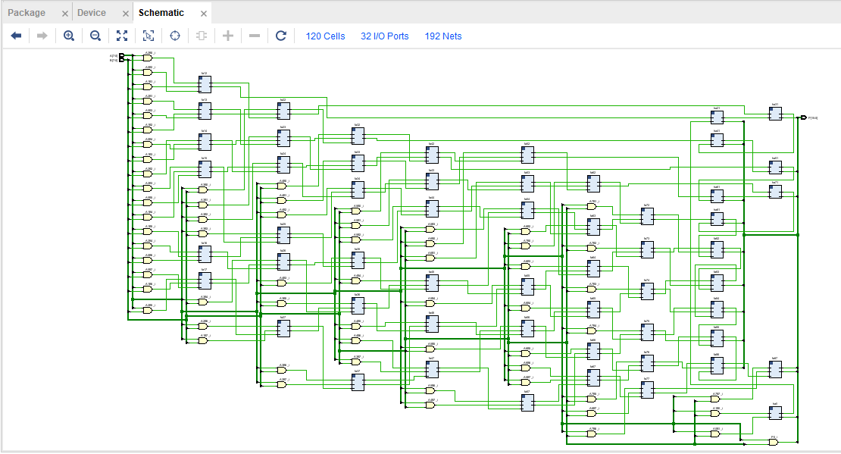
Figure 34 - Wallace RTL design logic

Speed and Power Comparisons

As can be seen from a sample of the signal time delays below, after just 5 calculations the Wallace is almost 20% faster.
Speed
Braun |  |  |  | Wallace
From | To | delay ns |  | From | To | delay ns
A0 | P15 | 18.64 |  | A0 | P15 | 16.70
B2 | P15 | 20.82 |  | B2 | P15 | 16.67
A0 | P14 | 20.95 |  | A0 | P14 | 16.66
B2 | P14 | 20.33 |  | B2 | P14 | 16.63
A2 | P15 | 21.45 |  | A2 | P15 | 16.54
Total |  | 102.19 |  | Total |  | 83.20

Figure 35 - Speed comparison table
Power
As shown here, the power demanded by the IC’s is extremely low on both multipliers.
Braun power summary

Wallace Tree power summary
Figure 36 - Power comparisons
 | Braun | Wallace
Power Consumption Watts (W)
Total on -Chip power | 0.081 | 0.081
Design Power Budget | 0.05 | 0.05
Power budget margin | 0.419 | 0.42
Junc temp | 25.4°C | 25.4°C
Therm margin | 74.6°C | 74.6°C
On-Chip Power | 18% | 17%
Figure 37 - Power comparison table

Power and Speed summary
From the testing and comparisons made in the Vivado software the Wallace tree multiplier is a very high speed low power multiplier and when compared to the Braun, after a small sample of just 5 compute’s the Wallace tree is almost 20% faster. Due to very little demand placed on the IC’s when running these simulation systems it has shown that they would handle multiple compute’s with ease as there is very little power demanded when running.
Overall the Wallace’s speed is far superior. The power difference required by each IC is almost identical, with the Wallace having a slight advantage.

System Operational Flow Chart
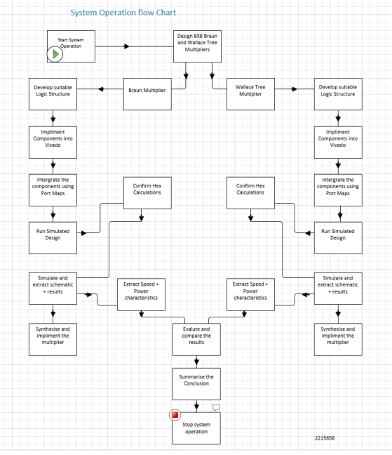
Figure 38 - System flow chart

Conclusion
During the investigative part of the report on the functional characteristics it was noted that the IC was demanding power over 14watts. This was down to a connection error during the pin allocation section of the Wallace tree multiplier and once corrected the power returned to 0.08 watts as expected.
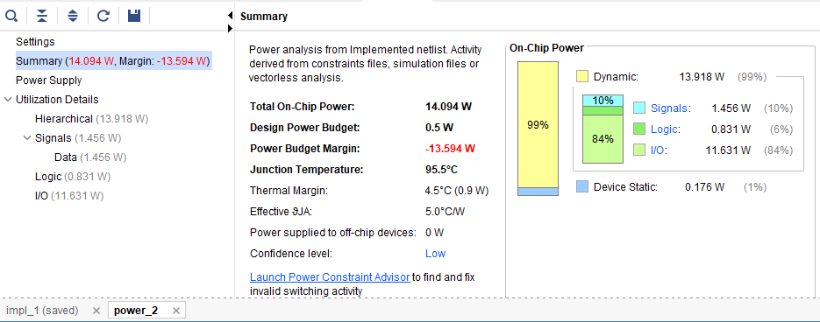
Figure 39 - Power consumption error
Power error summary
If I were to carry out this procedure again I would be interested to spend more time on pin allocation to see if this effects the speed and power as I feel this is a major factor in optimising the design aspect of the circuits.
Another learning curve was when I made a typo during the development of the Braun code, this was finally rectified and the errors cleared but the error took up a lot of investigative time and effort. An error was found on P5 but after cross referencing the structure in the code, line 185 was entered as S29 and was altered to S19 following the alteration the multiplier ran as expected. Pin allocation was also a factor that contributed to the error messages within vivado.

Error message evidence 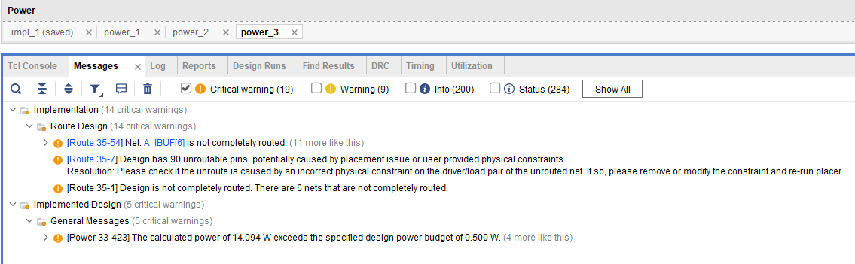
Figure 40 – Vivado error messages

Both Wallace and Braun have their advantages and disadvantages when it comes to their individual aspects. Suitable multiplier selection as the design phase is a key learning from this study.
Incorrect multiplier selection could be overkill, costly, larger in size than required and expensive to run over a long period of time.
Overall I consider the study to be a success as I was able to formulate the program code after developing the dot and logic diagrams. Errors in the program add to the investigative learnings.

Recommendations

To help optimise and improve the overall performance of the multipliers would have to be thought of at the design phase as selecting the correct multiplier for the system is an obvious advantage.
Altering critical paths, effected during pin allocation and minimising power consumption would easily improve the efficiencies of the multipliers. Any reduction in transistors space would be a great advantage. As mentioned, correct multiplier selection for task is key.
To help improve the Wallace tree multiplier the partial products could be readjusted in a reverse style pyramid style, this would make it easier to analyse the tree for efficient reduction. [6]

Bibliography

[1] | M. J. P. Devaraj, “Introduction to VHDL,” Electronics II, vol. lecture 6, p. 28, 2022.
[2] | S. C. Avinash, “Design and Implementation of Braun Multiplier,” International Journal of Engineering and Advanced Technology, vol. 9, no. 4, p. 4, 2020.
[3] | M. Bansal, “Comparison between conventional fast multipliers,” IOP, 2021, p. 13.
[4] | MADHU GUDHIMETLA, “Comparison of different types of multipliers with respect to speed, area and power,” International Journal of Industrial Electronics and Electrical Engineering, Dec 2017.
[5] | Hemalatha K N + Dr. Sangeetha B G, “Efficient Design of Compact 8- bit Wallace Tree Multiplier,” I. J. Engineering and Manufacturing, 2022, p. 8.
[6] | V. K. a. H. Saini, “A Review on Comparative Performance analysis of different digial multipliers,” in Advances in Computational Sciences and Technology, Research India, p. 16.
[7] | M. J. P. Devaraj, “Electronics II,” Combinational Circuits, vol. Lecture 4, p. 23, 2023.
[8] | M. J. P. Devaraj, “Electronics II,” in Combinational Circuits- Binary Multipliers, 2023, p. 14.

Appendices

Braun multiplier 8X8 VHDL program
Half adder example
Library IEEE
use IEEE.STD_LOGIC_1164.ALL;
entity half_adder is
Port ( A : in STD_LOGIC;
B : in STD_LOGIC;
Sum : out STD_LOGIC);
Cout : out STD_LOGIC;
end half_adder;
architecture gate_level of half_adder is
begin
S <= A XOR B ;
Cout <= (A and B) ;
end gate level;
Full adder example
Library IEEE
use IEEE.STD_LOGIC_1164.ALL;
entity full_adder is
Port ( A : in STD_LOGIC;
B : in STD_LOGIC;
Cin : in STD_LOGIC;
S : out STD_LOGIC);
Cout : out STD_LOGIC;
end full_adder;
architecture gate_level of half_adder is
begin
S <= A XOR B XOR Cin ;
Cout <= (A and B) OR (Cin AND A) OR (Cin AND B) ;
end gate level;
Brauns Multiplier 8X8
Library IEEE
use IEEE.STD_LOGIC_1164.ALL;
use IEEE.STD_LOGIC_ARITH.ALL;
use IEEE.STD_LOGIC_UNSIGNED.ALL;
entity brauns_multiplier is
Port ( A : in STD_LOGIC_VECTOR (7 downto 0) ;
B : in STD_LOGIC_VECTOR (7 downto 0) ;
P : out STD_LOGIC_VECTOR (15 downto 0)) ;
end brauns_multiplier;
architecture Behavioural of brauns multiplier is
signal A0B0 : std_logic ;
signal A1B0 : std_logic ;
signal A0B1 : std_logic ;
signal A2B0 : std_logic ;
signal A1B1 : std_logic ;
signal A0B2 : std_logic ;
signal A3B0 : std_logic ;
signal A2B1 : std_logic ;
signal A1B2 : std_logic ;
signal A0B3 : std_logic ;
signal A4B0 : std_logic ;
signal A3B1 : std_logic ;
signal A2B2 : std_logic ;
signal A1B3 : std_logic ;
signal A0B4 : std_logic ;
signal A5B0 : std_logic ;
signal A4B1 : std_logic ;
signal A3B2 : std_logic ;
signal A2B3 : std_logic ;
signal A1B4 : std_logic ;
signal A0B5 : std_logic ;
signal A6B0 : std_logic ;
signal A5B1 : std_logic ;
signal A4B2 : std_logic ;
signal A3B3 : std_logic ;
signal A2B4 : std_logic ;
signal A1B5 : std_logic ;
signal A0B6 : std_logic ;
signal A7B0 : std_logic ;
signal A6B1 : std_logic ;
signal A5B2 : std_logic ;
signal A4B3 : std_logic ;
signal A3B4 : std_logic ;
signal A2B5 : std_logic ;
signal A1B6 : std_logic ;
signal A0B7 : std_logic ;
signal A7B1 : std_logic ;
signal A6B2 : std_logic ;
signal A5B3 : std_logic ;
signal A4B4 : std_logic ;
signal A3B5 : std_logic ;
signal A2B6 : std_logic ;
signal A1B7 : std_logic ;
signal A7B2 : std_logic ;
signal A6B3 : std_logic ;
signal A5B4 : std_logic ;
signal A4B5 : std_logic ;
signal A3B6 : std_logic ;
signal A2B7 : std_logic ;
signal A7B3 : std_logic ;
signal A6B4 : std_logic ;
signal A5B5 : std_logic ;
signal A4B6 : std_logic ;
signal A3B7 : std_logic ;
signal A7B4 : std_logic ;
signal A6B5 : std_logic ;
signal A5B6 : std_logic ;
signal A4B7 : std_logic ;
signal A7B5 : std_logic ;
signal A6B6 : std_logic ;
signal A5B7 : std_logic ;
signal A7B6 : std_logic ;
signal A6B7 : std_logic ;
signal A7B7 : std_logic ;
signal S1 : std_logic ;---P1
signal C1 : std_logic ;---P2
signal S2 : std_logic ;
signal C2 : std_logic ;---P3
signal S3 : std_logic ;
signal C9 : std_logic ;
signal S9 : std_logic ;
signal C3 : std_logic ;---P4
signal S4 : std_logic ;
signal C10 : std_logic ;
signal S10 : std_logic ;
signal C17 : std_logic ;
signal S16 : std_logic ;
signal C4 : std_logic ;---P5
signal S5 : std_logic ;
signal C11 : std_logic ;
signal S11 : std_logic ;
signal C18 : std_logic ;
signal S17 : std_logic ;
signal C25 : std_logic ;
signal S23 : std_logic ;
signal C5 : std_logic ;---P6
signal S6 : std_logic ;
signal C12 : std_logic ;
signal S12 : std_logic ;
signal C19 : std_logic ;
signal S18 : std_logic ;
signal C26 : std_logic ;
signal S24 : std_logic ;
signal S33 : std_logic ;
signal S30 : std_logic ;
signal C6 : std_logic ;---P7
signal S7 : std_logic ;
signal C13 : std_logic ;
signal S13 : std_logic ;
signal C20 : std_logic ;
signal S19 : std_logic ;
signal C27 : std_logic ;
signal S25 : std_logic ;
signal C34 : std_logic ;
signal S31 : std_logic ;
signal S41 : std_logic ;
signal S37 : std_logic ;
signal C7 : std_logic ;---P8
signal S8 : std_logic ;
signal C14 : std_logic ;
signal S14 : std_logic ;
signal C21 : std_logic ;
signal S20 : std_logic ;
signal C28 : std_logic ;
signal S26 : std_logic ;
signal S35 : std_logic ;
signal S32 : std_logic ;
signal S42 : std_logic ;
signal S38 : std_logic ;
signal C49 : std_logic ;
signal C8 : std_logic ;---P9
signal C15 : std_logic ;
signal S15 : std_logic ;
signal C22 : std_logic ;
signal S21 : std_logic ;
signal C29 : std_logic ;
signal S27 : std_logic ;
signal C36 : std_logic ;
signal S33 : std_logic ;
signal C43 : std_logic ;
signal S39 : std_logic ;
signal C50 : std_logic ;
signal C16 : std_logic ;---P10
signal C23 : std_logic ;
signal S22 : std_logic ;
signal C30 : std_logic ;
signal S28 : std_logic ;
signal C37 : std_logic ;
signal S34 : std_logic ;
signal C44 : std_logic ;
signal S40 : std_logic ;
signal C51 : std_logic ;
signal C24 : std_logic ;---P11
signal C31 : std_logic ;
signal S29 : std_logic ;
signal C38 : std_logic ;
signal S35 : std_logic ;
signal C45 : std_logic ;
signal S41 : std_logic ;
signal C52 : std_logic ;
signal C32 : std_logic ;---P12
signal C39 : std_logic ;
signal S36 : std_logic ;
signal C46 : std_logic ;
signal S42 : std_logic ;
signal C53 : std_logic ;
signal C40 : std_logic ;---P13
signal C47 : std_logic ;
signal S43 : std_logic ;
signal C54 : std_logic ;
signal C48 : std_logic ;---P14
signal C55 : std_logic ;
signal C56 : std_logic ;---P15
component full_adder
Port (A : in STD_LOGIC;
B : IN STD_LOGIC;
Cin : STD_LOGIC;
Sum : out STD_LOGIC;
Cout : STD_LOGIC;
end component;
component half_adder
Port (A : in STD_LOGIC;
B : IN STD_LOGIC;
Sum : out STD_LOGIC;
Cout : STD_LOGIC;
end component;
begin
signal A1B0 <= A (1) and B(0) ;
signal A0B1 <= A (0) and B(1) ;
signal A2B0 <= A (2) and B(0) ;
signal A1B1 <= A (1) and B(1) ;
signal A0B2 <= A (0) and B(2) ;
signal A3B0 <= A (3) and B(0) ;
signal A2B1 <= A (2) and B(1) ;
signal A1B2 <= A (1) and B(2) ;
signal A0B3 <= A (0) and B(3) ;
signal A4B0 <= A (4) and B(0) ;
signal A3B1 <= A (3) and B(1) ;
signal A2B2 <= A (2) and B(2) ;
signal A1B3 <= A (1) and B(3) ;
signal A0B4 <= A (0) and B(4) ;
signal A5B0 <= A (5) and B(0) ;
signal A4B1 <= A (4) and B(1) ;
signal A3B2 <= A (3) and B(2) ;
signal A2B3 <= A (2) and B(3) ;
signal A1B4 <= A (1) and B(4) ;
signal A0B5 <= A (0) and B(5) ;
signal A6B0 <= A (6) and B(0) ;
signal A5B1 <= A (5) and B(1) ;
signal A4B2 <= A (4) and B(2) ;
signal A3B3 <= A (3) and B(3) ;
signal A2B4 <= A (2) and B(4) ;
signal A1B5 <= A (1) and B(5) ;
signal A0B6 <= A (0) and B(6) ;
signal A7B0 <= A (7) and B(0) ;
signal A6B1 <= A (6) and B(1) ;
signal A5B2 <= A (5) and B(2) ;
signal A4B3 <= A (4) and B(3) ;
signal A3B4 <= A (3) and B(4) ;
signal A2B5 <= A (2) and B(5) ;
signal A1B6 <= A (1) and B(6) ;
signal A0B7 <= A (0) and B(7) ;
signal A7B1 <= A (7) and B(1) ;
signal A6B2 <= A (6) and B(2) ;
signal A5B3 <= A (5) and B(3) ;
signal A4B4 <= A (4) and B(4) ;
signal A3B5 <= A (3) and B(5) ;
signal A2B6 <= A (2) and B(6) ;
signal A1B7 <= A (1) and B(7) ;
signal A7B2 <= A (7) and B(2) ;
signal A6B3 <= A (6) and B(3) ;
signal A5B4 <= A (5) and B(4) ;
signal A4B5 <= A (4) and B(5) ;
signal A3B6 <= A (3) and B(6) ;
signal A2B7 <= A (2) and B(7) ;
signal A7B3 <= A (7) and B(3) ;
signal A6B4 <= A (6) and B(4) ;
signal A5B5 <= A (5) and B(5) ;
signal A4B6 <= A (4) and B(6) ;
signal A3B7 <= A (3) and B(7) ;
signal A7B4 <= A (7) and B(4) ;
signal A6B5 <= A (6) and B(5) ;
signal A5B6 <= A (5) and B(6) ;
signal A4B7 <= A (4) and B(7) ;
signal A7B5 <= A (7) and B(5) ;
signal A6B6 <= A (6) and B(6) ;
signal A5B7 <= A (5) and B(7) ;
signal A7B6 <= A (7) and B(6) ;
signal A6B7 <= A (6) and B(7) ;
signal A7B7 <= A (7) and B(7) ;
P0 : P (0) <= A (0) and B (0) ;
P1 : half_adder port map ( A1B0 ,A0B1 ,P (1) , C1) ;
S2_1 fulladder port map ( A2B0, A1B1 , C1, S2, C2) ;
P2 : halfadder port map ( A0B2, S2, P (2), C9) ;
S3_1 : fulladder port map (A3B0, A2B1,C2,S3,C3) ;
S9_1 : fulladder port map (A1B2, C9, S9, C10) ;
P3 : halfadder port map (A0B3, S9, P (3) C17) ;
S4_1 fulladder port map ( A3B1, A4B0, C3,S4, C4) ;
S10_1 fulladder port map (A2B2, C10,S10,C11) ;
S16_1 fulladder port map (A1B3, C17,S16,C18) ;
P4 : halfadder port map (A0B4, S16, P (4) C25) ;
S5_1 fulladder port map ( A4B1, A5B0, C4,S5, C5) ;
S11_1 fulladder port map (A3B2, C11,S11,C12) ;
S17_1 fulladder port map (A2B3, C18,S17,C19) ;
S23_1 fulladder port map (A1B4, C12,S23,C26) ;
P5 : halfadder port map (A0B5, S23, P (5) C33) ;
S6_1 fulladder port map ( A5B1, A6B0, C5,S6, C6) ;
S12_1 fulladder port map (A4B2, C12,S12,C13) ;
S18_1 fulladder port map (A3B3, C19,S18,C20) ;
S24_1 fulladder port map (A2B4, C26,S24,C27) ;
S30_1 fulladder port map (A1B5, C33,S30,C34) ;
P6 : halfadder port map (A0B6, S30, P (6) C41) ;
S7_1 fulladder port map ( A6B1, A7B0, C6,S7, C7) ;
S13_1 fulladder port map (A5B2, C13,S13,C14) ;
S19_1 fulladder port map (A4B3, C20,S19,C21) ;
S25_1 fulladder port map (A3B4, C27,S25,C28) ;
S31_1 fulladder port map (A2B5, C34,S31,C35) ;
S37_1 fulladder port map (A1B6, C41,S37,C42) ;
P7 : halfadder port map (A0B7, S37, P (7) C49) ;
S8 : halfadder port map (A7B1, C7, S8, C8) ;
S14_1 fulladder port map ( A6B2, C14,S14, C15) ;
S20_1 fulladder port map (A5B3, C21,S20,C22) ;
S26_1 fulladder port map (A4B4, C28,S26,C29) ;
S32_1 fulladder port map (A3B5, C35,S32,C36) ;
S38_1 fulladder port map (A2B6, C42,S38,C43) ;
P8 : fulladder port map (A1B7, C49, P (8),C50) ;
S15_1 fulladder port map ( A7B2, C15,S15, C16) ;
S21_1 fulladder port map (A6B3, C22,S21,C23) ;
S27_1 fulladder port map (A5B4, C29,S27,C30) ;
S33_1 fulladder port map (A4B5, C36,S33,C37) ;
S39_1 fulladder port map (A3B6, C43,S39,C44) ;
P9 : fulladder port map (A2B7, C50, P (9),C51) ;
S22_1 fulladder port map ( A7B3, C23,S22, C24) ;
S28_1 fulladder port map (A6B4, C30,S22,C31) ;
S34_1 fulladder port map (A5B5, C37,S34,C38) ;
S40_1 fulladder port map (A4B6, C44,S40,C45) ;
P10 : fulladder port map (A3B7, C51, P (10),C52) ;
S29_1 fulladder port map (A7B4, C31,S29,C32) ;
S35_1 fulladder port map (A6B5, C35,S35,C39) ;
S41_1 fulladder port map (A5B6, C44,S40,C45) ;
P11 : fulladder port map (A3B7, C51, P (10),C52) ;
S36_1 fulladder port map (A7B5, C39,S36,C40) ;
S42_1 fulladder port map (A6B6, C46,S42,C47) ;
P12 : fulladder port map (A5B7, C53, P (12),C54) ;
S43_1 fulladder port map (A7B6, C47,S43,C48) ;
P13 : fulladder port map (A6B7, C54, P (13),C55) ;
P14 : fulladder port map (A7B7, C55, P (14),C56) ;
P15 : P (15) <= C56 ;
end behavioural ;

Wallace tree Multiplier 8X8 VHDL program
Library IEEE
use IEEE.STD_LOGIC_1164.ALL;
entity wallace is
Port ( A : in STD_LOGIC_VECTOR (7 downto 0) ;
B : in STD_LOGIC_VECTOR (7 downto 0) ;
P : out STD_LOGIC_VECTOR (15 downto 0)) ;
end wallace;
architecture Behavioural of wallace is
component Fulladder is
Port ( A : in STD_LOGIC;
B : in STD_LOGIC;
Cin : in STD_LOGIC;
Sum : out STD_LOGIC);
Cout : out STD_LOGIC;
end component ;
component Halfadder is
Port ( A : in STD_LOGIC;
B : in STD_LOGIC;
Sum : out STD_LOGIC);
Cout : out STD_LOGIC;
end component ;
signal
S2,S3,S4,S5,S6,S7,S8,S9,
S10,S11,S12,S13,S14,S15,S16,S17,S18,S19,
S20,S21,S22,S23,S24,S25,S26,S27,S28,S29,
S30,S31,S32,S33,S34,S35,S36,S37,S38,S39,
S40,S41,S42,S43,S44,S45,S46,S47,S48,S49,
S50,S51,S52,S53,S54,S55,S56: std_logic ;

signal
C1,C2,C3,C4,C5,C6,C7,C8,C9,
C10,C11,C12,C13,C14,C15,C16,C17,C18,C18,C19,
C20,C21,C22,C23,C24,C25,C26,C27,C28,C29,
C30,C31,C32,C33,C34,C35,C36,C37,C38,C39,
C40,C41,C42,C43,C44,C45,C46,C47,C48,C49,
C50,C51,C52,C53,C54,C55,C56: std_logic ;
signal A1B0 : std_logic ;
signal A2B0 : std_logic ;
signal A3B0 : std_logic ;
signal A4B0 : std_logic ;
signal A5B0 : std_logic ;
signal A6B0 : std_logic ;
signal A7B0 : std_logic ;
signal A0B1 : std_logic ;
signal A1B1 : std_logic ;
signal A2B1 : std_logic ;
signal A3B1 : std_logic ;
signal A4B1 : std_logic ;
signal A5B1 : std_logic ;
signal A6B1 : std_logic ;
signal A7B1 : std_logic ;
signal A0B2 : std_logic ;
signal A1B2 : std_logic ;
signal A2B2 : std_logic ;
signal A3B2 : std_logic ;
signal A4B2 : std_logic ;
signal A5B2 : std_logic ;
signal A6B2 : std_logic ;
signal A7B2 : std_logic ;
signal A0B3 : std_logic ;
signal A1B3 : std_logic ;
signal A2B3 : std_logic ;
signal A3B3 : std_logic ;
signal A4B3 : std_logic ;
signal A5B3 : std_logic ;
signal A6B3 : std_logic ;
signal A7B3 : std_logic ;
signal A0B4 : std_logic ;
signal A1B4 : std_logic ;
signal A2B4 : std_logic ;
signal A3B4 : std_logic ;
signal A4B4 : std_logic ;
signal A5B4 : std_logic ;
signal A6B4 : std_logic ;
signal A7B4 : std_logic ;
signal A0B5 : std_logic ;
signal A1B5 : std_logic ;
signal A2B5 : std_logic ;
signal A3B5 : std_logic ;
signal A4B5 : std_logic ;
signal A5B5 : std_logic ;
signal A6B5 : std_logic ;
signal A7B5 : std_logic ;
signal A0B6 : std_logic ;
signal A1B6 : std_logic ;
signal A2B6 : std_logic ;
signal A3B6 : std_logic ;
signal A4B6 : std_logic ;
signal A5B6 : std_logic ;
signal A6B6 : std_logic ;
signal A7B6 : std_logic ;
signal A0B7 : std_logic ;
signal A1B7 : std_logic ;
signal A2B7 : std_logic ;
signal A3B7 : std_logic ;
signal A4B7 : std_logic ;
signal A5B7 : std_logic ;
signal A6B7 : std_logic ;
signal A7B7 : std_logic ;
begin
signal A1B0 <= A (1) and B (0) ;
signal A2B0 <= A (2) and B (0) ;
signal A3B0 <= A (3) and B (0) ;
signal A4B0 <= A (4) and B (0) ;
signal A5B0 <= A (5) and B (0) ;
signal A6B0 <= A (6) and B (0) ;
signal A7B0 <= A (7) and B (0) ;
signal A0B1 <= A (0) and B (1) ;
signal A1B1 <= A (1) and B (1) ;
signal A2B1 <= A (2) and B (1) ;
signal A3B1 <= A (3) and B (1) ;
signal A4B1 <= A (4) and B (1) ;
signal A5B1 <= A (5) and B (1) ;
signal A6B1 <= A (6) and B (1) ;
signal A7B1 <= A (7) and B (1) ;
signal A0B2 <= A (0) and B (2) ;
signal A1B2 <= A (1) and B (2) ;
signal A2B2 <= A (2) and B (2) ;
signal A3B2 <= A (3) and B (2) ;
signal A4B2 <= A (4) and B (2) ;
signal A5B2 <= A (5) and B (2) ;
signal A6B2 <= A (6) and B (2) ;
signal A7B2 <= A (7) and B (2) ;
signal A0B3 <= A (0) and B (3) ;
signal A1B3 <= A (1) and B (3) ;
signal A2B3 <= A (2) and B (3) ;
signal A3B3 <= A (3) and B (3) ;
signal A4B3 <= A (4) and B (3) ;
signal A5B3 <= A (5) and B (3) ;
signal A6B3 <= A (6) and B (3) ;
signal A7B3 <= A (7) and B (3) ;
signal A0B4 <= A (0) and B (4) ;
signal A1B4 <= A (1) and B (4) ;
signal A2B4 <= A (2) and B (4) ;
signal A3B4 <= A (3) and B (4) ;
signal A4B4 <= A (4) and B (4) ;
signal A5B4 <= A (5) and B (4) ;
signal A6B4 <= A (6) and B (4) ;
signal A7B4 <= A (7) and B (4) ;
signal A0B5 <= A (0) and B (5) ;
signal A1B5 <= A (1) and B (5) ;
signal A2B5 <= A (2) and B (5) ;
signal A3B5 <= A (3) and B (5) ;
signal A4B5 <= A (4) and B (5) ;
signal A5B5 <= A (5) and B (5) ;
signal A6B5 <= A (6) and B (5) ;
signal A7B5 <= A (7) and B (5) ;
signal A0B6 <= A (0) and B (6) ;
signal A1B6 <= A (1) and B (6) ;
signal A2B6 <= A (2) and B (6) ;
signal A3B6 <= A (3) and B (6) ;
signal A4B6 <= A (4) and B (6) ;
signal A5B6 <= A (5) and B (6) ;
signal A6B6 <= A (6) and B (6) ;
signal A7B6 <= A (7) and B (6) ;
signal A0B7 <= A (0) and B (7) ;
signal A1B7 <= A (1) and B (7) ;
signal A2B7 <= A (2) and B (7) ;
signal A3B7 <= A (3) and B (7) ;
signal A4B7 <= A (4) and B (7) ;
signal A5B7 <= A (5) and B (7) ;
signal A6B7 <= A (6) and B (7) ;
signal A7B7 <= A (7) and B (7) ;
stage 1
P0 : P (0) <= A (0) and B (0) ;
hall: Half_Adder port map (A1B0, A0B1, P(1), C1) ;
fa12: Full_Adder port map (A2B0, A1B1, A0B2, S2, C2) ;
fa13: Full_Adder port map (A2B1, A1B2, A0B3, S3, C3) ;
fa14: Full_Adder port map (A2B2, A1B3, A0B4, S4, C4) ;
fa15: Full_Adder port map (A2B3, A1B4, A0B5, S5, C5) ;
fa16: Full_Adder port map (A2B4, A1B5, A0B6, S6, C6) ;
fa17: Full_Adder port map (A2B5, A1B6, A0B7, S7, C7) ;
ha21: Half_Adder port map (S2, C1, P(2), C8) ;
fa22: Full_Adder port map (A3B0, S3, C2, S9, C9) ;
fa23: Full_Adder port map (A3B1, S4, C3, S10, C10) ;
fa24: Full_Adder port map (A3B2, S5, C4, S11, C11) ;
fa25: Full_Adder port map (A3B3, S6, C5, S12, C12) ;
fa26: Full_Adder port map (A3B4, S7, C6, S13, C13) ;
fa27: Full_Adder port map (A2B6, A1B7, C7, S14, C14) ;
ha31: Half_Adder port map (S9, C8, P(3), C15) ;
fa32: Full_Adder port map (A4B0, S10, C9, S16, C16) ;
fa33: Full_Adder port map (A4B1, S11, C10, S17, C17) ;
fa34: Full_Adder port map (A4B2, S12, C11, S18, C18) ;
fa35: Full_Adder port map (A4B3, S13, C12, S19, C19) ;
fa36: Full_Adder port map (A3B5, S14, C13, S20, C20) ;
fa37: Full_Adder port map (A3B6, A2B7, C14, S21, C21) ;
ha41: Half_Adder port map (S16, C15, P(4), C22) ;
fa42: Full_Adder port map (A5B0, S17, C16, S23, C23) ;
fa43: Full_Adder port map (A5B1, S18, C17, S24, C24) ;
fa44: Full_Adder port map (A5B2, S19, C18, S25, C25) ;
fa45: Full_Adder port map (A4B4, S20, C19, S26, C26) ;
fa46: Full_Adder port map (A4B5, S21, C20, S27, C27) ;
fa47: Full_Adder port map (A4B6, A3B7, C21, S28, C28) ;
ha51: Half_Adder port map (S23, C22, P(5), C29) ;
fa52: Full_Adder port map (A6B0, S24, C23, S30, C30) ;
fa53: Full_Adder port map (A6B1, S25, C24, S31, C31) ;
fa54: Full_Adder port map (A5B3, S26, C25, S32, C32) ;
fa55: Full_Adder port map (A5B4, S27, C26, S33, C33) ;
fa56: Full_Adder port map (A5B5, S28, C27, S34, C34) ;
fa57: Full_Adder port map (A5B6, A4B7, C28, S35, C35) ;
ha61: Half_Adder port map (S30, C29, P(6), C36) ;
fa62: Full_Adder port map (A7B0, S31, C30, S37, C37) ;
fa63: Full_Adder port map (A6B2, S32, C31, S38, C38) ;
fa64: Full_Adder port map (A6B3, S33, C32, S39, C39) ;
fa65: Full_Adder port map (A6B4, S34, C33, S40, C40) ;
fa66: Full_Adder port map (A6B5, S35, C34, S41, C41) ;
fa67: Full_Adder port map (A6B6, A5B7, C35, S42, C42) ;
ha71: Half_Adder port map (S37, C36, P(7), C43) ;
fa72: Full_Adder port map (A7B1, S38, C37, S44, C44) ;
fa73: Full_Adder port map (A7B2, S39, C38, S45, C45) ;
fa74: Full_Adder port map (A7B3, S40, C39, S46, C46) ;
fa75: Full_Adder port map (A7B4, S41, C40, S47, C47) ;
fa76: Full_Adder port map (A7B5, S42, C41, S48, C48) ;
fa77: Full_Adder port map (A7B6, A6B7, C42, S49, C49) ;
ha81: Half_Adder port map (S44, C43, P(8), C50) ;
fa82: Full_Adder port map (S45, C44, C50, P(9),C51) ;
fa83: Full_Adder port map (S46, C45, C51, P(10), C52) ;
fa84: Full_Adder port map (S47, C46, C52, P(11), C53) ;
fa85: Full_Adder port map (S48, C47, C53, P(12), C54) ;
fa86: Full_Adder port map (S49, C48, C54, P(13), C55) ;
fa87: Full_Adder port map (A7B7, C49, C55, P(14), P(15)) ;
end Behavioural;

Online Hex calculator
Hex Calculator
checked for confirmation against an online calculator
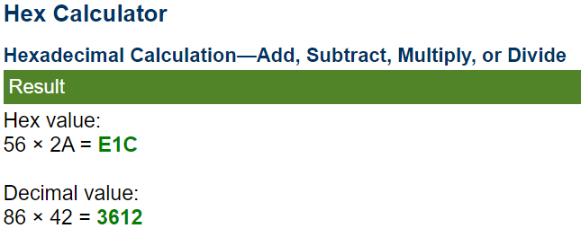
Figure 41- Online calculator screen shot

