University of Wales Trinity Saint David
Wales Institute of Science and Art


Electrical Circuit Testing
Electrical Control Systems
ACHA4014

Oscar Price
1909682
06/04/25

Contents
1 Task 3 1
1.1 Scope Time Division Calculations (3) 1
1.2 Function Generator output square wave (3) 1
1.3 Capacitor charge and discharge wave marked at correct points. (3) 1
1.4 Basic Capacitor Calculations (3) 1
1.5 Capacitor discharge table (2) 1
1.6 Plot log(V) Gradient (2) 1
1.7 Gradient Calculations and Compare(4) 1
1.7.1 Gradient Calculations 1
1.7.2 Comparison table 1
1.8 Capacitor Uses (5) 1
1.9 Inaccuracies Question (4) 1
2 References 2

Task 3

Scope Time Division Calculations (3)

Function Generator output square wave (3)
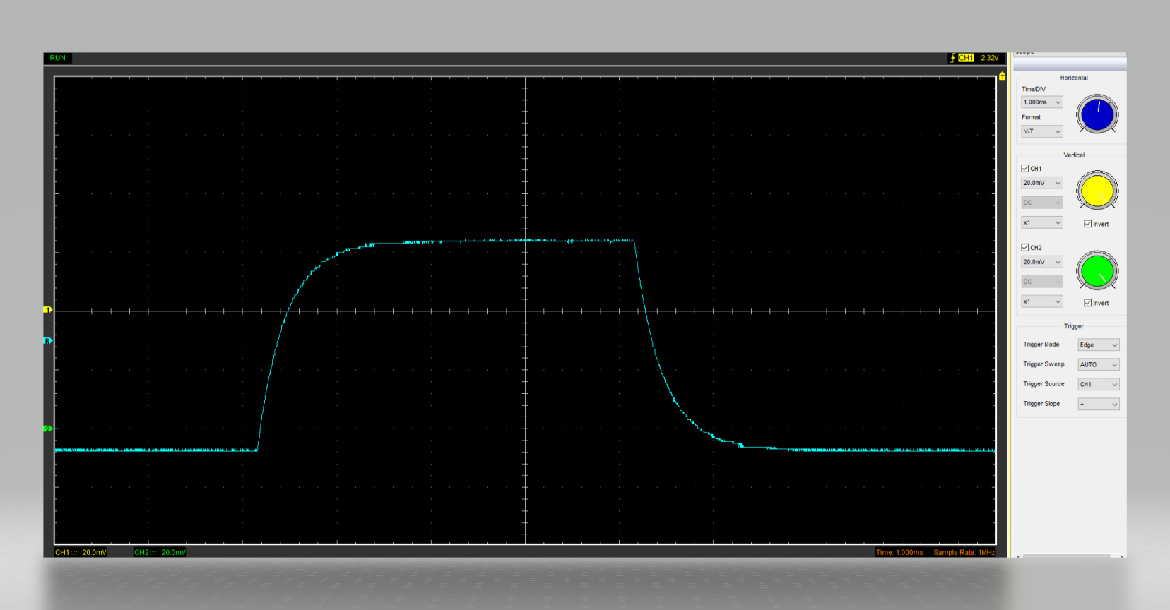
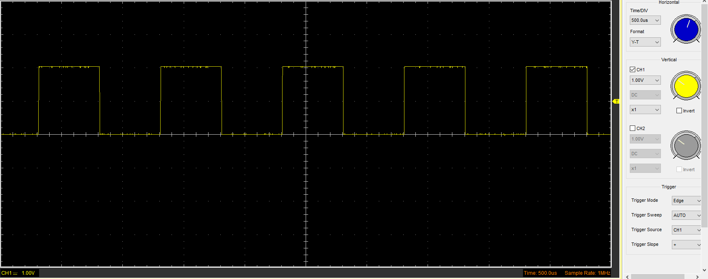
Figure 1: Function Generator Output Waveform
Figure 2: Image of Capacitor Charge and Discharge Waveform

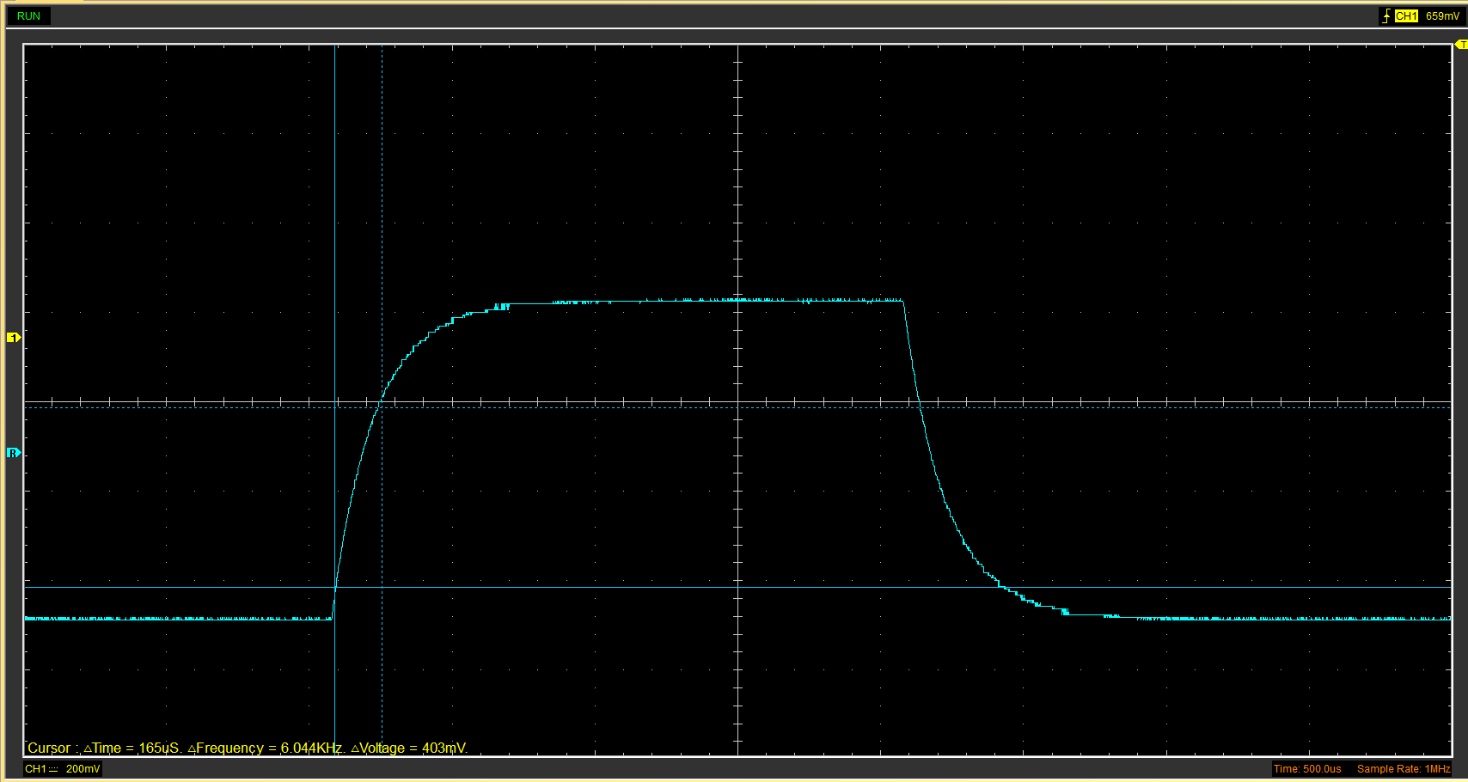
Capacitor charge and discharge wave marked at correct points. (3)
Figure 3: Image of the marked points on a waveform of capacitor charge and discharge

Basic Capacitor Calculations (3)
0.639 x 0.630 = 0.403
C = Time constants/ resistance (100)
0.403/ 100 = 0.00403

Capacitor discharge table (2)

Time (s) | Voltage (V) | ln (V) | dy = y2 – y1  dy = ln(V)2-ln(V)1 | dx = x2- x1  dx = Time2 – Time1 | dy/dx
 |  |  | x | x | x

Plot log(V) Gradient (2)

Gradient Calculations and Compare(4)

Gradient Calculations

Comparison table
 | Capacitance | Delta | Percentage difference
Actual | 1 µF | x | X
Marker Calculation
Gradient Calculation

Capacitor Uses (5)
Energy storage often found in power supply, capacitors store electrical energy and release it when required.
Power conditioning to safeguard delicate electronics, they even out variations in the power supply voltage.
Signal processing is used in oscillators and filters to control circuit waveforms and frequency.
Motor starters these devices help electric motors start and run by giving them a quick power boost.
By counteracting inductive loads, power factor correction increases the efficiency of AC power systems.
Timing circuits manage the timing of circuits, including oscillators, clocks, and timers.
Coupling and decoupling Isolate distinct circuit segments or block DC while permitting AC signals to flow.
Camera flashes are powered by a store charge that can be quickly released.
Antennas and radio frequency circuits use wireless communication for signalling and tuning.

Numerous automobile electronic applications use capacitors, necessitating knowledge of their operating conditions and performance characteristics.
(Chaudhari, 2022)

Inaccuracies Question (4)

References
Chaudhari, D. (2022). 10 Applications of Capacitors | Uses. [online] DipsLab. Available at: https://dipslab.com/applications-capacitors/?utm_source=chatgpt.com [Accessed 3 Apr. 2025].
‌

