Programme: MSc Public Health and Social Care in Practice
Module: Social Epidemiology and Public Health Development
Module code: LCHS7000
Assignment Title: Component 2 Analytical Report
Student ID:2512745
Student Name: Pogula Bharath
Lecturer’s Name: Dr. Hamdi Hussain
Table of contents

Task 1: Social Epidemiological Analysis 3
1. Introduction 3
2. Contextual background and underlying factor 5
2.1 Disease and Illness Inequalities 5
2.1.1 Increased incidences of Type 2 Diabetes 5
2.1.2 Disparities in Cardiovascular Disease 5
2.1.3 Inequalities in Maternal Mortality and Reproductive Health 5
2.2 Social Issues affecting Health Inequalities 6
2.2.1 Socioeconomic Disadvantage and Poverty 6
2.2.2 Discrimination and Racism in Health Care 6
2.2.3 Barriers in Language and Cultural Access to Healthcare 7
3. National Response to Reduce Health Inequalities 7
4. Organisation Supporting Black and South Asian Communities in the UK 7
4.1 The Race Equality Foundation 7
4.2 Black Thrive 7
5. Conclusion 7
References (Task 1) 7
Task 2: Epidemiological Analysis 7
1. Introduction 7
Main Body 7
2.1 Public Health Measures to Contain, Manage, Treat, and Reduce/Control the Impact of Type 2 Diabetes in Black and South Asian Communities 7
2.2 Pivotal Determinants/Risk Factors of Type 2 Diabetes. 7
2.3 Epidemiological Studies and Health Needs Assessment. 7
2.4 Public Health Approaches and Strategies for Monitoring Type 2 Diabetes 7
2.5 Public Health Impact and Consequences. 7
2.6 Health Intervention Programme Design and Evaluation. 7
2.7 Strengths and Weaknesses of the Epidemiological Approach. 7
Reference (Task 2) 7

Task 1: Social Epidemiological Analysis
Title: Ethnic Inequality and Health Outcomes: An Analysis of Health and Disparities among Black and South Asian Communities in the UK

1. Introduction
Ethnic health inequality is a one of the most significant public health problem in the UK. Black and South Asian communities have poorer health outcomes than the White British population as a result of complex social, economic and environmental factors. According to The Kings Fund (2023), these groups experience higher rates of chronic diseases, lower access to healthcare and are exempt from more deprivation. Social determinants such as income inequality, housing, education and discrimination also widen these disparities. This analysis examines the key illness and social issues of these communities, national responses to these issues and the role of organisations that are working to address ethnic health inequality.
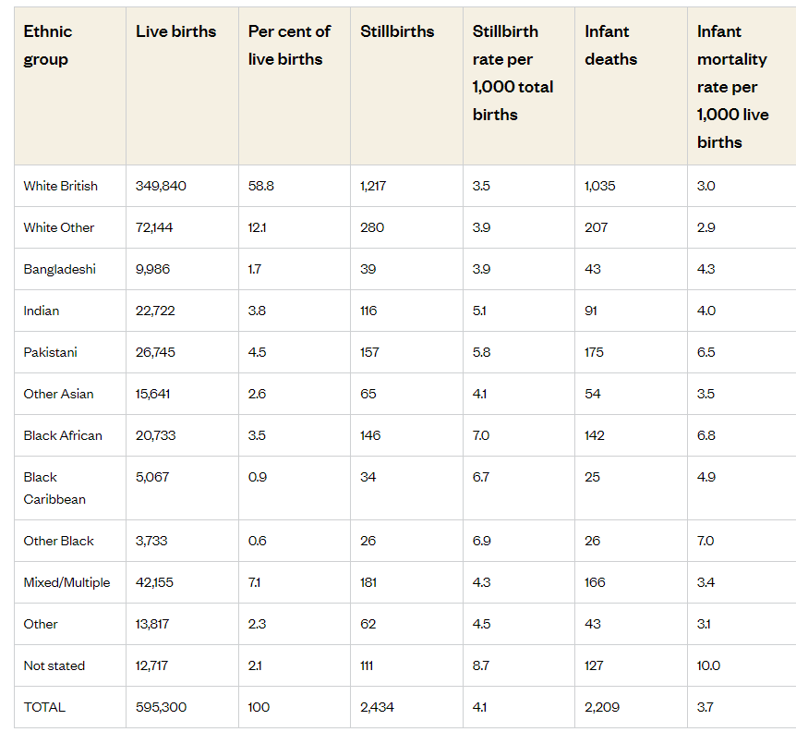
Figure 1: Lifebirths, Stillbirths and Infant mortality rate by Ethnic Group in the UK
(Source: The Kings Fund, 2023)

2. Contextual background and underlying factor

2.1 Disease and Illness Inequalities

2.1.1 Increased incidences of Type 2 Diabetes
Type 2 diabetes is up to three to five times more prevalent in South Asian and Black African people than White British people (British Journal of General Practice, 2022). This is due to cultural diets that are high in carbohydrates, genetic predisposition, and less physical activity. These communities are also less likely to get involved in screening and prevention programmes. The effect of the NHS Diabetes Prevention Programme is to try to reduce this inequality through culturally tailored diet and exercise education. The above figure 1 shows comparison between live births, stillbirths and mortality rate between white Britishers and other south and black Asiean communities.

2.1.2 Disparities in Cardiovascular Disease
Cardiovascular disease (CVD) is a disproportionate health issue for ethnic minorities. The British Heart Foundation (2021), reports that Black individuals are nearly twice as likely to be affected by hypertension that result in an increase in the cases of stroke and also heart diseases. Stress from racism, lower socioeconomic status and lack of access to regular health checks increase the risk. Early screening, community clinics and health campaigns that are more culturally inclusive are necessary to help narrow these disparities.

2.1.3 Inequalities in Maternal Mortality and Reproductive Health
Maternal mortality is 3-4 times higher in black women and half as high in Asian women than white women (UK Parliament, 2023). Bias in maternity care, lack of trust in healthcare professionals and no understanding of culture makes things worse. Solutions include midwifery diversity, improved data monitoring and training of culturally competent care within NHS maternity services.

2.2 Social Issues affecting Health Inequalities

2.2.1 Socioeconomic Disadvantage and Poverty
Ethnic minorities are more likely to live in deprived areas, more than 40% of Black African and 35% of Pakistani households are poor (Joseph Rowntree Foundation, 2024). Poor housing, unemployment and low income limits the availability of healthy food and healthcare. Addressing income inequality and developing employment programmes for communities are important to improving health. For example, figure 2 represents that in three or four years 39% Bangladeshi children will face poverty, as well as 9% working adults.
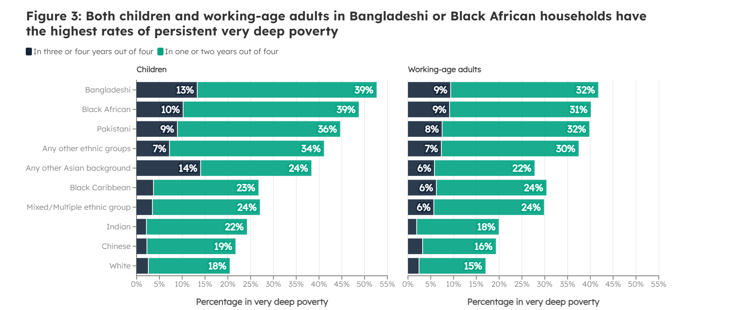
Figure 2: Poverty among Black and South Asian communities in the UK
(Source: Joseph Rowntree Foundation, 2024)

2.2.2 Discrimination and Racism in Health Care
The NHS Workforce Race Equality Standard (2023) demonstrates that ethnic minority staff and patients are at risk of discrimination, which results in mistrust and worse experiences (NHS England, 2023). For example, figure 3 highlights ethnicity in NHS UK with 24% BME, 70% white and 5% unknown. Racism also brings chronic stress, which are risk factors for hypertension and depression. Anti-racism policies and training, staff diversity and accountability systems are important to change institutional biases.
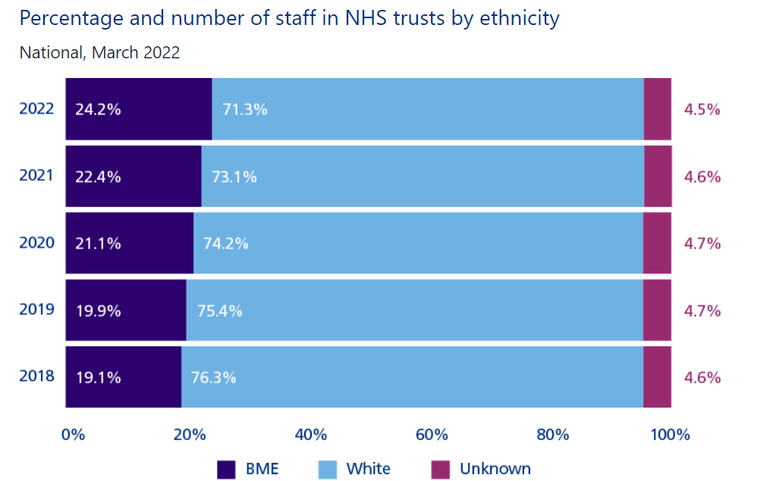
Figure 3: Ethnicity in NHS, UK
(Source: NHS England, 2023)

2.2.3 Barriers in Language and Cultural Access to Healthcare
Language differences and lack of appropriate health information in a person's culture decrease service use. South Asian and African patients have family interpreters who can increase the risks of miscommunication. Culturally sensitive campaigns, translation services and the outreach by the community health workers can strengthen the engagement and improve the early intervention.

3. National Response to Reduce Health Inequalities
The UK government and NHS have taken a number of steps to address ethnic health inequalities. The NHS Race and Health Observatory (2021) systematically reviews ethnic disparity in healthcare outcomes, specifically in the area of maternity, mental health and chronic illness. Its findings have been used to direct new policies promoted by the NHS addressing equitable design of services and cultural competence training (Robertson et al., 2021).
The Race Disparity Audit (2017) coordinated by the Cabinet Office, gathers and publishes data related to the impact of ethnicity in relation to public services such as health, education and employment. This transparency supports the ability to make targeted interventions as well as accountability at national and local levels.
Additionally, the emphasis on reducing inequalities through prevention, screening, and digital access to health is included in the NHS Long Term Plan (2019). Initiatives like Core20PLUS5 identify the most deprived communities which includes ethnic minorities for focus health support (Checkland et al., 2025).

4. Organisation Supporting Black and South Asian Communities in the UK

4.1 The Race Equality Foundation
The Race Equality Foundation is a UK charity which works to promote racial equality in health, housing and social care. It performs research and policy advocacy in order to address structural inequalities affecting ethnic minorities. Its Better Health Programme provides culturally adapted health education to increase awareness on diabetes, heart disease and mental wellbeing. The foundation also offers training to staff working in the NHS to ensure that services are inclusive and working on evidence. Working with government policy and local authorities, it supports the processes of ensuring cultural and linguistic diversity in relation to health promotion strategies (Ocloo et al., 2024).

4.2 Black Thrive
Black Thrive is a community partnership based in London, which focuses on improving mental health and wellbeing in Black communities. It came about after it was recognised that Black people have a higher likelihood of experiencing mental illness and being detained under the Mental Health Act. Black Thrive works with the councils local NHS Trusts and residents to co-design solutions to systemic racism and social exclusion. It conducts employment programmes, mental health awareness workshops and research projects on building trust in public institutions. Figure 4 shows the high mortality rate of white Britishers compared to black and other south Asian communities, which need major care.
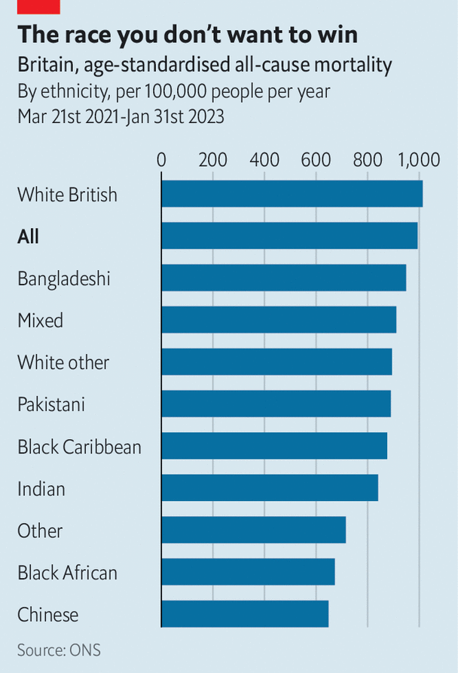
Figure 4: Standardization of health
(Source: The Economist, 2023)

5. Conclusion
Ethnic health inequalities in the UK are still deeply rooted in social, economic and cultural factors. Black and South Asian communities have a higher rate of chronic illness, poverty and discrimination, which altogether makes it difficult to access fair healthcare. While national policies and organisations have made underpinned strides in raising awareness and forming the strategy to be inclusive, persistent barriers in the form of structural inequalities require persistent attention. Achieving health equity takes a sustained effort by policymakers, healthcare providers and communities. Addressing racism, enhancing cultural competence and investing in prevention are all crucial in ensuring that all ethnic groups in the UK are able to achieve optimal health outcomes.

References (Task 1)
British Journal of General Practice, (2022). Characterisation of type 2 diabetes subgroups and their association with ethnicity and clinical outcomes: a UK real-world data study using the East London Database. Available at: https://bjgp.org/content/72/719/e421 [Accessed on 10.11.2025]
Checkland, K., Bramwell, D., Hammond, J., Bailey, S. and Warwick-Giles, L., (2025). Tackling health inequalities: What exactly do we mean? Evidence from health policy in England. Journal of health services research & policy, p.13558196251334571.https://journals.sagepub.com/doi/pdf/10.1177/13558196251334571
Joseph Rowntree Foundation, (2024). Bangladeshi, Black African and Pakistani households at higher risk of very deep, long-term poverty. Available at: https://www.jrf.org.uk/race-and-ethnicity/bangladeshi-black-african-pakistani-households-higher-risk-of-very-deep-poverty [Accessed on 10.11.2025]
NHS England, (2023). NHS Workforce Race Equality Standard (WRES) 2022 data analysis report for NHS trusts. Available at: https://www.england.nhs.uk/long-read/nhs-workforce-race-equality-standard-wres2022-data-analysis-report-for-nhs-trusts/ [Accessed on 10.11.2025]
Ocloo, J., Stuart, R., Dasch, H.K., Dyer, J., Choudhury, D., McAnuff, L., McGowan, S., Bakolis, I. and Das-Munshi, J., (2024). Living less safely through the pandemic in England for people with serious mental and physical health conditions: qualitative interviews with service users and carers of Black African, Caribbean, and South-Asian descent. BMC Public Health, 24(1), p.2718.https://link.springer.com/content/pdf/10.1186/s12889-024-20107-6.pdf
Robertson, R., Williams, E., Buck, D. and Breckwoldt, J., (2021). Ethnic health inequalities and the NHS. The King’s Fund, commissioned by the NHS Race and Health Observatory.https://healthwatchgreenwich.co.uk/sites/healthwatchgreenwich.co.uk/files/Ethnic-Health-Inequalities-Kings-Fund-Report.pdf
The British Heart Foundation, (2021). How your ethnic background affects your risk of heart and circulatory diseases. Available at: https://www.bhf.org.uk/what-we-do/our-research/research-successes/risk-factors/ethnicity-and-heart-disease [Accessed on 10.11.2025]
The Kings Fund, (2023). The health of people from ethnic minority groups in England. Available at: https://www.kingsfund.org.uk/insight-and-analysis/long-reads/health-people-ethnic-minority-groups-england [Accessed on 10.11.2025]
UK Parliament, (2023). Black maternal health. Available at: https://publications.parliament.uk/pa/cm5803/cmselect/cmwomeq/94/report.html [Accessed on 10.11.2025]

Task 2: Epidemiological Analysis

1. Introduction
Type 2 Diabetes Mellitus (T2DM) is a chronic metabolic disorder characterised by insulin resistance and relative deficiency of insulin which results in persistently high levels of blood glucose. It is one of the fastest growing non-communicable diseases in the world, representing major social, cultural and health challenges. Globally, there are over 540 million adults with diabetes and the World Health Organization (2023) estimates that the number of people living with diabetes might reach over 700 million by 2045 (National Institute of Health, 2025).
In the UK, diabetes affects around 4.3 million people with Type 2 diabetes making up some 90% of all cases (). The prevalence is 6.5% nationally but increases sharply amongst South Asian communities and they are four to six times more likely to develop the disease than White British individuals. In one of the most ethnically diverse and deprived places in London, East London, prevalence of adult diabetes is greater than 11%, one of the highest in the UK. The risk is increased by social deprivation, cultural dietary habits, sedentary life styles and genetic predisposition. This analysis discusses the epidemiological processes that underlie the identification, evaluation and management of T2DM in this high-risk population.

Main Body

2.1 Public Health Measures to Contain, Manage, Treat, and Reduce/Control the Impact of Type 2 Diabetes in Black and South Asian Communities
Prevention: Preventive interventions such as the Diabetes Prevention Programme (DPP) launched by Public Health England are lifestyle change interventions that help prevent Type 2 diabetes. The target population of this program consists of high-risk people, and in particular, ethnic minorities, as they receive a 9-month lifestyle change intervention, including dietary recommendations and physical exercises (Niddk, 2025). According to the studies made by the NHS, the effect of such interventions can help decrease the occurrence of diabetes by 50% in people at high risk in East London. Moreover, NICE suggests that individuals at high risk because of their ethnicities should screen on a regular basis to diagnose diabetes in its early stages and avoid complications.
Protection: Protection activities involve enhancing access to healthcare services and making sure that ethnic minorities do not receive less services. The NHS has implemented community clinic practices in regions where there are large deposits of Black and South Asian communities living in East London of UK by providing free screening of Type 2 diabetes and culturally sensitive services. In creating public health campaigns, like Known Numbers by Diabetes UK, to encourage early diabetes testing and self-management is important with the South Asians who are six times more prone to developing the health condition as compared to their white counterparts.
Promotion: Promotion entails educating the community on lifestyle activities that lead to Type 2 diabetes such as diet, physical activity, and weight management (Saefullah et al., 2024). The local councils and diabetes UK implement community-based education and public health campaigns in community centers, mosques and churches, which target ethnic minorities. The messages should be provided as a way of meeting cultural and dietary preferences, such as providing alternatives to foods that are rich in carbohydrates and fat as usually eaten by South Asians.

2.2 Pivotal Determinants/Risk Factors of Type 2 Diabetes.
Genetic Predisposition: Both the black population and the South Asian population of East London are more genetically predisposed to insulin resistance which is one of the major features of Type 2 diabetes. Research indicates that South Asians genetically have a preposition to developing Type 2 diabetes early in life and with lower body mass index than other ethnic groups.
Obesity and Physical Inactivity: Obesity is among the greatest modifiable risk factors of Type 2 diabetes (Vidal et al., 2022). As NHS Digital indicates, South Asians in East London, UK are also at a higher risk of being obese than Whites and half of the South Asian women are obese. Moreover, they are less physically active. This sedentary lifestyle along with the increasing incidence of obesity have a serious threat of diabetes development.
Dietary Patterns: Dietary habits of South Asians include high intake of carbohydrate rich foods e.g. rice and bread and low intake of fiber. This eating habit causes insulin resistance and glucose increase. The black populations and especially the Caribbean descent populations prefer high-calorie, fried cuisines which have increased occurrence of obesity and diabetes.
Socioeconomic Factors: The socioeconomic status (SES) is an important factor in Type 2 diabetes prevalence. Such factors as lower SES are frequently linked to the lack of access to healthy food sources and physical activity and an elevated smoking rate that raises the chances of Type 2 diabetes development. Research demonstrates that Black and South Asian communities of East London in the UK have lesser household income in comparison with White people which may restrict access to healthier lifestyles (Singh and Kumari, 2022).
Ethnicity-Related Factors: Cultural practices, poor awareness, and the underdiagnosis of Type 2 diabetes also lead to high rates of the same in these communities. As an example, undiagnosed Type 2 diabetes is more prevalent among the South Asian and Black population of East London due to cultural reasons where they do not seek healthcare services till the condition becomes severe.
Figure 1 draws a parallel between the occurrence of Type 2 diabetes across various races in the UK with reference to first and second-generation South Asians and African Caribbeans. It is also the comparison of these groups with mixed European or African Caribbean. The chart describes the variation in the prevalence of diabetes, pointing to such causes as adiposity, socioeconomic disadvantage, and unidentified factors.
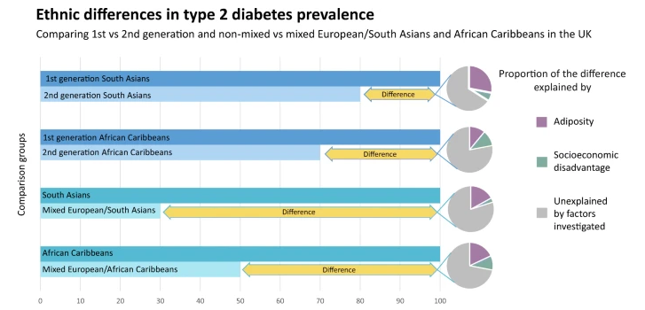
Figure 1: Type 2 Diabetes in Black and South Asians of UK
(Source: Springer, 2021)

2.3 Epidemiological Studies and Health Needs Assessment.
A number of epidemiological searches have dealt with Type 2 diabetes in the East London of UK in Black and South Asians. A report commissioned by the South Asian Health Foundation, (2018), indicated that the South Asians were more prone to diabetes at an earlier age and with a lower BMI as compared to the rest of the population. On the same note, the Diabetes UK Report (2020) pointed out that 1 in 6 adult South Asians as well as 1 in 8 adults of Black descent had diabetes as opposed to 1 in 10 adults of White British descent. The example of the UK Biobank Study indicates that South Asians and Black populations have a much higher rate of Type 2 diabetes as opposed to the White British. Type 2 diabetes is common amongst South Asians in the UK (13.4%), and the Black communities (10.2% ). This is quite high compared to the 6% prevalence rate in the general population.
In regions with dense populations of Black and South Asian communities like the East London shows that they have significantly higher rates of Type 2 diabetes than the rest of the country (Muniyappa and Narayanappa, 2024). In Tower Hamlets, it is found that more than 20% of South Asians (above 40 years) are found to be affected with Type 2 diabetes. This is a stark contrast of a national average of about 10%. Such statistics underscore the importance of focusing on the special population-specific health programs such as culturally sensitive health education and increased access to health services.

2.4 Public Health Approaches and Strategies for Monitoring Type 2 Diabetes
National Diabetes Audit (NDA): NDA is among the most detailed systems of monitoring diabetes in the UK. The audit indicates that diabetes Type 2 is overrepresented among ethnic minorities with South Asians and Black populations showing an increased rate of complications. The NDA has played a critical role in offering areas where the most interventions are required like the timely diagnosis deficiency of ethnic minority communities.
Diabetes Prevention Programmes (DPP): DPP introduced by Public Health England gathers the information about people at risk and analyses the efficacy of preventative interventions (Green et al., 2024). This program is particularly focused on high-risk groups such as the Black and South Asian people of East London and employs specific data to guide interventions within the region.
Local Surveillance Systems: In areas like Tower Hamlets, local surveillance systems are used to gather minute data on health trends to track Type 2 diabetes. These systems monitor demographic data and reveal areas that have the most burden that will be targeted in terms of health promotion and preventive measures.
Figure 2 imparts the timeline of the diabetes prevention program(DPP) and its follow up, the diabetes prevention program outcomes study (DPPOS). It reveals how the program has developed since 1996 up to now with different phases, such as the DPP Lifestyle Change Program, Metformin and placebo interventions and how these have been changed with time.

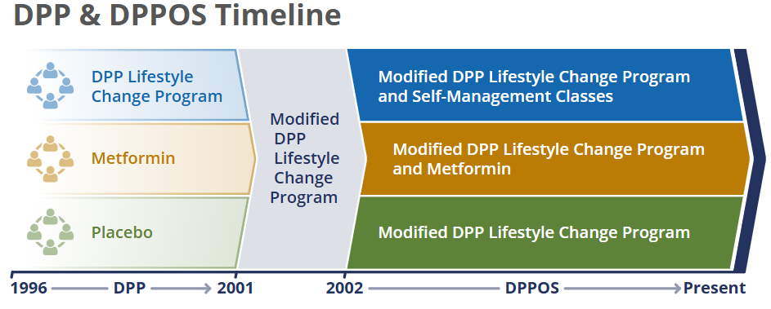
Figure 2: Diabetes Prevention Programmes (DPP)
(Source: Niddk, 2025)

2.5 Public Health Impact and Consequences.
The type 2 diabetes problem of the Black and South Asian population has a great impact on the population in South Asia and beyond. The short term effects are that there is high cost in healthcare in the form of regular hospital visits, problems like high blood pressure and stroke, and decrease in productivity. The long-term consequences are irreparable organ damage like kidneys, eyes, nerves, which later causes high disability and deaths.A study carried out by the department of health indicates that Type 2 diabetes costs the NHS about 10 billion a year, with much of this amount being attributed to complications that disproportionately affect the Black and South Asia groups. The communities are also covered with a high number of diabetic complications like amputation and kidney failure which puts a big burden on the health care facilities as well as the affected individuals.

2.6 Health Intervention Programme Design and Evaluation.
Targeted Awareness campaigns: It is aimed at educating the communities about the dangers of diabetes, particularly at the time of crucial stages in a person's life like the period of pregnancy and old age. Such campaigns are supposed to be culturally applicable and should be conducted in community areas like mosques, temples and local community centers.
Improved Screening and Early Diagnosis: Increase screening efforts to assure that an increasing number of individuals in high-risk ethnic groups are screened on a regular basis, regardless of whether they have the symptoms. This would involve conducting the blood sugar test to people over 40 years old annually, particularly in the regions where South Asians and the Black population is high.
Lifestyle and Dietary Interventions: This would involve culturally competent dietary recommendations, which involve portioning and healthier cooking techniques. The exercise programs based on the needs and preferences of ethnic minorities should be encouraged, i.e. group walking sessions or low-impact aerobic exercises.
Figure 3 brings out some of the important statistics regarding diabetes in the UK in 2021. It reveals that 4.1 million individuals are living with diabetes among them 90% are type 2 diabetics. Moreover, diabetes costs in the NHS amount to approximately 10 billion a year.

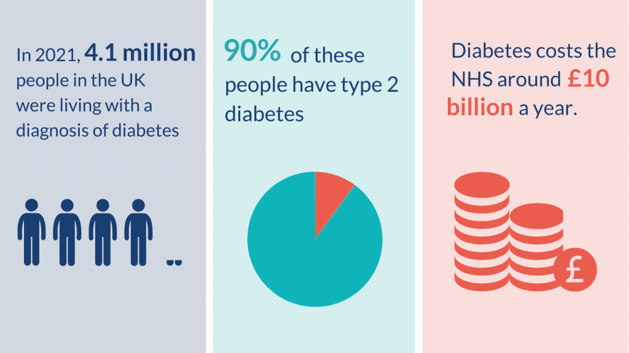
Figure 3: Type 2 diabetes-A growing health crisis
Source: Evidence, (2025).

2.7 Strengths and Weaknesses of the Epidemiological Approach.
Strengths: The epidemiological strategy enables recognizing the high-risk groups, including Black and South Asian communities in East London and creating targeted interventions on the basis of detailed information (Raleigh et al., 2022). Monitoring systems at national and local levels are able to offer powerful data to determine the effectiveness of the public health strategies and monitor the changes over time. In addition, the genetic and lifestyle inclusion in the epidemiological research assists in narrowing down the risk factors which contribute to Type 2 diabetes.
Weaknesses: It has one weakness that comprises underreporting of diabetes among the ethnic minorities because of cultural stigma or unawareness. The use of self-reported data in health surveys is another problem since this can give misleading results. More so, epidemiological studies are useful in giving data, but they do not necessarily reveal the complexity of social determinants like access to healthcare and education, which can be highly differentiated within those communities.

Reference (Task 2)
Evidence, (2025). Diabetes, Metabolics and Hormones. https://evidence.nihr.ac.uk/collection/diabetes-putting-people-at-the-heart-of-services/. [Accessd on 16.11.25]
Green, J.B., Crowley, M.J., Thirunavukkarasu, S., Maruthur, N.M. and Oldenburg, B., (2024). The final frontier in diabetes care: implementing research in real-world practice. Diabetes care, 47(8), pp.1299-1310. https://diabetesjournals.org/care/article-pdf/47/8/1299/777496/dci240001.pdf
Muniyappa, R. and Narayanappa, S.B.K., (2024). Disentangling dual threats: premature coronary artery disease and early-onset type 2 diabetes mellitus in South Asians. Journal of the Endocrine Society, 8(1), p.bvad167. https://academic.oup.com/jes/article-pdf/doi/10.1210/jendso/bvad167/55340338/bvad167.pdf
National Institute of Health, (2025). IDF DIABETES ATLAS [Internet]. 10th edition. Available at: https://www.ncbi.nlm.nih.gov/books/NBK581940/#:~:text=An%20estimated%20537%20million%20adults%20aged%2020%E2%80%9379,are%20projected%20to%20be%20living%20with%20diabetes. [Accessed on 10.11.2025]
Niddk, (2025). Diabetes Prevention Program (DPP). Available at: https://www.niddk.nih.gov/-/media/Images/Research-Areas/DPP-DPPOS.SVG?imbypass=true [Accessed on 10.11.2025]
Raleigh, V., Jefferies, D. and Wellings, D., (2022). Cardiovascular disease in England. The King's Fund, pp.2022-11. https://assets.kingsfund.org.uk/f/256914/x/ad22aeaeff/cardiovascular_disease_in_england_2022.pdf
Saefullah, R., Hidayana, R.A. and Cahyandari, R., (2024). The role of physical activities in enhancing physical fitness among the community. International Journal of Health, Medicine, and Sports, 2(3), pp.66-70. https://pdfs.semanticscholar.org/4fcf/03b236b58bb6c567a7b014ac7165cf5181a1.pdfhttps://pdfs.semanticscholar.org/4fcf/03b236b58bb6c567a7b014ac7165cf5181a1.pdf
Singh, J. and Kumari, M., (2022). Cardiovascular health of people of African & Asian Descent in the United Kingdom: A literature review. International Journal of Pharmaceutical Research and Applications, 7(5), pp.205-216. https://www.researchgate.net/profile/Jagdeep-Singh-69/publication/363653568_Cardiovascular_Health_of_People_of_African_Asian_Descent_in_the_United_Kingdom_A_Literature_Review/links/6328330670cc936cd31d55ce/Cardiovascular-Health-of-People-of-African-Asian-Descent-in-the-United-Kingdom-A-Literature-Review.pdf
Springer, (2021). Type 2 diabetes risks and determinants in second-generation migrants and mixed ethnicity people of South Asian and African Caribbean descent in the UK. Available at: https://link.springer.com/article/10.1007/s00125-021-05580-7 [Accessed on 10.11.2025]
Vidal, T.M., Williams, C.A., Ramoutar, U.D. and Haffizulla, F., (2022). Type 2 diabetes mellitus in Latinx populations in the United States: a culturally relevant literature review. Cureus, 14(3), p.e23173. https://assets.cureus.com/uploads/review_article/pdf/71809/20240724-319105-5k3z9t.pdf

