
Skills for the Workplace
Module Assignment Submission
Student Name: | Mahmuda Begum
Student Number: | 1811540
Module No: | BMSK6002
Module Title: | Developing Innovation and Creativity for Business Advantage

Statement of Confirmation of Authenticity
By the act of making this submission, the student declares that this is the work of the student named above. The work has not, in whole or in part, been knowingly presented elsewhere for assessment, or where assessment has been built on a previous assessment, this has been identified. Where materials have been used from other sources it has been properly acknowledged. If this statement is untrue, the student acknowledges that an assessment offence has been committed.
Attention is drawn to the plagiarism and unfair practice policies of both the University and of ILM.

Table of Contents
1.0 Introduction 3
2.0 Innovation 3
2.1 Innovation Models 5
2.2 Types of Innovation 9
2.3 The innovation Process 10
2.4 Innovation at HMRC 13
3.0 Creativity 15
3.1 The factors that contribute towards creative culture in an organisation 19
3.2 Differences between Creativity and Innovation 23
3.3 Importance of Creativity in the Organisation 24
4.0 Conclusion 25
References 26
Appendix A 30
Appendix B 31

1.0 Introduction

Many motivations exist for businesses to be continually innovating, including the Covid-19 pandemic. This will assist them in preparing for additional unanticipated challenges, thus it is critical to determine whether your company encourages creativity and innovation. Every day, people are becoming more inventive and innovative. As time passes organisations are receiving pressure to innovate so that they can compete against their competitors. ‘’Business innovation is of top priority for entrepreneurs and CEOs.’’ AF Bureau (2020). People can be passionate and committed to advancing their creativity at times, which is why we need to encourage them. In this assignment we will be looking at creativity theories and innovation models and how the writer’s organisation fosters creativity and innovation in this assignment.

2.0 Innovation

Dictionary.com definition of innovation is ‘’the act if innovating; (the) introduction of new things or methods’’. If everyone kept their creative ideas to themselves, people, society and the economy would not change, grow or progress. According to (Hodgeback, J) it was Vinton Cerf and Bon Kahn, two computer scientists invented the internet. So, for example, had they not innovated on their creativity; we would not have the internet. Which means there would be no video calling, online purchasing, online businesses, limited communication with one other, no culture development and many other beneficial things if it weren’t for the internet.‘’ Innovation is the specific tool of entrepreneurs, the means by which they exploit change as an opportunity for a different business or service. It is capable of being presented as a discipline, capable of being learned capable of being practiced’’. Peter Drucker (1985), Innovation and Entrepreneurship, Harper & Row, New York.
Frey, C. (2009) wrote an article about Peter Drucker and the sources of opportunity that will ultimately drive innovation:
- The organisation’s own unforeseen failures and successes, and those of the competition.
- Incongruities, specifically those in a procedure, such as distribution, production or incompatibilities in customer behaviour.
- Process needs.
- Changes in market structures and in the industry.
- Changes in demographics.
- Changes in perception and meaning.
- New knowledge.
Drucker also mentions that there are three conditions that need to be met for innovation to be successful which are:
1. Innovation requires creativity, knowledge, ingenuity and is work. Usually innovators work in one area and the work requires persistence, diligence and commitment.
2. In order to be successful, innovators need to build and develop their own strengths. There needs to be a connection to business plan and a temperamental fit with the practitioner. The innovator also needs to look at a wide range of opportunities and identify which is the most suitable for them and the company.
3. Innovation is a repercussion in society and economy, it is a behaviour change in customers, farmers, teachers and people in general. Or it can be a change in a process and how people produce something or work. When innovation the focus should be on the market and market oriented.
‘’People care about innovation because it offers important answers to critical business challenges. Innovation must be more than clever; it must be useful in a meaningful way.’’ McClure, D. (2015). At HMRC they have an Innovation & Growth Team and they can be contacted through the HMRC staff intranet, which includes a table of team members, contact information, and their responsibilities.

2.1 Innovation Models

A detailed structure for identifying, developing and implementing ideas is provided by an innovation model. As a result, the focus is on implementing ways to generate the needed value. Peter Drucker believed that if you want the innovation to be successful you should start small you should focus on doing one thing at a time. This implies that by starting small it allows room for adjustments. Therefore, we will look at some innovation models below:
The Stage-Gate Model
The model was created by the co-founder of Stage-Gate international, Robert Cooper in 2011. It was developed to assist management in prioritising possible new ideas and better allocating limited resources by filtering out those with the least potential and supporting those with the most. The process generates several gates, which are critical decision-making points along the development path of innovative ideas in any industry. It is focused on prioritising, tracking and funding the candidate ideas that most senior managers are evaluating at any given moment (Sebell, M, H. 2018).
According to (Alfaro, I. 2017) the stage-gate systems is based on four elements:
The project team – a cross-functional team in charge of performing the different tasks on each stage.
The stages – a set of activities created to help choose whether the project should develop to innovation pipeline. The objective of a stage is to minimise project risk and reservations. The stage concentrates on certain dimensions of the project and the earlier stages usually need over-all information about the project for example, create new product designs. During the more progressive stages it needs more detailed information to make an assessment e.g. project plan. The stage process increases in value in relation to determination and commitment.
The gates – conclusion points where gatekeepers evaluate the deliverables produced by the team and decide on either killing or moving it to the next stage. Next to each stage is a gate, which is a go/stop decision point. The gates are there to evaluate points to describe resources distribution and priorities projects. In the decision-making progress, there are three main objects that are used:
Deliverables: what the project manager and team contribute to the decision-making process.
The following are the criteria used to evaluate the project: There are two types of criteria: must-meet criteria, which are scored and added based on a point count system used to prioritise projects, and should-meet criteria, which are scored and added based on a point count system used to prioritise projects.
Outputs: include a decision (Go/Kill/Hold/Recycle), an accepted action plan for the next stage (with a dedicated timetable and resources), and a list of deliverables and a date for the next gate.
The gatekeepers: key stakeholders from different business areas that own the resources required by the project team to move advance on their project. A cross-functional leadership group—the heads of marketing, sales, technical, operations, and finance—should be the gatekeepers for big new product projects. Because senior people's time is limited, start with mid-management at Gate 1 and work your way up to the business's leadership team at Gates 3, 4, and 5. Consider setting one day, per month aside for practical reasons and given executives' busy schedules. According to (Simple Pdh,2018) the work on the product is completed in ‘’stages’’ and decisions are made at ‘’gates’’ in a classic stage-gate model. This suggests that by following the Stage-Gate process it will minimize wasted effort and increase the opportunity that ideas will development within the project pipeline.
The two key advantages that organisations can accomplish while applying a Stage-Gate process are:
1) Before financially committing, they can recognise if the new ideas that should not be followed.
2) The procedure guarantees that feasible ideas, get the required resources to be developed.
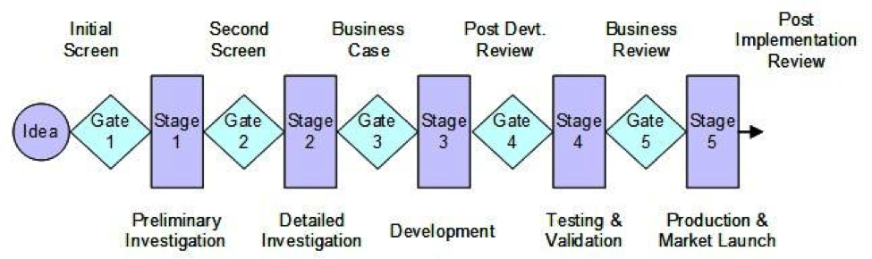

Figure 1. Five Stage Process defined in Cooper, 2008.
(Byrne, 2021) wrote an article about the pros and cons of a phase gate process in new product development. He says that the gates divide the new product development (NPD) into important stages, with the chance to evaluate progress at the conclusion of each. Teams can utilise criteria to choose which projects should be permitted to continue and which should be terminated by holding stop/go meetings at the end of each vital stage with stakeholders. This is supposed to terminate unproductive projects and keep the business oriented on customer needs, process transparency and profitability.
Pros
- It prevents you from investing time and money on projects that are doomed to fail.
- It is required in many industries. ‘’About 80% of US companies use a stage-gate model for innovation today’’. Simple Pdh, (2018).
- The formal review meetings, which are strongly supported by data and documentation, will ensure you are making the correct choices, for the correct reasons and at the correct time.
- There are various team members that are involved in important strategic decision-making, this means everyone is responsible for the failures and successes of an idea, as well as the way it is constructed.
- It provides you with a structure, so each stage will ensure that you can evaluate the potential, progress and completion status. It keeps you focused adhering to ongoing review processes and on achieving targets.
Cons
- Large number of gates can disrupt your flow. ‘’One of the big dangers of phase gating is thar they become bureaucratic hurdles rather than helpful review opportunities.’’ (Byrne, J. 2021)
- As Clayton Christensen highlighted out, we may not realise the actual commercial potential of an innovation, until after it has been launched in the marketplace. It has the potential to impede creativity.
- It is not just about the money so if you use simple financial metrics of
- It is usually done incorrectly. For each new stage to be started, the gates must have objectives, be realistic, measurable and approved goals or else it will become a competition about who can shout the loudest.

First-Generation Innovation Model (IG) – Technology Push
In the 1960’s, NASA developed the model as a management tool and termed it as ‘Phase-review-processes’. The model is used to help break down the complex processes and focuses on gaining control over the activities and systemizing the work.
Roy Rothwell, a British sociologist, is recognised as a pioneer in the field of industrial innovation. He made significant contributions to the management of innovation. From the 1950’s until now, Rothwell identified five generations of advances. His results are based on several promotional tools, stagflation, unemployment, inflation, and economic recovery.
Rothwell came up with a descriptive innovation model that describes the various structuring of a company’s innovation process in response to market fluctuations. (Bureau, F. 2020).
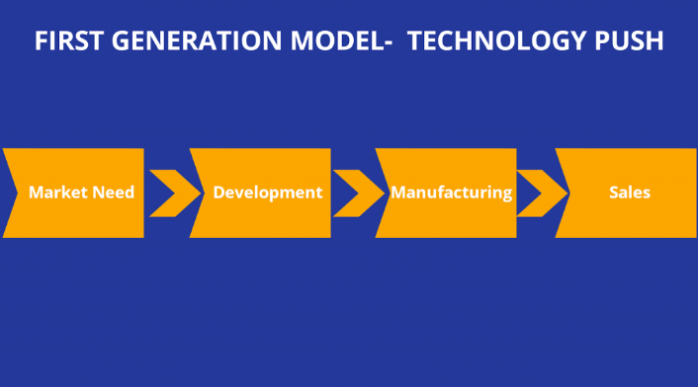
Figure 2: First Generation Model -Technology Push

2.2 Types of Innovation

According to (Kylliainen, J, 2018) there are different types of innovation:
Disruptive vs Sustaining innovation
Disruptive innovation introduced in 1995 by Clayton Christensen, is refers to a service, product or concept that generates a new value network by creating a new market or disrupting an existing one.
Sustaining innovation refers to the innovations currently existing in the market and focuses on improving and growing them instead of making new value networks.
Radical vs Incremental Innovation
(Kylliainen, 2018) mentions that both disruptive and sustaining innovation can be either incremental or radical.
Radical innovation occurs when a new technology fully disrupts existing economy or business and produces a new business model. She mentions that due to difficulty in executing, only 10% of innovation fall into this category.
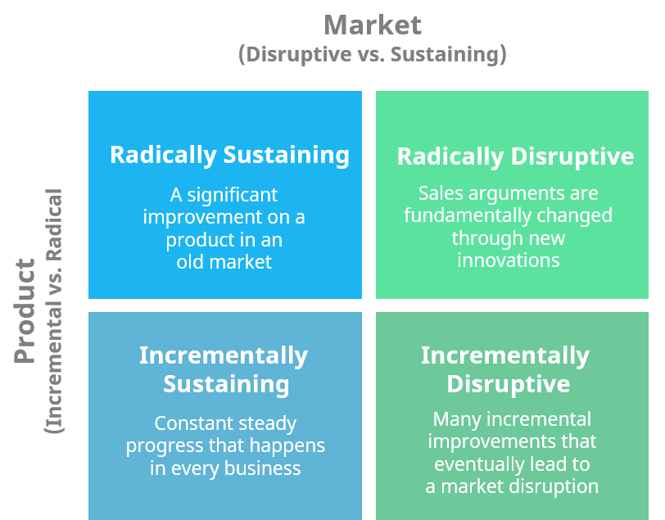
Incremental innovation refers to a sequence of progressively built and small improvements to current methods, products or procedures so that they can sustain a competitive place overtime.

Figure 3

Architectural vs Modular innovation.
Architectural innovation was introduced by Rebecca Henderson and Kim Clark in 1990, and it is defined as the reconfiguration of existing product technologies.
Modular innovation is when the overall design is the same, but one or more components of a product is changed.

2.3 The innovation Process

Lauren Landry wrote a blog in December 2017 where she spoke about The Innovation Process: A Step-by-Step Guide. She mentioned that research showed that 40 percent of new products and services fail which suggests why the innovation process is so important. Establishing an innovation process is necessary for turning a concept into reality. That approach challenges you to think through many processes to guarantee you’re solving the problem, receiving user input on a regular basis, repeating as needed, and obtaining the resources and methodologies needed to fully represent the innovation.
(Landry, L. 2017) speaks about Tucker Marion who is an associate professor and director of the Master of Science Innovation program. ‘’The innovation process is broken into phases,’’ states Tucker Marion and she also mentions that the larger the company the more phases there will be which suggest, that the innovation process will be more complex. According to Marion the three important phases in the innovation process that all organisations cycle through are:
- Discovery – thought processed like brainstorming and prototyping can be utilised to a company’s advantage in this situation
- Ideation – the creative act of producing new ideas is a vital aspect of the design thinking process, that focuses on understanding the non-obvious pain points that customers are experiencing and developing new products, services, and business models that are suited for their needs.
- Commercialisation, or introducing your product or service to market, comes towards the end of the development phase. From the first introduction of a product or service through large manufacturing and adoption, the commercialization process is divided into phases. You'll get more client input as you proceed through each step, and you'll need to refine your product on a regular basis.
- Development - companies can move on to phase two, development, after the idea has been established and an MVP has been created, according to Marion. “This is where you decide to spend real money on design and engineering.” Depending on your product or service, you may also be doing the following during the development process:
-Identifying and evaluating potential new suppliers
-Designing manufacturing and supply chain strategies
-Making a software development kit available to third-party vendors
-Creating connections with channel partners

While there is no specific time for moving through each step, it is recommended that you dedicate more work to the discovery phase up front.

The 4P’s of Innovation
Tidd and Bessant created the concept of the 4 P’s of Innovation Space, which was initially published in 2005. Figure 1 shows a summary of their findings:
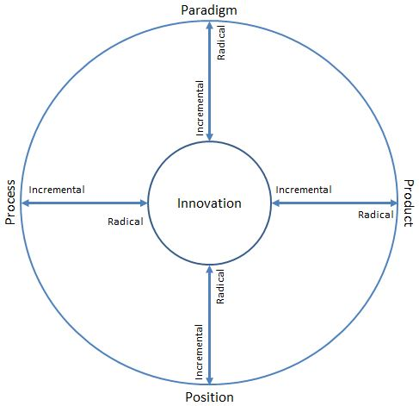

Figure: The 4 P of Innovation (Tidd & Bessant 2013).

Product, process, position, and paradigm are the four P's of innovation, according to Tidd and Bessant, and are defined as follows:
When we think of innovation, the first thing that comes to mind is product innovation, which refers to changes in the things (products/services) that a company offers. Changes in the way things are created and distributed are mentioned to as process innovation. Position innovation refers to a change in the context in which products/services are introduced, or, in other words, where the offering's target is and what the story is about it.
The change in the fundamental mental models that frame what the organisation does, or otherwise how the corporation frames what it does, is known as paradigm innovation. The border between these is frequently fuzzy, and innovations in one dimension frequently result in changes in the others. The boundary between these is frequently unclear, and innovations in one dimension often result in changes in the others. (David, 2016)

2.4 Innovation at HMRC

HMRC is a government organisation and it strives to become better. The work we conduct at HMRC is critical to the country's overall success.
In 2019, HMRC launched ‘TechConnect (which is external)', a 12-week digital skills programme established jointly by the government and trade group techUK. The initiative brings together 48 early-career tech experts from industry and the government to work in mixed teams on a govtech challenge of their choice and deliver innovative solutions that combine the best of the public and commercial sectors. The true power of technology lies in its ability to solve problems, HMRC has always wanted to bring the outside in, bringing all of the exciting innovation happening in the private sector into government and sharing best practises for applying it to real-world problems that government and citizens face.
Sara Vogt who works for the Ministry of Justice wrote a blog about the civil service – Want a more creative team? Where she carried out sessions with civil service employees to focus on practice ideas to improve creative leadership. She said that when we formed our group values last year, the themes of innovating, learning, and exploring new ideas to improve the services we provide emerged strongly. She mentioned that her team has sought to embody those principles in the way we communicate our values: from e-thank-you cards that capture the power of gratitude to how we're displaying the human stories of employees performing outstanding work across our organisation in a highly visual way.
The information regarding HMRC is provided on the HMRC intranet which is internal hence why the writer cannot reference it. However, the research is all based on the writer’s own experience at HMRC and from the HMRC intranet.
Customers can use the Personal Tax Account (PTA) service to submit claims, claim refunds, make payments, file tax returns, register as self-employed or a limited company. This innovative solution has alleviated a significant amount of labour for HMRC employees. There is less wastage of people and resources, and expenses are lower because fewer staff are needed. Customers can use the PTA from the comfort of their own home.
In 2018 HMRC provided their employees with a Surface Pro each which was a brilliant idea. This was before the Covid-19 pandemic, as a result HMRC was not adversely affected, and workers were able to work from home while being safe. It also gives employees more flexibility and lowers sick days at work. For example, an employee may have a foot injury that prevents them from coming to the office, forcing them to call in sick, but with the help of the Surface Pro, they can work from home.
Surely, we’ve all experienced the frustration of being on hold for 45 minutes with customer services and being unable to speak to them due to excessive demand. Therefore, HMRC built a webchat service on the government website where customers can contact them with any queries. It is both free and simple to use. This minimises the tension of the employees who are still on the phone and causes a shift change to break things down, meanwhile customer needs were still being met.
HMRC have a Customer Services Firelighters team who are a group of dedicated professionals from all levels of customer services. Their ambition is to be the best customer service organisation in the United Kingdom. Their role is to go out and speak to colleagues across customer services, allowing them to have a say in what needs to change in order to meet our goals. Firelighters collaborate with colleagues throughout customer services group to make happen on the ground by challenging the status quo and supporting innovation and continuous improvement. They seek out their peers’ opinions and suggestions, relaying them to leaders and working together to break down barriers and they also share development successes and experiences with their peers. Firelighters also ensure that HMRC employees have a say in how they conduct themselves by providing: Firelighter dial-ins and their Google community are used to replay input on CS-wide topics. Attending workshops, leadership activities and focus groups when possible.
Please see Appendix A for the writer’s creativity questionnaire for her workplace. Appendix B contains the results. This was an excellent technique to learn how employees felt. The survey was conducted anonymously by 100 employees. The writer will show the input to the seniors to see what changes they can make to foster creativity and innovation more.

Multiple regional offices have been built all over the country, employees are given spacious offices with a beautiful modern interior design. This is a more stimulating atmosphere compared to the previous old, boring, grey office.

3.0 Creativity

‘’Creativity is the ability to transcend traditional ways of thinking or acting, and to develop new and original ideas, methods or objects.’’ Morr, K. (2018). This implies that creativity is a skill and it is unique to each individual and transcending suggests going above and beyond. So, you are recognising the limits of what is available and attempting on improving it. The most vital word is developed, it shows that creativity is more than just imagining things: it is about growing. So, if you have an idea, you should go out and conduct the research to back it up and if it is a new process you can try it out and see if it works. If it is an object, you can establish it.
There are many other definitions and theories of creativity, another one is ‘’Creativity is the process of bringing something new into being. Creativity requires passion and commitment. It brings to our awareness what was previously hidden and points to new life. The experience is one of the heightened consciousness: ecstasy.’’ – Rollo May, The Courage to Create. This implies that without creativity we would be unable to generate new ideas and make them into a reality. As a result, encouraging creativity in the workplace is critical because it develops employees and their behaviours while also benefiting the organisation. ‘’Creativity plays a role in many everyday activities’’. Runco, M.A.
Creativity is usually original and one-of-a-kind, and depending on how it is applied, it can be very effective. Dictionary.com definition of creativity is ‘’the ability to transcend traditional ideas, rules, patterns, relationships, or the like, and to create meaningful new ideas, forms, methods, interpretations, etc.; originality, progressiveness or imagination’’. Not everyone is aware of how creative they are or can be. All our creative skills originate from our brain. Individuals who are creative will find it easier to solve complex problems and develop critical thinking skills. They will be able to make more informed and effective decisions. Employers who encourage their employee’s creativity will inspire them to come up with novel and stimulating ideas, as well as increase their productivity. ‘’There is no doubt that creativity is the most important human resource of all. Without creativity, there would be no progress, and we would be forever repeating the same patterns’’. Edward de Bono.
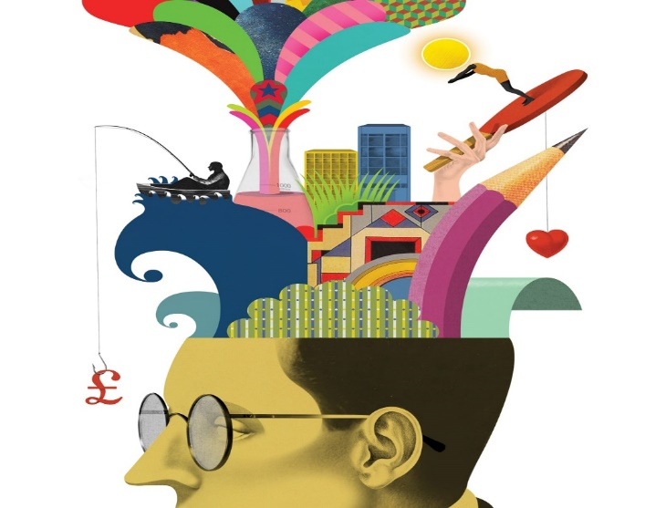
(Christensen, 2016) talked about the research published by Robert J. Sternberg in 1995, who theorised a concept around creativity called the Investment Theory. In the theory he examines the type of individuals and environments that foster creative productivity. According to Sternberg’s research, he believes that creativity is a process of learning new ideas which are then sold later, to a specific audience. He also suggests that each time you have an idea that you should mentally assess it and check if it has potential to progress and if so, what the potential value might be as an outcome. Sternberg provides six resources that allow us to decide whether our idea is worth exploring:
- Intellectual skills
- Knowledge
- Styles of thinking
- Personality
- Motivation
- Environment

Can creativity be taught?
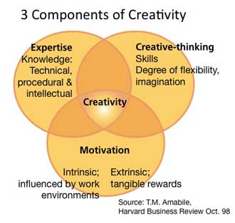
‘’Yes, creativity skills can be learned. Not from sitting in a lecture, but by learning and applying creative thinking processes.’’ According to Naiman, L. (2014). Creativity is both a skill and a process that can be cultivated. Learning a discipline and perfecting a method of thinking are all basics for creativity. Experimenting, investigating, questioning assumptions, using imagination, and synthesizing information are all ways to learn to be creative. (Naiman, 2014)

’Managers can influence all three components of creativity which are expertise, creative-thinking skills, and motivation’’. (Amabile, T.M, 1998).
George Land carried conducted research in 1968, to find out the creativity amongst children and if creativity can be taught. He invented a creativity test for NASA to help him choose innovative scientists and engineers, which he also tested among 1,600 children from ages three-to-five years old who were registered in a Head Start program and the same children were retested at 10 years and 15 years of age. The results showed the creativity amongst:
Five-year olds were 98%
Ten-year olds were 30%
Fifteen-year olds were 12%
And the same test was given to 280,000 adults whose results were 2%.
‘’What we have concluded, is that non-creative behaviour is learned’’. (George Land and Beth Jarman, Breaking Point and Beyond. San Francisco: HarperBusiness, 1993). Therefore it is crucial that we foster creativity in children from an early age so that it can mature as we grow older.
From Creativity - Flow and the Psychology of Discovery and, Csikszentmihalyi. (2013) speaks about the three ways that creativity is commonly used:
1) Individuals who have an impact and have made a change in our culture in a significant way. Their achievements are known by the public and is defined, which makes it easier to write about them. For example, Nelson Mandela, Mahatma Ghandi, Winston Churchill etc.
2) Individuals who appear bright, interested, thought-provoking and express unique views.
3) Individuals who live their life in original ways and are personally creative. They look at thigs with a fresh perspective, make significant discoveries by themselves and have insightful judgements.
Csikszentmihalyi created The Systems Model of Creativity in 1997. The model proclaims that creativity results from the process of ‘a system made of three elements:
- Culture – containing symbolic rules
- Person – who brings originality into the domain
- Field of experts – who distinguish and authorize the innovation
This suggests that creativity transforms something existing.
Characteristics of a creative person
According to Csikszentmihalyi (2013) the characteristics of a creative person are:
- They are energetic but can also be quiet
- They are passionate about their work but can be objective
- They alternate between fantasy and reality
- They are smart but also naïve
- They have a combination of discipline and irresponsibility
- They are independent and rebellious
- They are proud and humble at the same time
- They are open and sensitive which can cause them to suffer or enjoy
- They can be androgyny
- They have the traits of an extrovert and introvert

3.1 The factors that contribute towards creative culture in an organisation

The culture evaluates how the organisation inspires and empowers their employees to rise about daily challenges, overcome adversity and motivate others. This considers how well motivational leaders foster trust and promote behaviours that are consistent with in the organisation’s goals, values and ethics.
Cohen, J. (2019) wrote an article about how to foster creativity in the workplace, and the following six ways to encourage it:
1. Set the stage for brainstorming – if you provide employees with a white paper or a whiteboard along with markers, they may be able to produce ideas by brainstorming. HMRC provide employees with notepads, pen and markers which employees use daily. This will give them the opportunity to be creative and do any brainstorming.
2. Encourage individuality – you should allow and encourage employees to express their thoughts and ideas and let them feel valued. HMRC encourages their employees through coaching, mentoring and during meetings. ‘’Creativity flourishes in organisations that support open ideas: these organisations create environments that inspire personnel and maintain innovative workplaces; those that fail are large organisations that stifle creativity with rules and provide no slack for change’’. Serrat, O. (2009).
3. Provide a stimulating atmosphere – consider the environment for example the office space lighting, space, temperature, design, sounds etc. If employees have a positive workplace it will make them enjoy coming to work. This implies that employees might be more stimulated and encouraged to be creative if they are provided with a varied group of colleagues and an inspiring environment. On each floor of HMRC, employees have access to a quiet space where they can reflect on their work and be creative. All employees are advised to be polite, positive and not discuss any political or unnecessary matters. According to studies, when employees are under a lot of time pressure, their creative thinking drops by almost half. (Amabile, 2002). HMRC give their employees 1 hour a week of development time so that employees can take the time to learn a new skill, new guidance’s or be creative.
4. Facilitate anonymous suggestions – sometimes employees may be scared to suggest in public for example in a meeting, they may be embarrassed, have confidence problems, anxiety and so on. So, by keeping suggestion boxes it will encourage people to drop their suggestions anonymously. HMRC have anonymous surveys that they do send out via emails however there are no suggestion boxes, hence a few should be set up.
5.Continue to hire diverse talent – ‘’Diversity contributes to an atmosphere of creative thinking’’. Cohen, J. (2019). This implies that it is vital to have employees from a variety of backgrounds such as different schools, nations, field etc. Businesses that hire the same types of people with similar backgrounds will experience a recurrence of ideas. ‘’Creativity starts in the hiring process. More organisations are hiring based on diversity (both culturally and with respect to employee skill sets) to bring in team members with fresh ideas. This often means focusing on a worker’s background and potential, rather than specific qualifications.’’ Prentiss, B. (2018). Companies that want diverse ideas and want to connect with people who think differently should hire people with varied backgrounds or experiences, according to Page. Instead of endorsing pre-existing opinions and ideas, this forces your team to consider how others think. One of the great things about HMRC is that they give equal opportunities to people and hire from different backgrounds.
6. Act on good ideas – employees will be more inspired to offer any recommendations if they know their ideas will be valued and applied. You should acknowledge their ideas and let them know if you are implementing them. After monitoring the creative idea, if it is successful and with their permission, you can discuss who came up with the idea and can also reward them. This will make them feel important and it will increase their motivation to contribute more. Employees who come up with innovative ideas are rewarded by HMRC this can be a bonus, gift voucher, certificate, acknowledgement etc.

According to the HMRC Innovation awards criteria, the nominee would have:
- Gone above and above by inventing more efficient processes or customising existing ones to fit specific company and customer needs, demonstrating a proactive interest in the department's aspirations for future improvement.
- Welcomed new ideas and demonstrated enthusiasm for participating in testing, implementing, and/or improving new processes and procedures
- Suggested and acted on positive solutions to improve the engagement of colleagues within their own team, directorate, or business area.
- Helped improve quality by introducing and/or implementing new processes and procedures.
If creative behaviour is rewarded it will become the dominant way of behaving. The issue is that organisations often encourage creative and innovative behaviour but incentivise employees to do the opposite. For example, encouraging risk-taking but incentivising people to produce fault-free work. Instead, employees should be rewarded for generating new ideas, risk-taking and experimentation. (Nash, 2018). However, you need to be careful because if you choose the wrong motivation then employees will be more focused on the rewards and less on how to solve the issue.
From Human Motivation, 3rd ed, by Robert E, Franken, pg. 394, he speaks about the three reasons about what motivates individual’s to be creative:
1. need for varied, complex stimulation and novel
2. need to solve problems
3. need to communicate values and ideas
Robert mentions that in order to be creative, people must be able to see things from a different angle or perspective, as well as generate new options and possibilities. ‘’Creativity is defined as the tendency to generate or recognise ideas, alternatives, or possibilities that may be useful in solving problems, communicating with others, and entertaining ourselves and others’’. Franken, R. E. (1993).

Edward De Bono’s Six Thinking Hats
The six thinking hats is a technique developed by Dr. Edward De Bono in 1985, and is used to strengthen creative discussions, by ensuring that a wide-ranging number of thinking styles and viewpoints are represented. This will let them team structure abstract thinking easier to result in creative results.

3.2 Differences between Creativity and Innovation

As previously stated, creativity is the use of imagination to generate new ideas, whereas innovation is acting and implementing these ideas, so making them happen. Innovation is the successful implementation of creative ideas (Hennessey & Amabile, 2010). ‘’When it comes to creativity and innovation, one thing is certain; they rely on each other, but they are not the same. To be creative, a person, group or business must be able to come up with new ideas. To be innovative, they need to act on these ideas.’’ Rowlands, D. (2018). Both creativity and innovation also share the aim of new practices and ideas. An example is: a creator(s) came up with the idea of using a horse for transportation, which was then changed to a bicycle, which was then developed into a motorbike, which was then developed into a car, which was then developed into an aeroplane and the list goes on. These were all a creative idea that developed and produced and then led to innovations. ‘’In business, originality isn’t enough. To be creative, an idea must also be appropriate—useful and actionable.’’ Amabile, T.M (1998).

According to (Rowlands, D. 2018) the differences between Creativity and Innovation are:
Creativity | Innovation
- Ideas  - Concepts  - Imagination  - Creative Process  - Brainstorming  - Problem Solving  - Thoughts  - Expression  - Ingenuity  - Ideation | - Invention  - Process  - Product  - New  - Useful  - Change  - Value  - Doing  - Action  - Enable  - Measurable  - Implementation

3.3 Importance of Creativity in the Organisation

Some organisations do not understand the value of creativity. ‘’Creativity is crucial for our organizations; it’s one of the elusive abilities that managers are desperately seeking in their employees so their companies can survive in today’s competitive marketplace.’’ Amabile. M, T. (2020). It is important to measure the creativity in the organisation because it will identify the employee’s creative capabilities and show who can generate new ideas. It will also help employers understand if there is a creative culture and if it needs to be encouraged more. ‘’Tests of creativity measure not only the number of alternatives that people can generate but the uniqueness of those alternatives’’. Franken, R. E. (1988).
Amabile. M, T. (2020) spoke about a study she carried out in 1996 where she investigated how social factors influence people’s motivation and creativity in organisations. The study showed that support from supervisors were vital and that ‘’the most creative projects were done under supervisors who fostered clear, honest communication, valued individual contributions to team projects, and set clear goals’’. Creativity will maximise coordination, control and productivity. It will generate useful ideas.
According to Barry Saltzman, founder of the Saltzman Enterprise Group, “creating a collaborative approach with your team has wide-ranging benefits, all of which are positive.” “Open communication becomes second nature when executives share ideas and updates with their employees, and everyone feels equally invested in the company's ultimate goals.” People who identify as creative earn 17 percent more money than those who do not, according to an Adobe survey. Likewise, IBM identified that creativity is the most crucial trait for business success in a survey of 1,500 CEO’s.‘’Creative employees can help grow your business by coming up with better solutions to problems, expanding sales opportunities, and distinguishing your products and services from competitors.’’ Cohen, J. (2019).

4.0 Conclusion

The author can apply innovation models herself and become more effective as a leader. Roles like manager, leader, head of, directors are designed to be responsible got influencing a culture that drives disruptive ideas that stand them apart from the competition. Dunning, J. (2019). For creativity and innovation to develop, the organisational culture must be supportive. The correct structure and support mechanisms must be in place for leaders to participate in the right behaviours. After researching about the innovation and creativity in organisations, the writer has attempted to find out how to improve. After seniors approve the research findings, the writer will attempt to use the Stage-Gate model for the innovation process. Creativity and innovation can be used for problem-solving, communication and many other aspects for an organisation.

References

AF Bureau (2020). Innovation Models. Alcor. Available at: https://alcorfund.com/insight/innovation-models-innovation-process-models-examples/ (Accessed 1 August 2021).
(Alfaro, I. 2017). How to manage your innovation process: The Stage-Gate Framework. Wellspring Blog. Available at: How to Manage your Innovation Process: The Stage-Gate® Framework (wellspring.com) (Accessed 19 August 2021).
Amabile, T.M (1998). How to Kill Creativity. Innovation. Harvard Business Review. Available at: https://hbr.org/1998/09/how-to-kill-creativity (Accessed 7 August 2021).
Amabile, T. M., Hadley, C. N., & Kramer, S. J. (2002). Creativity under the gun. Harvard Business Review, 80(8): 52– 61.
Amabile. M, T. (2020). How Your Work Environment Influences Your Creativity. Greater Good Magazine. Available at: https://greatergood.berkeley.edu/article/item/how_your_work_environment_influences_your_creativity (Accessed 12 August 2021).
Christensen, T. (2016). The 6 Resources That lead to Creativity, According to Research. Inc. Available at: https://www.inc.com/tanner-christensen/the-six-resources-that-lead-to-creativity-according-to-research.html (Accessed 3 August 2021).
Cohen, J. (2019). How to foster creativity in the workplace. Wework. Available at: https://www.wework.com/ideas/professional-development/creativity-culture/foster-creative-culture (Accessed 11 August 2021).
Cooper, R. G. (2008). Perspective: The Stage‐Gate® idea‐to‐launch process—Update, what's new, and NexGen systems. Journal of product innovation management, 25(3), 213-232.

Csikszentmihalyi, M. (2013). Creativity - Flow and the Psychology of Discovery and Invention by Mihaly Csikszentmihalyi. Available at: http://www.csun.edu/~vcpsy00h/creativity/define.htm (Accessed 5 August 2021).
David, (2016). Innovation Space 4P’s. Innovation Management – Group 4. Available at: Innovation Space 4P’s | Innovation Management – Group 4 (wordpress.com) (Accessed 1 September 2021).
(Dunning, J. (2019). Innovation Culture, Innovation Strategy. Idea Drop. Available at: https://ideadrop.co/innovation-strategy/the-strategic-role-of-creativity-in-innovation/ (Accessed 10 August 2021).
Franken, R. E. (1993). Human Motivation, 3rd ed, by Robert E, Franken, pg. 394,
Frey, C. (2009). Peter Drucker on the essentials of innovations. Available at: https://innovationmanagement.se/2009/03/23/peter-drucker-on-the-essentials-of-innovation/ (Accessed 1 August 2021).
(Hennessey & Amabile, 2010). B. Hennessey, T. Amabile. Creativity. Annual Review of Psychology, 61 (2010), pp. 569-598
Innolytics.ag (2020). What is an innovation network? Innolytics.ag Available at: https://innolytics-innovation.com/innovation-network/ (Accessed 14 August 2021).
(Kylliainen, J, 2018) Key Innovation Management Models and Theories. Viima. Available at: https://www.viima.com/blog/innovation-management-models (Accessed 19 August 2021).
McClure, D. (2015). Digital Innovation. Thought works. Available at: https://www.thoughtworks.com/insights/blog/what-innovation-simple-definition (Accessed 1 August 2021).
Morr, K. (2018). What is creativity? The ultimate guide to understanding today’s most important ability. 99 designs. Available at: https://99designs.co.uk/blog/creative-thinking/what-is-creativity/ (Accessed 5 August 2021).

Naiman, L. (2014). Creativity at work. Available at: https://www.creativityatwork.com/2012/03/23/can-creativity-be-taught/ (Accessed 4 August 2021).
Nash, M. (2018). Creating a Culture for Innovation and Creativity to Thrive. Leadership Success. Available at: https://www.leadershipsuccess.co/blog/innovation-culture (Accessed 27 August 2021).
Prentiss, B. (2018). How to build a Creative Culture within your organization. The Uncommon League. Available at: https://theuncommonleague.com/blog/2018313/how-to-build-a-creative-culture-within-your-organization (Accessed 22 August 2021).
Rowlands, D. (2018). What is the Difference Between Creativity and Innovation? Available at: https://weareive.org/what-is-the-difference-between-creativity-and-innovation/?ppc_keyword=creativity%20and%20innovation&gclid=EAIaIQobChMInsGazKrZ8gIVzevtCh0jjAiQEAAYASAAEgJmr_D_BwE (Accessed 3 August 2021).
Runco, Mark A. and Jaeger Garrett J. (2012). The Standard Definition of Creativity. Creativity Research Journal, 24:1, 92-96. Available at: (PDF) The standard definition of creativity | Garrett Jaeger - Academia.edu (Accessed 2nd July 2019). (Accessed 1 August 2021).
Runco, M.A. Creativity, Theories and Themes: Research, Development and Practice. Second Edition. Mark A. Runco. Pg. xi Available at: https://books.google.co.uk/books?hl=en&lr=&id=XwjUAgAAQBAJ&oi=fnd&pg=PP1&dq=what+affects+creativity&ots=b1CxHbUtl4&sig=O0qR-xZk1ZgnNpyHBUddSDRC_Vk#v=onepage&q&f=false (Accessed 3 August 2021).
Serrat, O. (2009). Harnessing Creativity and Innovation in the Workplace. Available at: https://www.researchgate.net/publication/318016546_Harnessing_Creativity_and_Innovation_in_the_Workplace (Accessed 1 August 2021).
Vogt, S. (2018). Want a more creative team? Civil service. Gov.uk Available at: https://civilservice.blog.gov.uk/2018/06/13/want-a-more-creative-team/ (Accessed 21 August 2021).
Weisberg. R. W. (1992). Creativity – Beyond the Myth of Genius, by Robert W. Weisberg. First Edition. 1992. Page 4.
Figure 1. Five Stage Process defined in Cooper, 2008. Source: https://www.wellspring.com/blog/how-to-manage-your-innovation-process-the-stage-gate-framework
Figure 2: First Generation Model -Technology Push. Source: https://alcorfund.com/insight/innovation-models-innovation-process-models-examples/
Figure 3: Source: https://www.viima.com/blog/innovation-management-models

Appendix A
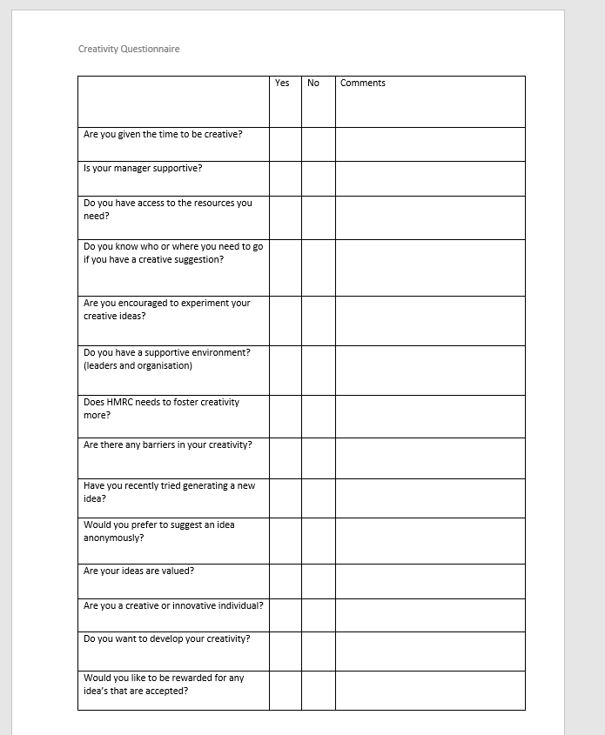

Appendix B

