DS1 Portfolio
Name: Mariana Sima
Student ID: 2542277

My Screenshots Photos

Screenshot Photo 1
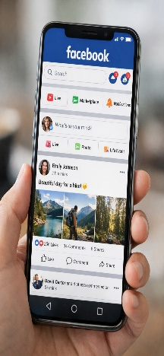
What this shows: This screenshot shows my Facebook feed where I connect with friends and family, share photos, and follow local events. It demonstrates how I use social media to keep in touch and discover community news.

Screenshot Photo 2
Insert Photo: 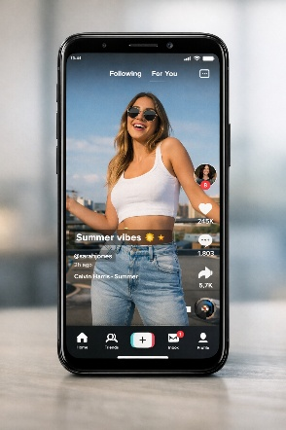
What this shows: This screenshot shows a TikTok For You video feed I use for short-form learning and entertainment. It represents how trends and creative content influence my ideas and help me learn new skills quickly.

Screenshot Photo 3
Insert Photo: 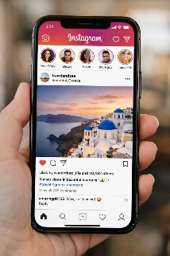
What this shows: This screenshot shows my Instagram feed with travel and photography posts I follow for inspiration. It highlights how I use visual platforms to explore creative work and build aesthetic ideas.

Screenshot Photo 4
Insert Photo: 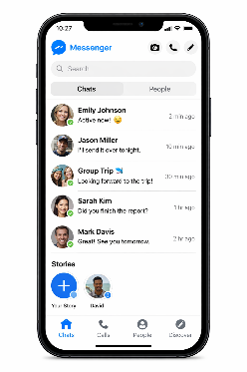
What this shows: This screenshot shows my Messenger chats used for instant communication with classmates and group project coordination. It shows how I share files, ask quick questions, and organise meetings.

Screenshot Photo 5
Insert Photo: 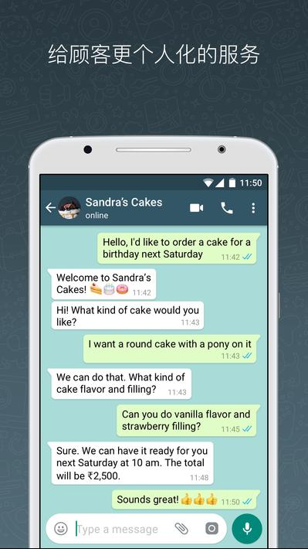
What this shows: This screenshot shows my WhatsApp conversations used for family and study groups. It demonstrates how I manage both personal and academic communication in one place.

My Short Reflection
I use digital tools to communicate with friends and classmates, find information, and share creative work.
I feel confident when I use messaging apps to organise group tasks and when I search for quick tutorials online.
I want to improve my skills in editing photos and short videos so my posts look more professional.
I often use these tools: Facebook, TikTok, Instagram, Messenger, and WhatsApp for different purposes.
I sometimes feel nervous about privacy settings and how my data is shared across platforms.
I hope this module will help me learn safer online habits and better ways to present my work digitally.
Digital skills are important for me because they help me study, collaborate, and prepare for future work in a digital world.

Conclusion
Creating this DS1 portfolio helped me see how each app plays a different role in my digital life: social connection, creative inspiration, quick communication, and group collaboration. Reflecting on my screenshots made me realise I rely on a mix of platforms to manage study and social life, and that improving technical skills like photo and video editing will make my digital work more effective. I will focus on learning privacy best practices and simple editing techniques so I can share confidently and responsibly.

References
- Facebook App — Meta Platforms Inc.
- TikTok App — ByteDance Ltd.
- Instagram App — Meta Platforms Inc.
- Messenger App — Meta Platforms Inc.
- WhatsApp App — Meta Platforms Inc.

