7/21/2026
Mesfin Tezera
University Of Walse Trinity Sanit David London
Module code: ACCA4023
Student Name: Mesfin Tezera
Student ID: 2510889
Group: 2
Lecture: Dr. Anum Paracha
Database Development task 1
Database

Table of Contents

Table of Contents
Table of Contents 1
Executive Summary & Scenario Analysis 1
Entity-Relationship Diagram (ERD) Planning 1
Data Structure Development (Tables & Relationships) 1
Normalization Compliance (3NF) 1
Sample Data Population 1
1. Query Development (SQL & MS Access Logic 1
Validation, Testing, and Reflection 1
1)Executive Summary & Scenario Analysis 2
Purpose and Context 2
Main Entities and Attributes 2
Relationships 3
4. Normalization Compliance (3NF) 4
Parking Sites Data 4
Parking Slots Data 5
Customers Data 5
Payments Data 6
Query 1: View Active (Occupied) Slots and Vehicle Details 7
Query 2: Total Revenue Collected Per Parking Site 7
7. Validation, Testing, and Reflection 7
Validation Plan 7
Test IDObjectiveInput ActionExpected ResultStatusTC-01Prevent negative paymentsTry entering -$5.00 in PaymentsMS Access shows validation rule errorPASSTC-02Ensure slot associationTry adding a slot without a Site_IDDatabase rejects due to Referencing IntegrityPASS 7
Short Design Report & Challenges 8
8. References 8

Introduction

The rapid growth of cities has caused a large increase in car ownership, which makes parking management a big challenge. A city parking provider currently runs multiple parking spots but relies entirely on manual, paper records and cash payments. This outdated paper system leads to frequent human error, misplaced logs, and double-booked parking spaces. Furthermore, management cannot see real-time parking availability or track their financial performance easily. To fix these problems, the company needs a centralized Microsoft Access database solution to truck cars, monitor parking spots, and record money accurately.

Scenario Analysis

The Auto Park management system uses five core database entities. Customer stores driver details for communication. Vehicles track cars using unique licence plates. Parking sites represent the physical location in the city. Each site contains multiple parking slots with Realtime availability statuses. Finally, bookings act as the transactional bridge that connect all these parts together.

Task 1, Question 2: Entity-Relationship Diagram (ERD)
This is the logical design for my MS Access database. I created it to guide me later when I build the actual database structure. Using a tool like draw.io makes the diagram easy for anyone in this field to understand. Mapping my data this way bridges the gap between a conceptual idea and physical reality, which is why I chose this method [1].

Main Entities and Attributes
Conceptual diagram
Figure 1: is Entity-Relationship Diagram (ERD) Planning
Parking Slots: The specific spaces inside each parking site
Customers: The vehicle owners who use the service.

Bookings: The records of a vehicle parking in a slot for a specific time.

Payments: The financial transactions for each booking

Vehicles: Cars, motorbikes, Trucks which belong to customer

Parking Sites: The physical parking stations across the city.

Relationship
One Parking Site contains many Parking Slots (1-to-Many).

One Customer can make many Bookings (1-to-Many).

One Parking Slot can have many Bookings over time (1-to-Many
One Booking generates exactly one Payment (1-to-1).

Many Vehicles can Blong to one customer

One payment c be paid to different parking slot

2. Entity-Relationship Diagram (ERD) Planning
Logical diagram

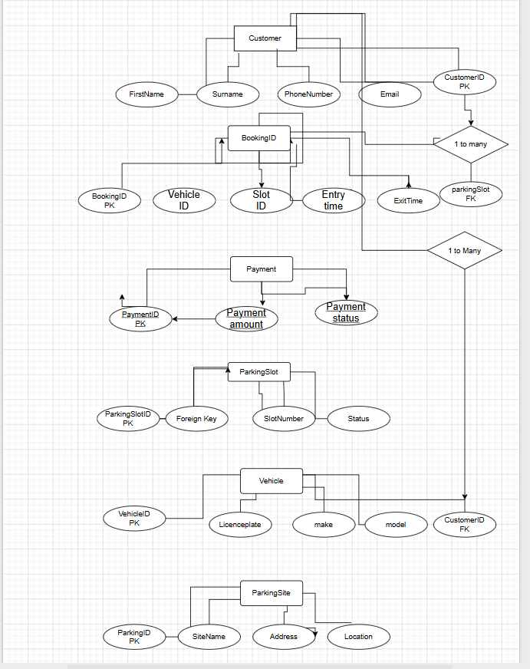

Figure 1: This diagram provides a conceptual view of the Auto Park Management System database using Chen's notation. It maps out each entity, its individual attributes, and the structural relationships connecting them.

i
3. Data Structure Development

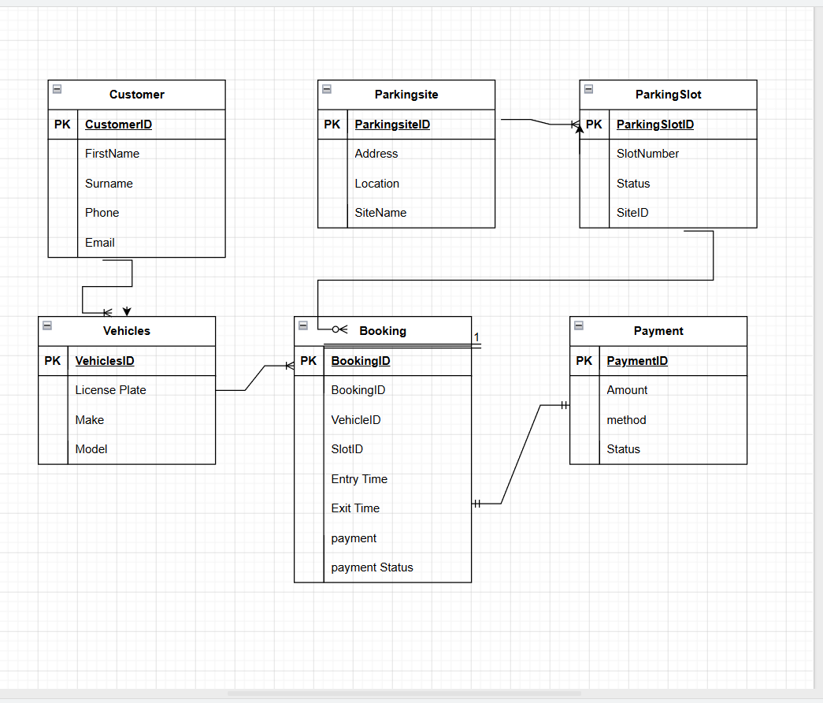
Figure 2: logical entity-relationship diagram illustrates the fully normalized relationship database structure designed for the Auto Park management system.

4. Normalization Compliance (3NF) 4. Normalization Compliance (3NF)
In relational database design, normalization is the process of organizing data to minimize redundancy. It usually involves dividing a database into two or more tables and defining clear relationships between them. The main objective is to isolate data so that additions, deletions, and modifications can be made in just one table, then safely shared across the rest of the system via those relationships [2].
To minimize data duplication, this design follows Third Normal Form (3NF) rules:
- 1NF first normal form every cell contains a single, value, no repeating data or group exist all are kept in individual record in my table for Example customer table there is no cell contains multiple phone number or multiple car licence in single box.
- 2Nf second normal form: the data basses meet 1NF, and all non-key columns depend entirely on the primary key Ex, Slot number depends structurally on slot ID not on Customer. I spilite my data in into separate table so, everything matches perfectly.

- 3NF third normal form: the database meets 2 NF, and non-key columnas depend on other non-key columnas Ex: the amount paid depend on the Booking ID not directly on the Customer tab Booking Id Ver Vehicle ID If my booking table included I only keep Vehicle ID

5) Sample Data Population
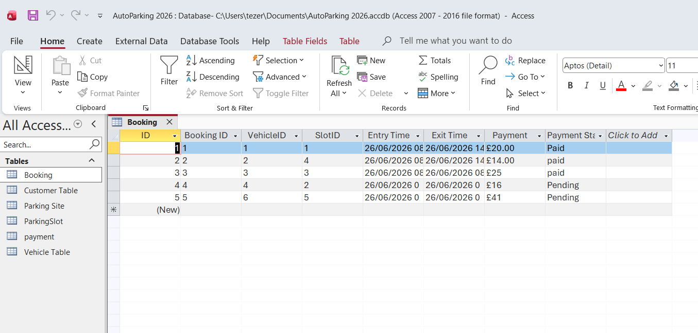
Figure 1: shows a database table named Booking open in Microsoft Access.

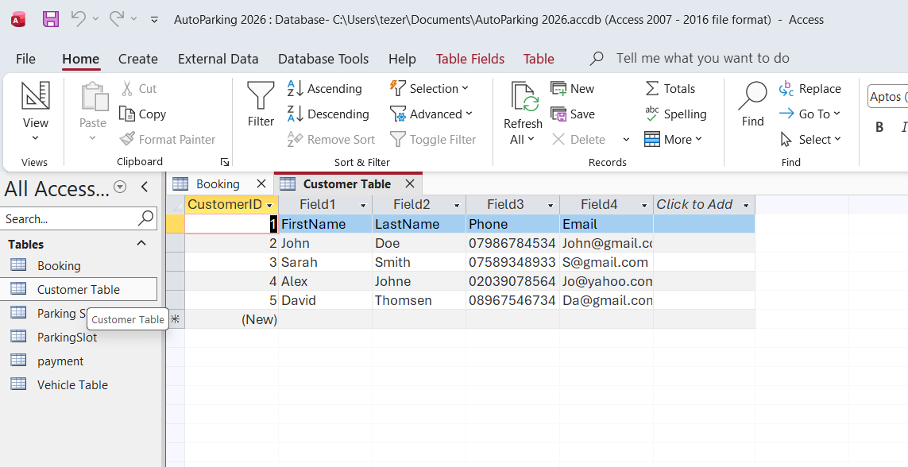
Figure 2: The image shows a Microsoft Access database window with a table named Customer Table open.
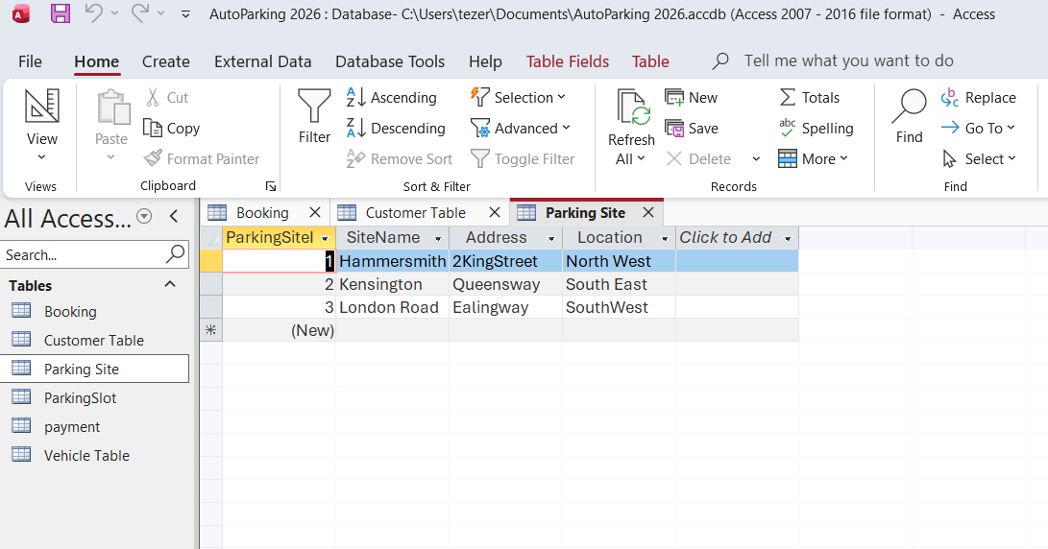
Figure 3: shows a Microsoft Access database window with a table named Parking Site open.

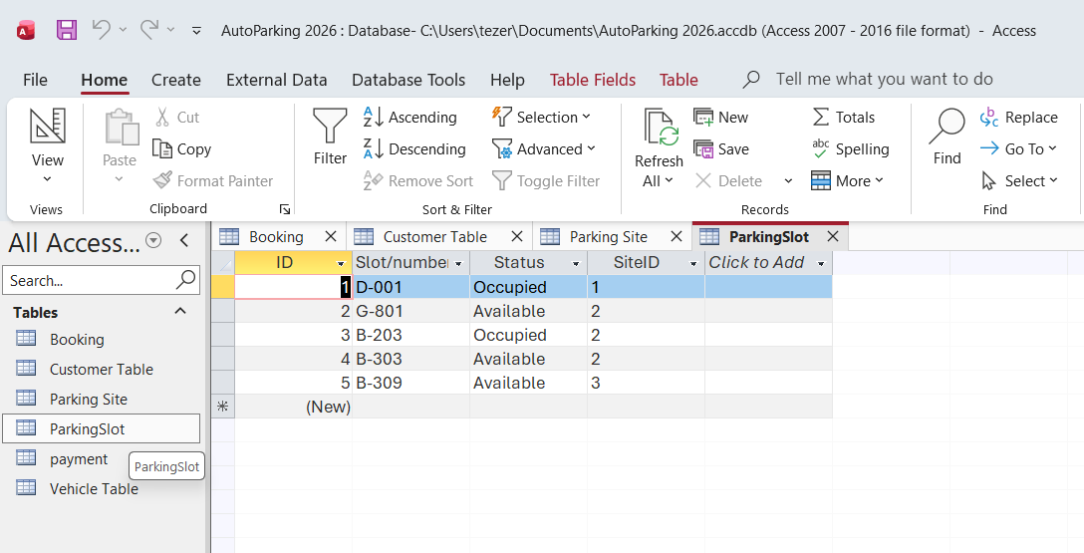
Figure 4: image shows a Microsoft Access database window with a table named Parking Slot open.

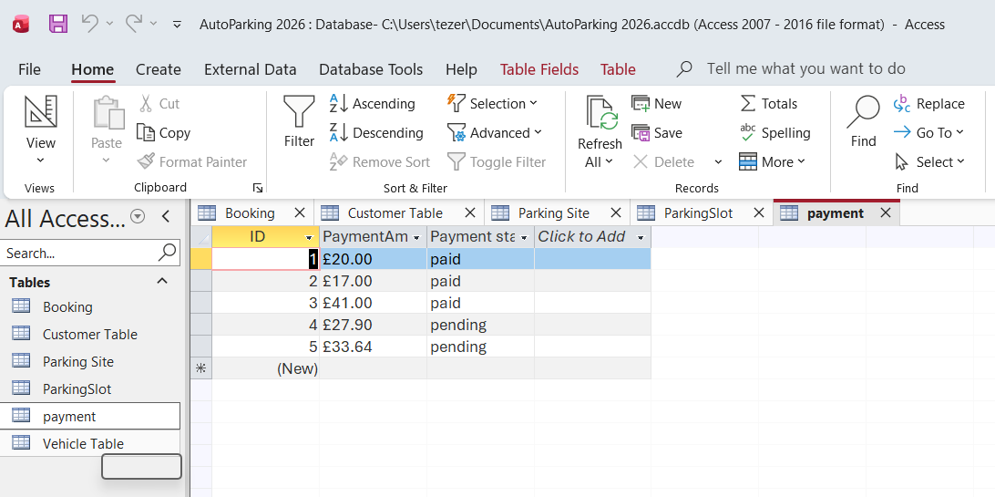
Figure 5: The image shows a Microsoft Access database window with a table named payment open.
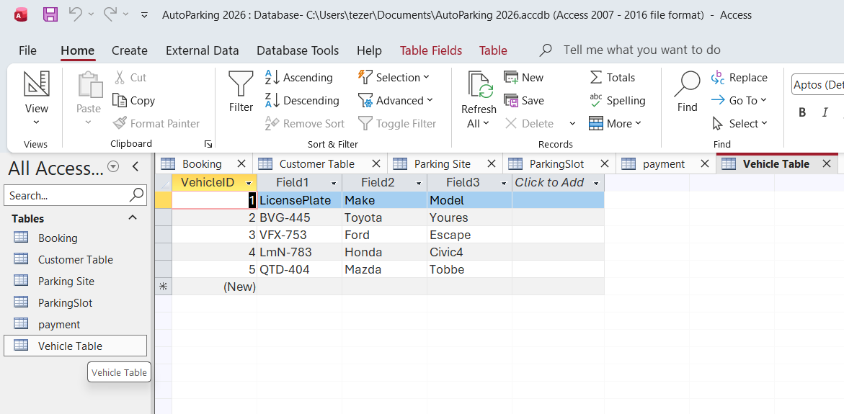
Figure 6: The image shows a Microsoft Access database window with a table named Vehicle Table open.

6 Query Development
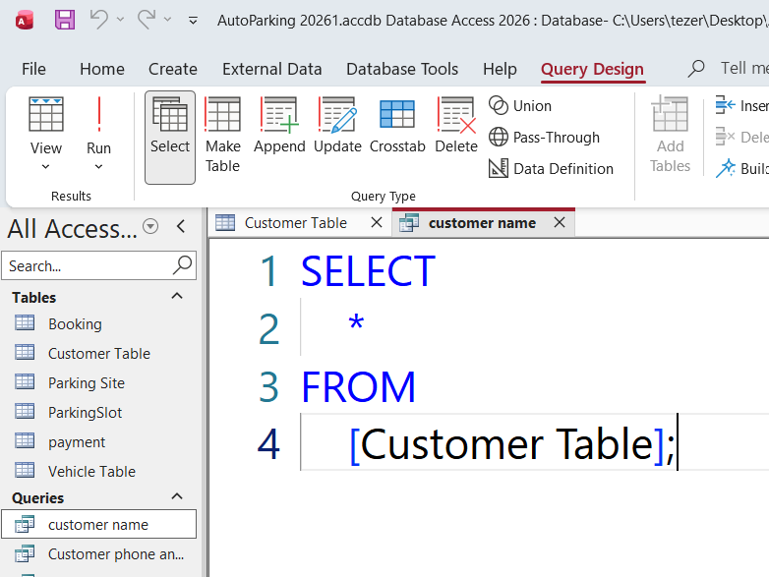
Figure 1: This is a screenshot of the Microsoft Access user interface
displaying the SQL view of a query Customer name

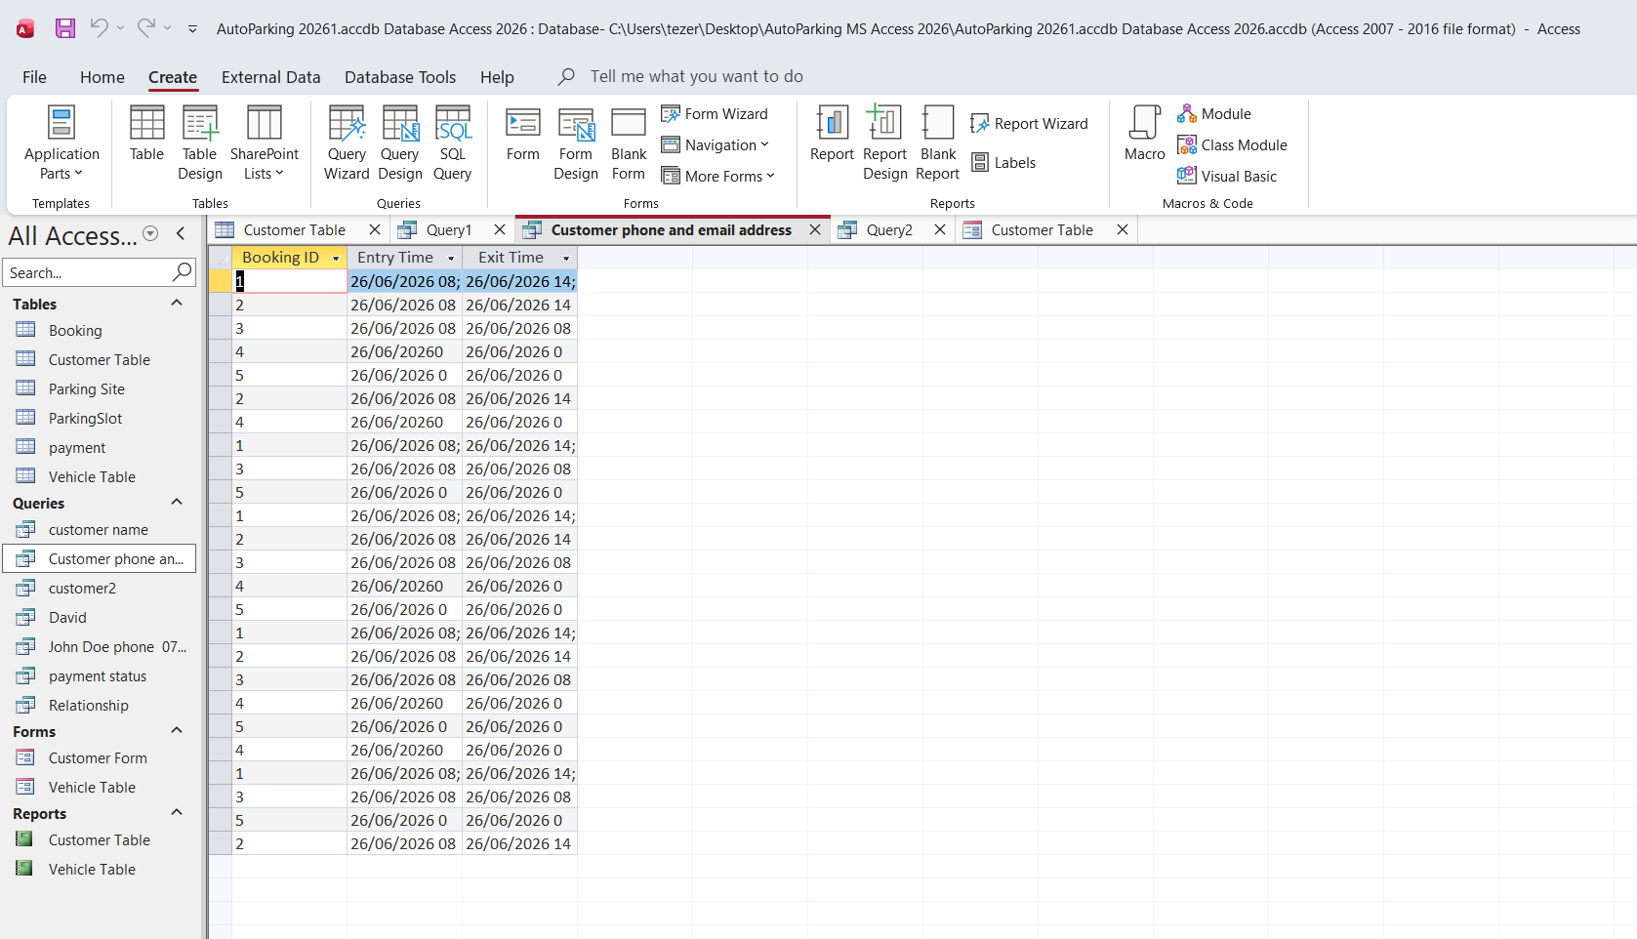
Figure 2: Query output, this is datasheet view of a query named customer phone and email address.

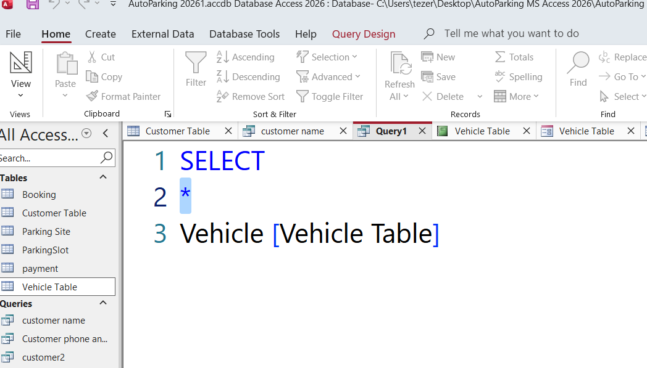
Figure 3: This is a screenshot of the Microsoft Access user interface displaying the SQL view of a query Vehicle table.

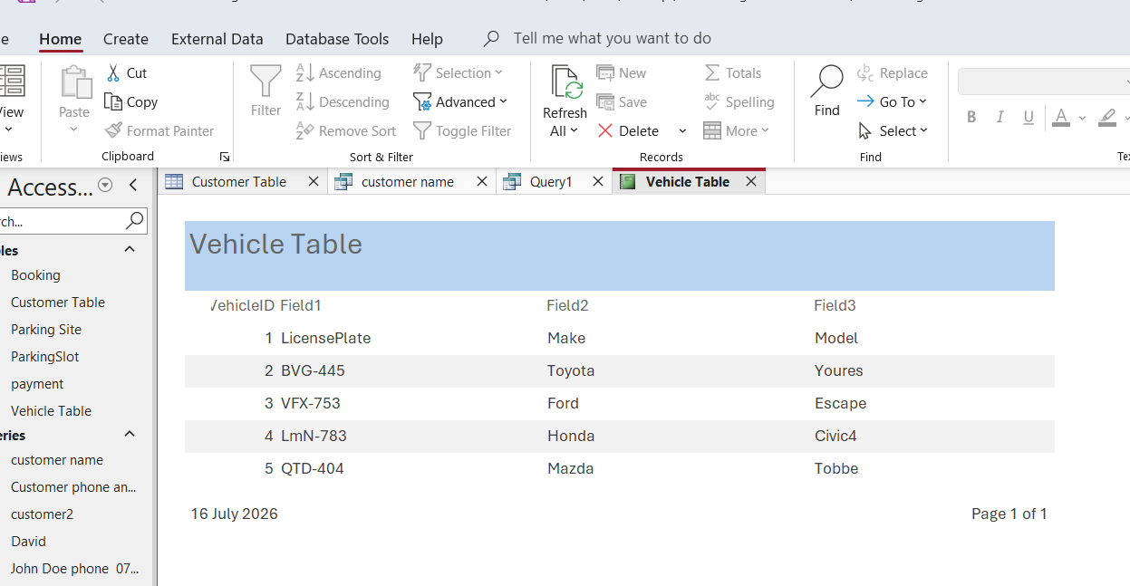
Figure 4: this is query report of Vehicle table.

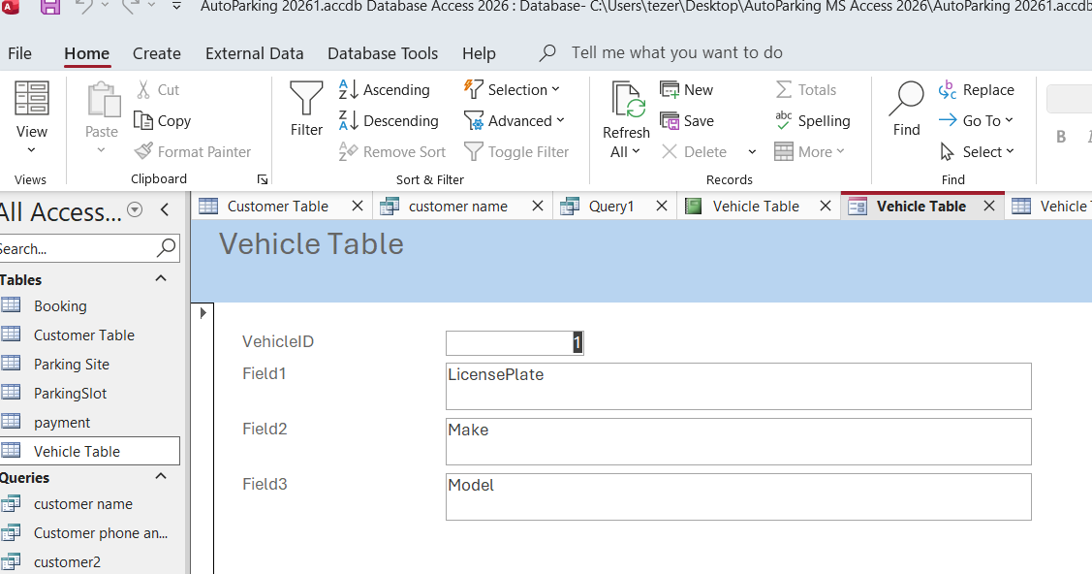
Figure 4: query report for Vehicle table

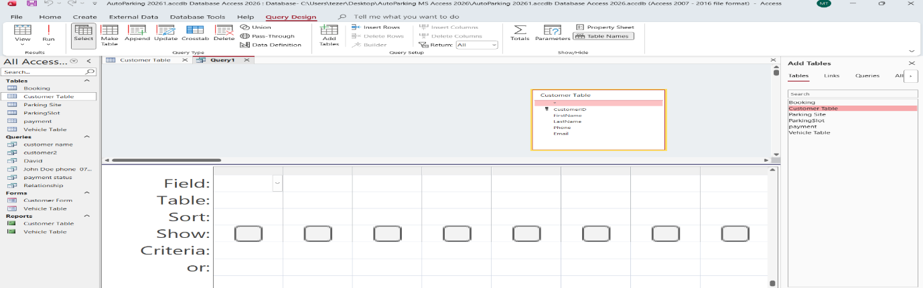
Figure 5: This is displaying query Design interference in Microsoft Access for Auto parking, the workspace is set up to create a new query using the customer table.

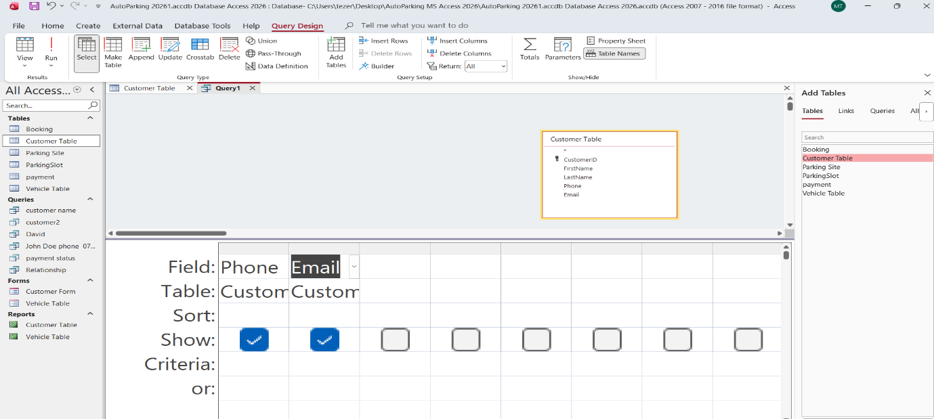
Figure 6: This is Query development of phone and email address from customer list

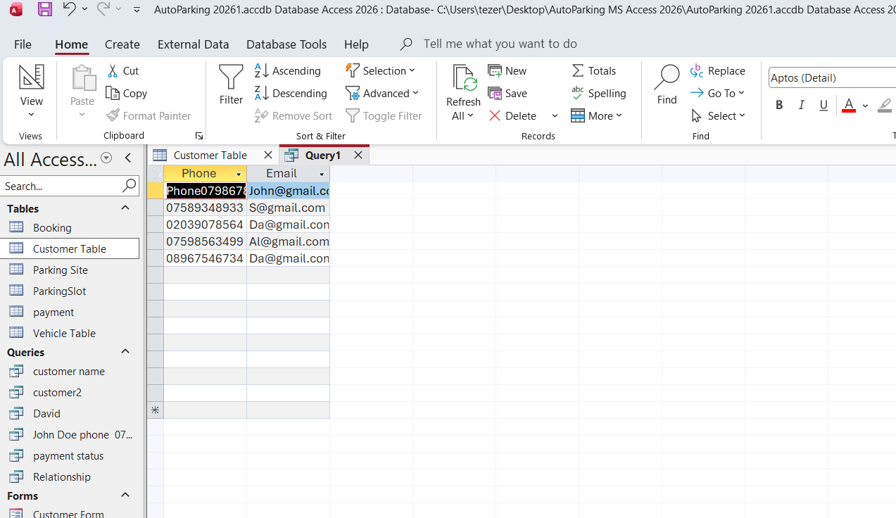
Figure 7: This query output of phone and email address from customer table.

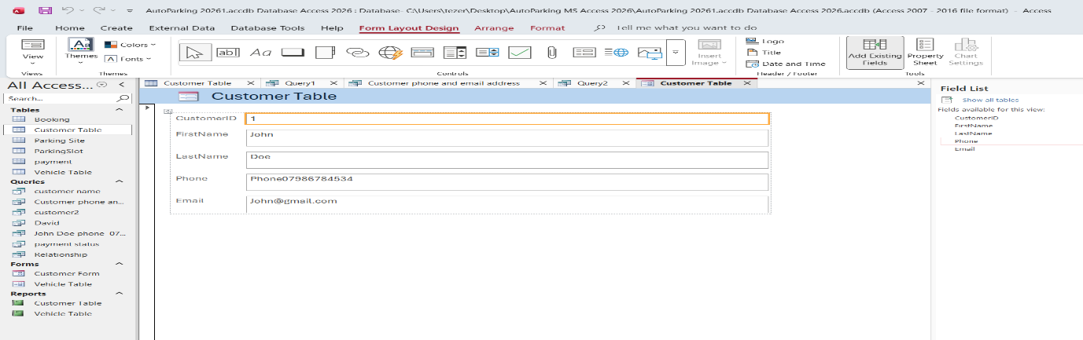
Figure 8: This query form which I can change anything I want to the customer

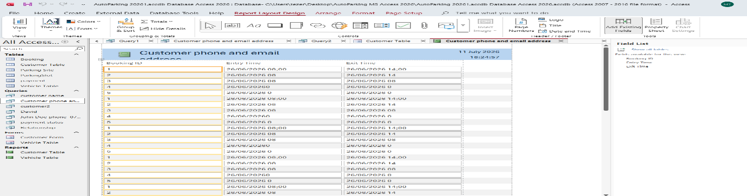
Figure 9: This is Query Report which has been developed by Microsoft Database,

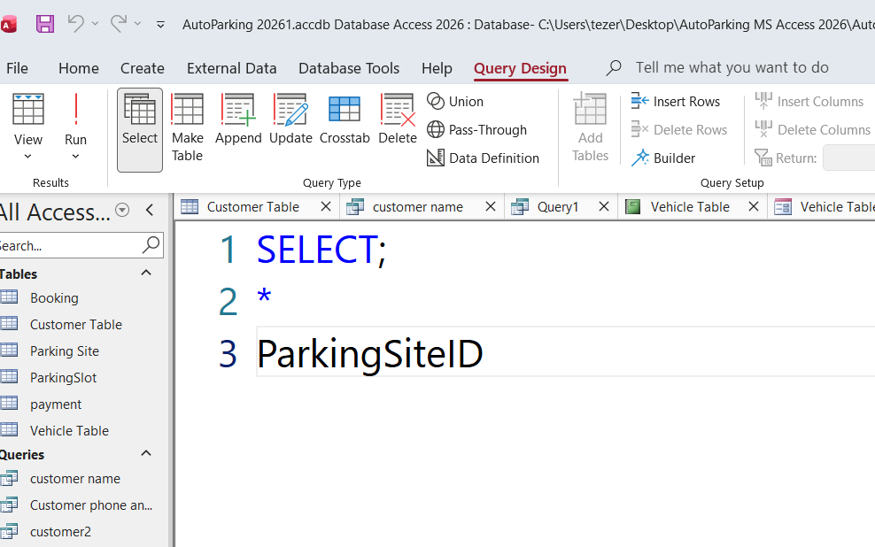
Figure 10: This is Input Query for parking site

Figure 11: This is vehicle query Report Enter and exit report to the parking site.

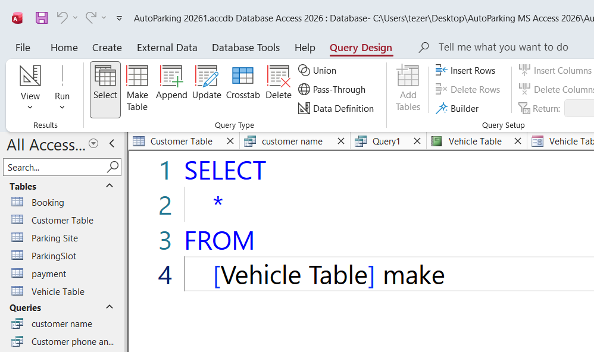
Figure 12: This is query input for vehicle table.

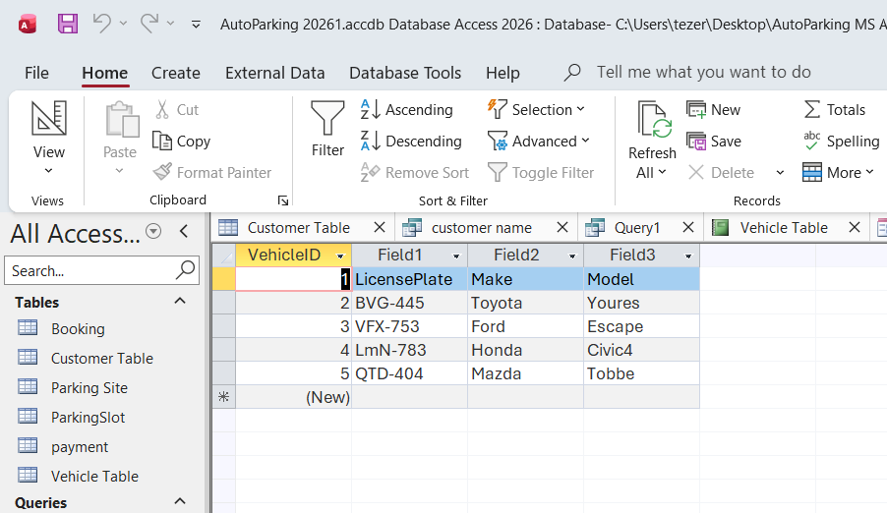
Figure 13: This is query output for Vehicle table.

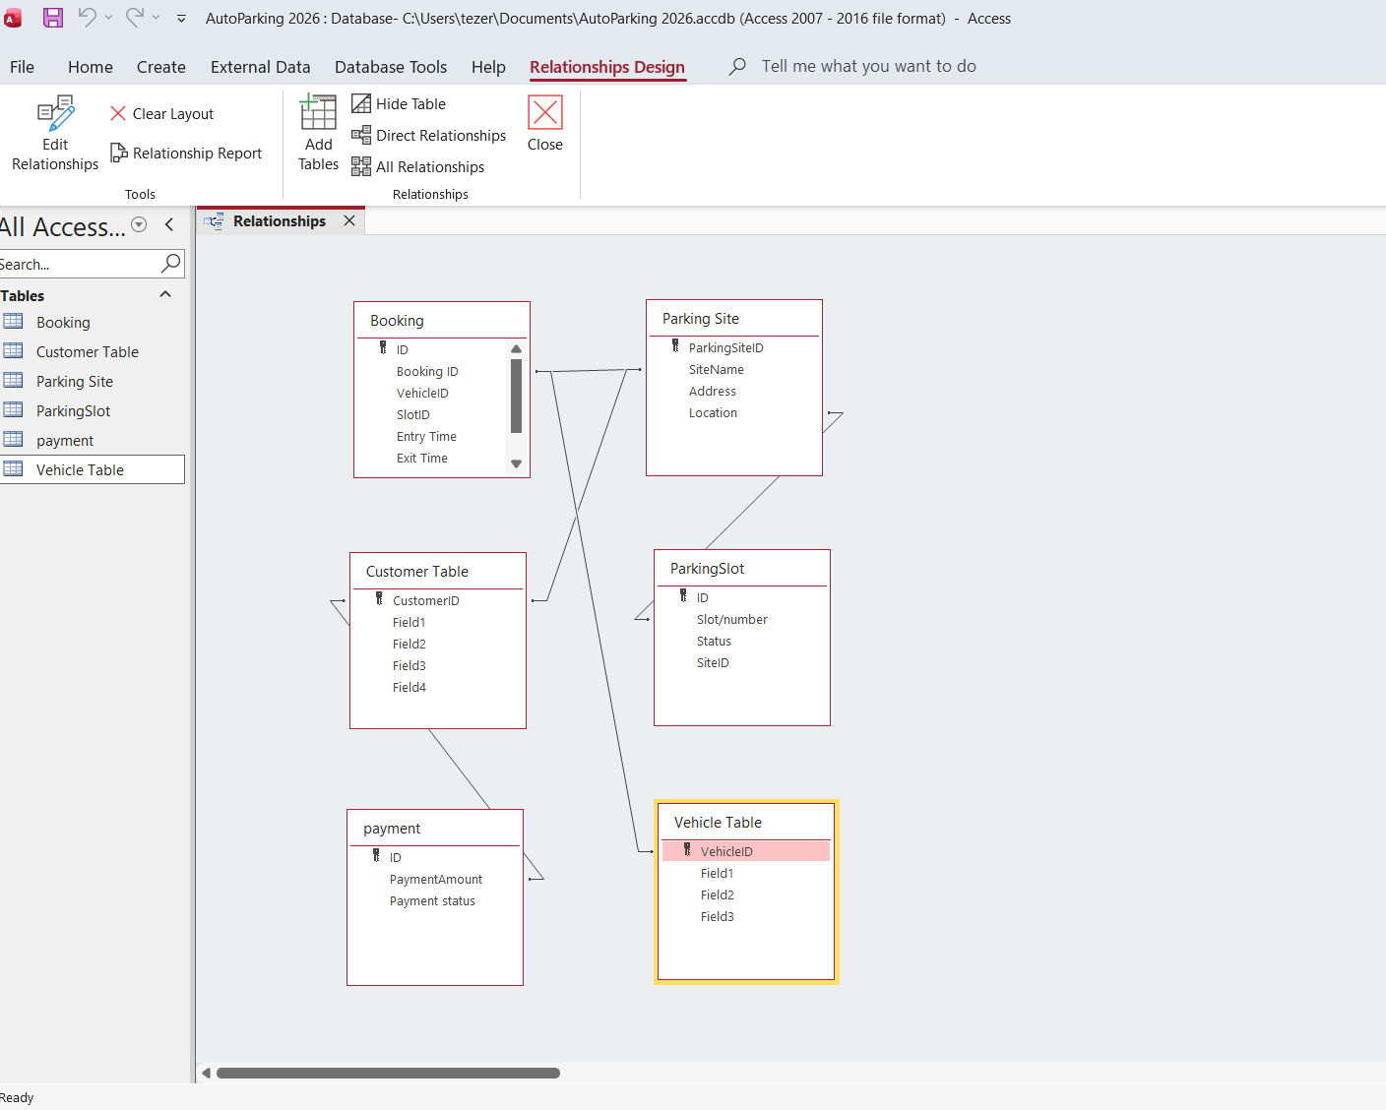
Figure 14: The image shows the Relationships window in a Microsoft Access database. This view visualizes how different tables link together.

Figure 15: This is Relationships in a Microsoft Access database. This view visualizes how different tables link together.

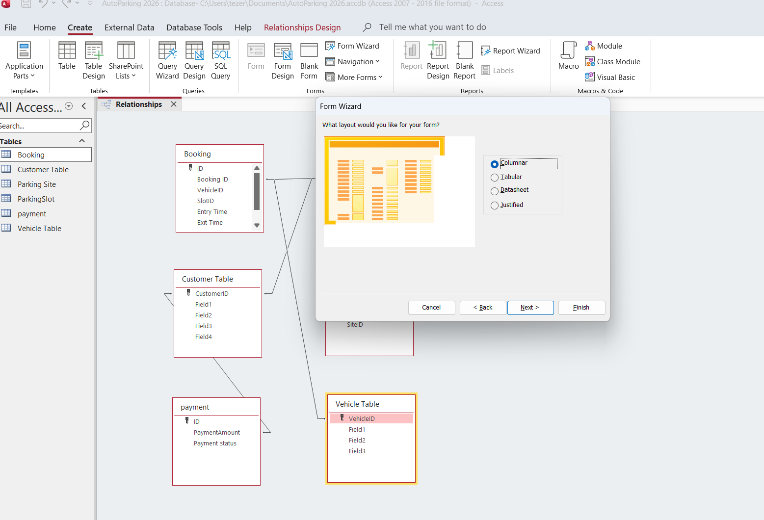
Figure 16: The image shows the Relationships window in a Microsoft Access database. This view visualizes how different tables link together.

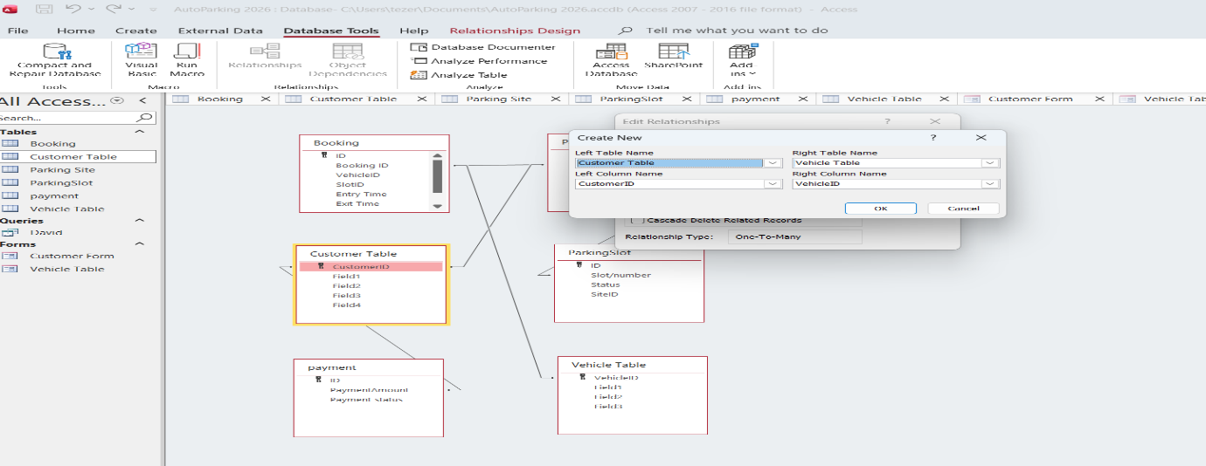
Figure 17: shows the Relationships Design interface within Microsoft Access 2026, displaying the entity-relationship schema for an automated parking database application named "Auto Parking 2026."

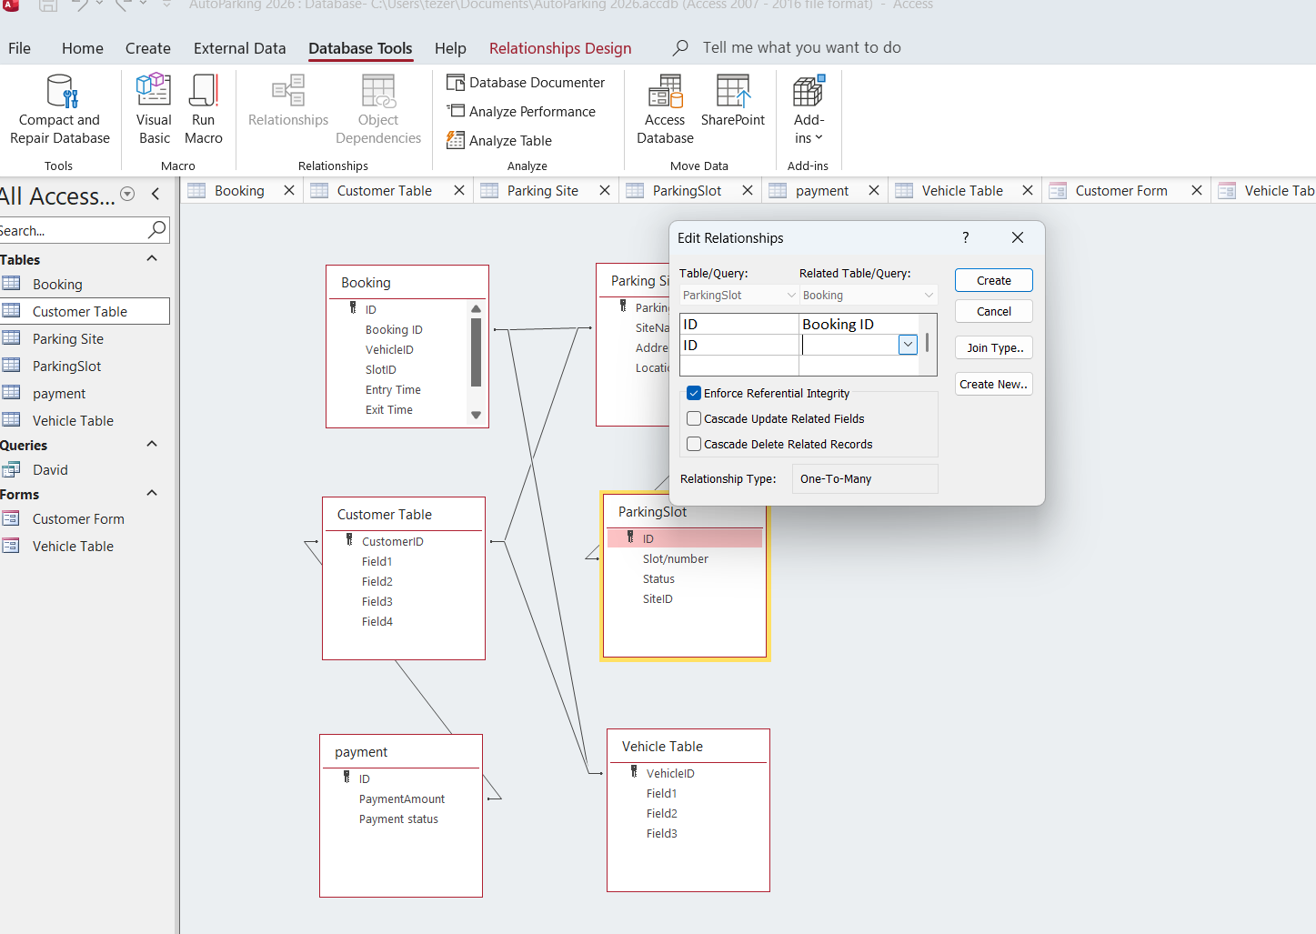
Figure 18: Working on diagram to make a relationship between both tables
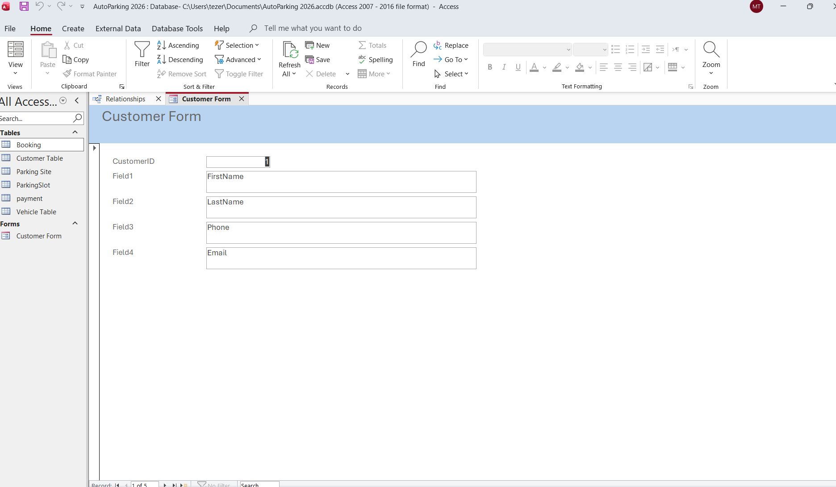
Figure19: The image shows a Microsoft Access database window with a database form named Customer Form open.

.

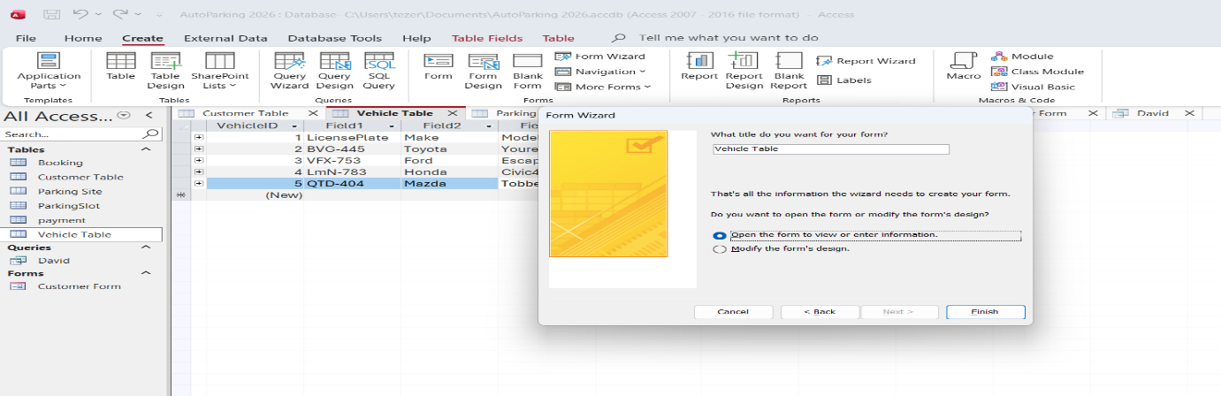
Figure 20: The image shows a Microsoft Access database window with the Form Wizard dialog box open in the foreground. In the background, the Vehicle Table is partially visible.

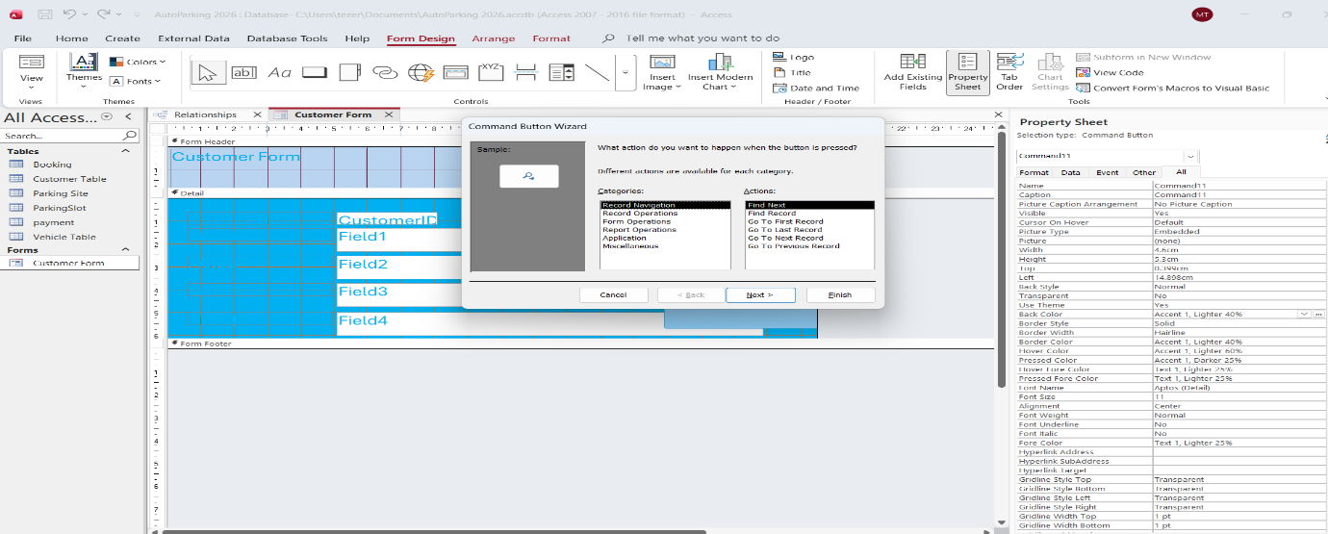
Figure 21: The image shows a close-up of a Microsoft Access window displaying the Customer Form in Form Design View.
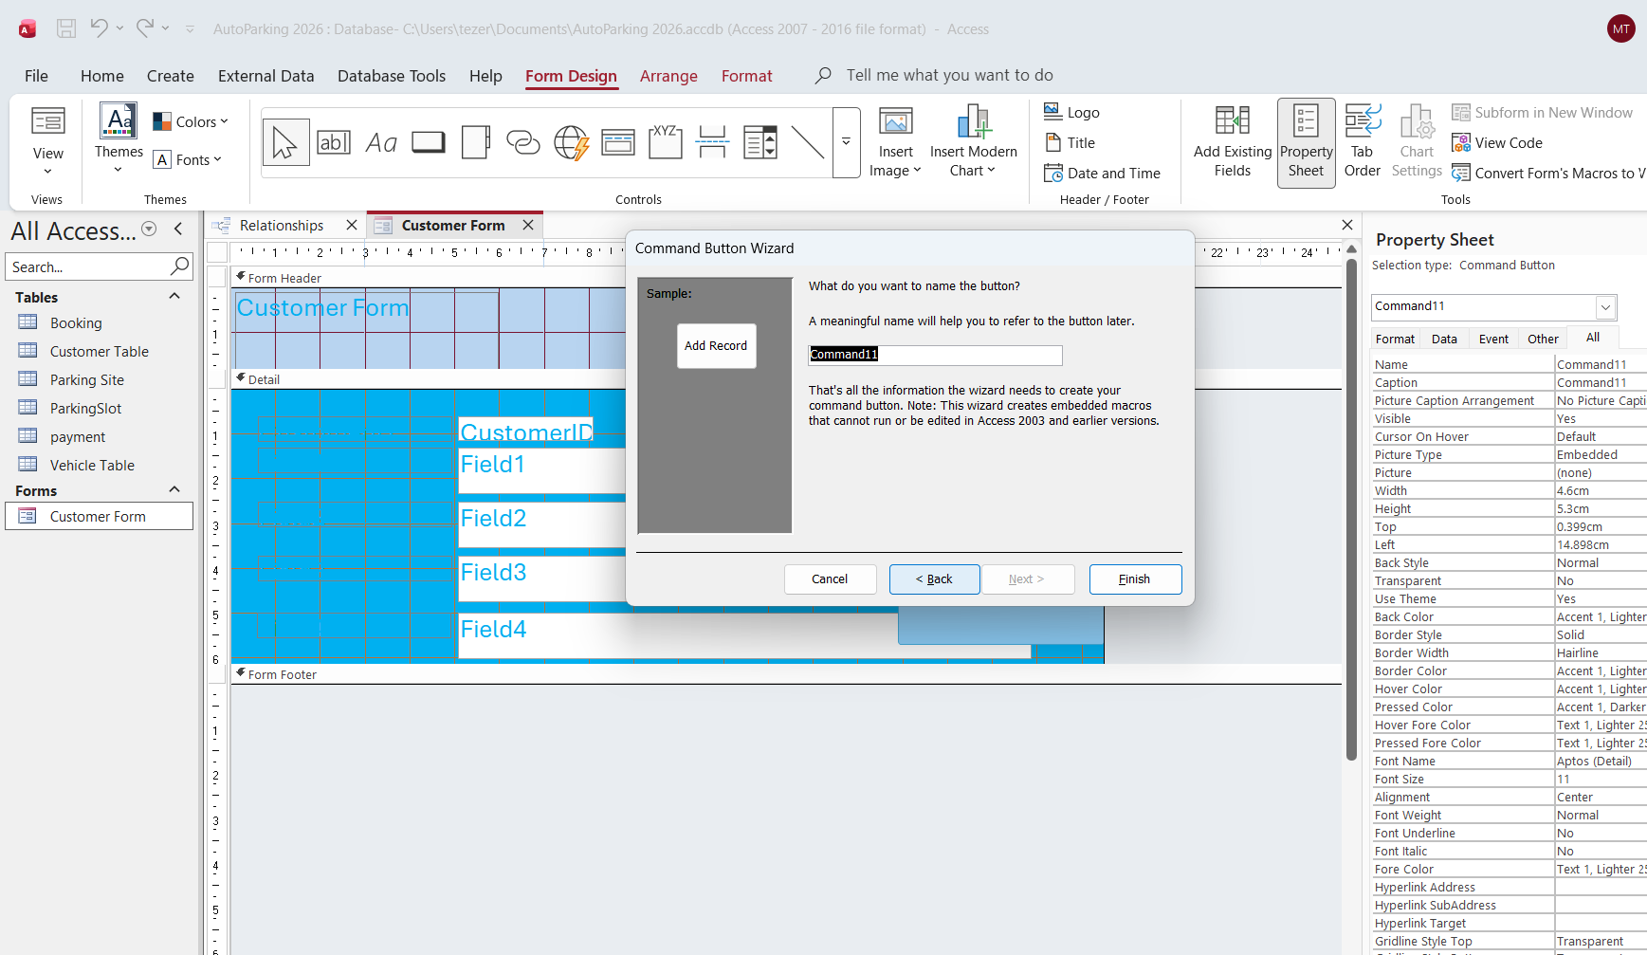
Figure 22: The image shows the final Customer Form running in active Form View with its finished user interface styling.

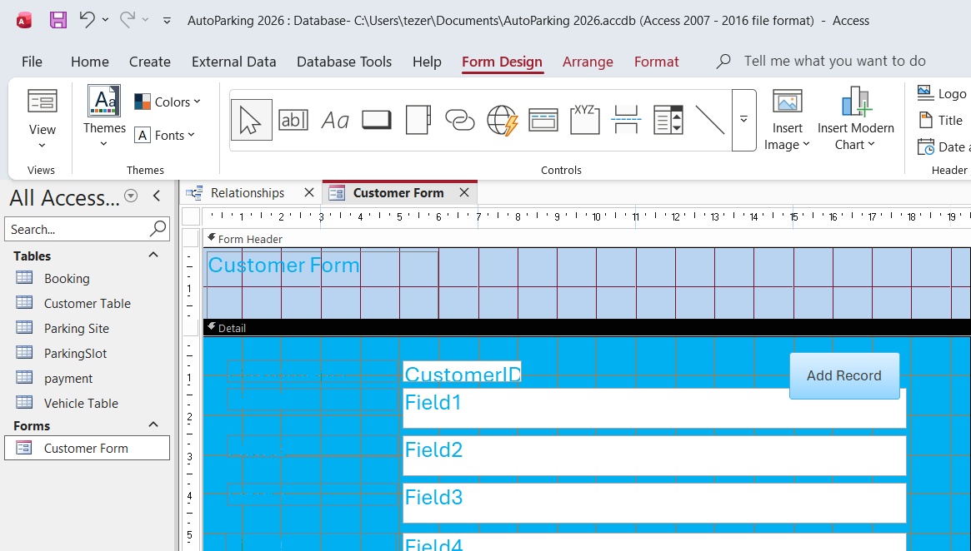
Figure23: This image shows a close-up view of the Customer Form in Form Design View..
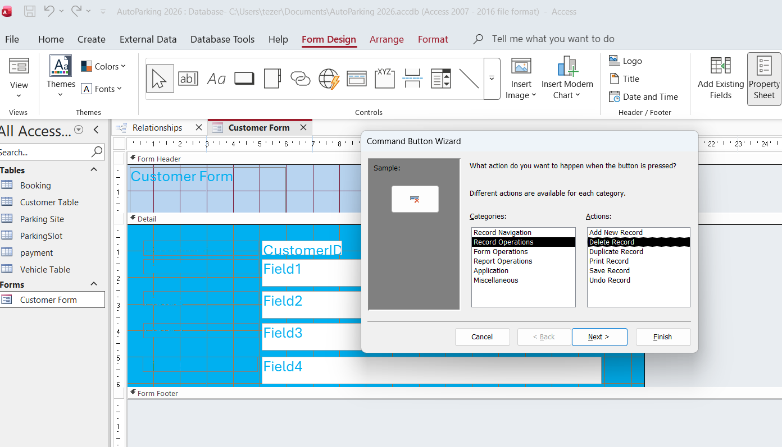
Figure 24: The image captures the completed Customer Form running live in Form View..

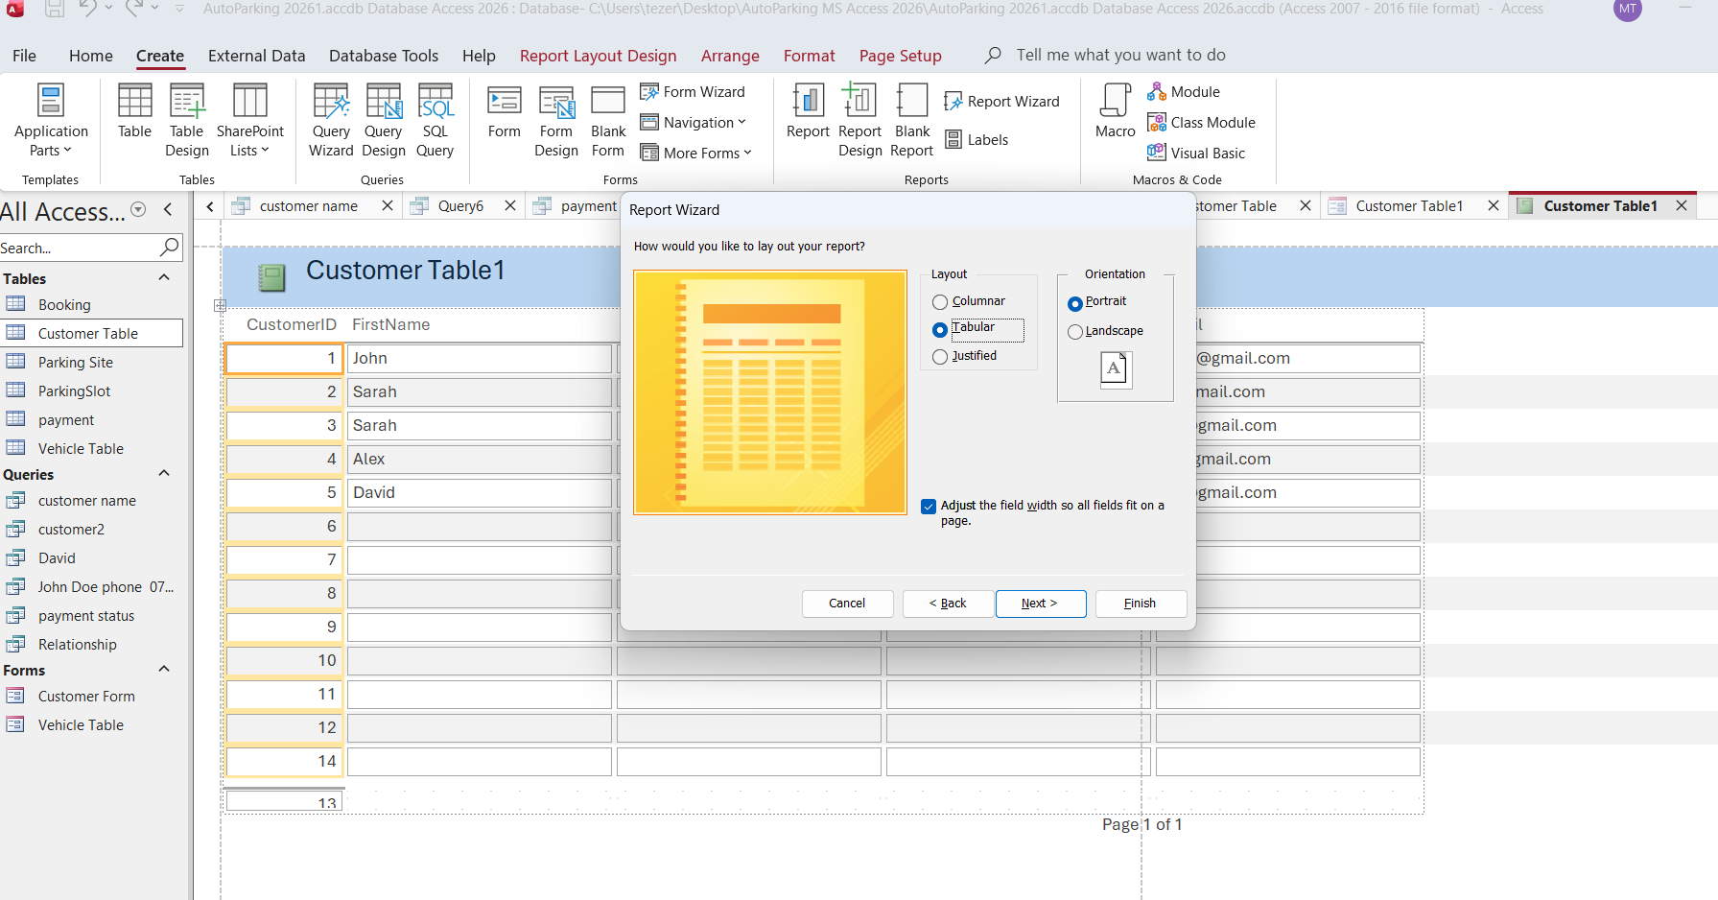
Figure25: shows a screenshot of the Microsoft Access user interference during the process of creating a database report
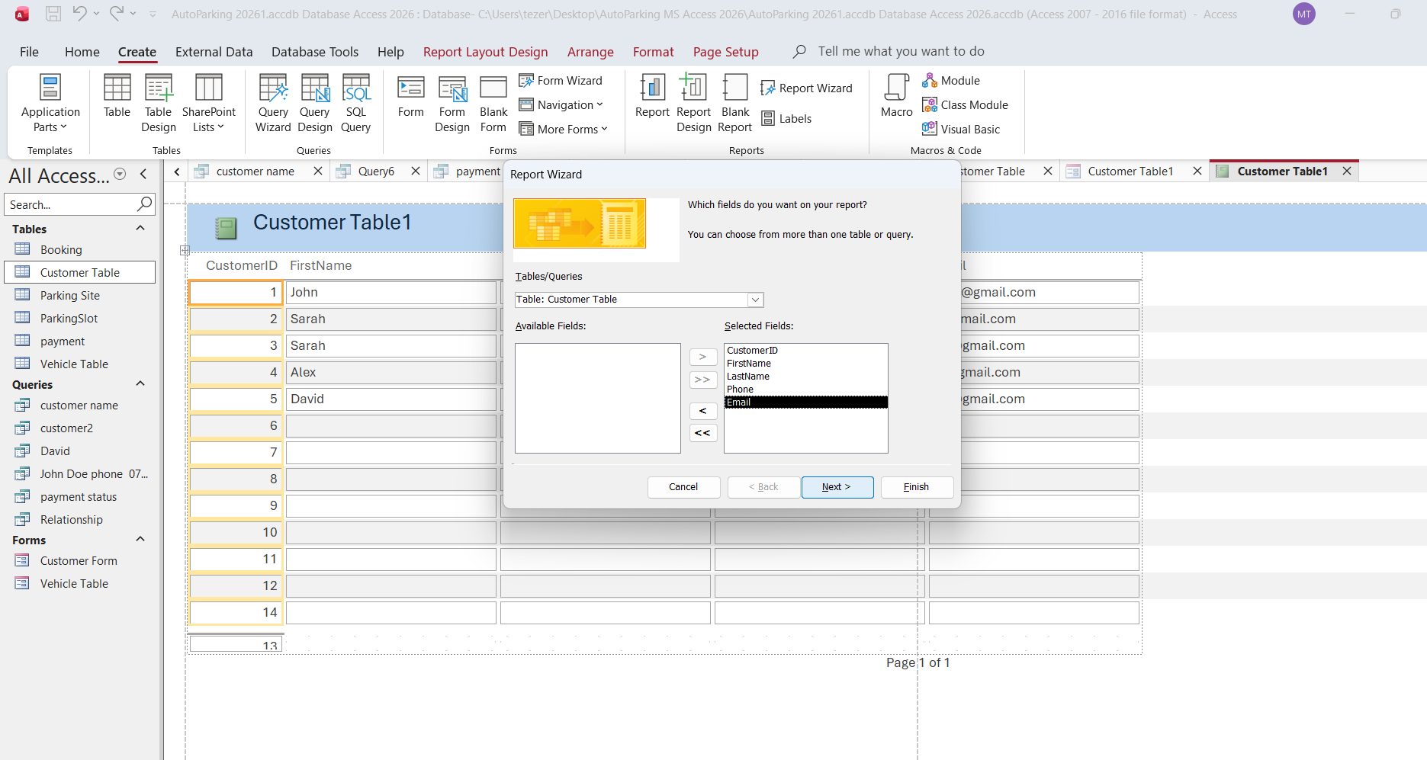
Figure26: This image displays the software’s top navigation ribbon, left hand navigating pane listing database objects like tables and queries.
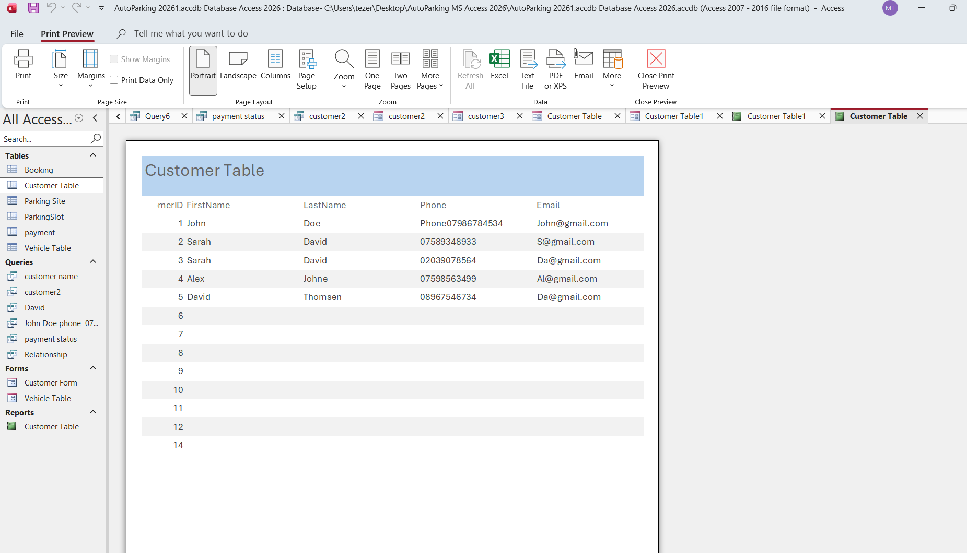
Figure27: This image shows forms and reports of customer table and a screenshot of the Form of Microsoft Access user interference displaying a finished database report in print preview mode.

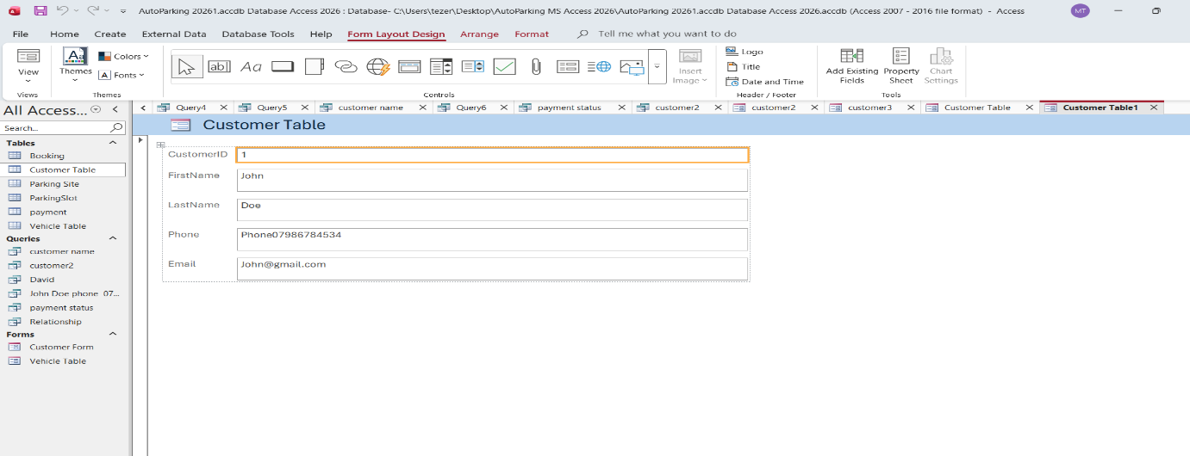
Figure 28: shows a screenshot of the Microsoft user interface in a from layout design view

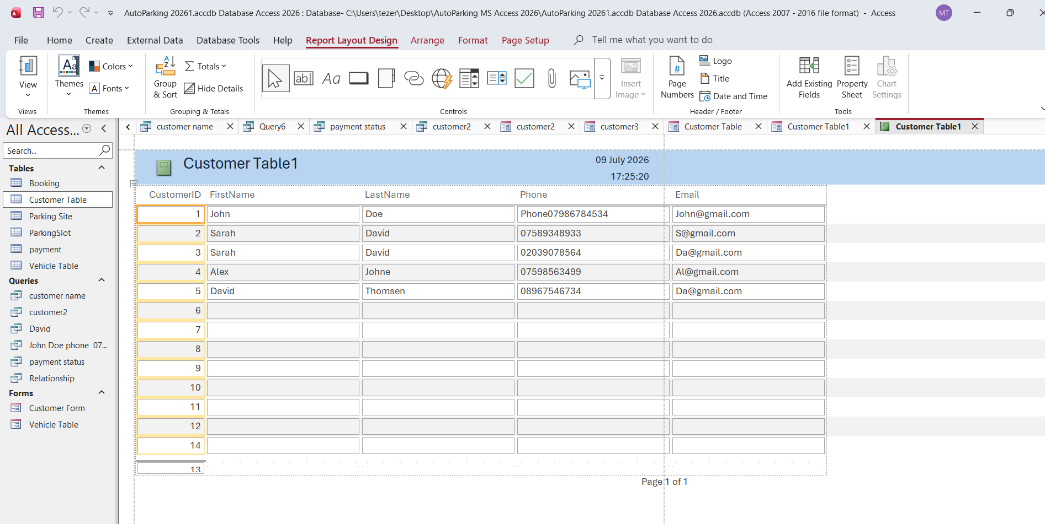
Figure 29: This Query-based report titled “Customer table” extract and displays essential contact information, including customer names, phone numbers and email address directly from database

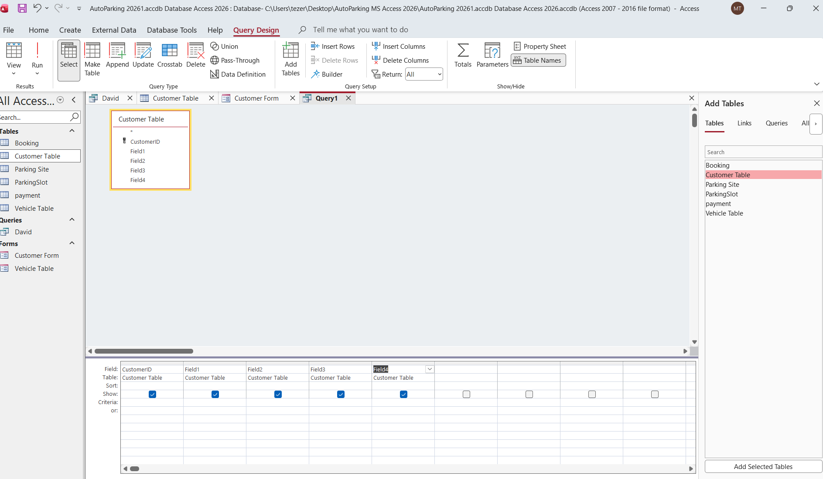
Figure 30: This image shows a screenshot of the Microsoft access user interference in a query design view.
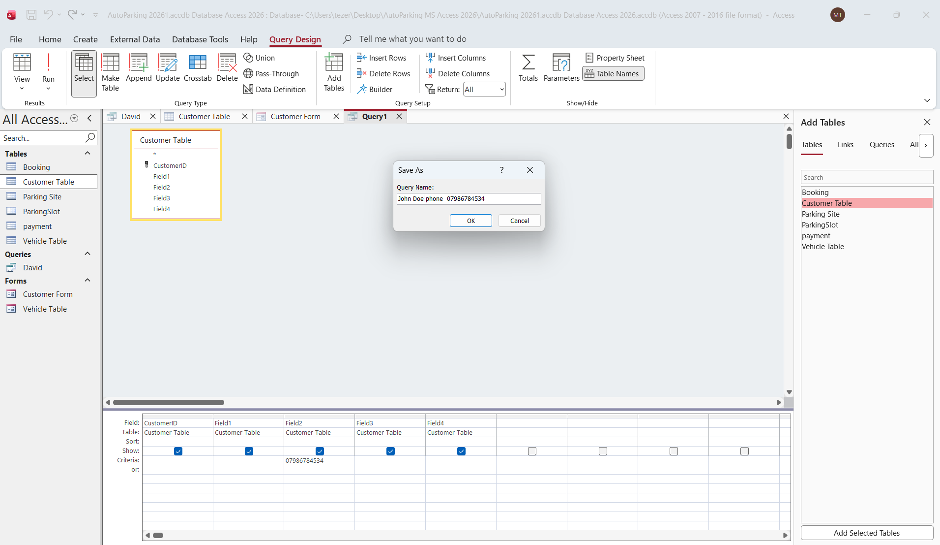
Figure 31: This image shows a screenshot of the Microsoft access user interference in a query design view.

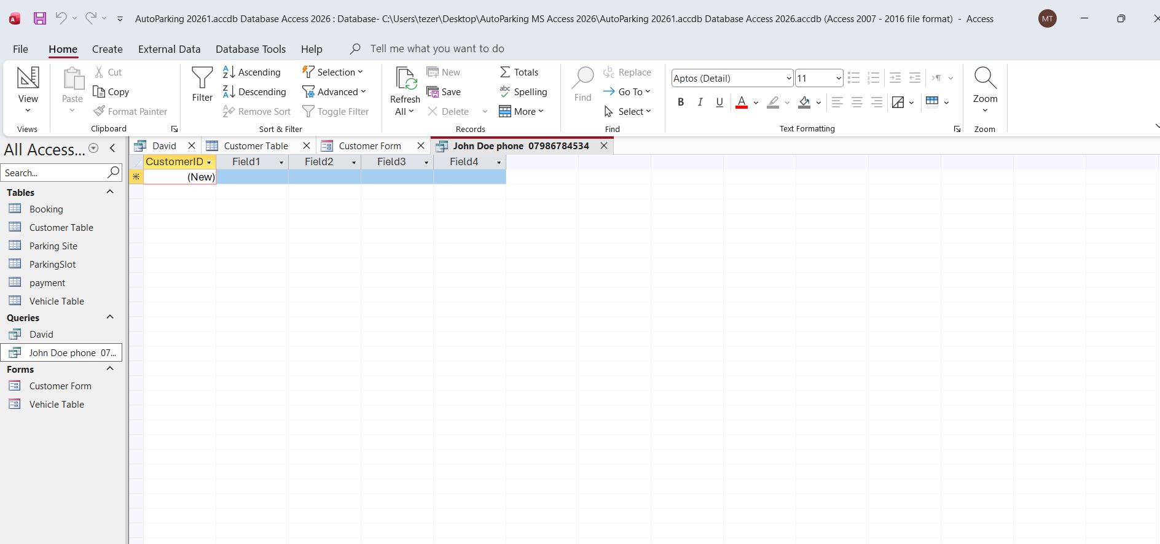
Figure 32: This is list of queries created as asked to delete details of Mr. john phone number we can see this information has deleted.

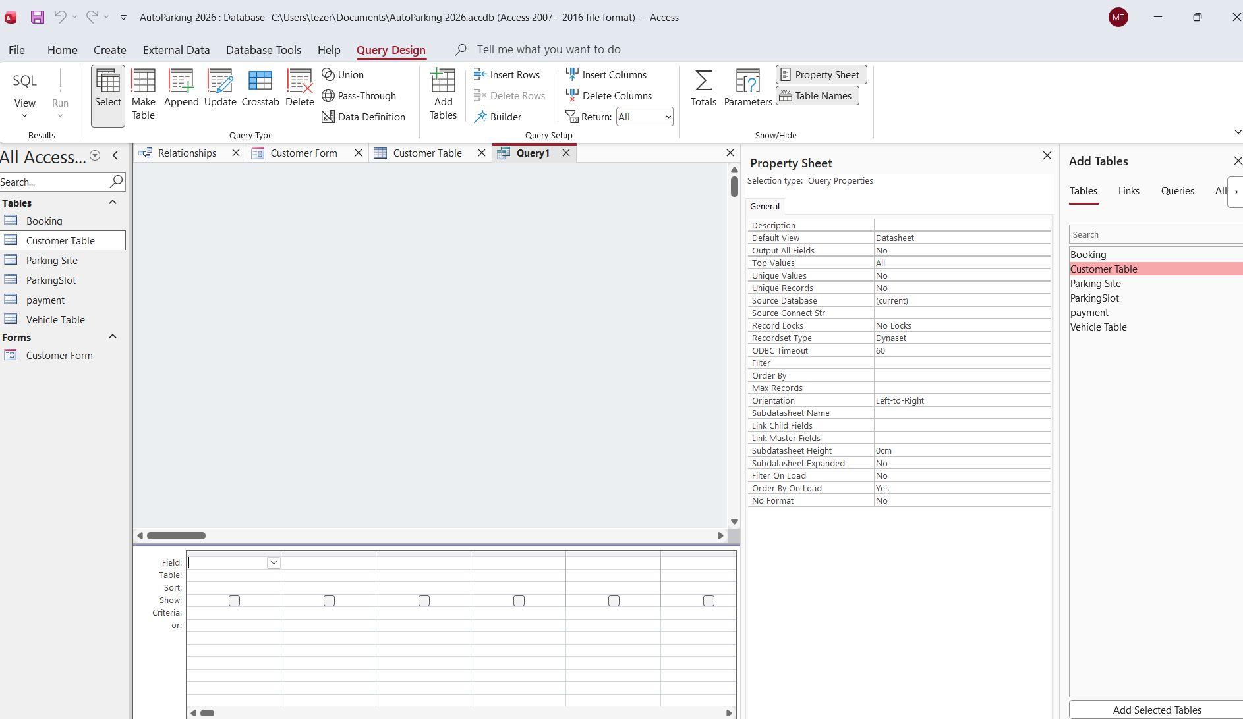
Figure 33: This Query Design interference, where a new query named “Query1” is being built for a database called “auto Parking”

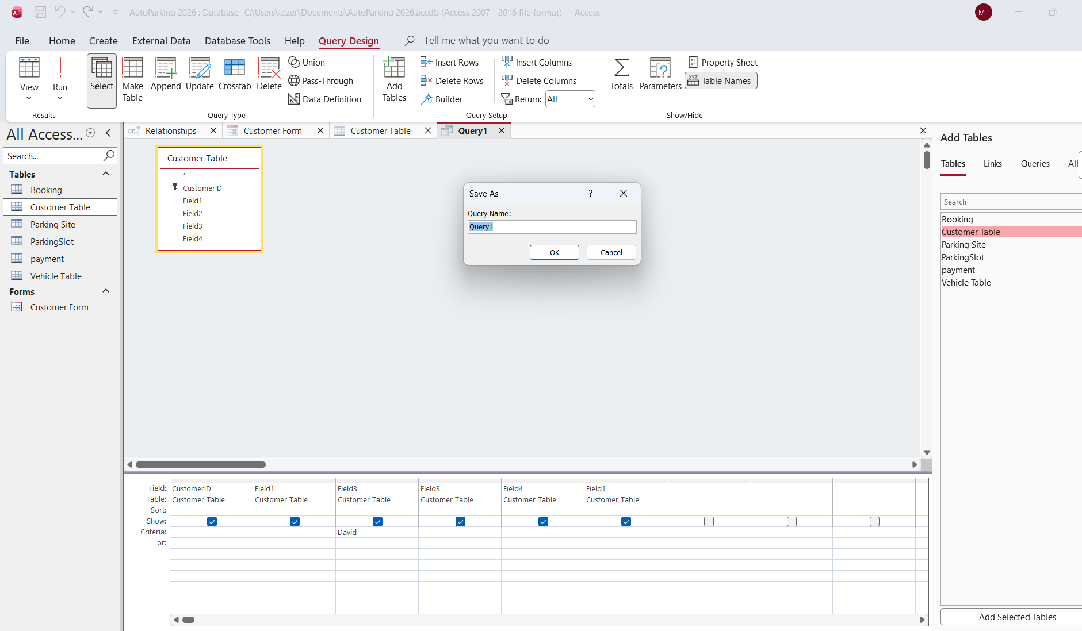
Figure 34: This is Microsoft Access running on Window, the database interference is currently active on the Query Design ta building new query to delete Mr. John phone number
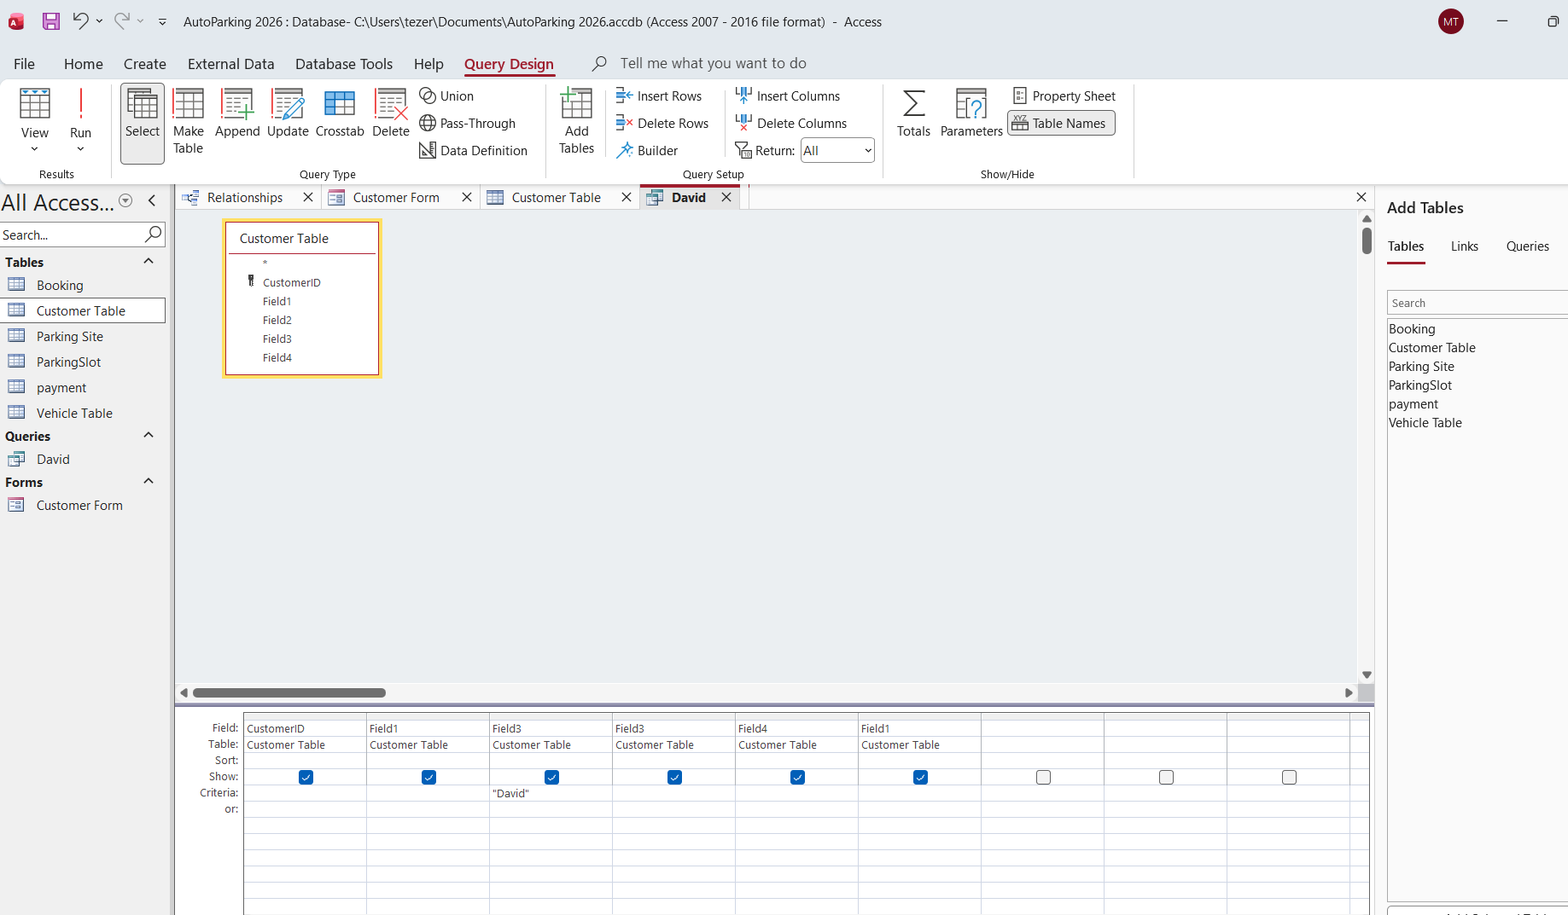
Figure35: This is displaying a query tab named David open in Query Design View

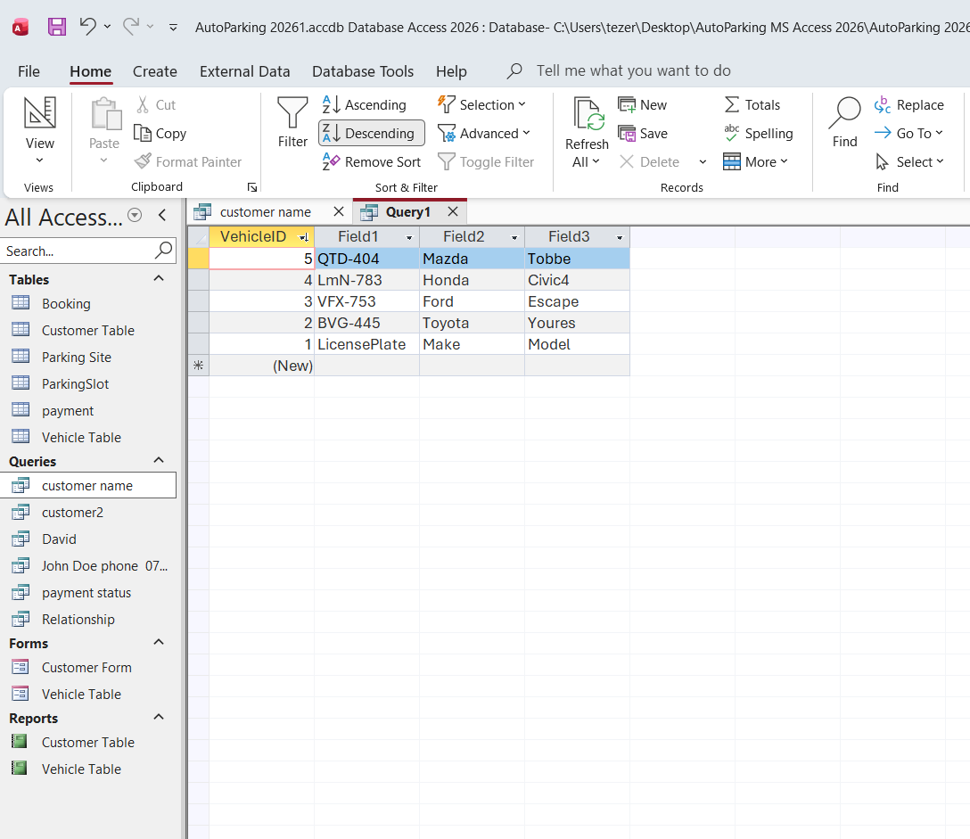
Figure 36: This image is query of Vehicles to make descending order all the cars.
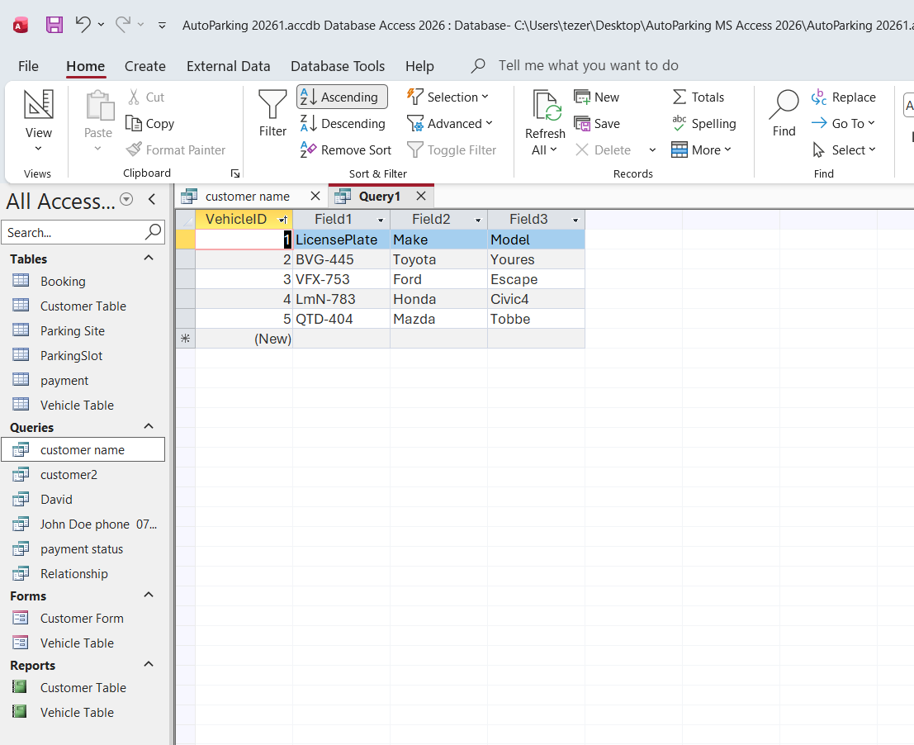
Figure 37: This image list of queries created from Vehicle table to make ascending order

7) Validation, Testing, and Reflection

Data integrity testing is vital because it ensures your information remains accurate, complete, and completely uncorrupted over time. Without proper testing, hidden system errors, hardware failures, or security breaches can quietly change your data, leading to costly business mistakes or broken system files [3].

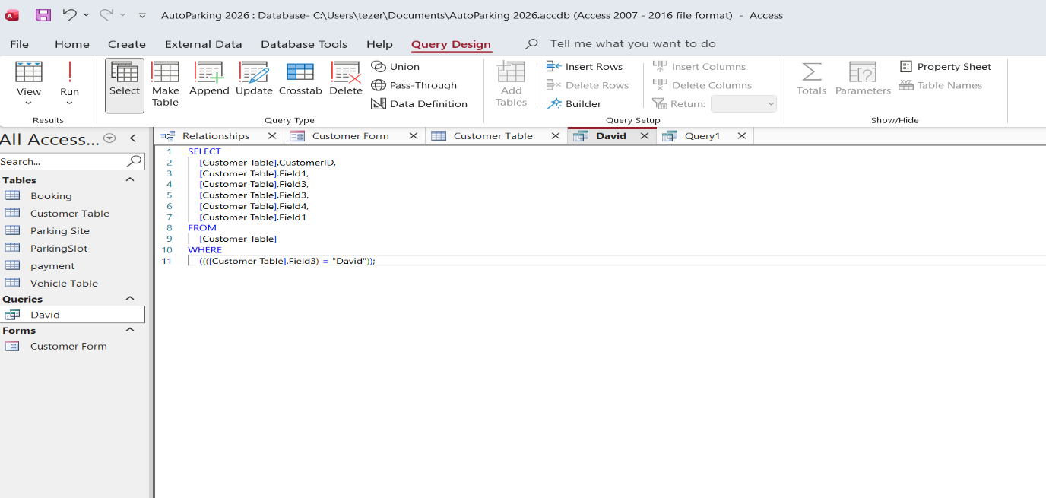
Figure 1: The image shows a Microsoft Access interface tracking database query development, with the query named David open in SQL View. It documents the exact backend relational script running to draw targeted entries out of the client information tables.
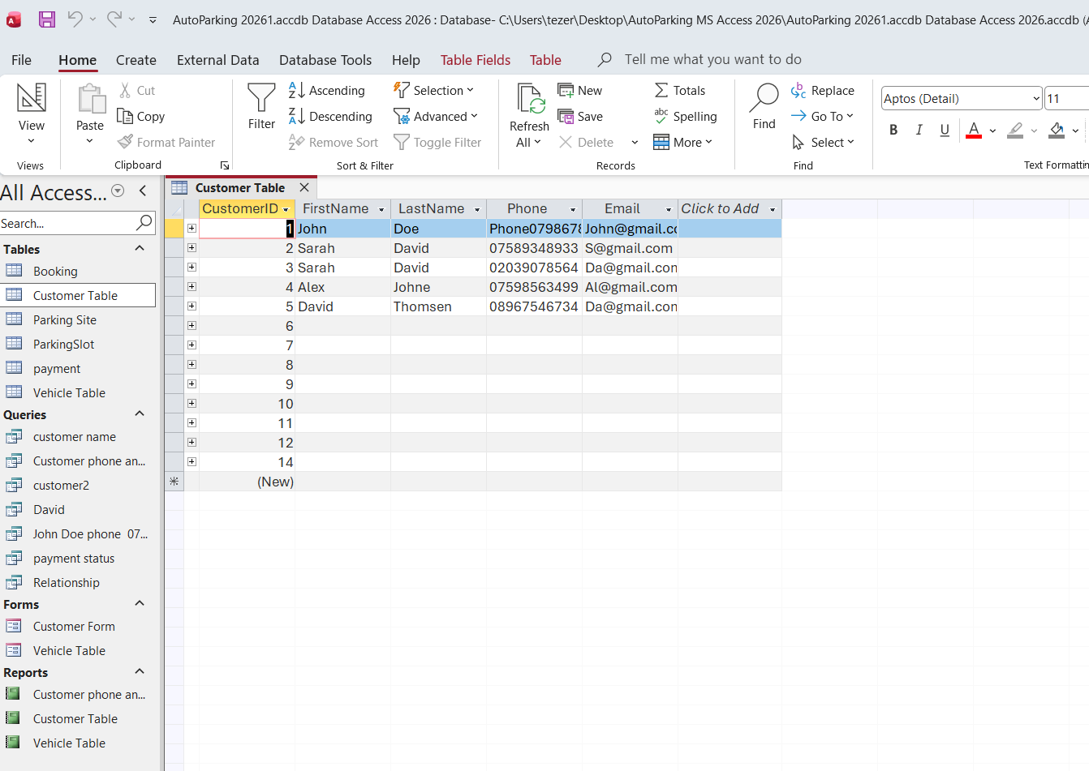
Figure2: The image shows the backend SQL view of the queries named “David” and “John” in Microsoft Access. Switching to this text-based view is a critical step in database testing and validation

Figure 1: SQL view Validation and testing

The image shows the backend SQL view of the queries named “David” and “John” in Microsoft Access. Switching to this text-based view is a critical step in database testing and validation. It allows developer to verify that the visual query setup matches the intended syntax and structure. The query is automatically formatted into clean, standard SQL code. It displays a SELECT statement pulling specific columns from the source table (Customer Table), confirming that the database structure accurately maps the fields to their target destinations without any broken syntax.
Testing Logic Constrains: The clause at line 10 explicitly dictates the testing conditions: {Customer Table} Field 3} = (” David”). this allows developers to test data integrity by ensuring the query filters reliable and isolates only the records where field 3 strictly matches the value “David”. I also made query to delate Mr. John phone number and his details on the the second attempt to check my next query respond and I deleted the phone number accordingly.
Result Validation: Reviewing this raw script ensure there are no unintended database behaviours, such as pulling completely unfiltered table or causing system performance bottlenecks, before executing the query against live test data.

Short Design Report & Challenges
The process of designing the database and implementing its features in Microsoft access presented several district operational challenges. Constructing a cohesive Entity -relationship diagram required careful planning to properly establish table hierarchies, such as linking customer to their respective vehicles and specific parking slots.
Further Improvement
Real-time Sensor Integration: Suggest connecting the database to physical IoT gate sensors or license plate recognition (LPR) cameras so vehicle entries and exits are logged completely automatically without manual typing. Advanced Dashboard Reporting: Propose adding complex SQL aggregate charts to visually map monthly revenue trends or identify which parking sites are the most heavily occupied. User Security Roles: Recommended implementing user login accounts so that parking lot attendants can only log entries, while only senior management can view the payment table and financial report.

Conclusion
In conclusion, automating the parking system effectively elements data error and optimizes daily operational tracking. Moving from manual logs to a centralized database ensures that vehicle movements, slot availability, and payments are records securely and accurately. Utilizing a normalized structure gives managements reliable, real-time data to run helpful queries and generate performance reports. While the current system fulfils all core assignments goals, future version could improve functionality by introducing automated licence plate recognition, digital payments, and mobile app connectivity, offering a more rebuts scalable solution for the company’s long-term needs.

References

[1] | S. Bagui, Database design using Entity Relationship digram, USA: 2000, 2003.
[2] | M. Demba, “Algerthm For Relational database Normalization up to 3NF,” Algerthm For Relational database Normalization up to 3NF, no. 1, p. 1, 2013.
[3] | G. Sivathanu, “Ensuring data integrity in storage: techniques and applications,” Ensuring data integrity in storage: techniques and applications, vol. 1, no. 1, pp. 26-36, 2005.

------------------------==============-//=============---------------------

======================END=========================

