Your Exit Strategy: Personal Promotional Material
Thomas Nurse (2004043)

17th May 2024

Contents
Business Card: Front 3
Business Card: Back 3
Link to Online Showreel 4
Bibliography 5

Business Card: Front
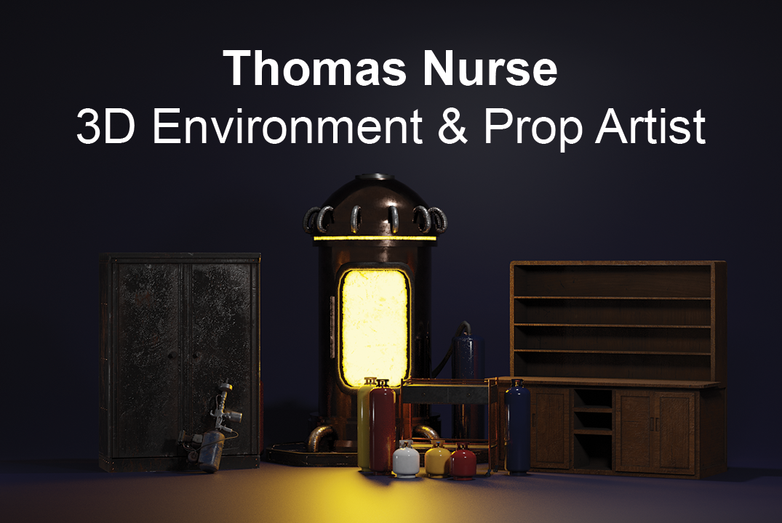
Business Card: Back
Link to Online Showreel
https://www.youtube.com/watch?v=-8RtrRuPsgg

Bibliography

[1] | A. B. Chatham, “How to design a business card: the complete guide,” 14 June 2023. [Online]. Available: https://www.wix.com/blog/how-to-design-a-business-card. [Accessed 15 May 2024].
[2] | E. Selin, “Blender: A Cycles render settings guide,” 26 October 2021. [Online]. Available: https://artisticrender.com/blender-a-cycles-render-settings-guide/. [Accessed 15 May 2024].
[3] | Blender Foundation, “Wireframe Node,” 23 April 2024. [Online]. Available: https://docs.blender.org/manual/en/latest/render/shader_nodes/input/wireframe.html. [Accessed 15 May 2024].
[4] | artist B, “3 Point Lighting Setup | Blender Studio Lighting Tutorial for Beginners,” 22 Feburary 2022. [Online]. Available: https://www.youtube.com/watch?v=aukE3PVVlDU. [Accessed 15 May 2024].
[5] | Adobe, “How to add blur to a photo in Adobe Photoshop.,” 2024. [Online]. Available: https://www.adobe.com/creativecloud/photography/discover/blur-image.html. [Accessed 15 May 2024].
[6] | Creative Lives In Progress, “A guide to making a successful showreel,” 5 August 2022. [Online]. Available: https://www.creativelivesinprogress.com/article/a-guide-to-making-a-successful-showreel. [Accessed 15 May 2024].
[7] | J. Edwards, “How To Create The Perfect Showreel,” 15 November 2023. [Online]. Available: https://artlist.io/blog/how-to-create-a-showreel/. [Accessed 15 May 2024].
[8] | audio network, “SHOWREEL MUSIC: HOW TO FIND MUSIC FOR SHOWREELS,” 16 April 2024. [Online]. Available: https://blog.audionetwork.com/the-edit/music/showreel-music. [Accessed 15 May 2024].
[9] | D. Kolesnikov, “Space,” 14 July 2023. [Online]. Available: https://pixabay.com/music/ambient-space-158081/. [Accessed 15 May 2024].

