BA Business Management (BABMGSH-LI)

Assessment 1

Student name: Antoaneta Andreeva-Metodieva
Student ID: 2215257

Module: Global Business Environment
Lecturer: Dr. Nadeem Mirza

Contents

1. Introduction 2
2. Business environment in Romania 3
3. Analysis of the business environment in Romania 3
4. Opportunities and challenges 6
5. Possible barriers 7
6. Strategies and recommendations 8
7. Conclusion 9
References 10

- Introduction
International business comprises of a vast spectrum of international trade of stock, services, and materials between several countries. This trade, however, is not limited to physical goods and can incorporate, as stated by Carpenter (2011):
International transfers of other resources, such as people, intellectual property (e.g., patents, copyrights, brand trademarks, and data), and contractual assets or liabilities (e.g., the right to use some foreign asset, provide some future service to foreign customers, or execute a complex financial instrument.
Business globalization creates an interdependent and unified global economy allowing businesses to trade internationally on markets with dynamic user preferences and fewer barriers.
Business environment incorporates environmental forces such as the actions and preferences of clients, rivals, political laws, foreign institutions, social and cultural factors of the environment, technological progress, and others. All these factors have an effect on companies’ transactions and approach (Harrison, 2013).
Every company has a goal that it aims to achieve. To do so, the company needs to create strategies to demonstrate its methods of achieving the set goals. These strategies should be supported by examining the company’s internal and external factors. These strategies will navigate the organization’s operations. One of the techniques for analyzing a firm’s operational potential is the SWOT analysis which helps to establish the strong and weak points of the enterprise and the possibilities and risks posed by external factors (Harrison, 2013).
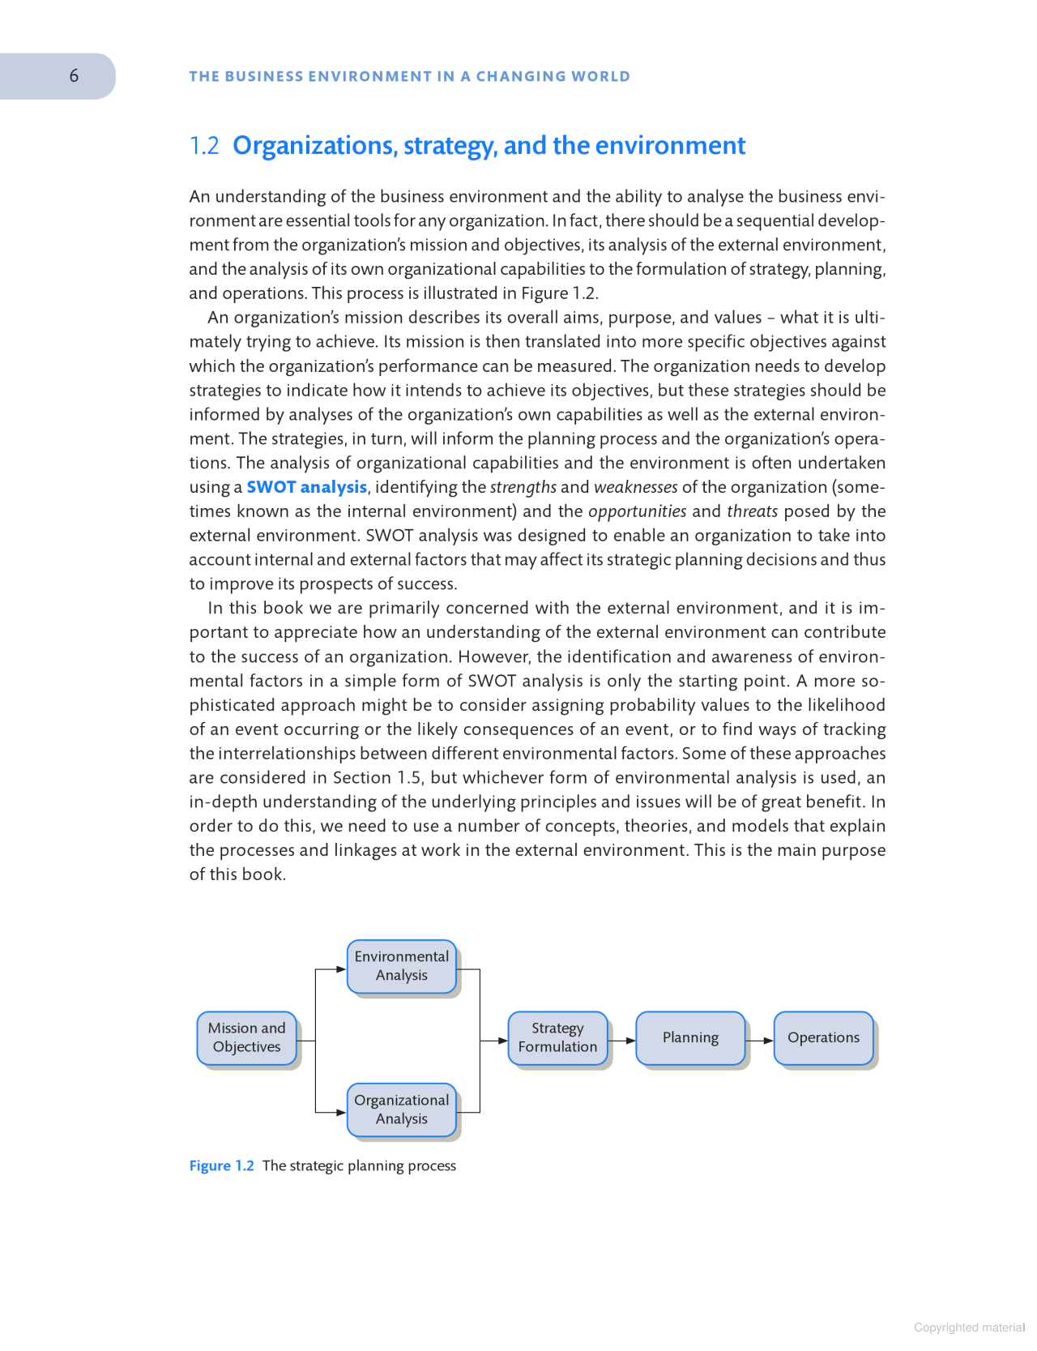
This report will explore the political and economic environment of Romania.
Romania is located in East-Central Europe and shares borders with Bulgaria, Moldova, Serbia, Hungary, and Ukraine. To the east Romania reaches the Black Sea where it shares a maritime border with Turkey. Romania spans over 238 391 sq/km and has a population of 19.2 million people (2021). The governmental structure of the country is a Parliamentary republic with semi-presidential regime. The government is led by a prime minister (Nicolae Ciuca since 2021) and a president (Klaus Iohannis since 2014) as a head of state (European Union, 2022).

Business environment in Romania
Since the country's integration into the European Union in 2007, the Romanian economy has achieved great strides, fueled by a robust rise in productivity.
However, following the financial crisis, productivity growth slowed due to a lack of company vitality and investment with the COVID-19 pandemic having a huge impact on the economy. Romania is already taking action to recover from the crisis and at the moment the country is using different strategies to help improve its economic and political state.
The Romanian economy rebounded at 5.9 percent in 2021 and outperformed expectations in the first half of 2022, expanding at 5.8 percent despite a considerable rise in inflation and heightened unpredictability resulting from the Ukraine conflict. In 2021, the budget deficit remained significant at 7.1% and might approach 7% in 2022 as fiscal constraints continue.

Analysis of the business environment in Romania
Because brand expansion globally may be appealing, a plethora of enterprises would choose such a method to increase their income margins. Yet, the process may be rather difficult owing to different circumstances. Before approaching a new market, a brand should analyze the country's commercial climate and construct approaches for adapting to different cultures and abiding by current regulations. To do that the companies need to do a PESTLE analysis of the country’s business environment (Hyder, 2021).
- An abbreviation for a marketing approach used to evaluate and track the macro environment factors that could affect a firm is Market analysis. PESTLE analysis concentrates on the company system's political, economic, social, technological, environmental, and legal aspects, amongst many others.

3.1 Political Factors
Romania has adopted a strategy of increasing its connections with other countries, especially the US and other (EU) nations, since the collapse of the communist regime in 1989. The country is an active participant in the European Union (EU), (NATO), World Trade Organizations (WTO), World Health Organization (WHO), and the United Nations (UN), among others. Due to its strong worldwide relationships, Romania is able to both import stuff from other nations and export them to others. Its top trading contacts are Germany and Italy. Because of Romania's robust international links, the value of its imports and exports has significantly expanded during the previous few years. Romania's imports and exports totaled $96 billion and $77 billion, correspondingly, in 2019 (Yuan, 2021).
Strong international contacts have contributed to the growth of Romania's economy by fostering its commerce.
Romania has liberalized progressively its trade restrictions and incentives since the collapse of the communist regime and now the country follows the EU trade and investment policies.
The primary purpose of Romania is to maintain healthy economic development, and to this end, the governing authorities are often changing the law regulations and financial expectations for companies doing activities in Romania. In addition, Romania has enacted an investment legislation that outlines the procedures for the application and distribution of public funding. The investment legislation mandates that such procedures be conducted in a transparent manner (Rao, 2021).
The government also offers other economic benefits, such as equal treatment of domestic and international investors, total recovery of funds, and unrestricted overseas investment of businesses. Romania allows international investors to establish entirely foreign-owned businesses.
Moreover, Romania has implemented attractive tax rates to enable investors to operate their firms. The corporate income tax rate is 16%, the personal income tax rate is 10%, the regular value-added tax rate is 19%, and the reduced value-added tax rate is 10%. The government also permits businesses to create and keep bank accounts in any currency and in other countries. Romania's commercial advantages have attracted several international investors, therefore contributing to the country's economic progress (Yuan, 2021).
  - Economic Factors
Romania's economy has grown strongly and steadily over the past few years thanks to rising consumer spending and resurgent industry. The nation experienced the best rate of GDP expansion since the fall of communist control in 1989 after managing to resolve its economic issues in 2007 and the first quarter of 2008. The country's GDP expanded by around 8.2 percent in 2008, reaching $24.5 billion. Since then, Romania’s economy has grown to $284.09 billion in 2021, according to official data from the World Bank.
The large growth in the country's GDP may be ascribed to efficient tax-collecting mechanisms, greater private spending, and increased investments both domestically and abroad. Despite strong GDP growth, the nation faces a recession in 2020 as a result of the coronavirus pandemic's effect (Verbeke, 2020).
Inflation is another factor that affects a nation's economy, and Romania is known for having high inflation rates. Romania's inflation rate has increased since the end of 2016 following a time of negative inflation brought on by a decline in crude oil prices and home tax reductions in 2015-2016. By 2019, the nation's inflation rate had risen to 3.8%. A number of factors, along with a 15% rise in energy expenses, including fuel and electricity, as well as increasing demand for household goods, can be blamed for the nation's inflation rate rising. The price of living, taking loans, and mortgages have increased in Romania due to the country's high inflation rate (Maiz, 2021).
Another thing that should be considered is Romania’s economic rating, as the country is in the first 15 in the EU and is in 40th place at the time of making global charts. Romania’s annual output is approximately $559 billion with is a growth over the past few years (Monteiro, 2022).

  - Social Factors
Individuals of various ages, genders, and ethnics can be found in Romania: Romanians (71.9%), Hungarians (7.9%), Germans (4.1%), Jews (4.0%), and Ukrainians (3.2%) are some of the respective societies. In 1990, there were 24.49 million individuals living in the nation at its highest numbers. Nevertheless, that figure has now dropped as a consequence of many people escaping corruption and extreme poverty. With a predicted demographic of 19.24 million in 2019 and a predicted decline to 11.88 million by the end of this century due to factors including its high migration rate, Romania's existing population growth rate is expected to be negative 0.66 percent (Dahlstrom, 2021).
The country's economy has suffered as a result of the above tendency, as highly educated Romanians migrate to pursue higher-paying positions in developed countries. This migration has also caused a labor deficit, which has affected the country's already weakened economy. The age structure of the nation is as follows: 0-14 years (14.31%), 15-24 years (10.45%), 25-54 years (46.11%), 55-64 years (12.37%), and 65 years and above (16.76). The overall reliance ratio in Romania is 48, the youth dependency ratio is 22.8, the senior dependency ratio is 25.2, and the potential support ratio is 4. As a result, a higher proportion of Romania's population is extremely reliant on a few working people (Yuan, 2021).
  - Technological Factors
The use of information systems is gradually increasing even if many Romanians have limited technical capabilities. One-tenth of Romanians between the ages of 16 and 74 are stated to have adequate computer skills, compared to nearly half who have subpar digital skills. The percentage of Romanians who owned and used internet increased with time, from around 24.6 percent in 2007 to 61.9 percent in 2015. Approximately 61 percent of Romanian households had internet access in 2015, and 67 percent of people lived in urban areas. Despite this, Serbia and Hungary are among Romania's borders with the fastest internet speeds. The Republic of Romania spent more than $10 million on online advertising in 2007, and from that year to 2019, it increased significantly, with an estimated $346.3 million invested. Additionally, the adoption of mobile phones has increased significantly, going from 42.44 percent in 2016 to 52.76 percent in 2020 (Dahlstrom, 2021).
  - Ecological factors
Romania is still facing environmental problems due to use of fossil fuels in many of its industries. Production plants often allow for industrial waste to reach river Danube, affecting the water quality and destroying the rivers’ ecosystem.
Past practices for creating agricultural terrains have led to deterioration and erosion of the soil along the Danube basin.
Romania has created policies for reducing the environmental impact of production since becoming a member of the European Union, however, environmental protection has not yet been made a priority (Smith, B. 2015).

Opportunities and challenges
Since joining the European Union in 2007, many improvements have been made in Romania. However, reforms are still necessary for areas such as corruption, political instability, bureaucracy, and law application and system. The countries’ insufficient infrastructure has a negative impact on safety of people, commercial expenses, and production, thus discouraging interest from global investors. To fulfill its full business potential, Romania should work on improving its transport links to the rest of the EU.
A further negative point is the fact that Romania is not yet part of the “Euro Zone” and transactions are made in the local currency – Romanian Lei. As some products and services as well as some commercial and consumer credits are denoted in Euro, price discrepancies could occur leading to higher cost and currency rate variation. The Ukrainian war has caused increased variation in the currency rates affecting those involved in global trade.
There are several factors affecting the sourcing and engagement of employees – the higher workforce demand from the developing economy and work emigration. In some lesser developed regions of the country, this poses a drawback for companies to settle, making international enterprises concentrate in bigger cities where skilled workforce is available (International Trade Administration, 2022).
Regardless of the above, International Trade Administration (2022) suggests that Romania still has potential when it comes to global and national trade.
As a member of the EU, Romania has a vast local market and offers an affordable stand for access to the European markets. Romania’s location also provides good access to markets beyond Europe – Turkey, the Middle East, etc.
Following the conflict in Ukraine, many European countries were affected by gas shortages being mostly reliant on gas imports from Russia. Romania, however, was found to be only 20 percent reliant on imported energy making it the top energy-independent country in the European Union – one of the reasons for increased foreign investment interest (FDA raise by 141% in 2021 as opposed to 2020). The availability of a quality, highly skilled workforce further attracts foreign investors.

Possible barriers
One of the most common problems in Romania is corruption. Since the fall of the communist regime in 1989, corruption has been gradually developing to a point where “giving a gift of money or doing a favor in order to achieve something from local authorities” is considered normal in the business culture.
The Romanian economy has been troubled by political instability and corruption for for many years. There really are four sorts of corruption in the nation: fraud, thievery, fraudulent, and blackmail. Aside from political uncertainty, crime has been a major problem for the nation's overall economy. When we dig deeper into the issue, we discover that traditions, an absence of political willpower, and the frailty of governmental bodies have been the main causes of corruption. Corruption in Romania has led to poor distribution of public resources and hindered the pace of economic progress in the country (Rao, 2021).
According to World Bank “Markets and people: Romania Country economic memorandum” (2020), another barrier to business development in Romania is the decreasing human capital. Romania has a decreasing demographic growth along with work emigration which may lead to some regions being short of human resources. There has been a demographic decline of 3 million people between the years 2000 – 2018, 75 percent of which accounts to emigration.
Romania’s dual business sector tends to have a growing gap between large, well-developed enterprises and smaller, not-so-well-performing companies. State-owned enterprises are treated preferentially, using exemptions from corporate government law, andbeing given priority to using public funds and resources.

Strategies and recommendations
Expansion strategies are used when an enterprise is looking to grow its operations internationally. To create an adequate expansion plan, the company should perform comprehensive research on the chosen countries’ economic, political, social and other factors.
Based on the findings one of the following strategies can be used:
  - Partly owned subsidiary/ joined venture – when the parent company owns at least 50% but less than 100%. Despite parents’ company share in the subsidiary, both companies remain separate legal entities. The parent firm has partial control over the subsidiary. These establishments are often used as a means of entering into a market of interest and can be set up by either registering a new entity or purchasing an existing business, established in the market of interest.
  - Wholly-owned subsidiary (branches) – owned fully by the parent company which is a sole shareholder. Despite being a separate legal entity, fully owned subsidiary has its operations controlled by the parent enterprise. They are also used as a way to enter a new market and can be established by building from scratch (involving the acquisition of premises, sourcing local workforce, meeting legal requirements, etc.). Alternatively, an existing, established business in the target market can be absorbed (Majaski, C. 2020).
In consideration of the Romanian economic, political and social situation, using a joint venture strategy or purchasing an existing business would significantly accelerate the setting-up process and help avoid barriers such as bureaucracy and delays caused by local legislations.

Conclusion
Romania has a diverse economy with rapid growth and high wealth. The country is regarded as one of the best in terms of GDP expansion rate and has a highly developed manpower and social progress index. Romania's annual output is rising swiftly, and its GDP per person in terms of purchasing capacity is now virtually equal to the average for the EU. Additionally, the nation has become the top location for foreign investors in Central and Eastern Europe. Romania has benefited from the arrival of foreign direct investment from nations like Germany and Italy, which has helped the economy’s growth. Nevertheless, issues like a sharp decline in population expansion, political unrest and dishonesty, and rising inflation levels have all threatened the nation's economic advancement. Because of factors like political unrest and high inflation rates, expanding a business to Romania is a sign that it might face sluggish growth before finally failing (Zhang, 2022).

References

Abraha, D. and Hyder, A.S., (2021), Institutional Factors in Emerging Markets. In Transformation of Strategic Alliances in Emerging Markets, Volume I, Bingley: Emerald Publishing Limited.
Burki, U., Najam, U. and Dahlstrom, R. (2022), "Measuring environmental performance in business to business relationships: a bibliometric review", Marketing Intelligence & Planning, Vol. 40 No. 2, Emerald Publishing Limited
Mason Carpenter (2011) International business. Saylor Foundation (Online access: Center for Open Education Open Textbook Library). Available at: http://search.ebscohost.com/login.aspx?direct=true&site=edspub-live&scope=site&type=44&db=edspub&authtype=ip,guest&custid=ns011247&groupid=main&profile=eds&bquery=AN 11760050 (Accessed: November 24, 2022).
European Union (2022) Romania, Available at: https://european-union.europa.eu/principles-countries-history/country-profiles/romania_en, Accesses on 15 Nov 2022
Fainshmidt, S., Witt, M.A., Aguilera, R.V. and Verbeke, A., (2020), “The contributions of qualitative comparative analysis (QCA) to international business research”. Journal of International Business Studies, 51(4), pp.455-466, https://doi.org/10.1057/s41267-020-00313-1
Garrido-Ruso, M., Aibar-Guzmán, B. and Monteiro, A.P., (2022). Businesses’ Role in the Fulfillment of the 2030 Agenda: A Bibliometric Analysis. Sustainability, 14(14), p.8754, https://doi.org/10.3390/su14148754
Ghauri, P, Strange, R & Cooke, FL., (2021), Research on international business: the new realities, International Business Review, vol. 30, no. 2, 101794, https://doi.org/10.1016/j.ibusrev.2021.101794
Harrison, A., (2013), Business Environment in a Global Context, 2nd ed., Oxford: OUP Oxford
International Trade Administration, (2022) Romania – country commercial guide, Available at: https://www.trade.gov/country-commercial-guides/romania-market-opportunities (Accessed: 22/11/22)
Jiménez Maiz, S.G., 2021. Analysis of the Sustainable Development Goals (SDG) in a selected group of European countries. Available at: https://addi.ehu.es/handle/10810/51861?show=full (Accessed: 19th Nov 2022)
Majaski, C (2020) Subsidiary vs. Wholly-Owned Subsidiary: What's the Difference?, Available at: https://www.investopedia.com/ask/answers/032615/what-difference-between-subsidiary-and-wholly-owned-subsidiary.asp#:~:text=The%20difference%20between%20a%20joint%20venture%20(JV)%20and%20a%20wholly,owned%20by%20a%20single%20entity. (Accessed on: 22nd Nov 2022)
Peng, X. and Zhang, R., 2022. Corporate governance, environmental sustainability performance, and normative isomorphic force of national culture. Environmental Science and Pollution Research, 29(22), pp.33443-33473. DOI: 10.1080/13504851.2022.2097628
Rao, S., (2021). International Business Environment. Mumbai, Himalaya Publishing House.
Shulla, K., Voigt, BF., Cibian, S. et al. Effects of COVID-19 on the Sustainable Development Goals (SDGs). Discover Sustainability 2, 15 (2021). https://doi.org/10.1007/s43621-021-00026-x
World Bank (2020). Markets and People: Romania Country. Economic Memorandum. International Development in Focus. Washington, DC: World Bank.
Smith, B., (2015), How clean Is your country. Available at: https://www.azocleantech.com/article.aspx?ArticleID=562#:~:text=Environmental%20Issues%20of%20Romania,acid%20rain%2Dproducing%20sulfur%20dioxide. (Accessed: 22nd Nov 2022)
Verbeke, A. and Yuan, W. (2021), A Few Implications of the COVID-19 Pandemic for International Business Strategy Research. J. Manage. Stud., 58: 597-601. https://doi.org/10.1111/joms.12665

