Salt mummification experiment | Soli Green (2402480)

Abstract
This report serves as a documentation of a mummification experiment on organic material. Even though the experiment is not fully accurate, it follows the purpose of analysing if table salt can effectively be used as a desiccant in the process of mummification. For this experiment we used an orange and a hotdog which we split into half, we labelled one half as the experimental, and the other half as the controlled. The experimental half was put into an airtight bag where it was submerged in salt, whereas the controlled was just in an airtight bag.
We recorded the changes of both the controlled and the experimental once a week, for three weeks. The main changes we were focused on recording was the changes in length, width, weight, colour, and other changes that we could sense (like smell and texture).
Overall, our experiment showed that the experimental showed that the process of decomposition had been halted. This would have been through the salt absorbing the water, causing the experimental to become desiccate. With water then becoming absent, there is no fuel for bacteria to grow and decompose the organic material. The results support the hypothesis that table salt is an effective replacement for natron when mummifying organic material, such as food.

Key Words: Mummification, Desiccation, Decomposition, Preservation.

Contents
Abstract 1
Key Words: Mummification, Desiccation, Decomposition, Preservation. 1
Introduction 3
Method 4
Results 6
Week Two Observations 6
Week Three Observations 8
Visual representation of change 10
Discussion of Results 11
Conclusions 11
References List 11

Introduction
One of the most well-known practices from Ancient Egypt is mummification. As a culture, Egyptians believed in life after death, and the body must be prepared for it. Because of this it was important to prevent any decomposing of the body and preserve it. In doing so, the Egyptians developed a special process of mummifying the dead, which consisted of drying out the bodies. This process would usually involve the usage of a natural salt mixture, called natron. Natron includes several different kinds of salts, such as sodium carbonate and sodium bicarbonate.
Salt serves as a desiccant; it dries out organic materials by absorbing water from it. The removal of water is an important step in preservation, as bacteria thrive on dark, wet environments, leading the organic material to decompose. With the organic material now desiccate, the process of decomposition is slowed down, or halted. As noted by Lucas, (Lucas, 1914), the significance of the natron could not be denied.
Moreover, modern science proved the efficiency of the natron because of its capacity to dehydrate tissues (Nerlich, Falter and Zink, 2021). Experiments showed that even in the absence of other factors, salt can provide significant preservation results (Zimmerman, Brier and Wade, 1998; Morozova et al., 2020).
What is also essential about the use of the natron in mummification process is the mixture of different kinds of salts. According to Abdel-Maksoud and El-Amin (Abdel-Maksoud and El-Amin, 2011), this combination may increase the effectiveness of dehydration significantly due to creating even less favourable conditions for bacteria. Therefore, the mixture of different salts may help to achieve much better results compared to the usage of a simple salt.
The aim of this experiment is to check the effectiveness of various salts and salt combinations in drying and preserving organic material through comparing organic material. Food is chosen to serve as proxy to human body samples because direct research would prove unethical in this case. Nevertheless, this type of research can be quite common in archaeology because it allows recreating the processes in the most realistic way possible (Manchester Museum, 1979). Recording various changes like mass, texture, colour, and smell of samples, one can judge the effectiveness of dehydration.

Method
The first step is picking what food to mummify, for this experiment an orange and hotdog were used. One of the main key features about the food items chosen was that a hotdog is filled with preservatives, unlike an orange, this means you were able to see the natural changes and decay in the food products and compare them. This contrast helps to show how different types of organic material respond to the mummification process, particularly when one has already undergone chemical preservation and the other has not.
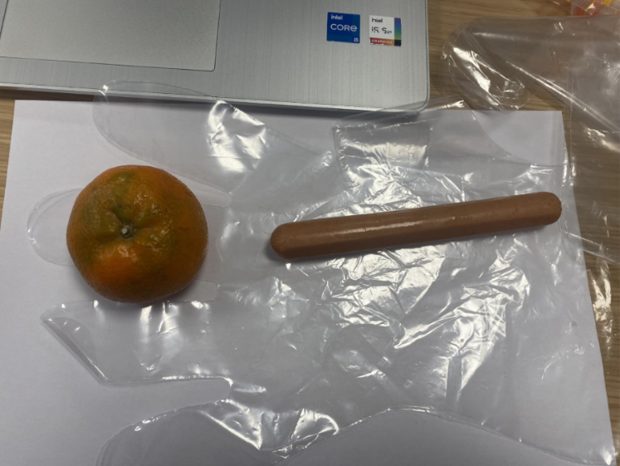
Figure 1 - The organic material, week 1, before the experiment - S.Green
After picking the food items, it is time to start taking measurements. For the hotdog, it was the length, width and whole weight, and for the orange it was, width, height, circumference, and weight. These were the measurements:
- Hotdog length: 15cm
- Hotdog width: 1.7cm
- Hotdog weight whole: 33.68g
- Orange height: 4.5cm
- Orange width: 5.8cm
- Orange circumference: 19.1cm
- Orange weight whole: 86.63g
These initial measurements are important as they provide a baseline to compare any physical changes that occur over time, particularly in terms of size and mass loss.
Once all the measurements for the whole product were taken, it was then onto the half items. The length and weight of the hotdog was taken, but just the weight of the orange was taken. The results were:
- Hotdog length half controlled: 7.7cm
- Hotdog length half experimental: 7.3cm
- Hotdog weight half controlled: 17.1g
- Hotdog weight half experimental: 16.24g
- Orange weight half controlled: 47.22g
- Orange weight half experimental: 38.99g
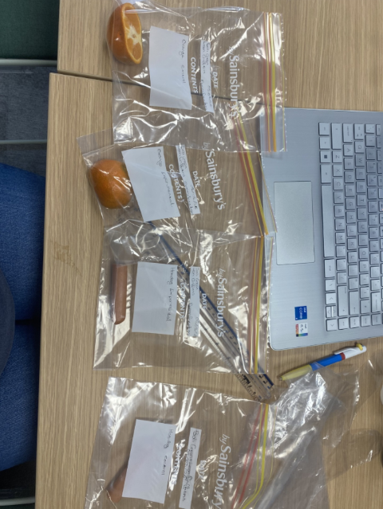
After all the food was weighed, it is then time to bag the products. The bag had writing on it, stating names, what food item it was (either orange or hotdog), and if the item was the controlled or experimental. The reason for having both a controlled and an experimental is to be able to compare the process of decomposition with the desiccation process. This makes it easier to clearly see the effect that salt has on preservation over time.
Figure 2 - experimental and controlled halves, bagged before salt was added - S.Green

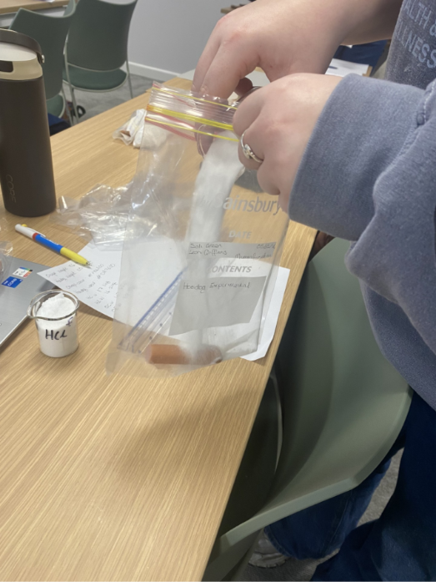
Next was to add the salt. For the experiment 100% table salt was used. For the hotdog experimental bag there was 100g of 100% table salt, and for the orange there was 300g of 100% table salt. Once the salt is in the bags with the experimental half, be sure to fully cover the food item, making sure it is buried in the salt. Now that it is fully covered make sure to leave the bags airtight, so there is no room for the food item to be uncovered, but also to prevent the spread of bacteria. The samples were then stored in the same environment for the duration of the experiment to keep conditions consistent.
Figure 3 - Adding table salt to the experimental organic material - L.Griffiths

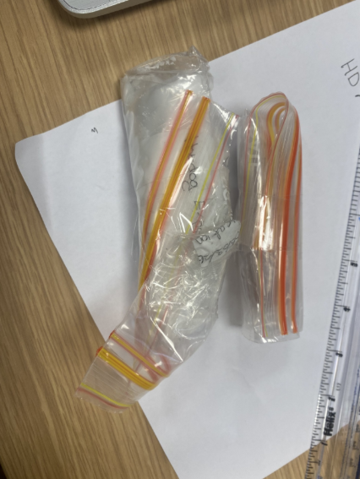
The over the next three week the experimental and controlled food products were left in the same room. Them being left in the same room means they were under the same temperature conditions, allowing there to be a consistent in the experiment. This helps reduce external variables that could affect the results, such as differences in humidity or exposure to light, which may influence the rate of decomposition or drying.
Figure 4 - The experimental and controlled in an airtight bag, ready to be left for a week - S.Green

Once every week, go back to examine the products, and take their measurements and changes. For this colour was added as one changing factors, so that was added to the results as well. Along with personal examinations of the product, such as smell and look. Any visible signs of mould, shrinking, or texture change were also noted, as these give a clearer indication of how effective the salt was at preserving the samples over time.

Results

Week Two Observations
The results from week two show the organic material after being left in the room for a week.
  - Controlled Hotdog
The weight of the controlled hotdog had changed from 17.1g to 16.72g, a 0.38g decrease, and the length had decreased from 7.7cm to 7.5cm. The colour had not changed, but there was this white sticky substance which covered the hotdog and the bag.

  - Experimental Hotdog
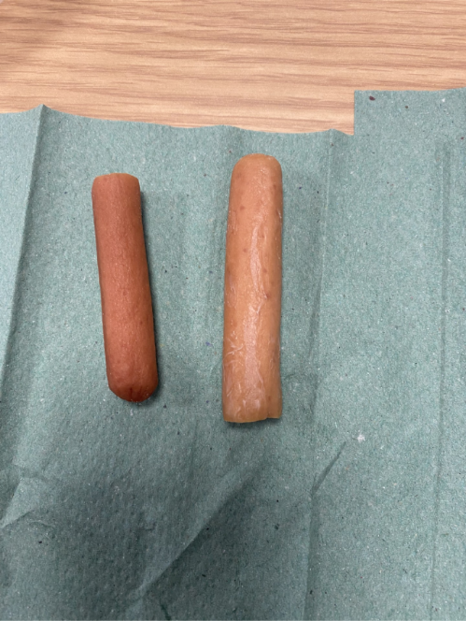
The weight of the experimental hotdog had decreased from 16.24g to 9.96g, that is a 6.28g change. This shows that the salt is absorbing the water from the hotdog, causing it to lose its water weight. The length of the experimental hotdog also shrunk substantially, from 7.7cm to 6.5cm. The outside of the hotdog had already started to change colour and darken, as the outside becomes more leather like, having more of a wrinkled texture. The hotdog was starting to look and smell like preserved meat.
Figure 5 - This picture shows the difference between the experimental hotdog (on the left) and the controlled hotdog (on the right) after being in the airtight bags for one week - S.Green

  - Controlled Orange
The weight of the controlled orange decreased by 0.6g, and the colour of the peel did darken, with some white patched starting to form. No drastic changed, however there was a strong sour odour coming from the fruit.

  - Experimental orange
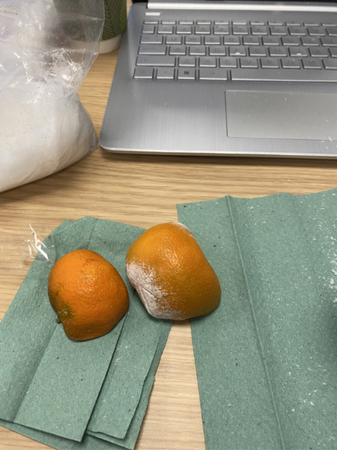
There was a drastic change in the experimental oranges weight, from 38.99g to 27.88g, an 11.11g decrease. It did not change much in how it looks, the inside looks much stringier as the inside had started to dry out. The smell of the orange was very citrusy.
Figure 6 - This image shows the difference between the experimental orange (on the left) and the controlled orange (on the right) after being in the airtight bag for one week - S.Green

Week Three Observations
The results from week two show the organic material after being left in the room for two weeks.

  - Controlled Hotdog
On the final week the controlled hotdogs weight decreased by 0.48g, and its length shrunk by 0.2cm. Apart from the weight and length decreasing, there was not much more change. There was still the white liquid in the bag, but the smell had become a lot sourer.
  - Experimental Hotdog
The weight on the experimental hotdog had increased by 0.46g, while its length shrunk by 0.1cm. the colour of the hotdog had become a very dull, the outer layer had become a lot tougher.

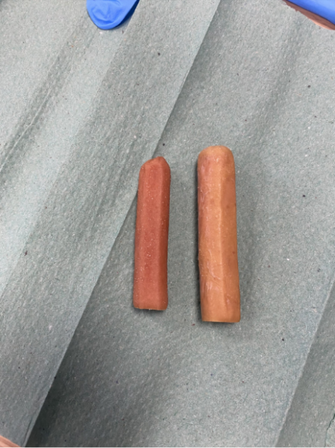
Figure 7 - the experimental and control hotdog on after being in an airtight bag for two weeks - S.Green
  - Controlled Orange
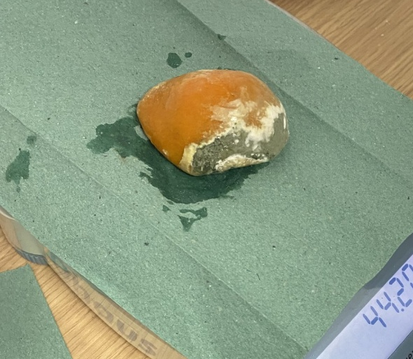
The weight of the controlled orange had changed from 46.62g to 44.2g, that’s a 2.42g decrease. On this week the controlled orange had started to decompose fast. There was green and white mould on the orange peel, and it had a slime layer covering it. The smell from the orange was sour and putrid.
Figure 8 - Controlled orange after being in an airtight bag for two weeks, starting to decompose - S.Green

  - Experimental orange
on the final week the weight of the orange decreased by 21.11g, showing that the absorption of liquid through the table salt was highly effective. The smell of the orange became more lemon like, with the texture not being quite soft and springy, the peel had become very dark.

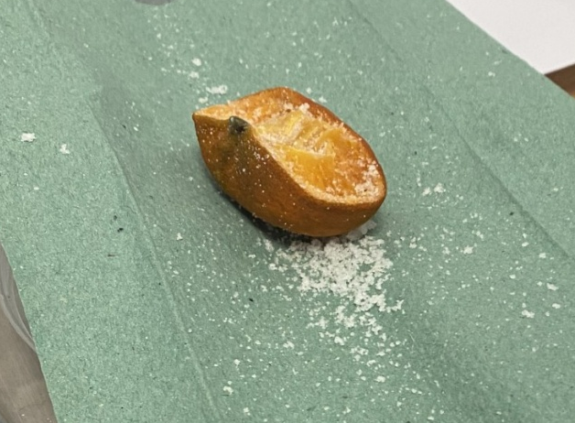
Figure 9 - Experimental orange on week three - S.Green

Visual representation of change

Colour | Week 1 | Week 2 | Week 3
Hotdog C | #DA7E00 | #DA7E00 | #FCAC00
Hotdog E | #DA7E00 | #CB6800 | #CB6800
Orange C | #FB6A00 | #FE9603 | #FE8A03
Orange E | #FB6A00 | #FB6A00 | #E35800
colour chart - Search Images

Conclusions
This experiment proved that regular table salt is quite effective when mummifying organic material. Even though the conditions for the experiment, such as temperature and humidity, didn’t not compare to that of ancient Egypt, because we kept both food halves in the same conditioned, you could still see the difference.
The results from the experimental food material shows direct correlation with ancient Egyptian mummification. The outside layer becoming darker, with a tougher texture, the material shrinking and becoming more compact, the material becoming lighter due to the water weight being removed. So even though the experiment didn’t not exactly line up with ancient Egyptian mummification/enbalming practices, it still produced the same results.

References List
Abdel-Maksoud, G. and El-Amin, A.-R. (2011) ‘A REVIEW ON THE MATERIALS USED DURING THE MUMMIFICATION PROCESSES IN ANCIENT EGYPT’, Mediterranean Archaeology and Archaeometry, 11(2), pp. 129–150.
Lucas, A. (1914) ‘The Use of Natron by the Ancient Egyptians in Mummification’, The Journal of Egyptian Archaeology, 1(1), pp. 119–123. Available at: https://doi.org/10.1177/030751331400100131.
Manchester Museum (1979) The Manchester Museum Mummy Project: Multidisciplinary Research on Ancient Egyptian Mummified Remains. Manchester University Press.
Morozova, I. et al. (2020) ‘Ongoing tissue changes in an experimentally mummified human leg’, Anatomical record (Hoboken, N.J. : 2007), 303(12), pp. 3085–3095. Available at: https://doi.org/10.1002/ar.24333.
Nerlich, A.G., Falter, J. and Zink, A. (2021) ‘Why did the Egyptians use natron for artificial embalming? An experimental study on organ mummification’, Journal of Biological Research, 80(1). Available at: https://doi.org/10.4081/jbr.2005.10174.
Zimmerman, M.R., Brier, B. and Wade, R.S. (1998) ‘Brief communication: Twentieth-century replication of an Egyptian mummy: Implications for paleopathology’, American journal of physical anthropology, 107(4), pp. 417–420. Available at: https://doi.org/10.1002/(SICI)1096-8644(199812)107:4%253C417::AID-AJPA4%253E3.0.CO;2-B.

