Analysis of an RLC network
Electrical Engineering
(ACDA5001)
Electrical and Electronic Engineering

Ayoob Mohammed Azhar (2400571)

CONTENTS

Abstract page 2

Introduction page 3 - 4

Method page 5 - 9

Task 1

Task 2

Results page 10 - 13

Before power factor correction (Task 1)

After power factor correction (Task 1)

The effect of capacitor value on phase angle (Task 1)

The effect of capacitor value on power factor (Task 1)

Phasor diagrams at specified frequencies (Task 2)

Discussion page 14 - 15

Behaviour of energy storage in the capacitor and the inductor

Interpretation of the phasor diagrams

Power factor correction and its relation to resonance, maximum power transfer, and energy efficiency

Why three-phase power

Conclusion page 16

References page 17

Appendices

Appendix A: Task 1 calculations page 18 - 20

Appendix B: Task 2 calculations page 21 - 23

Abstract
This report analyses a parallel RLC circuit consisting of components that represent an AC system. The goal is to apply power factor correction to improve energy efficiency in AC systems, which is essential in industrial applications. The circuit is modelled in simulation, and the phase angle, power factor, and power quantities are calculated before and after adding a correction capacitor to achieve a power factor of at least 0.95. The effects of varying capacitance and frequency are examined using graphs and phasor diagrams. The key summary of the results shows that power factor correction allows the supply current align closely with the supply voltage and substantially reduces the reactive and apparent power. This leads to reducing losses and improving efficiency in AC systems.

Introduction
An AC (Alternating Current) circuit is a type of circuit in which its current and voltage periodically change direction. They are typically generated as a sinusoidal waveform. To design RL, RC, and RLC circuits, AC circuits utilise inductive and capacitive components, such as inductors and capacitors. Those passive components have opposition to current flow known as reactance. $X_{C}$ is the capacitive reactance and $X_{L}$ is the inductive reactance. The combined effect of resistance and reactance is known as the impedance. In an AC system, the phase angle is the angular position of a point in time on a waveform relative to a reference. [1]
Power in AC circuits is categorised into three types: Active or real power (P), is the power used up by the resistive component of the circuit which does the actual work in the circuit, determined in Watts, W. Reactive power (Q) has a significant effect on the phase shift between the current and voltage waveforms, but, it does not do any useful work, determined in Volt-Amperes Reactive, VAR. Apparent power (S) is the entire power delivered to the circuit, which is the resultant of the real power and reactive power, determined in Volt-Amperes, VA. [2]
Power factor is the cosine of the phase angle between the supply voltage and supply current. It is also defined as the ratio of real power to apparent power. It measures how effectively the power is converted into productive work output. The ideal power factor for 100% efficient power transmission is 1 or unity; however, this is realistically impossible to achieve. A low power factor in industrial applications is usually the result of inductive loads connected to the grid that consume reactive power, such as an induction motor, transformer, or electrical ballast. A low power factor can be increased using power factor correction. [3]
Power factor correction is a method to increase the power factor by adding a capacitor in parallel with the inductive load, for applications with fewer loads. Whereas for applications with a large number of loads, a capacitor bank is used. There are additional costs to the electricity supplier in the UK when the average power factor is below around 0.95, which are then passed on to customers as a reactive penalty fee. Therefore, correcting the power factor means lower electricity bill costs. It is also important to improve the power factor because it reduces power consumption, resulting in fewer greenhouse gas emissions by power stations, which in turn benefits the environment. Next, it also minimises I²R losses in transformers and distribution equipment, and reduces voltage drop in long cables. There is also longer equipment life, as there is less electrical strain on electrical parts and cables. [3]
An RLC circuit is a circuit that consists of a resistor, an inductor, and a capacitor connected in series or parallel. Here, the circuit is connected in parallel as an LR-C configuration, which is a two-branch circuit consisting of an inductor (L) and a resistor (R) in series, that is in parallel with the capacitor (C). [4]
Resonance in a parallel RLC circuit, here, occurs when the reactive component of the LR branch current and the capacitor current are equal, causing them to cancel each other’s reactive components at a particular frequency known as the resonant frequency. Ideally, this causes the circuit’s total impedance to be at its maximum and behave purely resistively. As a result, this also reduces the reactive current drawn from the supply and makes the supply current in phase with the voltage. [5]
For an AC system, maximum power transfer states that the power transferred is at its maximum only if the load impedance’s value is equal to the complex conjugate of the source impedance. This means that when the resistive component of the load impedance equals the resistive component of the source impedance, and when their reactive components are opposite in sign, they cancel each other, causing the circuit to behave purely resistive, allowing maximum power to flow to the load. [6]

Method

Task 1
Figure 1 shows the model of the circuit before adding the power factor correction capacitor, designed using Proteus, as required by the task specifications.
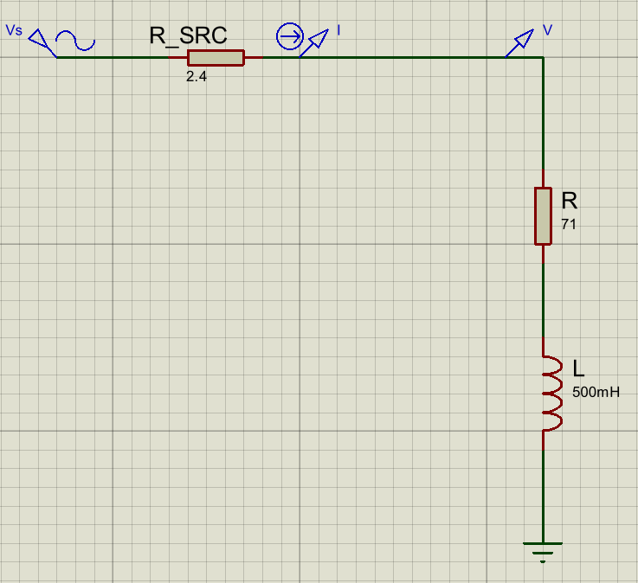
Figure 1: Circuit before power factor correction

In Figure 1, Vs represents the source voltage, which is 300 $V_{rms}$ at 50 Hz. R_SRC represents the resistance of transformer windings and cabling, which is 2.4Ω. R and L represent an inductive load such as a motor, where R is the DC resistance of the windings of 71Ω, and L is the inductance of the windings of 500mH.
In the circuit, a current probe (I) and a voltage probe (V) were placed before the load to simulate the circuit current and voltage on a graph. This was then used to calculate the phase difference between the current and voltage using Equation 1.
$$Φ=\frac{Δt}{T}×360°$$
Equation 1: Waveform phase angle [4]
Where$Φ$ is the phase angle between the current and voltage. $Δt$ is the time difference between corresponding points on the current and voltage waveforms (here, the points were taken at the crossing of the zero). $T$ is the time period of the waveform.
The calculated phase angle value was then used in Equation 2 to find the initial power factor before correction.
$$Power factor=\cos{Φ}$$
Equation 2: Power factor [4]
The $V_{m}$ and $I_{m}$values were then observed from the current and voltage waveforms in the graph, which were then used to calculate the $V_{rms}$ and $I_{rms}$ values using Equations 3 and 4.
$$V_{rms}=\frac{V_{m}}{√2}$$
Equation 3: Rms value of voltage [4]
Where $V_{m}$ is the peak value of the voltage waveform.
$$I_{rms}=\frac{I_{m}}{√2}$$
Equation 4: Rms value of current [4]
Where $I_{m}$ is the peak value of the current waveform.
The desired power factor of 0.95 was then used in Equation 2 to calculate the target phase angle by subjecting $Φ$ in the equation.
A phasor diagram was then created using the supply voltage, the load current $I_{LR}$(which is the calculated $I_{rms}$ value) lagging by a phase angle of $Φ_{1}$(the initially calculated phase angle), and $Φ$ (the calculated target phase angle for the power factor correction). The load phasor diagram was separated into two phasor triangles, and trigonometric calculations were performed. The change in vertical components between the initial and target phase angles was used to determine the reactive current that had to be subtracted, which gave the capacitor current $I_{C}$. The capacitive reactance $X_{C}$ was then calculated using Equation 5 (where $V$ is the calculated $V_{rms}$ value). The capacitance value for the power factor correction capacitor was calculated using Equation 6.
$$X_{C}=\frac{V}{I_{C}}$$
Equation 5: Capacitive reactance [4]
$$C=\frac{1}{2πfX_{C}}$$
Equation 6: Capacitance [4]
Figure 2 shows the calculated power factor correction capacitor (PFC) added to the circuit in parallel to the inductive load.

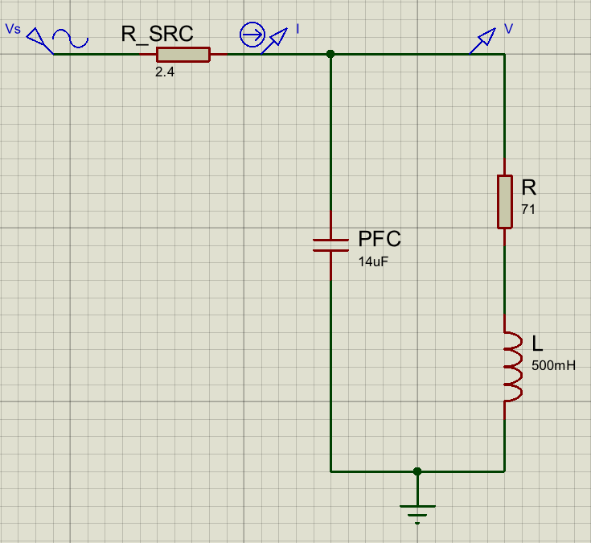
Figure 2: Circuit after power factor correction. Parallel LR-C circuit model

The circuit in Figure 2 was then simulated with the supply voltage and circuit current on a graph. The phase difference between the current and voltage was calculated using Equation 1, which was then used to confirm the power factor correction of ≥ 0.95 using Equation 2.
Using Equations 7, 8, and 9, the active, reactive, and apparent powers were calculated for the circuit before and after power factor correction.
$$P=VI cosΦ$$
Equation 7: Active power [4]
$$Q=VI sinΦ$$
Equation 8: Reactive power [4]
$$S=VI$$
Equation 9: Apparent power [4]
In the equations above, where $V$ is the 300 $V_{rms}$ source voltage, and $I$ is the $I_{rms}$ value of the circuit current.
The next stage was to show the effect of the capacitor value on the phase angle and the power factor. For that, capacitor values below and above the power factor correction capacitor value (from 8µF to 22µF) were used to simulate the circuit in Figure 2. Graphs were then created to calculate the phase angle and power factor using Equations 1 and 2 for the different capacitance values. The key values were recorded in a table created in Excel, which was used to plot line graphs to show the results.
Detailed calculations for Task 1 are available in Appendix A.

Task 2
This task required creating phasor diagrams for the Parallel LR-C circuit in Figure 2 at specified frequencies near the resonant frequency (25 Hz below and above it), including the resonant frequency and the initial frequency of 50 Hz. The resonant frequency was calculated using Equation 10.
$$f_{r}= \frac{1}{2π}\sqrt{\frac{1}{LC}-\frac{R^{2}}{L^{2}}}$$
Equation 10: Resonant frequency [4]
After noting down the resonant frequency, the frequencies of 25 Hz below and above it were noted. The circuit was then simulated at each of the specified frequencies, and the respective graphs were created to find out $V_{m}$ which was used to calculate the $V_{rms}$ value using Equation 3. Next, the capacitive reactance and inductive reactance were calculated using Equations 11 and 12. The inductive load impedances were then calculated using Equation 13. The capacitor currents were calculated using Equation 14. The inductive load currents were calculated using Equation 15, and their phase angles were calculated using Equation 16. Lastly, the phase angles of the supply currents were calculated using Equation 17, and the supply currents were calculated using Equation 18.
Detailed calculations for Task 2 are available in Appendix B.
$$X_{C}=\frac{1}{2πfC}$$
Equation 11: Capacitive reactance [4]
$$X_{L}=2πfL$$
Equation 12: Inductive reactance [4]
$$Z_{1}=\sqrt{R^{2} + {X_{L}}^{2}}$$
Equation 13: Inductive load impedance [4]
$$I_{C}=\frac{V}{X_{C}}$$
Equation 14: Capacitor current [4]
$$I_{LR}=\frac{V}{Z_{1}}$$
Equation 15: Inductive load current [4]
$$Φ_{1}=\tan^{-1}(\frac{X_{L}}{R})$$
Equation 16: Inductive load phase angle [4]
$$Φ=\tan^{-1}(\frac{I_{LR}sinΦ_{1}\sim I_{C}}{I_{LR}cosΦ_{1}})$$
Equation 17: Supply current phase angle [4]
$$I=\sqrt{{{(I}_{LR}cosΦ_{1})}^{2}+{{(I}_{LR}sinΦ_{1}\sim I_{C})}^{2} }$$
Equation 18: Supply current [4]
Where $\sim$ in the equations is the ‘difference between’.
Finally, all the key parameters calculated at each of the specified frequencies were recorded in a table in Excel, which was used to create phasor diagrams as accurately as possible.

Results

Before power factor correction (Task 1)
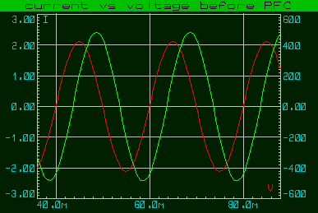
Figure 3: Graph of circuit current and voltage before power factor correction

In Figure 3, the phase angle of the lagging current (green waveform) was calculated to be 64.8°, and thus, the power factor was calculated to be 0.43.
The active power was calculated as 218.42 W. The reactive power was calculated as 464.18 VAR. The apparent power was calculated as 513 VA.

After power factor correction (Task 1)
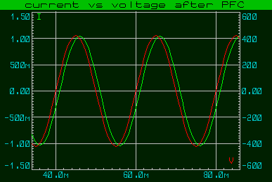
The capacitor value required to correct the power factor to at least 0.95 was calculated as 14µF.
Figure 4: Graph of circuit current and voltage after power factor correction

In Figure 4, the desired power factor of 0.95 was confirmed after calculating the phase angle of 18°.
The active power was calculated as 213.99 W. The reactive power was calculated as 69.53 VAR. The apparent power was calculated as 225 VA.

The effect of capacitor value on phase angle (Task 1)
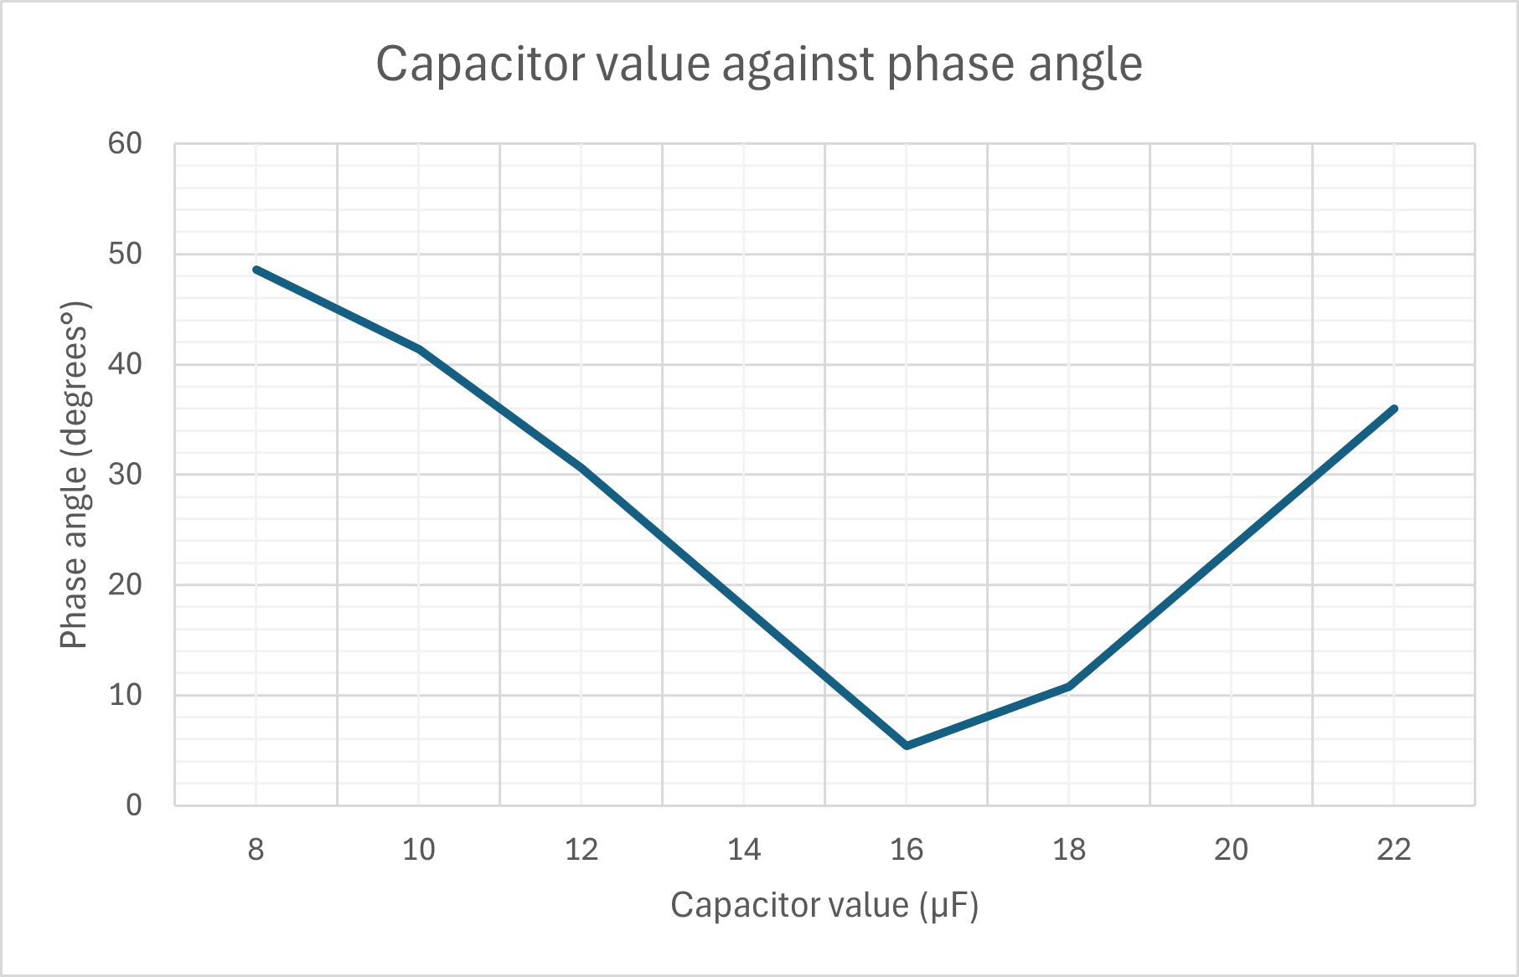

Figure 5: Graph of capacitor value against phase angle

Figure 5 shows that the phase angle decreases from 48.6° at 8µF to a minimum of 5.4° at 16µF, indicating the current is very close to being in phase with the voltage. The phase angle increases again for the values above 16µF.

The effect of capacitor value on power factor (Task 1)
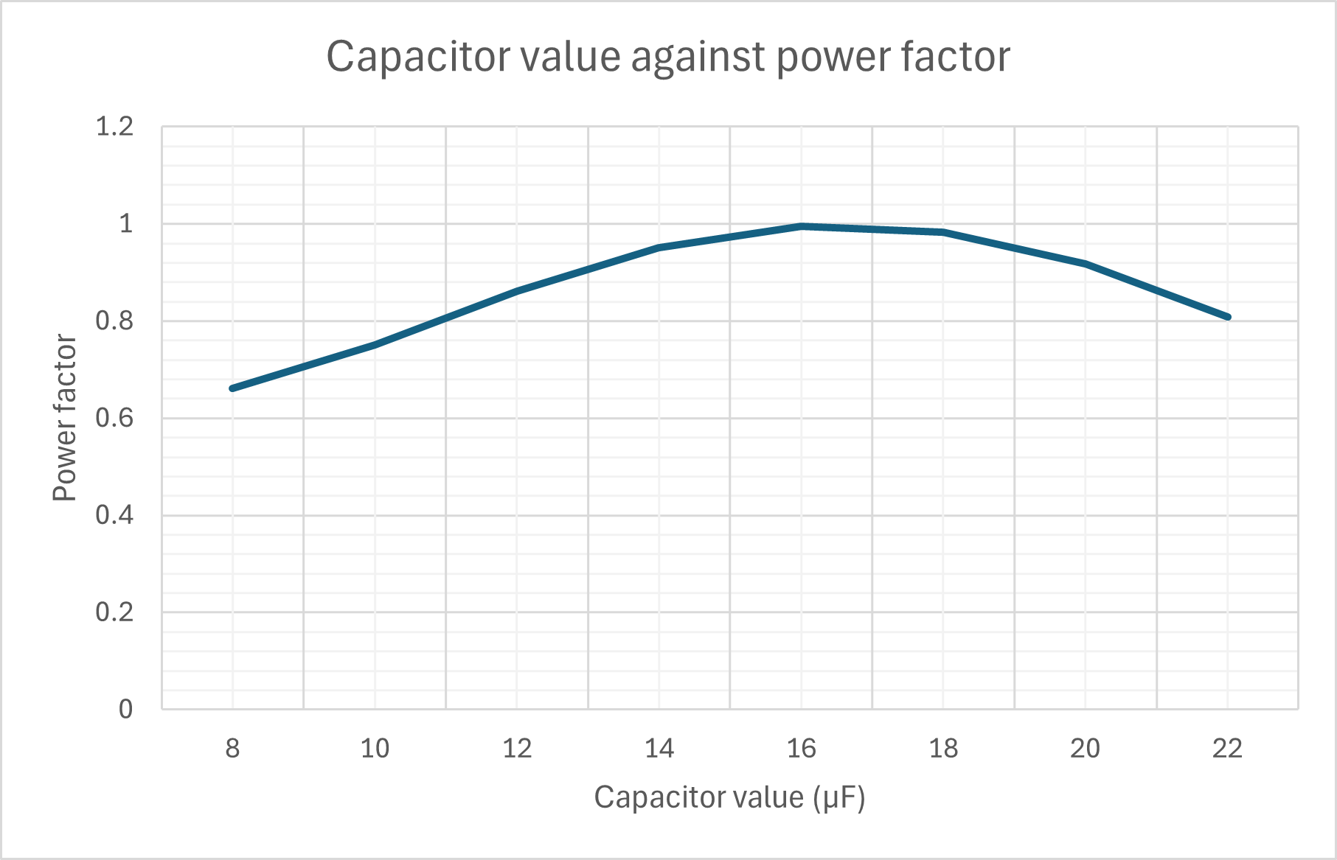

Figure 6: Graph of capacitor value against power factor

Figure 6 shows that by increasing the capacitor value, the power factor rises from 0.66 at 8µF to approximately 1 at 16µF. Raising the value above 16µF causes the power factor to decrease.

Phasor diagrams at specified frequencies (Task 2)
The resonant frequency was calculated to be 55.75 Hz.
25 Hz below resonant frequency = 30.75 Hz.
25 Hz above resonant frequency = 80.75 Hz.

The phasor diagram created for the circuit at 30.75 Hz is shown in Figure 7.
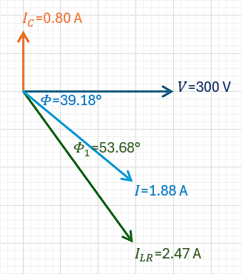

Figure 7: Phasor diagram at 30.75 Hz

The phasor diagram created for the circuit at resonance (55.75 Hz) is shown in Figure 8.
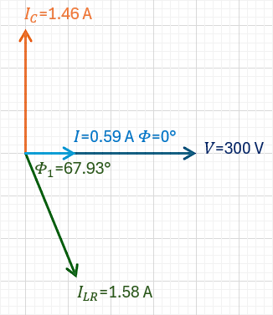
Figure 8: Phasor diagram at resonance

The phasor diagram created for the circuit at 80.75 Hz is shown in Figure 9.
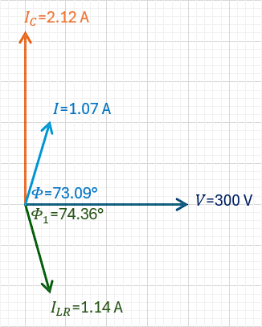

Figure 9: Phasor diagram at 80.75 Hz

The phasor diagram created for the circuit at 50 Hz is shown in Figure 10.
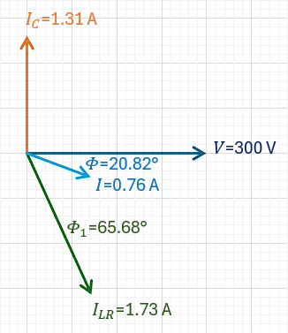
Figure 10: Phasor diagram at 50 Hz

Discussion

Behaviour of energy storage in the capacitor and the inductor
As the power factor approaches 1, the capacitor and inductor continuously transfer reactive energy back and forth between their electric and magnetic fields rather than drawing it from the source. When the capacitor value is increased, the capacitive reactive power increases and progressively cancels the inductive reactive power, resulting in both the total reactive power and the reactive current drawn from the supply being small. At this stage, most reactive power circulates between the capacitor and the inductor and the source delivers mostly real power.

Interpretation of the phasor diagrams
At 25 Hz below resonance (30.75 Hz), the capacitor current $I_{C}$ leads the voltage by 90° and the load current $I_{LR}$ lags by 53.68°. The supply current lags the voltage by a phase angle of 39.18° because $I_{C}<I_{LR}sinΦ_{1}$ denoting that the circuit is mainly inductive.
At resonance (55.75 Hz), the capacitor current $I_{C}$ leads the voltage by 90° and the load current $I_{LR}$ lags by 67.93°. The supply current is in phase with the voltage because $I_{C}=I_{LR}sinΦ_{1}$ denoting that the circuit is mainly resistive.
At 25 Hz above resonance (80.75 Hz), the capacitor current $I_{C}$ leads the voltage by 90° and the load current $I_{LR}$ lags by 74.36°. The supply current leads the voltage by a phase angle of 73.09° because $I_{C}>I_{LR}sinΦ_{1}$ denoting that the circuit is mainly capacitive.
At 50 Hz, the capacitor current $I_{C}$ leads the voltage by 90° and the load current $I_{LR}$ lags by 65.68°. The supply current lags the voltage by a phase angle of 20.82° because $I_{C}<I_{LR}sinΦ_{1}$ denoting that the circuit is mainly inductive.
As the frequency of the circuit changes from 30.75 Hz to 50 Hz, then to resonance at 55.75 Hz and lastly to 80.75 Hz, the supply current is largest below resonance, drops to a minimum at resonance, and then rises again above resonance.

Power factor correction and its relation to resonance, maximum power transfer, and energy efficiency
With the corrected capacitor value for a 0.95 power factor, the supply current becomes almost in phase with the supply voltage, as shown in Figure 4. This is related to resonance, as it occurs when the inductive and capacitive reactive effects cancel, making the supply current in phase with the supply voltage; thus, the circuit behaves mainly resistively. Hence, with power factor correction, the circuit operates close to resonance, where more real current is drawn from the supply, and the reactive current drawn from the supply is reduced. As a result, the reactive currents mostly circulate between the inductor and the capacitor.
In terms of achieving maximum power transfer, after power factor correction, the apparent power drawn from the supply was 225 VA, while the real power was 213.99 W, giving a power factor of 0.95. This implies that 95% of the apparent power delivered by the supply is converted into real power in the load, so most of the current now contributes to useful power, and less is wasted circulating reactively. Therefore, this relates to the maximum power transfer in AC systems, as it allows for maximum power transfer.
As the reactive power drawn from the supply decreases from 464.18 VAR to 69.53 VAR after power factor correction, the supply current drops from 1.71 A to 0.75 A, which in turn lowers the $I^{2}R$ losses in transformer cabling and windings. This leads to better overall efficiency and cheaper running costs in industrial applications that use power factor correction capacitors to improve their utilisation of transformers. [4]

Why three-phase power
In a three-phase power system, the supply is generated when three coils are placed 120° from each other and rotated in a consistent magnetic field. As a result, power is generated in three independent waveforms with equal voltages that peak at various times, each offset by 120°. Consequently, this produces a continuous, smooth flow of power, which is essential for industries that utilise heavy loads that require a smooth and efficient operation, such as large motors and pumps. Additionally, compared to a single-phase motor with the same voltage and rating, a three-phase electric motor consumes less electricity and often lasts longer. It can also transmit more power than a single-phase system while only requiring one additional wire, making it cost-effective. Overall, it is more efficient for the transmission and distribution of power from the power plants, which is why electricity in the UK and in other countries is transmitted on a three-phase basis. [4][7]
Systems with more than three phases are not used because they increase the complexity and cost of the generators. This can lead to requiring more complex transmission and distribution infrastructure with higher installation costs. This is also not economical because a three-phase system provides almost constant power flow, which is sufficient for the general industrial and residential requirements. [7]

Conclusion
In conclusion, the initial power factor was 0.43, with the active power being 218.42 W, the reactive power being 464.18 VAR, and the apparent power being 513 VA. After adding the 14µF power factor correction capacitor, the power factor improved to 0.95. The active power was 213.99 W, the reactive power was 69.53 VAR, and the apparent power was 225 VA. The phasor diagram at the resonant frequency showed that the circuit becomes mainly resistive, operating below it makes the circuit inductor dominant, and operating above it makes the circuit capacitor dominant. Power factor correction here is important because it makes the supply current align closely with the supply voltage, which operates close to resonance, ensuring that the reactive current drawn from the supply is reduced, and most of the current is contributed to useful power for maximum power transfer. As a result, the reduced supply current lowers the $I^{2}R$ losses in transformer cabling and windings, leading to improved overall efficiency and lower operating costs in industrial applications.

References
[1] “Basic Concepts of AC Power and its Importance,” Monolithic Power Systems Inc, [Online]. Available: https://www.monolithicpower.com/en/learning/mpscholar/ac-power/introduction/basic-concepts-and-importance. [Accessed 26th December 2025].
[2] “Power Triangle and Power Factor,” Electronics Tutorials, [Online]. Available: https://www.electronics-tutorials.ws/accircuits/power-triangle.html. [Accessed 26th December 2025].
[3] J. Ware, “POWER FACTOR CORRECTION,” 2006. [Online]. Available: https://electrical.theiet.org/media/1687/power-factor-correction-pfc.pdf.
[4] J. Bird, Electrical circuit theory and technology, Fifth edition. London: Routledge, 2014.
[5] “Parallel Resonance Circuit,” Electronics Tutorials, [Online]. Available: https://www.electronics-tutorials.ws/accircuits/parallel-resonance.html. [Accessed December 26th 2025].
[6] “Maximum Power Transfer Theorem,” BYJU'S, [Online]. Available: https://byjus.com/physics/maximum-power-transfer-theorem/. [Accessed 26th December 2025].
[7] “Three Phase Power,” The Engineering Mindset, 20th November 2024. [Online]. Available: https://theengineeringmindset.com/three-phase-power/. [Accessed 26th December 2025].

Appendices

Appendix A: Task 1 calculations
Initial phase angle and power factor:
$$Φ_{1}=\frac{Δt}{T}×360°$$$=\frac{(43.6×{10}^{-3})-(40×{10}^{-3})}{20×{10}^{-3}}×360°=64.8°$
$Power factor=\cos{Φ}=\cos{(64.8)=0.43}$
From the graph $V_{m}$, and $I_{m}$:
$$V_{m}=421 V \\ I_{m}=2.42 A$$
$$V_{rms}=\frac{V_{m}}{√2}=\frac{421}{√2}=297.69 V$$
$$I_{rms}=\frac{I_{m}}{√2}=\frac{2.42}{√2}=1.71 A$$
Target power factor phase angle:
$$Power factor=0.95 \\ \cos{Φ}=0.95 \\ Φ=\cos^{-1}\left(0.95\right) \\ Φ=18.19°$$
In Triangle $OAC$
$$\sin{Φ_{1}}=\frac{AC}{OC} \\ \sin{Φ_{1}}=\frac{AC}{I_{LR}} \\ AC=I_{LR}×\sin{Φ_{1}} \\ AC=1.71×\sin\left(64.8\right) \\ AC=I_{V}=1.55 A$$
In triangle $OAC$
$$\cos{Φ_{1}}=\frac{OA}{OC} \\ \cos{Φ_{1}}=\frac{OA}{I_{LR}} \\ OA=I_{LR}×\cos{Φ_{1}} \\ OA=1.71×\cos\left(64.8\right) \\ OA=I_{R}=0.73 A$$

In Triangle $OAB$
$$\cos{Φ}=\frac{OA}{OB} \\ \cos{Φ}=\frac{I_{R}}{I} \\ I=\frac{I_{R}}{\cos{Φ}} \\ I=\frac{0.73 }{\cos\left(18.19\right)} \\ I=0.77 A$$
In Triangle $OAB$
$$\sin{Φ}=\frac{AB}{OB} \\ \sin{Φ}=\frac{AB}{I} \\ AB=I×\sin{Φ} \\ AB=0.77×\sin\left(18.19\right) \\ AB=0.24 A$$
In triangle $OAC$
$$AC=AB+BC \\ BC=AC-AB \\ BC=1.55-0.24 \\ BC=I_{c}=1.31 A$$
To calculate the capacitive reactance and capacitance:
$$X_{C}=\frac{V}{I_{C}} \\ X_{C}=\frac{297.69}{1.31}=227.24Ω$$
$$C=\frac{1}{2πfX_{C}}$$
$$C=\frac{1}{2π×50×227.24}$$
$$C=1.4×{10}^{-5} F=14µF$$
Confirming the new power factor to ≥ 0.95:
$$Φ_{1}=\frac{Δt}{T}×360°$$$=\frac{(41×{10}^{-3})-(40×{10}^{-3})}{20×{10}^{-3}}×360°=18°$
$Power factor=\cos{Φ}=\cos{(18)=0.95}$
Power calculations before power factor correction
$$P=VI cosΦ=300×1.71×\cos{(64.8)}=218.42 W$$
$$Q=VI sinΦ= 300×1.71 ×\sin{(64.8)}=464.18 VAR$$
$$S=VI=300×1.71 =513 VA$$
Power calculations after power factor correction
$$P=VI cosΦ=300×0.75×\cos{(18)}=213.99 W$$
$$Q=VI sinΦ= 300×0.75 ×\sin{(18)}=69.53 VAR$$
$$S=VI=300×0.75 =225 VA$$

Appendix B: Task 2 calculations
$$Resonant frequency= f_{r}= \frac{1}{2π}\sqrt{\frac{1}{LC}-\frac{R^{2}}{L^{2}}} \\ = \frac{1}{2π}\sqrt{\left(\frac{1}{\left(500×{10}^{-3}\right)×\left(14×{10}^{-6}\right)}\right)-\left(\frac{({71)}^{2}}{({500×{10}^{-3})}^{2}}\right) }$$
$$= 55.75 Hz$$
$$25 Hz above fr= 80.75 Hz$$
$$25 Hz below fr= 30.75 Hz$$

Phasor diagram calculations for the frequency at $30.75 Hz$
$$X_{C}=\frac{1}{2πfC}=\frac{1}{2π×30.75×(14×{10}^{-6})}=369.70Ω$$
$$X_{L}=2πfL=2π×30.75×\left(500×{10}^{-3}\right)=96.60Ω$$
$$Z_{1}=\sqrt{R^{2} + {X_{L}}^{2}}=\sqrt{{71}^{2} + {96.60}^{2}}=119.89Ω$$
$$V_{rms}=\frac{V_{m}}{√2}=\frac{419}{√2}=296.28 V$$
$$I_{C}=\frac{V}{X_{C}}=\frac{296.28 }{369.70}=0.80 A$$
$$I_{LR}=\frac{V}{Z_{1}}=\frac{296.28 }{119.89}=2.47 A$$
$$Φ_{1}=\tan^{-1}\left(\frac{X_{L}}{R}\right)=\tan^{-1}\left(\frac{96.60}{71}\right)=53.68°$$
$$I_{LR}sinΦ_{1}=2.47×\sin\left(53.68\right)=1.99 A$$
$$I_{LR}cosΦ_{1}=2.47×\cos\left(53.68\right)=1.46 A$$
$$Φ=\tan^{-1}\left(\frac{I_{LR}sinΦ_{1}\sim I_{C}}{I_{LR}cosΦ_{1}}\right)=\tan^{-1}\left(\frac{1.99-0.80}{1.46}\right)=39.18° (lagging)$$
$$I=\sqrt{{{(I}_{LR}cosΦ_{1})}^{2}+{{(I}_{LR}sinΦ_{1}\sim I_{C})}^{2} }=\sqrt{{(1.46)}^{2}+{(1.99-0.80)}^{2} }=1.88 A$$

Phasor diagram calculations for the frequency at $55.75 Hz$
$$X_{C}=\frac{1}{2πfC}=\frac{1}{2π×55.75×(14×{10}^{-6})}=203.91Ω$$
$$X_{L}=2πfL=2π×55.75×\left(500×{10}^{-3}\right)=175.14Ω$$
$$Z_{1}=\sqrt{R^{2} + {X_{L}}^{2}}=\sqrt{{71}^{2} + {175.14}^{2}}=188.98Ω$$
$$V_{rms}=\frac{V_{m}}{√2}=\frac{421}{√2}=297.69 V$$
$$I_{C}=\frac{V}{X_{C}}=\frac{297.69 }{203.91}=1.46 A$$
$$I_{LR}=\frac{V}{Z_{1}}=\frac{297.69 }{188.98}=1.58 A$$
$$Φ_{1}=\tan^{-1}\left(\frac{X_{L}}{R}\right)=\tan^{-1}\left(\frac{175.14}{71}\right)=67.93°$$
$$I_{LR}sinΦ_{1}=1.58×\sin\left(67.93\right)=1.46 A$$
$$I_{LR}cosΦ_{1}=1.58×\cos\left(67.93\right)=0.59 A$$
$$Φ=\tan^{-1}\left(\frac{I_{LR}sinΦ_{1}\sim I_{C}}{I_{LR}cosΦ_{1}}\right)=\tan^{-1}\left(\frac{1.46-1.46}{0.59}\right)=0°$$
$$I=\sqrt{{{(I}_{LR}cosΦ_{1})}^{2}+{{(I}_{LR}sinΦ_{1}\sim I_{C})}^{2} }=\sqrt{{(0.59)}^{2}+{(1.46-1.46)}^{2} }=0.59 A$$

Phasor diagram calculations for the frequency at $80.75 Hz$
$$X_{C}=\frac{1}{2πfC}=\frac{1}{2π×80.75×(14×{10}^{-6})}=140.78Ω$$
$$X_{L}=2πfL=2π×80.75×\left(500×{10}^{-3}\right)=253.68Ω$$
$$Z_{1}=\sqrt{R^{2} + {X_{L}}^{2}}=\sqrt{{71}^{2} + {253.68}^{2}}=263.43Ω$$
$$V_{rms}=\frac{V_{m}}{√2}=\frac{423}{√2}=299.11 V$$
$$I_{C}=\frac{V}{X_{C}}=\frac{299.11 }{140.78}=2.12 A$$
$$I_{LR}=\frac{V}{Z_{1}}=\frac{299.11 }{263.43}=1.14 A$$
$$Φ_{1}=\tan^{-1}\left(\frac{X_{L}}{R}\right)=\tan^{-1}\left(\frac{253.68}{71}\right)=74.36°$$
$$I_{LR}sinΦ_{1}=1.14×\sin\left(74.36\right)=1.10 A$$
$$I_{LR}cosΦ_{1}=1.14×\cos\left(74.36\right)=0.31 A$$
$$Φ=\tan^{-1}\left(\frac{I_{LR}sinΦ_{1}\sim I_{C}}{I_{LR}cosΦ_{1}}\right)=\tan^{-1}\left(\frac{2.12-1.10}{0.31}\right)=73.09° (leading)$$
$$I=\sqrt{{{(I}_{LR}cosΦ_{1})}^{2}+{{(I}_{LR}sinΦ_{1}\sim I_{C})}^{2} }=\sqrt{{(0.31)}^{2}+{(2.12-1.10)}^{2} }=1.07 A$$
Phasor diagram calculations for the frequency at $50 Hz$
$$X_{C}=\frac{1}{2πfC}=\frac{1}{2π×50×(14×{10}^{-6})}=227.36Ω$$
$$X_{L}=2πfL=2π×50×\left(500×{10}^{-3}\right)=157.08Ω$$
$$Z_{1}=\sqrt{R^{2} + {X_{L}}^{2}}=\sqrt{{71}^{2} + {157.08}^{2}}=172.38Ω$$
$$V_{rms}=\frac{V_{m}}{√2}=\frac{421}{√2}=297.69 V$$
$$I_{C}=\frac{V}{X_{C}}=\frac{297.69 }{227.36}=1.31 A$$
$$I_{LR}=\frac{V}{Z_{1}}=\frac{297.69 }{172.38}=1.73 A$$
$$Φ_{1}=\tan^{-1}\left(\frac{X_{L}}{R}\right)=\tan^{-1}\left(\frac{157.08}{71}\right)=65.68°$$
$$I_{LR}sinΦ_{1}=1.73×\sin\left(65.68\right)=1.58 A$$
$$I_{LR}cosΦ_{1}=1.73×\cos\left(65.68\right)=0.71 A$$
$$Φ=\tan^{-1}\left(\frac{I_{LR}sinΦ_{1}\sim I_{C}}{I_{LR}cosΦ_{1}}\right)=\tan^{-1}\left(\frac{1.58-1.31}{0.71}\right)=20.82° (lagging)$$
$$I=\sqrt{{{(I}_{LR}cosΦ_{1})}^{2}+{{(I}_{LR}sinΦ_{1}\sim I_{C})}^{2} }=\sqrt{{(0.71)}^{2}+{(1.58-1.31)}^{2} }=0.76 A$$

