Record your reflection
- What are the TIA/EIA Standards? How does 568 A differ from 568 B? Are there any other standard? (100 – 300 words)
The EIA/TIA standards are a group of standards covering different aspects of premise cabling and other wiring practices. They cover both residential and commercial wiring.
The standards were devised by TIA (Telecommunications Industry Association) and the EIA (Electronic Industries Association) in the mid-1980s with the objective of developing a wiring system to support multivendor products and environments.
The standards define how to design, build and manage a cabling system, and define the use of fibre-optic, STP (Shield Twisted Pair) and UTP (Unshielded Twisted Pair) cables.
T-568-A/B specifically refer to Commercial Building Telecommunications Wiring.
The T568A and T568B are the backbone termination standards of the internet, from ISPs down to end users. The 568A standard is the most widely accepted standard as it is backwards compatible to most wiring schemes, unlike the T568B.
The wiring of the 568A and 568B are also different with the second and third pairs being swapped, so appear on different pins. Pins 1,2,3 and 6 (T568A) swap with pins 3,6,1 and 2 (T568B) respectively.
Other standards are;
- TIA/EIA-569-A, commercial building standard for telecommunications pathways and spaces
- TIA/EIA-570-A, residential and light commercial telecommunications wiring
- TIA/EIA-606, building infrastructure administration
- TIA/EIA-607, grounding and bonding requirements

- What is a straight through cable and cross over cable? Which cable should be selected during a simple network installation (Topology includes Routers, Switches and End Devices)? (100 – 300 words). You shall use Tables, Diagrams to clarify.
A straight through cable use the same wiring standard on each end, whereas the crossover cable uses different standards on each end. This is illustrated in the following image.
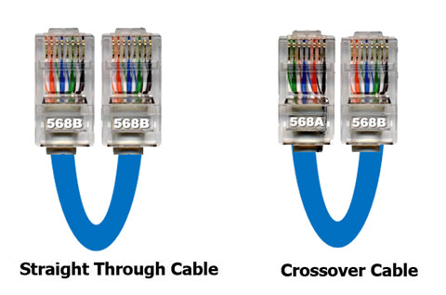
The straight through cable has the same pinout on each RJ-45 connector at the end, they are a copper wire cable for local area networks (LAN).
A cross over cable is used for the interconnection of two similar devices, negating the need for a component such as a switch to be placed in the middle. The internal wiring reverses the transmit and receive signals.
A simple network installation would likely only require the use of straight through cables as the cables would be joining devices which are not alike. The following diagram illustrates how this could look.


