

Electronics 1 Jenifer Prince Davaraj

Electronics 1 Jenifer Prince Davaraj

Designing an Automatic Traffic Light Controller for a T- Junction Road.
ACDB5002

age

Designing an Automatic Traffic Light Controller for a T- Junction Road.
ACDB5002

age

Designing an Automatic Traffic Light Controller for a T- Junction Road.
ACDB5002

age

Designing an Automatic Traffic Light Controller for a T- Junction Road.
ACDB5002

age
  - Emily De Lange
  - Student number: 2306894

26/02/25
Contents
Figure table 3
Tables 3
Introduction 3
Traffic lights 3
Micro controllers 3
Circuit design 3
PIC 4
7 Segment display 5
LEDS and traffic lights 6
Button 6
Flowchart, system operation 8
Flowchart Steps 9
Software 9
Details of testing, simulated outputs 9
Results 10
Expected outcomes 10
Actual outcomes 10
Conclusion and recommendations on future work 11
Future improvements 11
Button press improvements 11
Adding sensors 11
Smaller PIC 11
References 12
Appendix 13

Figure table
Figure 1, traffic light circuit 3
Figure 2, PIC18F8722 4
Figure 3, 7 segment display 4
Figure 4, Traffic lights 5
Figure 5, Pedestrian button 5
Figure 6, flow chart of code 6

Tables
Table 1, Simulation test 8
Table 2, proteus vs hardware 8

Introduction
Effective traffic management is essential to ensure the safety of pedestrians, vehicles, and surrounding infrastructure. Without proper control, traffic congestion and accidents can occur, leading to damage and inefficiencies in urban transportation. This report outlines the design and development of a traffic light system for a T-junction with a pedestrian crossing, utilising timed delays to maintain a smooth and controlled traffic flow. The system is designed to be a safe and reliable solution, leveraging the capabilities of the PIC18F8722 microcontroller within Proteus software to simulate a functional prototype.
The proposed system consists of three traffic lights, two LEDs, a pedestrian crossing button, and a 7-segment display for countdown timing. This report details the research conducted, the design and implementation process, testing procedures, and the results obtained during development.

Traffic lights
The first recorded use of traffic lights dates back to 1868, when they were installed outside the Houses of Parliament in London. These early systems were modified versions of railway signals intended to regulate the increasing traffic in busy cities [1]. Over time, traffic light technology has evolved significantly, with modern systems now incorporating smart traffic control mechanisms, including IoT sensors, cameras, and cloud-based traffic management platforms [2].
Traditional traffic light systems are controlled via dedicated controllers, which are typically housed in roadside control cabinets. These cabinets contain essential components such as:
- A power panel for electrical distribution,
- A detector interface panel to connect loop and other sensors,
- Detector amplifiers for signal processing,
- A traffic light controller, and
- A conflict monitor unit for safety management [3].

Microcontrollers
A microcontroller is a small, self-contained computer system integrated onto a single chip [4]. Unlike general-purpose computers, microcontrollers are designed to perform specific automated tasks, typically executing repetitive functions based on predefined input and output signals.
Microcontrollers consist of essential components such as:
- A microprocessor (CPU) for executing instructions,
- Memory for storing program code and data,
- Input and Output (I/O) interfaces to interact with external components,
- Timers and counters for event scheduling, and
- Communication protocols such as SPI, I2C, or UART for interfacing with sensors and peripherals.
A typical microcontroller-based system operates based on real-time inputs and triggers appropriate responses. For instance, if a temperature sensor detects a threshold breach, the microcontroller can activate a cooling fan or issue an alert.
A simple block diagram of a generic microcontroller architecture is illustrated in Figure 1. However, the exact configuration varies depending on the specific microcontroller used.
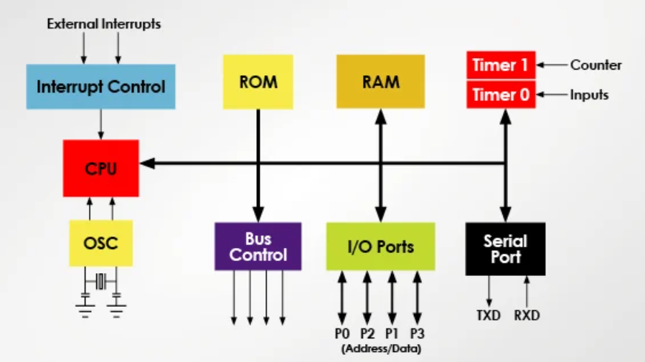
Figure 1, Microcontroller block diagram
Microcontrollers are used in many applications. Any electronic device containing a sensor, display or programable output control is likely to have MCU fitted [4].

Circuit design
The design of the circuit and why the following components were picked, seen in Figure 2.
- PIC18F8722
- 7SEG-MPX2-CA
- 3 x traffic lights
- Red LED and Green LED
- Button
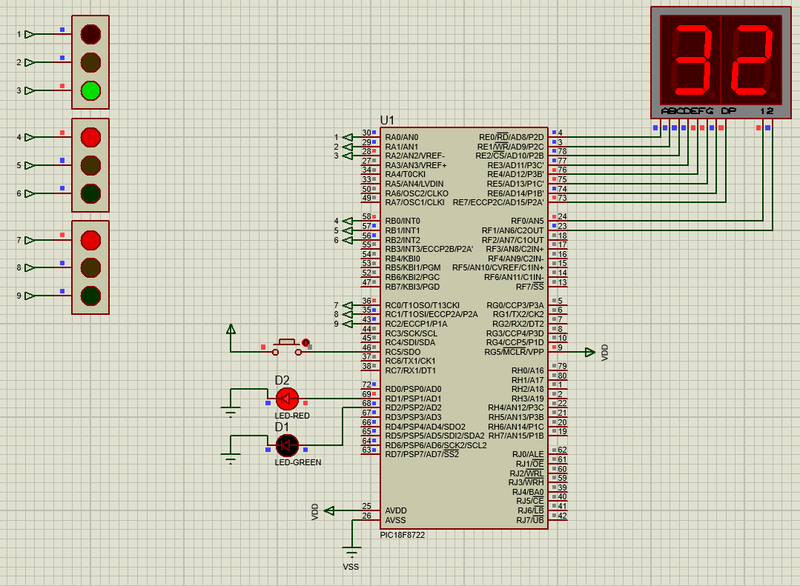
Figure 2, traffic light circuit

PIC
When deciding on the correct PIC, this one was picked because it is a high performing 8-bit microcontroller from Microchip. It has plenty of I/0 pins to choose from, (eighty) [5]. The traffic lights needed 9 pins, the 7-segment display needed eight pins for data and two for digit control, the LEDs needed two pins and the button needed one. This PIC has multiple 16-bit timers that makes the millisecond delays more precise. The project is running at 20MHz providing fast execution of condition checks ensuring the button press works without lag. If this was applied practically and open to the elements this PIC can withstand harsh environments. For this some what simple application, this PIC may have been a bit over kill but it leaves options for future adaptions and improvements. A picture of it if used in a practical circuit is show in Figure 3.
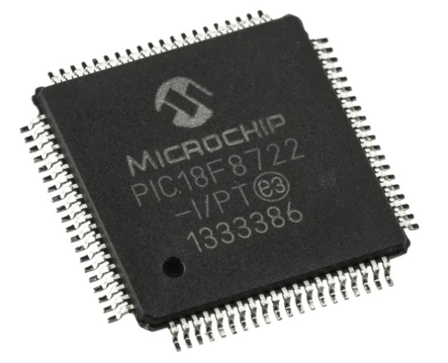
Figure 3, PIC18F8722

7 Segment display
This display was chosen as it displays both tens and ones on the one unit saving pins and a cleaner viewing experience. The 7SEG-MPX2-CA, shown in Figure 4, is a common anode meaning it requires a LOW
signal (0V) on the segment pin. This display is used to demonstrate the countdown from 40 – 0. The count down on this display seems smooth to naked eye but due to the Multiplexing switching between the digits (500Hz) it is in fact only showing one digit at a time but switching very rapidly. The PIC can efficiently drive this two-digit display and only requires 10 pins in total, appose to using two induvial displays and needing 14.
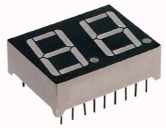
Figure 4, 7 segment display
The code to work out the display was constructed from converting binary to HEX using the chart in Figure 5 [6].
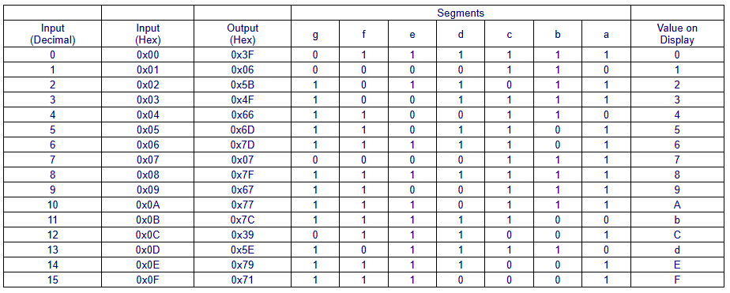
Figure 5, Hex to decimal chart [6]

LEDS and traffic lights
Three traffic lights and been inputted to create a more “realistic” look like in Figure 6 while two more LEDs are added to demonstrate when the pedestrians can cross the road. The lights cycle through red to green on all three of the traffic lights, then all go to red when the pedestrian light is green the pedestrian light is red while the traffic lights are cycling through. The whole system runs through a countdown of 40 seconds, 10 seconds for each traffic light and the last 10 seconds for the pedestrian crossing. The main loop of the code continually updates the system based on the elapsed seconds in the countdown, the function checks which light should be on based on the current second.

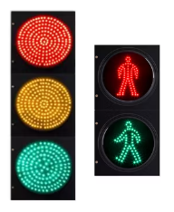
Figure 6, Traffic lights

Button
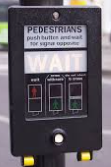
The button has been added to the circuit to simulate the button in Figure 7, which triggers a pedestrian sequence when pressed. If the button is pressed it stops normal operation and enters the pedestrian mode for 5 seconds before returning to the normal 40 seconds sequence. The button is active LOW so reads 0V when pressed. To avoid false triggers there’s a 50ms delay. When pressed there is a 2 second delay before turning all the traffic lights to red and turn the pedestrian green LED on for 5 seconds.
Figure 7, Pedestrian button

Flowchart, system operation
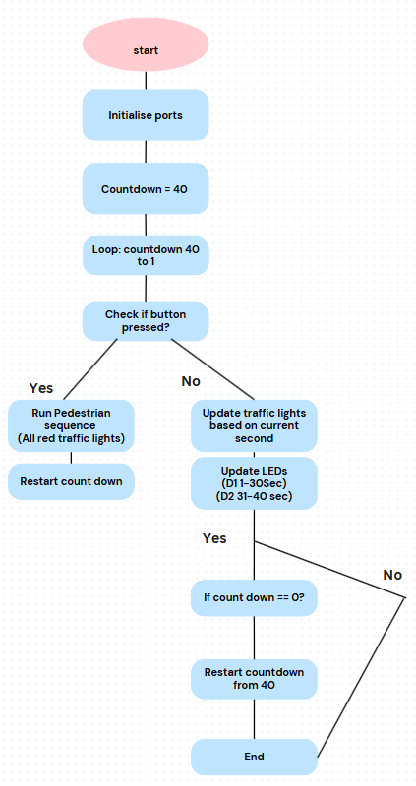
Figure 8, flow chart of code

Flowchart Steps
These are the steps taken in flow chart in Figure 8
- Start
- Initialize Ports (Set up traffic lights, 7-segment display, and LEDs)
- Loop (Forever)
- For countdown from 40 to 1:
- Check if the button is pressed?
- If Yes → Trigger Emergency Sequence, restart countdown.
- If No → Continue.
- Update Traffic Lights based on the current second.
- Update LEDs:
- LED_D1 ON for first 30 seconds.
- LED_D2 ON for last 10 seconds.
- Update 7-segment display to show countdown.
- Loop repeats until countdown reaches 1, then restarts from 40.

Software
The code used for this simulation was in the C coding langue, using the Microchip “getting started with C-Code for PIC” data sheet for reference [7], compiled within CCS and simulated on proteus. Unlike C programming for computers, embedded systems interact directly with hardware using #include which directly loads the Pic specific library. #use delay(clock=20000000) sets the clock speed to 20MHz. The traffic lights are controlled by the #define statements, which assign microcontroller pins to each light using ‘set_traffic_light()’. The 7 segment display cycles rapidly between two digits to display the countdown. The cycles are so quick they cannot be spotted by the naked eye, the code for this is under ‘void multiplex_display(int number)’. The Button is connected to ‘PIN_C5’ and seen in the code, ‘if(input(BUTTON_PIN))’, if the button is pressed it waits two seconds then turns all traffic lights to red and lights up the green pedestrian LED for 5 seconds, then resets the countdown. The countdown is in a while loop inside the main(). The loop will run in defiantly, when the countdown reaches one it restarts at 40. If the button is pressed it pauses the cycle for five seconds then restarts from 40. All code can be found in the Appendix.

Time (seconds) | Active Traffic Light | Light Colour
0 - 9 | Traffic Light 1 | Green (except for first sec: red/amber)
10 - 19 | Traffic Light 2 | Green (except for first sec: red/amber)
20 - 29 | Traffic Light 3 | Green (except for first sec: red/amber)
30 - 39 | All traffic Lights | Red

Details of testing, simulated outputs
Using proteus to simulate the system I connected the 7-segment display, button, traffic lights and LED’s to the PIC to test the hardware behaviour. Predicted outputs are shown in Table 1.
Test | Expected result | How to validate
System start | Countdown begins (40seconds). Traffic light one moves from red to green. (pedestrian crossing is red) | Check 7 segment display is displaying correct time
At 10 seconds | Traffic light two moves from red to green | Check correct pins are activated
At 20 seconds | Traffic light tree moves from red to green, (traffic light one goes back to red) | Ensure state transitions in simulation
At 30 seconds | All traffic lights go red, reen LED for pedestrian crossing illuminates. | Check LED state changes
When button is pressed | Pedestrian mode triggers | Ensure all traffic lights change to red. Green pedestrian LED illuminates.
Table 1, Simulation test
It is always important to remember that simulation on Proteus may show up different results to hardware, real world imperfections like component tolerances and power supply fluctuations. Shown in Table 2. Another issue maybe that the debounce on the button could behave differently to hardware, proteus is more likely to instantly trigger. Having the system built in proteus allows for easier debugging, there will be no issue with bad soldering or faulty parts causing issues. For example, an LED will always turn on in proteus, while using hardware a weak resistor or loose connection may cause the LED to flicker or not turn on.
Factor | Proteus simulation | Hardware
Quick prototyping | Great foe testing logic and design | Requires physical setup
Debugging | Step by step simulation tools | Harder to troubleshoot issues
Accuracy | Limited by ideal conditions | Includes real-world imperfections
Time precision | May not match real clock speeds | Shows real-world timing
Competent Flexibility | Limited by software library | Can use any physical component
Cost | Free or low-cost | Expensive
Table 2, proteus vs hardware

Results
Simulations were carried out in Proteus to evaluate the performance of the traffic light system before practical implementation. The expected and actual outcomes were analysed as follows

Expected outcomes
- Traffic light system should cycle every 40 seconds as designed.
- The 7-segment display should show a countdown from 40 to 1 correctly.
- The button press should trigger the pedestrian mode, pausing traffic flow.
- LED indicators and traffic lights should illuminate at the correct time

Actual outcomes
- Traffic light Cycle operated as expected, the traffic lights switched correctly every 10 seconds for each phase, maintaining the 40 second cycle.
- 7 segment display, counts down correctly, except it freezes on the current value when the pedestrian button is pressed. This display update is interrupted when the button is pressed triggering the pedestrian mode.
- The button response, triggers the pedestrian mode. It works as expected, but the display freezes on the last count down value. There may be a de bounce issue meaning requiring a longer button press to activate.
- Traffic lights and LED timing. Lights illuminate at the correct time responding to the system conditions correctly.
- Cycle reset, restarts correctly at the end of the 40 second cycle or after the button is pressed.

Conclusion and recommendations on future work
The circuit demonstrated the expected functionality, ensuring the traffic lights cycled correctly within the designated 40-second period. The LEDs and 7-segment display operated as intended, with the countdown visibly decrementing from 40 to 1. Additionally, the pedestrian button effectively triggered the pedestrian crossing mode, pausing vehicle traffic when activated.
However, some issues were identified during testing. The 7-segment display freezes when the pedestrian button is pressed, likely due to the use of blocking delays within the pedestrian sequence function. Additionally, the button requires a long press (approximately 1 second) to register, which may indicate inefficiencies in the debounce handling mechanism. Despite these minor challenges, the system correctly resets and continues its cycle after the pedestrian mode is completed, ensuring overall functionality is maintained.
Improvements in real-time responsiveness and non-blocking execution would enhance the system's reliability, making it more practical for real-world deployment.

Future improvements
To address the identified issues and enhance system performance, the following improvements are recommended.

Button press improvements
Replace blocking delays (delay_ms()) in the pedestrian sequence with a timer-based approach to ensure the countdown display continues updating during pedestrian mode activation. Implement interrupt-driven button detection instead of the current polling method to allow for instant responsiveness without requiring a prolonged press. Ensure that the display refresh rate remains stable even during pedestrian mode by optimizing the multiplexing timing and reducing interruptions. Additional features like a noise or flashing LED when the pedestrian mode is activated could also improve the system.

Adding sensors
Adding an ADC (analogue to digital converter) with IR (infer red) sensors, will allow for traffic or pedestrian sensors to be added to the system. Allowing for a smoother flow of traffic by adjusting light timings. This has not been used in this code but there is an option for sensors to be added to the circuit when future upgrades are made.

Smaller PIC
Using a smaller PIC like the PIC16F877A would mean a lower cost and smaller in size. If this project was to be physically made with hardware constructing something cheaper and smaller is always the best option.

References

[1] | M. Maxwell, “Hisotry of traffic lights,” Stone care motor group , 20 03 2020. [Online]. Available: https://www.stoneacre.co.uk/blog/the-history-of-traffic-lights. [Accessed 28 02 2025].
[2] | V. Zavadko, “How Do Smart Traffic Lights Work?,” intellias, 11 07 2022. [Online]. Available: https://intellias.com/smart-traffic-signals/. [Accessed 04 03 2025].
[3] | Wikipedia, “Traffic controllers,” [Online]. Available: https://en.wikipedia.org/wiki/Traffic_light_control_and_coordination. [Accessed 04 03 2025].
[4] | RS , “What is a Microcontroller?,” RS parts, 25 01 2024. [Online]. Available: https://uk.rs-online.com/web/content/discovery/ideas-and-advice/microcontrollers-guide. [Accessed 04 03 2025].
[5] | “PIC18F8722,” Microchip, [Online]. Available: https://www.microchip.com/en-us/product/pic18f8722. [Accessed 28 02 2025].
[6] | “SEG - Hex / BCD to 7 Segment Display,” [Online]. Available: https://hosteng.com/dmdhelp/content/instruction_set/SEG_Hex_BCD_to_7_Segment_Display.htm. [Accessed 03 03 2025].
[7] | “Getting Started with Writing C-Code for PIC16,” Microchip, [Online]. Available: https://ww1.microchip.com/downloads/aemDocuments/documents/MCU08/ApplicationNotes/ApplicationNotes/TB3261-Technical-Brief-DS90003261A.pdf. [Accessed 03 03 2025].

Appendix



