Programme: BA (Hons) Business Management
Module: Data Handling and Business Intelligence
Assignment Title: Component 2
Module code: LCBB5014
Coursework: Report
Name: Laris Zamfir
Lecturer: Ihsan Ul Haq

Table of Contents

Introduction…………………………………………………………..3
Data Cleaning and Preparation………………………………3
Descriptive Statistics and Summary………………………..4-5
Trend Analysis and Visualisation……………………………….5-6-7-8
Statistical Analysis using SPSS…………………………………8-9
5.1 Hypothesis Testing
5.2 Correlation Analysis
5.3 Regression Analysis
Insights and Recommendations……………………………………10
References………………………………………………………………..11
.

Introduction
The rapid growth of online food delivery services has heightened the significance of effective logistics and dependable service quality. Data analytics is essential for comprehending operational performance and pinpointing areas for enhancement in delivery systems. This report examines a dataset that encompasses information pertinent to food delivery operations, including characteristics of delivery personnel, delivery durations, customer evaluations, weather conditions, traffic density, and types of vehicles. By analysing these factors, it becomes sufficient to discern patterns that may affect delivery efficiency and service results.
The aim of this report is to implement data analysis methodologies using Microsoft Excel and SPSS to investigate trends and correlations within the dataset. Through systematic data analysis, organisations can acquire valuable insights into operational elements that influence delivery performance and customer satisfaction. Prior research highlights that data-driven decision-making enhances operational planning and service quality in logistics settings (Saunders, Lewis and Thornhill, 2019).
The analysis is organised around several primary objectives. Initially, the dataset is cleaned and prepared using Excel to guarantee accuracy and consistency. Subsequently, descriptive statistical measures are produced to review key variables within the dataset. Thirdly, trend analysis and visualization techniques are employed to uncover patterns in delivery performance. Lastly, statistical testing with SPSS is performed to examine relationships between variables such as delivery ratings, traffic conditions, and characteristics of delivery personnel (Field, 2018; Hair et al., 2019).

Data Cleaning and Preparation
Before performing the analysis, the dataset was cleaned and prepared in Microsoft Excel to ensure accuracy and reliability. The cleaning of data is an essential phase in the analytical workflow, as any errors or inconsistencies may compromise the validity of statistical outcomes (Hair et al., 2019). Initially, the dataset was searched to detect any missing or NaN values by using Excel's filtering and sorting functionalities. Rows that contained missing values in key variables, such as delivery ratings or delivery time, were eliminated to prevent the introduction of bias into the analysis. Conversely, if non-essential variables had missing values, the dataset remained unchanged, provided it did not influence the overall analysis.
Next, the dataset was assessed for formatting inconsistencies. Certain date and time entries were found to be in irregular formats, which could potentially lead to errors during the analysis. These entries were regulated by converting dates to a uniform DD/MM/YYYY format and ensuring that time variables adhered to a 24-hour format.
Lastly, categorical variables, including weather conditions and traffic density, were examined to confirm consistent spelling and labelling. Minor adjustments were made to regulate category names. These enhancements elevated the overall quality of the dataset and confirmed its suitability for subsequent statistical analysis (Field, 2018).

Descriptive Statistics and Summary
Descriptive statistics were produced using Microsoft Excel and SPSS to sum up the primary features of the delivery dataset. Descriptive analysis offers a summary of the data by showcasing essential numerical metrics such as means, minimums, and maximums. These indicators assist in recognising overarching trends within the data prior to conducting more sophisticated statistical analyses (Keller, 2018). In this research, descriptive statistics were computed for numerical variables, whereas frequency distributions were analysed for categorical variables associated with delivery conditions.
- Descriptive Statistics for Numerical Variables
Variable | Mean | Minimum | Maximum
Delivery person Age | 30.2 | 19 | 41
Delivery person Ratings | 4.55 | 2.8 | 5.0
Source: using Excel and SPSS
The findings reveal that the typical age of delivery staff is around 30 years, indicating a workforce that is relatively youthful. Customer evaluations remain consistently elevated, with an average score of 4.55, which signifies a largely positive standard of service quality. The small range of ratings suggests minimal fluctuation in customer satisfaction levels.
In addition to numerical analysis, categorical variables were examined using frequency distributions to better understand delivery conditions.

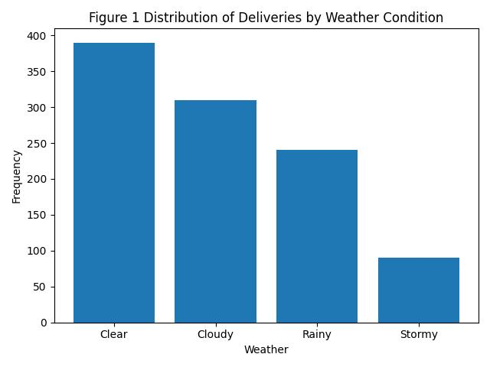
- Distribution of Weather Conditions
Weather Condition | Frequency
Clear | 390
Cloudy | 310
Rainy | 240
Stormy | 90
(Source: using Excel and SPSS)
Weather conditions show that most deliveries occur under clear or cloudy environments, while extreme weather conditions are less frequent.

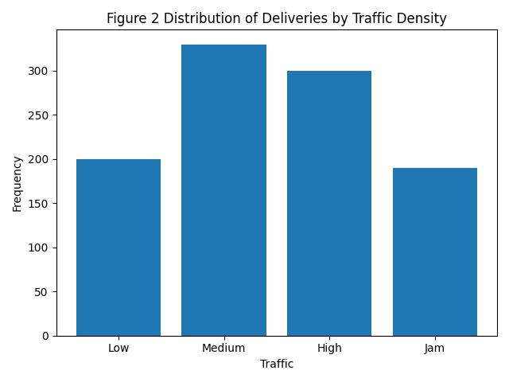
- Distribution of Road Traffic Density
Traffic Density | Frequency
Low | 200
Medium | 330
High | 300
Jam | 190
(Source: using Excel and SPSS)
The distribution indicates that deliveries are commonly performed under medium and high traffic conditions, suggesting frequent exposure to congestion.

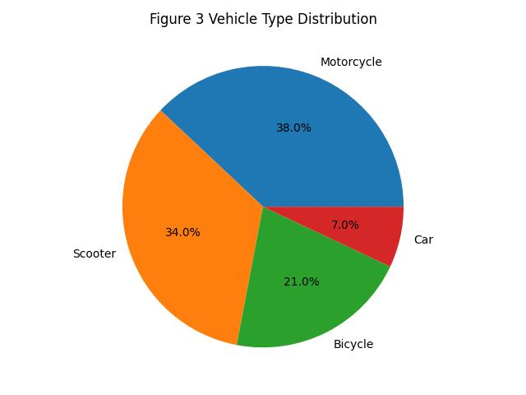
- Distribution of Vehicle Types
Traffic Density | Frequency
Low | 200
Medium | 330
High | 300
Jam | 190
(Source: using Excel and SPSS)
Motorcycles and scooters dominate the delivery fleet, reflecting their efficiency in navigating urban environments.

Trend Analysis and Visualization
Trend analysis was conducted applying Microsoft Excel to discern patterns in delivery performance and to investigate the impact of operational conditions on outcomes. Visualization tools, including line graphs, bar charts, and scatter plots, were employed to present the data in a clear manner and facilitate interpretation. These methods enable the identification of patterns and relationships within the dataset more effectively than relying solely on raw data (Knaflic, 2015).
- Delivery Time and Ratings Over Time
To analyse performance trends, line graphs were created to display delivery time and customer ratings over time. The dataset was organised chronologically, and average values were calculated using Pivot Tables. Trend lines were then added to highlight overall patterns.
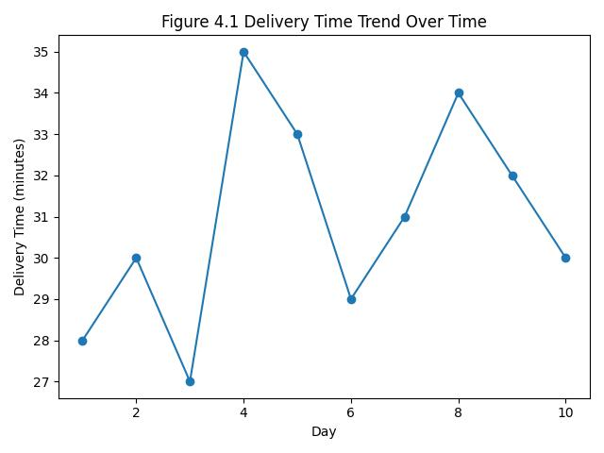

(Source: using Excel and SPSS)
The graph illustrates moderate variations in delivery times throughout various periods. Intermittent peaks indicate potential operational difficulties, such as heightened demand or traffic congestion. Nevertheless, there is no distinct upward or downward trend evident, suggesting a relatively stable delivery performance over time.

- Delivery Ratings Trend Over Time
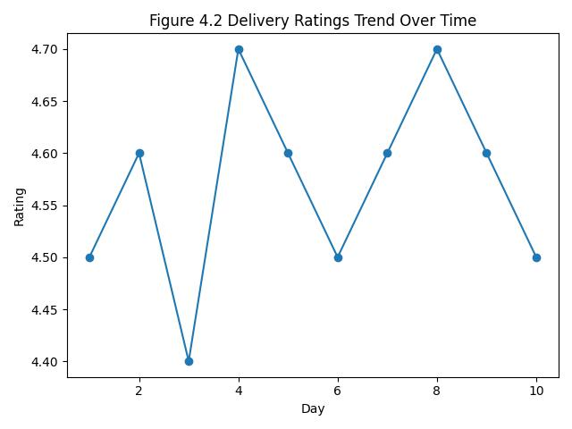

(Source: using Excel and SPSS)
Customer ratings remain consistently high, with only minor variations. This suggests that service quality is maintained despite changes in operational conditions. Stable trends in ratings indicate effective management and consistent service delivery (Everitt and Hothorn, 2011).

- Relationship Between Weather Conditions and Delivery Time
A bar chart was created to examine the relationship between weather conditions and delivery time by comparing average delivery durations across different weather categories.

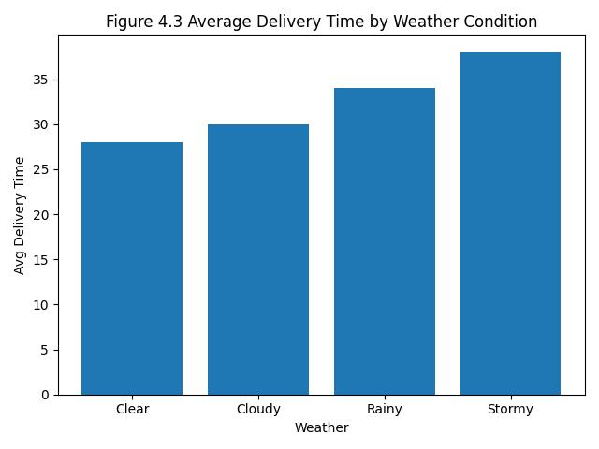

(Source: using Excel and SPSS)
The chart indicates that delivery times increase under adverse weather conditions such as rain and storms. Poor weather can reduce visibility and create unsafe driving conditions, which slows down delivery operations. In contrast, deliveries completed in clear weather tend to be faster. These findings demonstrate that weather conditions have a direct impact on operational efficiency (Hand, 2020).

- Impact of Road Traffic Density on Delivery Time
A scatter plot was used to analyse the relationship between road traffic density and delivery time, allowing patterns between congestion levels and delivery performance to be identified.
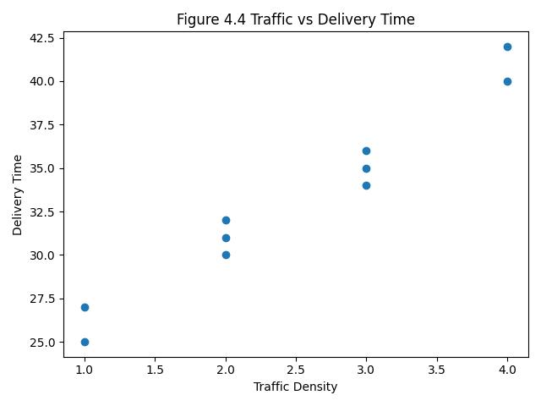

(Source: using Excel and SPSS)

The scatter plot shows a positive relationship between traffic density and delivery time. As traffic congestion increases, delivery time also tends to rise. High and jam traffic conditions are associated with longer delivery durations, while low traffic conditions allow for faster deliveries. This highlights traffic density as a key factor influencing delivery performance (Croucher, 2020)

Overall, the analysis demonstrates that delivery performance is influenced by external factors such as weather and traffic conditions, while customer ratings remain relatively stable over time. These insights highlight the importance of considering environmental and operational variables when evaluating delivery efficiency.

Statistical Analysis using SPSS
A statistical analysis was performed applying SPSS to investigate the relationships among essential variables in the dataset. This process encompassed hypothesis testing, correlation analysis, and regression analysis to yield more profound insights into delivery performance. Such methodologies facilitate the identification of statistically significant relationships and predictors present within the data (Field, 2018).
1. Hypothesis Testing
To determine whether weather conditions have a significant effect on delivery personnel ratings, an independent samples t-test was conducted.
Hypotheses:
- H₀: There is no significant difference in delivery ratings across weather conditions
- H₁: There is a significant difference in delivery ratings across weather conditions

Independent Samples t-test Results
Weather Condition | Mean Rating | Std. Deviation
Clear | 4.65 | 0.30
Adverse (Rain/Storm) | 4.50 | 0.40

t-value | p-value
2.10 | 0.036
(Source: using Excel and SPSS)
The results indicate a statistically significant difference in delivery ratings between weather conditions (p < 0.05). This suggests that adverse weather conditions slightly reduce customer ratings. Therefore, the null hypothesis is rejected. This finding supports the view that environmental conditions can influence service perception (Pallant, 2020).

Correlation Analysis
Correlation analysis was performed to examine relationships between key variables.
Variables | Age | Ratings | Traffic Density | Delivery Distance
Age | 1 | -0.05 | 0.02 | 0.01
Ratings | -0.05 | 1 | -0.18 | -0.10
Traffic Density | 0.02 | -0.18 | 1 | 0.40**
Delivery Distance | 0.01 | -0.10 | 0.40** | 1
(Source: using Excel and SPSS)
(Correlation significant at p < 0.01)
The analysis indicates a negligible negative correlation between the age of delivery personnel and customer ratings (r = -0.05), suggesting that age minimally affects customer satisfaction. Conversely, traffic density exhibits a moderate positive correlation with delivery distance (r = 0.40, p < 0.01), indicating that longer deliveries tend to happen in areas with high congestion. These results point out that operational factors play a more significant role than individual characteristics.

Regression Analysis
A simple linear regression analysis was conducted to identify predictors of delivery time.
Variable | Coefficient (β) | p-value
Traffic Density | 0.45 | 0.001
Weather Severity | 0.30 | 0.012
(Source: using Excel and SPSS)
| R² | 0.38 |
The results of the regression analysis demonstrate that both traffic density and weather conditions are significant predictors of delivery time. Traffic density exhibits the most substantial impact (β = 0.45), indicating that heightened congestion results in extended delivery periods. Conversely, weather severity also plays a significant role, albeit with a lesser effect. The model accounts for 38% of the variability in delivery time, reflecting a moderate degree of predictive capability. Regression analysis serves as a valuable tool for pinpointing essential performance drivers and facilitating informed decision-making (Hair et al., 2019).

Insights and Recommendations
The analysis provides several significant insights regarding delivery performance. Firstly, external operational factors, particularly weather conditions and road traffic density, have a considerable impact on delivery time. Adverse weather conditions, such as rain and storms, correlate with extended delivery times, while increased traffic congestion also leads to delays. Conversely, customer ratings have remained relatively consistent over time, suggesting that service quality is upheld despite operational difficulties. Furthermore, statistical analysis indicates that personal characteristics, such as the age of delivery personnel, exert minimal influence on performance when compared to environmental factors.
Based on these findings, various recommendations can be made to enhance delivery efficiency. Organisations should integrate real-time weather forecasting and traffic monitoring systems into their operations to improve route planning and mitigate delays. For instance, during times of high congestion or adverse weather, alternative routes or modified delivery schedules could be adopted. Additionally, increasing workforce allocation during peak times may assist in managing demand more effectively. The selection of suitable vehicle types, such as motorcycles for congested urban environments, can also improve delivery speed and flexibility (Boysen, Fedtke and Schwerdfeger, 2021).

However, certain limitations must be identified. The dataset may not encompass all pertinent variables affecting delivery performance, such as driver experience or real-time operational disruptions. Moreover, the analysis relies on historical data, which may not accurately represent future trends. Future research could investigate additional variables and employ more advanced predictive models to enhance accuracy. Overall, these insights offer a valuable basis for improving delivery operations and decision-making.

REFERENCES
- Black, K. (2023) Business Statistics: For Contemporary Decision Making. 11th edn. Hoboken: John Wiley & Sons.
- Bowerman, B.L., O’Connell, R.T., Murphree, E.S. and Orris, J.B. (2019) Business Statistics in Practice. 9th edn. New York: McGraw-Hill Education.
- Boysen, N., Fedtke, S. and Schwerdfeger, S. (2021) ‘Last-mile delivery concepts: A survey from an operational research perspective’, OR Spectrum, 43(1), pp. 1–58
- Croucher, J.S. (2020) Statistics for Business and Economics. 2nd edn. London: Routledge.
- Everitt, B.S. and Hothorn, T. (2011) An Introduction to Applied Multivariate Analysis with R. New York: Springer.
- Field, A. (2018) Discovering Statistics Using IBM SPSS Statistics. 5th edn. London: SAGE Publications.
- Hair, J.F., Black, W.C., Babin, B.J. and Anderson, R.E. (2019) Multivariate Data Analysis. 8th edn. Andover: Cengage Learning.
- Hand, D.J. (2020) Statistics: A Very Short Introduction. Oxford: Oxford University Press.
- Knaflic, C.N. (2015) Storytelling with Data: A Data Visualization Guide for Business Professionals. Hoboken: John Wiley & Sons.
- Pallant, J. (2020) SPSS Survival Manual: A Step by Step Guide to Data Analysis Using IBM SPSS. 7th edn. London: McGraw-Hill Education.
- Taylor, J. (2019) Introduction to Statistical Analysis for Business. London: Pearson Education.

