

Evaluating the Feasibility of a Holistic Yoga and Well-being Business in the UK: A Business Development Proposal for Sudha Yoga Journey



- Programme of Study: Master of Business Administration
- Name and Student ID: Yordanka Kancheva, 2017633
- Supervisor: Masud Ibrahim

Declaration

I, Yordanka Kancheva, declare that this Business Development Proposal has been composed by me, that the work contained herein is entirely my own except where explicitly stated otherwise in the text, and that this work has not been submitted for any other degree or qualification, in whole or in part, except as specified.

Signature: Yordanka Kancheva
Date: 1 May 2026

Acknowledgements

I would like to thank the University of Wales Trinity Saint David and the academic staff involved in the MBA programme for their guidance and support throughout my studies. I am also grateful to my family and close friends for their encouragement during this period, as well as to everyone who has supported the development of Sudha Yoga Journey.

Table of Contents

Declaration 2
Acknowledgements 2
List of Tables and Figures 4
1. Executive Summary 6
2. Company description 8
2.1 Business Overview 8
2.2 An overview of the founder’s profile 8
2.3 Business Concept 9
Market Context and Rationale for Sudha Yoga Journey 10
Target Market and Customer Profile 11
Value Proposition and Value Creation Strategy 12
Core Service Offering and Supporting Activities 13
Growth Strategy and Phased Development 14
2.4 Vision 15
2.5 Mission 16
2.6 Value Proposition 16
3. Market Research and Concept Validation 17
3.1 UK Market Context and Well-being Sector Trends 17
3.2 Customer Needs and Target Market Relevance 19
3.3 Existing UK Yoga Provision and Market Gap 21
3.4 Strategic market assessment: PESTEL, Porter’s Five Forces and SWOT analysis 23
3.5 Justification and Feasibility of Sudha Yoga Journey 27
4. Business Model Canvas and Operating Model for Sudha Yoga Journey 30
4.1 Key Partnerships and Support Network for Sudha Yoga Journey 31
4.2 Key Activities Required to Deliver Sudha Yoga Journey 33
4.3 Value Proposition and Customer Benefits 34
4.4 Customer Relationships and Community Engagement Strategy 35
4.5 Customer Segments and Target Users for Sudha Yoga Journey 36
4.6 Key Resources Supporting Sudha Yoga Journey 37
4.7 Channels for Reaching and Serving Customers 39
4.8 Cost Structure and Resource Requirements for Sudha Yoga Journey 40
4.9 Revenue Streams and Financial Sustainability 42
5. Marketing and Sales Strategy 45
5.1 Segmentation, Targeting and Market Entry Focus 45
5.2 Marketing Channels and Performance Measures 47
5.3 Marketing Mix Strategy 48
5.4 Sales Process and Early Performance Targets 49
6. Operations Plan for Sudha Yoga Journey 50
6.1 Operational Model and Weekly Delivery Plan 50
6.2 Service Delivery Process 51
6.3 Resources, Equipment and Venue Requirements 52
6.4 Administration, Payment Systems and Digital Support 53
6.5 Health, Safety, Insurance and Scope of Practice 54
6.6 Quality Control and Operational Development 55
7. Human Resources, Skills and Role Allocation 56
8. Financial Plan for Sudha Yoga Journey 58
8.1 Financial Assumptions and Funding Strategy 58
8.2 Pre-trading, Start-Up and Operating Cost Requirements 59
8.3 Revenue Projections and 12-Month Cash-Flow Forecast 60
8.4 Monthly Break-Even Analysis and Financial Viability 61
9. Risk Analysis and Mitigation Strategy 63
10. Implementation Plan for Sudha Yoga Journey 65
11. List of References 67
12. Appendices 75

List of Tables and Figures

List of Tables | Page
Table 3.1: PESTEL Analysis for Sudha Yoga Journey | 23
Table 3.2: Porter’s Five Forces Analysis for Sudha Yoga Journey | 25
Table 3.3: SWOT Analysis for Sudha Yoga Journey | 26
Table 5.1: STP Market-Entry Focus for Sudha Yoga Journey | 46
Table 5.2: Route-to-Market Channels and Control Measures | 47
Table 5.3: Marketing Mix Decisions for Sudha Yoga Journey | 48
Table 5.4: Sales Process and Early Performance Targets | 49
Table 8.1: Summary of Start-Up and Operating Cost Requirements | 59
Table 8.2: Summary of 12-Month Cash-Flow Forecast | 60
Table 8.3: Monthly Cash-Flow Break-Even Position, January–December 2026 | 62
Table 9.1: Risk Register and Mitigation Plan for Sudha Yoga Journey | 64
Table 10.1: Year 1 Implementation Plan for Sudha Yoga Journey | 65
Table A1: Summary of Publicly Available Online Information on Local Yoga and Well-being Providers | 75
List of Figures | Page
Figure 4.1: Business Model Canvas for Sudha Yoga Journey | 31
Figure B1: Yoga Siromani Teacher Training Certificate, Sivananda Yoga Vedanta Centre, 2025 | 79
Figure B2: Bareface Yoga Level 1 Certificate, 2026 | 80
Figure B3: Asana Intelligence CPD Certificate, 2026 | 80
Figure B4: Vinyasa Krama CPD Certificate, 2026 | 81
Figure B5: Yoga Alliance Professionals Teacher Profile Overview | 82
Figure B6: Yoga Alliance Professionals Review Evidence, Page 1 | 83
Figure B7: Yoga Alliance Professionals Review Evidence, Page 2 | 84
Figure B8: Yoga Alliance Professionals Review Evidence, Page 3 | 85
Figure B9: Sivananda Spiritual Name Evidence for “Sudha” | 86
Figure B10: Yoga Alliance Professionals Certified Yoga Teacher Badge | 86
Figure B11: Sudha Yoga Journey Logo and Brand Identity | 86
Figure C1: 12-Month Cash-Flow Forecast for Sudha Yoga Journey, January-December 2026 | 87
Figure C2: Expense Records for Sudha Yoga Journey, January-April 2026 | 88
Figure C3: Actual Income and Expense Dashboard for Sudha Yoga Journey, January-April 2026 | 89
Figure C4: Income Payment Records for Sudha Yoga Journey, January-April 2026 | 89
Figure C5: Monthly Income, Expense and Attendance Summary, January–April 2026 | 90

1. Executive Summary

This Business Development Proposal evaluates the feasibility of Sudha Yoga Journey, a founder-led holistic yoga and well-being micro-business operating in the UK through rented venues. The business currently offers gentle Hatha yoga, guided relaxation, meditation and complementary face yoga workshops. It is positioned as an accessible, beginner-safe alternative to performance-led yoga, designed for adults seeking stress reduction, emotional balance, physical ease and a welcoming class environment rather than high-intensity fitness delivery.
The proposal finds that the concept is timely and relevant. UK evidence indicates growing demand for physical and mental well-being support, while cost, discomfort, low confidence and fear of judgement continue to limit participation in mainstream activity settings. The primary target market is adults, especially women aged around 30-60, beginners and mixed-ability participants who value gentle movement, reassurance and sustainable self-care, which is consistent with UK yoga participation evidence showing strong engagement among women and midlife practitioners. A secondary opportunity exists within the Bulgarian-speaking community and among local adults who prefer trust-based, community-oriented practice.
Market research shows that yoga provision in the UK and East Midlands is active but fragmented. The opportunity for Sudha Yoga Journey is therefore not based on the absence of yoga, but on differentiation: a calm, holistic and supportive service model with stronger emphasis on breathwork, relaxation, personal attention, clear communication and emotional safety for hesitant beginners. The Business Model Canvas supports this positioning through a low-fixed-cost model built around founder-led delivery, rented venues, direct customer relationships, word of mouth, simple digital channels and phased development.
Early traction supports the feasibility case. The business has been delivering classes since January 2026, with attendance usually around 7-11 participants and a wider pool of expressed interest. Credibility is also strengthened by the founder’s professional yoga training, Yoga Alliance Professionals profile and 14 positive client reviews. Operationally, the venture is feasible at micro-business scale if systems are strengthened gradually through written intake forms, clearer booking and payment routines, improved tracking, minimum viable digital infrastructure and limited online delivery.
Financially, the proposal adopts a cautious cash-flow-led feasibility test. The 12-month forecast combines actual January-April 2026 trading evidence with conservative May-December projections. It estimates total projected trading income of £6,621, operating outflows of £4,231.69 and a positive year-end cash position of £2,389.31 before the potential £500 university start-up grant. Break-even analysis suggests that regular operating costs can be covered at approximately £281.24 per month, equivalent to around 29 participant attendances per month, or 7-8 participants per weekly class at £10. The model remains viable but sensitive to attendance levels, venue costs and one-off development expenditure.
The main risks are attendance fluctuation, cash-flow pressure, venue dependence, founder capacity, health and safety, reputational expectations and scope-of-practice boundaries. These risks are manageable through flexible venue use, clear communication, insurance, participant screening, monthly monitoring, careful cost control and qualification-led expansion. Growth is therefore evidence-led: Derby expansion, additional sessions, online activity and future studio exploration should proceed only where demand, repeat participation, cash-flow and founder capacity justify further commitments.
Overall, the proposal concludes that Sudha Yoga Journey is a feasible and credible early-stage venture if developed through disciplined, evidence-led growth. Its strongest potential lies in combining traditional yoga training, lived understanding of stress, accessible teaching, community trust and a phased hybrid model that protects financial sustainability while allowing the brand to grow carefully over time.

2. Company description

2.1 Business Overview

Sudha Yoga Journey is a UK-based holistic well-being business that currently operates on a micro-scale through rented venues since January 2026. It offers yoga and complementary well-being services rooted in traditional yoga philosophy and is adapted to contemporary lifestyle and workplace needs. The business provides structured, accessible practices in a safe, welcoming environment. The current offer centres on gentle Hatha yoga classes and complementary face yoga workshops as an accessible entry point into holistic well-being practice. This positioning is particularly relevant in a context of rising stress, digitalisation and changing routines, which are increasing demand for supportive well-being practices (Akbar et al., 2025). In the longer term, the business is intended to develop into a broader hybrid well-being brand through phased service development and carefully selected extensions.

2.2 An overview of the founder’s profile

Sudha Yoga Journey was founded by Yordanka Kancheva, a certified yoga teacher whose professional direction has developed through formal training, personal practice, lived experience and ongoing business study. She completed her Yoga Teacher Training Course (Yoga Siromani) at the Sivananda Yoga Vedanta Centre in Austria. This training is relevant because the Sivananda tradition forms part of the wider transnational development of modern yoga while retaining recognisable links to disciplined practice, philosophical grounding and integrated daily living (Newcombe, 2009). Swami Sivananda’s teaching of the “Yoga of Synthesis” is also important to the business because it presents yoga as a balanced and integrated practice, rather than reducing it to physical exercise alone (Divya Jeevan, 2018).
The business was not developed only from professional interest, but also from personal experience. Before moving into yoga teaching, Yordanka Kancheva worked in demanding operational roles, including line leadership, which gave her direct experience of pressure, workload intensity and the cumulative effects of stress in everyday working life. Over time, this helped shape a clearer understanding of how easily modern routines can lead people away from balance, rest and connection with themselves. Her move towards yoga and well-being, therefore, developed not as a sudden career change, but as a gradual and meaningful change in direction informed by both lived experience and practice.
During her time in the ashram, she was given the spiritual name “Sudha”, meaning “nectar” or “essence” in Sanskrit. This was later incorporated into the business identity. The word “Journey” was chosen deliberately to reflect well-being as an ongoing process of growth and self-development rather than a quick result or one-off intervention. This interpretation is consistent with Lear’s discussion of personal transformation as an emergent process shaped through lived experience and growth over time (Lear, 2016).
This background now informs the founder’s approach to teaching and business development. As a woman with lived understanding of stress, responsibility and midlife transitions, she brings a perspective that is both practical and relatable. This is reflected in a teaching style that values calm, encouragement, accessibility and gradual progress, particularly for those who may feel overwhelmed, underconfident or disconnected from their own well-being.
In addition to her yoga teaching qualification, she has completed Bareface Yoga Level 1 and continues her professional development through planned study in Bareface Yoga Level 2 and yoga mudras. She is also completing a Master of Business Administration at the University of Wales Trinity Saint David, which strengthens the venture through strategic planning, business development and a more structured approach to sustainable growth.
Overall, the founder profile combines tradition-informed yoga training, lived understanding of modern stress and ongoing business development. This supports Sudha Yoga Journey as a credible, grounded and personally meaningful well-being venture.
Supporting evidence of the founder’s yoga teacher training, additional CPD and the origin of the name “Sudha” is provided in Appendix B, Figures B1-B4 and Figure B9.

2.3 Business Concept

Sudha Yoga Journey is an early-stage holistic well-being micro-business in the United Kingdom offering structured yoga-based services designed to support physical, mental, and emotional well-being. The concept positions yoga not as a conventional fitness service, but as a practical and accessible well-being system that brings together movement, breath regulation and guided rest in a way that can be integrated into everyday life. This broader understanding is relevant because wellness is increasingly seen as multidimensional, extending beyond the absence of illness and encompassing physical, mental, and wider balance (Kumar, Gupta, and Joshi, 2025).

Market Context and Rationale for Sudha Yoga Journey

UK sector evidence indicates that consumer demand is increasing as physical and mental well-being become more important (UKactive, Sport England and 4GLOBAL, 2025).
However, the same evidence shows that non-members still face major barriers to participation: cost is the biggest hurdle, and many also report feeling uncomfortable, lacking confidence, and fearing negative judgment in mainstream gym environments (UKactive, Sport England and 4GLOBAL, 2025).
Sudha Yoga Journey is therefore timely because it is explicitly designed to reduce these barriers through a gentle, beginner-safe format and a welcoming delivery style, positioning well-being as accessible rather than intimidating (UKactive, Sport England and 4GLOBAL, 2025).
In parallel, future-of-work literature highlights that digital technologies are linked with longer screen-time, blurred work–family boundaries and reskilling/upskilling pressures, with associated stress and well-being challenges for many workers (Abe, 2021).
Also, UK consumer evidence suggests that home-based and away-from-home exercise complement rather than replace one another, supporting the longer-term relevance of a staged hybrid delivery pathway - in-person first, then digitally supported practice (UKactive, Sport England and 4GLOBAL, 2025).
Finally, as a wider academic anchor, modern yoga scholarship notes that yoga in Western contexts is commonly associated with posture-based practice (asana) while still carrying diverse well-being-related meanings, making accessible postural yoga a culturally recognisable, market-ready format (Newcombe, 2009).

Target Market and Customer Profile

Sudha Yoga Journey is aimed primarily at women aged around 30 to 60, while remaining open to other adults where this suits the group format and teaching environment. This focus is consistent with UK survey evidence showing that yoga practitioners are predominantly women and that the average age of respondents is 48.7 years, which suggests strong engagement among midlife women in the UK yoga population (Cartwright et al., 2020).
The main target users are beginners and mixed-ability adults who are living under stress and pressure and are looking for a gentler, more sustainable form of well-being practice than mainstream fitness settings often provide. They are not primarily seeking intense cardio-based exercise, but moderate physical movement combined with relaxation, emotional release, and relief from everyday demands. UK evidence suggests that yoga participation commonly includes postures, breathing practices, relaxation, and meditation, and that motivations often include stress management and health-related benefits (Cartwright et al., 2020). This includes people experiencing the effects of sedentary and digitally mediated routines, such as stiffness, back pain, neck discomfort, fatigue, and physical inactivity. Future-of-work literature highlights how prolonged digital technology use, longer screen time and boundary blurring are increasingly shaping stress and well-being challenges in contemporary work (Abe, 2021). Workplace-based evidence also supports the relevance of yoga for musculoskeletal issues, including back pain and work-related discomfort (Hartfiel et al., 2017). The concept is also relevant to adults whose fast-paced routines leave little space for rest, self-awareness and regular self-care.
In the current UK market, physical and mental well-being are becoming increasingly important drivers of participation, while discomfort and low confidence remain common barriers for non-members of gyms and leisure facilities (UKactive, Sport England and 4GLOBAL, 2025). Sudha Yoga Journey is therefore designed for people who may feel hesitant or underconfident in performance-driven environments and who are more likely to respond to calm, supportive and community-based practice.
A secondary target group includes members of the Bulgarian community in the UK, particularly women who may value culturally familiar communication, trust and a stronger sense of personal connection within a group setting. These users are likely to be drawn to Sudha Yoga Journey because the offer is built around individual attention, practices adapted to specific needs, and a teaching approach that values encouragement, trust and gradual progress. This is particularly important for adults who need motivation and reassurance rather than pressure or intensity. Group exercise research supports this emphasis, showing that instructor encouragement and perceived competence are associated with higher intrinsic satisfaction in exercise classes (Maher, Gottschall and Conroy, 2015).
In this sense, the business is not primarily aimed at advanced or performance-focused practitioners, but at people seeking a realistic and holistic way to reconnect with their bodies, reduce stress and build well-being into everyday life. Modern yoga scholarship supports this positioning by showing that yoga in Western contexts is often valued for its practical health and well-being benefits, alongside the wider personal meanings practitioners attach to it (Newcombe, 2009).

Value Proposition and Value Creation Strategy

The value of Sudha Yoga Journey lies not only in what is taught, but in how people feel during and after the class. The offer is designed so participants leave with a greater sense of calm and physical ease, rather than feeling pushed or overwhelmed, consistent with UK yoga practice evidence that yoga commonly combines postures with breathwork, relaxation and meditation and is frequently used for stress management and well-being (Cartwright et al., 2020).
This is created through a supportive teaching style that includes clear explanation, a slower pace, practical adaptations, individual attention and encouragement throughout the session. Group exercise research indicates that instructor encouragement and perceived competence are associated with higher intrinsic satisfaction in exercise classes, and that social climate factors such as cohesion are linked to enjoyment and ultimately adherence, supporting the focus on encouragement and progressive, confidence-building delivery (Maher, Gottschall and Conroy, 2015).
The aim is to make the class feel safe, welcoming and manageable, especially for people who may be new to yoga or returning to practice after a long break. Trust, atmosphere and personal attention are therefore treated as core value drivers, while regular scheduling, group familiarity and gradual progress are used to support longer-term engagement, consistent with evidence that perceived class cohesion and supportive instructor style contribute to positive class experience and satisfaction over time (Maher, Gottschall and Conroy, 2015).
At this stage, the business generates income mainly through class fees and workshop fees, with the option to support participation further through single-session access, introductory offers and small package structures. This pricing flexibility is strategically relevant in a UK context where cost is identified as the largest barrier to gym/leisure membership among non-members, supporting the rationale for entry-level offers that reduce the initial participation hurdle (UKactive, Sport England and 4GLOBAL, 2025).

Core Service Offering and Supporting Activities

At the current stage, Sudha Yoga Journey offers gentle Hatha yoga classes structured around asana, pranayama, guided relaxation and meditation (Cartwright et al., 2020).
The service is designed as an accessible and supportive well-being format, with attention given not only to the content of the practice but also to how it is presented and experienced. Research on yoga studio communication suggests that class type, duration, cost, teacher qualifications, and the overall feel and intention of the space are all relevant to how offerings are understood by potential participants, while studio representatives also emphasise the importance of building relationships and helping people feel comfortable in the space (Dysart, Barnett and Harden, 2023).
Alongside the core classes, the complementary offer includes face yoga workshops positioned as a self-care practice, with claims framed cautiously given variability and limited standardisation across the literature (Balwani, Choudhari and Wasu, 2020; Śleboda, 2025).
Selected sessions may also incorporate introductory mudra practice and simple sound-based elements as supportive components of the overall class environment. Recent review literature suggests that hasta mudras may be understood as embodied practices linked to attention, emotional regulation and wider psychophysiological processes, although direct evidence on isolated mudra practice remains limited and much of the available research examines mudras alongside broader yogic techniques (Bhoomika et al., 2026).
Where appropriate, selected sessions may draw on simple sound-based elements such as bowl, bell or chime tones as part of the relaxation atmosphere. This is positioned cautiously and non-clinically. Recent sound-based meditation research suggests possible benefits for relaxation, stress reduction and psychological well-being, but the evidence base is still developing and should not be overstated (Ravikumar and Sathyanarayanan, 2025). In addition, scholarship on so-called “Tibetan singing bowls” highlights that many of the spiritual-historical claims surrounding them are modern constructions rather than straightforward ancient continuities, so in this business context, such instruments are more appropriately framed as supportive sensory or meditative tools rather than as culturally absolute or medically validated healing devices (Brown, 2020).
The service model also allows for a gradual hybrid extension over time. Evidence from yoga studio research suggests that online and streamed formats can widen access, support participation from people who may feel more comfortable practising at home and help studios adapt their delivery model as needs change (Wadhen and Cartwright, 2021). For this reason, the current offer is intentionally focused but flexible, with scope for later development into broader complementary well-being formats as the business grows.

Growth Strategy and Phased Development

Sudha Yoga Journey is designed to scale through phased, evidence-led development rather than immediate fixed-cost expansion. This reflects scale-up literature, which emphasises alignment between value proposition, value creation, operational capability and strategic direction (Panigrahi, Nikou and Calabretta, 2025). Decisions across phases will be guided by actionable indicators and the main constraint at each stage, consistent with lean scale-up thinking (Maurya, 2016).
The first phase is delivery through rented community venues. This allows the business to stabilise the existing Nottingham class, test Derby-based demand, refine the class format, build a regular participant base and strengthen trust before committing to higher fixed costs. The focus is on proving traction and learning what works before expanding infrastructure (Maurya, 2016).
The second phase is basic digital infrastructure and limited online delivery. This includes a simple website or landing page, clearer booking and payment routines, and trial online sessions where demand and founder capacity allow. Online delivery is intended to extend access, flexibility and continuity rather than replace in-person teaching. Research suggests that online and streamed yoga can widen access and support people who prefer practising at home (Wadhen and Cartwright, 2021), while UK fitness evidence indicates that home-based and facility-based exercise increasingly complement rather than replace one another (UKactive, Sport England and 4GLOBAL, 2025).
The third phase is the strengthening of the hybrid model once demand, repeat participation, operational systems and cash-flow evidence support further development. This may include stronger online delivery, digital resources, additional workshops and a more consistent mix of local and online participation. In scale-up terms, this represents a move from early validation to capacity-building before larger commitments are considered (Panigrahi, Nikou and Calabretta, 2025).
A dedicated studio space is therefore treated as a later strategic option rather than an immediate expansion step. It would only be explored once attendance, retention, financial viability, venue-cost comparison and founder capacity show that fixed premises would be sustainable. Later complementary services, workshops and products would also need to remain consistent with the core concept and be supported by further qualifications, professional standards and regulatory considerations. This is particularly important for yoga therapy, Ayurveda or bodywork-related services, where educational standards, self-regulatory structures and clear professional boundaries are linked to safe practice and public credibility (Seitz, 2010).
Overall, the growth model moves from low-risk venue-based validation to basic digital and online development, to a stronger hybrid model, and only later to possible studio exploration and selective service expansion.

2.4 Vision

The vision of Sudha Yoga Journey is to become a trusted hybrid well-being brand that helps people build calmer, more confident and more sustainable lives through yoga‑based practice. Over time, the business aims to foster a supportive environment for personal growth, community connection and holistic self‑care, encouraging continued development through both local and accessible online practice.

2.5 Mission

The mission of Sudha Yoga Journey is to help people cultivate calm, confidence and sustainable self-care through accessible, structured and supportive yoga-based practices. The business does this through safe, inclusive and progressively guided sessions that make regular practice feel welcoming and manageable, while maintaining clear boundaries and a high-quality participant experience. A further part of the mission is to inspire and encourage people to take an active role in their own health and self-care, building trust, motivation and long-term engagement through a positive, supportive environment and ongoing professional development.

2.6 Value Proposition

Sudha Yoga Journey offers a gentle, tradition-informed alternative to performance-led yoga by creating a safe and realistic entry point for adults who want regular practice without pressure, intensity or intimidation. Its distinctive value lies in helping participants move from hesitation to confidence through structured guidance, gradual progress and a practice experience that feels manageable within everyday life. Rather than presenting yoga as fitness performance, the business offers a sustainable pathway towards calm, balance and ongoing self-care.

3. Market Research and Concept Validation

3.1 UK Market Context and Well-being Sector Trends

Academic literature suggests that yoga now operates within a broader contemporary well-being economy and should be understood not only as a traditional practice, but also as a modern cultural and commercial phenomenon. Mora, Berry and Salen (2018) suggest that yoga is increasingly positioned as a well-being experience associated not only with physical practice, but also with personal development, balance and self-improvement, while Yoga in the Modern World describes yoga as “a thoroughly globalised phenomenon” practised across diverse settings, including homes, workplaces, schools, gyms, yoga studios and temples. In the UK specifically, Gemar (2020) suggests that yoga has become increasingly culturally visible and socially significant as part of an emerging landscape of lifestyle and self-care practices rather than remaining confined to specialist spiritual environments. This is important for market context because it suggests that yoga is no longer peripheral; rather, it has become a recognisable and legitimate form of contemporary lifestyle consumption.
Wider sector evidence also points to favourable conditions for paid wellness services in the UK. The UK Health & Fitness Market Report 2025 describes a resilient and expanding market, with growing membership, rising total income, and increasing consumer demand as physical and mental health become more important in everyday life. Although this report relates to the broader health and fitness sector rather than yoga specifically, it is useful in establishing the wider market context in which yoga businesses now operate.
A particularly relevant source for understanding the UK yoga sector is Cartwright et al. (2020), whose large cross-sectional survey of 2,434 UK yoga practitioners provides insight into who practises yoga, how they practise it and why. Their findings suggest that yoga in the UK is already supported by a substantial and active participant base. Respondents were predominantly women, mostly white and highly educated, with a mean age of 48.7 years, indicating that yoga in the UK has a relatively identifiable demographic core. The same study also found that general wellness and fitness were among the most common initial motivations for taking up yoga, while ongoing participation increasingly reflected stress management and spirituality. This suggests a market in which yoga begins for many people as a health or lifestyle activity but often develops into a broader well-being practice over time.
The survey also highlights important structural characteristics of current provision. A wide range of yoga styles were reported, but Hatha, Iyengar and Vinyasa were among the most practised, and the most popular venues included yoga studios, community halls and gyms, alongside home practice using online resources. Average monthly spending on classes and workshops was also reported, indicating that yoga in the UK already functions through a mixed but normalised paid participation model. This is especially relevant for the proposed venture, because it shows that consumers are accustomed to accessing yoga through a combination of local, studio-based, community-based and increasingly flexible formats.
A further important sector trend is the growing alignment between yoga and health-related discourse. Smit and Cartwright (2023) note that yoga is increasingly discussed within healthcare settings as a health-supportive practice and that there is growing interest in its use for a range of health conditions. Their study of UK healthcare practitioners indicates that yoga is gradually moving closer to mainstream health conversations, even if formal integration remains incomplete. This does not mean yoga has become a medical service, but it does suggest that the sector is benefiting from increased professional legitimacy, especially in relation to prevention, self-management and holistic well-being.
This pattern is also consistent with wider evidence on complementary and well
being-related service use in England. Sharp et al. (2018) found that practitioner-led complementary medicine use was commonly self-referred and self-financed, suggesting that private-pay engagement with health-supportive services is already normalised beyond yoga alone. This is relevant because it supports the commercial plausibility of a yoga and well-
being venture operating within a self-funded participation model.
Overall, the literature suggests that growing cultural legitimacy, an established private-pay participation model, a recognisable user base, and a widening association with both lifestyle well-being and health support characterise the UK yoga market. For the proposed venture, this indicates entry into a market that is already familiar to consumers, but still open to differentiation in terms of style, values, delivery and positioning.

3.2 Customer Needs and Target Market Relevance

Customer needs in the proposed market are best understood not as a generic desire for exercise, but as a demand for support with stress regulation, emotional well-being, sleep, confidence and musculoskeletal discomfort. In the first comprehensive UK survey of yoga practice, Cartwright et al. (2020) found that the principal initial reasons for taking up yoga were general wellness (39%), fitness (19%) and flexibility (8.5%), while 16% of participants reported starting yoga specifically to manage a physical or mental health condition. Almost half (47%) also reported that their motivation changed over time, most notably towards spirituality (21%) and stress management (18%). This suggests that yoga is often adopted through a practical well-being need and then retained because it offers broader psychological and lifestyle value. For Sudha Yoga Journey, this supports a business concept centred on holistic well-being, stress reduction and sustainable self-care rather than fitness-only delivery.
The same study indicates that the most valued outcomes are closely aligned with the proposed service concept. Participants reported yoga as helpful for stress (98.4%), anxiety (96.8%), depression (93.2%), neck and shoulder pain (91.7%), arthritis (87.0%) and sleep issues (79.0%). They also reported perceived improvements in physical health (88%), mental health (86.2%), stress levels (82.6%), strength (87.1%), flexibility (91.6%) and sleep (57.4%). These findings suggest that customer need is concentrated around regulation, restoration and body-mind support, rather than high-intensity training alone. For Sudha Yoga Journey, this provides strong justification for an offer built around calming practice, breath awareness, mobility, relaxation and accessible support for everyday self-care.
Wider UK consumer evidence reinforces the commercial relevance of this positioning by showing that uptake of paid activity services is constrained not only by cost, but also by confidence and emotional comfort. The UK Health & Fitness Market Report 2025 found that, among non-members, 68% identified cost as a barrier, 47% said they would feel uncomfortable at the thought of joining a gym or leisure facility, 44% lacked confidence, and 32% felt they would be negatively judged. At the same time, the strongest motivations for membership were improving or maintaining physical strength and fitness (83%), improving mental health and well-being (76%), improving overall confidence (75%), improving sleep (68%), and managing a short- or long-term health condition (56%). For Sudha Yoga Journey, this is especially important because it indicates that customers are not only seeking positive outcomes but are also avoiding intimidating environments. This strengthens the rationale for positioning the business as a gentle, confidence-building and explicitly non-intimidating entry point into well-being participation.
Customer demand for yoga as self-care aligns with wider English evidence that people commonly self-refer to, and self-fund, well-being support for musculoskeletal and mental health needs (see Section 3.1). This reinforces the commercial plausibility of Sudha Yoga Journey operating within a private-pay model while remaining accessible.
Research on yoga participation barriers also clarifies what kind of service design is needed for such customers. Spadola et al. (2017) found that barriers to yoga engagement included fear of injury, low self-efficacy, perceptions that yoga lacks physical relevance, preference for other activities, and scheduling difficulties. Facilitators included beginner-level classes, supportive and relatable instructors, individualised instruction, stress-reduction messaging, and clear descriptions of what to expect before attending. Although this study is US-based and should not be treated as evidence of UK prevalence, it offers highly transferable design insights for hesitant or underserved groups. For Sudha Yoga Journey, the implication is that onboarding, reassurance, beginner-sensitive progression, clear class descriptions and flexible scheduling should be treated as core components of the offer rather than operational details.
Evidence from group exercise research also helps explain how participation may be sustained once customers attend. Maher, Gottschall and Conroy (2015) found that intrinsic satisfaction in group exercise classes was higher when participants felt more involved in the group task, experienced greater feelings of competence, and received stronger encouragement from the instructor. The authors conclude that the social and motivational characteristics of classes contribute to intrinsic satisfaction and may improve adherence. Although this is not a yoga-specific study, it is highly relevant for the business plan because it provides a behavioural explanation for retention: customers are more likely to continue attending when the class environment helps them feel capable, supported and positively guided. For Sudha Yoga Journey, this supports a service model in which teaching style, pace, encouragement and emotional safety are central to customer value and repeat attendance.
Taken together, the evidence suggests that the most relevant initial market for Sudha Yoga Journey is not defined only by who already practises yoga, but by what customers are trying to solve: stress, low confidence, poor sleep, emotional overload, physical tension and a desire for more sustainable well-being practices. The literature also shows that these customers may be blocked by cost, discomfort, uncertainty and fear of judgment. This means that customer relevance lies not simply in offering yoga, but in offering it differently: through welcoming entry points, supportive instruction, clear communication, beginner-safe progression and a realistic self-funded model. In this sense, the evidence does not merely justify the existence of the venture; it justifies the distinctive way in which Sudha Yoga Journey should be designed and delivered.

3.3 Existing UK Yoga Provision and Market Gap

Because this BDP relies on secondary research rather than primary fieldwork, existing provision is considered through sector evidence and a supplementary review of publicly available online information from local yoga and well-being providers. The purpose is not to suggest that yoga provision is absent, but to identify what appears to characterise current provision and where meaningful gaps remain for Sudha Yoga Journey.
Existing UK evidence indicates that yoga is already available through multiple forms of provision, including studio-based, community-based, one-to-one, therapeutic and home-supported formats (Cartwright et al., 2020; Wadhen and Cartwright, 2021). Hybrid and online delivery also appear viable in the UK context, as an online-streamed yoga intervention for people working from home showed high acceptability and improvements in perceived stress and mental well-being (Wadhen and Cartwright, 2021). Therefore, the competitive issue is not whether yoga exists, but what kind of yoga is offered, how it is accessed, and how clearly it is communicated to prospective participants.
A review of publicly available online information from local providers also supports this conclusion. As summarised in Appendix A, Table A1 provision across Derby, Nottingham, and the wider East Midlands area includes broader health and fitness facilities, specialist hot yoga studios, Pilates and reformer studios, maternity-focused well-being services, yoga and meditation studios, community-based yoga providers, independent hybrid teachers, and holistic spaces offering yoga, breathwork or Ayurveda. This indicates that the local market is active but fragmented across different models. Within the reviewed sample, directly comparable provision to Sudha Yoga Journey appears limited, particularly where the proposed model combines gentle Hatha yoga, breath awareness, relaxation, beginner-friendly teaching, community-based delivery and low-overhead rented venues.
The academic evidence also indicates several gaps in current provision. In the UK survey sample reported by Cartwright et al. (2020), yoga practice remained weighted towards a predominantly postural model: 64.6% of practice time was spent on physical postures, compared with 13.1% on breathwork, 12.0% on relaxation and 8.6% on meditation. This suggests an emphasis gap, where Sudha Yoga Journey can differentiate itself by giving greater space to breath awareness, relaxation, reflective practice and a broader holistic ethos, rather than relying mainly on asana-led delivery.
A second gap relates to accessibility and belonging. Brown (2024) suggests that yoga participation in high-income countries remains concentrated within a relatively narrow and privileged demographic, with access shaped by factors such as venue, discomfort, image, spirituality and the challenge of finding the “right class” and “right teacher.” This is relevant to Sudha Yoga Journey because the opportunity lies partly in reducing intimidation and increasing emotional safety for hesitant beginners, rather than simply adding another class to the market.
Further gaps relate to signposting, trust and referral-adjacent well-being support. Smit and Cartwright (2023) found that UK healthcare practitioners were generally open to recommending yoga, but barriers included lack of opportunity, lack of referral pathways and insufficient information about where patients could access appropriate and affordable instruction. Dysart et al. (2023) similarly found that yoga studio websites commonly provide class type, duration and cost, but instructor biographies did not always include sufficient detail on training or specialist expertise. For hesitant beginners and referral-adjacent users, clearer class descriptions, visible teacher credentials and explicit reassurance about suitability can therefore become meaningful differentiators.
Affordability also remains important. Michopoulou, Kudrakova and Azara (2015) found that wellness suppliers recognised price sensitivity but also faced operational and commercial barriers to making services more affordable. This highlights the trade-off between accessibility and viability for small providers. For Sudha Yoga Journey, this supports a careful pricing model, such as introductory offers, community-oriented entry points or tiered options, rather than either premium-only positioning or unsustainably low pricing.
Overall, the evidence suggests that the market gap is not the absence of yoga provision. Instead, the opportunity lies in a more specific form of provision: yoga that is less posture-dominated, more holistic in emphasis, more psychologically approachable for hesitant participants, more clearly signposted and trustworthy for beginners and referral-adjacent users, and more carefully designed around accessibility and sustainability. Sudha Yoga Journey can therefore be differentiated as a welcoming, breath-and-relaxation-informed, community-oriented and health-aware service model.

3.4 Strategic market assessment: PESTEL, Porter’s Five Forces and SWOT analysis

To consolidate the market research and validation evidence, PESTEL, Porter’s Five Forces and SWOT are applied as practical decision tools. PESTEL supports macro-environmental analysis by identifying external political, economic, social, technological, environmental and legal factors. Porter’s Five Forces assesses competitive pressure within the market, while SWOT brings together internal strengths and weaknesses with external opportunities and threats affecting the feasibility of Sudha Yoga Journey (Nykiel, 2003; Barbosa et al., 2023). The purpose is not to repeat the previous market discussion, but to translate the evidence into strategic implications for the business.

Table 3.1: PESTEL analysis for Sudha Yoga Journey
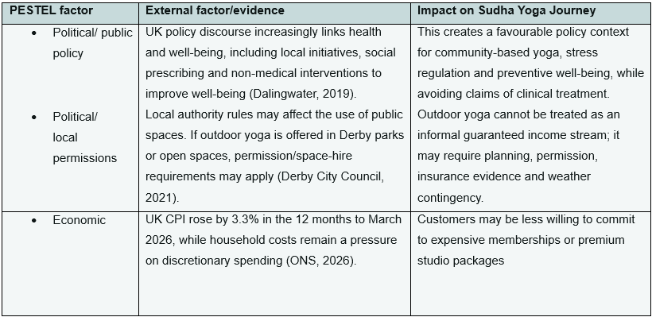

Table 3.1: PESTEL analysis for Sudha Yoga Journey (continued)
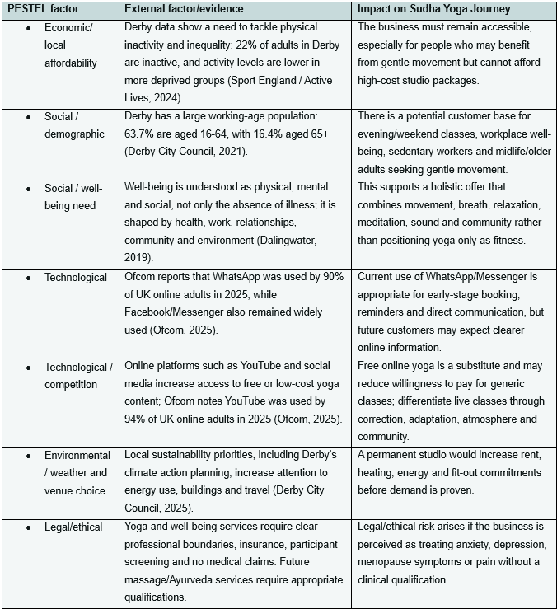
Source: Author’s own analysis, based on Dalingwater (2019), ONS (2026), Derby City Council (2021; 2025), Sport England / Active Lives (2024), Ofcom (2025) and the author’s operational context.

Table 3.2: Porter’s Five Forces analysis for Sudha Yoga Journey
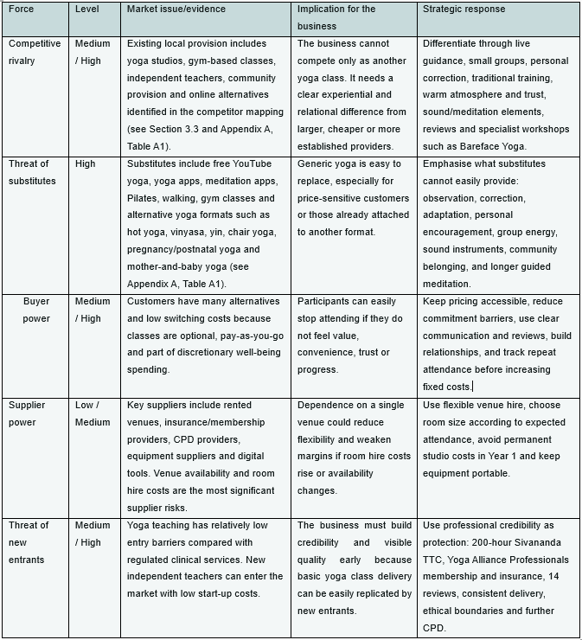
Source: Author’s own application of Porter’s Five Forces, based on the competitor analysis in Section 3.3, Appendix A competitor mapping, and the strategic framework developed by Porter (1980).

Table 3.3: SWOT analysis for Sudha Yoga Journey
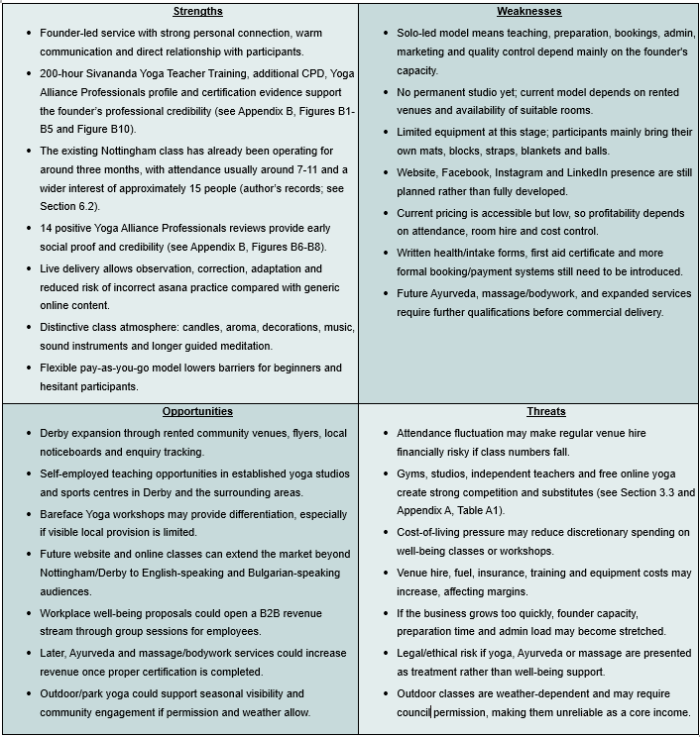
Source: Author’s own SWOT analysis, based on the current trading position of Sudha Yoga Journey, Yoga Alliance Professionals reviews, operational evidence, competitor mapping and founder qualifications. SWOT is used to summarise internal strengths and weaknesses alongside external opportunities and threats (Nykiel, 2003; Barbosa et al., 2023).

Overall, the strategic assessment supports a cautious but viable market-entry approach. The PESTEL analysis identifies external conditions that support accessible well-being, movement and stress-management services, but also highlights economic pressure, venue dependence, digital competition and legal/ethical boundaries. Porter’s Five Forces confirms that Sudha Yoga Journey must differentiate from gyms, studios, independent teachers and free online yoga through live guidance, personal correction, atmosphere, reviews and specialist workshops. The SWOT analysis shows early strengths, including founder credibility, live delivery and positive reviews, but also weaknesses such as solo capacity, limited equipment, developing digital visibility and attendance fluctuation. This supports a phased model based on rented venues, low fixed costs, gradual digital development and qualification-led service expansion.

3.5 Justification and Feasibility of Sudha Yoga Journey

The concept of Sudha Yoga Journey is justified not only by evidence of customer need and market gaps, but also by evidence that yoga can be delivered in formats that are operationally and commercially feasible within the contemporary UK well-being context. Recent UK research suggests that yoga is increasingly recognised as a health-supportive practice rather than solely a leisure activity. Smit and Cartwright (2023) found that UK healthcare practitioners were generally open to recommending yoga for health, while also reporting practical barriers relating to opportunity, referral pathways and signposting to appropriate and affordable provision. For the proposed venture, this supports the relevance of a yoga offer that is clearly described, accessible and easy to understand within wider well-being contexts.
The feasibility of the concept is also strengthened by evidence on viable delivery models. Wadhen and Cartwright (2021) found that, in a UK sample of people working from home, an online-streamed yoga intervention was feasible, highly acceptable and associated with improvements in perceived stress, mental well-being, depression and coping self-efficacy. Participants also valued convenience, flexible scheduling and ease of access. For Sudha Yoga Journey, this suggests that feasibility does not depend on a single venue type or delivery mode. A hybrid model combining community-based in-person sessions with optional online support may therefore be realistic, especially in the early stages when flexibility and lower overheads are commercially advantageous.
A further argument for feasibility comes from structured programme evidence. Hartfiel et al. (2017) found that an eight-week yoga programme for NHS employees was likely to be cost-effective, with substantially fewer sickness-absence days related to musculoskeletal conditions in the yoga group than in the control group at six months. For the proposed venture, this is important because it suggests that yoga can be packaged not only as an open community class offer, but also as a structured well-being programme with potential relevance for workplaces, staff well-being initiatives and future partnership-based delivery. This strengthens the feasibility of the concept beyond a single small-class format.
Commercial feasibility, however, depends on careful pricing and scope. Michopoulou, Kudrakova and Azara (2015) found that wellness providers recognised affordability as a barrier to uptake but also faced operational limits in lowering prices. These findings are indicative, but they highlight a structural trade-off between affordability and viability for small providers. For Sudha Yoga Journey, this supports a modest and structured pricing strategy, such as introductory offers, tiered participation routes or community-oriented entry classes, rather than either premium-only pricing or unsustainably low fees.
Operational viability also depends on whether the service can be clearly understood and trusted by prospective users from first contact. Dysart et al. (2023) suggest that yoga studio websites do not always provide enough information about instructor training or specialist expertise. For Sudha Yoga Journey, this has direct practical implications: the offer becomes more legible through transparent class descriptions, visible credentials, clear language about suitability, and explicit reassurance about what beginners can expect.
The concept is further strengthened by its potential for carefully phased service diversification. While the core offer remains yoga-led, the business model allows for selected complementary well-being services, workshops or one-to-one sessions that can increase customer value, support repeat engagement and provide greater revenue resilience if attendance in regular classes fluctuates. For Sudha Yoga Journey, this is important because it creates scope for a modular offer built around a coherent well-being identity rather than dependence on one single class format. This phased approach strengthens feasibility because lean scale-up logic emphasises disciplined focus on measurable progress and constraints, while scale-up frameworks highlight the need to maintain alignment between value proposition, value creation and operational capability as services expand (Maurya, 2016; Panigrahi, Nikou and Calabretta, 2025). Any future specialist services, such as Ayurveda-informed support or therapeutic bodywork, would need to be developed in line with relevant qualifications, scope of practice and verified customer demand (Seitz, 2010).
Taken together, the evidence suggests that Sudha Yoga Journey is conceptually justified and operationally feasible if developed with disciplined focus. The strongest case is not for a broad or undifferentiated yoga business, but for a carefully positioned offer that combines holistic well-being aims with accessible delivery, transparent communication, a realistic self-funded pricing model and the flexibility to operate across community, hybrid and future partnership-based settings. In this sense, feasibility is supported not by scale from the outset, but by the practical fit between the concept and the types of delivery, pricing and trust signals that the literature suggests are workable.

4. Business Model Canvas and Operating Model for Sudha Yoga Journey

The Business Model Canvas is widely used as a practical framework for describing how a business creates, delivers and captures value. It is particularly useful because it provides a shared language for discussing a business model in a way that is simple, relevant and intuitively understandable, while still organising the model through nine building blocks (Qastharin, 2015). Osterwalder, Pigneur and Tucci (2005) further describe the business model as a conceptual tool that expresses the business logic of a firm, while Bachmann et al. (2025) explain that these building blocks can also be understood through four broader dimensions: value creation, value proposition, value delivery and value capture. In this proposal, the canvas is used to translate the concept and market analysis for Sudha Yoga Journey into a practical operating model. At the same time, it should be used analytically rather than mechanically, as fixed block structures can otherwise encourage a simple “filling-in” exercise and obscure the broader logic of value creation (Verrue, 2014).
The completed canvas below summarises the core logic of the proposed business at its current stage of development. As an early-stage, founder-led micro-venture, Sudha Yoga Journey is structured around a focused value proposition, low fixed-cost delivery, trust-based customer relationships and phased growth through carefully selected channels, partnerships and revenue streams. The canvas, therefore, brings the preceding sections together by showing how the venture’s market positioning, customer relevance and concept feasibility are operationalised as a coherent business model.

Figure 4.1: Business Model Canvas for Sudha Yoga Journey

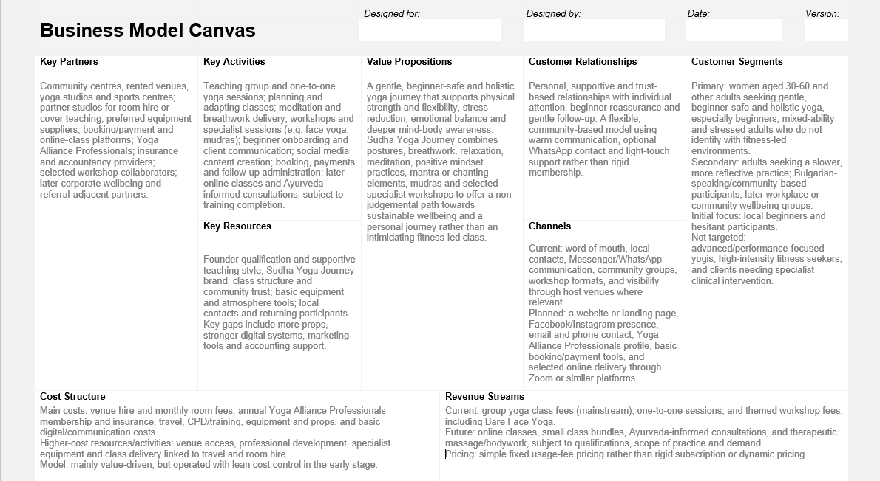
Source: Adapted from Osterwalder and Pigneur (2010), author’s own application.

4.1 Key Partnerships and Support Network for Sudha Yoga Journey

In the Business Model Canvas, key partnerships refer to the network of suppliers and partners that help the business model function effectively (Qastharin, 2015). For a small, early-stage venture, these relationships can be especially important because limited internal resources often make external cooperation, complementary capabilities, and practical support necessary for delivery and growth. Research on co-creation among SMEs similarly suggests that smaller ventures often depend on external input, cooperation networks, shared resources, and appropriate governance arrangements to strengthen capabilities and create value (Garmann-Johnsen, Olsen and Eikebrokk, 2021).
For Sudha Yoga Journey, the most important current partners are likely to be community centres, yoga studios and sports centres that can provide space for classes, workshops and one-to-one sessions. This is a realistic partnership structure for the early stage of the business because it allows the venture to operate without the immediate cost and risk of maintaining a permanent studio. In addition, partner studios may also provide opportunities for room hire, substitute teaching or freelance teaching arrangements, helping the business extend its reach while remaining flexible. This reflects a practical, low-fixed-cost model in which access to delivery spaces is more important than ownership of them at the outset.
A second group of key partners includes selected collaborators who may support specialist workshops or complementary well-being sessions, for example in areas such as face yoga, mudras, breathwork or other related practices. These relationships are valuable not only because they can broaden the offer, but because they may also support co-created value, wider audience reach and gradual diversification without requiring Sudha Yoga Journey to build all capabilities internally from the beginning (Garmann-Johnsen, Olsen and Eikebrokk, 2021).
The business also depends on several enabling partners that make delivery manageable on a self-employed basis. These include digital booking and payment platforms, online-class tools, insurance providers and accountancy support. Although such partners are less visible from the customer perspective, they are important in making the business operationally workable, administratively manageable and professionally credible. Preferred equipment suppliers may also be relevant where they provide reliable access to mats, props or other yoga materials at professional rates; however, these relationships are better understood as supportive supply arrangements than as core strategic alliances.
Professional networks are also relevant. Yoga Alliance Professionals, for example, may strengthen credibility, visibility, and access to teaching opportunities, including cover work or collaborations with other studios. In a later phase, additional partners may include corporate well-being clients, community well-being organisations, and other referral-adjacent contacts able to signpost suitable participants towards the business. This is consistent with earlier evidence that appropriate provision, clear signposting and access routes matter in health- and well-being-related contexts (Smit and Cartwright, 2023). Overall, the key partner structure for Sudha Yoga Journey is therefore based on flexibility, credibility, resource sharing and phased expansion rather than dependence on one formal partnership model.

4.2 Key Activities Required to Deliver Sudha Yoga Journey

In the Business Model Canvas, key activities are the most important actions a business must perform to make the model work, including those required to create and offer a value proposition, reach markets, maintain customer relationships and generate revenue (Qastharin, 2015). For Sudha Yoga Journey, these activities are strongly founder-centred because the business is intended to operate initially as a self-employed, owner-led venture rather than as a multi-staff organisation. Delivery, communication, administration and early-stage marketing are therefore largely carried out by the founder.
The first key activity is service delivery. This includes teaching group yoga classes, one-to-one sessions, guided relaxation, meditation, breathwork practices and, where appropriate, workshops or small themed events. Delivery also involves responsive instructional choices, including pacing, adaptation, gentle cueing and an inviting rather than overly directive teaching style. Qualitative research on yoga instruction suggests that inviting practice, cadence, scoping and connection can shape how embodied teaching is experienced by participants (Reeves and White, 2021). Because the business is positioned as beginner-friendly, holistic and supportive, class planning also needs to respond to common customer needs such as stress relief, low confidence, tension reduction and gradual progression. This is consistent with value proposition design, which emphasises the importance of aligning value propositions with actual customer needs rather than internal assumptions or product features (Kyhnau and Nielsen, 2015).
A second group of activities relates to customer communication and audience building. In the early stage, Sudha Yoga Journey depends heavily on direct communication, especially for beginner onboarding. Explaining what to expect, answering questions, reducing anxiety, building trust and maintaining supportive follow-up all contribute to the value created by the service. Regular social media content, including short videos, educational posts, class updates and well-being messages, can also help communicate the brand identity and make the offer more visible and approachable.
A third group of activities is administrative and organisational. These include scheduling, bookings, payments, venue coordination, follow-up communication, feedback collection and routine self-employed administration. Although less visible than teaching, these activities are essential because the business model depends on reliability, continuity and a manageable customer journey. The Business Model Canvas literature makes clear that key activities must support not only the value proposition, but also channels, customer relationships and revenue generation (Qastharin, 2015).
Over time, activities may expand to include online classes, additional workshops and Ayurveda-informed consultations once the required training, confidence and demand are in place. At the present stage, however, these are better treated as future extensions rather than core current activities. Overall, the key activities of Sudha Yoga Journey combine teaching, experience design, customer onboarding, community communication, content creation and practical administration to deliver an accessible, supportive and holistic yoga and well-being offer.

4.3 Value Proposition and Customer Benefits

In the Business Model Canvas, a value proposition is the bundle of products and services that creates value for a specific customer segment (Qastharin, 2015). Value Proposition Design extends this by emphasising the need for fit between customer segments and value propositions, rather than confusing value with internal assumptions or product features (Kyhnau and Nielsen, 2015). Customer-centred innovation literature similarly argues that service development should begin with customer needs, desired outcomes and the progress customers are trying to achieve (Partanen, 2021).
For Sudha Yoga Journey, the value proposition is not simply access to yoga classes as physical activity. It is a gentle, beginner-safe and holistic yoga and well-being offer designed to support physical strength and flexibility, stress reduction, emotional balance and deeper self-awareness. This positioning is consistent with UK evidence showing that yoga practice is associated not only with fitness and general wellness, but also with stress management and spirituality as important motivations for continued practice (Cartwright et al., 2020).
The business is framed as a journey because it presents yoga as more than posture-based exercise. Contemporary yoga research describes traditional yoga as a multicomponent practice involving postures, breathing techniques, meditation, mantras and ethics, and suggests that combining several elements may enhance well-being more than meditation alone (Matko, Sedlmeier and Bringmann, 2021). Research also presents yoga as a holistic philosophical and methodological framework involving physical, mental, moral and spiritual practices, although in many Western contexts it is often reduced to exercise and stretching (Csala, Springinsfeld and Köteles, 2021).
In practical terms, Sudha Yoga Journey seeks to create value through a rounded combination of asana-based practice, breathwork, relaxation, meditation and reflective elements rather than through a fitness-only class. Selected traditional elements such as mantra, chanting or mudras may be included cautiously where appropriate; however, the evidence base for mudras is considerably weaker than for yoga more broadly (Sagar et al., 2025). The delivery style is also part of the value proposition, as qualitative research suggests that inviting rather than overly directive teaching, together with pacing, scoping and connection, shapes how participants experience yoga in practice (Reeves and White, 2021).
The value proposition is therefore differentiated by its balance of traditional inspiration and modern accessibility. Sudha Yoga Journey offers a calm and rounded well-being format that aims to help participants feel welcomed, safe and gently guided during the class, and calmer, more grounded and more connected to themselves afterwards. Over time, the longer-term value lies in helping participants build confidence, supportive routines and a more holistic sense of well-being, consistent with a value proposition designed around meaningful customer outcomes rather than isolated service features (Kyhnau and Nielsen, 2015; Partanen, 2021).

4.4 Customer Relationships and Community Engagement Strategy

In the Business Model Canvas, customer relationships refer to the types of relationships a business establishes with specific customer segments (Qastharin, 2015). For a service-led venture such as Sudha Yoga Journey, this is especially important because relationship quality is not separate from the service itself; rapport and emotional connection can shape customer satisfaction and longer-term loyalty in service settings (Wang et al., 2025). Relationship-oriented literature also suggests that, in contemporary service contexts, the objective is not simply the completion of a transaction, but the development and maintenance of a meaningful relationship with the client (Kiseleva and Anikina, 2015).
For Sudha Yoga Journey, customer relationships are intended to be personal, supportive and trust-based rather than formal or transactional. This is particularly relevant for beginners or hesitant participants, because relationship-oriented communication literature emphasises collaborative, respectful, trusting and individualised relationships (Tahan and Sminkey, 2012; Reeves and White, 2021). In this sense, the relationship model is designed not only to support attendance, but also to reduce anxiety, encourage openness and help clients feel emotionally safe enough to return.
In practical terms, this implies a model of gentle onboarding and continued reassurance. New participants may need clear explanations before their first class, a calm and non-judgemental welcome, brief opportunities to ask questions, and light follow-up after sessions where appropriate. The aim is to help clients feel seen, safe and encouraged without creating an intrusive relationship. This approach is consistent with evidence that trust-building, empathy and respectful communication improve the ability to form meaningful helping relationships and support positive behavioural engagement (Tahan and Sminkey, 2012; Wang et al., 2025).
At the same time, the relationship model should retain a sense of community. WhatsApp communication, workshop invitations and occasional supportive messages can help create continuity and belonging, but the model is better framed as flexible and community-based than as a rigid fitness-style membership. This is also consistent with a well-being-oriented business philosophy, which places emphasis on longer-term consumer well-being and relationship value rather than narrow short-term exchange alone (Sirgy and Lee, 2008). For Sudha Yoga Journey, the preferred customer relationship is therefore warm, individual, and encouraging: close enough to build trust, but spacious enough to respect client autonomy, different levels of readiness and different patterns of engagement (Tahan and Sminkey, 2012).

4.5 Customer Segments and Target Users for Sudha Yoga Journey

In the Business Model Canvas, customer segments are the distinct groups a business aims to serve with its value proposition (Qastharin, 2015). For Sudha Yoga Journey, segmentation needs to remain focused rather than broad, because the business is designed for a specific type of participant rather than for the whole yoga market.
The primary customer segment is adults, especially women aged 30-60, who are looking for a gentler and more supportive yoga practice. This is consistent with UK survey evidence showing that yoga practitioners are predominantly women, with a mean age of 48.7 years (Cartwright et al., 2020). However, the offer is not intended to be female-only; it remains open to other adults where this fits the class format and environment.
Within this primary segment, the clearest focus is on beginners, hesitant participants and mixed-ability adults experiencing stress, overload, or low confidence. This is supported by UK consumer evidence showing that discomfort, low confidence, and fear of judgement are important barriers to participation in paid activity environments, alongside cost (UK Health & Fitness Market Report, 2025). UK yoga survey data also suggest that participation is motivated not only by fitness but by stress management, spirituality and broader well-being aims (Cartwright et al., 2020).
A secondary segment includes adults with previous yoga experience who still prefer a slower, less performative, and more reflective style of practice. It may also include Bulgarian-speaking women and other community-based participants for whom familiar communication and trust may make the offer especially accessible. This is compatible with research suggesting that yoga access can be shaped by identity, culture and perceived fit (Brown, 2024).
The initial target focus should be on local beginners and hesitant participants first. At this stage, the business is not primarily aimed at advanced or performance-focused yogis, people strongly seeking fitness-led formats, or clients requiring specialist clinical or therapeutic intervention beyond the founder’s scope of practice. This focused approach is also supported by qualitative evidence that yoga engagement is facilitated by beginner-level classes, individualised instruction and stress-reduction-oriented messaging (Spadola et al., 2017). Overall, the segmentation strategy is deliberately narrow: not yoga for everyone, but yoga for those most likely to value reassurance, gradual progress, and holistic well-being support.

4.6 Key Resources Supporting Sudha Yoga Journey

In the Business Model Canvas, key resources are the most important assets required to make the business model work. They enable the business to create and offer its value proposition, reach markets, maintain customer relationships, and earn revenues, and they may be human, intellectual, physical or financial in nature (Qastharin, 2015). For a small service-led venture such as Sudha Yoga Journey, the most important resources are not only physical assets, but also founder capability, trust, brand identity, and the ability to deliver a consistent customer experience.
The strongest current human resource is the founder herself. Sudha Yoga Journey is built around founder-led delivery, so qualifications, teaching style, personal presence, and relational capability are central assets rather than secondary ones. The founder has completed a 200-hour Sivananda Yoga Teacher Training Course and Bareface Yoga Level 1, with further paid training already planned in mudras and Bareface Yoga Level 2, while longer-term progression is intended through advanced TTC, Ayurveda and therapeutic massage. The existing business profile also positions her teaching approach as calm, encouraging and accessible. At this stage, these human capabilities are among the venture’s most important resources because the service depends heavily on trust, reassurance, and the quality of direct teaching.
A second major group of resources is intellectual and relational. These include the brand identity of Sudha Yoga Journey, the philosophy behind the offer, structured class formats, self-written guided meditations, and the emerging reputation of the business. The existing venture materials show that the name Sudha was intentionally chosen to reflect essence, authenticity, and a longer-term well-being journey, while the founder has already built early social proof through client reviews, returning participants and a WhatsApp-based community. In service contexts, rapport, authenticity, and emotional connection are strongly linked with customer satisfaction and longer-term loyalty, which means that trust and reputation should be treated as genuine business resources rather than as vague background qualities (Wang et al., 2025). The emerging brand identity is supported by the Sudha Yoga Journey logo and visual materials shown in Appendix B, Figure B11.
Physical resources are important, but at this stage they are deliberately modest. The business does not yet operate from a permanent studio and currently depends on rented venues, which is consistent with the low-cost validation model already described elsewhere in the proposal. Existing physical assets include sound and atmosphere tools such as a singing bowl, Koshi chimes and a rin bell, as well as candles, crystals, essential oils, massage oils and equipment, and a yoga chair for participants with reduced mobility. These resources support the intended atmosphere and inclusivity of the service. However, the physical resource base is still incomplete: more general class props, blankets, bolsters, branding materials and printed forms are needed if the business is to deliver larger groups more consistently and professionally.
Digital and operational resources remain the clearest development gap. The venture already benefits from local contacts, community trust, and direct communication channels, but it does not yet have a dedicated website, stronger digital marketing tools or more structured booking and administrative systems. These are important because small service businesses increasingly depend on legibility, discoverability and clear presentation of credentials and offer design from first contact. The current proposal has already noted that transparent class descriptions, visible credentials and accessible communication are important for helping prospective users understand and trust the service. For Sudha Yoga Journey, this means that future key resources will need to include a stronger digital presence, basic marketing infrastructure, and appropriate administrative support, such as accounting input, even if these are developed gradually rather than all at once.
Overall, the key resources of Sudha Yoga Journey are strongest in the human and relational domains: qualification, teaching quality, brand meaning, trust and community connection. The physical and digital resource base is sufficient for an early freelance stage but still developing. This fits the wider business logic of the venture, which is designed to begin lean, rely on founder capability and trust, and strengthen infrastructure gradually as demand and operational consistency grow.

4.7 Channels for Reaching and Serving Customers

In the Business Model Canvas, channels describe how a company communicates with and reaches its customer segments, supporting access to the value proposition rather than simply advertising the business (Qastharin, 2015; Ojasalo and Ojasalo, 2018). For Sudha Yoga Journey, channels should reflect the behaviour and preferences of its target users: mainly local adults, beginners and hesitant participants seeking a gentle well-being offer. Multichannel marketing research shows that firms need to consider multiple customer touchpoints and align channel choice with everyday customer behaviour (Chen, 2015). For this reason, the most appropriate early channels are simple, familiar and low-pressure, including word of mouth, Messenger or WhatsApp, email, phone contact, a basic website and a clear social media presence.
At the current stage, the most realistic channels are word of mouth, local contacts, community groups, host venue visibility, workshop participation and direct messaging. These channels are suitable because they are trust-based, low-cost and close to existing customer routines. Host venues can support discovery where they provide listings, local visibility or promotion, while workshops can act as low-pressure entry points for new participants. This fits the logic of relationship-oriented service businesses, where direct contact, familiarity and confidence can be more influential than broad promotional reach (Wang et al., 2025).
A stronger digital presence is an important next step, but it should remain simple and credibility focused. A basic website or landing page can present class information, philosophy, pricing, contact details, booking guidance and suitability information in one place. Research on yoga studio websites suggests that they often shape first impressions and communicate mission, values, class type, cost and suitability to prospective participants (Dysart, Barnett and Harden, 2023). For Sudha Yoga Journey, the website should therefore provide clarity, reassurance and credibility rather than aggressive promotion. Facebook, Instagram and the Yoga Alliance Professionals profile can support discoverability through calm, educational and welcoming content.
Over time, the channel system may also include simple booking and payment tools, as well as online delivery platforms such as Zoom or Teams where live online sessions become relevant. However, the overall approach should remain selective and integrated, with each channel playing a clear role in the customer journey (Chen, 2015). Therefore, the most suitable channel model for Sudha Yoga Journey is not to be “everywhere at once”, but to use a cost-conscious mix of accessible, trust-building channels that fit the routines of its target customers and remain aligned with customer-centred business model thinking (Ojasalo and Ojasalo, 2018).

4.8 Cost Structure and Resource Requirements for Sudha Yoga Journey

In the Business Model Canvas, cost structure refers to the most important costs involved in operating the business model. The key issue is which costs are indispensable for delivering the value proposition, since key activities and key resources are the main cost drivers (Brunner et al., 2025). For early-stage ventures, cost structure also needs to be considered alongside financial viability, including the balance between committed costs, variable costs and cash burn over time (York, 2018).
For Sudha Yoga Journey, the current cost structure reflects its position as a founder-led, low-infrastructure well-being micro-venture. The most important present costs are venue hire and related monthly room fees, annual Yoga Alliance Professionals membership including insurance, travel costs, continuing professional development, and the gradual purchase of equipment and props needed to deliver classes safely and professionally. Additional costs include a Spotify subscription, speaker, books, and atmosphere-supporting materials such as candles, aromatic products, sound tools and decorative items. These costs directly support delivery quality, professionalism and the intended class experience.
At this stage, the business includes both fixed or semi-fixed costs and variable costs. The clearest recurring committed costs are professional membership and insurance, music subscription and, in future, a website/domain or basic digital tools. The main variable costs are room hire, fuel and travel, additional props and equipment, consumable materials, and workshop-specific or marketing-related spending. This distinction matters because fixed costs remain even when attendance fluctuates, while variable costs increase with class frequency, workshop activity or business growth (York, 2018).
The most expensive key resources are the founder’s qualifications and continuing development, access to suitable delivery space, and sufficient equipment and props to support mixed-ability participants safely and comfortably. This is consistent with start-up research suggesting that early-stage ventures often face strong resource constraints and that cash and competence are central managerial concerns in the early phase (Malmström and Johansson, 2017). Although start-up studies also identify personnel and development costs as important, Sudha Yoga Journey adapts this pattern to a solo service model, where founder training and service delivery infrastructure are more significant than payroll in the current phase (Slávik, Bednár and Mišúnová Hudáková, 2021).
The most expensive key activities are class delivery, workshop delivery and professional development. In-person classes are cost-sensitive because each session may involve room hire and travel, making venue choice closely linked to expected attendance. Workshops may require additional preparation, materials, venue arrangements and promotion. Ongoing professional development is also a significant activity-related cost, but it should be treated as an investment in quality and differentiation rather than as avoidable overhead. This reflects start-up research showing that service development and promotion can be among the more expensive early business activities, although cost patterns vary by sector (Slávik, Bednár and Mišúnová Hudáková, 2021).
Strategically, Sudha Yoga Journey is better described as value-driven rather than purely cost-driven. It is not built around the lowest possible price, maximum automation or extensive outsourcing, but around a calm, supportive and holistic experience. Therefore, spending on atmosphere, training, safety, reassurance and professionalism forms part of the value offered. At the same time, the venture is managed with lean cost awareness: rented venues are used instead of a permanent studio, venue size is matched to expected attendance, and infrastructure is developed gradually. This combination of value orientation and cost discipline is consistent with the distinction between value-driven and cost-driven models discussed in the literature (York, 2018).
The model currently offers limited economies of scale because class volume remains small and many costs are linked to each additional session. However, there is potential for economies of scope over time, as the same brand, equipment, digital presence, travel routines and teaching preparation may support group classes, one-to-one sessions, workshops, face yoga and related complementary formats. Overall, the cost structure is modest but sensitive: it is not heavy in corporate overhead, but it is strongly affected by venue, travel, training and equipment decisions, making careful cost control essential within a value-led business model (York, 2018).

4.9 Revenue Streams and Financial Sustainability

In the Business Model Canvas, revenue streams refer to the cash generated from each customer segment and should remain aligned with the value proposition and with the way customers access and pay for the service (Ojasalo and Ojasalo, 2018). For Sudha Yoga Journey, the revenue model should therefore remain simple, selective and consistent with a gentle, trust-based well-being offer rather than rely on aggressive monetisation.
The main current revenue stream is expected to come from group yoga classes. This is the most realistic starting point because the core offer is built around guided, beginner-safe, and holistic practice delivered to small groups. A second current stream is one-to-one sessions, which can command a higher price because they involve more personalised support and individual attention. A third stream is workshop income, especially from themed formats such as Bareface Yoga or beginner-oriented sessions. These streams fit a usage-fee model, where customers pay for participation rather than for ownership or long-term contractual membership.
This structure is also realistic in the English context. Sharp et al. (2018) found that practitioner-led complementary medicine use in England was self-referred and self-financed, and that people commonly paid for practices including massage and yoga. The same study found that respondents were willing to pay varying amounts, although 22% said they would not pay anything. For Sudha Yoga Journey, this supports a private-pay model but also suggests that pricing should remain accessible and proportionate to perceived value.
In practical terms, customers are most likely to pay for a service that feels safe, supportive, and personally relevant rather than for “yoga” as an abstract label. This is especially important for one-to-one sessions and future specialist offers, where the quality-of-service experience becomes part of the value itself. Suhail and Srinivasulu (2021) found in Ayurveda healthcare that service quality and patient satisfaction significantly influenced behavioural intentions, including recommendation and revisit. For Sudha Yoga Journey, this supports a revenue model in which repeat attendance and referral are strengthened by the quality of the experience rather than by high-pressure sales logic.
At the early stage, the most suitable pricing logic is simple fixed pricing. Pay-per-class, pay-per-session, and separately priced workshops are more appropriate than a rigid subscription model, particularly for beginners and hesitant participants who may prefer low-commitment entry. As the client base becomes more stable, small bundles or multi-class passes could be introduced to support continuity without creating the pressure of a gym-style membership.
A future phase may broaden revenue streams without changing the ethos of the business. The most realistic additions are online classes, Ayurveda-informed consultations delivered online or in person once qualifications are completed, and therapeutic massage/bodywork, subject to training, scope of practice and verified demand. Schiele et al. (2024) found that Ayurvedic services in Germany were commonly accessed through wellness resorts/spas, outpatient practices, and hotels, and that users often associated Ayurveda with both Indian medicine and wellness. This is useful because it suggests that Ayurveda-related revenue may sit across both well-being and more therapeutic positioning but needs clear framing.
For the UK specifically, future Ayurveda-related revenue streams need to be developed cautiously. Ravindran et al. (2026) note that in the UK, Ayurveda is currently classified under CAM, is not formally recognised within the NHS, and is available privately rather than as a commissioned mainstream service. The same study found that healthcare professionals reported substantial knowledge gaps and supported more research, education, and regulation. This supports the inclusion of Ayurveda-informed services only as a later, clearly bounded revenue stream, introduced transparently and in line with relevant qualifications and professional scope.
Payment methods should also remain easy and familiar. For this type of business, the most suitable methods are likely to be simple user payments such as bank transfer, cash, or card, where appropriate, and later basic online payment tools if these are linked to a website or booking system.
Overall, the model remains commercially realistic because it reflects how comparable complementary services are commonly paid for in England, while preserving the brand’s supportive and non-intimidating ethos.

5. Marketing and Sales Strategy

5.1 Segmentation, Targeting and Market Entry Focus

Segmentation, targeting, and positioning (STP) are used here as a practical marketing framework to translate the wider market opportunity into a focused entry strategy. Rather than attempting to serve the whole yoga market, Sudha Yoga Journey will prioritise the customer groups most likely to value accessible, structured, and well-being-oriented yoga. This is consistent with the STP logic that effective marketing requires identifying relevant segments, selecting priority targets, and positioning the offer clearly for those customers (Kotler and Armstrong, 2024).
This STP focus is evidence-based rather than descriptive. UK yoga evidence shows a strong female and midlife practitioner base, with a mean participant age of 48.7 years. It indicates that people commonly begin yoga for general wellness, fitness, flexibility, or health-related reasons. Reported perceived usefulness for stress, anxiety, neck and shoulder pain, and sleep issues supports targeting customers seeking prevention, self-care, stress regulation, and musculoskeletal comfort rather than high-intensity exercise (Cartwright et al., 2020). Wider UK sector evidence also shows that cost, discomfort, low confidence, and fear of judgement remain important barriers to participation, supporting the use of accessible pricing, pay-as-you-go entry, and local visibility (UKactive, Sport England, and 4GLOBAL, 2025). Future-of-work literature further supports the relevance of customers affected by screen-heavy and boundary-blurred routines (Abe, 2021).
To avoid an overly broad marketing approach, the STP framework is used to define the most relevant market segments, the priority target groups, and the intended competitive position of Sudha Yoga Journey. Table 5.1 summarises how segmentation, targeting and positioning are applied to the current and future development of the business.

Table 5.1: STP Market-Entry Focus for Sudha Yoga Journey
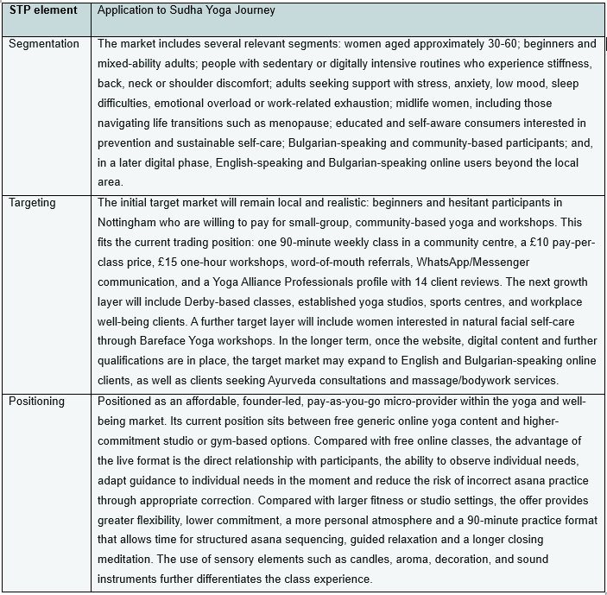
Source: Adapted from Kotler and Armstrong (2024), author’s own application.

5.2 Marketing Channels and Performance Measures

Following the STP focus, the marketing strategy will be implemented through a staged route-to-market plan. The emphasis is on low-cost, measurable, and realistic channels that align with Sudha Yoga Journey's current micro-business stage while also preparing for future growth. Table 5.2 shows how each channel will be used and how its effectiveness will be monitored.

Table 5.2: Route-to-Market Channels and Control Measures
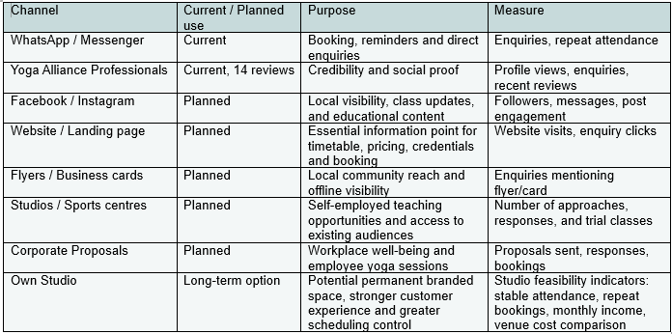
Source: Author’s own application.

This route-to-market plan follows a multichannel approach, but without overextending the business at an early stage. Current channels are based on direct communication, reviews and referrals, while planned channels will increase visibility, credibility and access to new customer groups. This is consistent with multichannel marketing logic, where different touchpoints support awareness, enquiry, and customer engagement (Chen, 2015). The planned website or landing page is particularly important because prospective yoga customers often need clear information about class type, cost, duration, teacher credentials, and suitability before attending (Dysart, Barnett and Harden, 2023). The measures in the final column also keep the strategy practical by linking each activity to observable outcomes rather than general visibility alone.

5.3 Marketing Mix Strategy

The 4Ps are used here to summarise the main marketing decisions that follow from the STP focus and route-to-market plan. This keeps the marketing mix practical and avoids treating product, price, place and promotion as separate theoretical categories.

Table 5.3: Marketing Mix Decisions for Sudha Yoga Journey
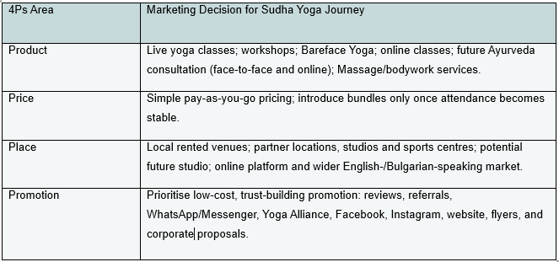
Source: Adapted from Kotler and Armstrong (2024), author’s own application.

The 4Ps table shows that Sudha Yoga Journey’s marketing decisions are deliberately staged. The current mix is kept simple: live classes and workshops, pay-as-you-go pricing, rented venues and low-cost direct promotion. The future mix adds new revenue streams and wider reach only where there is evidence of demand: online classes, Bareface Yoga, Ayurveda-informed services, massage/bodywork, partner venues, corporate proposals and eventually an own studio. This prevents the business from expanding too widely before attendance, income and operational capacity are stable. This staged approach is consistent with evidence from micro- and small-enterprise research suggesting that marketing strategy should be actively managed and adapted using performance data and customer feedback, although the study is not UK- or yoga-specific (Ali, Ameen and Tirwanshi, 2024).

5.4 Sales Process and Early Performance Targets

The sales process for Sudha Yoga Journey will remain simple, low-pressure and suitable for a small service business. The aim is not to use aggressive selling, but to make the customer journey clear enough for interested people to move from awareness to attendance and, where appropriate, repeat participation.

Table 5.4: Sales Process and Early Performance Targets
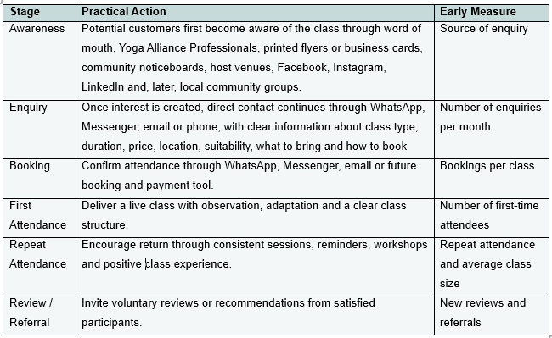
Source: Author’s own application.

The early performance targets should remain realistic. In the first stage, the business should track enquiries, attendance per class, repeat participation, workshop bookings, reviews, referrals and income per session. These indicators will show whether demand is becoming stable enough to justify further investment in partner venues, online delivery or a future studio. This keeps sales activity linked to evidence of traction rather than assumptions (Maurya, 2016; Nykiel, 2003).

6. Operations Plan for Sudha Yoga Journey

Operational planning explains how the business will function in practice rather than how it will be positioned or promoted. For Sudha Yoga Journey, this means translating the strategy into weekly delivery, venue use, booking, administration, resources, safety and quality control. This is particularly important because the business is currently founder-led and depends on the founder’s ability to organise, deliver and monitor the service consistently. Business strategy literature distinguishes the operational level from broader strategy by linking it to routine tasks, short-term objectives and immediate results, while also emphasising the role of performance indicators in monitoring execution (Barbosa et al., 2023).

6.1 Operational Model and Weekly Delivery Plan

Sudha Yoga Journey will operate as a solo, founder-led service business in the early stage. The founder will be responsible for teaching, class preparation, venue coordination, participant communication, payment administration and follow-up. No permanent staff are planned at this stage, although future collaborations or guest teachers may be considered for workshops or specialist sessions once demand and operational capacity are clearer.
The current operating base is a weekly 90-minute group class in a community centre in Nottingham. This class will continue because it has already been established over approximately three months of regular delivery and provides a useful foundation for testing the service, maintaining customer relationships and building early consistency. The 90-minute format responds to participant preference for a longer practice, including a closing meditation of around 20 minutes. However, future classes in Derby, sports centres or established studios may use a shorter one-hour format, which is more common in local class schedules and easier to fit into venue timetables. One-to-one sessions and Bareface Yoga sessions are also expected to operate mainly as one-hour formats. The use of rented venues is consistent with the market gap identified in Section 3.3, as it allows Sudha Yoga Journey to test local demand with lower fixed costs before considering permanent premises or wider expansion.
The intended weekly delivery model is gradual but growth oriented. The founder aims to build towards three to four self-organised classes per week, supported by one or two workshops per month where demand allows. These workshops may include Bareface Yoga, mudras, pranayama or meditation-based themes and may be delivered face-to-face or online in the future. However, this growth will not be implemented all at once. Additional classes will be introduced only where there is sufficient customer interest, suitable venue availability and a realistic relationship between expected attendance and room-hire cost.
The next operational development is to explore Derby-based delivery. This may include hiring a local community venue if a viable class group can be formed through local promotion, flyers, community noticeboards and direct enquiries. In parallel, the founder will approach managers of larger sports centres and established yoga studios in Derby and the surrounding area, including through LinkedIn and written enquiries, to explore self-employed teaching opportunities. This creates two operational routes: self-organised classes through rented rooms and freelance teaching through existing venues.
Venue selection will be based on practical criteria: affordability, accessibility, appropriate room size, parking or transport access, cleanliness, heating, quiet atmosphere and suitability for yoga practice. This is especially important during the winter months and for participants who may be beginners or less confident in unfamiliar environments. A permanent own studio remains a longer-term operational aim, potentially within twelve months, but only if attendance, income and venue-cost comparison show that fixed premises would be sustainable rather than premature.

6.2 Service Delivery Process

The service delivery process begins before the class itself. At least one day before each session, the founder checks expected attendance through the WhatsApp group, as this helps determine the appropriate room size, venue booking needs and the type of practice suitable for the participants expected. Since the first Nottingham session at the end of January, initial attendance of approximately 11 participants has developed into wider expressed interest from around 15 people. However, actual weekly attendance remains variable, usually ranging between 7 and 11 participants and most commonly around 8-9. This supports a flexible room-booking model.
This pre-class communication also allows the founder to identify whether specific props may be needed, such as blocks, straps, blankets or small balls, and to remind participants in advance where they need to bring their own equipment. Class preparation includes planning the session theme, selecting the broad asana focus and writing the guided meditation in advance. This is particularly important for the current Nottingham class because the 90-minute format includes a longer closing meditation of around 20 minutes. Once attendance is clearer, the venue is booked, payment is made where required, and a confirmation email is sent to the community centre.
On the day of the class, the founder arrives approximately 30 minutes early to prepare the room. This includes arranging the space, setting out decorations, preparing music and creating an appropriate atmosphere through sensory elements such as candles, aroma and sound tools, where permitted by the venue. Participants are welcomed individually in a warm and friendly way, which helps create familiarity and ease before the practice begins.
The class itself follows a structured but responsive flow. It begins with an introductory settling-in stage, where participants are guided to leave the stress of the day outside the room and bring attention to the present moment. This is followed by warm-up movements and the main asana sequence. During the asana section, the founder explains correct alignment, benefits, points of attention and alternative options where participants have different levels of ability. Live observation is an important part of delivery, as it allows the teacher to adjust instructions, offer individual guidance and correct unsafe or incorrect execution where needed.
Each class ends with a guided meditation of approximately 20 minutes, followed by a short informal reflection. Participants are invited to share how they feel, what they found useful and whether anything should be considered for future classes. This creates a simple feedback loop and allows the founder to refine future sessions based on participant experience, rather than delivering each class as a fixed or disconnected event.

6.3 Resources, Equipment and Venue Requirements

The current resource model is deliberately lean and portable. At this stage, participants mainly bring their own mats, blankets, blocks, straps and small balls, while the founder keeps a limited number of spare items for those who forget or need additional support. This reduces early equipment costs and keeps the business practical while it is still operating from rented venues rather than a permanent studio.
The founder already provides the key equipment needed to support the atmosphere and delivery of the class. This includes a speaker, Spotify subscription, candles, incense, decorations and sound instruments such as singing bowls, Koshi chimes and a rin bell, which are used mainly for opening, meditation and relaxation. A yoga chair has also been purchased for a participant with reduced mobility, allowing more inclusive adaptation where needed. Eye pillows are optional and some participants bring their own, while bolsters are not currently used because restorative yoga is not part of the regular offer at this stage.
The current Nottingham venue is operationally suitable because it allows candles, incense, music, sound instruments and decoration, and the room can be arranged freely according to the class needs. It is heated, reasonably clean, quiet and has parking. The availability of both a smaller and larger room also supports cost control, as the founder can select the room according to expected attendance.
Equipment is transported by car in portable baskets, which makes the current set-up manageable. In the short term, participants will continue to bring their own main props. In the longer term, once the business has a dedicated studio, Sudha Yoga Journey aims to invest in a fuller set of mats, blocks, straps, blankets, bolsters and other props. This staged approach avoids unnecessary early costs while allowing future improvement in consistency, comfort and brand presentation.

6.4 Administration, Payment Systems and Digital Support

Administration is currently kept simple because Sudha Yoga Journey is still a founder-led micro-business. Attendance is checked mainly through the WhatsApp group before each session, although some participants may confirm and not attend, while others may attend without prior confirmation. For this reason, attendance estimates are used for room planning, but final numbers are checked at the class itself.
Payments are currently made through a combination of cash and bank transfer. At this stage, payments are received through the founder’s personal bank account, where necessary, but a separate business bank account is planned to distinguish business income and costs from personal finances and reduce administrative confusion.
Basic financial records are already maintained manually. The founder records class income, payment method, date, related bank account and business expenses in a notebook. Attendance numbers are also monitored for each session, although participant names are not yet formally recorded in a structured booking system. This is appropriate for the current small scale, but as the business grows, record-keeping will need to become more formal.
In the next phase, digital administration should be strengthened through a website or landing page, clearer enquiry routes and a simple booking/payment system. This will help manage larger class numbers, workshops, Derby-based classes and future online sessions more efficiently. Until then, direct communication through WhatsApp, Messenger and bank transfer remains practical, low-cost and proportionate to the current stage of the business.

6.5 Health, Safety, Insurance and Scope of Practice

Health and safety are managed through active insurance, participant screening and clear teaching boundaries. The founder currently holds a Yoga Alliance Professionals membership with active insurance, which supports professional delivery and provides an important protection layer for class-based work.
Before a new participant attends, the founder asks informally about injuries, operations, pregnancy, blood pressure issues, back pain or other relevant limitations. This is currently managed verbally, but a written health/intake form should be introduced as the business grows, particularly before expanding into new venues, workshops or one-to-one sessions.
During classes, participants are reminded to listen to their bodies, work within their own capacity, avoid movements that cause pain and rest whenever needed. The founder also offers modifications and observes participants during practice to reduce the risk of unsafe execution. The service is positioned as yoga and well-being support, not medical diagnosis or clinical treatment.
The founder does not currently hold a first aid certificate, but this would be a useful future operational improvement, especially if class numbers increase or more venues are used. Future Ayurveda-informed consultations, massage/bodywork or other specialist services will only be introduced after appropriate training and certification. This is important because there is already an informal interest in massage, but these services must remain qualification-led and within professional scope.

6.6 Quality Control and Operational Development

Quality control will be managed through informal feedback, repeat attendance monitoring and continued professional development. At the current stage, feedback is collected verbally after classes and through Yoga Alliance Professionals reviews. The business already has 14 positive reviews, which are included in the appendices as evidence of early customer satisfaction.
Repeat participation is also monitored informally. The founder is already aware of which participants attend regularly and which attend occasionally, allowing future sessions to be adjusted to the needs of the group present. Class content is refined in response to participant experience where appropriate. For example, the current longer guided meditation reflects the preference of the majority of regular participants, while asana choices and modifications are adapted according to who attends each session.
Teaching quality is maintained through preparation, personal practice, reading, written meditation scripts and continuing professional development. Planned CPD includes mudra training and Bareface Yoga Level 2, while Ayurveda and massage/bodywork training are intended for a later stage due to the higher financial commitment involved.
The next operational improvements will include a written health/intake form, a separate business bank account, a website, a basic booking system, additional props and a first aid certificate. Founder overload is not currently a major risk, but capacity will need to be reviewed as the number of classes, workshops and venues increases. Overall, operational development will remain gradual and evidence-based, using feedback, attendance and practical capacity to guide the next stage of growth.

7. Human Resources, Skills and Role Allocation

Sudha Yoga Journey will operate as a founder-led micro-business in the first stage. The founder currently carries out all core roles herself, including class delivery, preparation, guided meditation writing, participant communication, venue booking, payment tracking, basic administration, marketing activity and customer feedback monitoring. This keeps labour costs low and gives the business strong personal consistency, but it also means that founder time, energy and capability are the main human resource constraints.
At present, no employees are planned for the first year. The business does not yet require a formal staffing structure because class numbers, workshops and venue commitments are still developing. The founder has already registered as self-employed with HMRC and is maintaining manual records of income and expenses. Basic bookkeeping and tax submission may be managed independently at first, although accountancy advice may be used when needed to ensure that tax reporting, business records and future financial separation are handled correctly.
The most important current human capital is the founder’s teaching qualification, lived experience, communication style and continuing professional development. Existing capability includes the 200-hour Sivananda Yoga Teacher Training qualification and Bareface Yoga Level 1. Further capability development is already planned and partly secured: mudra training is booked and paid for on 1 June, and Bareface Yoga Level 2 is planned and paid for in early July. Additional training in first aid, Ayurveda and massage/bodywork is intended for a later stage, because these areas require further financial investment and appropriate certification before being offered commercially.
External support will be used selectively rather than as a fixed cost. In the short term, the founder will continue to manage social media, administration and customer communication herself. Website development may initially be attempted independently, although a web designer could be used if a more professional result is required. Guest teachers or collaborators are not part of the immediate operating model, but may be considered later for workshops, retreats or specialist services once demand is clearer.
Founder capacity will be allocated first to service quality, participant communication, class preparation and essential administration. At the current stage, the founder is also balancing university work and limited part-time work, but the longer-term intention is to increase focus on Sudha Yoga Journey if customer demand and income become strong enough. The main human resource risk is therefore not staffing cost, but the concentration of many roles in one person. This reflects the operational reality of founder‑led micro‑businesses, where human resource capacity is closely tied to the founder’s time, skills and ability to manage routine activities and short‑term delivery (Barbosa et al., 2023). Growth will therefore be managed through gradual expansion, selective outsourcing and further training only where it clearly supports service quality, customer demand or operational sustainability. Documentary evidence of the founder’s relevant training and professional profile is provided in Appendix B, Figures B1-B5 and Figure B10.

8. Financial Plan for Sudha Yoga Journey

The financial plan tests whether Sudha Yoga Journey can remain viable as a founder-led micro-business during its first year of development. The 12-month cash-flow forecast covers January-December 2026 and combines actual income and expenditure records for January-April with forecast assumptions for May-December. This is appropriate because start-up ventures face uncertainty around demand, capacity, costs and profitability, and financial projections are most useful when they reduce uncertainty rather than present unsupported optimism (Cassar, 2008). The full forecast is provided in Appendix C, Figure C1, with supporting actual income and expenditure evidence in Appendix C, Figures C2-C5.

8.1 Financial Assumptions and Funding Strategy

The forecast is based on cautious growth from actual early trading evidence. January-April 2026 show income of £1,100 and operating expenditure of £1,615.77. May-December assumptions therefore build gradually from the existing Nottingham 90-minute class, priced at £10 per participant and forecast at an average of eight participants per class. Additional income is introduced only where a realistic delivery route has been identified: one online participant from June, Bareface Yoga workshops from June, introductory one-to-one sessions from July, and one weekly Derby class from September.
Unconfirmed income from Everyone Active, future public well-being grants, massage/Ayurveda services and product sales is excluded from the first-year forecast. These remain possible future opportunities, but they are not treated as secured cash inflows. This keeps the forecast aligned with small-business forecasting principles, where operational assumptions should be translated into realistic cash inflows and outflows for decision-making (Răscolean and Rakos, 2018; Vidhate, 2018).
The funding strategy is based on personal founder contribution, bootstrapping, reinvestment of early income and a potential £500 university start-up grant, subject to approval. External loans and investors are excluded because the business is still testing demand and should avoid repayment pressure before stronger cash-flow stability is established (Moro Visconti, 2020). Tax and National Insurance are treated as review items rather than material forecast payments at this stage and will be checked through Self-Assessment/accounting advice as trading develops.

8.2 Pre-trading, Start-Up and Operating Cost Requirements

As shown in Table 8.1, Sudha Yoga Journey’s cost structure is divided between pre-trading founder-funded investment and first-year operating expenditure. This distinction is important because cash-flow planning should identify both the type and timing of cash outflows, rather than treating all costs as equivalent within the forecast period (Răscolean and Rakos, 2018). Training-related start-up costs support capability development, but they do not function as recurring monthly operating costs in the 2026 forecast.

Table 8.1: Summary of Start-Up and Operating Cost Requirements

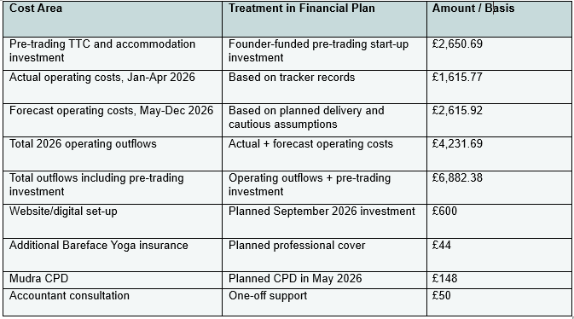
Source: Author’s own calculations based on the 12-month cash-flow forecast and income/expense tracker evidence in Appendix C, Figures C1-C5.

The table further shows that the main cost pressures arise from venue hire and a small number of planned professional and digital development costs, while the overall model remains relatively low-fixed-cost due to rented venues, no permanent premises and no employee wage commitments. Supporting evidence is provided in Appendix C, Figures C1-C5.

8.3 Revenue Projections and 12-Month Cash-Flow Forecast
The 12-month cash-flow forecast indicates that Sudha Yoga Journey can move from a modest early trading position towards a positive first-year cash position if cautious growth assumptions are achieved. The forecast uses actual January-April income and expenditure records, followed by May–December projections based on continued Nottingham classes, gradual Bareface Yoga workshops, limited one-to-one sessions, online delivery and a Derby class from September. This approach is appropriate because cash-flow forecasting should connect expected income, operating costs and payment timing, rather than only estimate general profitability (Răscolean and Rakos, 2018; Vidhate, 2018). The full cash-flow forecast is provided in Appendix C, Figure C1.
Table 8.2: Summary of 12-Month Cash-Flow Forecast
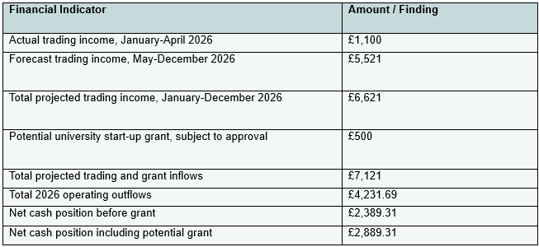
Source: Author’s own forecast, based on actual January-April 2026 income and expenditure records and forecast assumptions for May-December 2026.

. The forecast suggests that the business is financially viable on a cautious first-year basis, but remains sensitive to attendance, venue costs and one-off development expenditure. The September forecast shows temporary cash-flow pressure because the website/digital set-up is planned for that month. However, the overall year-end position remains positive, and the forecast deliberately excludes unconfirmed income from Everyone Active, future public grants, massage/Ayurveda services and product sales. This keeps the forecast conservative rather than dependent on income streams that have not yet been secured.

8.4 Monthly Break-Even Analysis and Financial Viability

Monthly cash position shows whether income covers all planned cash outflows in each month, including one-off costs such as CPD, website development and accounting support. Regular operating break-even shows the minimum income needed to cover recurring delivery costs once the business is operating more consistently. This distinction is important because early-stage cash-flow planning should consider both the timing of cash inflows and outflows and the sustainability of the recurring cost base (Răscolean and Rakos, 2018; Vidhate, 2018).
Table 8.3 shows that the business has negative cash positions in some early and development-heavy months, especially January, March and September. These shortfalls are linked to launch-period expenditure and one-off development costs rather than a consistently weak operating model. September shows a small shortfall of £13.49 because the website/digital set-up is planned for that month. This can be covered through accumulated cash from earlier positive months, founder contribution or the potential university start-up grant if approved.
For regular operating break-even, the most meaningful period is September-December, because this is when the forecast includes the fuller delivery model: Nottingham classes, Derby classes, Bareface Yoga workshops, online delivery and one-to-one sessions. Excluding exceptional one-off development costs only for analytical comparison, the business requires approximately £281.24 per month to cover recurring delivery costs. At £10 per participant, this is equivalent to around 29 participant attendances per month, or approximately 7-8 participants per weekly class. This is consistent with the current average attendance pattern recorded during the first months of teaching.
Overall, the first-year forecast indicates cautious financial viability rather than high profitability. The business can cover its regular operating base if attendance and workshop uptake remain close to forecast levels, but it remains sensitive to participant numbers, venue costs and the timing of planned development expenditure.
Table 8.3: Monthly Cash-Flow Break-Even Position, January-December 2026
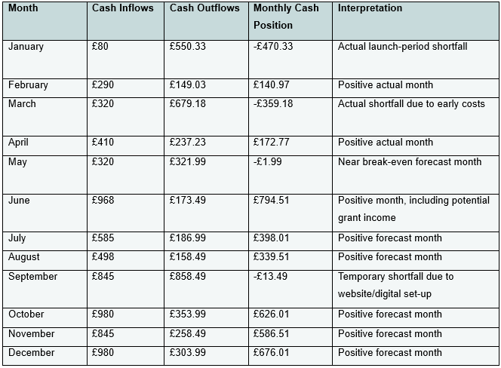
Source: Author’s own calculations based on the 12-month cash-flow forecast in Appendix C, Figure C1.

9. Risk Analysis and Mitigation Strategy

Sudha Yoga Journey is an early-stage, founder-led micro-business operating through rented venues, pay-as-you-go participation and phased growth. New venture literature highlights the “liability of newness” faced by early-stage businesses and the need to reduce uncertainty among customers and stakeholders (Shepherd, Douglas and Shanley, 2000). Start-up risk management is particularly relevant because new ventures are exposed to multiple risk categories while they are still developing routines, resources and resilience (Fauzi et al., 2022).
The risk approach is proportionate to the current scale of the business. Risks will be monitored through a small set of operational indicators: enquiries, average attendance, repeat participation, venue cost per session and monthly cash position. Cash-flow pressure remains especially important because new venture survival threats often concentrate around liquidity, limited resources and the ability to absorb shocks (Schulte, 2025). Risk ownership sits with the founder in Year 1 because the business has no employees and operational, financial and customer-facing decisions are centralised. Several risks are interdependent: attendance affects cash-flow, venue costs affect break-even, and founder capacity affects service quality and reputational outcomes. Mitigation therefore focuses on staged expansion and avoiding fixed commitments before demand signals stabilise.

Table 9.1: Risk Register and Mitigation Plan for Sudha Yoga Journey
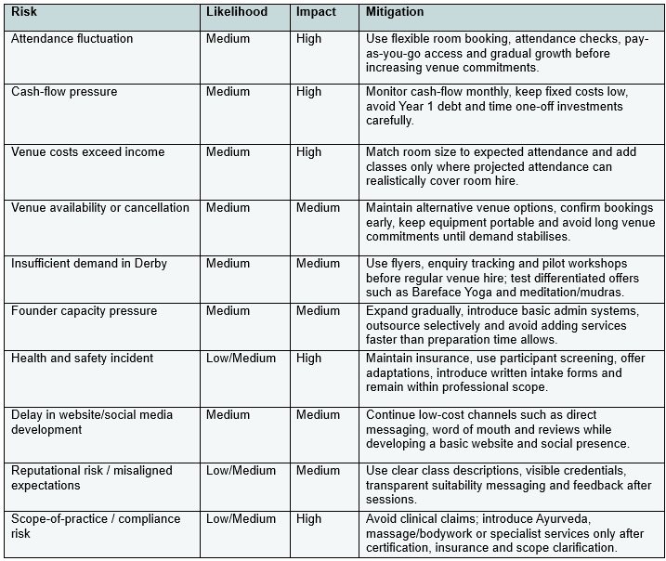
Source: Author’s own risk assessment, based on the financial plan, operational model, SWOT analysis and current trading position of Sudha Yoga Journey.

The risk register indicates that the strongest management priority is not eliminating all risk but maintaining operational flexibility while demand is still being tested. Additional classes, services and spending should proceed only where attendance, enquiries and cash-flow evidence support them. However, residual risk remains because demand, venue availability and founder capacity can change quickly; therefore, the plan prioritises monitoring and phased commitments over rapid expansion.

10. Implementation Plan for Sudha Yoga Journey

The implementation plan translates the operating model into a staged Year 1 action plan. The approach is intentionally phased: Sudha Yoga Journey expands only when attendance, enquiries and cash-flow evidence support additional commitments, consistent with lean and scale-up thinking that growth should remain evidence-led and aligned with operational capability (Maurya, 2016; Panigrahi, Nikou and Calabretta, 2025). The implementation priorities are therefore to strengthen basic systems, test Derby and partnership routes before fixed commitments, and build minimum viable digital infrastructure without over-investing ahead of traction.

Table 10.1: Year 1 Implementation Plan for Sudha Yoga Journey
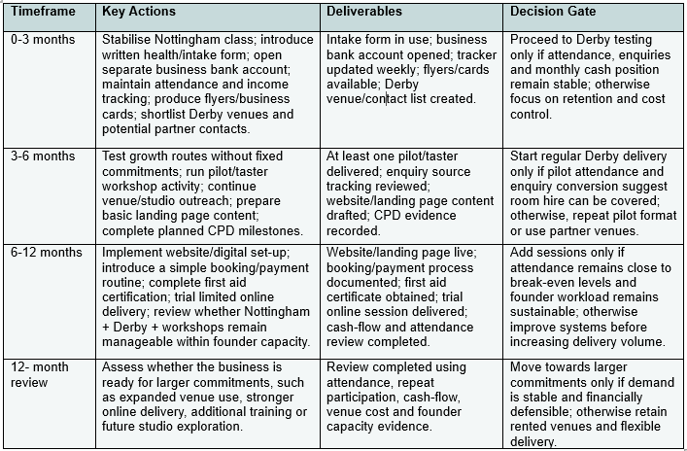
Source: Author’s own implementation plan, based on the operating model, financial plan, risk analysis and phased growth strategy.

The implementation logic is conditional rather than automatic. Derby classes, website spending, additional sessions and future service extensions proceed only where demand, repeat participation and cash-flow evidence support them. This protects the low fixed-cost model and recognises that founder capacity remains a practical constraint in Year 1. The plan therefore prioritises systems, evidence and controlled expansion over rapid growth.
Post-Year 1 Strategic Direction
Beyond the first-year implementation period, Sudha Yoga Journey may develop into a broader hybrid well-being brand if demand, qualifications and cash-flow capacity support this direction. Potential next-stage developments include massage/bodywork training, Ayurveda-informed consultations, a more developed website with online booking and resources, and a small online yoga studio or digital practice library. These are not included as committed Year 1 actions or confirmed income streams because they depend on further qualification, insurance, demand validation and funding. They are therefore treated as longer-term strategic options rather than immediate implementation commitments.

11. List of References

Abe, E.N., Abe, I.I. and Adisa, O. (2021) ‘Future of Work and Its Implication on Employee Well-Being in the 4IR Era’, in Abe, E.N. (ed.) Future of Work, Work-Family Satisfaction, and Employee Well-Being in the Fourth Industrial Revolution. Hershey, PA: IGI Global.
Akbar, M.A., Varias, V., Risa, T.D., Bhirawa, M.A. and Nugraha, R. (2025) ‘Workplace stress in the era of digital transformation: A psychological approach to employee well-being’, RIGGS: Journal of Artificial Intelligence and Digital Business, 4(3).
Ali, K.A., Ameen, A.A.M. and Tirwanshi, K.F.A. (2024) ‘The impact of marketing strategy on the sales performance: A study of micro and small enterprises’ owners’, IROCAMM, 7(1), pp. 65-86. Available at: https://doi.org/10.12795/IROCAMM.2024.v07.i01.04
Bachmann, N., Thienemann, A.-K., Tüzün, A., Brunner, M., Tripathi, S., Pöchtrager, S. and Jodlbauer, H. (2025) ‘The Evolution of the Business Model Canvas for Digital Sustainability’, Procedia Computer Science, 253, pp. 1012–1023.
Balwani, R.D., Choudhari, V.M. and Wasu, I.P. (2020) ‘Facial Yoga for Skin Rejuvenation’, International Ayurvedic Medical Journal (IAMJ), 8(4), pp. 3306-3309.
Barbosa, L.C.F.M., Reis, J.S.M., Mathias, M.A.S., Juliani, F., de Oliveira, O.J. and Santos, G. (2023) ‘Principles of business strategy: towards a holistic view’, Proceedings on Engineering Sciences, 5(4), pp. 679-692.
Bhoomika, B.R., Sharma, R., Shetty, V. and Archana, K. (2026) ‘Hasta Mudras in Yoga and Natyashastra: A Conceptual Review through the Lens of Embodied Cognition and Psychophysiological Correlates’, Indian Journal of Integrative Medicine, 6(1).
Brown, C.G. (2020) ‘Tibetan Singing Bowls - Los Cuencos Cantores Tibetanos’, American Religion, 1(2), pp. 52-73.
Brown, S.S.J. (2024) ‘Spirituality: A significant factor in yoga access for people with marginalised identities?’, in Obadia, L. and Pace, E. (eds.) Annual Review of the Sociology of Religion: The Sociology of Yoga, Meditation, and Asian Asceticism. Vol. 14. Leiden: Brill, pp. 100-123.

Brunner, M., Bachmann, N., Thienemann, A. K., Tüzün, A. and Jodlbauer, H. (2025) ‘To the end of the line - including intermediaries and end customers in the business model CANVAS’, Journal of Open Innovation: Technology, Market, and Complexity, 11, 100623.

Cassar, G. (2008) ‘Financial Statement and Projection Preparation in Start-up Ventures’.

Cartwright, T., Mason, H., Porter, A. and Pilkington, K. (2020) ‘Yoga practice in the UK: a cross-sectional survey of motivation, health benefits and behaviours’, BMJ Open, 10, e031848. Available at: https://bmjopen.bmj.com/content/10/1/e031848

Chen, S. (2015) Multichannel Marketing: A Generalised Framework, and the Antecedents and Consequences of Its Implementation. PhD thesis. Politecnico di Milano.

Csala, B., Springinsfeld, C.M. and Köteles, F. (2021) ‘The relationship between yoga and spirituality: A systematic review of empirical research’, Frontiers in Psychology, 12, 695939.

Dalingwater, L. (2019) ‘Linking health and well-being in public discourse and policy: The case of the UK’, Interventions economicus, 62.

Deeply Yoga Community (2026) Deeply Yoga Community. Available at: https://deeplyyoga.com/ (Accessed: 2 May 2026).

Derby City Council (2021) Census information. Available at: https://www.derby.gov.uk/council-and-democracy/statistics-census-information/census-information/

Derby City Council (2025) Climate Change Action Plan 2025–2027. Available at: https://www.derby.gov.uk/environment-and-planning/climate-change/council-climate-actions/#page-1
Divya Jeevan (2018) ‘Yoga of Synthesis’ by Sri Swami Sivananda [PDF].
Dysart, A., Barnett, J. and Harden, S.M. (2023) ‘Yoga studio websites: are they an accurate first glance at the studio’s mission, values, and resources?’, BMC Public Health, 23, 1622.
Fauzi, S.N.M., Ghazali, P.L., Abdul Razak, R., Mohamad Zain, E.N. and Muhammad, N. (2022) ‘A Review Paper on Risk Management of Start-up Business for Small Medium Entrepreneurs (SMEs)’, The Journal of Management Theory and Practice, 3(1), pp. 67–73.
Garmann-Johnsen, N.F., Olsen, D.H. and Eikebrokk, T.R. (2021) ‘The Co-creation Canvas’, Procedia Computer Science, 181, pp. 189–197.
Hartfiel, N., Clarke, G., Havenhand, J., Phillips, C. and Edwards, R.T. (2017) ‘Cost-effectiveness of yoga for managing musculoskeletal conditions in the workplace’, Occupational Medicine, 67(9), pp. 687-695.
Hotpod Yoga (2026) Hotpod Yoga Derby. Available at: https://hotpodyoga.com/studios/derby/ (Accessed: 2 May 2026).
Kiseleva, E.S. and Anikina, O.V. (2015) ‘Modern model of competences of personal agents as an increase factor of clients’ subjective well-being’, Procedia - Social and Behavioural Sciences, 166, pp. 116-121.
Knights Health & Fitness (2026) Knights Health & Fitness. Available at: https://www.knightshealthandfitness.co.uk/ (Accessed: 2 May 2026).
Kotler, P., Armstrong, G. and Balasubramanian, S. (2024) Principles of Marketing. 19th edn. Pearson.
Kumar, S., Gupta, K. and Joshi, A. (2025) ‘Workplace Holistic Health & Wellness: Primary care program to address lifestyle disorders’, Indian Journal of Community Health, 37(4), pp. 508-513.
Kyhnau, J. and Nielsen, C. (2015) ‘Review of Value Proposition Design: How to create products and services customers want’, Journal of Business Models, 3(1), pp. 81-89.
Lear, G. (2016) ‘Midlife awakening: An emergent transformation of the self’, Journal of Transformative Education, pp. 1–19.
Maher, J.P., Gottschall, J.S. and Conroy, D.E. (2015) ‘Perceptions of the activity, the social climate, and the self during group exercise classes regulate intrinsic satisfaction’, Frontiers in Psychology, 6, 1236.
Mama Blossom (2026) Home | Mama Blossom. Available at: https://www.mamablossom.com/ (Accessed: 2 May 2026).
Malmström, M. and Johansson, J. (2017) ‘Practising Business Model Management in New Ventures’, Journal of Business Models, 5(1), pp. 1-13.
Matko, K., Sedlmeier, P. and Bringmann, H.C. (2021) ‘Differential effects of ethical education, physical Hatha yoga, and mantra meditation on well-being and stress in healthy participants-An experimental single-case study’, Frontiers in Psychology, 12, 672301.
Maurya, A. (2016) Scaling Lean: Mastering the Key Metrics for Startup Growth. Portfolio/Penguin.
MindFit Yoga (2026) Yoga Teacher | MindFit Yoga | Derby. Available at: https://www.mindfityoga.co.uk/ (Accessed: 2 May 2026).
Michopoulou, E., Kudrakova, V. and Azara, I. (2015) ‘Suppliers’ perspectives on the affordability of wellness services’, Tourism and Hospitality Management, 21(2), pp. 127–142.
Moro Visconti, R. (2020) Cash flow forecasting of debt-free startups. Working paper.
Nalbant, G., Lewis, S. and Chattopadhyay, K. (2022) ‘Characteristics of Yoga Providers and Their Sessions and Attendees in the UK: A Cross-Sectional Survey’, International Journal of Environmental Research and Public Health, 19(4), 2212. Available at: https://www.mdpi.com/1660-4601/19/4/2212
Newcombe, S. (2009) ‘The Development of Modern Yoga: A Survey of the Field’, Religion Compass, 3(6), pp. 986–1002.
Nykiel, R.A. (2003) Marketing Your Business: A Guide to Developing a Strategic Marketing Plan. Best Business Books.
Ofcom (2025) Online Nation Report 2025. Available at: https://www.ofcom.org.uk/siteassets/resources/documents/research-and-data/online-research/online-nation/2025/online-nations-report-2025.pdf?v=409837
Office for National Statistics (ONS) (2026) Consumer price inflation, UK: March 2026. Available at: https://www.ons.gov.uk/economy/inflationandpriceindices/bulletins/consumerpriceinflation/march2026
Ojasalo, J. and Ojasalo, K. (2018) ‘Service logic business model canvas’, Journal of Research in Marketing and Entrepreneurship, 20(1), pp. 70-98.
Osterwalder, A. and Pigneur, Y. (2010) Business Model Generation: A Handbook for Visionaries, Game Changers, and Challengers. John Wiley & Sons.
Osterwalder, A., Pigneur, Y. and Tucci, C.L. (2005) ‘Clarifying business models: Origins, present, and future of the concept’, Communications of the Association for Information Systems, 16, pp. 1-25.
Panigrahi, A., Nikou, S. and Calabretta, G. (2025) ‘The sustainability scale-up framework: A tool to design scale-up strategies for sustainable businesses’, Sustainable Production and Consumption, 59, pp. 375-392.

Partanen, P. (2021) Defining a Framework for Collecting Customer Needs Using Jobs-to-be-done Theory and Outcome-driven Innovation Methodology: Case Study: Janssen, Pharmaceutical Company of Johnson & Johnson. MBA thesis. Laurea University of Applied Sciences.

Pickett, A.C. and Cunningham, G.B. (2017) ‘Creating Inclusive Physical Activity Spaces: The Case of Body-Positive Yoga’, Research Quarterly for Exercise and Sport, 88(3), pp. 329–338. Available at: doi:10.1080/02701367.2017.1335851

Porter, M.E. (1980) Competitive Strategy: Techniques for Analysing Industries and Competitors. Free Press.

Pressler, D. (2022) An Investigation to Inform and Create a Service Quality Model for the Fitness Industry in the Northwest of England. PhD thesis. University of Central Lancashire. (Submitted October).

Qastharin, A.R. (2015) ‘Business Model Canvas for Social Enterprise’, in Proceedings of the 7th Indonesia International Conference on Innovation, Entrepreneurship, and Small Business (IICIES 2015).
Ravikumar, H. and Sathyanarayanan, S. (2025) ‘Effects of Sound-based Meditative Healing Method on Stress, Tension, Cortisol’s Level & Blood Pressure: A Randomised Controlled Trial’ (preprint), Research Square. Posted 17 September 2025.
Ravindran, A.V., Choudhury, N., Bansal, N., Sinha, S., Lohana, P., Premkumar, T., Venkateswaran, R., Basu, P., Suseel, S. and Devasenapathy, N. (2026) ‘Awareness and attitudes towards Ayurveda in chronic disease management and related knowledge gaps among UK healthcare professionals: an analytical cross-sectional survey’, BMC Complementary Medicine and Therapies, 26, 89.
Reeves, T. and White, C.L. (2021) ‘Embodied instruction: An exploration and qualitative comparison of expression and performance of yoga instruction’, Frontiers in Education, 6, 683139.
Reformer Studio (2026) Arthur Street Studio - Derby. Available at: https://www.reformerstudio.co.uk/location/arthur-street (Accessed: 2 May 2026).
Sagar, S., Rastogi, R., Basavaraddi, I.V. and Garg, V. (2025) ‘Impact of yoga and meditation with mudras in building quality of life’, in Mohanty, S.N., Pradhan, R.K. and Priyadarshini, S. (eds.) Yoga and Meditation: Past and Present Evidence. New York: Apple Academic Press / CRC Press, pp. 135-157.
Schiele, C., Cramer, H., Louche, R., Kropp, P., Mueck-Weymann, M., Michalsen, A. and Brinkhaus, B. (2024) ‘Wellness or medicine? Use and perception of Ayurveda in Germany: data from an online-representative cross-sectional study’, Frontiers in Medicine, 11, 1408609.
Schulte, R. (2025) ‘New venture risk management: Theoretical framework and research perspectives’, Journal of the International Council for Small Business, 6(4), pp. 639–658.
Seitz, D.D. (2010) ‘An Overview of Regulatory Issues for Yoga, Yoga Therapy, and Ayurveda’, International Journal of Yoga Therapy, 20, pp. 34-40.
Sharp, D., Lorenc, A., Morris, R., Feder, G., Little, P., Hollinghurst, S., Mercer, S.W. and MacPherson, H. (2018) ‘Complementary medicine use, views, and experiences: a national survey in England’, BJGP Open. Available at: https://bjgpopen.org/content/2/4/bjgpopen18x101614

Sirgy, M.J. and Lee, D.-J. (2008) ‘Well-being marketing: An ethical business philosophy for consumer goods firms’, Journal of Business Ethics, 77, pp. 377-403.
Slávik, Š., Bednár, R. and Mišúnová Hudáková, I. (2021) ‘The structure of the start-up business model-Qualitative analysis’, Sustainability, 13, 8386.

Smit, C., and Cartwright, T. (2023) ‘Recommending yoga for health: A survey of perceptions among healthcare practitioners in the UK’, Complementary Therapies in Clinical Practice, 52, 101765.
Spadola, C.E., Rottapel, R., Khandpur, N., Kontos, E., Bertisch, S.M., Johnson, D.A., Quante, M., Khalsa, S.B.S., Saper, R.B. and Redline, S. (2017) ‘Enhancing yoga participation: A qualitative investigation of barriers and facilitators to yoga among predominantly racial/ethnic minority, low-income adults’, Complementary Therapies in Clinical Practice, 29, pp. 97-104.
Sport England / Active Lives (2024) An insight into adult physical activity behaviour in Derby: Active Lives Adults Survey 2022–23. Available at: https://makingourmove.org.uk/wp-content/uploads/2024/10/Year-8-22-23-full-Derby-CITY-Active-Lives-survey.pdf
Suhail, P. and Srinivasulu, Y. (2021) ‘Perception of service quality, satisfaction, and behavioural intentions in Ayurveda healthcare’, Journal of Ayurveda and Integrative Medicine, 12, pp. 93-101.
Tahan, H.A. and Sminkey, P.V. (2012) ‘Motivational interviewing: Building rapport with clients to encourage desirable behavioural and lifestyle changes’, Professional Case Management, 17(4), pp. 164-172.
The Breathing Space (2026) Breathing Space Yoga Derby: Yoga Classes, Workshops & Teacher Training. Available at: https://breathingspaceyogastudio.co.uk/ (Accessed: 2 May 2026).
UKactive, Sport England, 4GLOBAL and Deloitte (2025) UK Health & Fitness Market Report 2025 [PDF]. Commissioned by UKactive; analysis by Deloitte.
Verrue, J. (2014) A Critical Investigation of the Osterwalder Business Model Canvas: An In-depth Case Study. Working paper.
Virgin Active (2026) Nottingham | Health club with gym, pool, spa & classes. Available at: https://www.virginactive.co.uk/clubs/nottingham (Accessed: 2 May 2026).
Wadhen, V. and Cartwright, T. (2021) ‘Feasibility and outcome of an online streamed yoga intervention on stress and well-being of people working from home during COVID-19’, Work, 69, pp. 331-349.
Wang, Y., Jin, Z.-J., Jin, C.-H. and Kan, C. (2025) ‘Building customer loyalty through emotional connection: How service provider rapport drives sustainable business’, Sustainability, 17, 2396.
While I Breathe (2026) While I Breathe: Yoga and Ayurveda. Available at: https://www.whileibreathe.co.uk/ (Accessed: 2 May 2026).
Yell (2026) Yoga near me in the United Kingdom. Available at: https://www.yell.com/s/yoga-uk.html (Accessed: 2 May 2026).
York, J.M. (2018) ‘Putting Lean Startup into perspective: A novel approach for discovering and developing a successful business model’, Archives of Business Administration and Management, article ABAM-104.

12. Appendices

Appendix A: Summary of Publicly Available Online Information on Local Yoga and Well-being Providers

Table A1: Summary of Publicly Available Online Information on Local Yoga and Well-being Providers
Provider / Source | Location / Area | Provider Type | Publicly Stated Offer | Source to Cite
Knights Health and Fitness | South Derbyshire / Burton-on-Trent | Health and fitness facility with yoga, Pilates and well-being services | Beginner yoga, hot yoga, Vinyasa Flow, Yin Yoga, Restorative Yoga, Iron Yoga, Pilates, Reformer Pilates, swimming pool, sauna, treatments and memberships | Knights Health and Fitness website
Lotus Health and Well-being | Within Knights Health and Fitness | Treatment and holistic well-being provider | Body treatments, massages, facials, scalp rituals, reflexology, pregnancy treatments and children’s therapies | Lotus Health and Well-being / Knights Health and Fitness treatment page
Hotpod Yoga Derby | Derby | Specialist hot yoga studio | Hot yoga classes; website states classes are offered seven days a week and are suitable for women and men of all abilities | Hotpod Yoga Derby website
School of Reform / Arthur Street Studio | Derby | Pilates / reformer-style studio | Studio timetable, memberships, packages, classes, levels and community-focused studio description | School of Reform website
Virgin Active | Nottingham | Fitness/leisure club | Facilities shown include boxing, swimming, spa, studios and cycle; no yoga offer was identified from the provided screenshot | Virgin Active website
Mama Blossom | Derby/Local pregnancy/motherhood well-being provider | Pregnancy, birth, baby, postnatal and fertility-focused well-being provider | Classes, antenatal courses, massage, shop and support for fertility, pregnancy, birth, baby and motherhood | Mama Blossom website
The Breathing Space | Derby area / local yoga and wellness provider | Yoga, meditation and wellness space | Yoga timetable, workshops, yoga passes, yoga classes, teacher training, meditation and wellness | The Breathing Space website
Deeply Yoga Community | Derby / Heatherton Community Centre and other venues | Community yoga provider | Yoga classes in schools, community centres, studios, student halls, GP surgery, online, outdoors and chair yoga; includes asana, pranayama, meditation and relaxation | Deeply Yoga Community website
MindFit Yoga | Belper, Ripley, Barton Under Needwood, Matlock and online | Independent yoga, Pilates, mindful movement and private session provider | Mindful movement, Vinyasa Yoga, Pilates, Reformer Pilates, private sessions and online membership | MindFit Yoga website
The Luna Shala / While I Breathe: Yoga and Ayurveda | Ilkeston | Yoga, Ayurveda, breathwork and holistic healing studio/community space | Yoga for All, pregnancy yoga, Mama Yoga, baby and postnatal yoga, Dru Yoga, meditation circle, women’s circle, conscious connected breathwork and Ayurveda consultation | While I Breathe / The Luna Shala website
Yell directory: Yoga near Derby | Derby and the surrounding area | Public online business directory | Lists multiple yoga and complementary therapy providers in and around Derby, including independent teachers, studios and community-based providers | Yell website

Source: Author’s own review of publicly available online information from local provider websites and Yell directory, based on the sources listed in the final column.
Note: This table is used as supplementary competitor mapping based only on publicly available online information. It does not represent primary research with providers or customers.

Appendix B: Founder Credentials, Professional Profile, Brand Identity and Early Social Proof Evidence

Appendix B provides supporting screenshot evidence for the founder’s yoga-related qualifications, professional membership, early customer reviews and brand identity. These materials support the founder profile, SWOT analysis, key resources and early validation discussion in the main report.

Figure B1: Yoga Siromani Teacher Training Certificate, Sivananda Yoga Vedanta Centre, 2025

Source: Author’s personal training certificate issued by the Sivananda Yoga Vedanta Centre.

Figure B2: Bareface Yoga Level 1 Certificate, 2026

Source: Author’s personal training certificate issued by Bareface Yoga / Triple Goddess Yoga.

Figure B3: Asana Intelligence CPD Certificate, 2026

Source: Author’s personal CPD certificate issued through Yoga Pros Training Academy.
Figure B4: Vinyasa Krama CPD Certificate, 2026
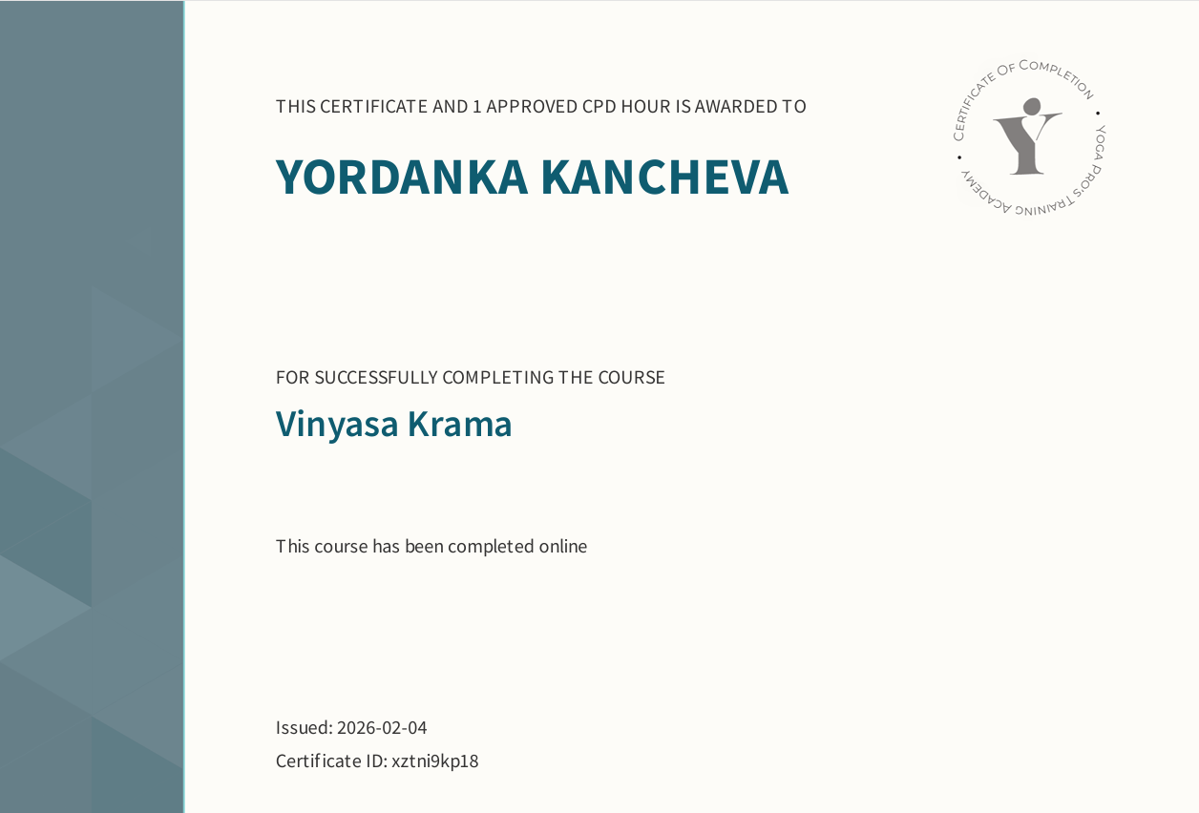
Source: Author’s personal CPD certificate issued through Yoga Pros Training Academy.

Figure B5: Yoga Alliance Professionals Teacher Profile Overview
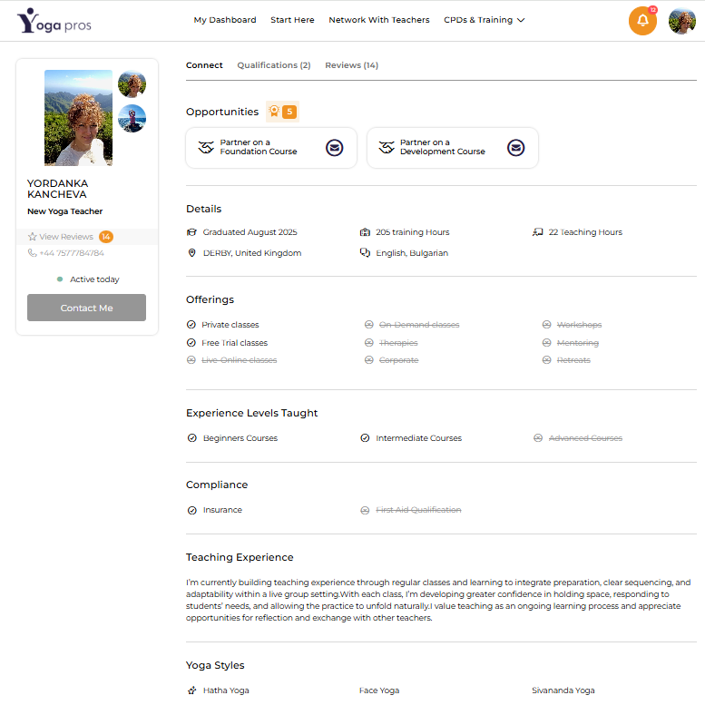

Source: Author’s own screenshot of Yoga Alliance Professionals teacher profile.

Figure B6: Yoga Alliance Professionals Review Evidence, Page 1
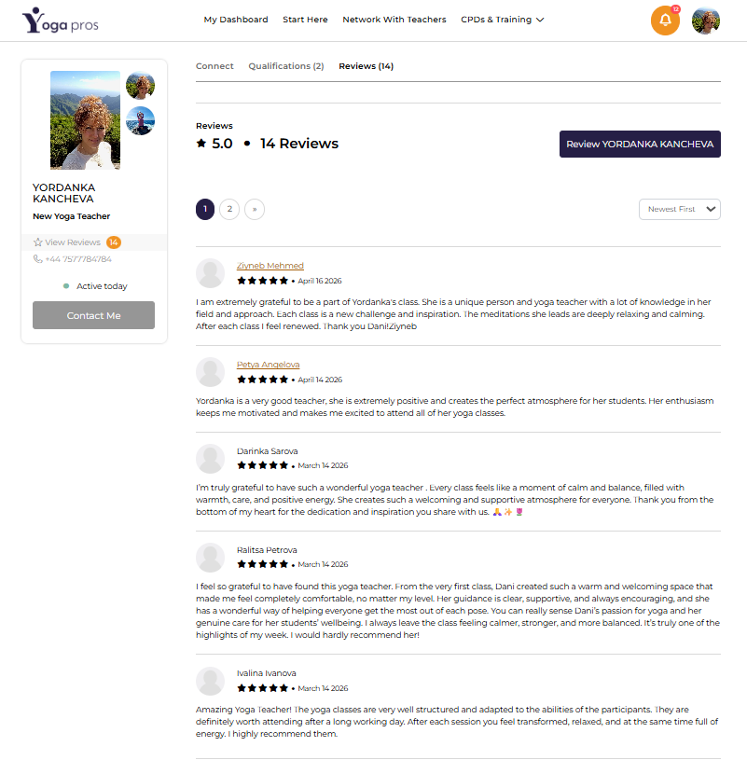
Source: Author’s own screenshot of Yoga Alliance Professionals review page

Figure B7: Yoga Alliance Professionals Review Evidence, Page 2
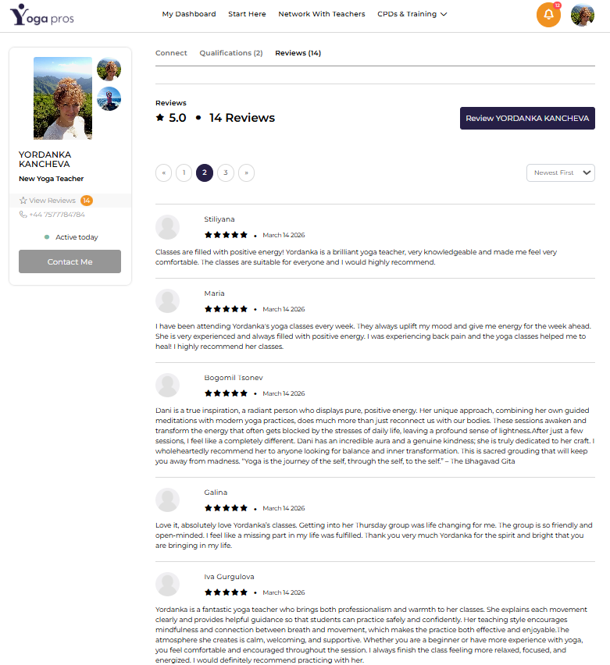
Source: Author’s own screenshot of Yoga Alliance Professionals review page.

Figure B8: Yoga Alliance Professionals Review Evidence, Page 3
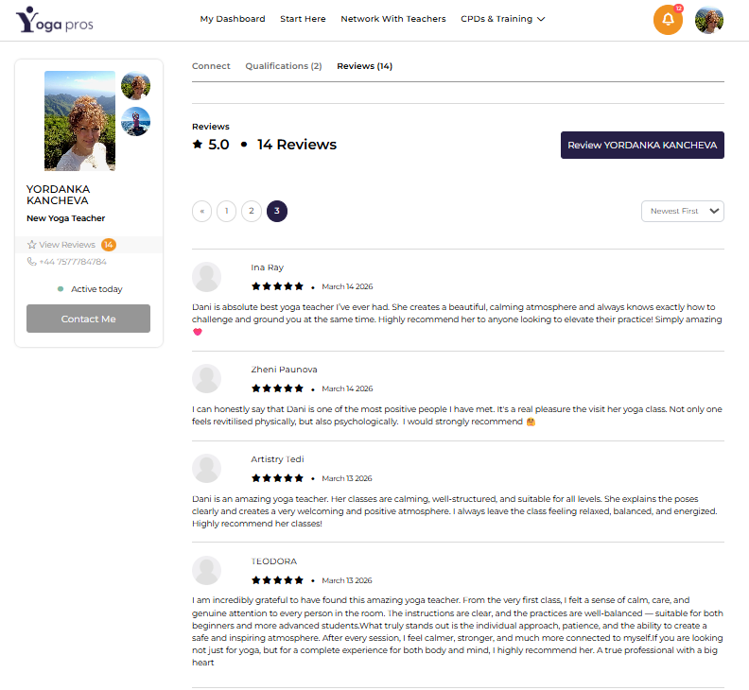
Source: Author’s own screenshot of Yoga Alliance Professionals review page.

Figure B9: Sivananda Spiritual Name Evidence for “Sudha”

Source: Author’s own photograph/screenshot of Sivananda spiritual name record.

Figure B10: Yoga Alliance Professionals Certified Yoga Teacher Badge

Source: Author’s own screenshot of Yoga Alliance Professionals certification badge.

Figure B11: Sudha Yoga Journey Logo and Brand Identity


Source: Author’s own brand material for Sudha Yoga Journey.
Appendix C: Financial Evidence and 12-Month Cash-Flow Forecast
Appendix C provides supporting financial evidence for the 12-month cash-flow forecast, actual income and expense records, and early attendance/income tracking. These figures support the financial assumptions and viability discussion in Section 8.
Figure C1: 12-month cash-flow forecast for Sudha Yoga Journey, January-December 2026
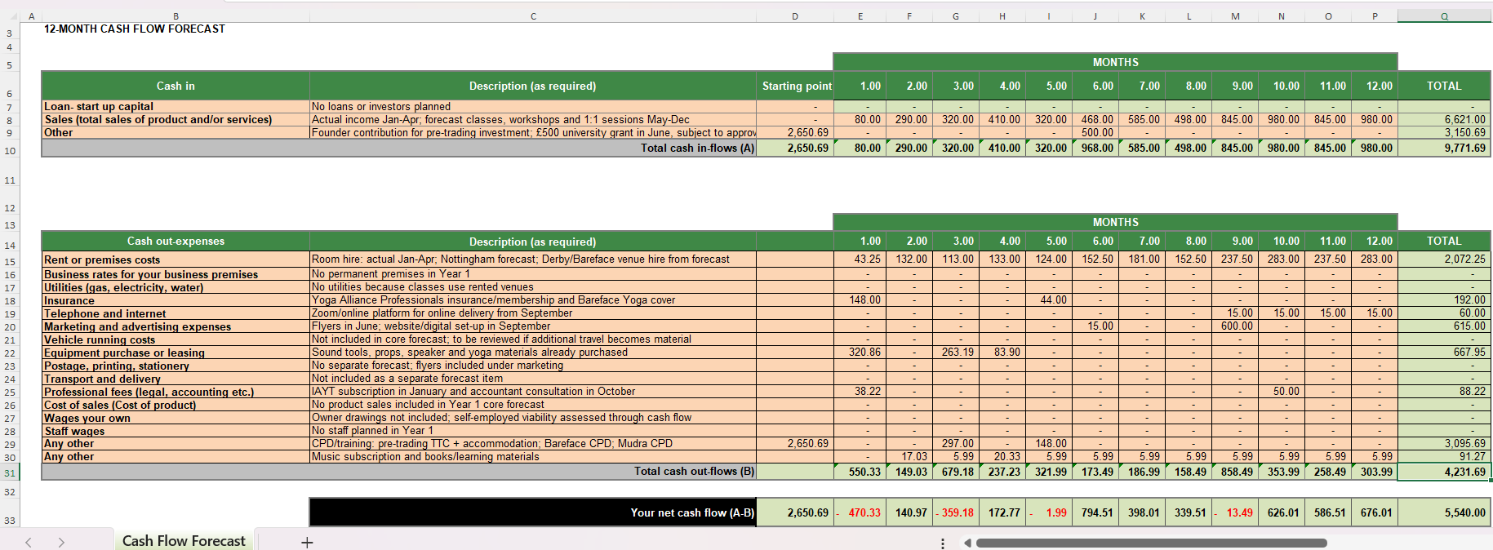
Source: Author’s own forecast, based on actual income and expenditure records for January-April 2026 and forecast assumptions for May-December 2026.

Figure C2: Expense Records for Sudha Yoga Journey, January-April 2026

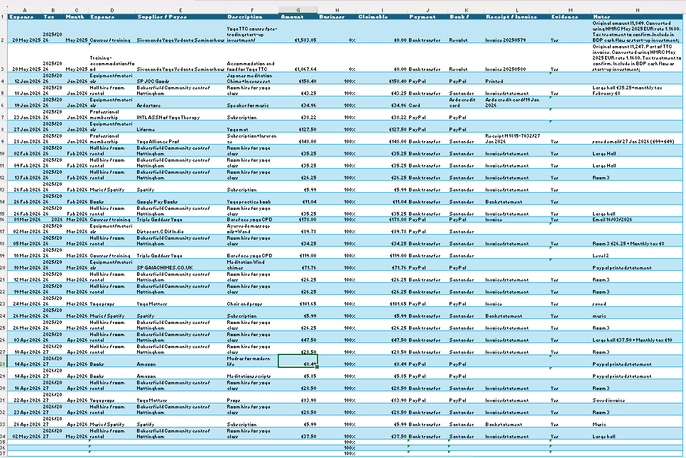
Source: Author’s own expense tracker and receipts/invoices.

Figure C3: Actual Income and Expense Dashboard for Sudha Yoga Journey, January-April 2026
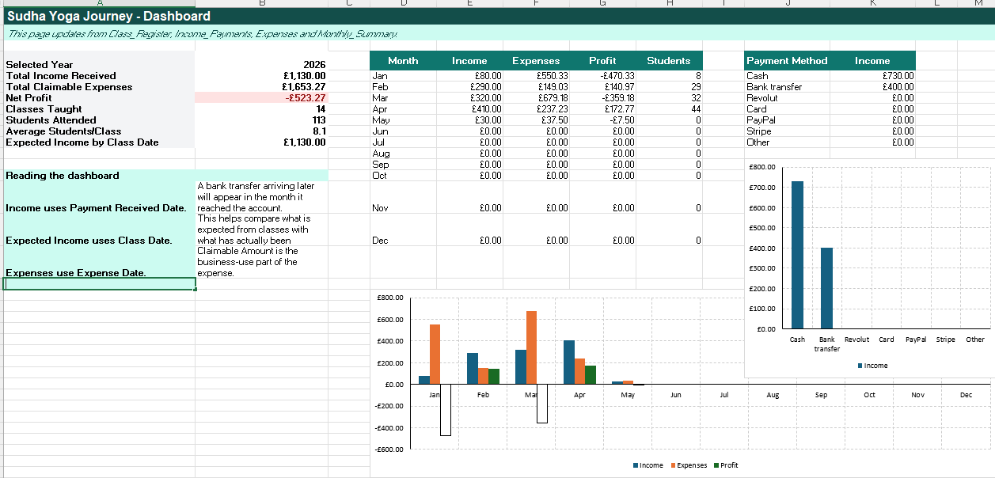
Source: Author’s own income and expense tracker.

Figure C4: Income payment records for Sudha Yoga Journey, January-April 2026
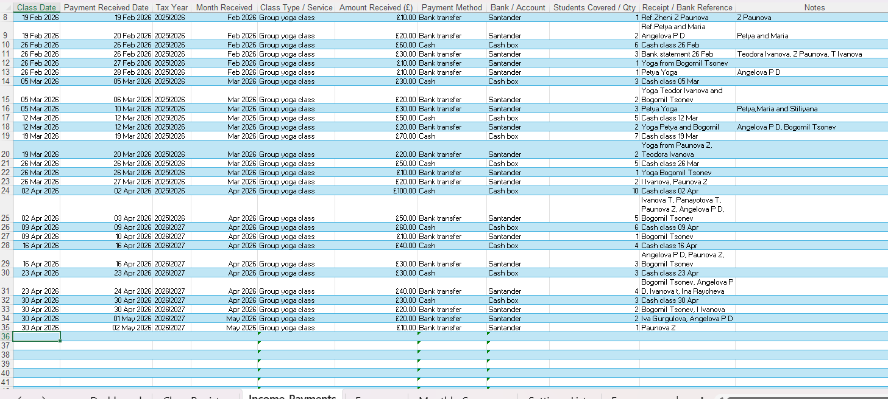
Source: Author’s own income tracker and payment records.

Figure C5: Monthly income, expense and attendance summary, January-April 2026
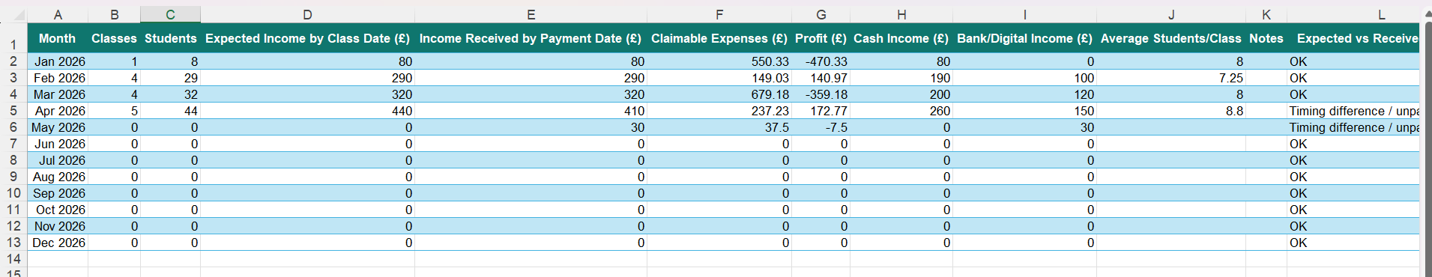
Source: Author’s own monthly summary tracker.

