Module Title: Problem Solving and Decision Making
Module Code: BMSK4004
Module Lecturer: Dr Gregory Cowan
Submitted by: Sadiya Affrin Tarin
Student ID: 1714273
Assignment Title: Business Optimization of
Coca-Cola

Executive Summary
Coca-Cola is the world’s largest manufacturer of beverages which has been facing a huge problem recently because of the lower demand of the carbonated beverages from the consumers around the world. The entire report focuses on this problem and how to resolve problem as soon as possible to regain the momentum of growth of this company. The report states the nature and scope of the problem that the company has been facing since 2013. And how to resolve the problem is discussed in this report. There are four alternative courses of actions that can be applied to regain the momentum in the growth such as increasing marketing spending, focusing on acquisition and merging, focusing on developing healthier variant of beverages and entering into emerging economies around the world. After the solutions have been adopted, the proposed solutions are communicated to the stakeholders of the company and continuous monitoring has been ensured to achieve what is expected.

Table of Contents
Introduction: 4
Background of the company: 4
Nature of the problem: 5
Scope and impact of the problem: 5
Collection and analysis of data: 7
Alternative solutions to the problem: 7
Increasing marketing spending on the health concerns: 7
Focusing more on the healthier variant of drinks: 7
Focusing more on the emerging economies: 8
Focusing more on acquisition and merging: 8
Techniques for decision making: 9
SWOT analysis of Coca-Cola: 9
PESTLE analysis of Coca-Cola: 11
Fishbone diagram and brainstorming for decision making: 13
Implementing solutions: 14
Communicating to the stakeholders: 15
Monitoring and Reviewing: 17
Conclusion: 18
References: 19

Introduction:
The following report is based on the case study of Coca-Cola which is global business having operations in more than 180 countries around the world. To operate a business in stiff competitive environment like beverages is very tough and the mangers of Coca-Cola have to continuously focus on the global issues in the process of doing businesses. The entire report is based on a major problem that Coca-Cola has been facing since 2013. The problem is the continuous declining in the sales and revenue of the company globally. So, the higher-level managers of Coca-Cola have been trying to find the major issues that have been causing the revenue and sales of the company decline since 2013. The report has been focused on the core problem characters and optimum solutions for the problem. And how the proposed solutions can be communicated to the stakeholders is discussed in the report (Sooktip and Wattanapongsakorn, 2015).

Background of the company:
The business of Coca-Cola is mainly based on the soft drinks products and the company has a long business history of 125 years. In 1886, the pharmacist John Stith Pemberton invented the formula of Coca-Cola that was a non-alcoholic beverage by mixing caramel-colored liquid with carbonated water and fragrant. Because of the specialty of the flavor and formula in 1889 Asa Candler purchased the formula and the brand. He then founded the company in1892. The current annual revenue of the company is 31.86 BN dollars (Bonheure, Derlet and de Valeriola, 2013). The company has a worldwide distribution network and has business in more than 180 countries around the world. The headquarter of the company is located in Atlanta, Georgia. At present the company serves more than 1.7 billion servings each and every day. The mission road map of the company starts with the mission statement which states that the purpose of Coca-Cola is to refresh the world, to inspire moments of happiness and optimism and to create value and make difference. The vision od the company is set with the sets of Ps such as people, portfolio, partners, planet, profit and productivity. The overall vision of the company is to maximize the return of the shareholders by greening the planet and making the workplace a better place for the large number of employees of the company (Westney, 2011).

Nature of the problem:
Despite the strong growth indicators of beverages industry around the world, the condition is getting grim day by day for the carbonated soft drinks segment of the industry. The carbonated beverage segment of the industry has lost its sales to the healthier beverages like, fruit juices, flavored water and health drinks. Specially the carbonated soft drinks sales are in a decline stage in the developing countries market where the consumers are more concerned with their health issues. Moreover, the taxation of the beverages company is very high because of the health concerns of the people. The Coca-Cola company names its carbonated beverage segment sparkling beverages. Over the last decade, the sparkling beverages have been seriously criticized by the consumers’ protection organization and the consumers themselves. Because the consumers complain that the drinks carbonated are contained with high level of sugar and caffeine (Filippetti, 2011). Some health agencies also revealed their concerns about the reasons behind diseases such as obesity, osteoporosis and diabetes. For these health concerns from the consumers, they have started moving to still beverages like noncarbonated flavored water, juices, coffee and ready-to-drink tea. For these reasons, the sales level of the company has been reducing at a rate of 1% annually. For this declining trend of the revenue level, the share price of the company also decreases at 2.1% annually (Sooktip and Wattanapongsakorn, 2015).

Scope and impact of the problem:
Coca-Cola’s sales volume of carbonated soft drinks worldwide is dropping by 1% annually which makes the company very uncomfortable in the eyes of the concerned stakeholders of the company. As the health concerns among the consumers of soft drinks are increasing day by day, the sales of the soft carbonated drinks are decreasing day by day. Over the last week, the sales dropped to 5.1% to 11.5 BN dollars. The decrease in the sales volume is the major part of the ongoing downturn in the selling of carbonated beverage by the company in the US and around the world. There was a major decline in the sales volume of the consumption of carbonated beverages in the US which was 1.2% in 2015 compared to the decline of 0.9% in 2014 (Peeters and Blake, 2016). Immense
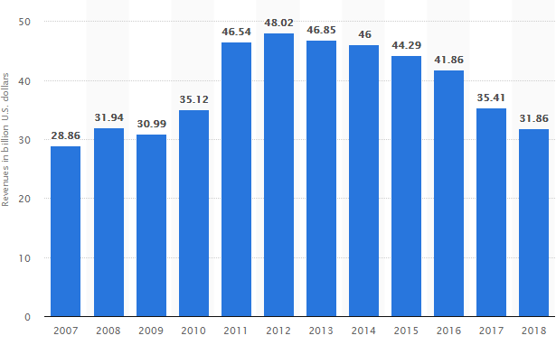Figure: Annual Sales in Billion Dollar
Source: (Coca-Cola, 2018)
pressures are coming out from the concerned stakeholders of the company because the share price of the company in the listed stock exchange is declining day by day which in turn reduces the wealth of the shareholders. This declining trends in the sales volume has a far-reaching impact on the overall performances of the company. Because as the demands of carbonated beverages are declining specially in the developing countries, the production of the carbonated beverages has been disrupted and sometimes the firing of worker in the factory level had occurred due to the loss of wages expense by the company. More the sales of the products produced by Coca-Cola, more the profit of the company. But this condition is hugely compromised due to the declining pattern of the consumption level by the consumers around the world. The major markets for Coca-Cola outside USA are China, India and Brazil. But the sales from these developing countries have been declining in a regular fashion by 4.9% on an average annually. So, the management of Coca-Cola has to revise their strategy to make changes in the company’s overall structure and hierarchy so that the problems can be resolved in a quick period of time (Peeters and Blake, 2016).

Collection and analysis of data:
The company needs data about the said problems regarding the reasons behind the declining of sales and revenue of the company over the few years. The data regarding the problems can be generated by creating a questionnaire and putting relevant questions on the questionnaire so that the target audience can exactly put their opinions on the questions asked to them. Their main opinions about the products of the company would be the major health concerns that the consumers right now are having regarding the carbonated beverage of the company. One thing about the data collection is that the data collection process must include the basic characteristics of the consumers so that the core reasons behind the revenue declining can be sorted out from the sample of the population. After the data has been collected from the target audience, the next task of the company would be the analysis of the data to find out the main reasons of the problems. The analysis of the data can be expedited by using the SPSS business tools to find out what are the main reasons behind the shortcoming of the company in a big deal (Peeters and Blake, 2016).

Alternative solutions to the problem:
To find the solutions to the problem stated above, the managers of the company need to dig into the core problems that impede the sales of the world largest manufacturer of soft drinks. According to the researches the following alternative solutions can be applied to resolve the problem immediately.

Increasing marketing spending on the health concerns:
The company can increase the budgets for the marketing department to strengthen the position in the market about the positive impacts of soft drinks that they sell to the consumers. The company can point out the advantages of the drinks to the market so that they can grab more market share form the competitors in the market (Bonheure, Derlet and de Valeriola, 2013).

Focusing more on the healthier variant of drinks:
As the health concerns for the carbonated beverages are growing high, the business of Coca-Cola should focus more on the other variant of soft drinks for the consumers. The other variant of the soft drinks might include flavored water, juices, health drinks and energy drinks. The consumers are deeply concerned with their health issues nowadays, so innovation in the healthier variant of soft drinks could bring the lost market in the business of Coca-Cola and boost up the revenue level of the company.

Figure: Alternative Solutions

Focusing more on the emerging economies:
Coca-Cola has the most growth potential in the emerging economies like China and Latin America. So, the company should work on to leverage this growth potential in those markets to increase the revenue base. The company should also increase the economies of scale by producing more products in the factory and sales the products to those emerging markets. There so many emerging markets where the demands for the soft drinks are increasing at a high rate. So, the company should consider entering into those markets more rigorously (Peeters and Blake, 2016).

Focusing more on acquisition and merging:
To maintain the growth of the company in sales and revenue, the company can acquire other companies with high growth potential in the same business area to maximize the growth stretch of the company. As an endeavor to resole this problem, the company had acquired 14% share of Green Mountain Coffee Roaster in 2014. By this acquisition, the company entered into the noncarbonated drinks and helped boosting the comprehensive revenue of the company (Bonheure, Derlet and de Valeriola, 2013).

Techniques for decision making:
There is a certain analysis that a company does when they try to solve a problem. The following analysis could be done in the context of Coca-Cola to reach a decision to solve the problem. The techniques are discussed below:

SWOT analysis of Coca-Cola:
The SWOT analysis of Coca-Cola is furnished below:
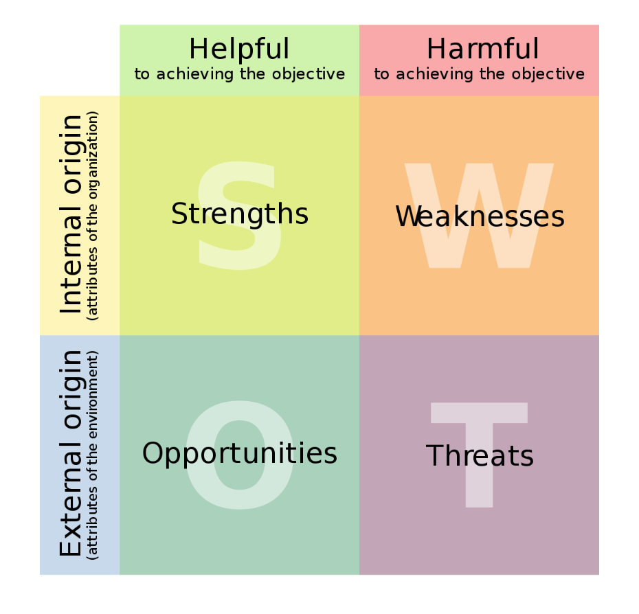
Figure: SWOT analysis matrix
Source: (Business-to-you, 2018)
Strengths | Weaknesses
- Brand equity, Coca-Cola has been awarded the most prestigious soft drinks brands in the world  - Company valuation, the fair value of Coca-Cola is over 80 BN dollars  - High global presence, the company has operations in more than 180 countries around the world which makes the company “too big to fail”  - Largest market share, there are only two rivals in this beverage market, Pepsi and Coca-Cola. Coca-Cola has the largest markets share.  - Customer loyalty, Coca-Cola has the most loyal customers in the world.  - Distribution network, the distribution network of Coca-Cola is worldwide which help the company meet the huge demand of the products (Mohammad Arabzad an, 2012). | - Rival Pepsi, the major rival is Pepsi which owns a big chunk of market share of this markets  - Less diversification, the product diversification of Coca-Cola is less where the product diversification is huge for Pepsi because Pepsi has snacks segment with Lays and Kurkure.  - Absence in health beverages, the business of Coca-Cola hugely lacks the products in the healthy drinks like juices, flavored water and healthy drinks  - Poor water management, in the past Coca-Cola faced so many challenges due to the poor water management in the company (Kawai, 2017).
Opportunities | Threats
- Diversification, diversification in the business segment of health and food business would improve the overall products offerings to the customers  - Emerging countries, the overall spending nature in the developing countries has been increasing. So, the company could enter into this emerging market for higher long-term growth.  - Packed drinking water, the health concerns among the consumers are increasing. So, Coca-Cola can make more bottled water to meet the incremental demands from the consumers.  - Supply chain improvement, the costs in the supply chain reduce the overall profit, the company might focus on this issue to bring improvements in this area (Vaněk, Mikoláš and Žváková, 2012). | - Sourcing of raw materials, water stands a great threat for the business of Coca-Cola because day by day the pure drinking water is getting shrunk in the world. The climate change is bringing the most negative impacts on this segment.  - Indirect competitors, the indirect competitors are the coffee chains like Starbucks, Café Coffee day, Costa Coffee etc. Because the demand for nonalcoholic beverages is getting higher day by day.

PESTLE analysis of Coca-Cola:
The PESTLE analysis of Coca-Cola is drawn below:
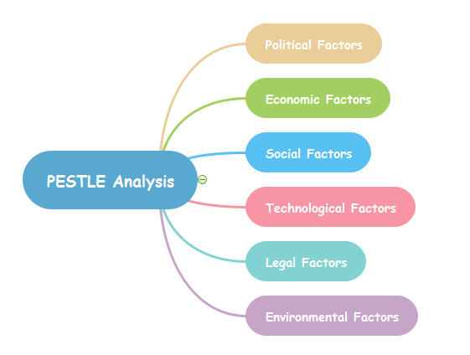
Figure: PESTLE analysis
Source: (Mindmap, 2018)

Political Factors | Economic Factors
- Coca-Cola highly depends on the political lobbying to make sure that the concerns and opinions of the company are being considered by the political decision makers.  - The rules and regulations set by the governments in which they operate, labor laws, consumer rights laws and other strict laws have to be complied by Coca-Cola to continue their business in that particular country (Arafat, 2018) | - The level of inflation, unemployment rate, GDP growth rate in the countries where Coca-Cola has operations hugely impact the business.  - If the level of inflation in the countries where Coca-Cola has operations decreases, the entire profit margin would be hampered because the money from those countries would be repatriated at a higher cost (Kampanje, 2012).
Social Factors | Technological Factors
- Social factors analyze the ways through which society is changing in terms of lifestyles and attitudes of the overall market that might affect the business of Coca-Cola.  - Consumers aging from 35 to 55 are more concerned with the nutrition facts of the soft drinks (Yüksel, 2012). | - The technology makes doing business easier. So, any changes in the technology by the company or by the competitors impact business of Coca-Cola.  - Technological factors increase the opportunities for product development and products improvements for the soft drink companies.
Legal Factors | Environmental Factors
- The consumers protections laws, labor laws and other laws enforced for the business context are being amended in a continuous fashion which could impact the business of Coca-Cola in which countries they operate their businesses.  - The products of Coca-Cola should be patented with the countries respective paten laws to protect the products from being copied by other companies. | - Environmental analysis finds the factors that might have strong impact on the businesses of the Coca-Cola. The factors could be pure water management, environmental degradation, air pollution by the factories and emitting carbon dioxide.  - All of the factories should be closely monitored by the headquarter of the company so that it can be ensured that the business is complying with the rules and regulations set by the government (Yüksel, 2012).

Fishbone diagram and brainstorming for decision making:
The fishbone diagram is a very powerful technique for categorizing the roots of a problem and find the causes of a particular problem. Fishbone diagrams also helpful for running brainstorming session to find out the reasons behind a problem. The problem associated with Coca-Cola is analyzed with the help of fishbone diagram below:
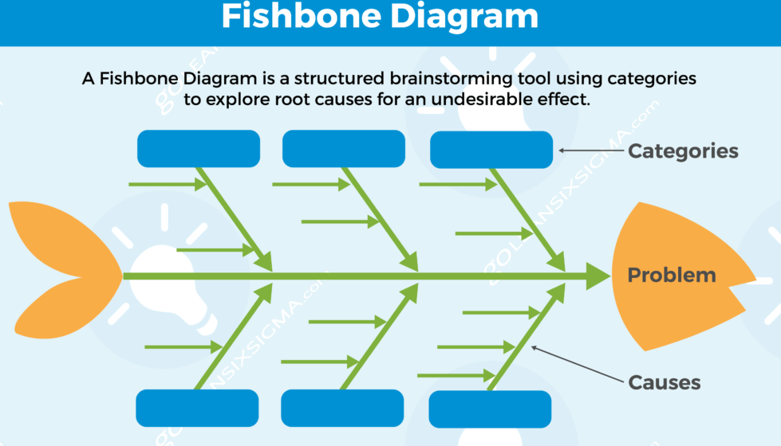
Figure: Fishbone Diagram
Source: (SixSigma, 2018)
The main problem that Coca-Cola has been facing recently is declining the sales and revenue level worldwide. The problem happening can be attributed to some major sub issues that make the problem long lasting for Coca-Cola. The first sub problem of the company is the losing demands due to increased health concerns regarding the carbonated beverages by the consumers (Jukić, 2019). The second sub problem is the stiff competition in the market which comes from the major rivals in the market and the health products that have been offered to the market. The third sub problem that causes the main problem of Coca-Cola is the lower availability of the raw materials that is the pure water which is shrinking day by day. The Coca-Cola uses water as the most important raw material for making the carbonated beverages and other soft drinks for the consumers but day by day the pure drinking water has been shrinking from the earth and it causes a great problem for Coca-Cola to do their day to day business. Another sub problem that triggers the main problem of Coca-Cola is the switching of demands from the carbonated market to the health drinks and food markets like coffee, health drinks, green tea, juices and bottled flavored water. These products continuously attract the concerned consumers and they day by day are increasing their buying of those products from the market which cause the problem to sustain for a certain of time (Sax and Andersen, 2018).
The fishbone diagram is also very useful to run a brainstorming session to find out the major sub problems that cause the main problem of the company. In the brainstorming session, the higher-level managers invite the front level managers to join the brainstorming session so that the front level managers can best opine that the main problem that is currently prevailing in the company is triggered by the core sub problems. After generating so many ideas about the problem, the higher-level managers select the most influential problems that might cause the root problems sustain for a long period of time. It has been also argued that the brainstorming session is very powerful and useful in terms of an organization that is flat in terms of the structure of the organization. So, Coca-Cola has to consider this thing to find the best solutions of the problems (Bonheure, Derlet and de Valeriola, 2013).

Implementing solutions:

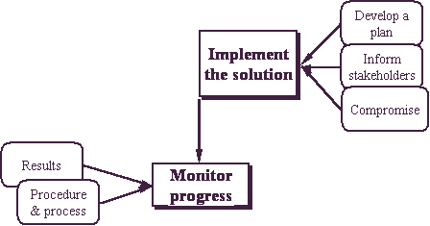
Figure: Implementation of solutions
Source: (Business Insider, 2018)
Now is the time to implement the solutions of the problems of declining sales growth and lower revenue of Coca-Cola. To implement the solutions that have been sort out by fishbone diagram and the brainstorming session, the managers of Coca-Cola have to follow certain steps. The first step that can be taken to implement the solutions is develop an overall plan that has to be followed throughout the course of implementing the solutions of the problems. For example, to implement the solution of focusing on merging and acquiring other similar companies, the company can develop a plan to find out the probable target company with the highest potential of growth in the market and in the long run and take managerial steps to acquire the company or set a merging situations to maintain the future growth and revenue increment.

Communicating to the stakeholders:
In this step, the mangers of Coca-Cola have to communicate the proposed solutions to the major stakeholders of the company. The stakeholders to which the proposed solutions must be communicated are discussed briefly in the following discussion.
To shareholders:
Firstly, the proposed solutions should be addressed to the shareholders saying that the possible impacts that the proposed solutions would bring to the company after the undertaking of the solutions. The shareholders of Coca-Cola are the most important stakeholders because they provide the necessary fund to run the business of Coca-Cola in the market (Saunders, Wong and Saunders, 2011). So, what will be the aftermath of implementing those selected solutions must be addressed to the shareholders (Bonheure, Derlet and de Valeriola, 2013).
To employees:
The next most important stakeholder to which the higher-level managers of the company should communicate the proposed solution is employees. Because employees are the ultimate players who will actively implement the solutions on behalf of the shareholders of Coca-Cola. So, the actual need of the proposed solution must be communicated properly to the employees.


Figure: Stakeholders of Coca-Cola
Source: (Business Insider, 2018)

To suppliers:
The suppliers of Coca-Cola have a huge stake in the company. So, it is very wise for the managers of Coca-Cola to communicate the proposed solutions to the suppliers to make them involve with the decision-making process of the company.
To regulators:
The regulators of the area in which the company is operating its business are very crucial stakeholders for the company. What will be the impacts of the solutions that have been selected on the society and on the consumers of the area have to be smoothly communicated with the regulators of the company.

Monitoring and Reviewing:
After the implementation of the solutions has been done, the next step comes up is the follow up of the decision taken. In this stage of controlling the actions taken by the company, the managers of Coca-Cola need to continuously monitor the consequences of the actions so that any amendments can be done if the plan has not worked according to the plan (Saunders, Wong and Saunders, 2011). If it is apparent that the decisions that have been taken are not working according to what is expected, then the committee responsible for reviewing and monitoring of the plan must take actions to amend the plan. It is not like that the actions have been taken and it will automatically perform in line with what is expected from the company. But it is that, the managers continuously have to monitor the decisions that have been taken and review the actions of the employees whether they are doing in accordance with what is expected or not.

Conclusion:
To draw the conclusion, it can be said that the business of Coca-Cola has so many uncertainties in the environment where they are doing their business. So, the managers of the company have to always be careful about the ongoing patterns of the business so that the company can reap the benefits of the externa environments. The SWOT analysis and the PESTLE analysis have given us the insights about the company’s external and internal capabilities that the company has in terms of doing business worldwide (Chung, 2014).

References:
Arafat, L. (2018). Faktor Eksternal Industri Pariwisata di Kota Padang dengan Pendekatan Pestel Analysis. Jurnal Pariwisata Pesona, 3(2).
Bonheure, D., Derlet, A. and de Valeriola, S. (2013). On the multiplicity of nodal solutions of a prescribed mean curvature problem. Mathematische Nachrichten, 286(11-12), pp.1072-1086.
Chung, H. (2014). The role of family management and ownership on semi-globalization pattern of globalization: The case of family business groups. International Business Review, 23(1), pp.260-271.
Filippetti, A. (2011). The Global Environment of Business. Global Policy, 2(3), pp.354-354.
Jukić, D. (2019). Strategic analysis of corporate marketing in culture management. Strategic Management, 24(1), pp.10-18.
Kampanje, B. (2012). Pestel Analysis of Malawi's Non-Life Insurance Industry. SSRN Electronic Journal.
Kawai, T. (2017). The historicity and potential of Jungian analysis: another view of ‘SWOT’. Journal of Analytical Psychology, 62(5), pp.650-657.
Mohammad Arabzad an, S. (2012). Improving Project Management Process in Municipality Based on SWOT Analysis. International Journal of Engineering and Technology, 4(5), pp.607-612.
Peeters, A. and Blake, M. (2016). Socioeconomic Inequalities in Diet Quality: from Identifying the Problem to Implementing Solutions. Current Nutrition Reports, 5(3), pp.150-159.
Saunders, J., Wong, V. and Saunders, C. (2011). The Research Evaluation and Globalization of Business Research. British Journal of Management, 22(3), pp.401-419.
Sax, J. and Andersen, T. (2018). Making Risk Management Strategic: Integrating Enterprise Risk Management with Strategic Planning. European Management Review.
Sooktip, T. and Wattanapongsakorn, N. (2015). Identifying preferred solutions for multi-objective optimization: application to capacitated vehicle routing problem. Cluster Computing, 18(4), pp.1435-1448.
Vaněk, M., Mikoláš, M. and Žváková, K. (2012). Evaluation Methods of Swot Analysis / Metody Vyhodnocení Swot Analýzy. GeoScience Engineering, 58(2), pp.23-31.
Westney, D. (2011). Global strategy and global business environment: changing models of the global business environment. Global Strategy Journal, 1(3-4), pp.377-381.
Yüksel, I. (2012). Developing a Multi-Criteria Decision Making Model for PESTEL Analysis. International Journal of Business and Management, 7(24).

