Network Operating Systems Assessment
Paper Number Four
Mark L. E. Vaughan
#Undergraduate, University of Wales Trinity St David
Swansea Wales
1909160@student.uwtsd.ac.uk

Abstract— This document is the fourth of four papers detailing the practical work and observations to install two virtual networks utilising the Microsoft Hyper-V software. As part of the Network Operating Systems assignment.

Introduction
Work Sheet four deals with the installation of routing functions, service and resource redundancy and failover practices. This work involves the activation of remote access and routing services the effectively turns the server into a software router and demonstrates the purpose and function or the address resolution protocol (ARP) and the Routing Information Protocol Version 2 (RIPv2). As bread has butter the routers have firewalls. Here, the IP services are used to demonstrate the process of packet filtering that is used in firewalls (both packet filter and stateful inspection types). The last part of the worksheet is a research-based task that deals with system security and data integrity. If requires investigation into the use of failover clusters and their application within a server environment.
Processing of the worksheet was extremely simple. The first task simply demonstrated the use of the ARP command in the terminal that displays the internal table content that provides gateway, IP address and net masking information. This was performed with no trouble as the author first learnt to use this tool in 1994 with my first installation of Slackware version 1.4. The second task is to install and configure an file transfer protocol (FTP) server. This task was a little more interesting than previous. Being experienced in setting up FTP Daemons on BSD and Linux systems, the Windows server install was more a lesson on navigating the setup wizards than gaining technical information. The task also required a test configuration to be configured and a specified file to be transferred. This was performed without incident. One thing I did learn from this assignment is to set windows update to activate installs on shutdown. This annoying but important Windows service has a habit of installing updates with little or no warning when one is working. This situation occurred just before the author started task three. This update closed all the VM's and rebooted the pc several times. The one upside is that it provided the opportunity for a suitable coffee break. Task three was the installation of the remote access and routing services. This is the service that manages the gateway features of the servers and allows the subnets to communicate with each other, process authentication and manages Virtual Network Connections. At this point the author would install a third network adaptor to connect to the host network using a NAT connection. This would be to allow the server to connect to the internet. On this occasion this was not done. This reasons for this omission are that internet connectivity was not required for this exercise and the networks were configured to run on a Hyper-V switch configuration that specifically isolated the host from the test environment to minimise side effects from any bridging adaptor. As with task two, this activity was a navigational exercise of the software interface. It was a much easier task to perform compared to other OS's. Installation of these services on non-Microsoft systems consists of a lot of tinkering with configuration files on a command-line interface or with vi editors and fooling around with package management software, repositories and the like.
Task four was the application of IP filters on the network. In this application, the filters are built into the Remote Access and Routing component of the server system. On foreign systems, this is often handled by dedicated firewall software such as IPChains or IPTables. The exercise is to demonstrate the application of filters to communication channels of both inbound and outbound modes. The ruleset implementation is simple and lacked the complication that s often found with Stateful inspection type firewall systems that often have multiple entries covering a mix of protocols and port addresses. The testing regime for this task was the passing or blocking of ICMP packets across the firewall. This was performed with the expected results. Tasks five and six were research tasks, the result of which is presented in section two – Observations.

II. Observations

Observation 3a
Except for stand-alone networks, the presence of a router is mandatory. This network device acts as the gateway to the outside world for the network being served. As a network device, routers will need to store details about other networks to which they are connected. This is where the RIP of Routing Information Protocol is used. This protocol facilitates storing network routing location data as a set of internal tables that pair router IP addresses to network Addresses. The protocol updates these tables by transmitting and receiving routing information from connected routers via UDP message packets (port:520). The messages can request copies of routing tables from neighbouring routers or issue a table transfer to a request. With extensive networks, the tables can become very large that will slow down network operation. The protocol has been designed to limit the number of records in a table by setting sixteen hops per router. A hop is defined as the connection between routers. In this way, the tables can be kept to a manageable size and avoid circular referencing in ring-based topologies. Other problems can occur with large hop values, and techniques such as split-horizon advertising, route poisoning and hold-down are used to eliminate these problems.
Split-horizon is a technique used in distance-vector systems to eliminate closed routing loops. The method specifies that a routing entry is disallowed if the calling interface is referenced in the routing message, thereby preventing the closing of a routing loop. Route poisoning is used to prevent non-available routes from being broadcast or used. During regular operation of a network, there will be occasions where a router may cease communication or leave the network. In this event, routing information for that router will become erroneous and would cause wait states to arise within the net. The protocol deals with this by poisoning the route, which is a message designed to inform other routers that the routing entry is invalid and dropped. The poisoning message will cease to exist once all the routing tables have been synchronised in line with the network state. Despite the inclusion of randomisation to network timers, network synchronisation will present another problem. Multiple routers may be at conflicting states of synchrony and transmit routing data that may not be current. A typical example of this problem is the handling of poisoned routes. A router receiving a poisoned route message, would by default, ignore that route. However, if the router receives another message that reinstates access to that route from a desynchronised router, then the table entry becomes unstable if subsequent messages contradict each other. This eventuality is where they hold down protocol is used. The protocol deals with the problem by introducing a timed auto discard interval after the initial route not accessible message. The principle is to allow desynchronised routing tables to synchronise, so that false routing data is ignored. After the interval expires, the requesting router can receive accurate table entries that align with the network router system's current state.
At the time of writing, there are two main versions of the RIP protocol. Version one is the original version that was introduced in 1988 and is based on RFC1058. This version set the standard for the protocols and the design of the internal routing tables. For reference, the tables consist of entries for the reachable IP address, hop count and the sending interface address.
This version has several shortfalls that were corrected in the version two release that is now considered the recommended version.
Version two was released in 1993 and is based on RFC1723. With the new version, the following changes were made:

- Multicasting of routing tables on 224.0.0.0
- Introduction of MD5 authentication (introduced in 1997)
- Support of CIDR addressing methods and subnetting.
- Backward compatibility with version 1 messaging.

The new version offered authentication and improved security by adding encrypted passwords. Class-based addressing was dropped, and message packets now carried subnet information that would now work with network addressing architectures that used classless implementations and VLSM masking methodologies. It also reduced network loads by sending routing tables via multicast on address 224.0.0.0, which is more effective than the broadcast method used on version one. The is also a next-gen version of the protocol called RIPng, which was defined in RFC2080. This version is an extension to RIP V2 that supports IPV6 networking. The main changes are:

• Discontinued support for RIP V1
• Use of IPSEC for authentication
• Table updating is now sent on port 521
• Support for IPV6

This version of RIP is currently under development and has not been officially adopted by the IETF.

Observation 5a
Failover Cluster
To explain the concepts of failover clusters, we must first determine what a failover cluster is. The term failover cluster consists of two words that describe a switching process that occurs when there is a failure and a group of related objects. In terms of computer servers, this represents a group of servers that undertake the function of a failing server. The object of a cluster like this is to maintain systemic function(s) in hardware failure or maintenance. This system is different from fail-safe and failback systems. Failsafe refers to a process where a device or system is designed to fail in a manner that renders the system safe. An example of a failsafe system is the uninterruptable power supply (UPS). When triggered, it sends a shutdown signal to the supporting server. It provides enough power to the server to allow the software to process the closure of file systems, communication links and the storage of internal and system state data before the power flatlines. In this manner, the data and system state data are stores in a safe state and are ready for re initialisation once the cause of the power outage is resolved. Failback systems are also different in that in the event of failure, the failing process or system is transferred to a secondary system that undertakes the process to operate in the failed system. The secondary system being emplaced to protect the asset concerned uniquely. This is different to failover systems as the backup equipment is usually on standby during normal operation. Failover systems utilise all the assets in the cluster and eliminate the inefficient use of non-functional hardware as part of the operational process. They also operate with a higher redundancy factor to ensure more efficient operation.

Usage considerations.
Typical usage for failover clusters is to provide high availability (HA) or continuous availability (CA) systems. HA systems have the requirement to process client requests and access resources quickly and with minimal delay. Example of such HA-based systems includes web servers and backup systems.CA systems, on the other hand, do not have the exact requirements as HA systems. Instead, CA systems need to operate continuously and are used for operating system critical functions. An example of such a system would be the DNS server which requires constant operation to maintain internetwork connectivity in a network environment.
When considering high and constant availability functions, several factors need to be considered. The initial consideration is the degree of use required for the failover cluster to operate. The term used for this is Traffic Loading. With CA applications, the loading on the server is generally consistent with only mild variation in flow rate. HA applications tend to have more variable loadings. These traffic loading factors also need to be calculated with the expected extra loads acquired when a cluster component fails. The determination of these calculations will indicate the size of the cluster and the resources required for efficient operation. An additional factor would be to include the use of load balancing in the operation of the cluster. The purpose of load balancing is to ensure that server requests do not impair data processing on any one server by distributing server request across cluster members. This function makes HA systems more efficient in data processing and optimises each cluster members operations. CA functions can use load balancing, but as their load is constant, they generally do not require it. Instead, a primary server manages most requests with a handoff facility to delegate requests once the traffic load exceeds a specified limit.
This situation is where the quorum feature becomes relevant. Based on the ancient Roman system for convening a court to make judgments according to a vote, the quorum in a failover cluster determines the operational state of a cluster member. The typical organisation of a failover cluster revolves around a central subnet hub known as the heartbeat. The function of the heartbeat is to convey server state information to other members of the cluster. This server state information is based on system metrics such a network data rate, processor usage and memory usage values. Every member of the cluster evaluates this information. A vote is taken to check the fitness of the server in the cluster. If a particular server's state diverges from the cluster norm, the cluster is removed from cluster operation and flagged for corrective action. This method is helpful because it can transfer workloads from a failing server before the server fails. The technique has the virtue of maintaining cluster reliability and, at the same time, optimising system maintenance planning as it can be used to disconnect a server from the cluster without disrupting server operations.
One final consideration to be made when constructing failover clusters is the matter of the cost-benefit ratio. While not a technical calculation, the cost of implementing will have a bearing on introducing a new cluster. As an administrator, a technical manager will always have to justify the cost to upper management, influencing the cluster's design and configuration.
In the windows server environment, failover clusters can be applied to several roles. One such role would be managing files and storage as typified by the files and storage management role. Failure of the file server would seriously disrupt most networks, so keeping the servers up and running can be considered a critical function. By clustering the file servers, file access is improved, and extra integrity protection is gained. The files can be stored in the network-attached storage subsystem separate from the servers themselves and have independent protection systems such as RAID-6 configurations. The typical failover configuration for this service would ordinarily lean to a High Availability design. Still, a better option would be to configure a Constant Availability system with dual primary servers that would give better network access and have additional servers load balancing or secondary processing. Such an installation would consist of between three to four non-virtual servers with backup power supplies; also, real-world servers allow the cluster to be physically separated across the site to increase the physical protection from accident fire. Virtual servers would typically reside on a single machine that would introduce an unwanted single point of failure. The use of virtual servers on separate stand-alone devices would not be cost-effective.

Observation 6a

<Generic Network Diagram here>

- Network management Description
Adoption of Active Directory at all levels.
Domain forest to include domains for outlying sites.
Implementation of an Information security manager (Separate from Site Security).
Adoption of Acceptable Use and BOYD policies for all staffing levels.
Set policy for regular replacement of drives and storage racks as part of standard maintenance.
Regular evaluation of onsite redundant power supplies and power generation.
Regular security reviews to be instituted as part of an ongoing risk assessment cycle.
Network links to be based on IPV6 for additional speed subject to ISP availability.
Use of round robin server configurations for short cycle backup of active files.

- Security design

Use of VPN to secure communication links.
Application of IPsec with corporate key repositories.
Use of multilayer onion skin model to secure networks (min 3 internal firewalls).
Administration accounts to be secured with Hardware FIDO keys.
Limitation of web access to authorised sites only.
Third party endpoint security to be used on workstations. (backup for AD user access policy).
Implementation of a corporate password manager such as Dashlane. Policy to enforce a 16+ character passphrase with spaces to be substituted with random characters.
Evaluate cost of instituting use of FIDO encryption keys.
Set disposal policy for end-of-life hardware and storage drive destruction.
Implement redundancy for backbone routers and data comms relays and concentrators.

- Storage Configuration
Use of NAS with RAID 6 volumes.
Sensitive data to be stored behind firewalled encrypted NAS cluster.
Constant Availability clustering for general file system.
NAS Clusters to be incorporated as a dedicated Storage Array Network (SAN).
Use of dedicated cross-site backup archives to backup cloud archive system.

- Regulatory considerations
Institute procedures to comply with the UK Governance code and the Waites Corporate Governance Principles. Provisions to be made for the upcoming UK SOX act being complied by the UK financial regulation Council (FRC).

- Disaster Recovery Process design (DRP)
Investigate possible options for contracting specialist emergency recovery services.
Evaluate possibilities of installing cross site fail-back facilities.

- Contingency Planning
Data commissioners to be informed of unavoidable breach conditions as policy for legal defence.
Adoption of cloud-based archive for data and backup.

Software List.
CRM Database.
Office Suits (word Proc, Spreadsheet etc.)
Mail Clients/ CRM Managers.
Groupware for remote working.
Relational and Graph Database software.
IDPS software/Firewall i.e. Suricata.
Accounting Software (Sage50)
Backup/Archival software (Macrium Reflect Multisite).

Network policy (to be placed in appendices)
-ipsec vpn connections for interconnect
-onion skin sec. model
-min 16 char passwords
- use of 2fa hard key for admins
-- crit biz apps
- CRM database
- split NAS storage
Store 1 gen files
Store 2 is high sec – xtra firewall
-sec. encrypt fs
- NAS to Raid 6 config.
- FO clustering for gen fs.
- Webserver cluster
- Web access restriction
- Domain forest structure, use of adglp groups for general policy
- Add endpoint sec.
- Triple intern fwall
- Redundancy for backbone routers and data comms relays
- Internal cert stores for authentication
- Sup firewalls with 3rd party IDPS
- Offsite log backup – SOX act principle
- Define site based DRP.
- Power redundancy planning
- Dedicated archive system
- Cross-site backup storage
- Intro round-robin servers
- Sep site & info sec functions
- Regular sec. eval of logs, intrusions, and data breaches.
- Staff data policy,
- Acceptable use policy
-- Boyd policy
-

III. Bibliography and References
[1] "Failover Clustering," in SQL Server 2000 Fast Answers, 2006.

[2] . N. V. P., "COST EFFECTIVE FAILOVER CLUSTERING," Int. J. Res. Eng. Technol., vol. 03, no. 03, 2014, doi: 10.15623/ijret.2014.0303040.

[3] W. A. Aziz and Z. ElMehy, "High Availability Solution over Hybrid Cloud Using Failover Clustering Feature," Int. J. Simul. Syst. Sci. Technol., 2020, doi: 10.5013/ijssst.a.21.04.02.

[4] S. Joshi, U. Patwardhan, and P. Deshpande, "RAID 5 for secured storage virtualisation," 2010, doi: 10.1109/DSDE.2010.67.

[5] S. A. Rahalkar, Certified Ethical Hacker (CEH) Foundation Guide. 2016.

[6] E. Retnoningsih, H. Faqih, M. Informatika, A. BSI Tangerang Komplek BSD Sektor XIV-C, and J. Letnan Sutopo, “High Availability Web Server with Failover Clustering Windows Server System (Case study PT. Solusi Integrasi Utama Jakarta),” Int. Semin. Sci. Issues Trends, 2014.

[7] E. Sakic and W. Kellerer, "Response Time and Availability Study of RAFT Consensus in Distributed SDN Control Plane," IEEE Trans. Netw. Serv. Manag., vol. 15, no. 1, 2018, doi: 10.1109/TNSM.2017.2775061.

[8] B. Svidergol, V. Meloski, B. Wright, S. Martinez and D. Bassett, Mastering Windows Server® 2016. 2018.

[9] "Cluster-Aware Updating overview | Microsoft Docs." https://docs.microsoft.com/en-us/windows-server/failover-clustering/cluster-aware-updating (accessed Apr. 29, 2021).

[10] "Heartbeat, failover and quorum in a Windows or Linux cluster - Evidian." https://www.evidian.com/products/high-availability-software-for-application-clustering/heartbeat-failover-quorum-windows-linux-aix-cluster/ (accessed Apr. 29, 2021).

[11] "Create a failover cluster | Microsoft Docs." https://docs.microsoft.com/en-us/windows-server/failover-clustering/create-failover-cluster (accessed Apr. 29, 2021).

[12] "What's new in Failover Clustering in Windows Server | Microsoft Docs." https://docs.microsoft.com/en-us/windows-server/failover-clustering/whats-new-in-failover-clustering (accessed Apr. 29, 2021).

[13] "Failover Clustering | Microsoft Docs." https://docs.microsoft.com/en-us/windows-server/failover-clustering/failover-clustering-overview (accessed Apr. 29, 2021).

Add: Scene of the Cybercrime, Cross, M ichael

Add : principles of info sec, Whitman, Michael F. and Matford, Herbert J.

Screenshot EvidenceTask 1

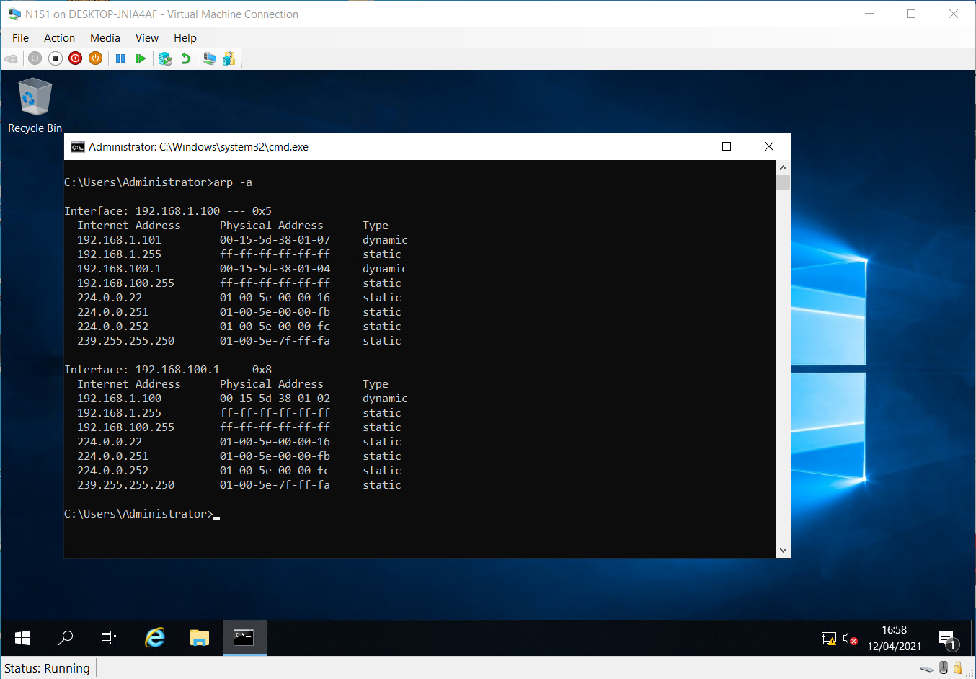
Arp Table for Server 1

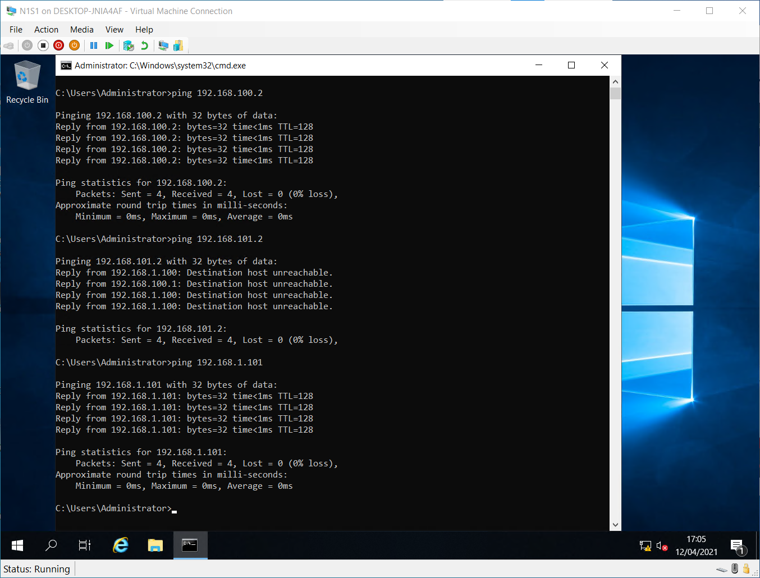

Ping Results for other devices. Server 2 is reachable but client 2 cannot be contacted. This is because routing is not enabled.

Task No 2

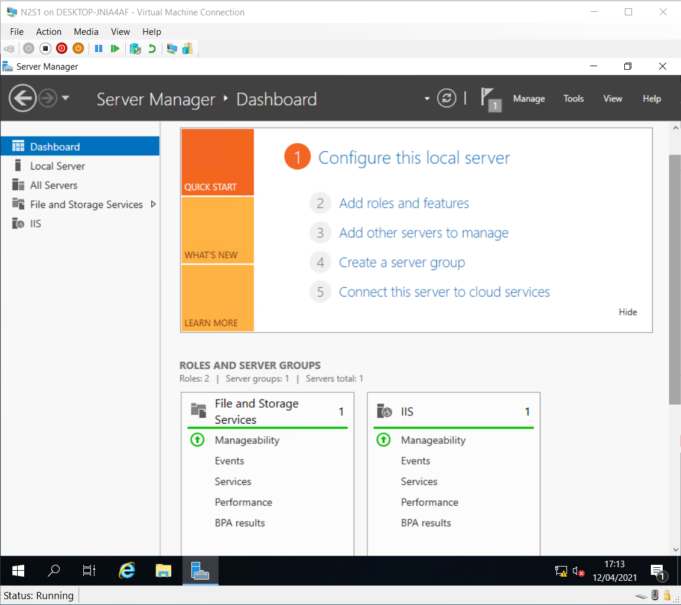
Dashboard of server 2 showing IIS installed. Notre server is not connectecd to AD at this time.

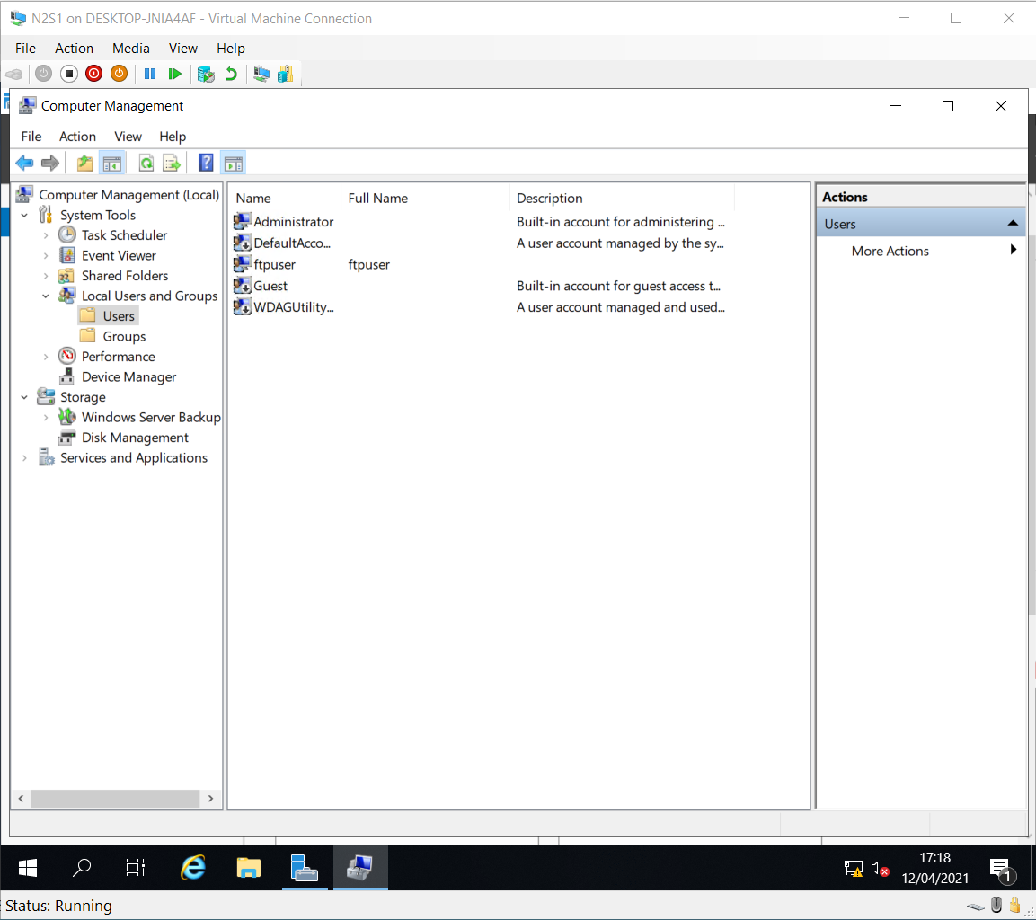
Evidence of new ftpuser account.

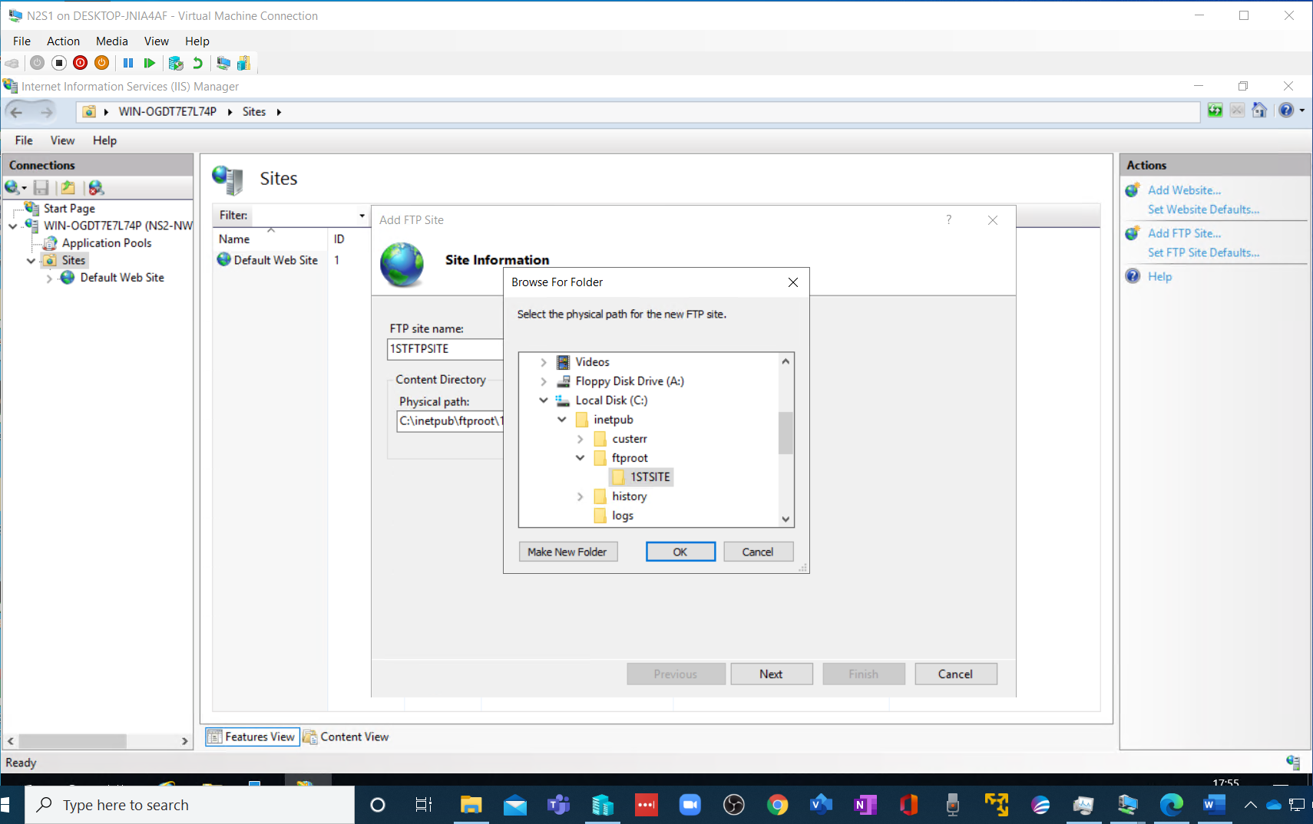

Creation of first FTP site.

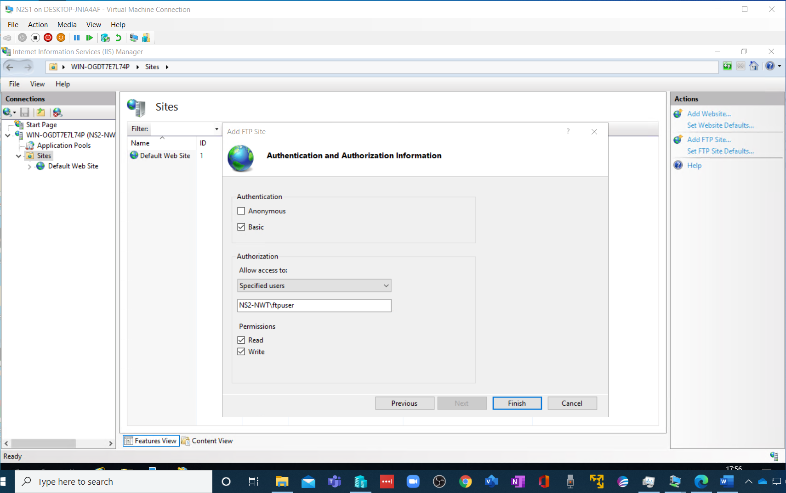
And user access rights.

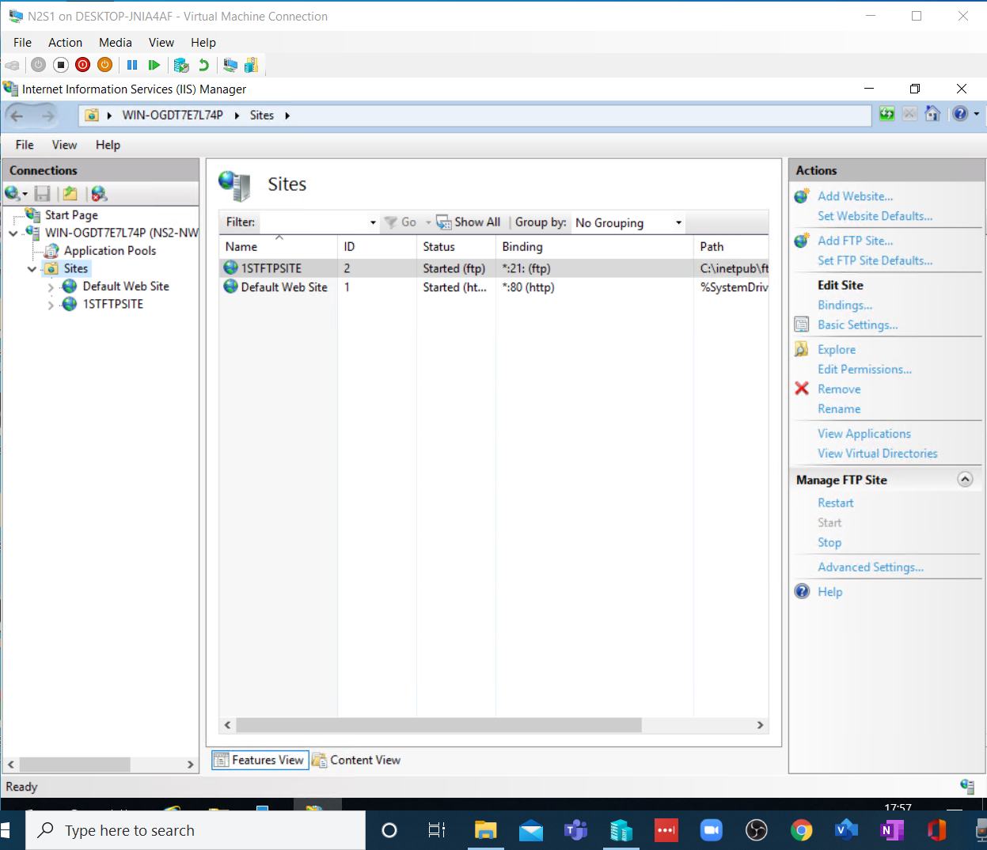
And the additional ftp site.

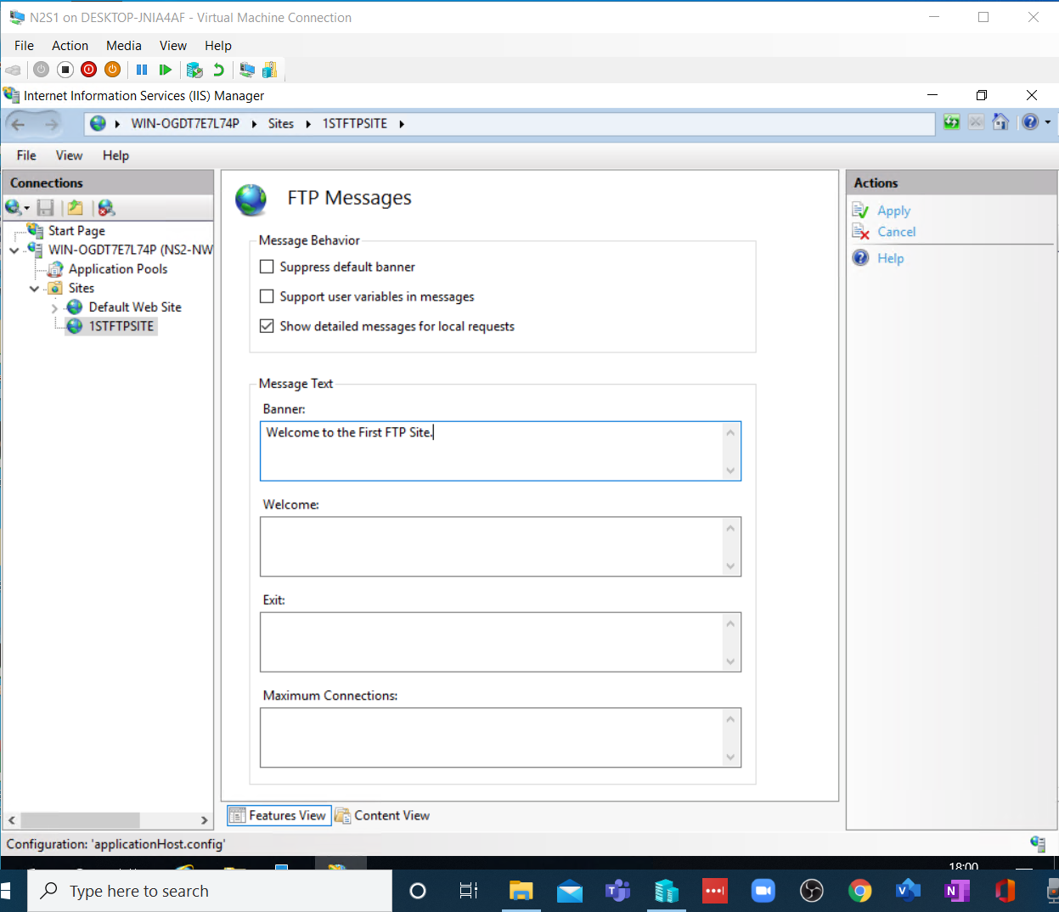
Added a banner…

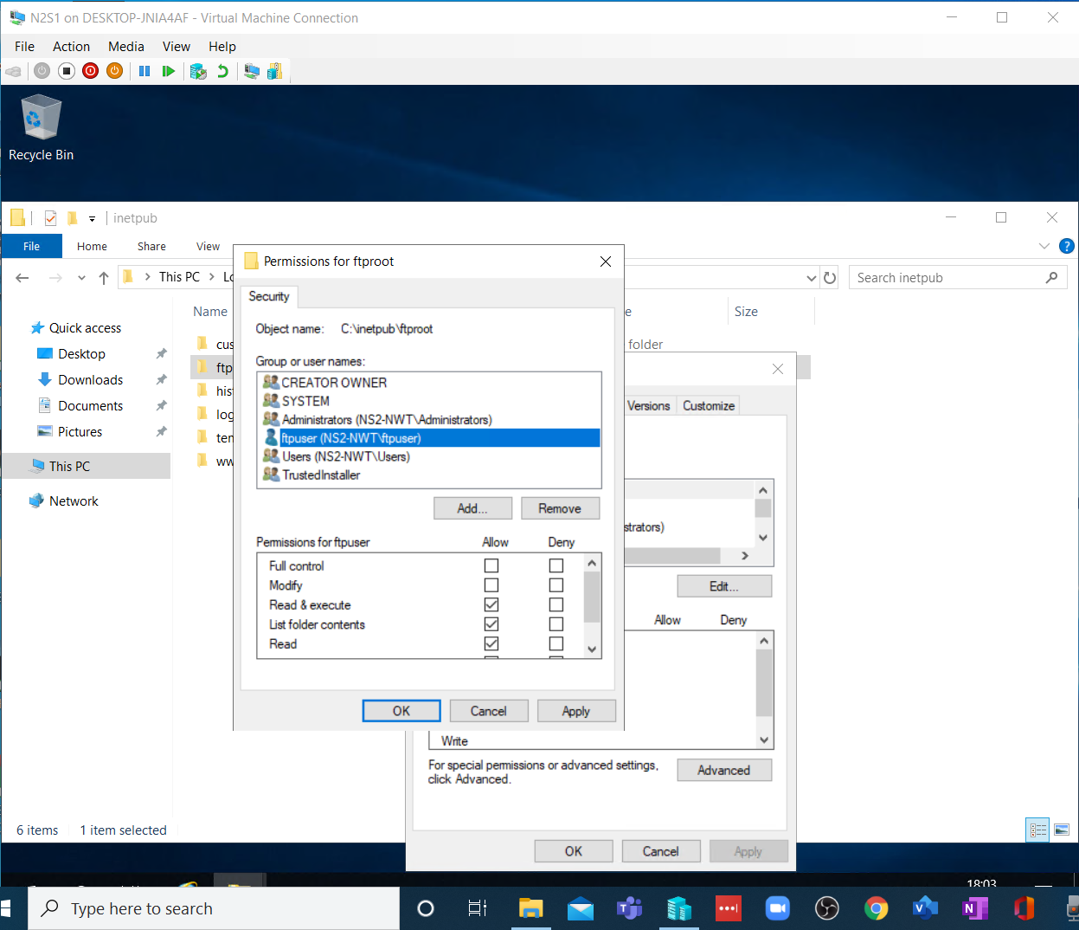

Security Access permissions set for user on the ftproot folder.

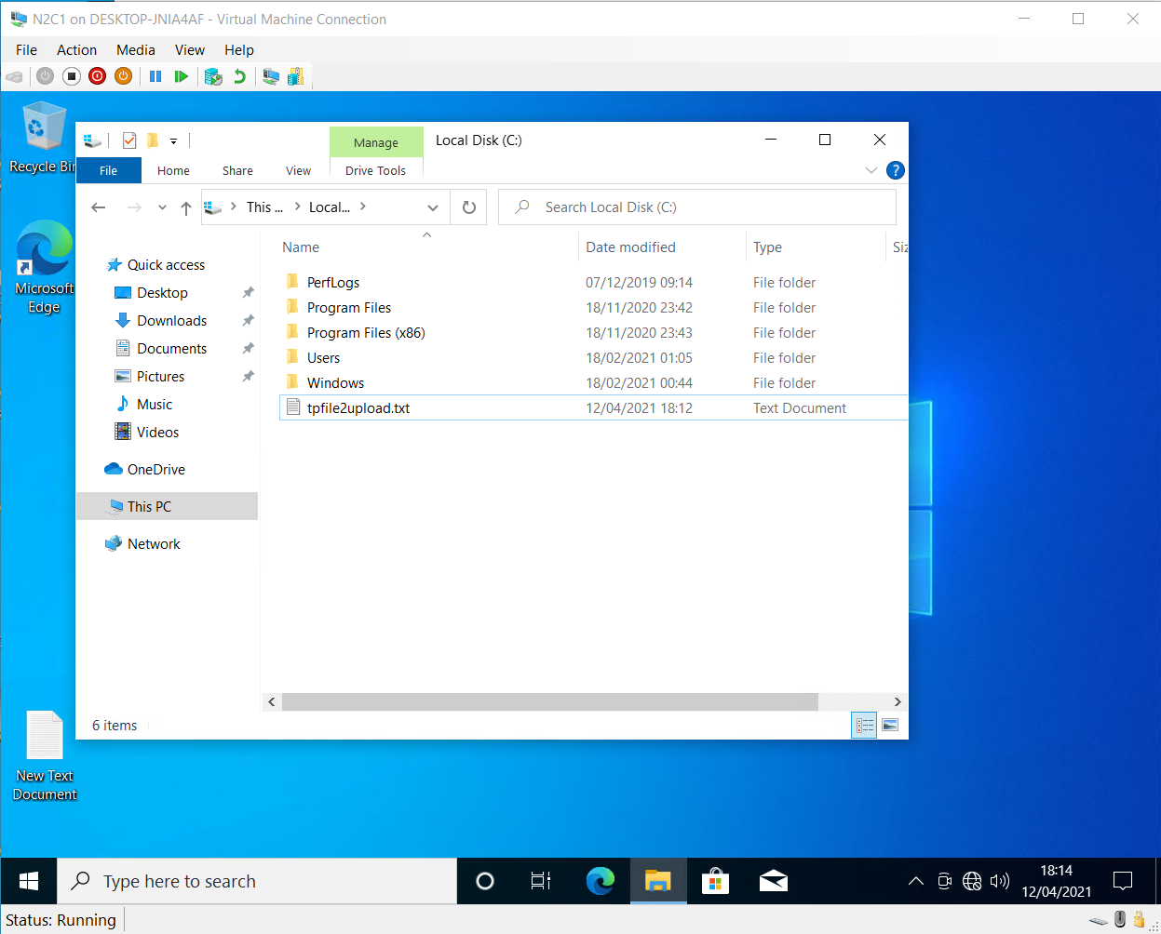
Prep for test transfer.

And the transcript for the file transfer once I had enabled write permissions on the receiving directory in ftproot. Rookie mistake!
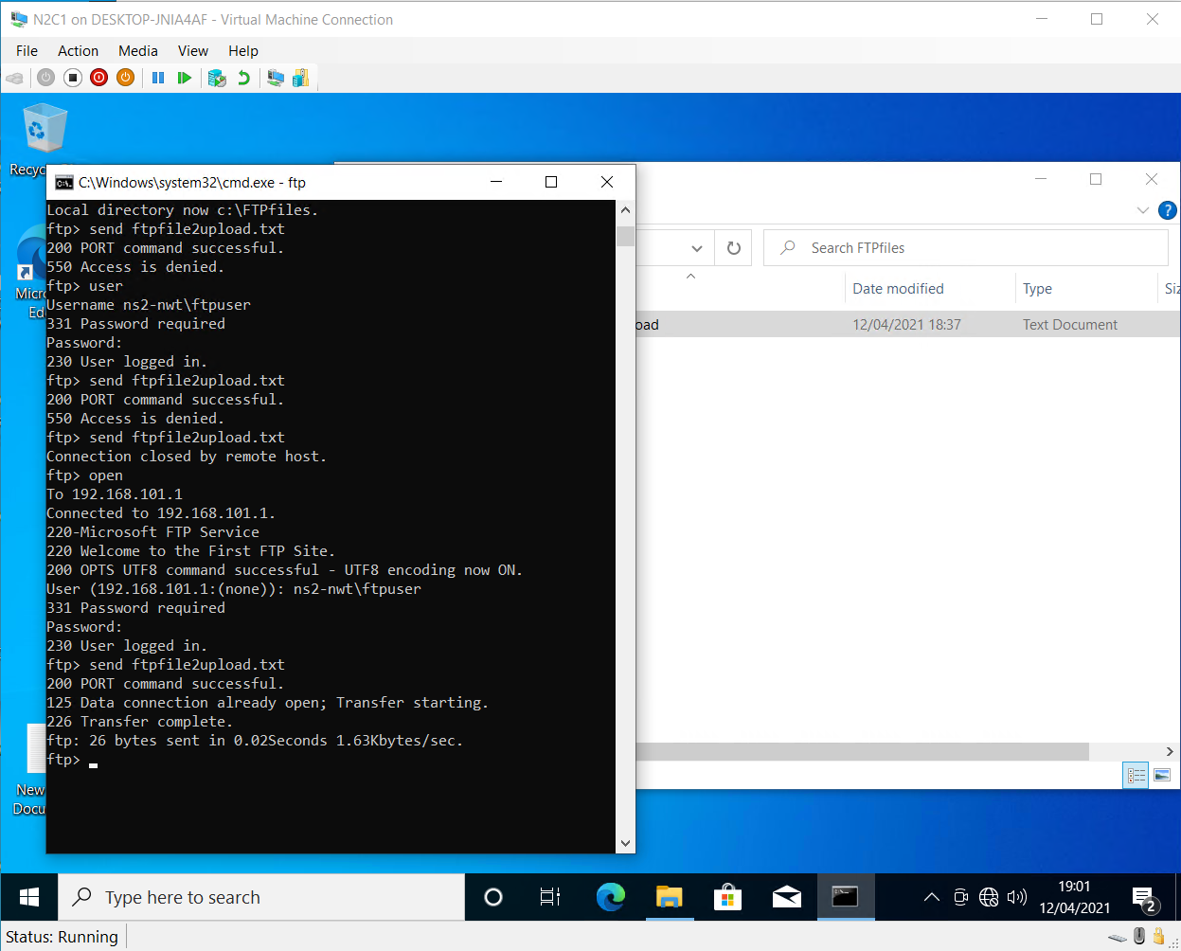

And the proof of the pudding…
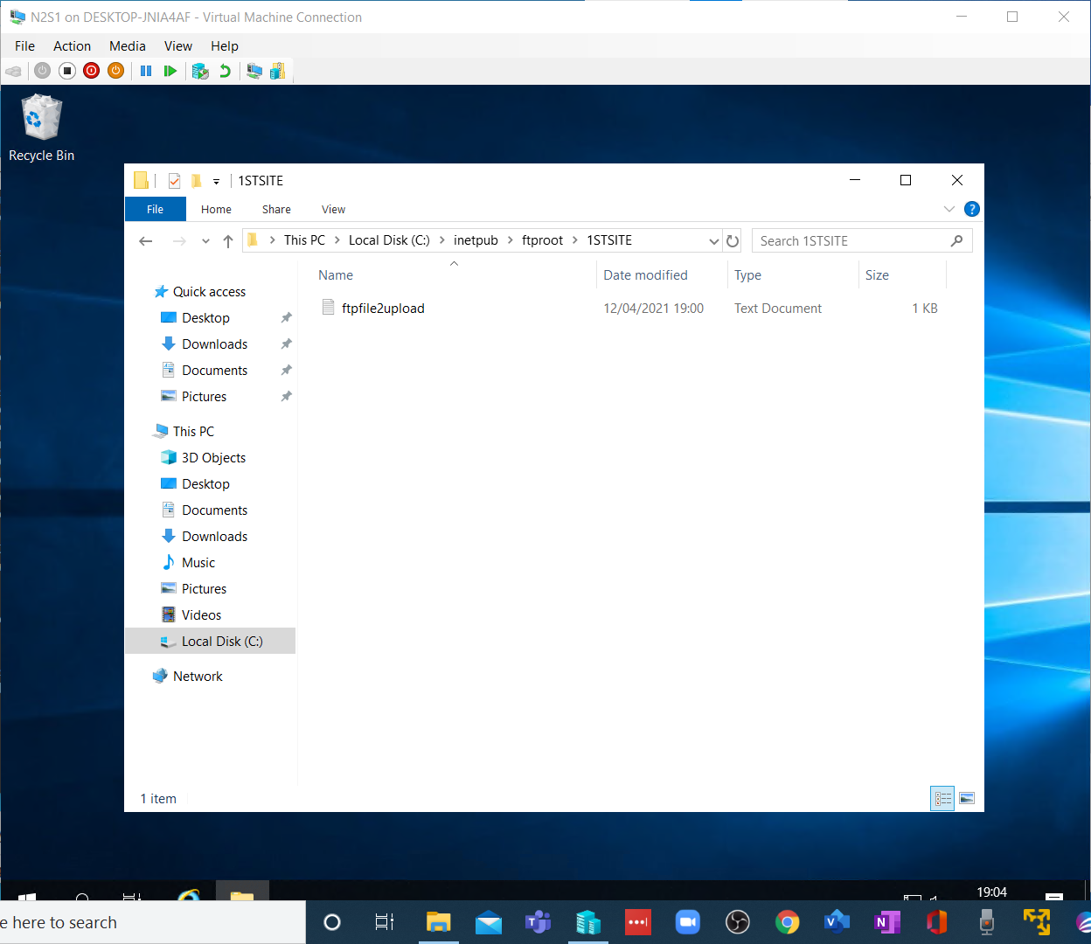

Task 3

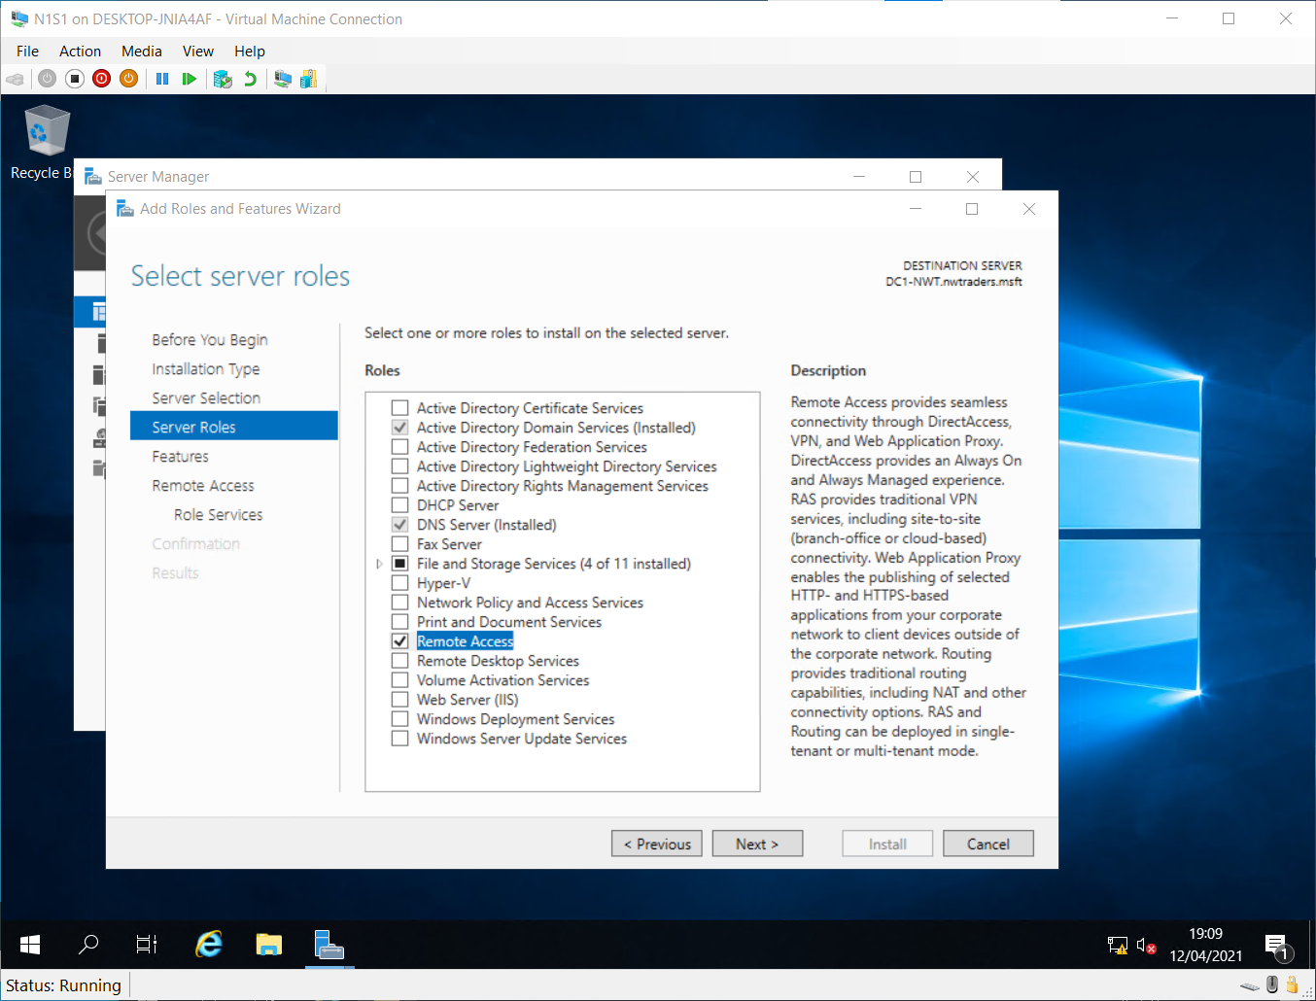
Starting Remote access setup

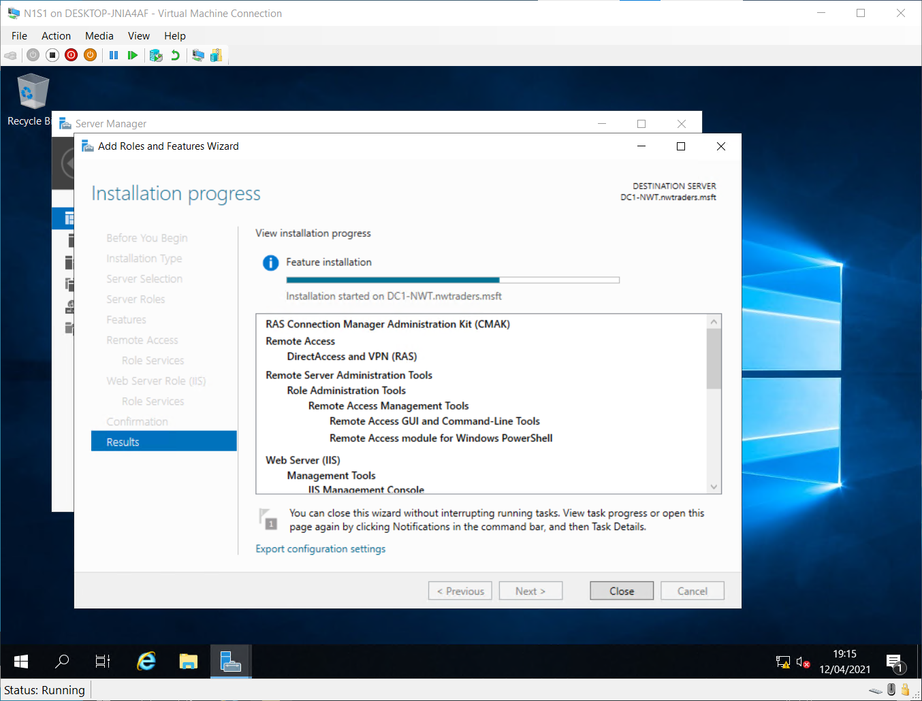
Installing remote access…

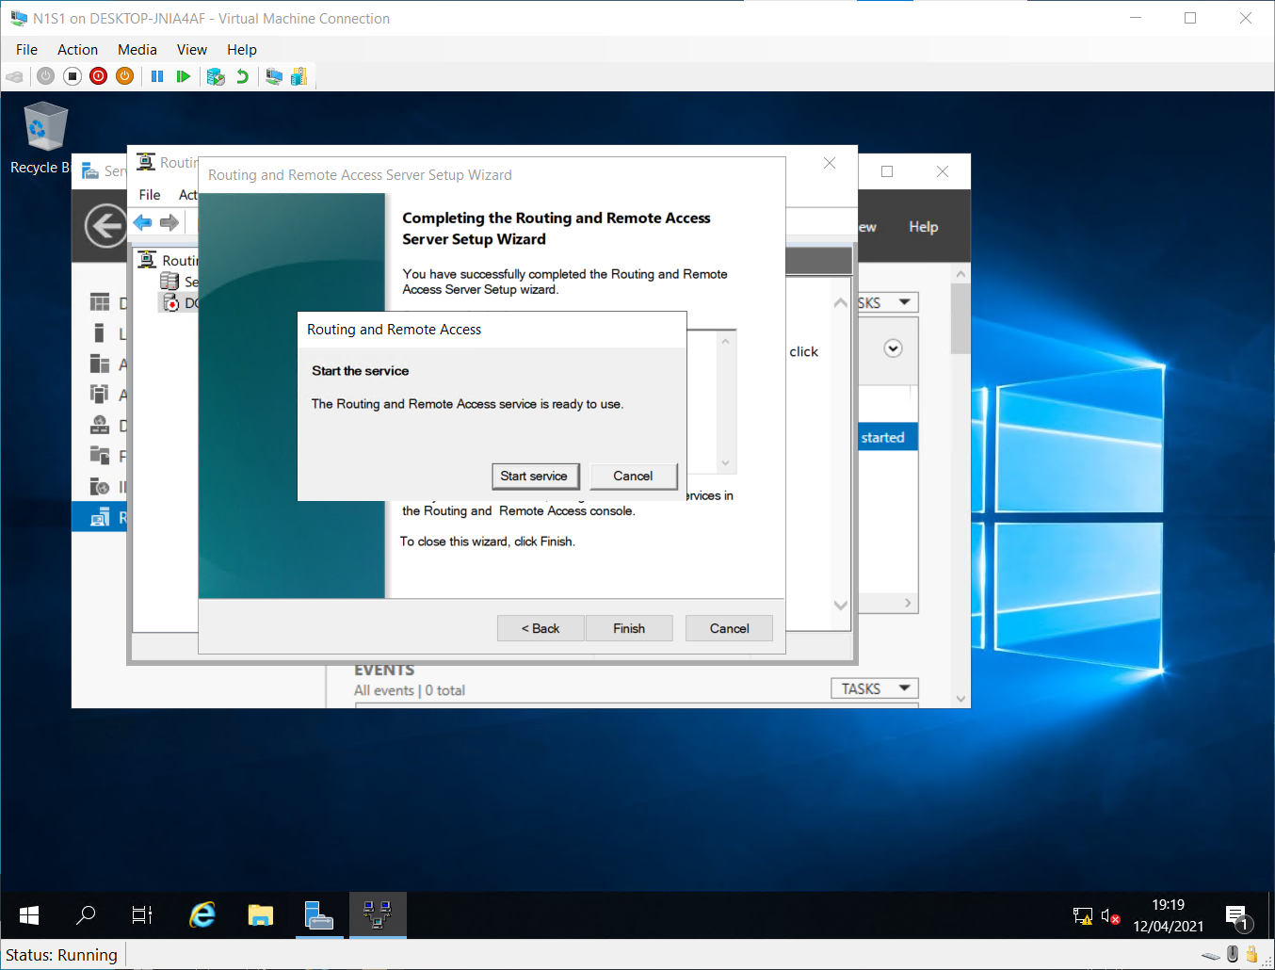

Configuring access to LAN only.

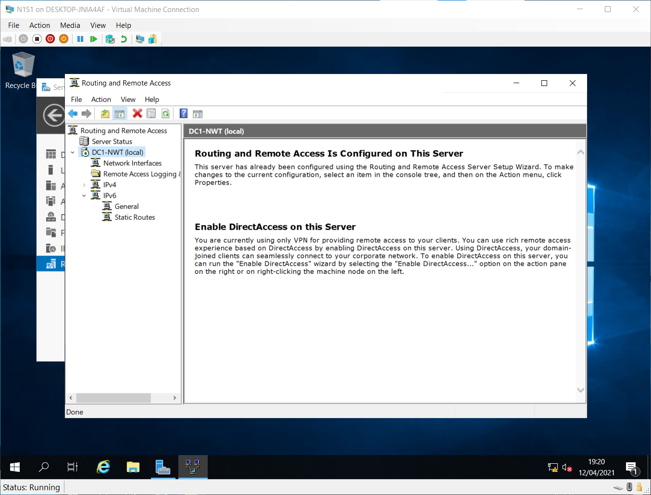
Which is confirmed.

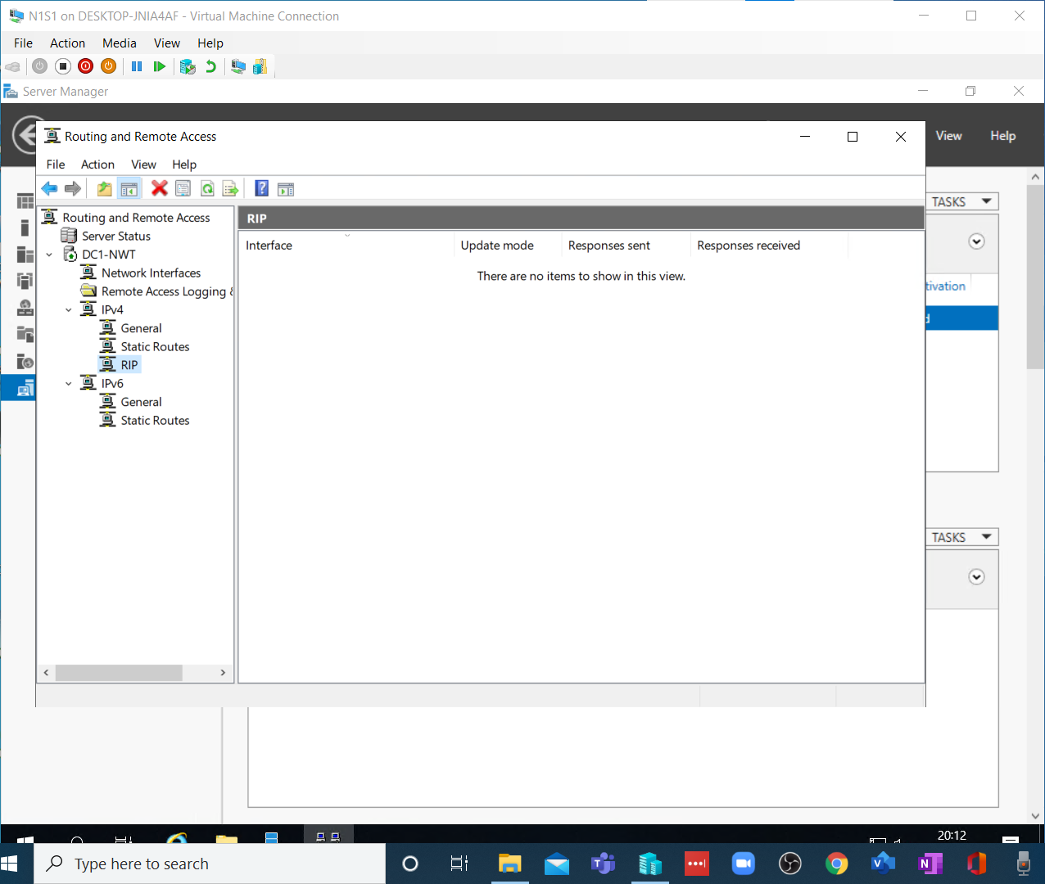
But only after I had to install routing which was not listed on my copy of the worksheet.

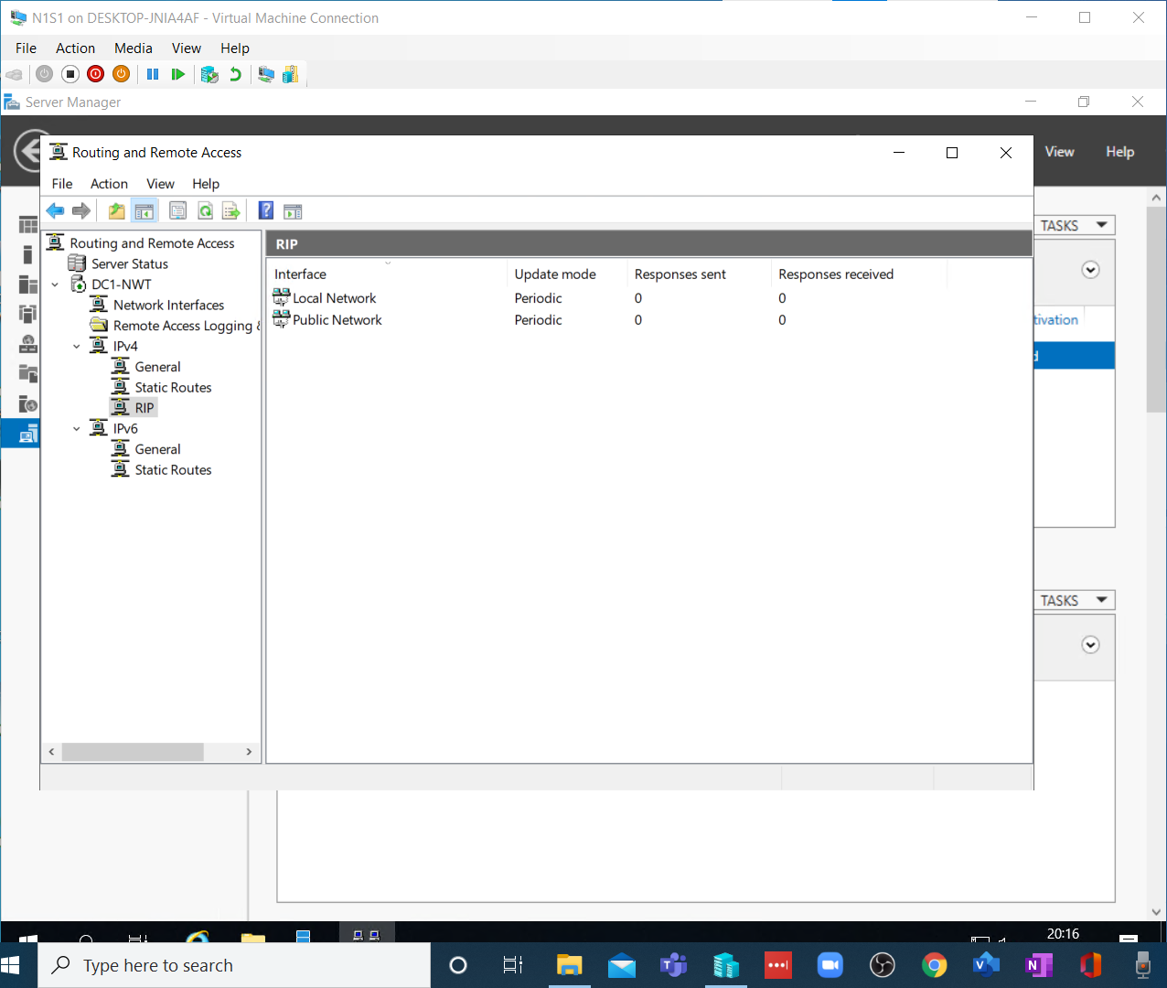
Then the two interfaces were configured to run RIP v2.

Having also configured server 2, a ping test was run on the public and local network connections from server 1….
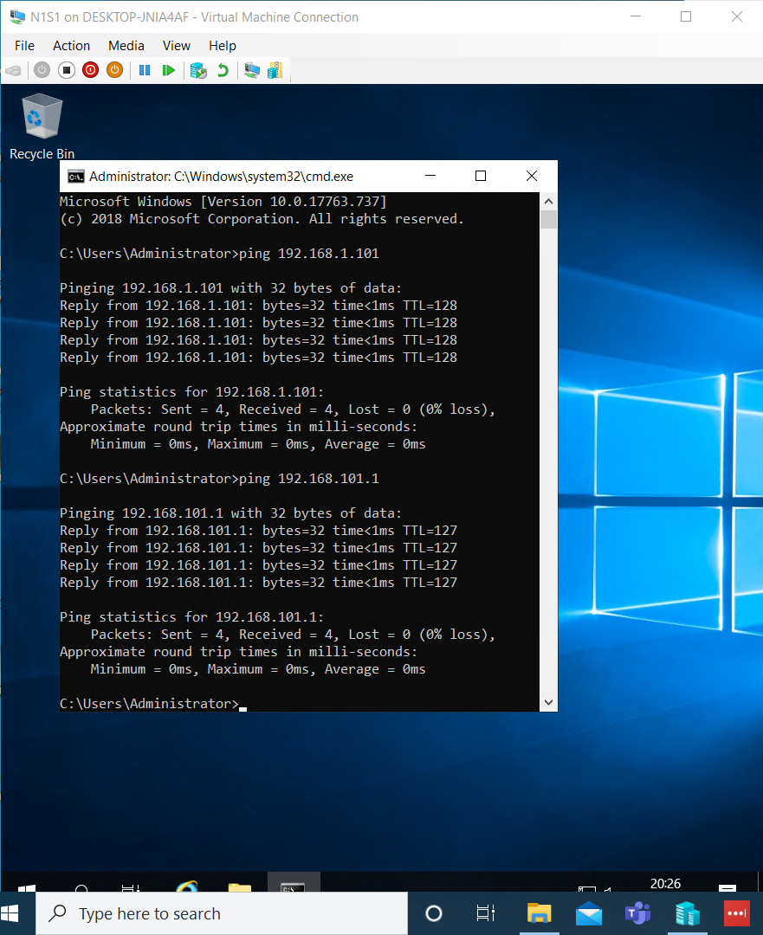

And then from workstation 1…
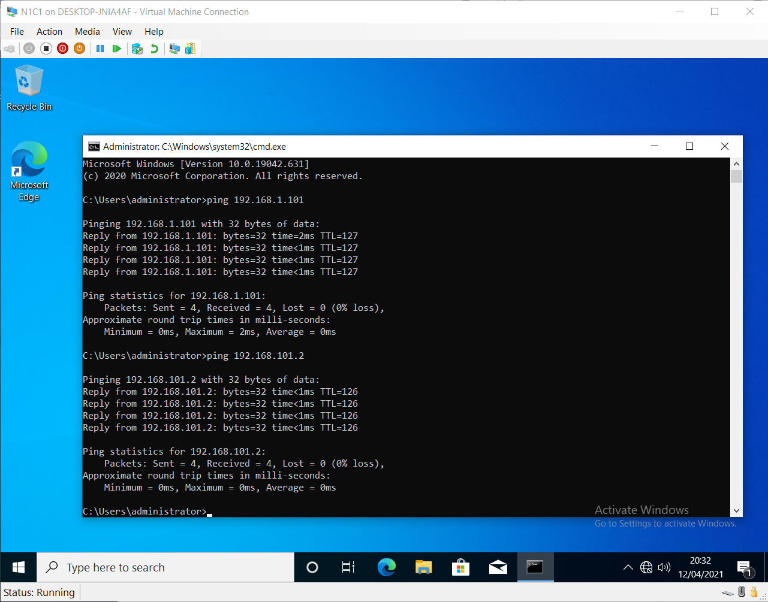
With good connections to both computers.

Task 4
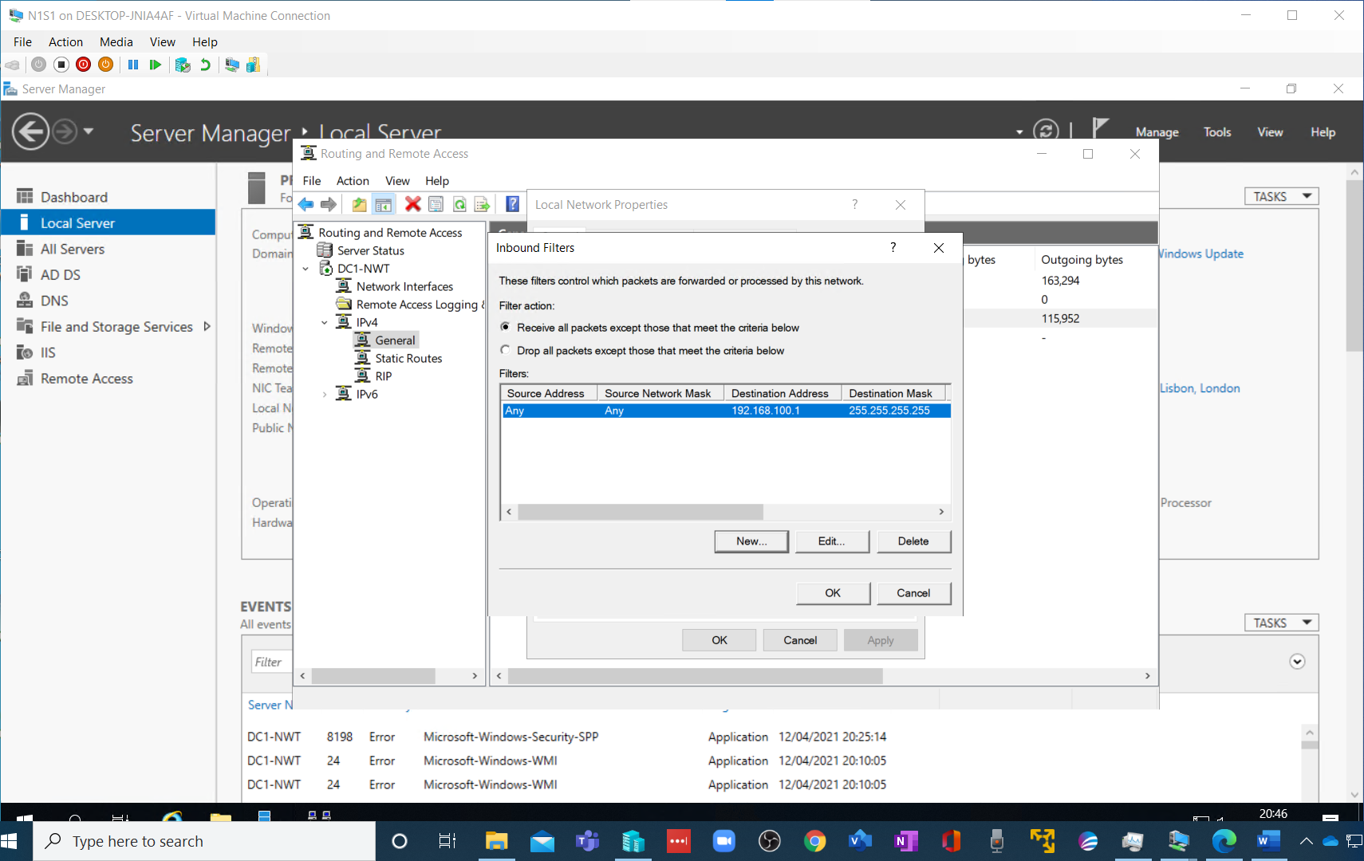
Filter configuration to block ICMP packets from traversing the gateway.

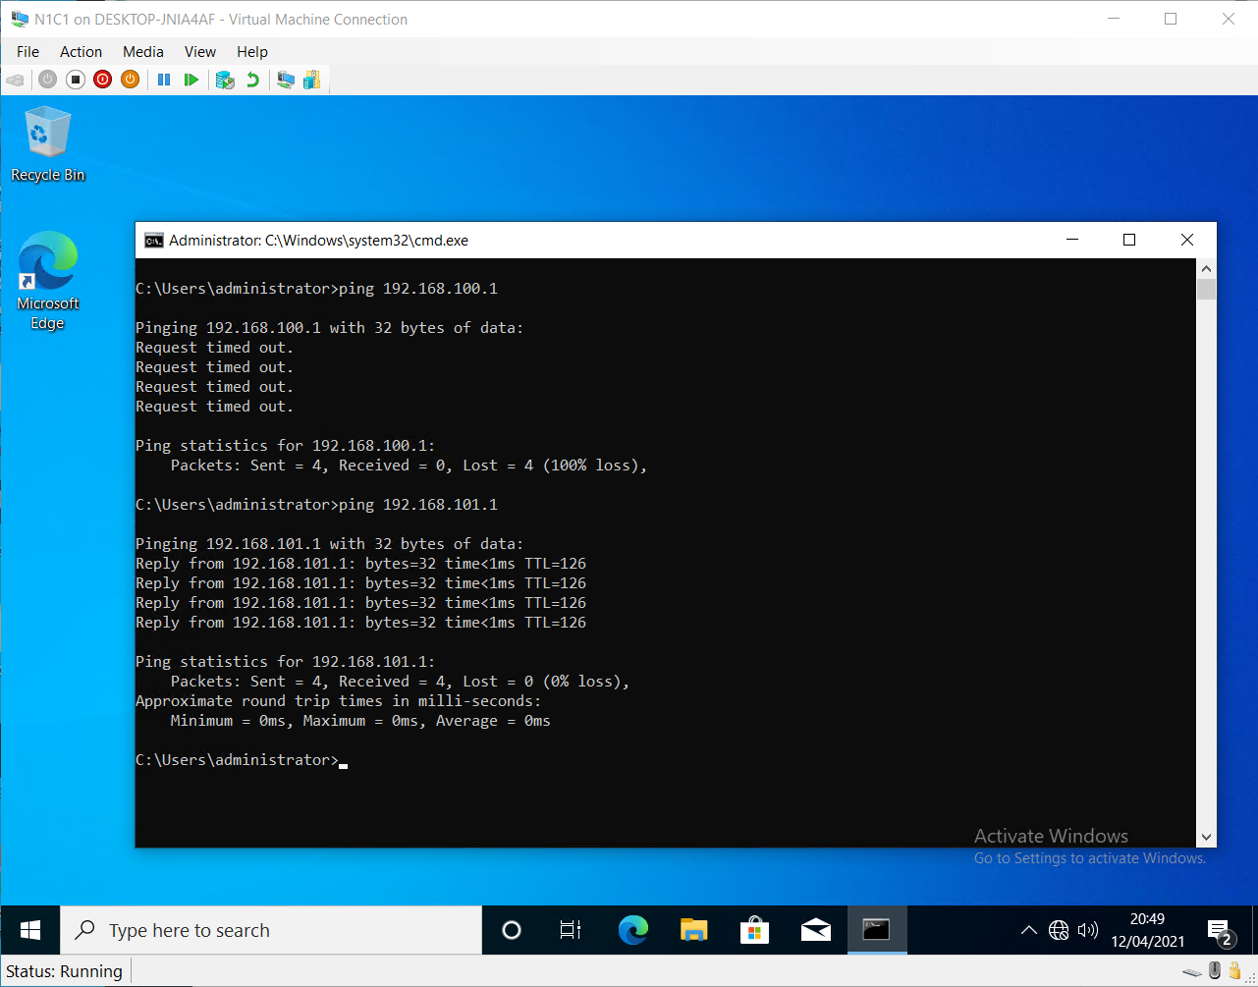
Which are blocked although server 2 is accessible.
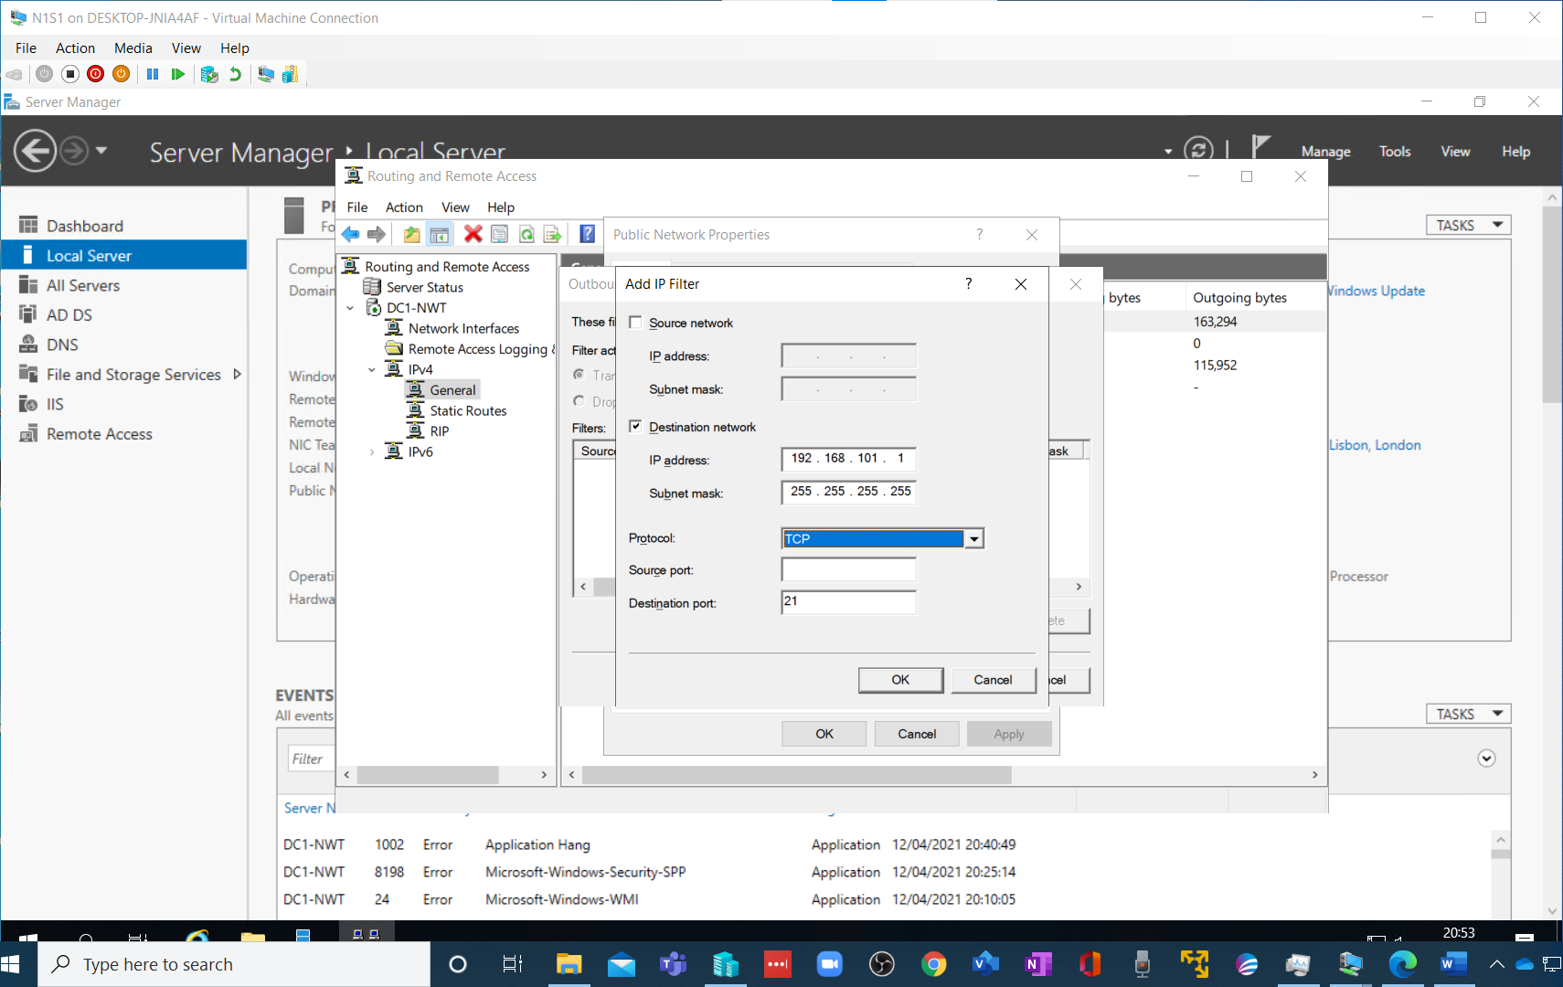
The outbound filter is configuring to prevent the exit of any tcp -21 packets from leaving….

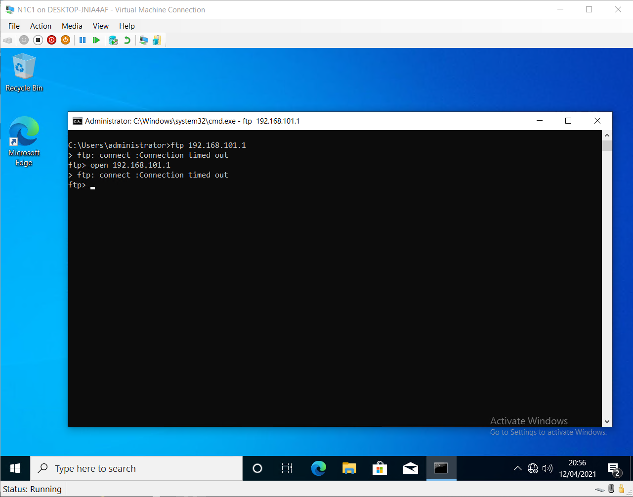
And is blocked and times-out…

