17/08/2026

Usability Engineering
UWTSD Pandemic-Style Teamwork Game: Full-Colour Interface Design and Usability Evaluation
Federico Mossa
BSc (Hons) Applied Computing
University of Wales Trinity Saint David
Lecturer: Dr Fahad Ahmed
Module: ACCB6017 Usability Engineering
Academic Year: 2025/26

Table of Contents
Abstract 2
Chapter 1 - Introduction 2
1.1 Background and Context 2
1.2 Scope and Design Progression 2
Chapter 2 - Full-Colour Interface Design and Storyboards 3
2.1 Development from the Assignment 1 Wireframes 3
2.2 Colour, Typography, Graphics and Visual Hierarchy 4
2.3 Significant Interaction States 5
2.4 Navigation and Mobile Interaction 6
2.5 Contextual Narrative Storyboard 7
Chapter 3 - Prototype Feedback and Usability Evaluation 8
3.1 Method and Purpose 8
3.2 Participants and Limitations 8
3.3 Quantitative Findings 8
3.4 Qualitative Findings 9
3.5 Emotional-Response Limitation 9
3.6 Refinement from v2.0 to v2.1 9
Chapter 4 - Data Collection in a Working Version 12
4.1 Behavioural and Gameplay Data 12
4.2 Performance and Error Data 12
4.3 Attitudinal and Emotional Data 12
4.4 Using Data to Inform Future Iterations 12
4.5 Privacy, Ethics and Limitations 13
Chapter 5 - Usability versus User Experience 13
5.1 If Designed Purely for Usability 13
5.2 Usability-UX Conflicts in Outbreak: Campus 13
5.3 How the Final Design Resolves Those Conflicts 13
Chapter 6 - Reflective Summary 14
Chapter 7 - Conclusion 15
References 15
Appendix A - Final Full-Colour Interface Screens (Figma) 17
Appendix B - Final Evaluation Questionnaire 22
Appendix C - Evaluation Results 23
Appendix D - Feedback-to-v2.1 Traceability 24

Abstract
This report presents the second design iteration of Outbreak: Campus, a cooperative mobile game adapted to a UWTSD setting. Assignment 1 established personas, requirements, interaction structure and low-fidelity wireframes; Assignment 2 developed these into a full-colour v2.0 prototype evaluated by seven UWTSD students. Ratings were positive for clarity, navigation, state communication and visual design, while open feedback identified onboarding, role selection, action terminology, information density and mobile text legibility. Findings informed v2.1. The report also considers data collection in a working release and design tensions between usability and user experience.

Chapter 1 - Introduction

1.1 Background and Context
Pandemic is a cooperative strategy game in which players coordinate specialist roles, manage outbreaks and work towards cures [1]. Outbreak: Campus adapts this model to a mobile UWTSD campus setting.
Assignment 1 established personas, requirements, low-fidelity screens, storyboards and evaluation. The final v1.2 wireframe contained twenty screens covering setup, cooperative play and terminal states. Evaluation supported the overall structure but identified hierarchy, text size and primary-action prominence as weaknesses.

1.2 Scope and Design Progression
Assignment 2 advanced the validated v1.2 structure into higher fidelity. Low-fidelity prototyping supports early examination of interaction structure [2], [3], while iterative UX evaluation refines developed solutions [4].
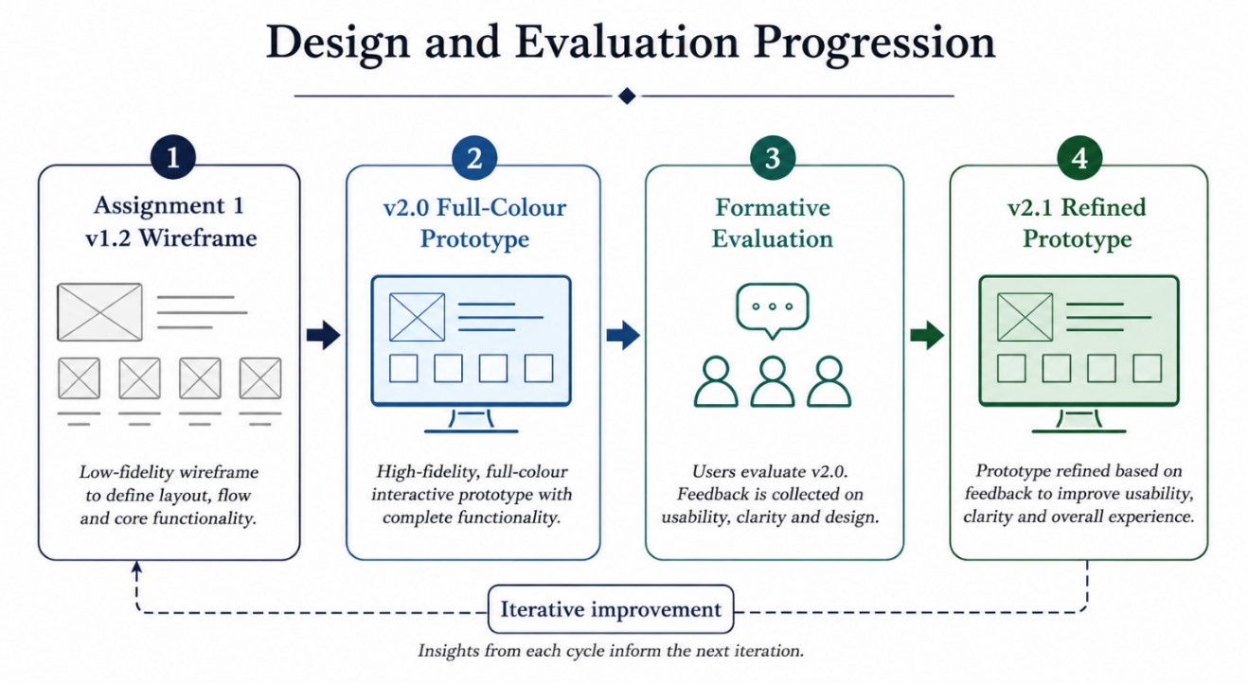
The second evaluation therefore focused on usability and UX issues introduced or exposed by colour, typography, interaction states and visual hierarchy.

Chapter 2 - Full-Colour Interface Design and Storyboards

2.1 Development from the Assignment 1 Wireframes
v2.0 retained the v1.2 interaction model because Assignment 1 had validated its structure: the Campus Map remained the gameplay hub, shared state stayed persistent, consequential actions used select-then-confirm, and contextual screens exposed legal actions only. Refinement instead targeted the perceptual weaknesses identified by three of five evaluators: hierarchy, small text and weak primary-action prominence.
Persona traceability also remained explicit. Elira supported persistent progress and lower-screen controls (FR-04, XR-03, XR-06); Doina supported concise labels and explicit consequences (FR-07, XR-04, XR-05, XR-08); Anisa supported A/B/C/D strain identifiers and non-colour cues (XR-01, XR-07); Andrei supported skippable guidance and efficient setup (FR-06, XR-02, XR-09).

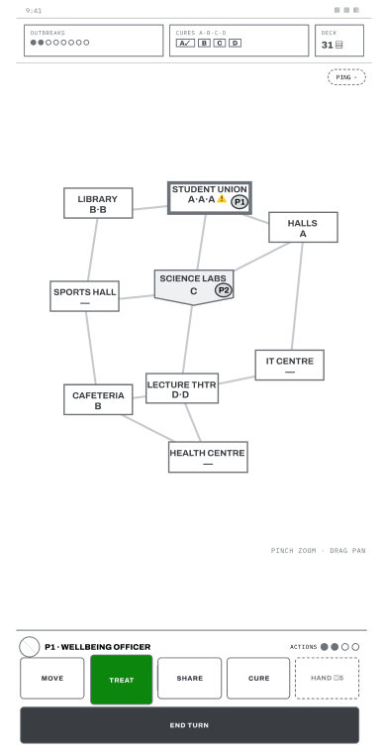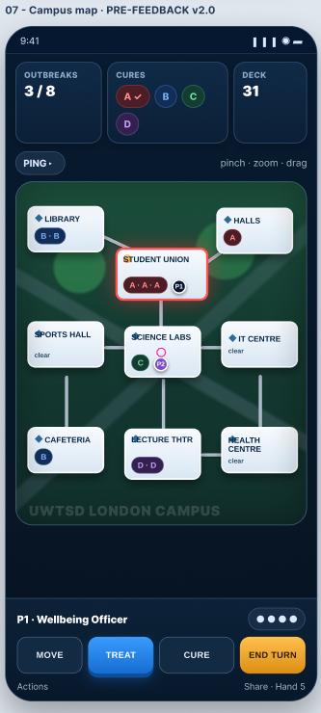
Figure 1. Progression from the final Assignment 1 v1.2 Campus Map wireframe to the Assignment 2 v2.0 full-colour design.
Higher fidelity therefore refined presentation without discarding useful information architecture. Usability engineering emphasises learnability, efficiency and error prevention or recovery [5]; the visual changes aimed to improve interpretation without unnecessary functionality.

2.2 Colour, Typography, Graphics and Visual Hierarchy
v2.0 uses a dark navy shell with layered blue panels and light typography. Blue marks normal primary actions, red danger or outbreaks, amber caution or turn-ending actions, and green cure or success progress.
The Campus Map uses a darker green play surface within the same HUD, separating spatial play from status and control regions while retaining visual coherence.
Lavie and Tractinsky distinguish coherent from expressive aesthetics [6]. Routine screens remain structurally consistent while outbreaks become more intense. Hassenzahl's pragmatic and hedonic distinction [7] also informed the balance: actions and shared state must be quickly interpretable while the interface still feels like a cooperative strategy game.
Meaning is never colour-only: strains retain A/B/C/D identifiers, exceptional states use explicit wording, and actions keep labels. This preserves Anisa's XR-01 requirement. Because text and background combinations affect readability and aesthetics [8], light text sits on the dark shell while saturated colour is reserved for status, controls and exceptional states.
Graphics remain functional: building cards and spatial connections are consistent, icons reinforce labels, and the HUD separates outbreak, cure and deck information from the map. This supports recognition without unnecessary decoration.

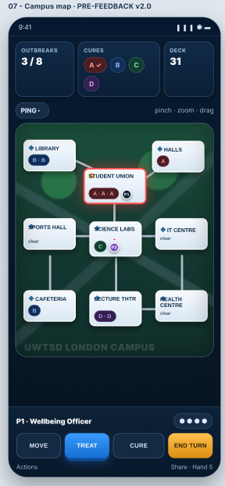
Figure 2. v2.0 PRE-feedback Campus Map used in the Assignment 2 evaluation, showing persistent, shared state, campus locations and the primary mobile action area.
Typography prioritises screen titles, changing strategic values and primary actions, with explanatory copy secondary. This directly addresses Assignment 1 hierarchy concerns and gave the v2.0 evaluation a specific perceptual question to test.

2.3 Significant Interaction States
Develop Cure is a focused state, concentrating attention on the selected strain, card requirement and consequence of confirmation.
Outbreak deliberately interrupts routine play through red emphasis, explicit consequences and a strong continuation action, giving a strategic event experiential weight. Norman treats emotional response as part of product experience [9].

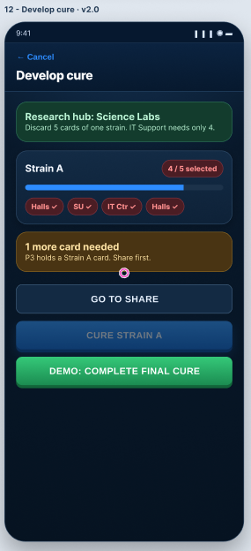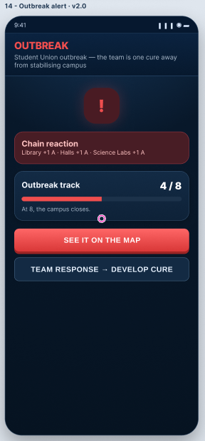
Figure 3. v2.0 PRE-feedback interaction states: focused cure development and high-priority outbreak interruption.

2.4 Navigation and Mobile Interaction
Navigation centres on the Campus Map. Entry moves through Splash/Main Menu, optional tutorial, Game Setup, Role Selection and Online Lobby; during play the hub opens Building Detail/Treat, Move, Hand/Share, Develop Cure, Draw Phase, Event/Outbreak and Pause. Non-terminal states return to the Map; Victory and Defeat are independent terminal outcomes, while Help and the Settings & Accessibility remain supporting routes.

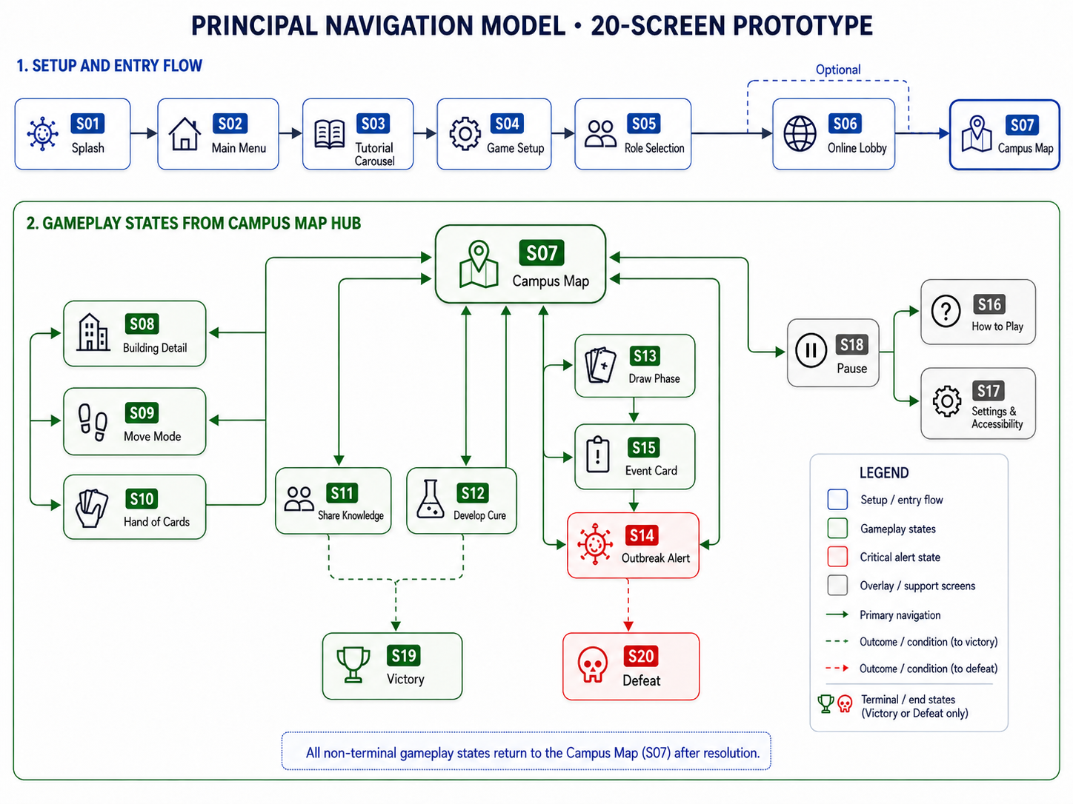
Figure 4. Principal navigation model for the 20-screen prototype, separating entry flow, Campus Map gameplay states, shared return routes and independent terminal outcomes.
Frequent controls remain low on the screen to preserve Elira's thumb-zone requirement (XR-06). The prototype demonstrates intended navigation; implementation behaviour requires validation in a working release.

2.5 Contextual Narrative Storyboard
The storyboard places the interface in context by following Andrei from a teammate request through shared-state review, resource sharing, outbreak response and cure contribution within a short session.
It connects isolated states into a cooperative progression from normal activity to threat, decision, crisis, recovery and achievement, consistent with flow-oriented emphasis on clear goals and matched challenge [10].
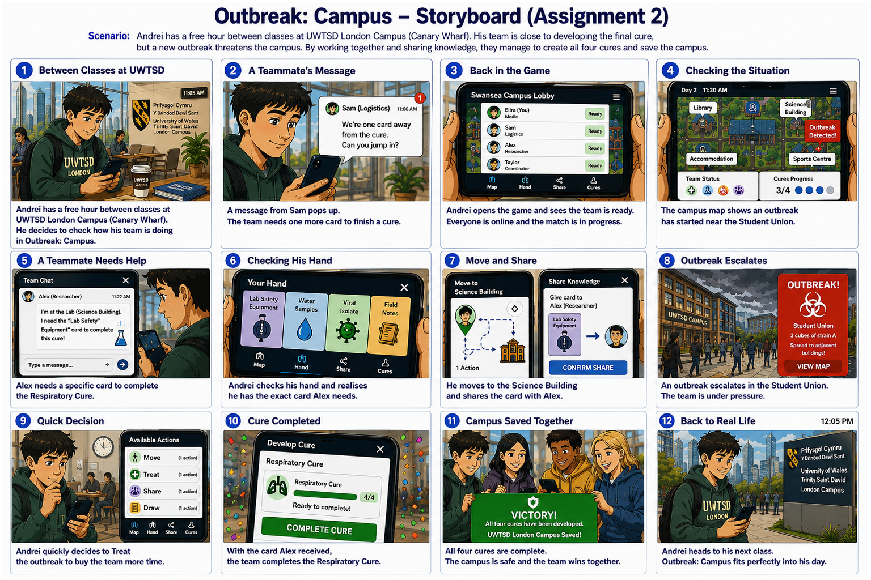
Figure 5. Full-colour narrative storyboard used in the final evaluation.

Chapter 3 - Prototype Feedback and Usability Evaluation

3.1 Method and Purpose
v2.0 was completed before feedback, so the evaluation was formative: it identified higher-fidelity problems to inform v2.1, consistent with ISO 9241-210's iterative human-centred design approach [11].
Participants reviewed the storyboard and prototype through Google Forms (LINK). Five 1-5 items assessed overall clarity, navigation/actions, game-state communication, Campus Map clarity/appeal and visual design; a sixth assessed perceived cooperation, followed by two open questions on confusion and improvement.
Combining scaled and open responses provided quantitative and qualitative evidence, both established HCI research methods [12].

3.2 Participants and Limitations
Seven valid anonymous responses were retained. Recruitment came from the same small UWTSD cohort; five participants had joined Assignment 1 and two were new. Because responses were anonymous, individuals could not be linked across rounds. Data collection was frozen at seven once final analysis began, creating a fixed formative dataset. This convenience sample supports formative problem identification, not population inference; small usability samples can vary substantially in the problems found [13]. Participant characteristics were not re-measured against the personas, so exact persona coverage cannot be claimed, and freezing at seven does not imply saturation.

3.3 Quantitative Findings
Mean ratings were 4.43/5 for overall clarity and 4.14/5 for navigation/actions, game-status clarity, Campus Map clarity/appeal and overall visual design. None of the 35 ratings fell below 3.
With n = 7 these are descriptive only, but they supported retaining the hub structure rather than assuming a systemic navigation problem.

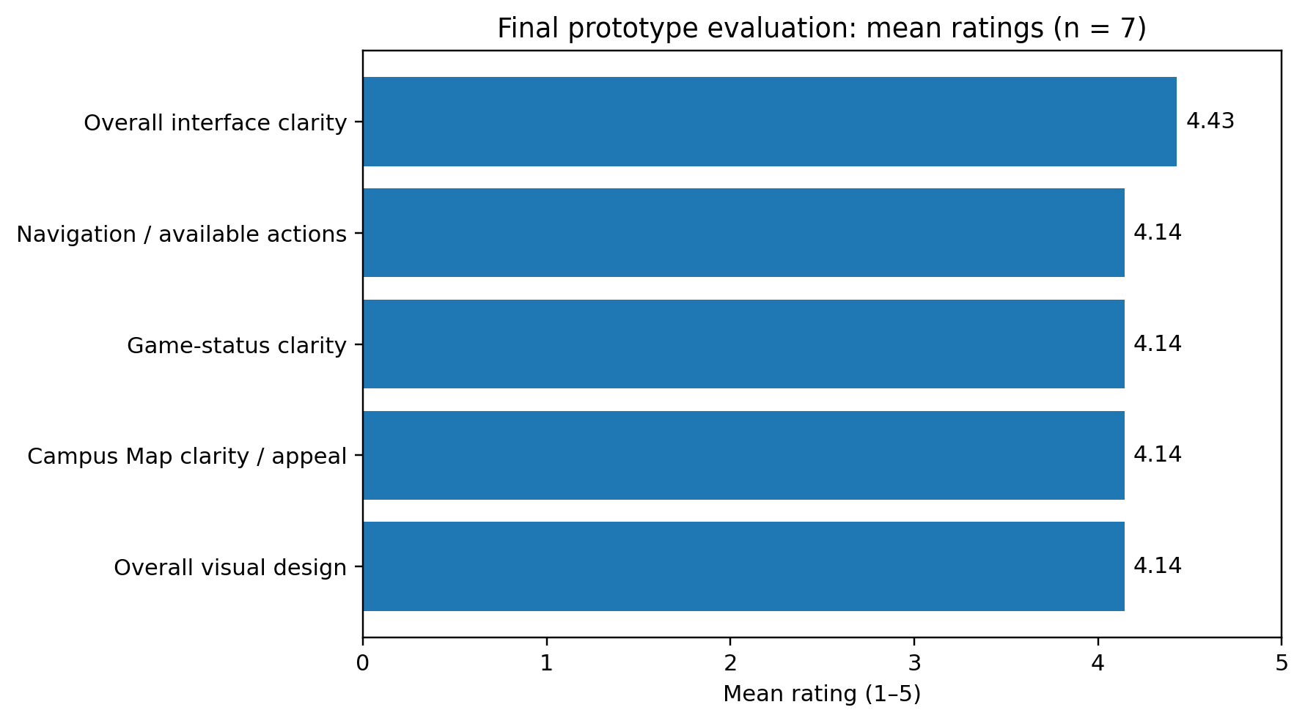
Figure 6. Mean questionnaire ratings for the five interface-evaluation questions (n = 7).
On cooperation, four participants selected 'Mostly yes' and three 'Definitely yes'; no neutral or negative response occurred. This supported the team framing but did not measure emotional response.

3.4 Qualitative Findings
Five of seven Q7 responses reported no confusion or described the interface as clear; scaled results also supported the Campus Map, navigation and shared-state presentation.
Actionable issues were onboarding/game flow, unclear role-selection state, the meaning of '1 action', information density and mobile text legibility. Two participants requested less complexity or fewer panels, showing that positive overall ratings still contained local problems.
One participant criticised storyboard length, not the interface. A later response requested larger mobile text after v2.1 was complete; it was retained as a residual future issue, not retrofitted into the design chronology.

3.5 Emotional-Response Limitation
The questionnaire lacked a dedicated affective measure, so perceived cooperation cannot evidence tension, enjoyment, urgency or frustration. Assignment 1 had elicited outbreak urgency, but that low-fidelity evidence cannot validate the v2.0 experience. Because UX is subjective and context-dependent [14], future testing should add a direct post-task affect question or short interview.

3.6 Refinement from v2.0 to v2.1
Findings produced targeted v2.1 changes: stronger onboarding/game-loop guidance; explicit SELECTED and TAKEN role states; clear four-action turn guidance; and reduced or regrouped secondary content while preserving outbreak, cure and card state. These changes address learnability, system-status visibility and hierarchy without discarding the understood interaction model [5] .

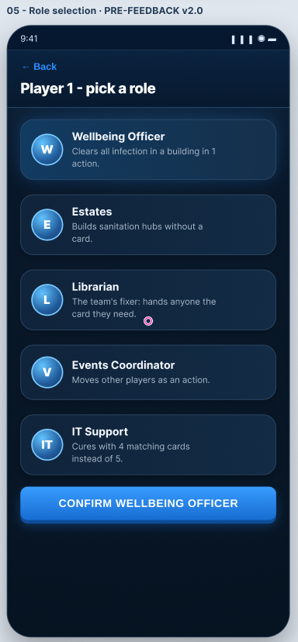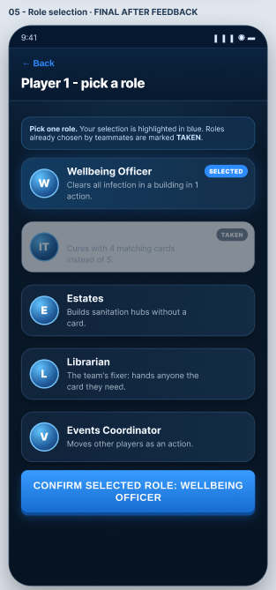
Figure 7. Role-selection refinement from v2.0 to v2.1 following participant feedback.

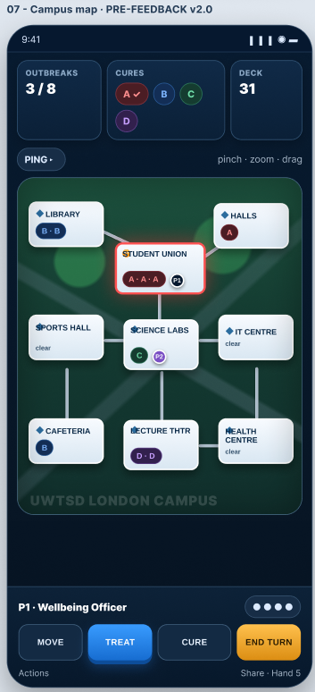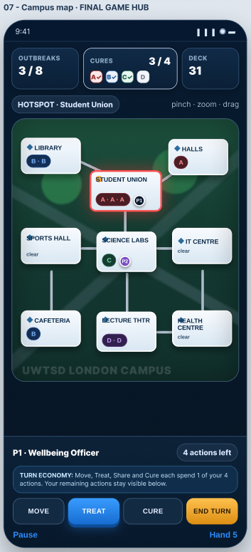
Figure 8. Clarification of action guidance and information density from v2.0 to v2.1 on the Campus Map.
Appendix D traces each finding to participant evidence, the affected usability/persona requirement, the v2.0 problem, the v2.1 response and implementation status, including suggestions deliberately not implemented.

Chapter 4 - Data Collection in a Working Version

4.1 Behavioural and Gameplay Data
A working release should collect measures tied to defined design questions. HEART links product goals to user-centred signals [15]. Useful behavioural signals include role selection or abandonment, navigation, action use, save/resume, outbreaks, cure progress and outcomes.
These signals identify patterns, not causes: abandonment may reflect onboarding difficulty or interruption; cancellations may reflect confusion or strategy.
Telemetry can flag balance issues, but rare role selection or repeated failure may reflect UI wording or game balance and require different responses.

4.2 Performance and Error Data
Crashes, failed saves, load time, latency and repeated confirmation errors can expose technical friction without measuring preference or enjoyment [16] .

4.3 Attitudinal and Emotional Data
Questionnaires or interviews can assess clarity, enjoyment, tension, frustration and cooperation [16]; usage data is not a proxy for experience [12], [16].
Triangulation is stronger: Share cancellations locate a pattern, while interviews distinguish cost uncertainty from deliberate strategy.

4.4 Using Data to Inform Future Iterations
Measures should map to responses: imbalance can trigger wording review; cancelled actions can prompt confirmation testing; failure clusters can separate communication from difficulty. Low accessibility-feature use does not prove such features unnecessary.

Data type | Example metric | What it may indicate | What it cannot explain | Possible design response
Behavioural | Role selection / abandonment | Possible choice or onboarding friction | Why the player stopped | Review wording; run targeted task test
Interaction | Cancelled actions | Potential uncertainty before commitment | Strategic change of mind vs confusion | Inspect confirmation copy and errors
Gameplay | Outbreak stage / win-loss | Difficulty or failure hotspot | UI problem vs game-balance problem | Test communication and balance separately
Performance | Load time / failed save | Technical friction and reliability | Enjoyment or perceived cooperation | Optimise reliability; correlate with exits
Attitudinal | Enjoyment / tension rating | Perceived experience | Actual behaviour over time | Combine with telemetry/interviews

4.5 Privacy, Ethics and Limitations
Collection should be data-minimised and transparent, using anonymous or pseudonymous events only where needed. Accessibility-feature use deserves particular care because it may support sensitive inferences. Analytics show what happened more readily than why, so qualitative research remains necessary for motivation, emotion and perceived cooperation [12], [16] .

Chapter 5 - Usability versus User Experience

5.1 If Designed Purely for Usability
A usability-only design would minimise interruption, confirmations and expressive state changes, and compress strategic information. This could improve speed and clarity but weaken the tension, consequence and cooperative atmosphere that distinguish a game from a productivity tool.

5.2 Usability-UX Conflicts in Outbreak: Campus
Outbreaks illustrate the conflict: a small status update would be efficient but weaken urgency; emotional response is part of product experience [9]. Likewise, hiding cure, outbreak and hand state would simplify the Campus Map but reduce shared strategic awareness.
Speed also conflicts with error prevention: confirmations slightly slow Move, Treat, Share and Cure but protect limited actions or resources from accidental commitment [5]. Strong colour supports atmosphere and differentiation, yet labels and strain identifiers remain necessary for accessibility.
Hassenzahl's pragmatic and hedonic distinction [7] frames the requirement: the game must be understandable while still supporting urgency, cooperation and achievement.

5.3 How the Final Design Resolves Those Conflicts
v2.1 uses bounded compromises: outbreaks interrupt but explain consequences; consequential actions retain confirmation; colour is paired with labels and A/B/C/D identifiers; critical shared state remains visible while secondary detail is reduced; and tutorial/help routes are optional. These choices retain pragmatic clarity and hedonic or affective qualities [7], [9], while mobile-text legibility remains unresolved.
The Campus Map makes the trade-off explicit. Keeping outbreak, cure and card information visible supports cooperative awareness but increases phone-screen density. v2.1 reduces or regroups secondary copy while retaining decision-critical state; the late request for larger text shows the compromise still needs testing. Outbreak makes the opposite trade: deliberate interruption adds urgency at a small efficiency cost, limited by clear cause-and-consequence wording.

Chapter 6 - Reflective Summary
Separating structural testing from visual refinement was effective. Assignment 1 validated navigation and major interactions while changes were inexpensive, revealing hierarchy and legibility weaknesses that gave v2.0 a focused basis.
Assignment 2 showed that positive overall ratings can coexist with local ambiguities. The first five responses informed v2.1; two later responses were retained in the frozen dataset, including the residual mobile-text issue. This preserved chronology without implying every late suggestion had been implemented.
Methodological weaknesses remain: seven anonymous convenience participants, five of whom had participated in Assignment 1; however, anonymous responses prevented participant-level comparison across rounds; participant characteristics were not re-measured against the personas; and no direct affect measure was included.
The structured second evaluation therefore improved evidence in some areas while leaving emotional UX under-measured.
Participant evidence drove hierarchy, onboarding and communication changes, while personas constrained accessibility and labelling. The dark shell, palette and campus visual treatment remained designer judgements bounded by those constraints, not findings directly produced by participants.
If repeated, I would recruit against persona characteristics, add moderated task testing with success and error measures, and include direct affective questions. The process nevertheless demonstrates iterative user involvement instead of final-stage validation [11].

Chapter 7 - Conclusion
Outbreak: Campus progressed from evaluated v1.2 wireframes to v2.0 and a targeted v2.1 refinement. Seven-response evaluation supported overall clarity and navigation while identifying onboarding, role-selection, action terminology, information-density and residual text-legibility issues. The project demonstrates an iterative human-centred process that preserves validated structure, responds to evidence and acknowledges unresolved usability/UX trade-offs. A working release should extend evaluation through behavioural, performance and direct attitudinal evidence.

References

[1] | Z-Man Games, “Pandemic,” 2026. [Online]. Available: https://www.zmangames.com/game/pandemic/. [Accessed 16 8 2026].
[2] | J. Rudd, K. Stern and S. Isensee, “Low vs. high-fidelity prototyping debate,” Interactions, vol. 3, no. 1, pp. 76-85, 1996.
[3] | C. Snyder, Paper Prototyping: The Fast and Easy Way to Design and Refine User Interfaces, San Francisco, CA, USA: Morgan Kaufmann, 2004.
[4] | R. Hartson and P. S. Pyla, The UX Book: Process and Guidelines for Ensuring a Quality User Experience, Waltham, MA, USA: Morgan Kaufmann, 2012.
[5] | J. Nielsen, Usability Engineering, Cambridge, MA, USA: AP Professional, 1993.
[6] | T. Lavie and N. Tractinsky, “Assessing dimensions of perceived visual aesthetics of web sites,” International Journal of Human-Computer Studies, vol. 60, no. 3, pp. 269-298, 2004.
[7] | M. Hassenzahl, “The interplay of beauty, goodness, and usability in interactive products,” Human-Computer Interaction, vol. 19, no. 4, pp. 319-349, 2004.
[8] | R. H. Hall and P. Hanna, “The impact of web page text-background colour combinations on readability, retention, aesthetics and behavioural intention,” Behaviour & Information Technology, vol. 23, no. 3, pp. 183-195, 2004.
[9] | D. A. Norman, Emotional Design: Why We Love (or Hate) Everyday Things, New York, NY, USA: Basic Books, 2004.
[10] | M. Csikszentmihalyi, Flow: The Psychology of Optimal Experience, New York, NY, USA: Harper & Row, 1990.
[11] | International Organization for Standardization, “ISO 9241-210:2019, Ergonomics of Human-System Interaction-Part 210: Human-Centred Design for Interactive Systems,” ISO, Geneva, Switzerland, 2019.
[12] | J. Lazar, J. H. Feng and H. Hochheiser, Research Methods in Human-Computer Interaction, 2 ed., Cambridge, MA, USA: Morgan Kaufmann, 2017.
[13] | L. Faulkner, “Beyond the five-user assumption: Benefits of increased sample sizes in usability testing,” Behavior Research Methods, Instruments, & Computers, vol. 35, no. 3, pp. 379-383, 2003.
[14] | E. L.-C. Law, V. Roto, M. Hassenzahl, A. P. O. S. Vermeeren and J. Kort, “Understanding, scoping and defining user experience: A survey approach,” in Proceedings of the SIGCHI Conference on Human Factors in Computing Systems (CHI '09), Boston, MA, USA, 2009.
[15] | K. Rodden, H. Hutchinson and X. Fu, “Measuring the user experience on a large scale: User-centered metrics for web applications,” in Proceedings of the SIGCHI Conference on Human Factors in Computing Systems (CHI '10), Atlanta, GA, USA, 2010.
[16] | T. Tullis and W. Albert, Measuring the User Experience: Collecting, Analyzing, and Presenting Usability Metrics, 2 ed., Waltham, MA, USA: Morgan Kaufmann, 2013.

Appendix A - Final Full-Colour Interface Screens (Figma)
This appendix presents the complete twenty-screen v2.1 full-colour prototype for standalone reference. Selected screens are also reproduced in the main body where they provide evidence for specific design decisions and v2.0-to-v2.1 refinements.
Final v2.1 Figma prototype LINK:

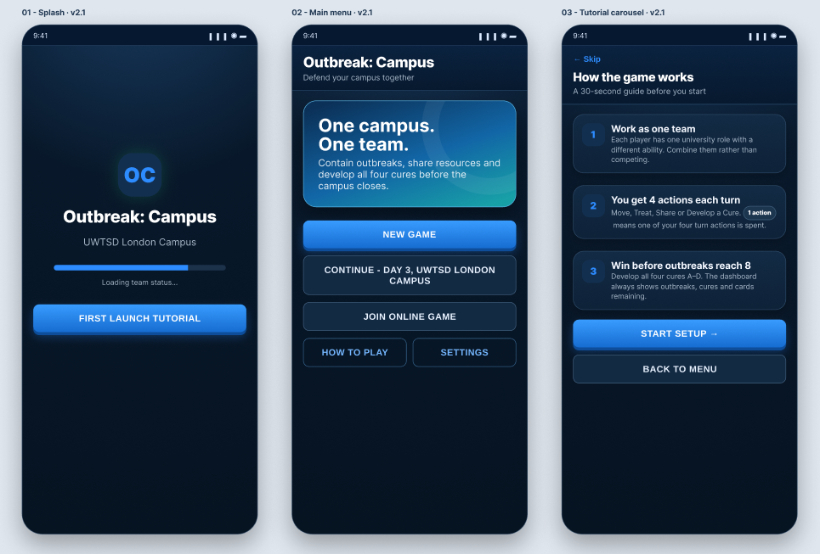

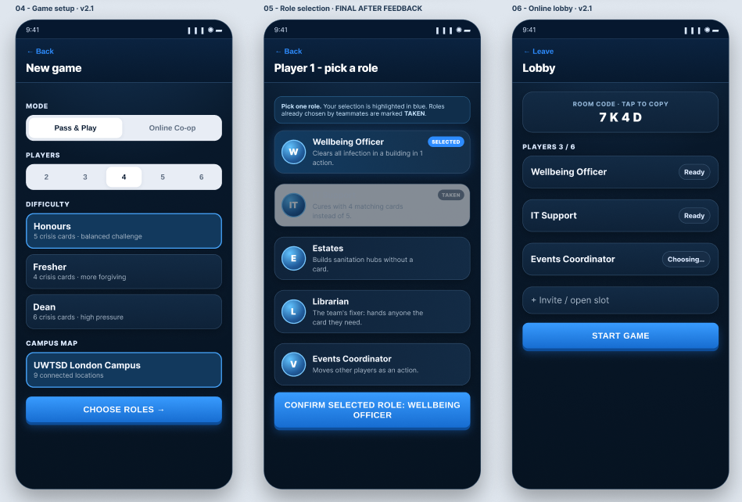

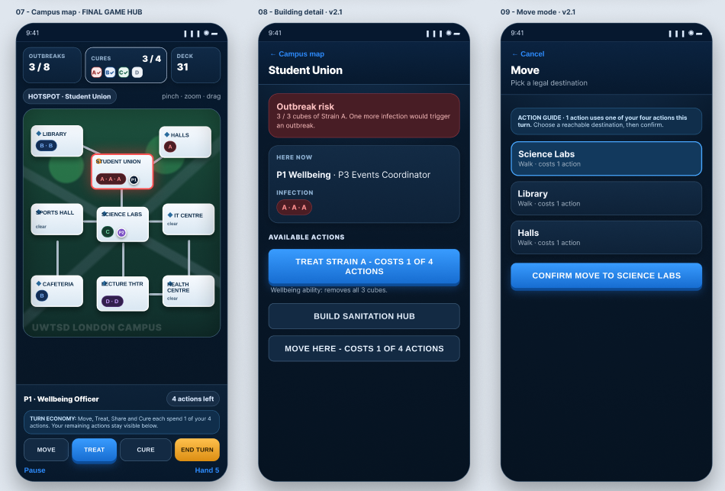

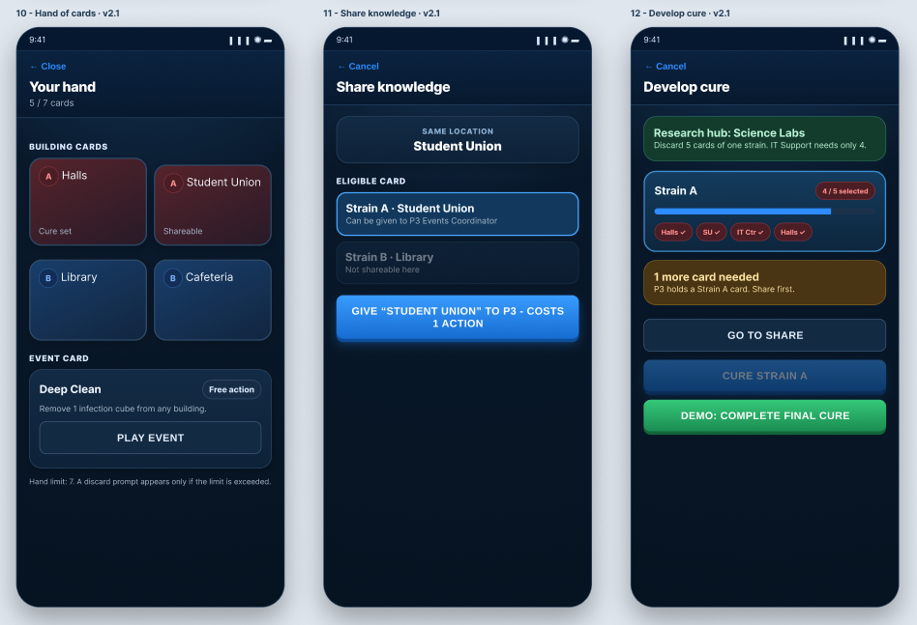

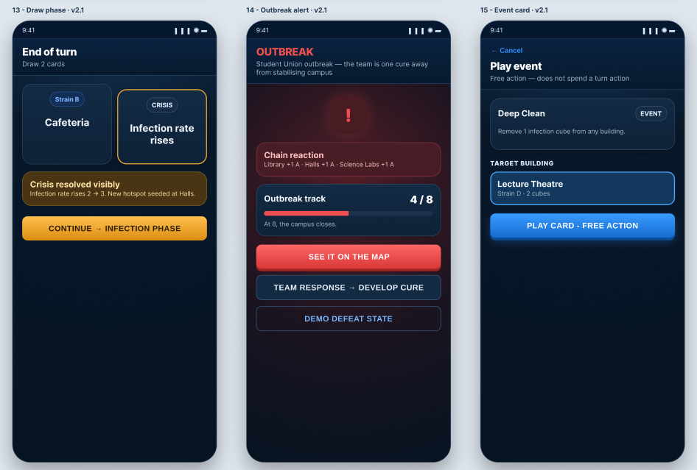

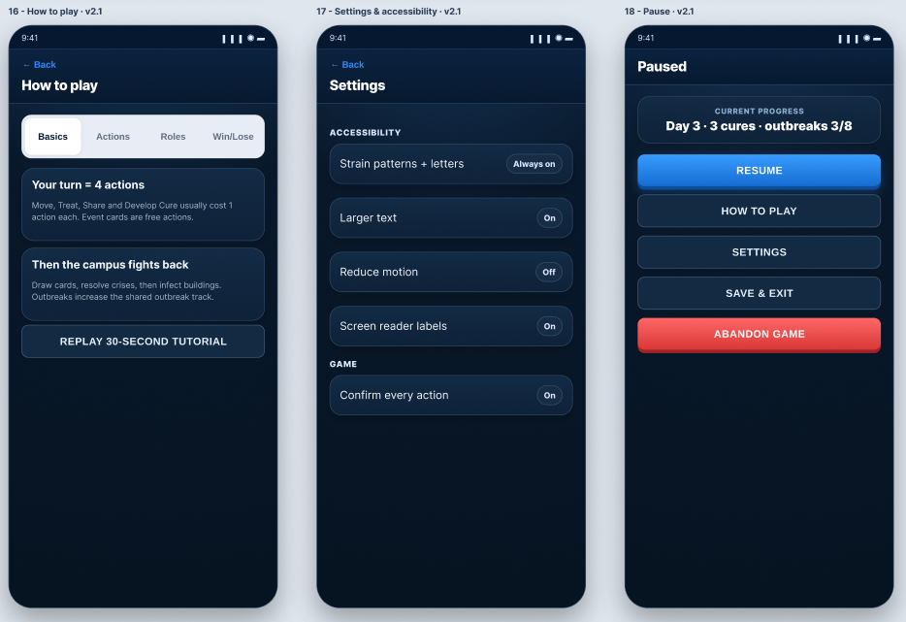
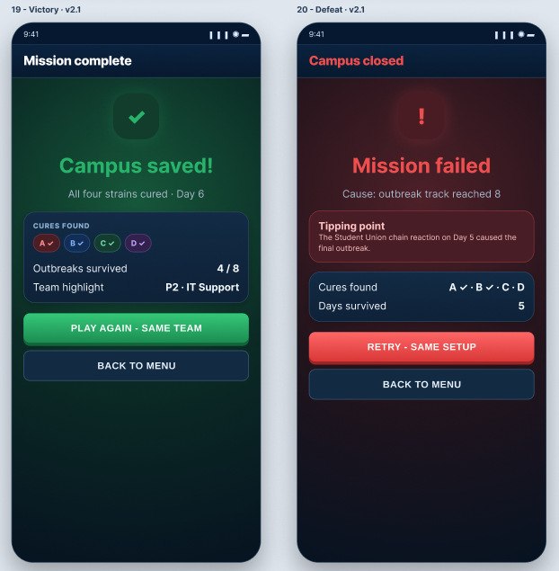

Appendix B - Final Evaluation Questionnaire
Participants were instructed to review the contextual storyboard and open the interactive v2.0 prototype before answering. All eight questions were required.
# | Question | Response type
1 | How clear was the overall interface when you first viewed the prototype? | Linear scale 1-5
2 | How easy was it to understand where to go and what actions were available? | Linear scale 1-5
3 | How easy was it to understand the game status, including outbreaks, cure progress and remaining cards? | Linear scale 1-5
4 | How would you rate the Campus Map in terms of clarity and visual appeal? | Linear scale 1-5
5 | How would you rate the overall visual design, including colours, typography and consistency? | Linear scale 1-5
6 | Does the interface communicate that this is a cooperative team game? | Definitely yes / Mostly yes / Unsure / Mostly no / Definitely no
7 | Was anything confusing, difficult to understand or visually unclear? | Paragraph response
8 | If you could change or improve ONE thing about the interface, what would it be and why? | Paragraph response

Appendix C - Evaluation Results
Seven valid anonymous responses were retained for the final analysis. The first five responses informed the v2.1 refinement; two additional responses arrived during report finalisation and were included before the dataset was frozen at seven. This provides a fixed evidential record while preserving the chronology of the design iteration.
Measure | Mean | Median | Range
Overall interface clarity | 4.43 | 4 | 4-5
Navigation and actions | 4.14 | 4 | 3-5
Game-status clarity | 4.14 | 4 | 3-5
Campus Map clarity and appeal | 4.14 | 4 | 3-5
Overall visual design | 4.14 | 4 | 3-5

Q6: four of seven participants selected “Mostly yes” and three selected “Definitely yes” when asked whether the interface communicated a cooperative team game. No participant selected a neutral or negative option.
Participant | Q7: confusion / clarity | Q8: one improvement
P1 | No, the interface was generally clear. The campus map, available actions and cure progress were easy to understand. | I would add a short tutorial explaining each player’s action before the game begins, so new players can understand how to play more quickly.
P2 | Maybe the game flow | Keep it more basic less complex about information gam
P3 | It doesn’t show when players choose or select roles to play the game clearly | Less panel
P4 | No, everything was clear. | Make it clearer what “(x action)” means in the decision phase.
P5 | No | To use less images for the storyboard, probs only 7 not 12
P6 | No | All good
P7 | No, everything was clear and easy to understand. | I would make the text slightly larger, as some parts may be difficult to read on a phone screen

Appendix D - Feedback-to-v2.1 Traceability
The table distinguishes interface findings from supporting-artifact feedback and records whether each response was implemented. It links participant evidence to the affected usability principle/persona requirement, the v2.0 problem and the justified v2.1 response rather than treating every preference as an automatic requirement.
Finding | Evidence | Principle / v2.0 problem → v2.1 response | Justification / status
Onboarding / game flow | Tutorial request and game-flow comment | Learnability; Andrei FR-06 / game loop insufficiently explained → three-step tutorial + clearer four-action model | Repeated guidance theme; implemented in v2.1
Role selection unclear | Specific Q7 comment | Visibility of system status; Doina XR-04 / selection and availability ambiguous → explicit SELECTED and TAKEN states | Improves recognition of current/unavailable roles; implemented
“1 action” unclear | Specific Q8 comment | Match with user terminology / action economy insufficiently explained → explicit four-action turn guidance | Removes terminology ambiguity; implemented
Information density | “Less panel” and request for more basic information | Hierarchy; Doina XR-08 / secondary copy competed with strategic state → reduce/regroup helper content | Preserves decision-critical state while reducing competition; implemented
Storyboard length | One suggestion for approximately seven rather than twelve images | Supporting artefact rather than UI / no interface defect → no interface change | Recorded separately; not implemented in interface
Mobile text legibility | Late suggestion to make some text slightly larger | Accessibility/readability; Anisa XR-07 / some copy remains small → future text-size refinement | Arrived after v2.1 completion; residual issue, not falsely claimed as implemented

Questionnaire invitations were distributed through direct messaging, but substantive usability and UX responses were intentionally collected through the anonymous Google Forms instrument.
One representative anonymised screenshot is included below as evidence of questionnaire distribution and completion. Additional messaging screenshots are not reproduced because they contain substantially the same recruitment exchange (questionnaire link, completion confirmation and thanks) and provide no additional usability evidence.



