BSc Health and Social Care
Changemakers: Creativity & Value Creation
BMHP5014

Student Name: Nazema Bibi
Student Number: 2333305
Lecturer Name: Raheela Shaikh
Assignment Title: Component 2: Written Assignment (Poster & Pitch)
Submission Date: Thursday 2nd April 2026

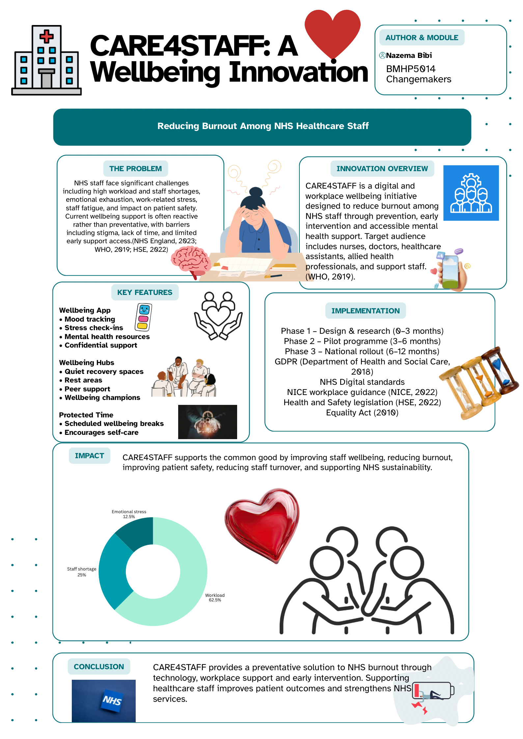
Poster
WRITTEN PITCH

CARE4STAFF: NHS Workforce Wellbeing Innovation

Introduction: The Issue and Proposed Innovation

This proposal introduces CARE4STAFF, a wellbeing initiative designed to reduce burnout among NHS healthcare professionals. The aim of this innovation is to provide accessible and preventative support for staff, improving both workforce mental wellbeing and the quality of patient care.
Burnout has become a significant concern within the NHS due to increasing workloads, staff shortages, and ongoing service pressures. Many healthcare professionals report experiencing emotional exhaustion as a result of work-related stress (NHS England, 2023). Burnout is defined as a syndrome resulting from chronic workplace stress that has not been successfully managed, which can negatively affect both physical and psychological health (World Health Organization, 2019).
Despite increased awareness of this issue, support for staff wellbeing remains inconsistent and sometimes difficult to access. In many situations, staff receive support only after their mental health has already deteriorated. This highlights the importance of early intervention and preventative strategies. CARE4STAFF addresses this gap by providing a combination of digital and workplace support aimed at helping staff manage stress before it escalates into more serious problems.

Background and Rationale
Healthcare professionals play a vital role in delivering safe and effective patient care; however, their wellbeing is not always adequately supported. High levels of stress may lead to burnout, which can result in reduced job satisfaction, increased sickness absence, and decreased quality of care. Evidence suggests that staff wellbeing is closely linked to patient outcomes and overall service performance (NHS England, 2023).
Burnout may also affect teamwork and communication within healthcare environments. When staff feel overwhelmed, they may find it difficult to concentrate, make decisions, or communicate effectively with patients and colleagues. This may increase the likelihood of errors and negatively affect patient safety.
Furthermore, the demanding nature of healthcare work means staff may not always take sufficient breaks or prioritise their own wellbeing. Organisational culture may sometimes discourage help-seeking behaviours due to stigma or fear of negative judgement. The World Health Organization (2019) emphasises that burnout should not be viewed solely as an individual issue but also as a result of organisational factors such as workload demands and working conditions.
These challenges highlight the importance of developing supportive working environments that prioritise staff wellbeing. Providing early support and encouraging open discussions about mental health may help prevent burnout and improve overall healthcare service quality.

The Innovation: How CARE4STAFF Works
To address these challenges, CARE4STAFF is designed as an integrated digital and workplace wellbeing initiative. The innovation focuses on prevention, early intervention, and the development of a supportive organisational culture.
CARE4STAFF consists of three main components. The first is a secure wellbeing mobile application that allows staff to monitor mood and stress levels, access mental health resources, and obtain confidential support. This enables healthcare workers to recognise early signs of burnout and seek support before their condition worsens.
The second component involves the development of on-site wellbeing hubs within healthcare organisations. These hubs would provide quiet, safe environments where staff can take restorative breaks, relax, or speak with trained wellbeing champions. Providing designated spaces for rest and reflection may support recovery during demanding shifts.
The third component involves protected wellbeing time during working hours. This approach encourages staff to take regular breaks and prioritise their mental health without experiencing guilt or workplace pressure. Promoting this approach may help create a workplace culture where staff wellbeing is recognised as an essential element of safe patient care.
Together, these elements aim to reduce workplace stress, improve resilience, and create healthier working environments for NHS staff.

Technology Integration
Technology forms an important part of the CARE4STAFF initiative. The wellbeing application would provide flexible and confidential access to support services, enabling staff to engage with wellbeing resources at convenient times. This is particularly important within healthcare settings where staff may have limited availability during clinical shifts.
The application could include features such as mood monitoring, stress tracking tools, and access to mental health information. These features may help staff develop greater awareness of their wellbeing and promote early help-seeking behaviours. Digital access may also reduce barriers such as stigma, as staff are able to seek support privately.
By combining digital solutions with face-to-face workplace support, CARE4STAFF provides a balanced approach capable of meeting the diverse needs of healthcare professionals.

Implementation Plan
The implementation of CARE4STAFF would follow a phased approach to ensure effectiveness and long-term sustainability. The first phase would involve consultation with healthcare staff, managers, and wellbeing teams to design the programme. This approach ensures the innovation reflects the real needs of the workforce.
The second phase would involve pilot testing within selected NHS organisations, including hospitals and GP practices. During this stage, feedback would be collected to evaluate effectiveness and identify potential improvements.
The final phase would involve wider implementation across NHS organisations. Training would be provided to staff and wellbeing champions to support effective delivery. The proposed timeline would include design and planning (0–3 months), pilot testing (3–6 months), and full implementation (6–12 months).
This structured approach allows the innovation to be evaluated and refined before wider adoption.

Stakeholders and Partnerships
CARE4STAFF would involve collaboration between multiple stakeholders to ensure effective delivery. These include NHS organisations, occupational health services, wellbeing teams, and healthcare professionals.
Collaboration between these groups is essential to ensure support is accessible, practical, and sustainable. Leadership engagement is also important in promoting a workplace culture that values staff wellbeing.
The initiative aligns with NHS priorities focused on improving workforce wellbeing and ensuring sustainable healthcare services (NHS England, 2023). Involving staff in the design and delivery of the programme may also increase engagement and ensure the initiative remains responsive to workforce needs.

Value, Feasibility and Barriers
CARE4STAFF offers clear value through improving staff wellbeing and reducing burnout. This may contribute to improved job satisfaction, lower sickness absence, and improved patient care outcomes.
However, some implementation challenges may arise. These may include time pressures, resource limitations, and ongoing stigma surrounding mental health. These barriers could be addressed through strong leadership support, awareness campaigns, and ensuring the programme is simple and accessible.
The use of digital tools may further improve feasibility by allowing scalable and flexible support. Over time, the programme could be adapted and expanded across different healthcare environments.

Conclusion
CARE4STAFF presents a practical and innovative response to the growing challenge of burnout within the NHS workforce. By combining digital technology with workplace wellbeing support, the initiative promotes early intervention and encourages a culture that values staff wellbeing.
Supporting healthcare professionals is essential for improving patient outcomes and ensuring the long-term sustainability of NHS services. It is therefore recommended that NHS organisations consider adopting CARE4STAFF to strengthen workforce wellbeing and healthcare delivery.

Reference List
Department of Health and Social Care (2018) Data Protection Act 2018. Available at: https://www.gov.uk (Accessed: 16 March 2025).

Equality Act (2010) Equality Act 2010. Available at: https://www.legislation.gov.uk (Accessed: 16 March 2025).

Health and Safety Executive (2022) Work-related stress, anxiety or depression statistics in Great Britain. Available at: https://www.hse.gov.uk (Accessed: 16 March 2025).

NHS Employers (2025) Beating burnout in the NHS. Available at: https://www.nhsemployers.org (Accessed: 16 March 2025).

NHS England (2019) The NHS Long Term Plan. London: NHS England. Available at: https://www.longtermplan.nhs.uk (Accessed: 16 March 2025).

NHS England (2023) NHS Staff Survey Results. Available at: https://www.nhsstaffsurveys.com (Accessed: 16 March 2025).

National Institute for Health and Care Excellence (2022) Mental wellbeing at work (NG212). Available at: https://www.nice.org.uk (Accessed: 16 March 2025).

The King’s Fund (2021) NHS staff survey analysis. London: The King’s Fund.

The King’s Fund (2024) Workforce retention and turnover in the NHS. London: The King’s Fund.

World Health Organization (2019) Burn-out an occupational phenomenon: International classification of diseases. Available at: https://www.who.int (Accessed: 16 March 2025).

