Student Name: Asif Khan
Student I.D: 1808529
Module Code: BMHP5003
Assignment Section: Introduction to Physiology
Lecturer Name: Mumtaz Golam

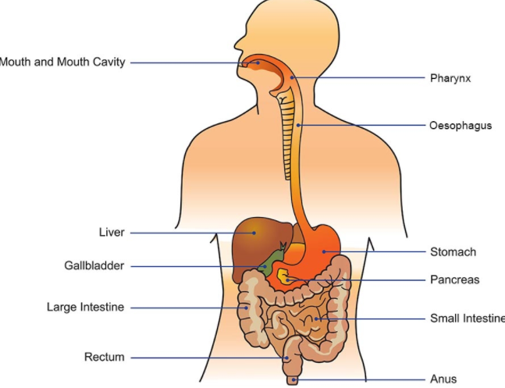

Functions of digestive system
The digestive system in the human body plays a significant role in absorption and digestion. In the case of breaking down foods in small molecules another significant function of the digestive system is the alimentary canal includes the esophagus, mouth, stomach, pharynx, large and small intestine which help in passing foods through the lumen.
DIGESTIVE SYSTEM
Waugh and Grant (2014) have explained in this context that the digestive system contributes to converting food into energy. Another function of the digestive system is absorbing food and passing it into lymphatic vessels. Besides, the digestive system of the body contributes to breaking down the complex macromolecules and absorbing them into the gastrointestinal tract. Moreover, the digestive system helps in defecation, mechanical digestion, motility, indigestion and defecation.

Mouth
Different accessory organs like salivary glands, teeth, and tongue push food items to go to pharynx. Wang et al. (2020) have noted that teeth help in grinding and cutting food items in smaller pieces whereas tongue muscles with rough papillae help to grind the food and push that food towards Pharynx. Salivary glands moisten food and contribute to the digestion of carbohydrates. It has been noted that swallowing segmentation and peristalsis are three main movements and mixing processes off the digestive system. Williams et al (2016) have emphasized on this topic that enzymes, mucus, saliva, hydrochloric acid and bile improve the chemical digestive of food.

Pharynx
This part is solely accountable for passing chewed food to esophagus. Thomson and Friendship (2019) have emphasized that In the respiratory system, this also plays a significant role. In terms of passing air and food, epiglottis and larynx both help a lot.
Esophagus
This muscular tube connects the pharynx with the stomach. Adriana and Andrea (2017) have remarked that the upper gastrointestinal tract also helps in passing the food. Moreover, the lower esophageal sphincter plays a significant role by closing the end of the esophagus and trapping food items in the stomach.

Stomach
Digestive enzymes and hydrochloric acid in the stomach foster the digestion process. Moreover, the stomach is considered a storage tank which improves the digestion of large meals.

Small Intestine
The maximum space of the abdominal cavity is taken by the small intestine. Muller (2018) has stated that different folds and ridges maximize the process of digestion as well as absorption of various nutrients. This is one of the most important parts which helps in the extraction of 90% of the nutrients.
Gallbladder and liver
The role of gallbladder is to recycle and store excess bile for the digestion process. The primary function of the liver is to produce bile and maintain its secretion.

Pancreas
In the secretion of digestive enzymes in the small intestine, the pancreas helps a lot. In the completion of chemical digestion, the pancreas plays a significant role.
Large Intestine
The large intestine plays its significant role in absorbing water and containing symbiotic bacteria which help in breaking down the wastes.
Rectum & anus: Rectum is the concluding part of large intestine and it functions as the storehouse of feces. It directly connects to the anus
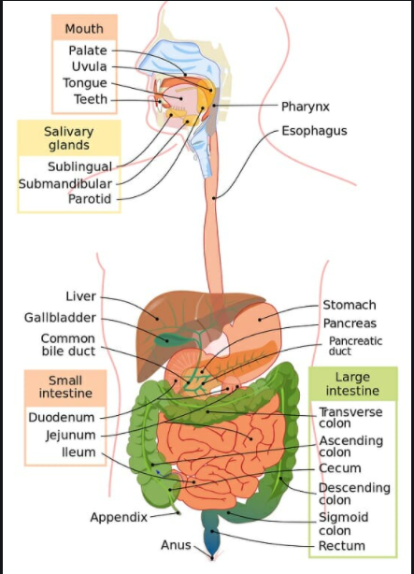
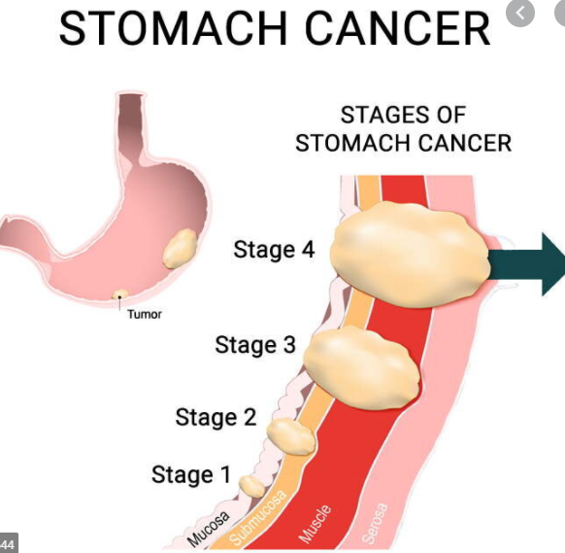

Physiology and anatomy of the digestive system
Accessory structures and alimentary canal are included with the digestive system of the body. Various organs of the alimentary canal help in chemical digestion and mechanical digestion under the digestive anatomy, pharynx, esophagus and mouth which help food to reach to stomach. Besides, cardiac sphincter helps in trapping food in the stomach.
Due to the issues in the digestive system in the body, several problems or health issues have been noticed. Stomach cancer is one of the illnesses which is caused due to indigestion. Moreover, chronic constipation, gastroesophageal reflux disease, chronic diarrhea and others have been noted. Ross and Wilson (1987) have opined in this regard that stomach and mouth have the storage capacity and improve the ingestion process. Moreover, gallstone pancreatitis, peptic ulcer, and gastroenteritis are the examples of illness which are caused due to issues in the digestive system. Cherpak and Van Lare (2019) have stated in this context that in terms of assembling large macromolecules like lipids, proteins and carbohydrates, enzymes play a significant role. Due to the ineffective digestive system, all these illnesses have been noted in the body.
Rubio (2018) has commented in this context that digestive enzymes and hydrochloric acid are contained in the stomach. Physiology of the digestive system lies in the indigestion of food, secretion of digestive enzymes and fluids, movement and mixing of wastes and foods in the body. The physiology of the digestive system positively helps in turning whole foods into nutrients and energy in the body. At the same time, with the help of the digestive physiology, the body can be able to grow, function as well as repair itself in the absorption of nutrients large intestine, lymphatic vessels and blood vessels contribute to absorbing vitamins and water in the bloodstream. Lupyr (2020) has remarked that indigestible substances are removed through defecation. Besides in the of supporting the indigestible materials, the anatomy of the digestive system plays a crucial role, the upper Gastrointestinal tract and lower esophageal sphincter help in trapping food. Alongside this digestive enzymes and hydrochloric acid in the stomach contribute to the digestion of food items. The Gallbladder in the digestive system helps in the digestion process of subsequent meals.

References
Adriana, W. and Andrea, D., 2017. How Food is Processed in the Human Body or Children's Concepts of How the Digestive System Works. Procedia-Social and Behavioral Sciences, 237, pp.1582-1587.
Cherpak, C.E. and Van Lare, S., 2019. Mindful Eating: A Review Of How The Stress-Digestion-Mindfulness Triad May Modulate And Improve Gastrointestinal And Digestive Function. Integrative Medicine: A Clinician's Journal, 18(4), pp.12-25.
Lupyr, M., 2020. Functional anatomy of the digestive system, pp.12-23.
Muller, A., 2018. Ross and Wilson Pocket Reference Guide to Anatomy and Physiology E-Book. Elsevier Health Sciences.
Ross, J.S. and Wilson, K.J., 1987. Ross and Wilson Anatomy and Physiology in health and illness. Churchill livingstone.
Rubio, C.A., 2018. Recent Studies on Digestive System Anatomy, pp.1-12.
Thomson, J.R. and Friendship, R.M., 2019. Digestive system. Diseases of swine, pp.234-263.
Wang, B.G., Yan, L.R., Xu, Q. and Zhong, X.P., 2020. The role of Transfer RNA-Derived Small RNAs (tsRNAs) in Digestive System Tumors. Journal of Cancer, 11(24), pp.7237-7245.
Waugh, A. and Grant, A., 2014. Ross & Wilson Anatomy and physiology in health and illness E-book. Elsevier Health Sciences.
Williams, E.K., Chang, R.B., Strochlic, D.E., Umans, B.D., Lowell, B.B. and Liberles, S.D., 2016. Sensory neurons that detect stretch and nutrients in the digestive system. Cell, 166(1), pp.209-221.

