Shabilah Hussain
1806501
University of Wales Trinity Saint David
Academic and Employability Skills
BMSK4001
Employability Skills
Date :11/01/2019
Lecturer- Mel Squire/Laura James

Executive Summary
The purpose of this report is to discuss the benefits of employability skills the report highlights the importance of employability skills to employers and employees working within Tesco industry. This report will include of the researcher and the skills gained through study. It also discusses wider employability skills that are required by employers. the report found that there are many benefits of employability skills.

Contents
Executive summary
Terms of reference 1.0
Introduction………………………………………………………………………………………………1.1
Procedure………………………………………………………………………………………………….2.0
Employability skills within Tesco
Finding……………………………………………………………………………………………………3.0
The benefits of employability skills to an employee in Tesco industry
Employability skills………………………………………………………………………………3.1
Interpersonal Communication skills .……………………………………………………3.2
Time management……………………………………………………………………………….3.3
Critical thinking…………………………………………………………………………………….3.4
Team management……………………………………………………………………………….3.5
Problem solving…………………………………………………………………………………….3.6
Self- management & organizational……………………………………………………….3.7
Negotiation …………………………………………………………………………………………3.8
Conclusion……………………………………………………………………………………………..4.0
Recommendation…………………………………………………………………………………….5.0
References/Bibliography………………………………………………………………………….6.0

1.0 Terms of reference
Report has been requested by Lecturer Mel Squire and Laura James at University of Wales Trinity Saint David. The assignment title is Employability skills. The module code is BMSK4001. Submission dead line is 11/01/2019. The purpose of this report is to discuss benefits of employability skills to employers and employees and a discussion of transferrable skills studied at University of Wales Trinity Saint David.
1.1 Introduction
This report analyses the benefits of employability skills for both employees and employers working in Tesco. The report will include a discussion of existing skills studied at University of Wales Trinity Saint David. It will include discussions of wider employability skills that are required by employers and it will analyse published literature relating to a specific topic employability skill and their benefits, conclusions will drawn to the benefits of employability skills.
2.0 Procedure
Employability skills within Tesco industry
Employability skills within the grocery sector specifically looking at the role of store manager at Tesco. The report will include looking at articles of job specifications, conduction research. Tesco is the largest grocery store over 3400 store nationwide. A job specification advertised for Tesco store manager someone with experience that can lead a team with good communication skills a highly motivated individual store manager for planning, implementing, practice and procedure, store policy, managing store stocks and employability skills needed for the role are good at team work and good communication skills.
Tesco advertise their jobs on the internet through their website. Second person, role can also be applied for through LinkedIn, indeed, twitter and Facebook. Once registered a job application is completed, if a candidate matches the skills required an interview may be requested. When recruiting a, it’s important to hire the right person for the job. A job specification will outline the purpose, responsibilities and requirement of the job. it will also include job title, location, department, hours and salary.
An accurate job description will make the recruitment process more effective. Help employees know what they need to do. Simplify appraisal and monitoring process.
3.0 Findings
The benefits of employability skills to an employee in Tesco industry.
Tesco store manager needs to ensure that they meet target and meet professional needs for the company as the company are profitable company and has a high standard to meet all over the UK being a limited company. Employability skills within this role which are highly important for the role are good communication skills to be able to interact with team and lead using appropriate language and good team working to be able to manage a team, managers can express their role and responsibilities and get along with others.
Figure 1
The diagram demonstrates what employability skills are needed for a Tesco retail grocery store manager.

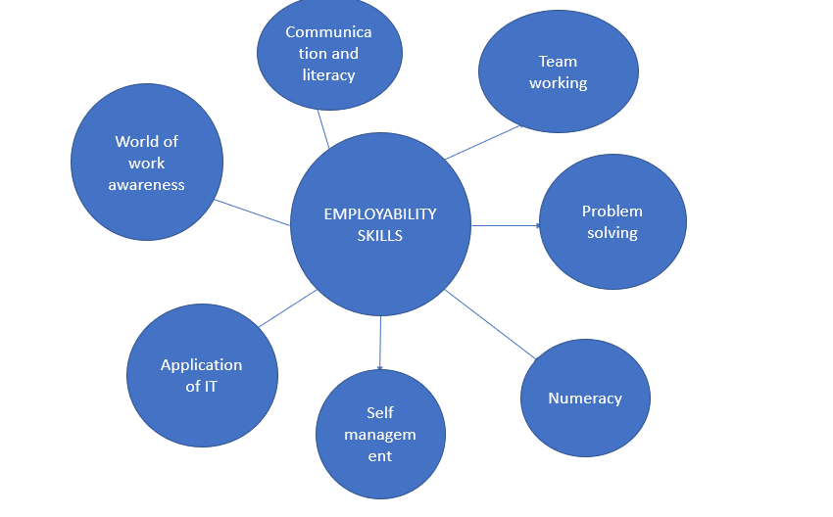
3.1 Employability skills
Employability skills are important skills and qualities needed in almost all jobs. These are common skills that make someone employable. Employee will check if they have the right abilities to match what the employers require. To have employability skills depending on the job role the right kind of skill can vary, all job roles require different skills. Gaining employability skills from studying, school, university and former experience will help with career development and seeking work.
Research suggest what skill, competencies, attributes and personal qualities were most valued by employers graduates with identity element as follows:
- Values
- Intellect
- Performance
- Engagement
Another research suggests the expectation is for graduates and student to be able to fit quickly in a team to be a good communicator both verbally and in writing. Another part of the research asked employee to range grouping of employability skill reflective to one another as follows
- Interpersonal skills
- Written/communication skill
- IT skills
- Experience in work environment
- Commercial and business awareness
- Numeracy skills
- Presentation skill
An important point here is what wide range of employers value the most. Tesco could utilise the method SMART objectives so that the enterprise can ensure that the level of business productivity does not get reduced at all. SMART objectives compromise of the characteristics of strategies that are specific, measurable, achievable, realistic and time bound in nature (Yammarinoetal.,2010) the adoption of strategy SMART objective within Tesco workplace could enhance the level of success.
Relating the smart objectives to the requirements of the role using the smart objectives. Enhancing the growth and success of the business. company will set a plan in place for this to happen. Employees to deliver company promises.

Employability skills for majority of job-related areas there is starting point for professional studies, a student studying or a graduate, the techniques for learning at work may still include from development of academic knowledge reading and professional studies university education including skills for place for higher education means that we can pursue widely recognised career

3.2 Interpersonal Communication skills
Communication skills are valuable, a store manager of Tesco can adapt verbal communication model so that the team leaders can convey the information and ideas to the members in person at regular intervals and also motivate them personally to give the optimum productivity towards the realisation of goals of the organisation (Jackson and Joshi.,2011)
Figure 2 Communication model
Sender (Encoding) – Message (oral, written, nonverbal) – (Decoding) Receiver
Figure 2 model indicates the process of communication verbal & nonverbal communication. Tesco store manager will habit verbal communication involves chatting, enquiring, delegating, directing and informing. Communication skills are important for grocery store manager to be able to communicate with staff and follow up meetings for staff and to communicate with higher managers. it is important for a store manager to able to communicate with staff and customer. To be able to share information. Competent communication within group settings is essential in the contemporary workplace (Worley & Dyrud,2001), widely recognised as essential to quality practices (M. W. Allen & Brady, 1997). Communication interpersonal skills used for employs and employees and student it can be used to communicate with a team or a one to one basis for any conversation there must be at least two people involved, involving a sender and receiver message. The message of thought, information, or idea that’s result in mutual understanding but also the non-verbal messages exchanged such as facial expressions and body movement is equally important process of communication. Effective communication helps make the information process. Whilst studying communication skills are used very often to communicate with lecturer or another student and when doing a class presentation your audience will listen actively to listen to what you are saying and able to process the information. A class presentation will involve your body language and movement.

3.3 Time management
Time management is important for student and employers who are able to manage their time, will show that they productive and more likely to meet deadlines.
When looking at Stephen Covey’s time management Matrix (1989), where do you spend your time?
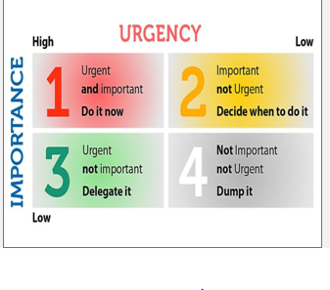
figure 3 Stephen Covey’s time management Matrix (1989)
In 1989 Stephen Covey developed the “time management Matrix” a tool illustrating how individuals managed their time using broad categories of importance and urgent.
figure 3 describe time management is used both in work place and whilst studying. Both students and managers can some time struggle with time management 3 is a tool which illustrates urgency which require immediate attention meaning its “now” to act that could be a deadline for a student and for a manager an important meeting. importance which is high priority goal both for student and a manager. For e.g. email that needs to be sent to fix an issue and for a student attend a lecture.
Time management is essential skill to have whilst looking for a job and whilst studying. Time management skill you use in everyday life planning to go to interview or when you need attend. Tesco store manager will have to plan time for meeting, target or whilst having a tending a shift pattern in place.
3.4 Critical thinking
As shown on the diagram Critical thinking is important for a Tesco store manager to be able to resolve problems to be the first point of contacts of that if staff have any problems relating in work they can speak to someone to resolve the issue. This skill is very important to be able to lead a team as well getting the job done. Whilst studying you may have to answer a question in class, in that moment you need to look at facts as quick as possible and answer the question.
Figure 4 Blooms taxonomy (bloom et al., 1956)
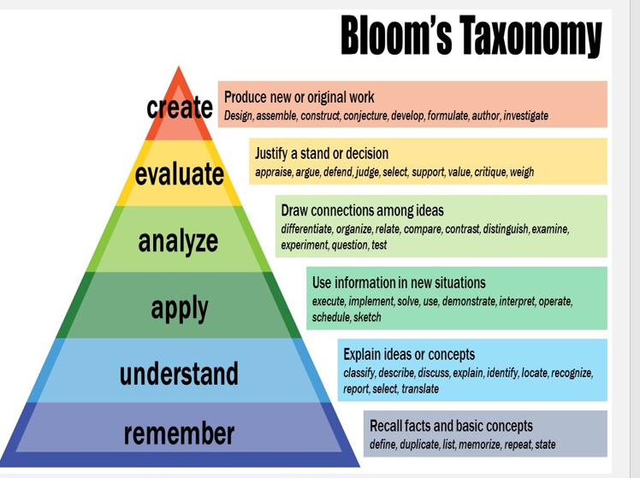
Critical thinking was developed by Benjamin Bloom (1956)- seen as a hierarchical set of skills by which work is typically assessed. As we can see studying and working apply to same method and whilst seeking for a job.

Figure 4
Implies list of personal skills:
level 1 -Remember by reproducing knowledge when attending a class or a meeting.
Level 2- Understand the idea listen to the lecturer actively or in a work situation, in a meeting listen to the senior manager or problem with co- workers.
Level 3- Apply the idea or practise, how it will support the business.
Level 4- Analyse, examine your findings, back up the decision with benefits.
Level 5- evaluate on a decision, thinking about the do’s and don’ts
level 6 -create to put your idea forward and back it up.

3.5 Team management
Effective team working is suggested important for a grocery store manager to collaborate with the team, research on theoretical perspective on teamwork indicates across the occupational field, team work has become increasingly important, team work has expanded quickly. In manual production, small groups of workers with bounded decision- making authority and flattened hierarchies help firms adapt rapidly shifting markets and consumer tastes (Cappelli et al., 1997). It is also important whilst studying to get along with team member and to work together in a group activity.
3.6 Problem solving
A store manager will set activities for the team. Will set a structure process of brain storming to achieve a solution for an issue. Research suggests in the information age, there is constant change, and an employee must be able to engage in problem solving activities (Zorn,2002). Problem solving involves not only making a choice but also coming up with quality alternatives, problem solving is also used whilst studying at university.
3.7 Self-management planning and organising
Self-management, planning and organising is crucial for a store manager, it is important so that they resolve team queries, customer concerns and business targets. Store manager need to prepare for the day ahead to utilise expectations to then forward the results to senior the manager or stakeholder. For students these skills are also essential to be able to self-manage assignment and exams and attending lesson being prepared for the day ahead.
A store manager for Tesco should have the ability to write well, currently IT is also a method of communication, partially through email. To self-manage a team and relaying information to team and delivering task on time. Numeracy will be essential for a Tesco store manager to be able to work out stocks in the store what sales have been made and what contribution is need for the stock. IT skills contributes widely recognised skill for both employer and student at most common form of communication to write, formal report and researching.
3.8 Negotiation
Effective negotiation skill is used in a workplace preparing for a meeting, to agree with outcome. To listen actively one to one or group. The setting could be in university or a work environment where two parties or the group need to agree with a decision.
All these skills are learnt through studying and working and personal skills. Employability skills are very beneficial to employers and employees having a good understanding and acting upon, it puts you in a better position to get the job as a store manager. To be able to work in a team, communicate with other employees. Time management, critical thinking and problem solving are all beneficial skills.
4.0 Conclusion
Although we can see what employers are looking for in employee it all relates to what you have learnt and studied. Transferrable skills studying Skills for the Workplace Employability Skills. Employability skills are necessary for accomplishment, possession and being successful in a job. They are the skills and attitudes that enable employees to get along with colleagues. Employability skills are developed through a course/ university also through experience. A student studying skills for the workplace in higher education as well researching the industry of what is learnt, employability skills in any industry are a majority of the skills learnt at university and required for a job. when a company will advertise job roles requiring all these skills they will advertise essential skills that they are looking for. Whilst studying skills for the work place at University of Wales Trinity Saint David the main topics covered which contribute to employability skills and career development and academic employability skills include:
- Reflective learning
- Harvard referencing
- Paraphrasing
- Designing and delivering a presentation
- Working as a team
- Report format
- Practicing writing skills
Reflective learning to enable professional development, to improve academic performance, to maintain quality reflecting on what went wrong how improvement can be made. Reflecting on what went well and why good practice is essential. What is reflective practice for future improvement when going into employment “do something think about what you did, come to conclusion about what you did and plan to try again”. (Kolb 1984)
Professional development plan intends to develop skills that are seen for working life particularly within an organisation. This may include IT skills, interpersonal skills and project managements skills.
To reflect on the subjects that were studied in skills for the workplace. It helps with professional career development, improves academic performance. reflection on what went wrong and how to improve it whilst studying lectures, set up task and exams which have a deadline which contributes to time management.
Harvard referencing, and paraphrasing prepare you for critical thinking, writing skills editing and proof reading. Harvard referencing method it is important to avoid plagiarism and it’s also important to acknowledge and reference information. paraphrasing also support writing skills.
Designing and delivering presentation contribute to working in a team analysing information problem solving, setting up a presentation in relation to recruitment and selection process a deadline to meet also develops you and readiness for employment.
5.0 Recommendation
Moving forward based on data generated from the research, Employability skills for a store manager are beneficial for the job. Employability skills for majority of job-related areas there is starting point for professional studies, a student studying or a graduate, the techniques for learning at work may still include from development of academic knowledge reading and professional studies university education including skills for place for higher education means that we can pursue widely recognised career in the retails sector. Studying at University of Wales Trinity Saint David Skills for the workplace are transferrable skills for a job it will put you in better position to start your career. Studying the course reflecting on what you have learnt can put you in to better position.

6.0 Bibliography /Reference list
Allen, M. W., Brady, R. M. (1997). Total quality management, organisational commitment, perceived organisational support, and interorganisational communication. Management communication quarterly,10, 316-341.
Bloom, B.S, Engelhart, M.D., Furst, W,J., Hill, W.H. and Krathwohl, D.R. (1956) Taxonomy of educational objectives: the classification of educational goals in Handbook 1: the Cognitive Domain. New York: David McKay.
Cappelli P and Rogovsky N (1998) Employee involvement and organisational citizenship: Implications for the labor law reform and ‘lean production’. Industrial and labor relations review 51(4):633-653.
Covey, S. R. (1989) the seven habits of highly effective people. New York: Simon & Schuster.
Higher education Academy (2009) ‘Employer concepts of graduate employability’. York: HEA
Jackson, S. E & Joshi, A. (2011). Work team diversity.
Kolb D.A (1984) Experiential learning experience as a source of learning and development, New jersey: Prentice hall
Worley, R.B., & Dyrud, M. A. (2001). Managing student groups. Business Communication Quarterly, 64(4), 105-106.
Yammarino, F.J, Mumford,M.D., Connelly ,M.S., Dionne,S.D.2010. Leadership and team dynamics for dangerous military context. military psychology, 22(S!), S15
Zorn, T. (2002). Converging with divergence: Overcoming the disciplinary fragmentation Business communication, organisational communications, and public relations. Business Communications quarterly, 65 (2),44-55.

7.Worley, R.B., & Dyrud, M. A. (2001). Managing student groups. Business Communication Quarterly, 64(4), 105-106.
5.Jackson, S.E & Joshi, A. (2011).Work team diversity.
6.Kolb D.A (1984) Experiential learning experience as a source of learning and development, New jersey: Prentice hall
8.0 Yammarino, F.J , Mumford ,M.D., Connelly ,M.S., Dionne,S.D.2010. Leadership and team dynamics for dangerous military context. military psychology, 22(S!), S15

9.Zorn, T. (2002). Converging with divergence: Overcoming the disciplinary fragmentation Business communication, organisational communications, and public relations. Business Communications quarterly, 65 (2),44-55.
3.Cappelli P and Rogovsky N (1998) Employee involvement and organisational citizenship: Implications for the labor law reform and ‘lean production’. Industrial and labor relations review 51(4):633-653.
3.Covey, S. R. (1989) the seven habits of highly effective people. New York: Simon & Schuster.
4.Higher education Academy (2009) ‘Employer concepts of graduate employability’. York: HEA

